Final Report

Biocomputing

Lotka-Volterra Model:

* What can you say about the “role” of each parameter?
  + In the case of the prey birthrate parameter (“b”), its role in the interaction between prey and predator seems to be centered around influencing the maximum peaks of prey and predator populations and the length of the cycles. When “b” is decreased the cycles become lengthier and the maximum peaks of population growth are less than those of the initial conditions. This suggests that a low prey birth rate is limiting the predator population in an indirect manner by limiting the available resources that are required for predators to multiply at a bigger and faster rate.

On the other hand, when “b” is increased cycles become shorter and both populations reach higher peaks of maximum growth relative to the initial conditions.

* + The predator attack rate (“a”) also affects the growth of the populations as well as the length of the cycle. A high attack rate severely limits the increase of both populations, neither prey nor predator populations can grow significantly under this conditions. In contrast, a low attack rate promotes extremely high growth in the herbivore population, predator population also increases in number but to a lesser extent; the cycles become shorter and both the increase and drop in populations sizes takes place in a short window of time.
  + In the case of the conversion efficiency of prey to predators (“e”), the cycle length is not altered when compared to the initial conditions. Once again, changes in “e” affect the population growth of prey and predator: when “e” is high the growth of the herbivore population is constrained, in addition, the size of the predator population grows closer to that of the prey; it represents more than 50% of the number of individuals present in the herbivore population. Inversely, when “e” is decreased herbivores multiply at a fast rate and reach a high maximum peak, whereas the predator population grows very little.
  + Lastly, when the predator death rate (“s”) is low the length of the cycles is increased; mostly because the predator population takes longer to drop, and the population size of prey is limited, however, that doesn’t mean it does not grow, it does but to a lesser degree, What’s more, the predator population increases but this increment seems to be limited by prey availability so the increase is not exaggerated. Conversely, a high “s” promotes the growth of the herbivore population, it maintains the population of predators at a small size and it also shortens the cycle.
* What can you say about the role of predators in the simulations?
  + Predators seem to be a limiting factor for herbivore population growth, this group reaches its maximum population size peak at a point that correlates with an accelerated decrease in the population size of the herbivores. Interestingly, the the number of predators never reaches the levels of the prey, in all simulations predators where always the smaller group, this is due to the fact that is not enough to have a large number of preys, predator success will also be dependent upon the attack rate an conversion efficiency.
* What is the relationship between parameter values and predator-prey cycle length?

b: Can shorten or lengthen cycles

a:Can shorten or lengthen cycles

e: Does not affect cycle lenght

s: Can shorten or lengthen cycles

Rosenzweig-MacArthur

* How do the dynamics differ from Lotka-Volterra?
  + The dynamic differ from the Lotka Volterra model in a number of different ways. The first is the Rosenzweig-MacArthur model incorporates prey density as a parameter that influences predator populations. The predator’s kills are limited, and therefore once prey is abundant enough, only a certain amount of prey can be consumed in a given time period.
* What can you say about the “role” of each parameter, especially what causes the dynamics to differ between the L-V and R-M models?
  + The birth rate (b) of the prey greatly affects predator abundance in the RM model. When the birth rate of the prey is increased, there is an initial sharp decline in the prey population. This decline in prey population decreases the abundance of predators. When the predator population declines, the prey population increase and steadies out near initial starting values. The predators then establish a stable low population. When prey birth rate is decreased, the predator population is decreased stabilized at low population numbers. When the parameter for conversion efficiency(e) from prey to predator is increased, there is a cyclic cycle of predator population size. A decrease in e leads to a sharp decline in the predator population. The parameter (s) is the predator death rate. An increase in (s) decrease the predator abundance very quickly, with little to no sustaining population. An lower s value shows a slight increase in predators followed by a decline once prey populations lower. The predator populations appear most sensitive to the death rate. When the (w) parameter of attack rate is high, there predator populations vary more due to their frequent consumption of prey. Low w values have a low, stable predator abundance over time.
* What is the relationship between parameter values and predator abundance?
  + Parameter values have a great effect on predator abundance, even without changes to the prey parameters.

Paradox of Enrichment

* What happens as carrying capacity increases?
  + As the carrying capacity of the prey increases, the predator population destabilizes and begins to crash. The predator abundance recovers and grows large again, only to destabilizes and crash once more. The predator population enters a cyclic cycle of population growth and decline.

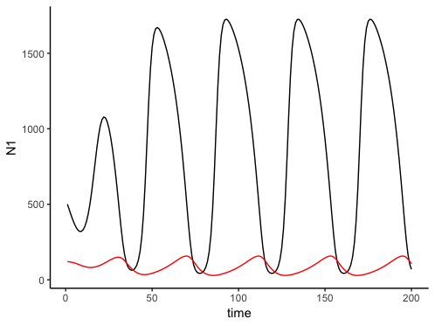

* Why do you think we see the Paradox of Enrichment?
  + We see the Paradox of Enrichment occur because the predator population becomes too large. With the large increase in food availability, the predators experience almost unrestricted growth. However, their high abundance is unsustainable and subsequently reduces their population as a consequence.