Final Report

Biocomputing

**Lotka-Volterra Model:**

Conceptual Model: See attached PDF file.

What can you say about the “role” of each parameter?

In the case of the prey birthrate parameter (“b”), its role in the interaction between prey and predator seems to be centered around influencing the maximum peaks of prey and predator populations and the length of the cycles. When “b” is decreased the cycles become lengthier and the maximum peaks of population growth are less than those of the initial conditions. This suggests that a low prey birth rate is limiting the predator population in an indirect manner by limiting the available resources that are required for predators to multiply at a bigger and faster rate. On the other hand, when “b” is increased cycles become shorter and both populations reach higher peaks of maximum growth relative to the initial conditions.

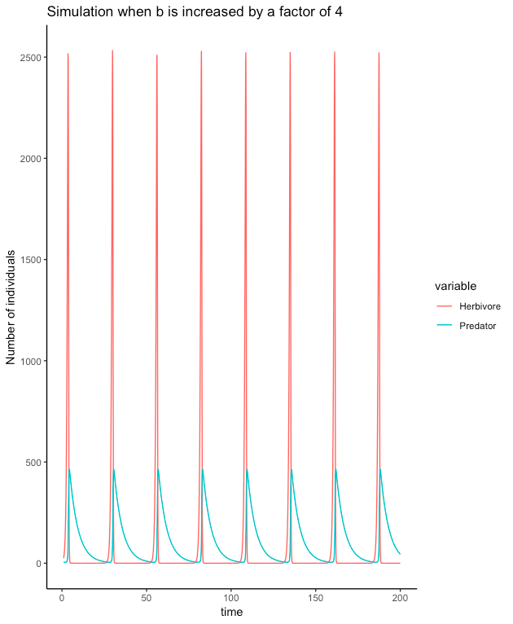

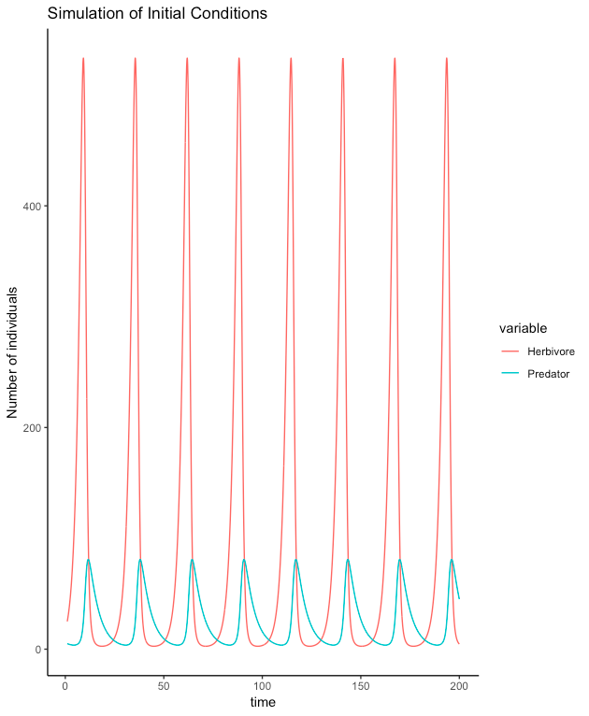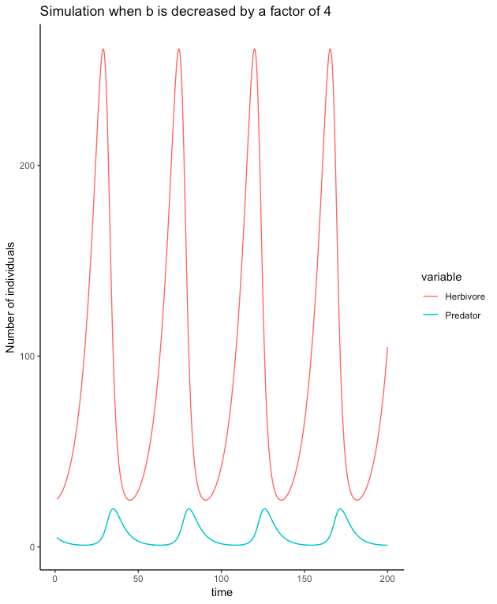

Figure 1. From left to right: data simulations for initial conditions, “b” increased by a factor of 4, and “b” decreased by a factor of 4.

The predator attack rate (“a”) also affects the growth of the populations as well as the length of the cycle. A high attack rate severely limits the increase of both populations, neither prey nor predator populations can grow significantly under this conditions. In contrast, a low attack rate promotes extremely high growth in the herbivore population, however, this is not followed by a high increase in the predator population. When this parameter is high cycles become shorter, and when it’s low cycles become longer.



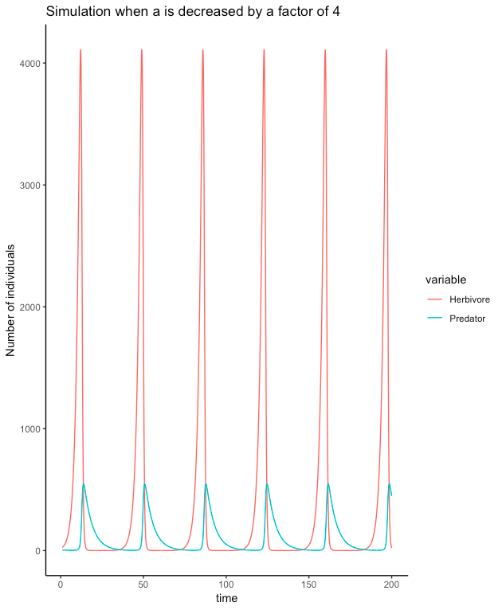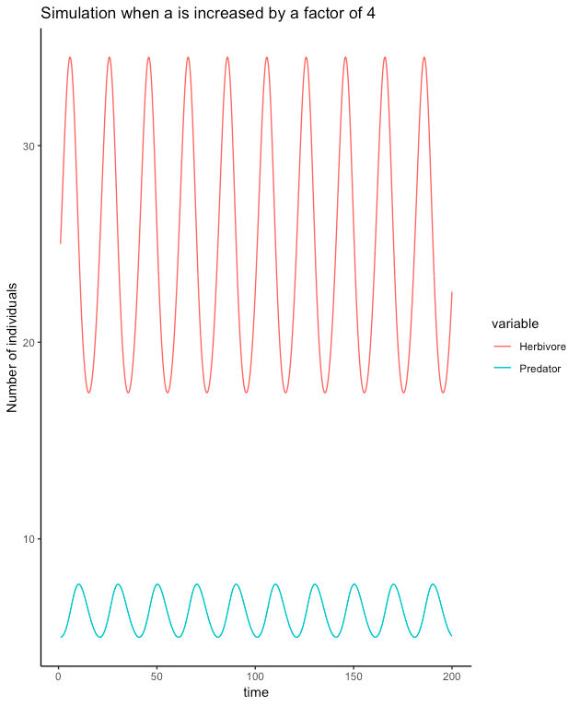

Figure 2. Data simulations for initial conditions (upper center), “a” increased by a factor of 4 (lower left corner) and “a” decreased by a factor of 4 (lower right)

In the case of the conversion efficiency of prey to predators (“e”), the cycle length is not altered when compared to the initial conditions when “e” is increased, when you decrease “e” cycles get a little shorter. Once again, changes in “e” affect the population growth of prey and predator: when “e” is high the growth of the herbivore population is constrained, in addition, the size of the predator population grows closer to that of the prey; it represents more than 50% of the number of individuals present in the herbivore population. Conversely, when “e” is decreased, herbivores multiply at a faster rate in response to a lower growth in the predator population and reach a higher maximum peak that doesn’t really alter the low growth in numbers of predators.

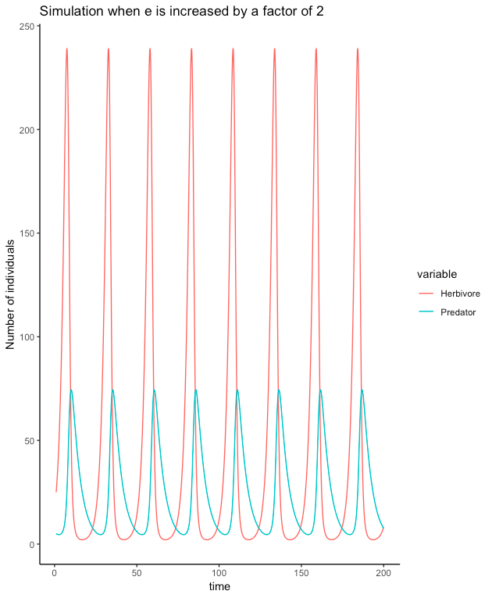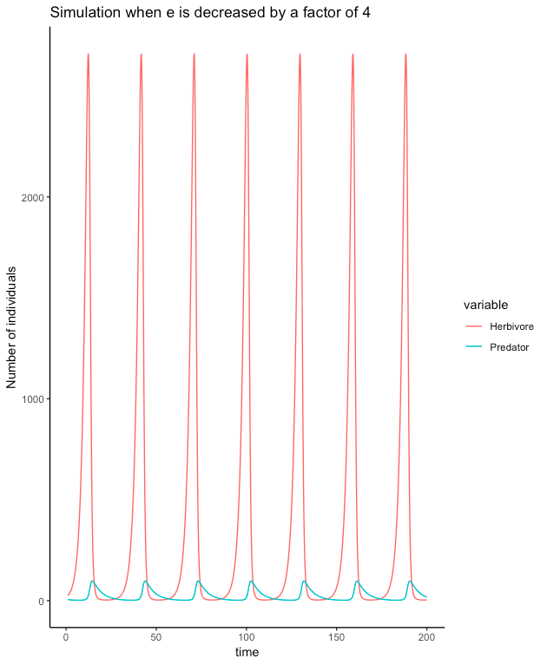

Figure 3. Data simulations for: initial conditions (upper center), “e” increased by a factor of 4 (lower left corner) and “e” decreased by a factor of 4 (lower right)

Lastly, when the predator death rate (“s”) is low, the predator population takes much longer to drop, this correlates to a prey population that isn’t growing to such large numbers. The rate of growth of the predator population is increased but this increment seems to be limited by prey availability so the raise is not so exaggerated. Conversely, a high “s” promotes the growth of the herbivore population to a high maximum, and it maintains the population of predators at a small size.



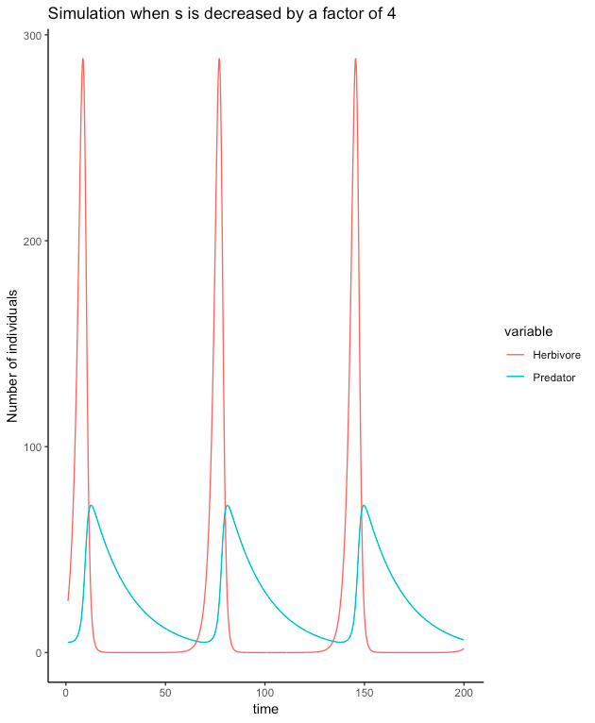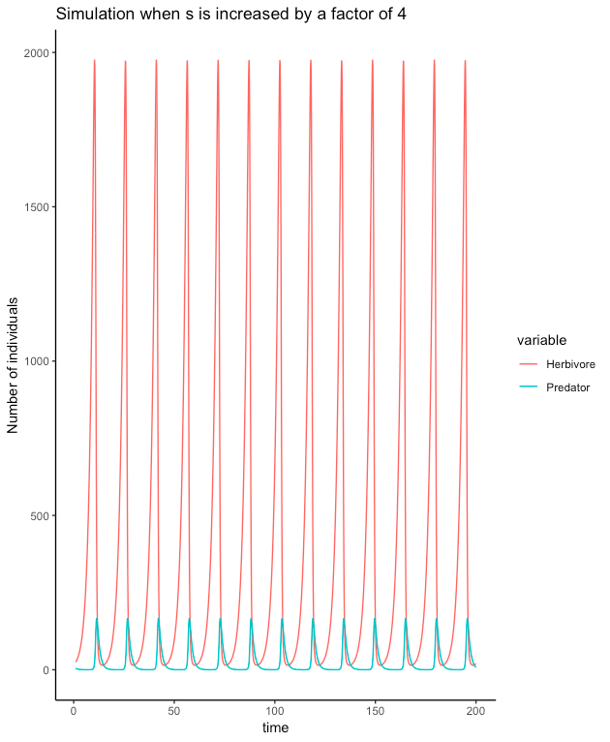

Figure 4. Data simulations for: initial conditions (upper center), “s” increased by a factor of 4 (lower left corner) and “s” decreased by a factor of 4 (lower right)

What can you say about the role of predators in the simulations?

* Predators seem to be a limiting factor for herbivore population growth, it can be observed in the graphs that this group reaches its maximum population size peak at a point that correlates with an accelerated decrease in the population size of the herbivores. Conversely, the number of herbivores also significantly limits the rate at which the predator population will grow; as one would expect under this assumption the highest rate of growth for the predator population always occurs before the number of herbivores starts declining.

Interestingly, the number of predators never reaches the levels of the prey, in all simulations predators where always the smaller group, this fact supports the idea that the growth of predators is limited by the availability of resources (herbivores) to a specific threshold value that depends on the way both species interact, as described by the Lotka-Volterra model variables.

What is the relationship between parameter values and predator-prey cycle length?

* b: Changes in the prey birthrate can affect the length of predator-prey cycle lengths. When this parameter is low, cycles get longer as a consequence of prey reproducing at a slower pace. On the other hand, when this parameter increases, the cycles get shorter because both prey and predator populations are increasing at a faster rate.
* a: A high “a” parameter (predator attack-rate) corresponds to shorter cycles, mainly due to the fact that the increase and decrease of the predator population are symmetrical, in other words, the fall of the predator population is as fast as its increase, something contrary to what happens under the original conditions where the drop in number of predators is slower. In contrast, a low “a” parameter corresponds to a lengthening of the cycles; fewer attacks mean that the prey will grow in numbers but that the predators won’t follow because they’re hunting too few animals, which causes its population to grow at a slower pace.
* e: A higher “e” parameter doesn’t alter cycle length, a lower “e” parameter makes the cycles a little longer, probably due to the fact that herbivores are multiplying for a longer period because the number of predators is extremely low.
* s: When the predator death rate (“s”) is low the cycles get lengthier because predator population takes longer to drop. On the other hand, when “s” is higher, cycles become shorter because the predator population isn’t increasing enough and it’s dropping really fast.

**Rosenzweig-MacArthur Model:**

Conceptual Model: See attached PDF file.

How do the dynamics differ from Lotka-Volterra?

* The dynamics differ from the Lotka Volterra model in a number of different ways. The first is that the Rosenzweig-MacArthur model incorporates prey density as a parameter which influences predator populations. The predator’s kills are limited, and therefore once prey is abundant enough, only a certain amount of prey can be consumed in a given time period. The predator and prey populations have a chance to diverge (see figures below) instead of a constant cyclic pattern of population growth and reduction, which can be seen in the L-V model.

What can you say about the “role” of each parameter, especially what causes the dynamics to differ between the L-V and R-M models?

* The birth rate (b) of the prey greatly affects predator abundance in the RM model. When the birth rate of the prey is increased, there is an initial sharp decline in the prey population. This decline in prey population decreases the abundance of predators. When the predator population declines, the prey population increase and steadies out near initial starting values. The predators then establish a stable low population. When prey birth rate is decreased, the predator population is decreased and stabilized at low population numbers.

When the parameter for conversion efficiency (e) from prey to predator is increased, there is a cyclic cycle of predator population size (Fig. 1). A decrease in e leads to a sharp decline in the predator population. The parameter (s) is the predator death rate. An increase in (s) decrease the predator abundance very quickly, with little to no sustaining population. An lower (s) value shows a slight increase in predators followed by a decline once prey populations lower. However, once the predator numbers are too low, the prey population shoots up. This causes a spike in predator numbers followed by a population decline (Fig 2). The predator populations appear most sensitive to the death rate The (d) parameter refers to the handling time of the prey by the predator. This contributes to the overall conversion efficiency. An increase in handling time reduces the predator population and increase the herbivore population. A decrease in (d) causes boom and bust pattern or prey and predator populations, with a sharp decrease in prey population right away. When the (w) parameter of attack rate is high, there predator populations vary more due to their frequent consumption of prey. Low w values have a low, stable predator abundance over time.

For all of the simulations, the main difference with the Lotka-Volterra Model is the fact that prey can’t continue to grow at the same rate, the more the population increases the bigger the self-limiting effect. In addition, it considers a saturation point that marks the maximum number of prey a predator can hunt even though density of herbivores might keep increasing, so beyond this limit positive changes in prey number won’t really affect the dynamic of the predators.



Figure 5. Increasing of the conversion efficiency (e) value. Quick growth and decline of prey population. Predators follow similar trend due to quickness of food to energy conversion.



Figure 6. Decrease in (s) parameter. This cause initial increase in predators followed by slow decline while prey populations are low. Once the predator numbers reach extinction, the prey population shoots up. Predators numbers react and also increase.

What is the relationship between parameter values and predator abundance?

* Parameter values have a great effect on predator abundance, even without changes to the prey parameters. As discussed above, certain changes in parameters can cause either a coexistence of two species or a complete extinction of predators.

**Paradox of Enrichment**

What happens as carrying capacity increases?

* As the carrying capacity of the prey increases, the predator population destabilizes and begins to crash. The predator abundance recovers and grows large again, only to destabilizes and crash once more. The predator population enters a cycle of population growth and decline.

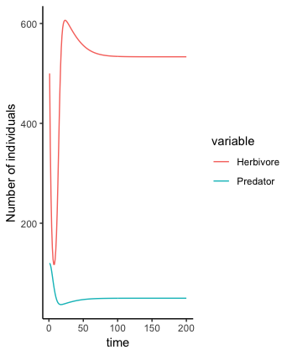

Figure 7. Data simulations for paradox of enrichment: simulation for when alpha=0.00125 (left); simulation for when alpha=0.0005 (right).

Why do you think we see the Paradox of Enrichment?

* We see the Paradox of Enrichment occur because the predator population becomes too large. With the large increase in food availability, the predators experience almost unrestricted growth. However, their high abundance is unsustainable and subsequently reduces their population as a consequence.