JQUERY

ARIK01

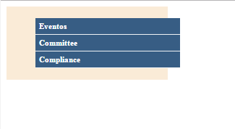

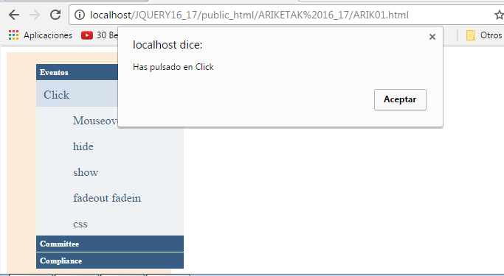

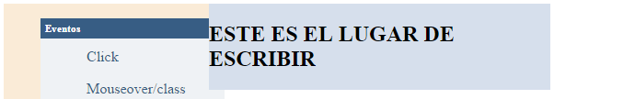

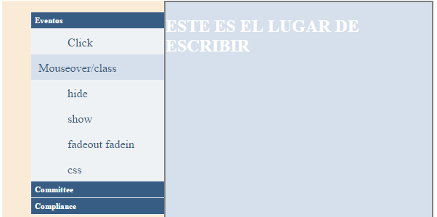

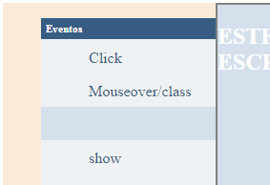

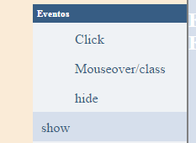

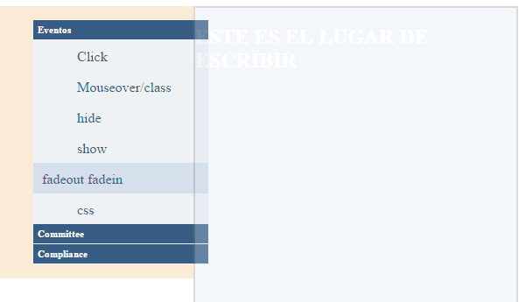

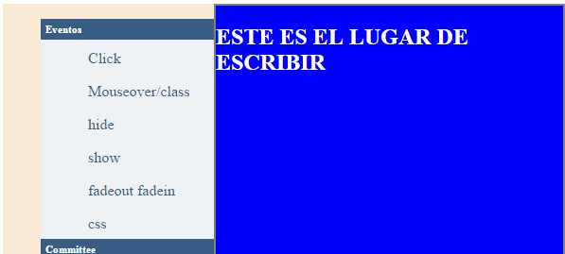

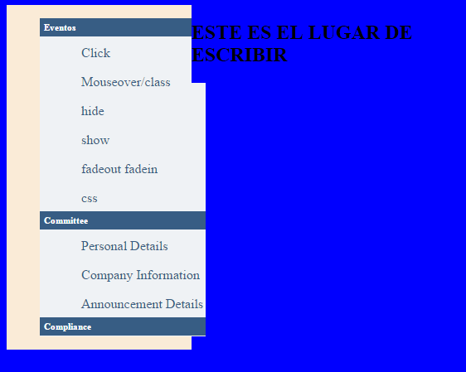

**ARIK02-**

- 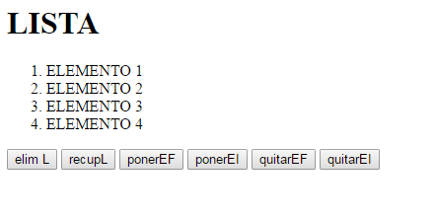

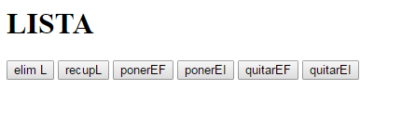

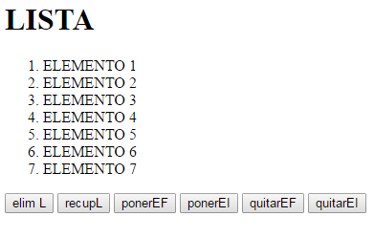

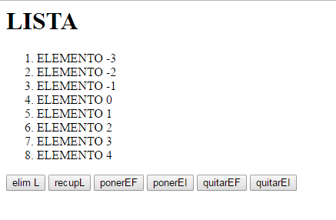

**ARIK03**

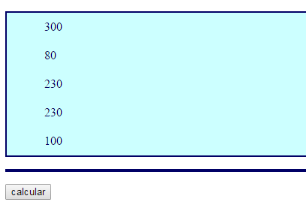

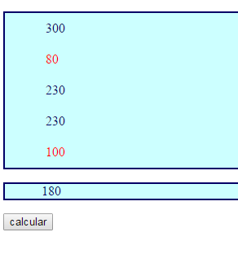

**ARIK04.HTML**

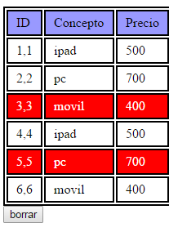

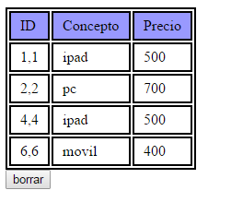

**ARIK05.HTML**



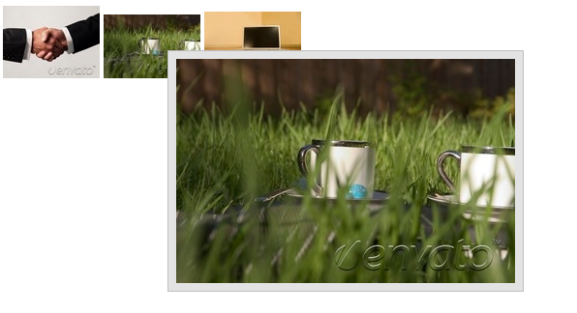

**ARIK06.html**

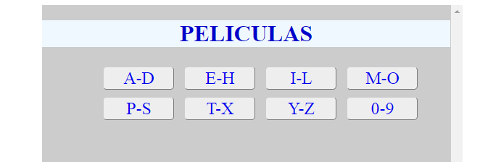

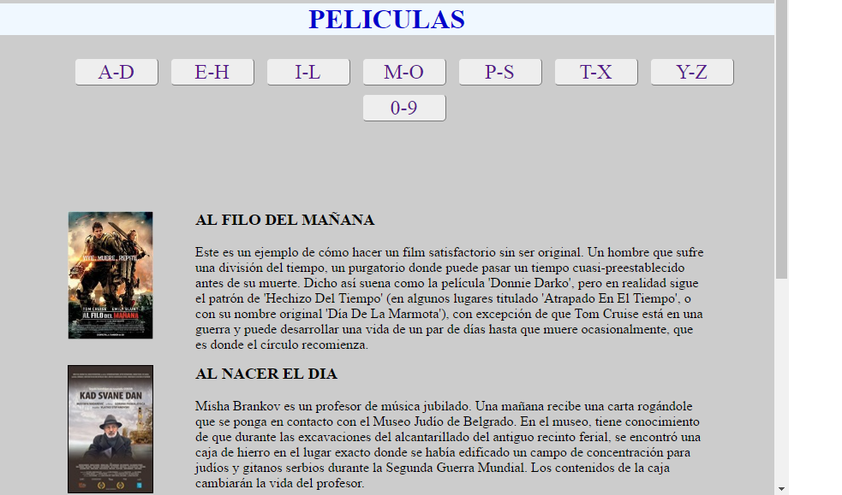

**ARIK09**

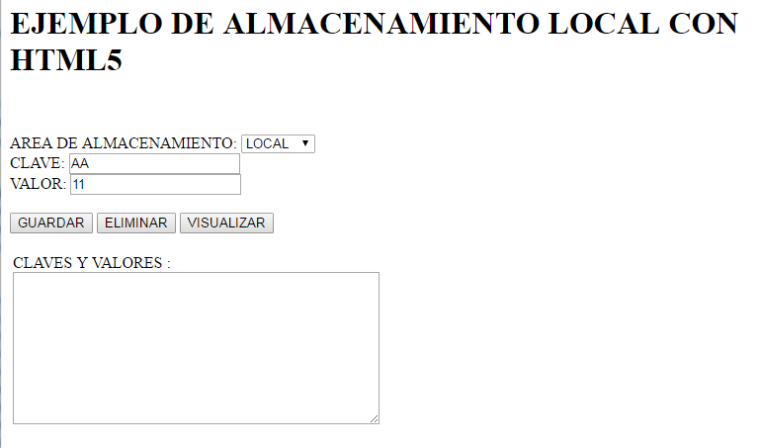

**ARIK10A.html**

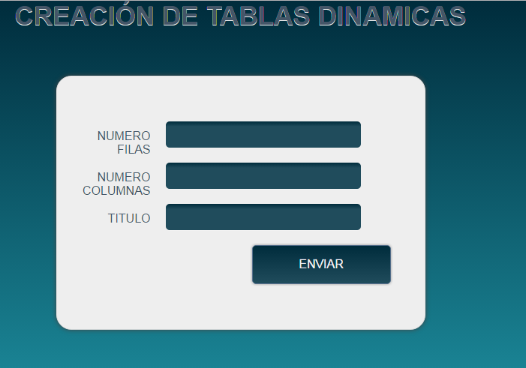

**ARIK10B**

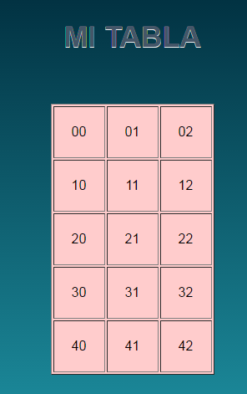

**ARIK11zinema**

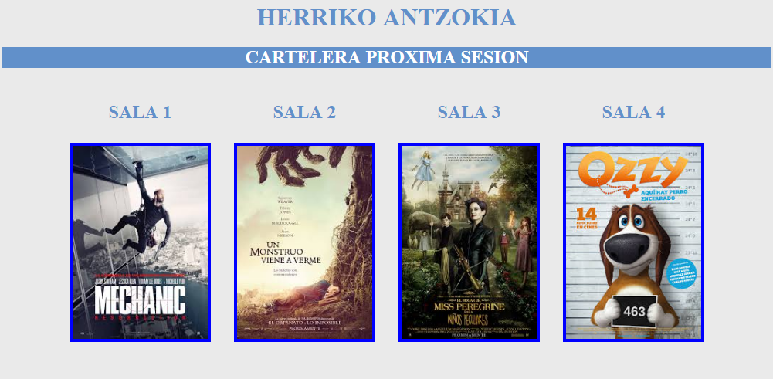

**ARIK11zinema_1**

var pelis =["MECHANIC:RESURRECTION","EL HOGAR DE MISS PEREGRINE PARA NIÑOS PECULIARES","UN MONSTRUO VIENE A VERME","OZZY"];

varcartelpeli=["img/mechanic.jpg","img/missperegrine.jpg","img/unmonstruo.jpg","img/ozzy.jpg",]

var json = [{"numlibres":"100","TotalButacas":"100"},{"numlibres":"150","TotalButacas":"150"},{"numlibres":"75","TotalButacas":"75"},{"numlibres":"50","TotalButacas":"50"}];

**ARIK12.html**

