**Photographic Essay: Cultural Diversity and Heritage Preservation in Africa**

**Introduction:**

* Introducing the theme of cultural diversity and the importance of preserving heritage in Africa.
* The richness of African cultures, traditions, languages, and historical legacies.

**Section 1: Cultural Festivals and Celebrations**

* These are photographs of vibrant cultural festivals, ceremonies, and rituals across different regions of Africa.
* They capture traditional dances, music performances, and ceremonial attire that reflect local customs and beliefs.

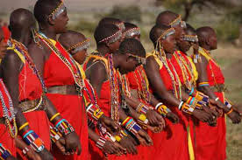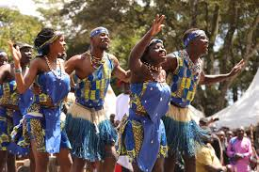

Cultural Dances

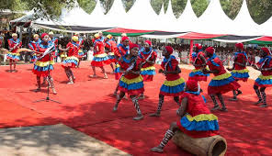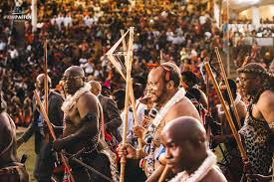**page2**

**Section 2: Traditional Crafts and Artisanal Skills**

* Images of artisans and craftsmen creating traditional pottery, textiles, carvings, and jewelry.

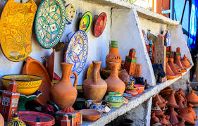

* Materials used

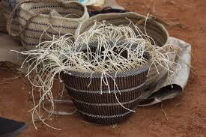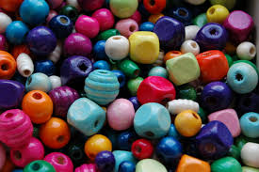

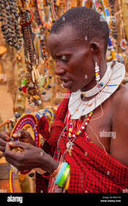

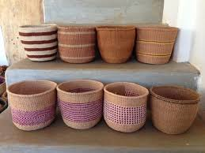sisal baskets

Making shangas using beads

**Section 3: Oral History and Storytelling**

* Portraits of elders and storytellers preserving oral traditions and passing down folklore and historical narratives.

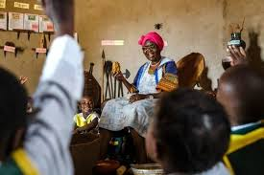

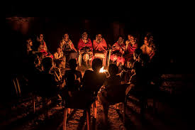

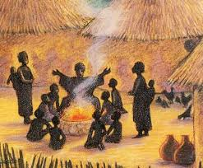

Illustration of the role of storytelling in maintaining cultural identity and transmitting knowledge across generations.

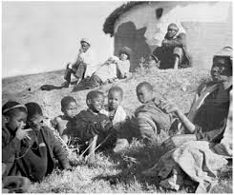

**Section 4: Sacred Sites and Historical Landmarks**

* Photographs of ancient ruins, sacred sites, and architectural marvels that symbolize Africa's rich history and cultural heritage.

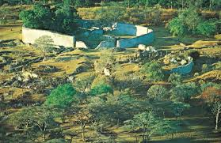

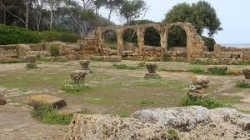

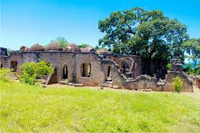

* these sites as part of global heritage.

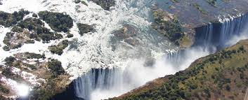World Heritage reactive monitoring process

**Section 5: Cultural Revitalization and Contemporary Expressions**

* Images of contemporary artists, musicians, and performers blending traditional elements with modern influences.



* Showcase cultural initiatives and movements revitalizing traditional practices and promoting cultural pride.

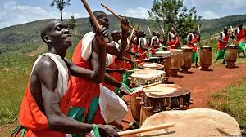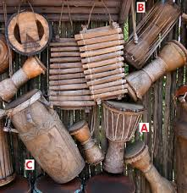artists playing drums and singing traditional songs

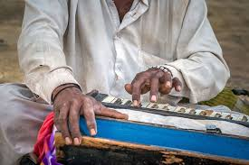contemporary artists

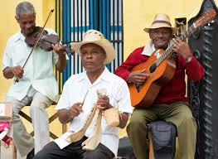**conclusion**

This essay uses photography to capture the beauty, diversity, and resilience of African cultures while advocating for the preservation and revitalization of cultural traditions as a source of identity, pride, and inspiration for future generations.