Ikindo WebEdit

Software Architecture Document

Version 1.0

Revision History

|  |  |  |  |
| --- | --- | --- | --- |
| **Date** | **Version** | **Description** | **Author** |
| 22.12.2020 | 1.0 | Filled in V1.0 of the SAD | Moritz, Jonas A., David, Jonas S. |
|  |  |  |  |
|  |  |  |  |
|  |  |  |  |

Table of Contents

1. Introduction 2

1.1 Purpose 2

1.2 Scope 2

1.3 Definitions, Acronyms, and Abbreviations 2

1.4 References 2

1.5 Overview 2

2. Architectural Representation 2

3. Architectural Goals and Constraints 2

4. Use-Case View 2

4.1 Use-Case Realizations 2

5. Logical View 2

5.1 Overview 2

5.2 Architecturally Significant Design Packages 2

6. Process View 2

7. Deployment View 2

8. Implementation View 2

8.1 Overview 2

8.2 Layers 2

9. Data View (optional) 2

10. Size and Performance 2

11. Quality 2

Software Architecture Document

# Introduction

[The introduction of the **Software Architecture Document** provides an overview of the entire **Software Architecture Document**. It includes the purpose, scope, definitions, acronyms, abbreviations, references, and overview of the **Software Architecture Document**.]

## Purpose

This document provides a comprehensive architectural overview of the system, using a number of different architectural views to depict different aspects of the system. It is intended to capture and convey the significant architectural decisions which have been made on the system.

## Scope

This document will describe how our software architecture will be build up and organized. It will define were specific data will be saved and how. Affected by these documents are underlying client-server connection happening all the time you interact with the website.

## Definitions, Acronyms, and Abbreviations

|  |  |
| --- | --- |
| Abbreviation | Description |
| n/a | Not Applicable |
| MVC | Model-View-Controller |
| MVT | Model-View-Template |

--links to the blog, GitHub, all graphics used in the document –

[Use case diagram](https://github.com/IkindoWebEdit/ikindo-docs/blob/main/UseCaseDiagram.svg)

[Activity diagram for view graphical editor use case](https://github.com/IkindoWebEdit/ikindo-docs/blob/main/ActivityDiagram_ViewGraphicalEditor.png)

[Activity diagram for view site statistics use case](https://github.com/IkindoWebEdit/ikindo-docs/blob/main/ActivityDiagram_ViewSiteStatistics.png)

[Activity diagram for view html editor use case](https://github.com/IkindoWebEdit/ikindo-docs/blob/main/ActivityDiagram_ViewHTMLEditor.png)

[Feature file for site statistics](https://github.com/IkindoWebEdit/ikindo-docs/blob/main/Narrative_SiteStatistics.png)

[Feature file for the graphical editor](https://github.com/IkindoWebEdit/ikindo-docs/blob/main/Narrative_GraphicalEditor.png)

[Feature file for the html editor](https://github.com/IkindoWebEdit/ikindo-docs/blob/main/Narrative_HTMLEditor.png)

<https://github.com/IkindoWebEdit/ikindo-code>

<https://github.com/IkindoWebEdit>

<https://ikindowebedit.wordpress.com/>

## Overview

We need a client server construction as well as a database to store information such as passwords and user data. We decided to give our customer a “site statistics” overview where he will be able to see site-access data such as location and time of site access of the users, therefore we will also in need to store this information. This document will be used to give newcomers of our project as well as our customer an overview about the software architecture of the project. Information in this document is not fixed and are subject to change.

# Architectural Representation

Django adheres to the Model-View-Template design pattern rather than the MVC pattern, this pattern can be seen here:

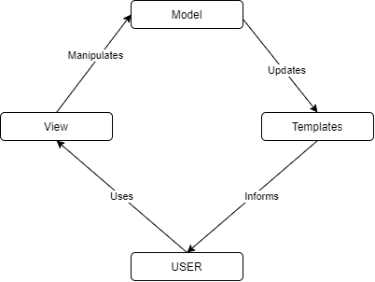

# Architectural Goals and Constraints

Our frontend consists of JavaScript, CSS and HTML.

As our backend we use Django. Django is a Python based web framework. The main goal of Django is to simplify the creation of complex, database-driven websites, which perfectly fits our needs.

# Use-Case View

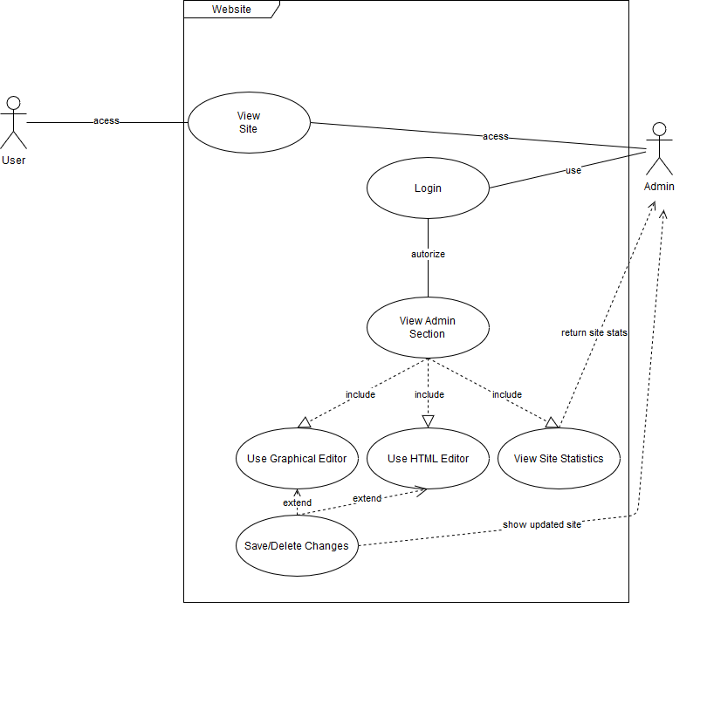

## Use-Case Realizations

### **UC Get Site-Statistics**

* ***Brief Description:***

The user is logged in on the Admin-Section and clicks on Site-Statistics. A new site opens up which shows the user all necessary statistics about what happens on his website

* ***Activity Diagram:***

<https://github.com/IkindoWebEdit/ikindo-docs/blob/main/ActivityDiagram_ViewSiteStatistics.png>

* ***.feature File:***

<https://github.com/IkindoWebEdit/ikindo-docs/blob/main/Narrative_SiteStatistics.png>

### **UC View HTML-Editor**

* ***Brief Description:***

The user is logged in on the Admin-Section and clicks on HTML-Editor. A new site with a text-editor opens up, in which the HTML-Code itself can be edited textually.

* ***Activity Diagram:***

<https://github.com/IkindoWebEdit/ikindo-docs/blob/main/ActivityDiagram_ViewHTMLEditor.png>

* ***.feature File:***

<https://github.com/IkindoWebEdit/ikindo-docs/blob/main/Narrative_HTMLEditor.png>

### **UC Get Graphical-Editor**

* ***Brief Description:***

The user is logged in on the Admin-Section and clicks on Graphical-Editor. The site with the editor opens up and gives the user several (and easy to use) opportunities to edit his website.

* ***Activity Diagram:***

<https://github.com/IkindoWebEdit/ikindo-docs/blob/main/ActivityDiagram_ViewGraphicalEditor.png>

* ***.feature File:***

<https://github.com/IkindoWebEdit/ikindo-docs/blob/main/Narrative_GraphicalEditor.png>

# Logical View

## Overview

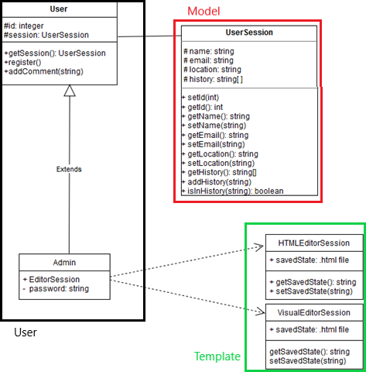

## Architecturally Significant Design Packages

Our Templates make up the view-part of the MVC-pattern. The model consists of our user information Database and the stored web-edit-sessions. This can not really be seen on the diagram above, as we don’t have the framework fully populated right now.

# Process View

n/a

# Deployment View

--server diagram(SCHREINER)--

[This section describes one or more physical network (hardware) configurations on which the software is deployed and run. It is a view of the Deployment Model. At a minimum for each configuration it should indicate the physical nodes (computers, CPUs) that execute the software and their interconnections (bus, LAN, point-to-point, and so on.) Also include a mapping of the processes of the **Process View** onto the physical nodes.]

# Implementation View

[Link to our code(GitHub)](https://github.com/IkindoWebEdit/ikindo-code)

# Data View

We will use SQL for our data base. SQL is a domain-specific language used to manage data held in a relational database system. The data base isn't set up jet and will be set up later.

# Size and Performance

n/a

# Quality

n/a