|  |  |  |
| --- | --- | --- |
|  | | |
|  | **CMPS 350 Project Phase 2 – Conference Management System (ConfPlus)**  **(15% of the course grade)** | |
| **Group Id:** | | G? |
| **Group Members:** | | Abdulla Al-malki (202009135)  Ahmed Deef (201606478)  Mohammed Al-Obaidly(201801987)  Youssef Ahmed (202107162)  **Emails:** [aa2009135@qu.eu.qa](mailto:aa2009135@qu.eu.qa)  [ya2107162@qu.edu.qa](mailto:ya2107162@qu.edu.qa)  [ad1606478@qu.edu.qa](mailto:ad1606478@qu.edu.qa)  [ma1801987@qu.edu.qa](mailto:ma1801987@qu.edu.qa) |

**Grading Rubric - In the Functionality column please specify either: *Working (completed x%)*, *Not Working (completed x%)* or *Not done or Not Applicable*.**

|  |  |  |  |  |
| --- | --- | --- | --- | --- |
| **Criteria** | **Weight** | **Functionality**\* | **Quality of the implementation** | **Grade** |
| **Improvement over the first phase:**  *Depending on the implantation status of the previous phase, the following might apply:*   * *Completing missing functionalities;* * *Improving the design and implementation of paper submission: paper status, etc.* * *Improving the design and implementation of paper review: distinction between reviewed papers and papers to review, etc.* * *Various filtering possibilities for the conf schedule* * *Correct interpretation of session* * *Clarity of the various UIs.*   *By default, if no improvement is made, the student will have the same grade of previous phase for this category.*  *Everything you improve will add up to your previous grade that will be used as a baseline.* | 25 |  |  |  |
| Design and implement the Data Model.  Clarity of data entities, their attributes and relations (in Prisma and the conceptual model (the diagram)) | 10 | 100% |  |  |
| Init DB: populate the database with the data from the json files. | 5 | %100 |  |  |
| Repository Implementation to read/write data from the database | 10 | %80 |  |  |
| Database:   * The design and implementation of the statistics page * All other use-cases use the database, not JSON files or local storage. * All queries function correctly. | 40 | %50 |  |  |
| **Design and Testing Documentation**  **\* Design documentation:**  - 3 key lessons learned from Phase 1.  - Data Model diagram.  - UI Design table  - Data caching table  **\* Testing documentation:** with evidence of working implementation using snapshots illustrating the results of your solution testing (you must use the provided template).  * **Discussion of the project contribution** of each team member [-10pts if not done] | 10 | %80 |  |  |
| **Total** | 100 |  |  |  |
| Bonus - successful deployment of the app and the Database to a cloud hosting service such as <https://vercel.com/> - successful implementation of use authentication. | 5 |  |  |  |
| Bonus- authentication through another service provider e.g. Google, Github, etc. | 5 |  |  |  |
| Copying and/or plagiarism or not being able to explain or answer questions about the implementation. | 0 |  |  |  |

# Application Design

# Improvement over the first phase

Give details and proof about:

* What was missing in your previous phase

We were lacking better user experience as our first implementation was too abstract. Authors couldn’t check their submitted papers for example.

* Your improvements + proofs
* What was not improved and still missing

|  |  |  |
| --- | --- | --- |
| Page | Caching strategy | Reasoning |
| Login | No-store | User data could change and we need to check that whenever we login |
| Home | No-store | New conference dates could be added in the future and papers |
| Staff/ | No-store, force-cache | More papers could be published later or sessions or reviews  But some data like locations can be stored in the cache with no issue |

# Data Model diagram

Conceptual Data diagrams, Prisma Model….

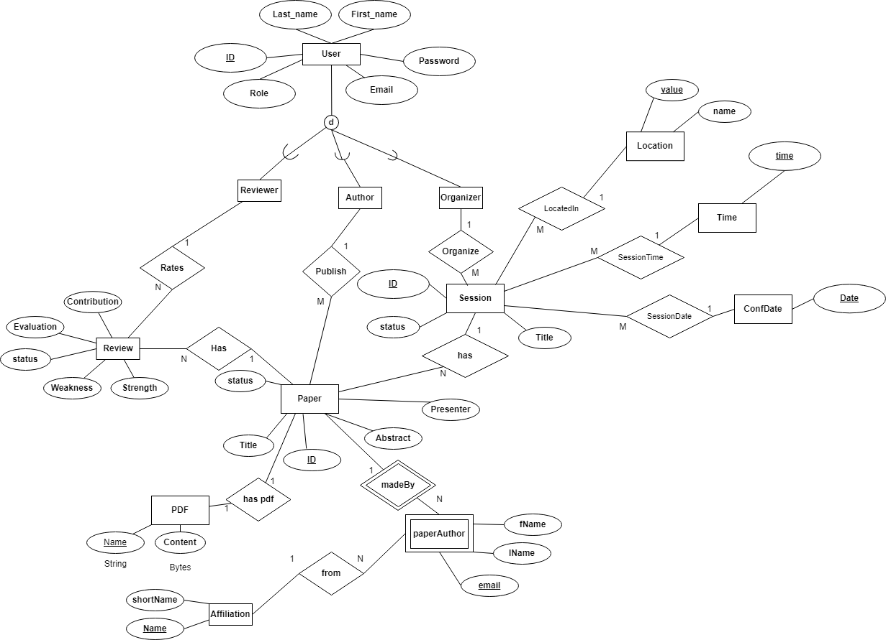

# Database population

Give details and proofs with screenshots how you have populated database, the current content ..

The schema was modeled by the diagram we made. We made a superclass User with subclasses based on role of the user. Each role has a specific relationship with the application entities.

The model was originally oriented on the json data files, as they will be used also to initialize the database.

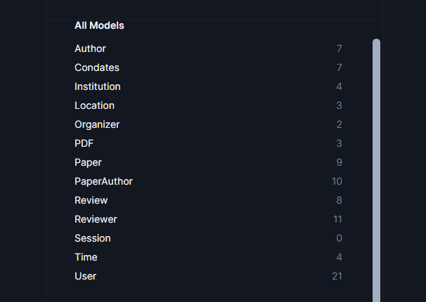

# Database

Give details and proofs about how you have updated your application to use database. This applies to all use-cases.

We updated the application to use prisma queries in getting data instead of reading the json files immediately using fs library.

Detail your statistics page

Statistics was only made server-side

Give the list of your Prisma queries

# 3 technical lessons learned from your submitted solution vs. the model solution

Technical Lessons Learned:

1. The first ERD does not need to be absolutely correct the first time. The advantage of prisma migrations is that we can always update our schema whenever we find we missed something or need to modify. At the same time, the rest of the team could work on the project using prisma client with little modifications needed later. The key here is saving time working on the project while the schema gets modified.
2. Cache options need to be taken care of. Some sensitive data could be needed to stay up to date and force-cache options will not make them work in the right way.
3. Initially starting UI with react saves time as layouts give the ability to reuse components shared by many pages.

# Testing

# Custom Login

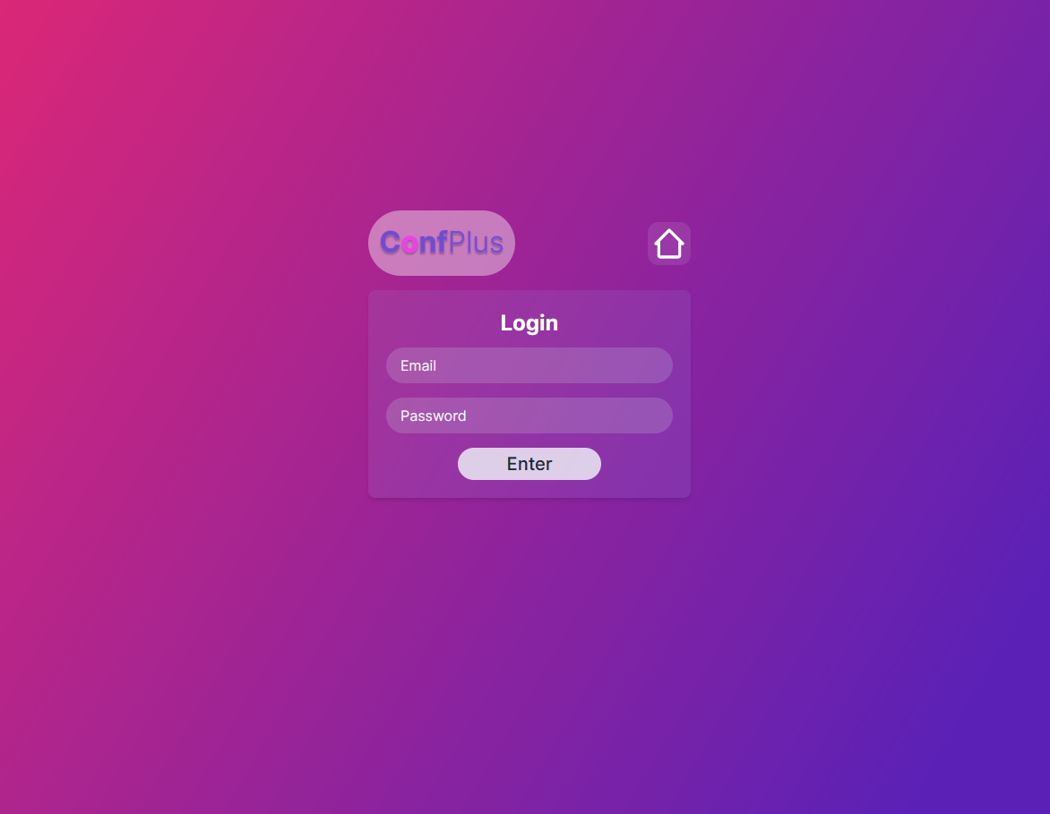

# Login using 2 Authentication Providers

# Submit paper

# Review paper

# Get conference schedule

# Edit conference schedule

# Conference Statistics Report

# Discussion of the project contribution of each team member

Contribution:

Abdulla 30%:

Frontend, actions, react, assisting.

Mohammed 25%:

Server-side, route, repo.

Youssef 25%:

Server-side, actions, seed, schema assistance.

Ahmed 20%:

ER diagram, schema model, seed assistance