Term_3_Individual Project 3

Adriaan Van der Westhuizen 240436415
  - Adriaan van der Westhuizen

Table of Contents
Introduction 2
Coding Progress 2
File structure 3
New Design Implemented with better flow 4
Pages 4
Database Implementation 7

Introduction
This report documents my individual progress on Forge Fitness, a full stack gym management web application built with React (Vite) on the front end and Supabase (PostgreSQL, authentication, and row level security) on the back end. The system supports three user roles, namely member, trainer, and admin, and provides class booking, membership packages, billing, training plans, and role based dashboards.

Coding Progress
I have made a lot of coding progress this term . I changed the layout of the home page and also a lot of styling changes has accured as we changed and conclude on a final colour pallete for our website .
I have coded the Home.jsx for the homepage , which gets its styling from app.css aswell as Home.css . I also made a admin section for the admin to login and manage content and also manage and see the flows between the customers and trainers .
For trainers I made a Trainer Dashboard for them to see their clients and to see what classes they have to give on the day
I also helpled Dayaan with the signup and login pages . Login.jsx and Signup.jsx.
Database implementation was also made . Connected to the profile table to make the Authentication work. 3 Different roles are managed . Admin , trainers and members.
I was also responsible for the About page . Which was basically just display more information about us as the gym founders and what the goals is .
Application running
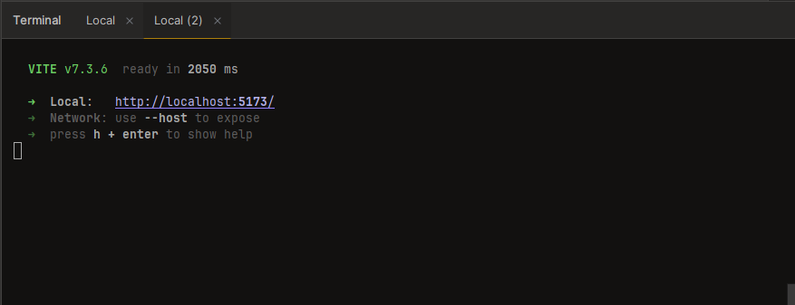

File structure
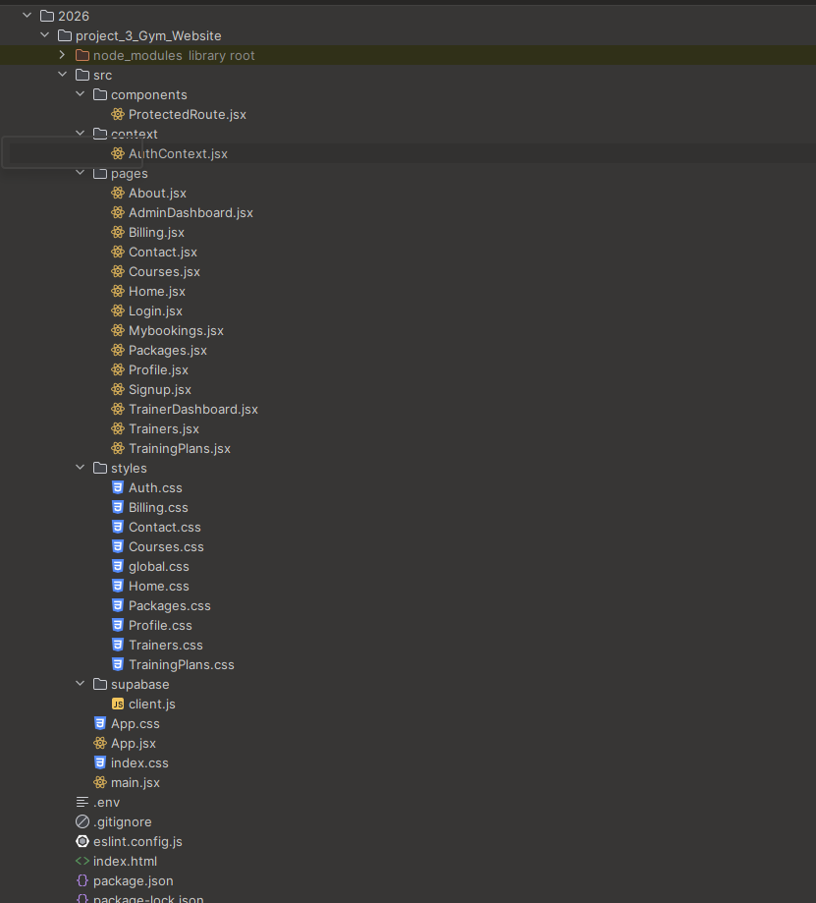

New Design Implemented with better flow

Pages

HomePage ( No user is logged in) ( part 1 )
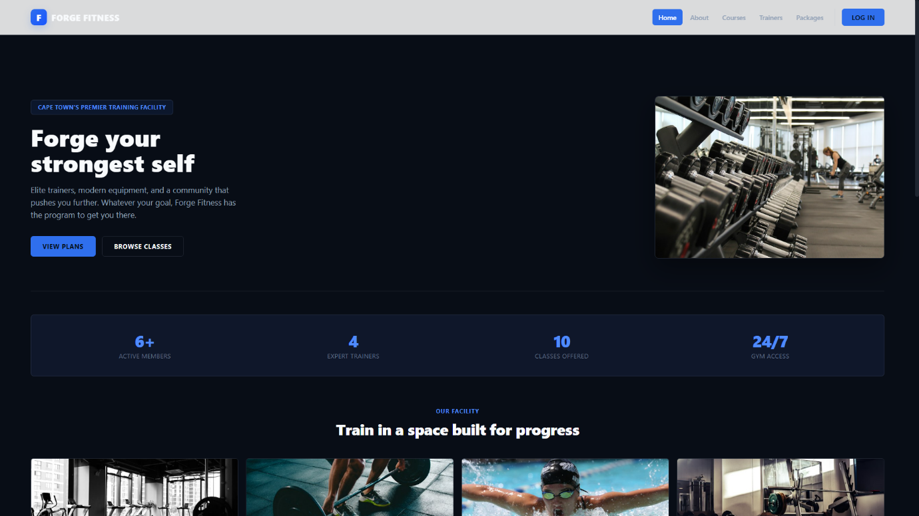
Homepage ( part 2 )
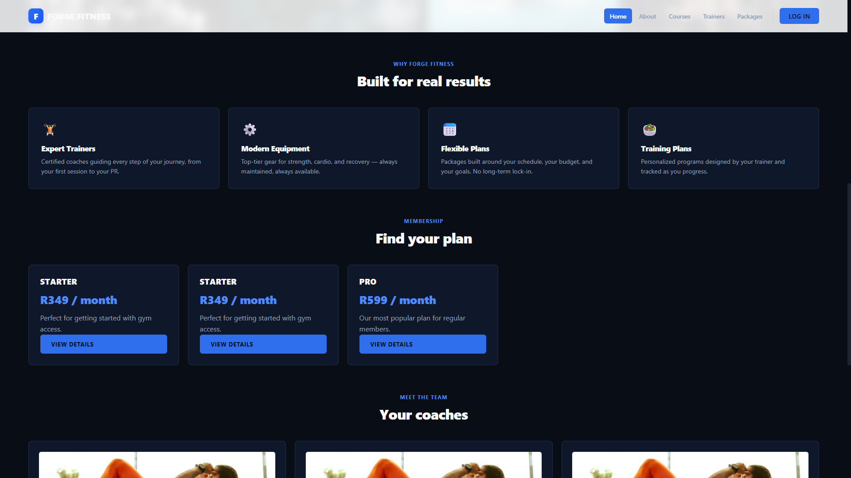
Homepage continues on next page .

Homepage ( part 3 )


Login Page
Allows user to Log in to their account .
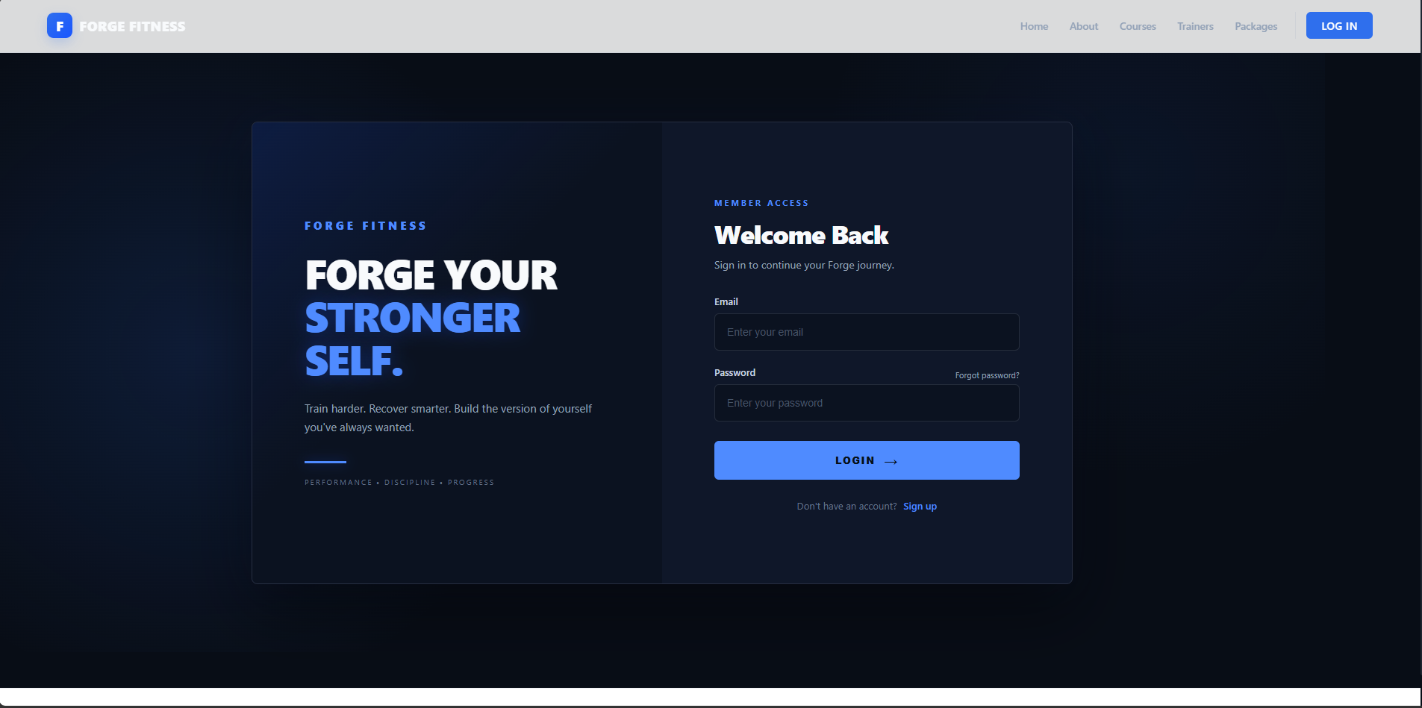

Register Page
Lets a member sign up to become a member of Forge Fitness ( without subscription) . This is totally free.
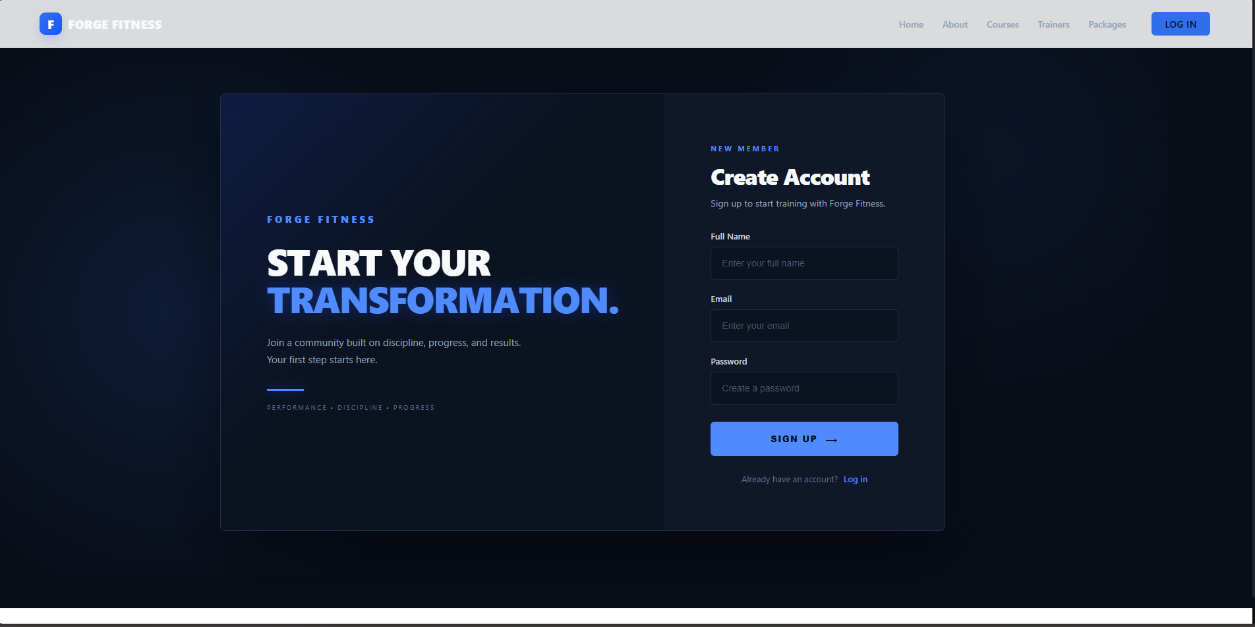

About us page
Displaying information about the gym and what our goals are for the customers.
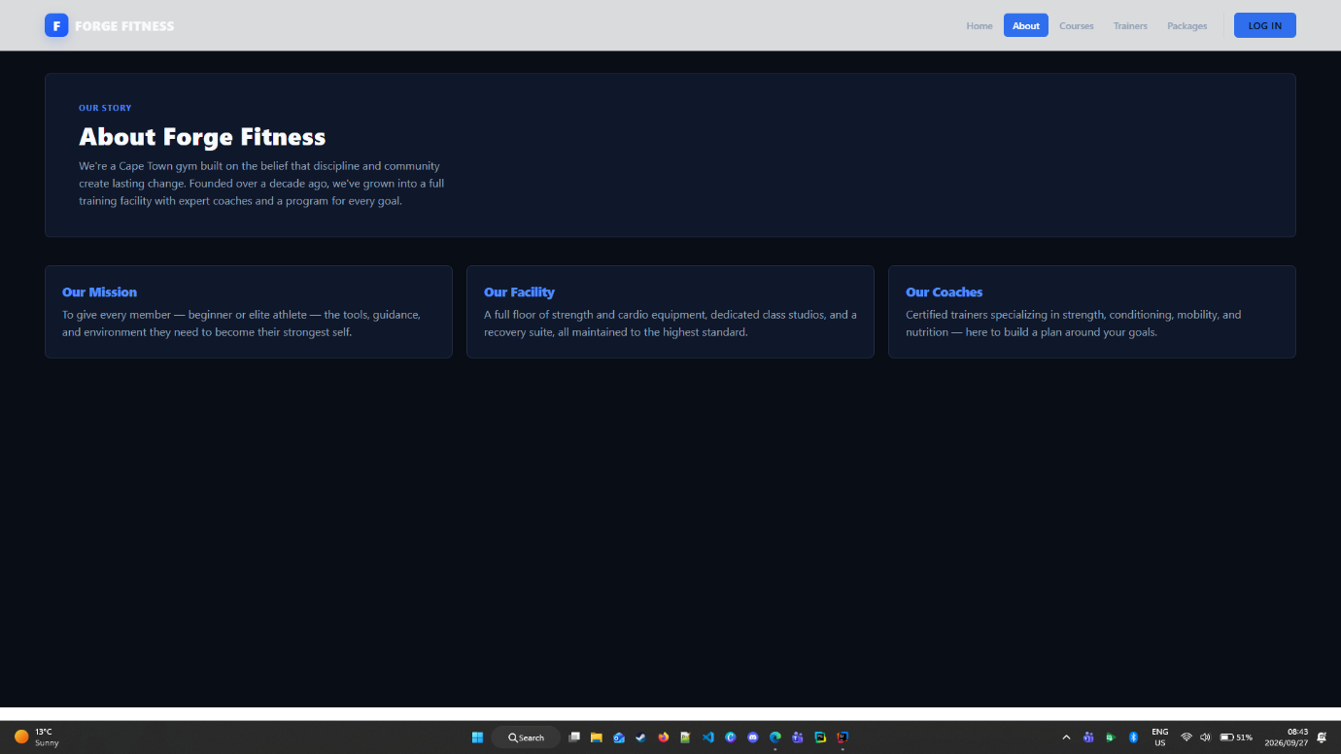

Database Implementation
Login and Signup ( helped Dayaan)
For the Login and Signup pages to work . The Api needs to connect to them . The api , client.js links the website with the Supabase database . The AuthContext.jsx has a useAuth method that gets imported to the login and signup pages to make it work.
The homepage , login and signup pages pulls data from the Profiles table.
The login page fetches the role from the table to see which role is assigned to user.
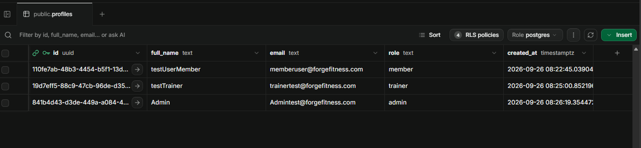

The homepage just pulls the amount of users in the database signed up to display it on the homepage.
