Test_Document

Adriaan van der Westhuizen 240436415
  - Adriaan van der Westhuizen 240436415

Contents
1. Description : 2
2.Testing 3
TC01 - Landing page loads 3
TC02 - User can signup and see homepage with indication of account 3
TC03 - Trainer can sign in and see homepage with indication of account 4
TC04 - Admin can sign in and see homepage with indication of account 4
TC05 - Admin can access AdminDashboard 5
TC06 - Trainer can access TrainerDashboard 5
TC07 - Members can access profile 6
TC08 – Access to About us page 6
3.Test_Table 7
4.Conclusion : 8

1. Description :
1.1 What was tested :
- Landing page loads
- User can signup and see homepage with indication of account
- Trainer can sign in and see homepage with indication of account
- Member can sign in and see homepage with indication of account
- Admin can access AdminDashboard
- Trainer can access TrainerDashboard
- Member can access profile

  - Tools:
- IDE : IntelliJ
- Browser : Microsoft Edge
- Database : Supabase
- Type of testing : System and user testing

2.Testing

TC01 - Landing page loads
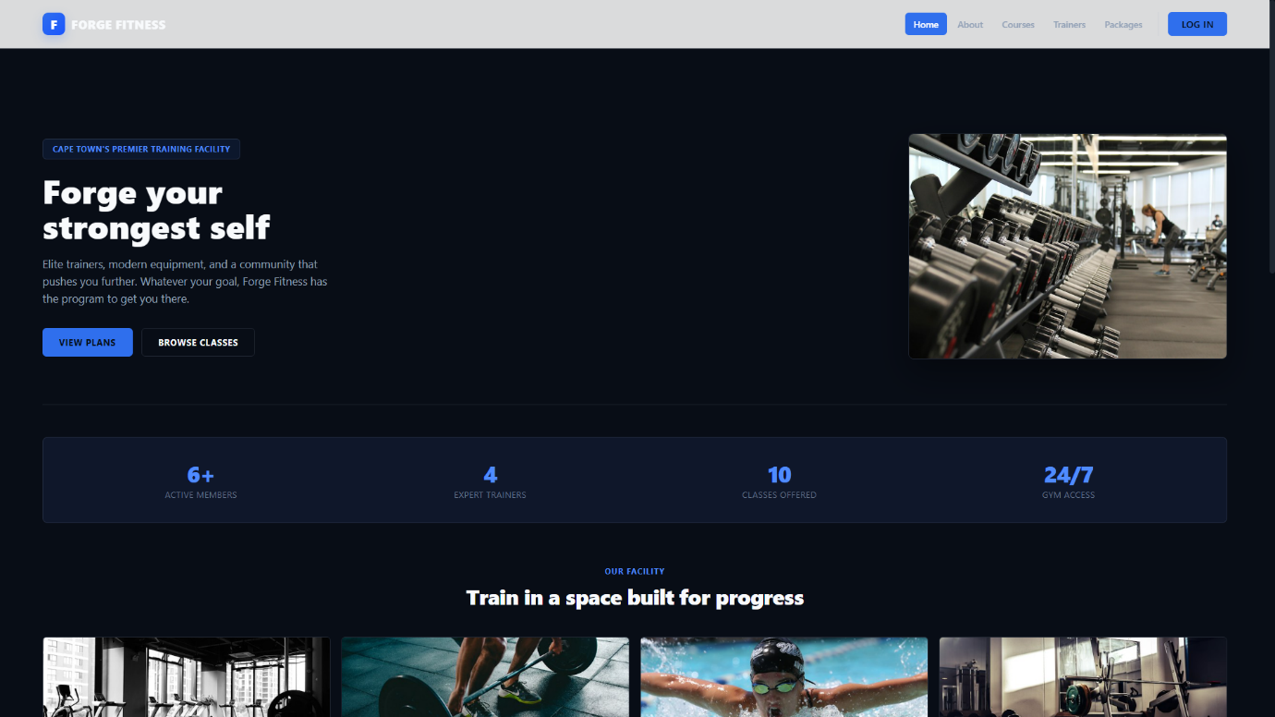
Part 2 of landing page loads
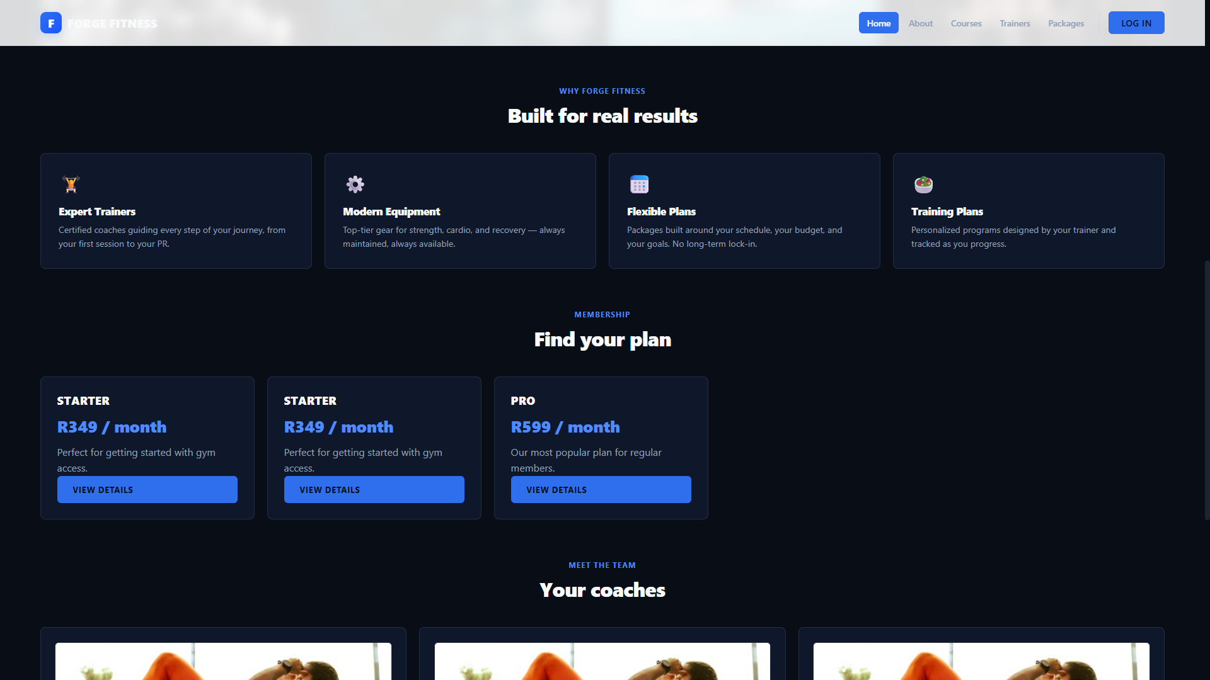

Part 3 of landing page loads
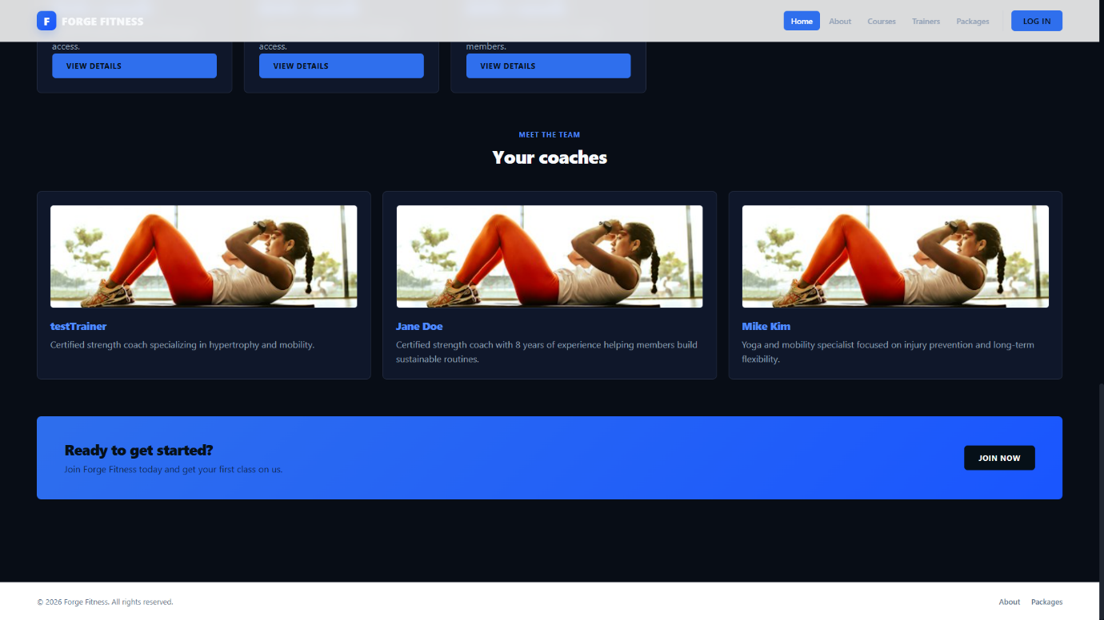
I tested to see if the server runs and if the landing page will load when user access the website .
Result : pass

TC02 - User can signup and see homepage with indication of account
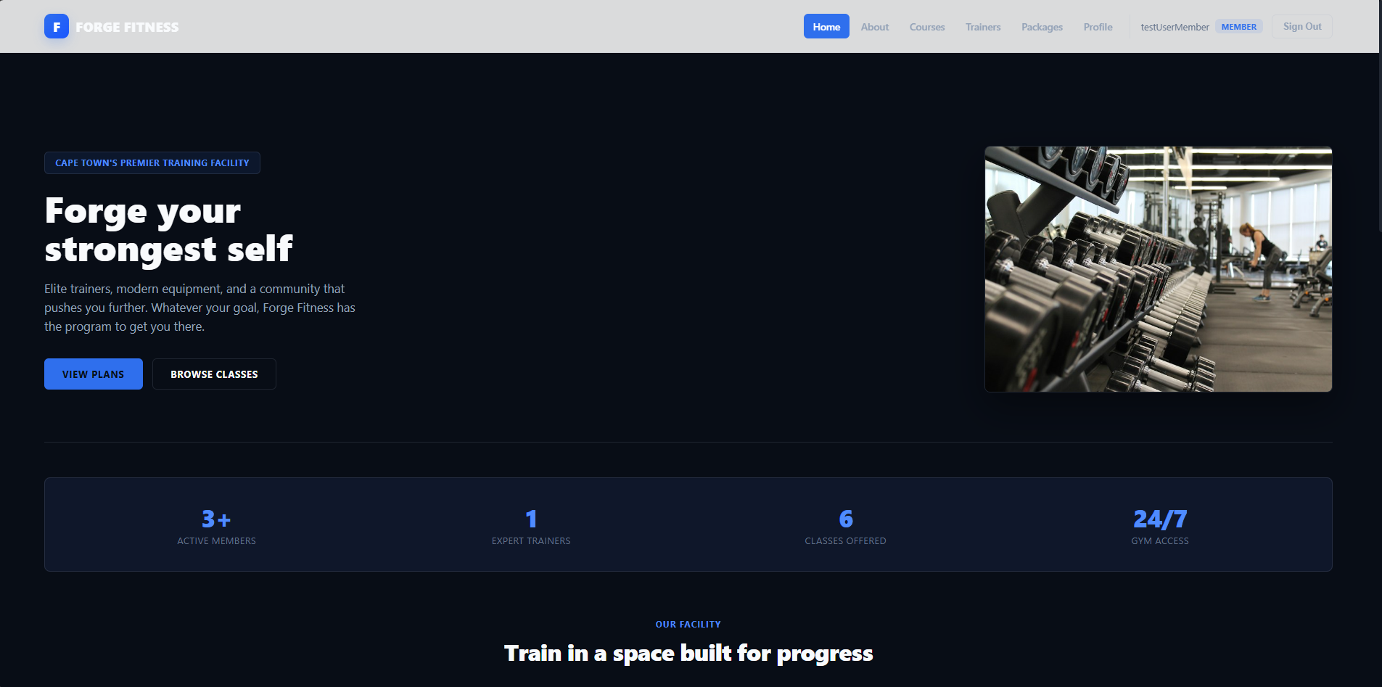
I tested a user can sign up or sign in and when the page loads , they can see at the top right if they are signed in with their name and also their role.
Result : Pass

TC03 - Trainer can sign in and see homepage with indication of account
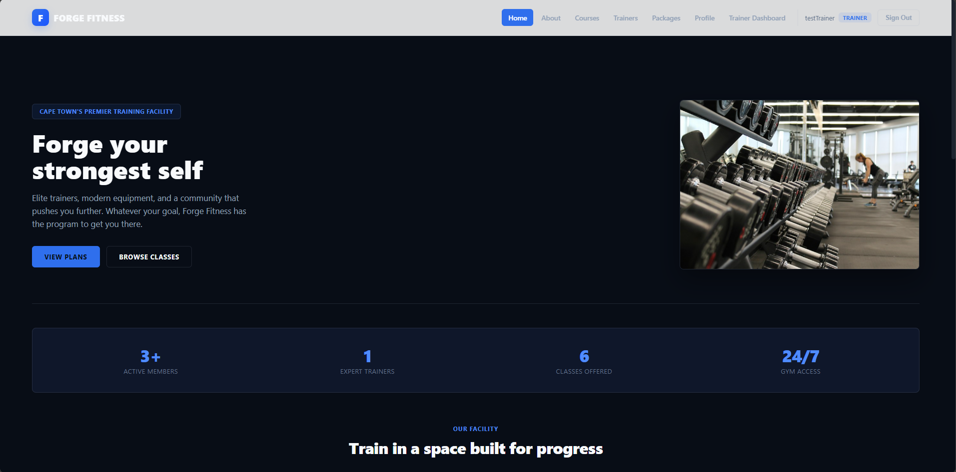
I tested if the Trainer is able to log in and see if their account exists. At the top right corner it will indicate that the trainer is signed in and their role will also be displayed
Result : pass

TC04 - Admin can sign in and see homepage with indication of account
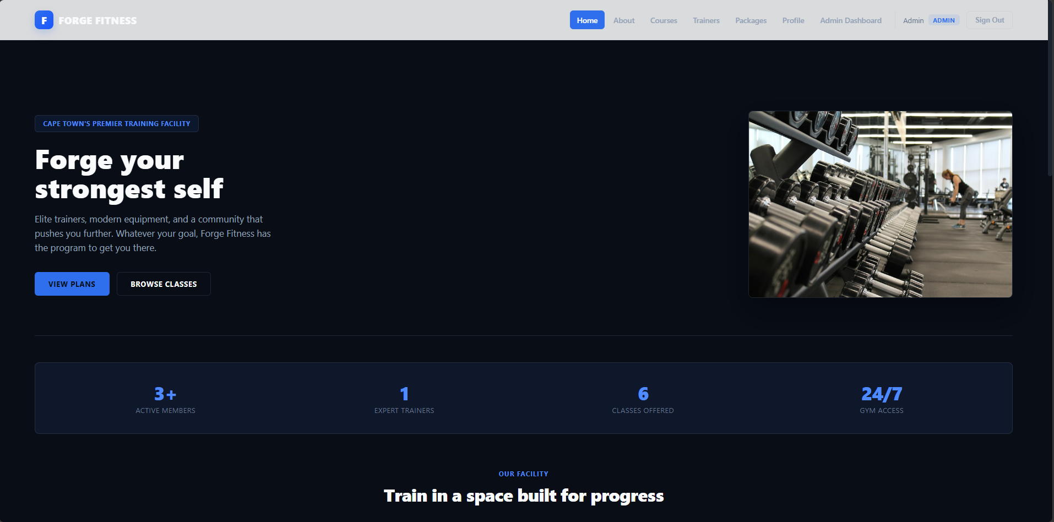
Tested to see if Admin is able to log in and see that their role displays as Admin.
Result : pass

TC05 - Admin can access AdminDashboard
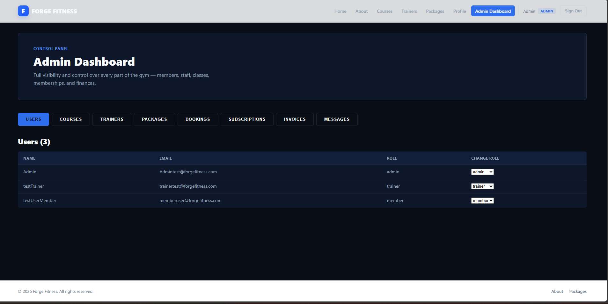
Tested to see if admin is able to access their dashboard .
Result : pass

TC06 - Trainer can access TrainerDashboard
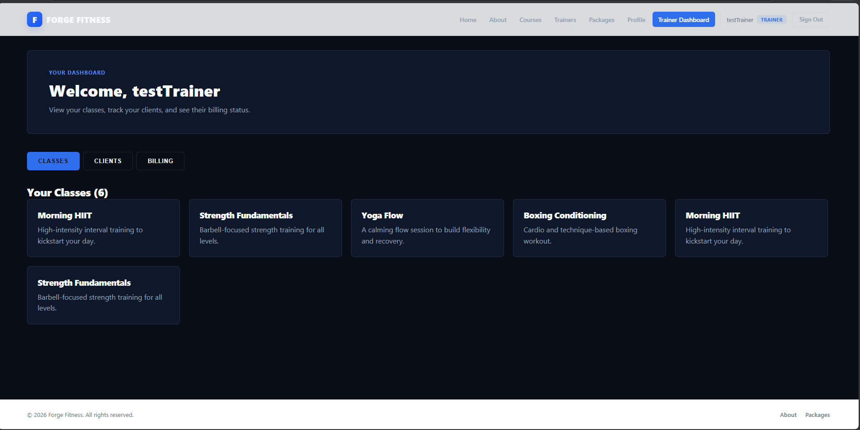
Tested to see if Trainer can log in and access their Dashboard.
Result : pass

TC07 - Members can access profile
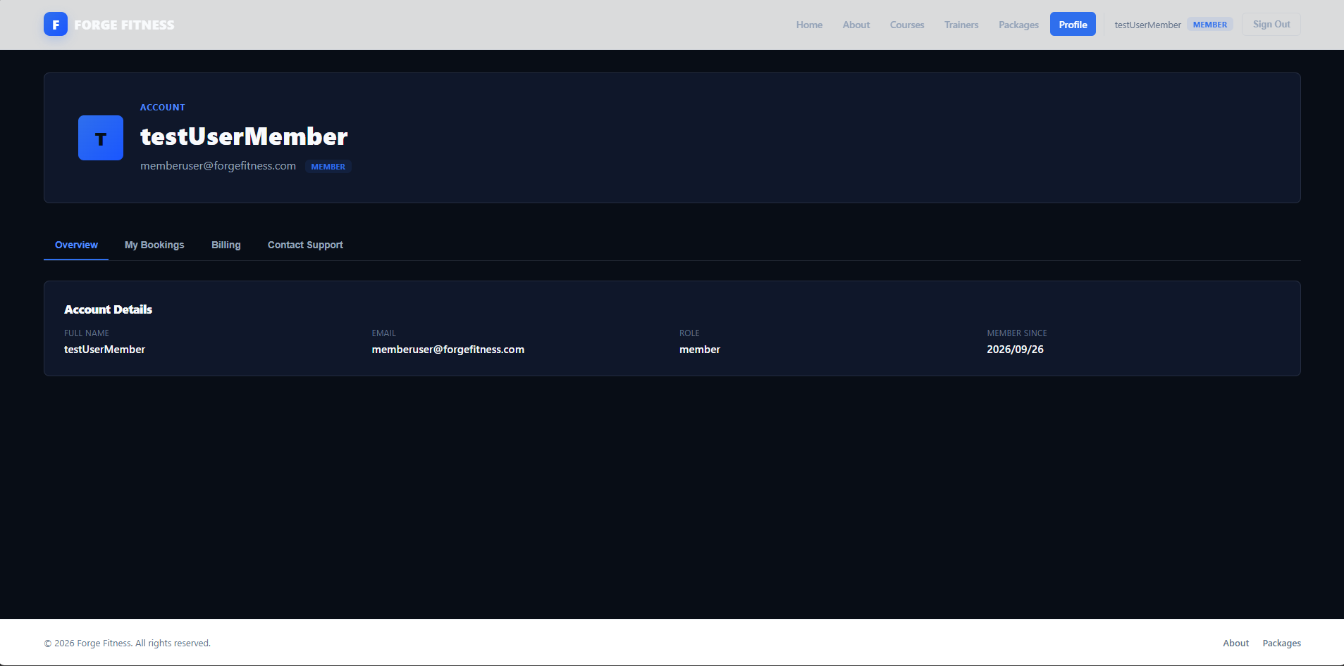
Tested to see if member can access profile . This counts for all roles . Admin , trainer and member each have profile sections .
Result : pass

TC08 – Access to About us page
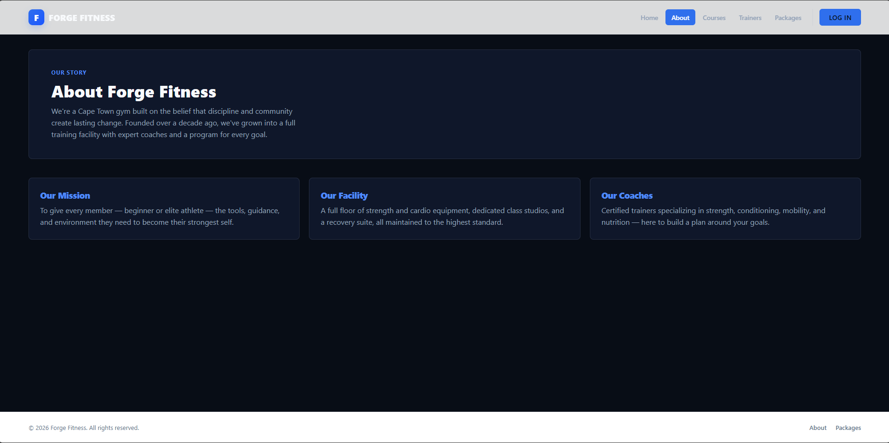
Tested to see if About us page is reachable
Result : pass

3.Test_Table
Test_ID | Feature | Input | Expected Result | Pass/Fail | Screenshot
TC01 | Landing page loads | --none because website is public | Website is visible | Pass | TC01
TC02 | User view of homepage | Email: memberuser@forgefitness.com  Password : password123 | User can signup and see homepage with indication of account | Pass | TC02
TC03 | Trainer access to website | Email : trainertest@forgefitness.com  Password : password123 | Trainer can sign in and see homepage with indication of account | Pass | TC03
TC04 | Admin access | Email : Admintest@forgefitness.com  Password : password123 | Admin can sign in and see homepage with indication of account | Pass | TC04
TC05 | Admin access to dashboard | Email : Admintest@forgefitness.com  Password : password123 | Admin can access Admin Dashboard | Pass | TC05
TC06 | Trainer access to dashboard | Email : trainertest@forgefitness.com  Password : password123 | Trainer can access TrainerDashboard | Pass | TC06
TC07 | Profile Section access | “All 3 roles details” | Members can access profile | Pass | TC07
TC08 | Access About us page | -- | User can access about us page | Pass | TC08

4.Conclusion :
All test cases passed and no major issues was found during the testing phase . The profile table populates the pages that is dependent on it . User authentication works and all roles are able to sign in and access their assigned pages/ dashboards.

