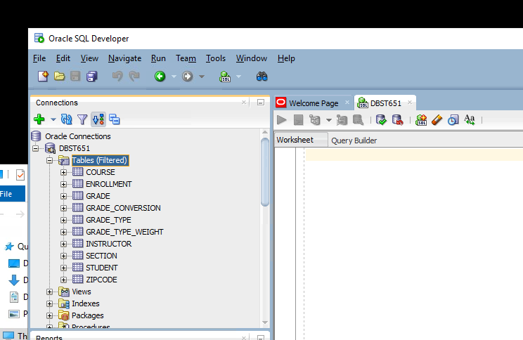
Student Schema Tables Screenshot
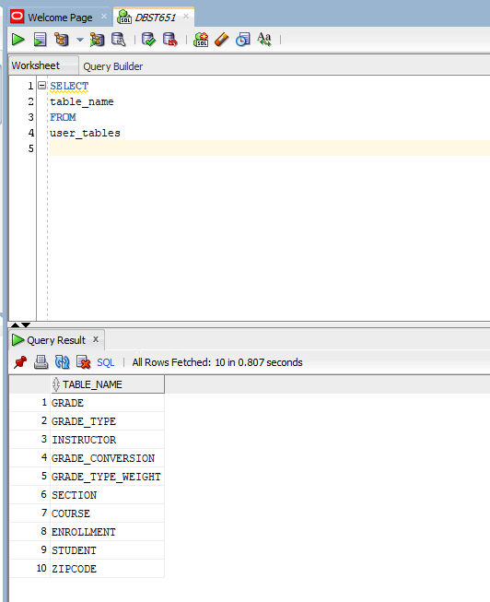
Name of Every Table in Student Schema Screenshot
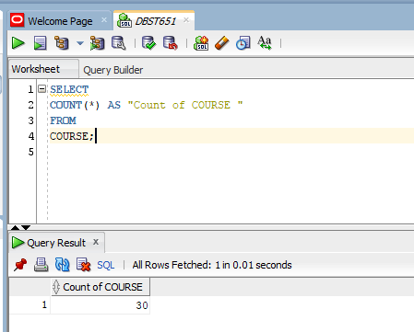
Total Number of Courses Available for Registration in Student Schema Screenshot

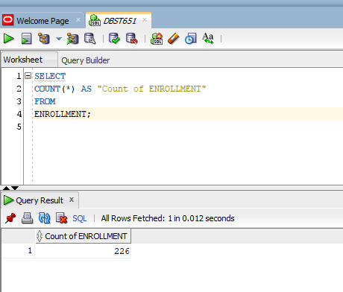
Total Number of Enrollments for any Section in Student Schema Screenshot

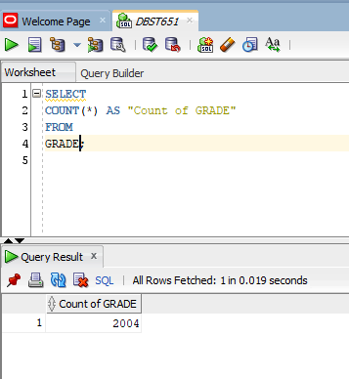
Total Number of Grades Received for any Section in Student Schema Screenshot

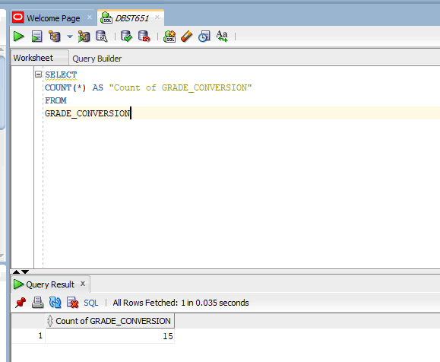
Total Count of Possible Letter Grades Applicable for Given Ranges in Student Schema

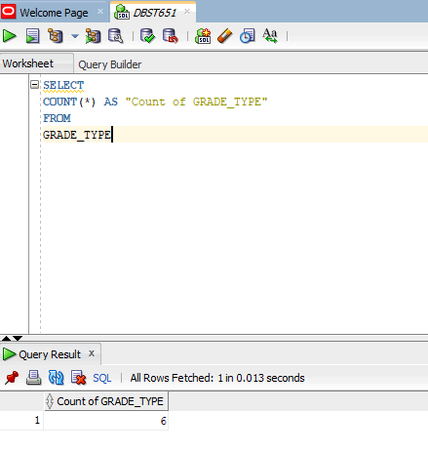
Total Count of Different Categories of Grades in Student Schema
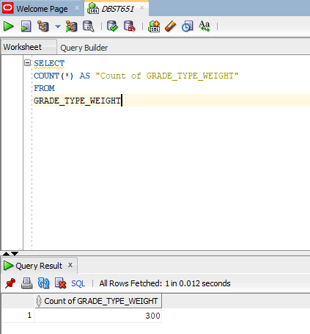
Total Number of Different Weights for Any Grade Type in Student Schema
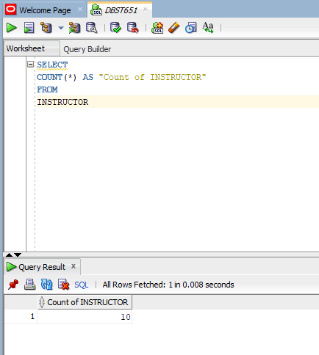
Total Number of Instructors in Student Schema
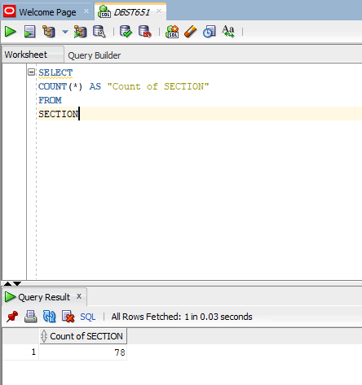
Total Number of Sections Available for Registration in Student Schema
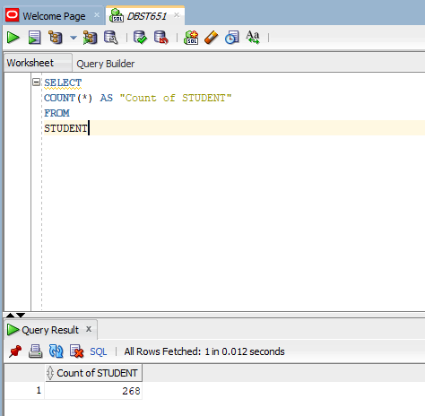
Total Number of Students in Student Schema
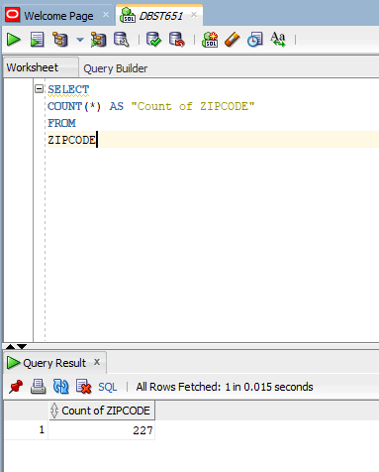
Total Number of Zip Codes in Student Schema

