**Quick Guide how to develop RESTful – 1**

There are 3 parts in this guideline.

**A. Preparing development environment**

B. Quick guide how to run RESTful using this project

C. Customizing for your project

1. Download the contents of Samsung/restful as a zip file or clone URL from <https://github.com/Samsung/restful>

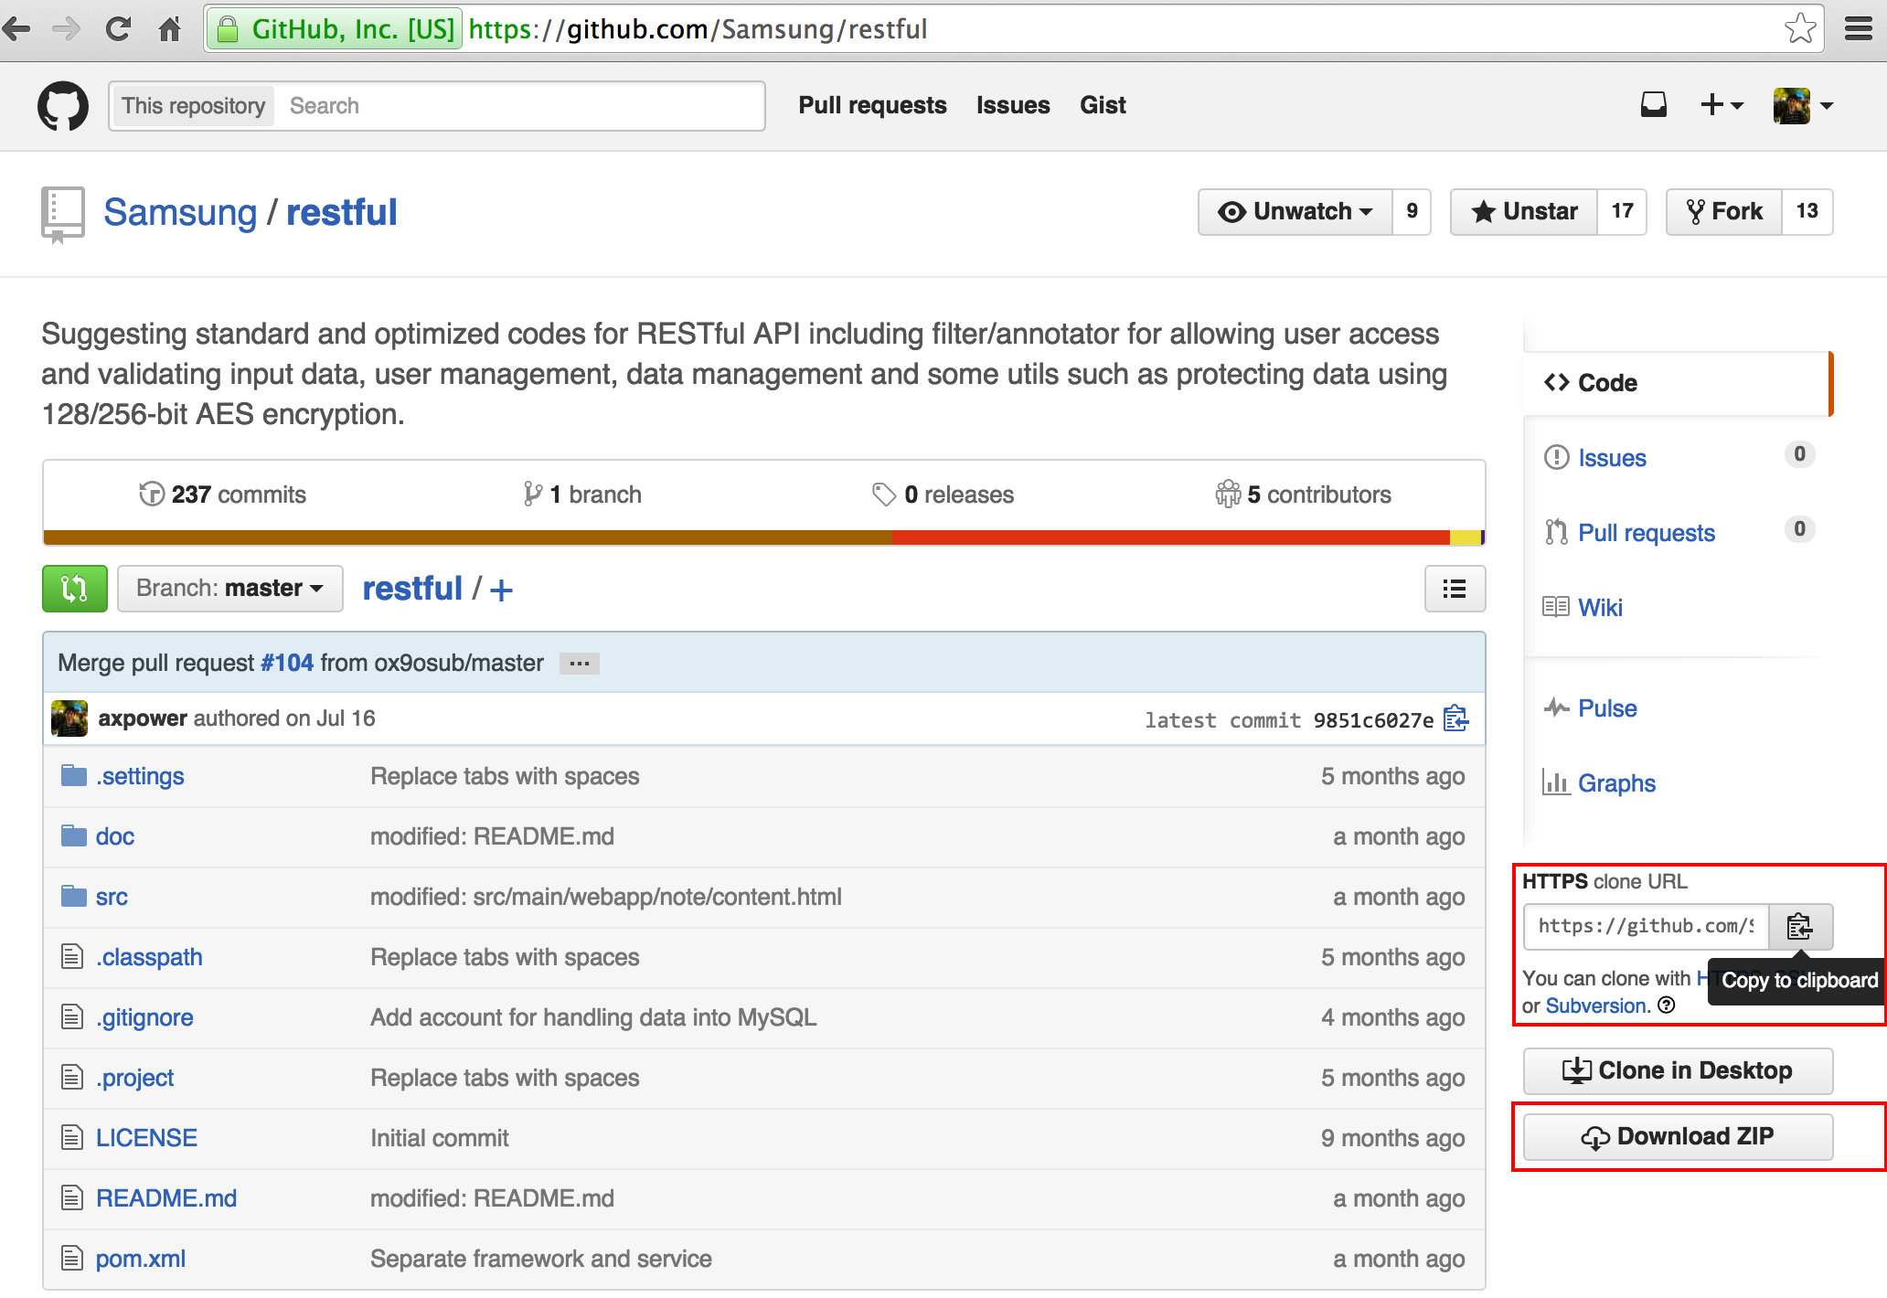

1. Import the project from Archive File if you download, or clone a Git Repository and add the clone to the view and then import

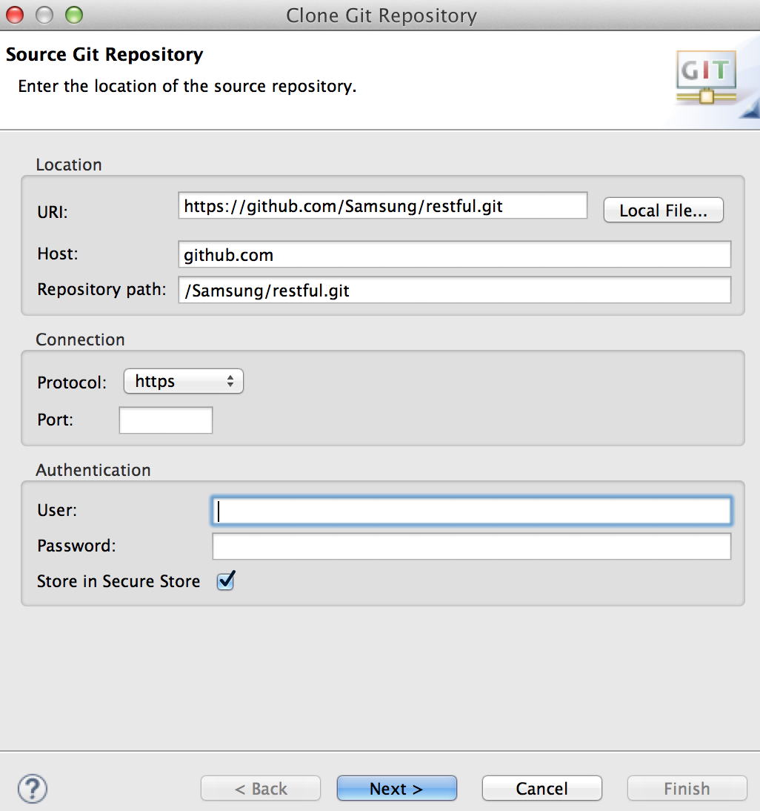 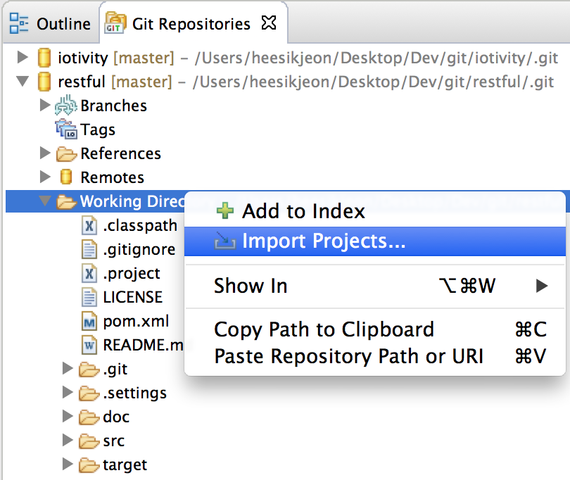

1. Install MySQL
   1. Visit <http://dev.mysql.com/>
   2. Download MySQL [Community Server](http://dev.mysql.com/downloads/mysql/) and [Workbench](http://dev.mysql.com/downloads/workbench/)
   3. Install MySQL Community Server and Workbench
2. Create database and tables
   1. Run Workbench

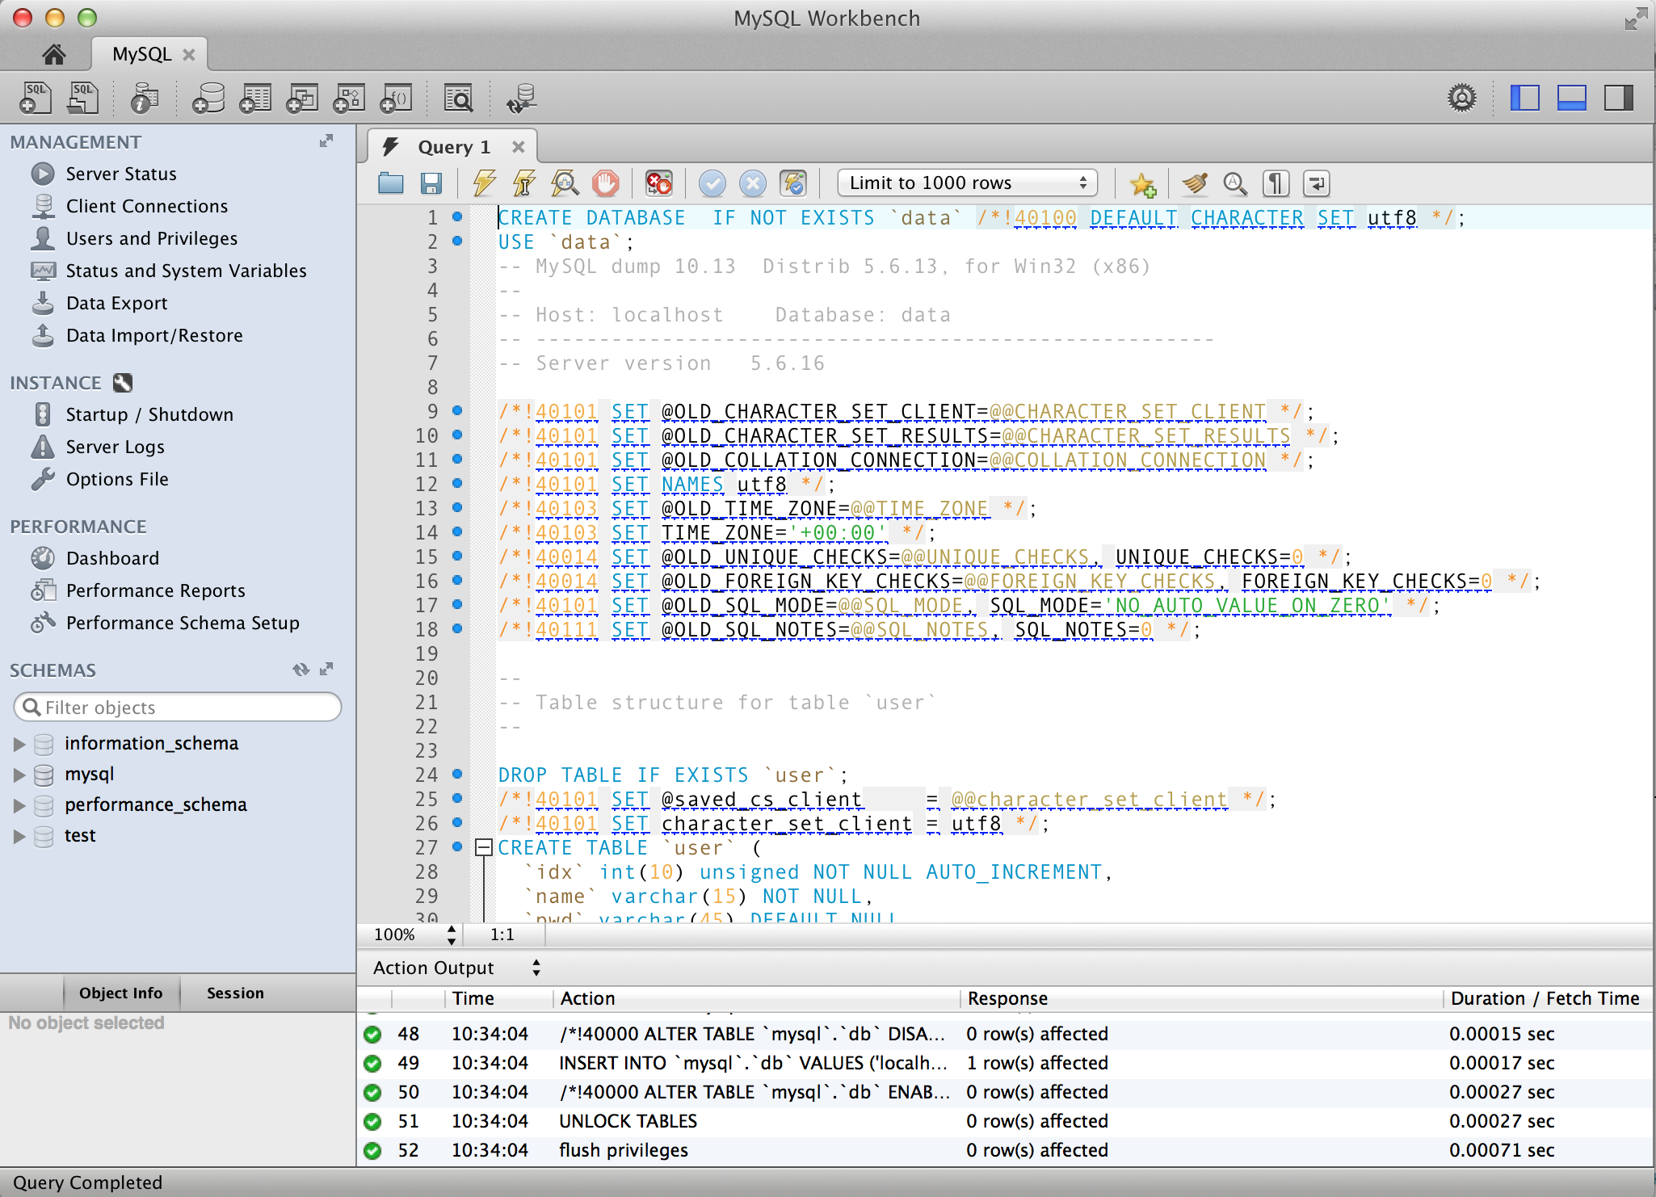

* 1. Execute below scripts

|  |
| --- |
| **CREATE** DATABASE IF **NOT** **EXISTS** `data` /*!40100 DEFAULT CHARACTER SET utf8 */;  USE `data`;  -- MySQL dump 10.13 Distrib 5.6.13, for Win32 (x86)  --  -- Host: localhost Database: data  -- ------------------------------------------------------  -- Server version 5.6.16  /*!40101 SET @OLD_CHARACTER_SET_CLIENT=@@CHARACTER_SET_CLIENT */;  /*!40101 SET @OLD_CHARACTER_SET_RESULTS=@@CHARACTER_SET_RESULTS */;  /*!40101 SET @OLD_COLLATION_CONNECTION=@@COLLATION_CONNECTION */;  /*!40101 SET NAMES utf8 */;  /*!40103 SET @OLD_TIME_ZONE=@@TIME_ZONE */;  /*!40103 SET TIME_ZONE='+00:00' */;  /*!40014 SET @OLD_UNIQUE_CHECKS=@@UNIQUE_CHECKS, UNIQUE_CHECKS=0 */;  /*!40014 SET @OLD_FOREIGN_KEY_CHECKS=@@FOREIGN_KEY_CHECKS, FOREIGN_KEY_CHECKS=0 */;  /*!40101 SET @OLD_SQL_MODE=@@SQL_MODE, SQL_MODE='NO_AUTO_VALUE_ON_ZERO' */;  /*!40111 SET @OLD_SQL_NOTES=@@SQL_NOTES, SQL_NOTES=0 */;  --  -- Table structure for table `user`  --  **DROP** **TABLE** IF **EXISTS** `**user**`;  /*!40101 SET @saved_cs_client = @@character_set_client */;  /*!40101 SET character_set_client = utf8 */;  **CREATE** **TABLE** `**user**` (  `idx` **int**(10) unsigned **NOT** **NULL** AUTO_INCREMENT,  `name` **varchar**(15) **NOT** **NULL**,  `pwd` **varchar**(45) **DEFAULT** **NULL**,  `sid` **varchar**(7) **DEFAULT** **NULL**,  `username` **varchar**(45) **NOT** **NULL**,  `role` **varchar**(12) **NOT** **NULL** **DEFAULT** 'User',  `status` tinyint(1) **NOT** **NULL** **DEFAULT** '1',  `createdate` **timestamp** **NOT** **NULL** **DEFAULT** CURRENT_TIMESTAMP,  `updatedate` **timestamp** **NULL** **DEFAULT** **NULL** **ON** **UPDATE** CURRENT_TIMESTAMP,  **PRIMARY** **KEY** (`idx`),  **UNIQUE** **KEY** `idx_UNIQUE` (`idx`),  **UNIQUE** **KEY** `name_UNIQUE` (`name`),  **UNIQUE** **KEY** `sid_UNIQUE` (`sid`),  **KEY** `status` (`status`),  **KEY** `name` (`name`)  ) ENGINE=InnoDB **DEFAULT** CHARSET=utf8;  /*!40101 SET character_set_client = @saved_cs_client */;  --  -- Dumping data for table `user`  --  LOCK TABLES `**user**` WRITE;  /*!40000 ALTER TABLE `user` DISABLE KEYS */;  **INSERT** **INTO** `**user**` **VALUES** (1,'axpower', PASSWORD('axpower'),'1','heesik.jeon','Admin',1,'2014-10-15 00:00:00','2014-10-15 00:00:00');  /*!40000 ALTER TABLE `user` ENABLE KEYS */;  UNLOCK TABLES;  /*!40103 SET TIME_ZONE=@OLD_TIME_ZONE */;  --  -- Table structure for table `note`  --  **DROP** **TABLE** IF **EXISTS** `note`;  /*!40101 SET @saved_cs_client = @@character_set_client */;  /*!40101 SET character_set_client = utf8 */;  **CREATE** **TABLE** `note` (  `idx` bigint(20) unsigned **NOT** **NULL** AUTO_INCREMENT,  `sid` **varchar**(7) **NOT** **NULL**,  `username` **varchar**(45) **NOT** **NULL**,  `subject` **varchar**(255) **NOT** **NULL**,  `access` **smallint**(4) unsigned **NOT** **NULL** **DEFAULT** '0',  `content` text **NOT** **NULL**,  `status` tinyint(1) **NOT** **NULL** **DEFAULT** '1',  `createdate` **timestamp** **NOT** **NULL** **DEFAULT** CURRENT_TIMESTAMP,  `updatedate` **timestamp** **NULL** **DEFAULT** **NULL** **ON** **UPDATE** CURRENT_TIMESTAMP,  **PRIMARY** **KEY** (`idx`),  **UNIQUE** **KEY** `idx_UNIQUE` (`idx`),  **KEY** `status` (`status`)  ) ENGINE=InnoDB **DEFAULT** CHARSET=utf8;  /*!40101 SET character_set_client = @saved_cs_client */;  --  -- Dumping data for table `note`  --  LOCK TABLES `note` WRITE;  /*!40000 ALTER TABLE `note` DISABLE KEYS */;  **INSERT** **INTO** `note` **VALUES** (1,'1','axpower','Hello',0,'It\'s really nice to meet you.',1,'2015-03-01 00:00:00','2015-05-02 00:00:00'),(2,'1','axpower','Hello',0,'Me too.',1,'2015-03-01 00:00:00','2015-03-02 00:00:00');  /*!40000 ALTER TABLE `note` ENABLE KEYS */;  UNLOCK TABLES;  /*!40103 SET TIME_ZONE=@OLD_TIME_ZONE */;  /*!40101 SET SQL_MODE=@OLD_SQL_MODE */;  /*!40014 SET FOREIGN_KEY_CHECKS=@OLD_FOREIGN_KEY_CHECKS */;  /*!40014 SET UNIQUE_CHECKS=@OLD_UNIQUE_CHECKS */;  /*!40101 SET CHARACTER_SET_CLIENT=@OLD_CHARACTER_SET_CLIENT */;  /*!40101 SET CHARACTER_SET_RESULTS=@OLD_CHARACTER_SET_RESULTS */;  /*!40101 SET COLLATION_CONNECTION=@OLD_COLLATION_CONNECTION */;  /*!40111 SET SQL_NOTES=@OLD_SQL_NOTES */;  --  -- Dumping data for table `db`  --  LOCK TABLES `mysql`.`user` WRITE;  /*!40000 ALTER TABLE `mysql`.`user` DISABLE KEYS */;  INSERT INTO `mysql`.`user` VALUES ('localhost','axpower',PASSWORD('axpower'),'N','N','N','N','N','N','N','N','N','N','N','N','N','N','N','N','N','N','N','N','N','N','N','N','N','N','N','N','N','','','','',0,0,0,0,'mysql_native_password','','N');  /*!40000 ALTER TABLE `mysql`.`user` ENABLE KEYS */;  UNLOCK TABLES;  --  -- Dumping data for table `user`  --  LOCK TABLES `mysql`.`db` WRITE;  /*!40000 ALTER TABLE `mysql`.`db` DISABLE KEYS */;  INSERT INTO `mysql`.`db` VALUES ('localhost','data','axpower','Y','Y','Y','Y','N','N','N','N','N','N','N','N','N','N','N','N','N','N','N');  /*!40000 ALTER TABLE `mysql`.`db` ENABLE KEYS */;  UNLOCK TABLES;  flush privileges;  -- Dump completed on 2014-10-15 00:00:00 |