**Quick Guide how to develop RESTful – 2**

There are 3 parts in this guideline.

A. Preparing development environment

**B. Quick guide how to run RESTful using this project**

C. Customizing for your project

Most of them are already prepared so you just need to follow below instructions

1. Open pom.xml from your Eclipse and run “Maven install” as below

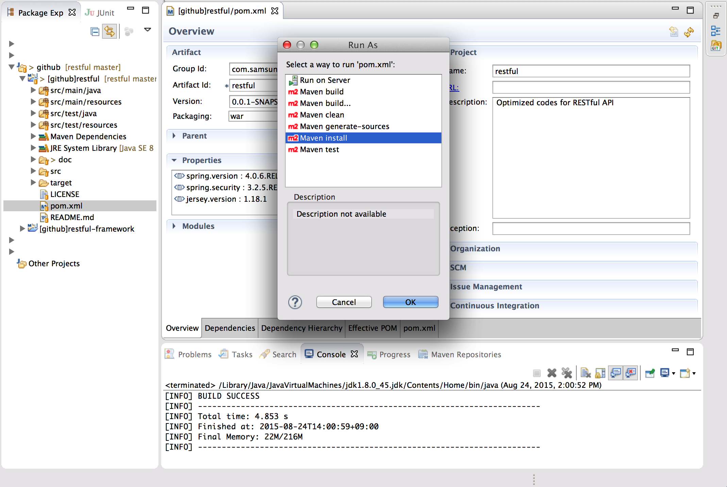

1. You will see restful.war under /target folder and copy it to webapps in your tomcat

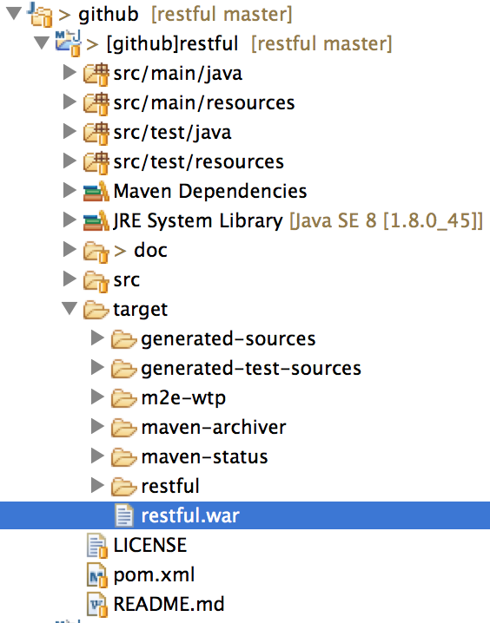

1. Start MySQL

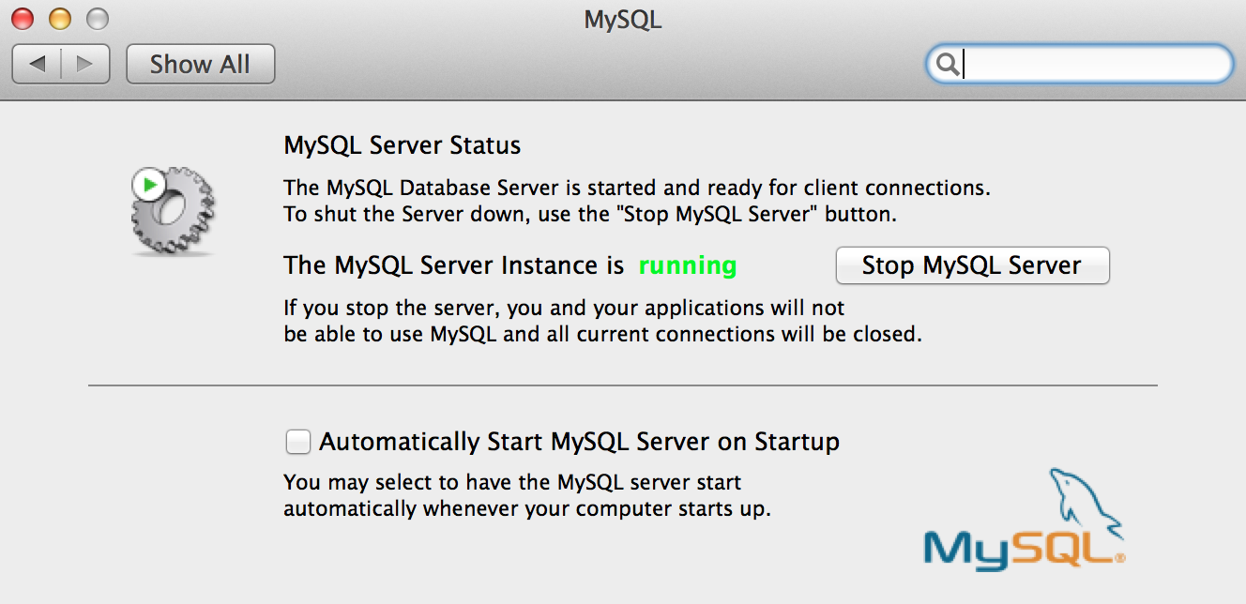

1. Start Tomcat

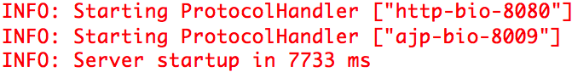

1. Access <http://localhost:8080/restful/note/list.html> (It can be different because of your tomcat configuration) from your browser and you will see below output

