DELIVERY TIME PREDICTION
FOR LOGISTICS
Week 1 Report
Strategic Planning & Data Exploration
Project Focus:
Historical Delivery Data Analysis and Future Delivery-Time Prediction
Dataset: Amazon Delivery Dataset (Kaggle)
43,739 records × 16 columns

Table of Contents
1. Project Overview
2. Logistics Scenario
3. Problem Statement
4. Project Objectives
5. Key Performance Indicators (KPIs)
6. Background Research
7. Data Science Methodologies
8. Strategic Roadmap
9. Dataset Exploration / Initial Findings
10. Expected Outcomes
11. Conclusion
12. References

1. Project Overview
Logistics companies handle a large number of deliveries every day. The time required to complete a delivery can vary depending on factors such as traffic, weather, delivery distance, order characteristics, pickup time, and delivery conditions. This project focuses on analyzing historical delivery data to understand the factors associated with delivery time and identify patterns in longer delivery times. The long-term goal is to use data analytics and machine learning to predict delivery time and support better logistics planning and resource allocation.

2. Logistics Scenario
A logistics company wants to improve the reliability and efficiency of its last-mile delivery operations. The company has historical information about its deliveries, including delivery-agent characteristics, weather conditions, traffic conditions, vehicle information, order timing, pickup information, and delivery time. However, the company does not yet have a systematic analytical approach for identifying patterns in delivery performance.
The proposed project will analyze historical delivery data to identify factors associated with longer delivery times. The analysis will eventually be extended to predictive modeling so that the company can estimate delivery time for future orders. These predictions could support operational decisions such as delivery planning, resource allocation, and prioritization of deliveries that may require additional attention.

3. Problem Statement
Delivery times can vary significantly between orders, making logistics operations less predictable and potentially affecting service reliability. The main problem addressed in this project is how historical delivery data can be analyzed to understand variations in delivery time and identify factors associated with longer deliveries. The project will develop a structured analytical approach that begins with data exploration and preprocessing and progresses toward predictive modeling of delivery time.

4. Project Objectives
Objective 1 — Understand delivery patterns
Analyze historical delivery data to understand delivery patterns and overall performance.
Objective 2 — Identify important factors
Identify factors associated with delivery time, such as traffic, weather, distance, vehicle type, and delivery area.
Objective 3 — Analyze logistics KPIs
Define and analyze key logistics performance indicators to evaluate delivery performance.
Objective 4 — Prepare the data for prediction
Prepare the delivery dataset for future predictive modeling by identifying relevant variables and potential data-quality issues.
Objective 5 — Develop a predictive approach
Develop a roadmap for using machine learning to predict delivery time and support logistics decision-making.

5. Key Performance Indicators (KPIs)
1. Average Delivery Time
The average time taken to complete a delivery. It is the main indicator of overall delivery performance and will also be the target for the predictive model.
2. Average Delivery Distance
The average distance between the store and the customer location. It can help us study whether longer delivery distances are associated with longer delivery times.
3. Delivery Time Variability
This measures how much delivery times differ between orders. High variability can indicate that delivery performance is inconsistent and may require further investigation.
4. Long-Delivery-Time Rate
The percentage of deliveries with unusually high delivery times. A suitable threshold will be determined from the dataset during analysis. This can help identify deliveries that may require attention.
Important data limitation: The dataset does not contain an expected or promised delivery time. Therefore, an official delay rate or on-time delivery rate cannot be calculated directly. Instead, this project will analyze unusually long delivery times and the factors associated with them.

6. Background Research

Research Paper 1 — Delivery Time Prediction
Summary: This research focuses on predicting delivery stop times using historical GPS data combined with operational information such as planned demand and actual deliveries. The study also uses additional information such as geographical and map data to improve the analysis. Different statistical and machine-learning approaches are used to estimate how long a delivery stop may take. The research shows that predicting delivery time can help logistics companies improve delivery planning and manage delivery time expectations more effectively.
Relevance to Our Project: This paper supports our project because we also aim to use historical delivery data to understand the factors affecting delivery time and eventually build a predictive model for delivery-time or delay prediction.

Research Paper 2 — Delivery Delay Prediction
Summary: This research reviews different approaches for predicting delivery delays in logistics and supply chain operations. It discusses how machine-learning methods can use historical delivery and operational data to identify whether a delivery is likely to be delayed. The research also highlights the importance of factors such as transportation conditions, delivery information, and other external factors when predicting delays. Predicting delays can help logistics companies take action before problems occur and improve delivery reliability.
Relevance to Our Project: This paper is directly related to our project because we want to analyze delivery data and eventually predict delivery time and delays. It supports the use of machine learning as a way to identify potentially delayed deliveries and improve logistics decision-making.

Research Paper 3 — Data-Driven Last-Mile Logistics
Summary: This research focuses on using historical logistics data to improve last-mile delivery operations. It explains how data analysis and data-mining techniques can help identify patterns in delivery operations and evaluate logistics performance. The research also considers factors such as traffic, weather, and other external conditions that can affect delivery performance. It highlights the importance of using KPIs and data visualization to understand logistics problems and support better decision-making.
Relevance to Our Project: This paper is relevant to our project because we also want to analyze historical delivery data to understand factors affecting delivery performance. It supports our use of KPIs, exploratory data analysis, visualization, and factors such as traffic and weather. The insights from this analysis can later help us build a delivery-time prediction model and provide better logistics planning recommendations.

7. Data Science Methodologies

7.1 Regression
Regression is used to predict a numerical value based on other variables. In this project, regression can be used to predict delivery time using factors such as:
- Traffic conditions
- Weather conditions
- Delivery distance
- Vehicle type
- Order time
- Pickup time
- Agent-related information

7.2 Clustering
Clustering is an unsupervised learning technique used to group similar data points together. In this project, clustering could be used to group deliveries based on characteristics such as:
- Delivery distance
- Delivery time
- Traffic conditions
- Order characteristics
- Delivery location
For example, the analysis may identify groups such as short-distance deliveries, long-distance deliveries, or deliveries that commonly experience high traffic.

7.3 Optimization
Optimization is used to find a better way of allocating resources or making decisions while considering specific constraints. In this project, optimization can be used after analyzing and predicting delivery performance. For example, the results could help with:
- Prioritizing deliveries that have a high risk of delay
- Allocating delivery agents more effectively
- Planning delivery schedules
- Managing delivery capacity
- Reducing unnecessary delays

8. Strategic Roadmap
Public Delivery Dataset ↓ Data Collection ↓ Data Cleaning ↓ Data Preprocessing ↓ Exploratory Data Analysis (EDA) ↓ KPI Analysis ↓ Feature Selection ↓ Predictive Modeling ↓ Model Evaluation ↓ Delivery Time Prediction ↓ Logistics Recommendations
The roadmap starts with the public delivery dataset and progresses from data preparation and exploratory analysis to predictive modeling and logistics recommendations. Week 1 establishes the planning and initial exploration foundation; later weeks will focus on cleaning, deeper analysis, and prediction.

9. Dataset Exploration / Initial Findings

9.1 Dataset Overview
The selected dataset is the Amazon Delivery Dataset, which contains historical information about delivery orders. The dataset contains 43,739 records and 16 columns. The available information includes agent details, store and customer locations, order and pickup times, weather, traffic, vehicle type, delivery area, product category, and delivery time.
The Delivery_Time column represents the time taken for a delivery in minutes and is the main target variable for the future predictive model.

9.2 Basic Data Exploration
During the initial exploration, the dataset structure, column types, missing values, unique categories, and basic delivery-time statistics were examined. The average delivery time was approximately 125 minutes, with a median of 125 minutes. Delivery times ranged from 10 to 270 minutes. Missing values were found in some columns, including Agent Rating and Weather, and will be handled during the data-cleaning stage in Week 2.

9.3 Geographic Distance Exploration
The store and customer latitude/longitude values were used to calculate an approximate delivery distance using the Haversine formula. The initial distance calculation produced some extremely large values, which suggested that some geographic coordinates might be incorrect. Further checking identified 188 records containing suspicious negative geographic coordinates. These records will be investigated and handled during data cleaning in Week 2.
Distance calculation used during exploration:
lat1 = np.radians(df["Store_Latitude"])
lon1 = np.radians(df["Store_Longitude"])
lat2 = np.radians(df["Drop_Latitude"])
lon2 = np.radians(df["Drop_Longitude"])
dlat = lat2 - lat1
dlon = lon2 - lon1
a = np.sin(dlat / 2)**2 + np.cos(lat1) * np.cos(lat2) * np.sin(dlon / 2)**2
distance = 2 * 6371 * np.arcsin(np.sqrt(a))
df["Distance_km"] = distance

9.4 Traffic vs Delivery Time
The analysis shows that delivery time generally increases as traffic becomes heavier. Deliveries during low traffic have the lowest average delivery time at approximately 101 minutes, while deliveries during jam conditions have the highest average at approximately 148 minutes. This suggests that traffic conditions may be an important factor for delivery-time prediction.
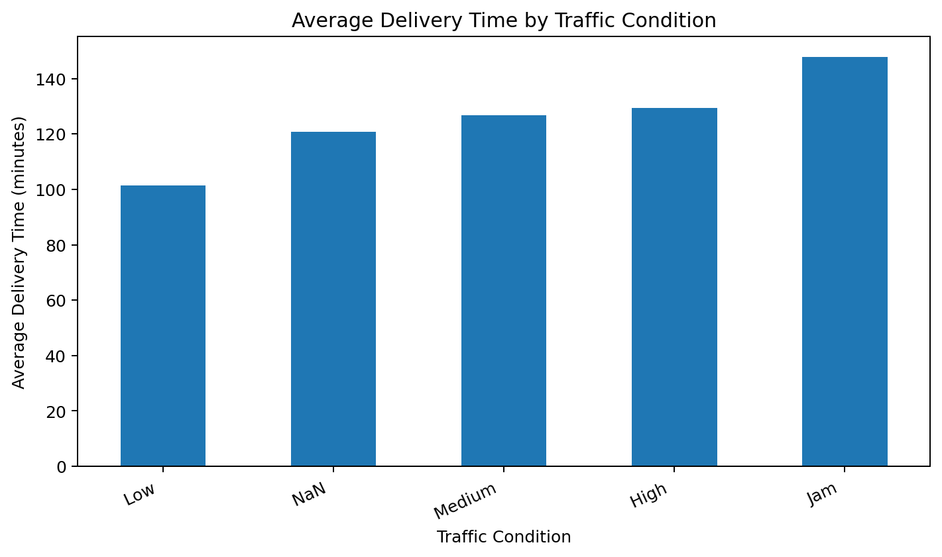
Figure 1. Average Delivery Time by Traffic Condition
Figure 1. Average Delivery Time by Traffic Condition (figure file not available in the current workspace)

9.5 Weather vs Delivery Time
The analysis shows that delivery time varies across different weather conditions. Deliveries during sunny weather have the lowest average delivery time at approximately 104 minutes, while cloudy and foggy conditions have higher averages of approximately 138 and 137 minutes respectively. This suggests that weather conditions may influence delivery time and could be considered as a factor in future delivery-time prediction.
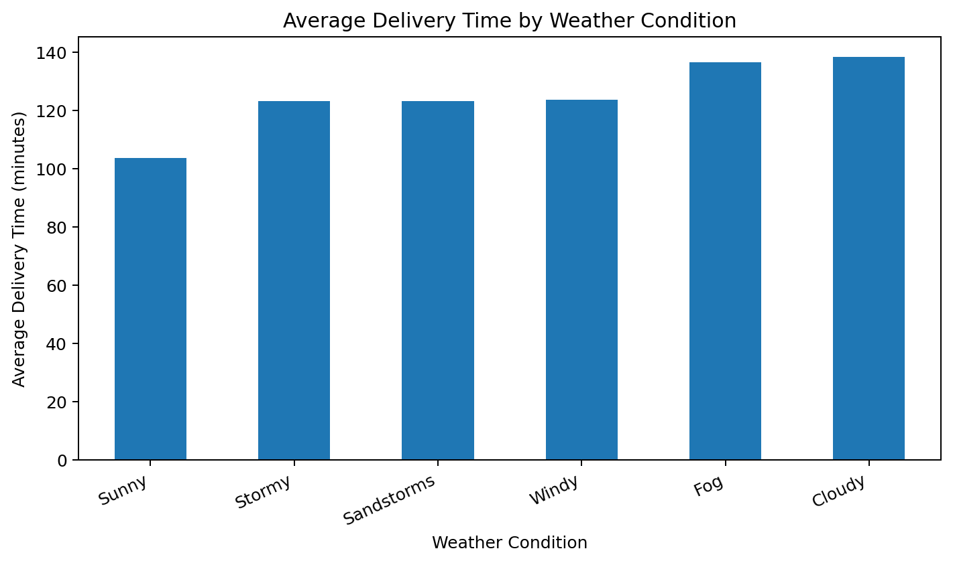
Figure 2. Average Delivery Time by Weather Condition
Figure 2. Average Delivery Time by Weather Condition (figure file not available in the current workspace)

9.6 Area vs Delivery Time
The analysis shows differences in average delivery time across delivery areas. Semi-Urban deliveries have the highest average delivery time at approximately 239 minutes. However, only 152 deliveries belong to this category, compared with 32,698 deliveries in the Metropolitian category. Therefore, the high Semi-Urban average should be interpreted carefully and investigated further during later analysis.
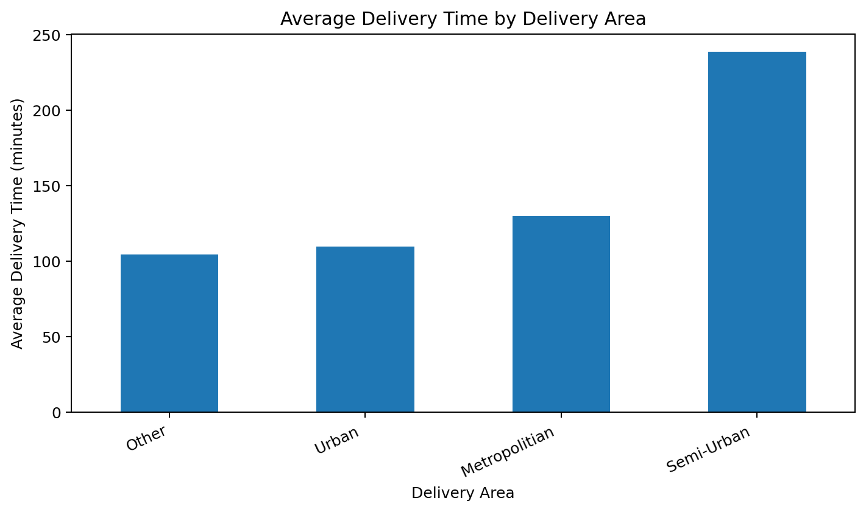
Figure 3. Average Delivery Time by Delivery Area
Figure 3. Average Delivery Time by Delivery Area (figure file not available in the current workspace)

10. Expected Outcomes
The project is expected to provide a better understanding of the factors associated with delivery time. The analysis will help identify patterns related to traffic, weather, delivery area, distance, and other available delivery information.
In the later stages of the project, the cleaned and prepared dataset will be used to develop a machine-learning model for predicting delivery time. The prediction results could support better delivery planning, resource allocation, and identification of deliveries that may require additional attention.
The project is also expected to provide a practical data-driven approach that can help understand delivery performance and support logistics decision-making.

11. Conclusion
This Week 1 analysis established a foundation for studying delivery performance using historical logistics data. The initial exploration showed differences in delivery time across traffic conditions, weather conditions, and delivery areas.
The analysis also identified data-quality issues, including missing values and suspicious geographic coordinates. These findings show that data cleaning and preprocessing are important before developing a predictive model.
The next stage of the project will focus on cleaning and preprocessing the dataset, preparing the relevant features, and performing more detailed analysis. The prepared data will then be used for predictive modeling in the later weeks.
Overall, this project provides a practical approach to understanding delivery-time variation and developing a future delivery-time prediction system.

12. References
Research Paper 1 — Delivery Time Prediction
ScienceDirect. Research on delivery time prediction using historical GPS and operational data.
https://www.sciencedirect.com/science/article/pii/S0968090X18314645
Research Paper 2 — Delivery Delay Prediction
ScienceDirect. Research on machine-learning approaches for delivery delay prediction in logistics and supply chain operations.
https://www.sciencedirect.com/science/article/pii/S2949863525000305
Research Paper 3 — Data-Driven Last-Mile Logistics
MDPI. Research on data-driven approaches for improving last-mile logistics operations.
https://www.mdpi.com/2071-1050/13/11/6230/html
Dataset
Amazon Delivery Dataset — Kaggle.
https://www.kaggle.com/datasets/sujalsuthar/amazon-delivery-dataset
End of Week 1 Report

