Git & GitHub checkpoint
- Create a folder called learn_git.
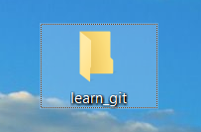

- Cd (change directory) into the learn_git folder.
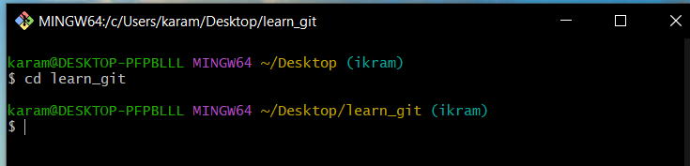

- Create a file called third.txt.
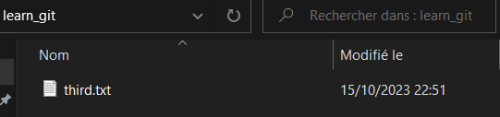

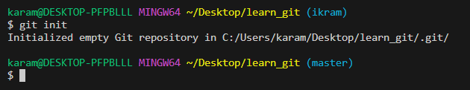

- Initialize an empty git repository.

- Add third.txt to the staging area.

- Commit with the message "adding third.txt".
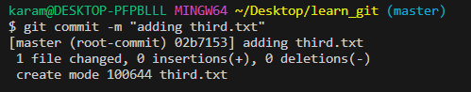

- Check out your commit with git log.
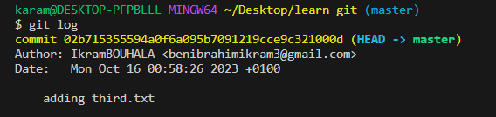

- Create another file called fourth.txt.

- Add fourth.txt to the staging area.
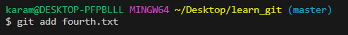

- Commit with the message "adding fourth.txt"
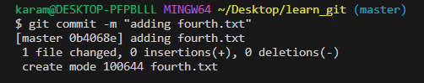

- Remove the third.txt file.
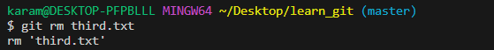

- Add this change to the staging area.
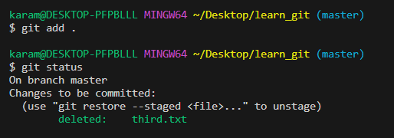

- Commit with the message "removing third.txt".
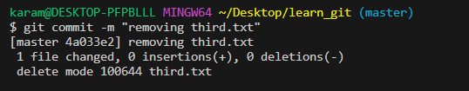

- Check out your commits using git log.
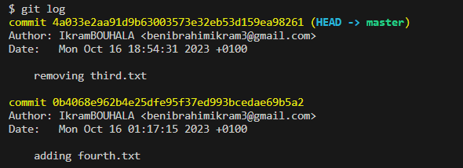

- Change your global settings to core.pager=cat
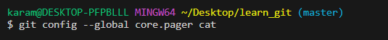1

- Write the appropriate command to list all the global configurations for git on your machine.
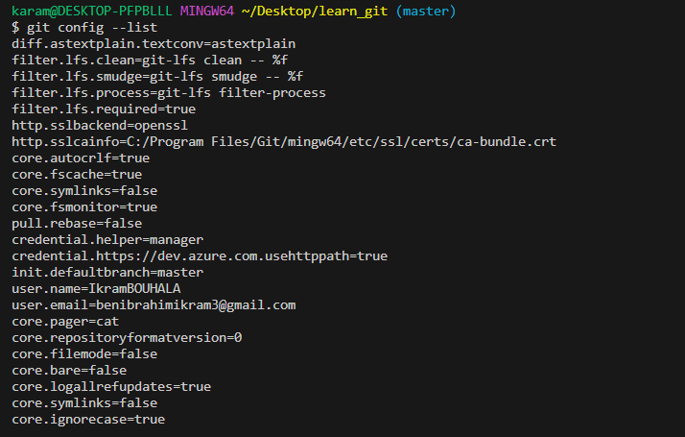

- Creating a new repository in Github “learn_git”
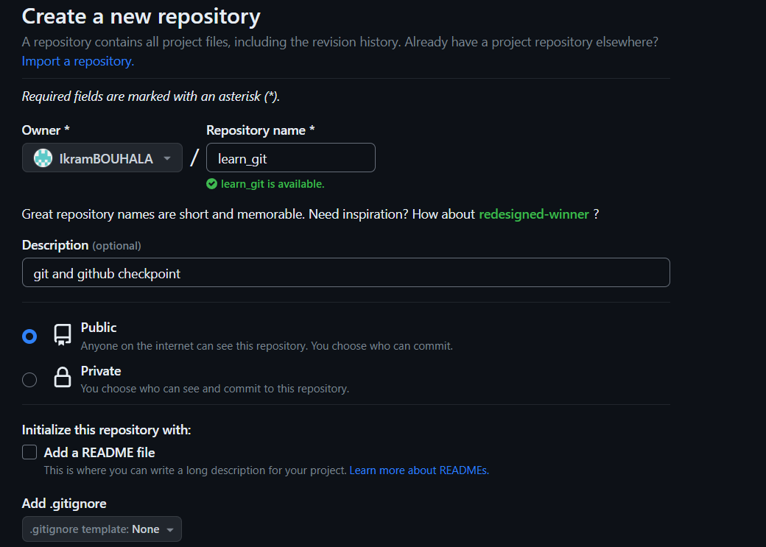

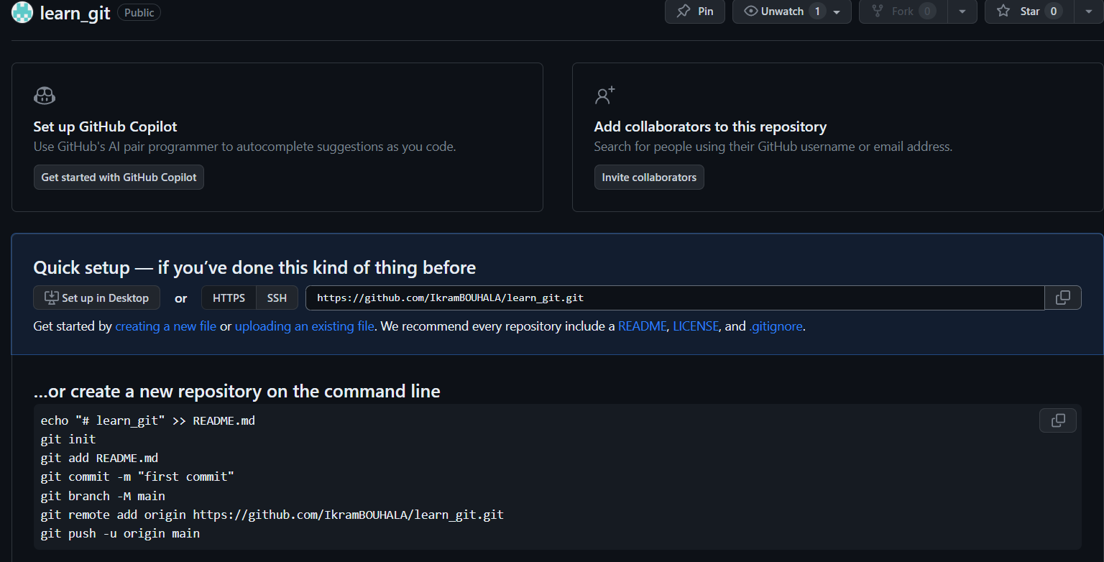

- Adding repository origin in git:
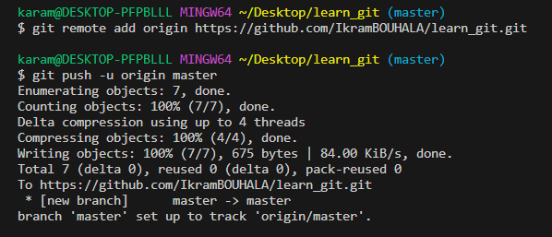

- Adding the checkpoint file to Github repository “learn_git”:
