August 2025

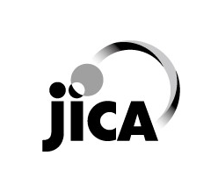

**JICA Knowledge Co-Creation Program**

**for Long Term Participants**

**(JICA Development Studies Program)**

|  |
| --- |
| General Information on **Master’s Degree and Internship Program of** African Business Education Initiative for YouthJFY2026 |

This information pertains to one of the Japan International Cooperation Agency (JICA)’s Knowledge Co-Creation Program(Long-Term). The program will be implemented as part of the Official Development Assistance of the Government of Japan based on bilateral agreement between respective governments. Each country may have its own schedule and/or qualifications for the program. With regard to the additional information, please contact our JICA overseas office in charge of your country.

The objective of the Knowledge Co-Creation Program (Long-Term) is to offer opportunities to people from developing countries to study at higher educational institutions in Japan and to help them build their network of people. This is intended to assist in the human resource development plans of the governments of developing countries and Japan, and eventually to expand and strengthen bilateral ties between the developing countries and Japan.

**0. Background**

**What is JICA Knowledge Co-Creation Program (KCCP)**

The Japanese Cabinet revised the Development Cooperation Charter in June 2023, which stated, “In its development cooperation, Japan has maintained the spirit of jointly creating things that suit partner countries while respecting ownership, intentions and intrinsic characteristics of the country concerned based on a field-oriented approach through dialogue and collaboration. It has also maintained the approach of building reciprocal relationships with developing countries in which both sides learn from each other and grow and develop together.” JICA believes that this ‘Knowledge Co-Creation Program’ will serve as a foundation of mutual learning process.

**What is JICA Development Studies Program (JICA-DSP)**

Japan is the very first country and still is one of the very few countries that has modernized from a non-Western background to establish a free, democratic, prosperous, and peace-loving nation based on the rule of law, without losing much of its tradition and identity. With such belief, JICA invites future leaders from partner countries to Japan under KCCP and offers them opportunity to learn about Japan's unique modernization and development experiences. This special program is called, JICA Development Studies Program (JICA-DSP).

JICA-DSP is provided to all participants of KCCP during their stay in Japan. JICA will offer participants various opportunities through which they can learn about Japan's modernization and development experiences.

<https://www.jica.go.jp/english/activities/schemes/dsp-chair/index.html>

**1. Overview**

　ABE initiative stands for “African Business Education Initiative”. Participants from Africa can get opportunities to study at Japanese universities as well as to do internships at Japanese enterprises. ABE Initiative builds on the concept that there is a need for human resource development in both private and public sectors of Africa through cultivating a strong human network between Japan and Africa.

**More detail of the ABE initiative, please check the below**

<https://www.jica.go.jp/africahiroba/business/detail/03/ku57pq00001jwm0b-att/abc_pamphlet_en.pdf>



**2. Objectives**

1. To foster human resources for industry and business that would be the key to growth of Africa.
2. To foster human resources that will connect and become the bridge between Japanese and African businesses.

**3. Course Outline**

The course consists of the acceptance of scholars from 54 countries from all over the Africa.

This handout provides information related to long-term master’s degree courses.

Candidate applicants may select the university to which he/she wishes to apply, from the universities which have concluded an agreement on accepting JICA participants on the condition that the candidate passes the entrance examination of the selected university. Detailed information of these partner universities will be provided separately.

Proposed research topics should consist of subjects that contribute to government policies on sustainable development (Examples: Administration/public policy, finance, public finance management, international politics/diplomacy, regional research, business, international trade/investment, disaster risk reduction, maritime issues etc.)

In addition to curriculums of the master’s courses, activities such as short-term programs (e.g. Understanding the Japanese Development Experience[1]), and/or internship programs will be planned in order to enrichen the participants’ academic and personal experience of their courses of studies at the universities.

**Internship at Japanese Private Companies**

Accepted applicants must participate in internship programs at public or private entities during their stay in Japan (ex. summer break, after graduation, etc.). JICA will prepare the contents and schedule of the internship in close consultation with the participants and host organizations. In principle, no reward or compensation should be paid to the participants or host organizations.

**4. Duration**

(Standard Timetable) September 2026 – August, 2029 (Maximum period)

- 6 months as a research student if applicable

- 1 or 2 years as a Master’s student

- Internship after graduation for the limited participants only (details are to be determined)

**5. Number of Participants**

78

**6. Language to be used in this Program**

English

**7. Eligibility**

Candidate applicants must satisfy the following requirements:

※ In principle, candidates without affiliations are not eligible for acceptance.

|  |  |
| --- | --- |
| 1. Nationality | Citizens of one of the 54 African countries |
| 1. Age | Under forty (40) years of age (as of April 1st, 2026) |
| 1. Educational background | Bachelor’s degree (equivalent to at least 16 years of academic background)  For more information, please check the website of the Universities. |
| 1. Working experience /status | Applicants for the category of “From the Private Sector” are required:   * to have working experiences, and * not to be employed by Japanese companies at the time of joining the program (arriving in Japan).   Applicants for the category of “From Government” are required:   * to have more than 6 months working experience at their current organizations, * to obtain permission for application, and * to secure reinstatement from their current organizations.   ※Any employment before university completion is not considered as working history. Only full-time working with acquisition of diploma, such as night school, is approved as working experience. |
| 1. English language Proficiency | * Adequate English skills both in written and oral communication to complete the Master’s Degree such as:   TOEFL iBT :80 / IELTS6.5 / CEFR :B2 (estimated score)  *The required level of English for admission may differ according to university. |
| 1. Others | Applicants must:   * must physically come to Japan to carry out research activities to complete this program. * allow to be receiving or planning to receive another scholarship except from the Japanese government, such as Japan Student Service Organization (JASSO), Japan Society for the Promotion of Science (JSPS), Japan Science and Technology Agency (JST), The Japan Foundation (JF) during the program. * contribute to networking with Japanese companies, * attend the activities on the weekends once or twice per year unless applicants have unavoidable circumstances, and * (if accepted to the program), cooperate in answering questionnaires regarding the participant’s current status, while participating and after completing the program, which will be sent out periodically. |
| 1. Recommended Qualifications | Gender Equality and Women‘s Empowerment:  Women are encouraged to apply for the program. JICA makes a commitment to promote gender equality and women’s empowerment, providing equal opportunity for all applicants regardless of sexual orientation and gender identity. |
| 1. Ideal Applicant Profile | 1. From the Private Sector  * Those who have an experience in economic activities in the local private sectors and wish to contribute to Africa’s development through cultivating strong network with Japanese companies.  1. From Government (Related to areas of interest of Japanese companies)  * Those who take part in formulation and/or implementation of industrial policies and wish to contribute to Africa’s development through government activities.   Those who is engaged in the areas of which Japanese companies have interest in the applicant’s country. |
| 1. Relationship with the Military / the Ministry of Defense | * The Government of Japan will examine applicants who belong to the military or other military-related organizations and/or who are enlisted in the military, taking into consideration of their duties, positions in the organization and other relevant information in a comprehensive manner to be consistent with [the Development Cooperation Charter of Japan.](https://www.mofa.go.jp/policy/oda/page_000138.html) * If your organization and/or your status is related to the Military or the Ministry of Defense (see the details below), it is requested for you to inform your status on the application form.  1. the Military, an active military personnel or military personnel listed in the muster roll/military register. 2. an organization affiliated with the Military, or personnel personnel currently not in active service but is listed in the muster roll/military register. 3. the Department or the Ministry of Defense, an organization affiliated with the Ministry of Defense, or staff of the Ministry of Defense 4. a civilian organization but with military personnel or a military division within the organization   an organization which will be affiliated with or under the control of the Military in times of emergency as specified clearly in its organic law/law of establishment |

**8. Admissions**

Candidates must be selected as JICA’s official candidate through JICA’s internal selection procedure and must pass the general entrance examination[2] of the university they have applied to, including examinations to enter the applicants’ desired master’s degree course.

**9. Application Guidelines**

Candidate applicants must apply through the procedures as described below, which are necessary requirements by both applicant’s Government and the Government of Japan for the Official Development Assistance.

1. Procedures and Required Documents for Application:

Each applicant is required to submit the “Application Documents[3]” listed in (2) below to JICA overseas office in charge of the applicants’ country.

1. Application Documents

・ Personal Information

・ Educational Background

* Present Organization and Nomination

・ Work Experience

* Declaration (Terms and Conditions needed to be agreed by candidate applicants)
* Research Plan（Annex 2）
* Career Plan（Annex 2）

1)Graduation certificate.

* Officially certified copies of the original

* Written in English or accompanied with official translation

2) Academic transcript

* Must contain all the grades earned at the university attended by the applicant

* Officially certified copies of the original transcript

* Written in English or accompanied with official translation in English

3) Photocopy of certificate of English Test

4) A copy of Passport or ID with photo (for checking nationality, name, sex, and date of birth).

5) 2 ID photos (4cm × 3cm) pasted on application form (Original and copy)

6) Health certificate (no later than April 30, 2026. The date of Health Certificate should be on or after April 1, 2026. JICA will NOT reimburse the cost to the applicants [4])

1. Procedures in General

Based on the above documents, candidate applicants are nominated and approved by their country’s government, and later approved by JICA.[5] After this procedure, screening will be conducted at the universities chosen by the applicant.

Please kindly note that universities may reject the applicant’s application when the required documents, or the submitted research plan is not accepted by the universities.

Candidate applicants must follow each university’s application procedure after the screening. If the applicants withdraw their applications after their official applications to the universities, applicants must inform their withdrawal to the university by letter.



1. Points to be Noted regarding Procedures
2. Fees for English proficiency test or preparation of application documents can be reimbursed only within the same Japanese fiscal year (from 1st April to 31st March of the next year) when the general entrance examinations are taken. Details of the reimbursement vary by each area and should be consulted with the nearest JICA overseas office of each candidate.

JICA shall determine whether the candidate is eligible to participate in training in Japan. JICA shall make a decision on acceptance or rejection based on several factors such as entrance examination results, planned number of participants, medical examination results and others. Reason for the decision will not be disclosed.

**10. Schedule**

There are mainly following three selection processes: (A) Selection in each country, (B) Pre-Matching with Japanese universities, and (C) Selection by Japanese universities.

**Flows:**

***(A) Selection in each country***

1. **1st Selection**

**[Necessary Actions for Applicants for this selection]**

Each applicant needs to submit JICA’s Application Documents by the deadline set by JICA office in the applicants’ country (basically end of September).

|  |  |
| --- | --- |
| **Period** | Aug 2025 - October 2025  (Please check with the JICA office in the country of your nationality.) |
| **Contents** | Selection of the submitted JICA’s Application Documents |
| **Objectives** | To check qualifications and requirements of each applicant.  To check applicants’ understanding of the program objectives and working experiences/educational background in the context of the “Eligible Participants” (shown in the section 2.). |
| **Result** | Applicants who pass this selection can proceed on to the 2nd Selection. |

1. **2nd Selection**

**[Necessary Actions for Applicants for this selection]**

Each applicant needs to be interviewed.

|  |  |
| --- | --- |
| **Period** | Aug 2025 – Beginning of November 2025  (Please check with the JICA office in the country of your nationality.) |
| **Contents** | Interviews by JICA office, etc. |
| **Objectives** | To check applicants’ capability of contributing to the achievement of the course objectives addressing Africa’s development challenges after the program. |
| **Venue** | To be determined.  (JICA office in the country of your nationality will announce.) |
| **Result** | The applicants who pass this selection can proceed on to the 3rd Selection. * |

**(B) Selection by Japanese universities**

1. **Pre-matching (3rd Selection)**

|  |  |
| --- | --- |
| **Period** | December 2025 - January 2026 |
| **Contents** | Document screening by Japanese universities (mainly “Research Plan” of the JICA’s Application Documents, the Undergraduate degree graduation certificate, and Academic transcript) |
| **Objectives** | To match applicants with university courses/supervisors |
| **Selection** | JICA will send JICA’s Application Documents to the applicants’ desired universities (from first choice to second choice.  Universities will examine the documents to check if the applicant’s field of study and research plan are matched with the courses/supervisors. |
| **Result** | The applicants who pass this selection can proceed on to the 4th Selection.  JICA will inform of these applicants of the name of university where the applicant can apply. The applicants then need to check and prepare university’s application documents and submit them directly to the university. |

1. **4th Selection (Final Selection)**

**[Necessary Actions for Applicants for this selection]**

Each applicant needs to check the necessary application documents set by the desired university. Then, he/she needs to submit the application documents directly to the university by the deadline set by the university.

During this selection process, each applicant may be interviewed depending on the university’s selection process.

|  |  |
| --- | --- |
| **Period** | February 2026 – End of July 2026 (approximately) |
| **Contents** | Selection of submitted university’s application documents and interviews by Japanese universities |
| **Objectives** | To select the final candidates (to be proceeded to official approval) |
| **Venue** | If necessary, using zoom, Microsoft Teams, or other means for interviews |
| **Selection** | Universities will screen the applicants through submitted university’s application documents and interviews. |
| **Result** | The applicants who pass this selection (and JICA adjustment if necessary) will be selected as successful candidates of the program. |

**[NOTES]**

**JICA adjustment**: JICA may adjust the number of candidates after the 4th Selection based on a balance of the number of candidates from each country. Therefore, some of the applicants who pass the4th Selection may not be selected as successful candidates of the program. **The notification by JICA is the final result. Be reminded that the result you receive from the university prior to JICA’s result is not the final one.**

Participants would be notified of the results regarding the acceptance or rejection of participation in this program from the end of July to the beginning of August in 2026

**Approval of the Successful Candidates**: Successful candidates (except from Private Sector) who pass the 4th Selection (and JICA adjustment if necessary) must be officially approved as participants of the program by the Steering Committee/the respective government and JICA. The successful candidates’ status as “officially dispatched student” should be endorsed by their home countries’ governments.

**[NOTES]**

Applicants can be admitted to the program as either 'Regular students’ or 'Research students’, depending on the university.

Regular students are full time students that have passed, and are judged to possess the academic ability equivalent to the entrance examination for the official Master’s course the university of admission.

Research students are part-time students who have not yet passed, but have the academic potential to pass the entrance examination for the official Master’s course of the university of admission. They will utilize their time as a research student to prepare for the entrance examination. Research students can join lectures, receive instructions from professors, and make use of university facilities. However, the period for being a research student is limited to six (6) months. Participants as research students are requested to study hard and must take official examination for the Master’s course within six (6) months. If failed, they would no longer be able to continue with the program, and would have to return to their home country immediately.

There are mainly three types of universities :

1. The university only accepts applicants as ‘Regular students’.

If an applicant passes the 4th Selection of the above university, the applicant would be admitted as a ‘Regular student’. Check the ‘University Information’ for details.

1. The university only accepts applicants as ‘Research students’

If an applicant passes the 4th Selection of the above university, the applicant would be admitted as a ’Research student'. The applicant would need to take the official examination to become a ‘Regular student’ within the first 6 months of the program and if successful, would become a ‘Regular’ student. Check the ‘University Information’ for details.

1. The university accepts applicants as both ‘Regular students’ and ‘Research students’.

During either the 3rd Selection or the 4th Selection, the university would decide whether the applicant would proceed as a ‘Regular student’ or a ‘Research student’, depending on the academic ability of the applicant. Even if an applicant applies as a ‘Regular student’, the university may give out acceptance notification to the said applicant as a ‘Research student’. Check the ‘University Information’ for details.

|  |  |
| --- | --- |
| Schedule of After the local selection. | |
| November - December, 2025 | Screening by JICA |
| Pre-application Matching Process by university |
| By the end of January, 2026 | Notification of the results of Pre-application Matching Process from each university through JICA overseas office |
| February -June(approximately), 2026 | Application to take University’s general entrance examination by the applicant |
| University’s application procedure  *General entrance examination schedule is followed by each university |
| June - July, 2026 | Arrival of results of general entrance examination from the university |
| February -June(approximately), 2026  June - August, 2026 | Determination of JICA KCCP (Long-term) participants |
| Preparation for study in Japan if candidate applicant is determined as a KCCP (Long-term) participant |
| August-October, 2026 | Orientation by JICA overseas office before departure |
| Arrival in Japan |
| June - August, 2026 | Orientation by JICA Domestic Offices |
| August-October, 2026 | Beginning of Fall 2026 Term |

NOTE:

* There are no fees to be charged directly by JICA during the selection process except for English examination fee as described in 9.(4)1.
* The reasons for disqualification on each selection procedure will NOT BE DISCLOSED.

**11. Expenses To Be Borne By JICA**

Under the JICA Long-term Trainee Allowance standards, JICA will cover expenses and allowance to participants accepted to the program/course. See the table below for further details. Note that the payments (e.g., for tuition, research support expenses, school support expenses) will not be paid to the accepted participants themselves, but directly to the university or other relevant institutions.

|  |  |  |
| --- | --- | --- |
| **Expense category** | **Payment amount** | **Payment frequency** |
| Tuition ( examination fees, entrance fees, course fees) | Actual costs | According to the request from universities |
| Living Allowance | JPY 143,000–148,000 per month* | Every month via university |
| Airfare | Actual costs | Upon arrival in Japan and upon returning home |
| Outfit Allowance** | JPY100,000 | Once (upon arrival in Japan) |
| Moving Allowance*** | Up to JPY164,000-224,000 | Once (during the training period)** |
| Research Support Expenses**** | Actual costs (up to JPY360,000 per year) |  |
| Medical care for participants who become ill after arriving in Japan (the costs related to pre-existing illness, pregnancy, or dental treatment are NOT included). | In accordance with the provisions of the medical insurance |  |

*Varies according to living area in Japan, type of accommodation, etc.

**Once, after opening bank account in Japan. As it takes several weeks to have the bank account opened, it is strongly recommended to bring cash for personal expenses during the period.

***Depending on the accommodation facility. Consultation with the university is required.

****Research Support Expenses are allowed to be provided via the university and be disbursed with the consultation and approval of the applicant’s supervisor.

**12. Expenses Not To Be Borne By JICA**

JICA will not bear costs other than the allowances described above. JICA is not responsible for the following expenses:

1. Passport fees (for re-issuance and extensions, etc.)
2. Visa fees of a transit country and transportation expenses to obtain Visa
3. Transportation expenses to obtain Japanese Visa
4. Domestic travel expenses at the applicant’s home country
5. Departure tax
6. Airport tax/airport facility charges outside of Japan, including third countries
7. Customs duty
8. Excess baggage charges
9. Compensation for lost and/or damaged baggage
10. “No show charge” to the transit airport hotel (non-refundable)
11. Lost - ticket fee
12. Accommodation fee for day-use hotel in return flight
13. Transportation expenses other than official programs
14. Telephone bill or mini-bar tab at accommodation
15. Medical costs related to pre-existing illness, pregnancy, or dental treatment
16. Medical cost related to the same illness over 180 days
17. National Health Insurance fee
18. Any costs incurred during the selection procedures including travel expenses, documents preparation (photos, official notification etc.).

Note: If participant / accepted applicant does not follow the regulation of JICA, the participant may have to bear such other costs of necessary expenses.

**13. Conditions for Participation**

The applicants/participants of KCCP are required

1. to understand that participants must physically come to Japan to participate in this program at the date designated by JICA,
2. not to change the air ticket (and flight class and flight schedule arranged by JICA) and lodging by the participants on their own,
3. not to change course subjects or extend the course period,
4. to understand that inviting participant’s family members is not recommended before their stay in Japan has passed more than 6 months,
5. to return to their home country on the designated flight by JICA, when they finish the program/course or when it is deemed impossible to finish the program within the program period, or when the participant is not successful on the regular course examination,
6. to carry out such instructions and abide by such conditions as may be stipulated by both the nominating Government and the Japanese Government in respect of the course,
7. to enroll and complete JICA-DSP online courses, when you receive JICA’s instructions to do so.
8. to observe the rules and regulations of the program implementing partners to provide the program or establishments,(“Plagiarism” especially is taken severely by enrolling university, regardless of whether it is direct plagiarism or self-plagiarism and participants may be subjected to disciplinary action such as suspension),
9. not to engage in political activities, or any form of employment for profit,
10. to agree to be discontinued of the program, should the participant (a)violate Japanese laws, JICA’s regulations, or University’s regulations, (b)commit illegal or any type of immoral conduct including sexual harassment, (c)become critically ill or seriously injured after arrival in Japan.
11. to be responsible for paying any cost for treatment of the said health conditions except for the medical care expenses described in the table of “11. Expenses To Be Borne By JICA”,
12. to return the total amount or a part of the expenditure for KCCP depending on the severity of such violation, should the participants violate the laws and ordinances,
13. not to drive a car or motorbike in Japan, regardless of an international driving license possessed,
14. to observe the rules and regulations at the place of the participants’ accommodation,
15. to refund allowances or other benefits paid by JICA in the case of a change in schedule,
16. to accept that the Government of Japan will examine applicants who belong to the military or other military-related organizations and/or who are enlisted in the military, taking into consideration of their duties, positions in the organization and other relevant information in a comprehensive manner to be consistent with the Development Cooperation Charter of Japan,
17. to submit a Health Certificate with Medical History in JICA format to JICA office of your country at the participant’s expense, no later than April 30 2026. The date of Health Certificate should be on or after April 1 2026. JICA will NOT reimburse the cost to the applicants.
18. to accept to submit a second Health Certificate in JICA format if deemed necessary by JICA. The cost of acquiring the Health Certificate will be borne by JICA unless it is required due to the candidates’ fault,
19. to promptly resubmit your medical history, If there are changes in your health condition, such as pregnancy or a pre-existing disease,
20. to be in good health to participate in the program. In order to reduce the risk of worsening symptoms associated with respiratory tract infection, please be honest when consulting the doctor for your Health Certificate,
21. not to be receiving nor plan to receive another scholarship except from Japanese government, such as Japan Student Service Organization (JASSO), Japan Society for the Promotion of Science (JSPS), Japan Science and Technology Agency (JST), The Japan Foundation (JF) during the program,
22. to understand not to make other applications for different JICA training courses at the same time,
23. to understand that the maximum duration of “Overseas research” and “Temporary Leave (leaving Japan for private purpose)” is 60 days, in principle.
24. to accept to take tuberculosis related inspections organized by JICA after arriving in Japan and to submit the results to JICA and university.
25. to approve the following conditions on summary of my thesis;

① Summary of the thesis shall be kept at JICA.

② Summary of the thesis can be read by anyone who made a request to JICA .

③ Summary of the thesis can be used for publication by JICA or JICA website.

1. Taking Photocopy of the thesis shall be allowed by anyone with JICA’s permission.
2. to acknowledge that a leave of absence from school is not permitted in principle,
3. to understand that the maximum duration of research student is 6 months for both master's and doctor's courses, and duration of acceptance as a regular student is based on the course years determined by the university,
4. to indicate all educational background, including currently enrolled university, if any.
5. to understand that the use of Generative AI such as Chat GPT to create Application Forms including Research Plans, and your research papers may not be acceptable and may result in rejection of your application or termination of training if discovered, according to each University policy.

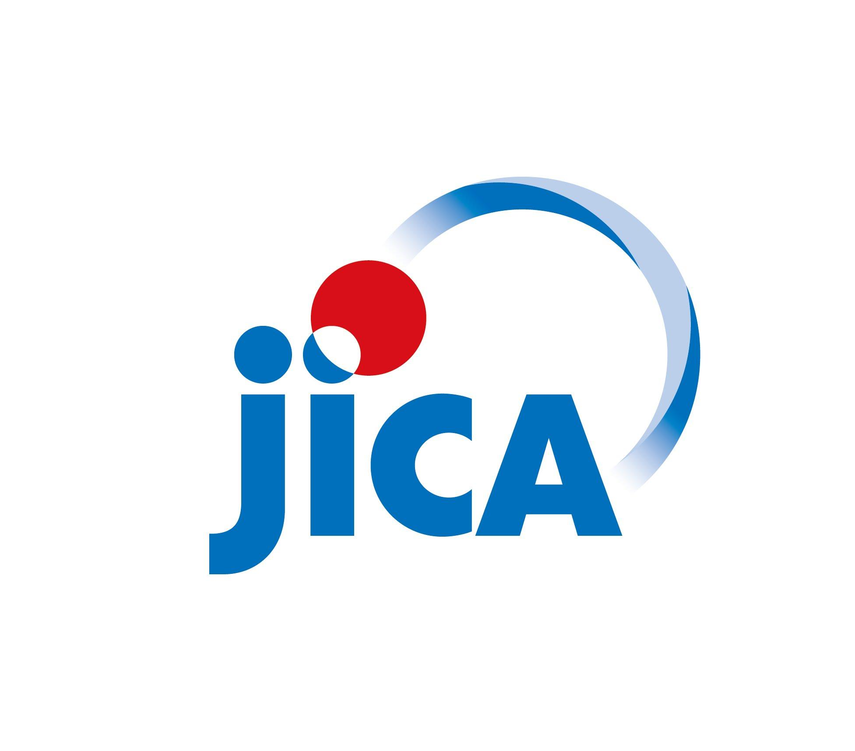

|  |
| --- |
| ***CORRESPONDENCE***  For enquiries and further information, please contact your nearest JICA office. |

If you have any inquiries, please contact Japan International Cooperation Center (hereafter referred to as the “JICE”) , the organization that JICA has partially outsourced for KCCP operation, via forms (<https://forms.office.com/r/Vb1cCEEREn><https://forms.office.com/r/vwFfMysBqk> QR code below). The officer of JICE ([africa@jice.org](mailto:africa@jice.org)) will contact you about your inquiries in order.

QR コード

AI によって生成されたコンテンツは間違っている可能性があります。

1. As part of JICA-DSP, this program is co-organized by GRIPS, IUJ and JICA for JICA Knowledge Co-Creation Program for Long Term Participants. The program offers participants with opportunities to gain a deep understanding of the Japanese development experience, and to draw lessons and gain insights that will support their development work at their home countries and internationally.
2. The results of JICA’s screening procedure and University’s general entrance examination will not accept any inquiry.
3. Submitted documents will not be returned.
4. a health certificate of JICA format will be required. Without the certificate, admission may become rejected.
5. The Government of Japan will examine applicants who belong to the military or other military-related organizations and/or who are enlisted in the military, taking into consideration of their duties, positions in the organization and other relevant information in a comprehensive manner to be consistent with the Development Cooperation Charter of Japan.

  