1. – activity_main.xml

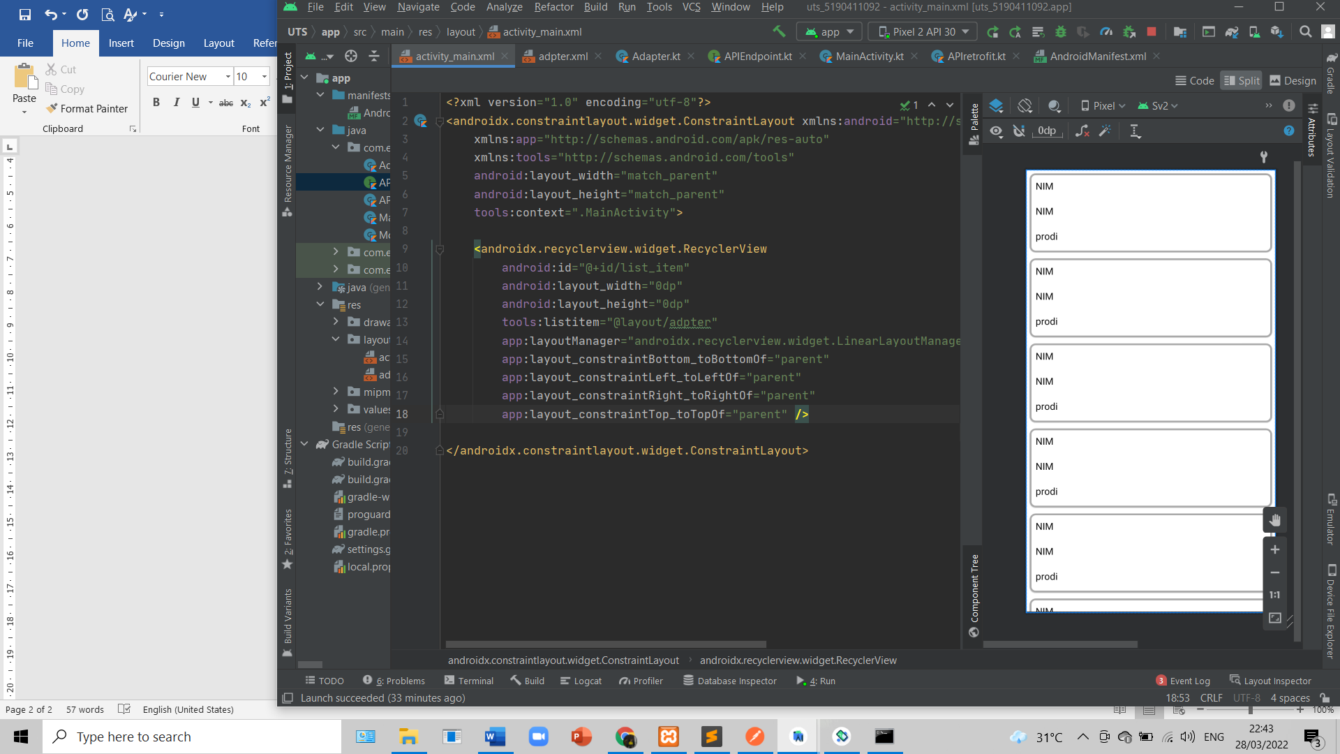

* Adapter.xml
* <com.google.android.material.card.MaterialCardView xmlns:android="http://schemas.android.com/apk/res/android"  
   android:layout_width="match_parent"  
   android:layout_height="wrap_content"  
   xmlns:app="http://schemas.android.com/apk/res-auto"  
   xmlns:tools="http://schemas.android.com/tools"  
   android:layout_margin="5dp"  
   app:cardCornerRadius="10dp"  
   app:strokeWidth="3dp"  
   app:strokeColor="@android:color/darker_gray"  
   >  
    
   <androidx.constraintlayout.widget.ConstraintLayout  
   android:layout_width="match_parent"  
   android:layout_height="131dp">  
    
   <TextView  
   android:id="@+id/nim"  
   android:layout_width="wrap_content"  
   android:layout_height="wrap_content"  
   android:padding="10dp"  
   android:text="NIM"  
   android:textColor="@color/black"  
   android:textSize="16dp"  
   app:layout_constraintStart_toStartOf="parent"  
   app:layout_constraintTop_toTopOf="parent"  
   />  
    
   <TextView  
   android:id="@+id/nama"  
   android:layout_width="wrap_content"  
   android:layout_height="wrap_content"  
   android:padding="10dp"  
   android:text="NIM"  
   android:textColor="@color/black"  
   android:textSize="16sp"  
   app:layout_constraintStart_toStartOf="parent"  
   app:layout_constraintTop_toBottomOf="@id/nim"  
   />  
    
   <TextView  
   android:id="@+id/prodi"  
   android:layout_width="wrap_content"  
   android:layout_height="wrap_content"  
   android:padding="10dp"  
   android:text="NIM"  
   android:textColor="@color/black"  
   android:textSize="16sp"  
   app:layout_constraintStart_toStartOf="parent"  
   app:layout_constraintTop_toBottomOf="@+id/nama"  
   tools:text="prodi" />  
   </androidx.constraintlayout.widget.ConstraintLayout>  
  </com.google.android.material.card.MaterialCardView>

