

Assessment Cover Page

Student Full Name | Ikramullah Mazhar
Student Number | 2024476
Module Title | Distributed Digital Transactions
Assessment Title | CA1: Trustless Hotel Booking on Ethereum
Assessment Due Date | November 13th, 2026
Date of Submission | November 13th, 2026
Declaration
By submitting this assessment, I confirm that I have read the CCT policy on academic misconduct and understand the implications of submitting work that is not my own or does not appropriately reference material taken from a third party or other source.
I declare it to be my own work and that all material from third parties has been appropriately referenced.
I further confirm that this work has not previously been submitted for assessment by myself or someone else in CCT College Dublin or any other higher education institution.

Video Representation:
https://drive.google.com/file/d/16HvP6oMVmA8JMPYFZPqbb1rUZXwgHMOQ/view?usp=sharing

AI Use Declaration
CA1 Trustless Hotel Booking on Ethereum, Distributed Digital Transactions (Dr. Muhammad Iqbal)
Ikramullah Mazhar (2024476)
GitHub: https://github.com/IkramullahMazhar/ddt-hotel-booking-dapp
AI Tool Used: Claude
Purpose of Use: Learning, understanding concepts, brainstorming ideas, clarifying assignment requirements and improving understanding of technical topics.

AI Fluency Framework
Competence | My response
Delegation | I used AI as a supporting tool during this assignment to improve my understanding of blockchain technology and the topics related to my project. I mainly used it for learning, understanding difficult concepts, getting explanations of blockchain and smart contracts, and improving my ideas. It helped me understand the assignment requirements. However, I completed my own practical work, research, coding and implementation.
Description | I used simple prompts to ask questions and understand different topics related to my assignment. I asked AI to explain concepts in simple English because I wanted to understand the topics step by step. Sometimes I asked follow-up questions when I needed further clarification.
Discernment | I used AI responses mainly to improve my understanding and learn about different concepts. The explanations were helpful, especially when learning about blockchain, smart contracts and cryptography. However, I did not automatically accept everything generated by AI. I checked the information and compared it with my course materials and other relevant sources. Where necessary, I made changes to my understanding and used my own words. I understand that AI can sometimes provide incorrect or incomplete information, so I take responsibility for checking the accuracy of the information before using it in my assignment.
Diligence | I used Claude (Anthropic) as a supporting tool and I used it I used AI responsibly as a learning tool during this assignment. I avoided entering personal information, private details or confidential information into the AI tool. I understand the importance of respecting copyright and academic integrity. I also made sure that AI was not replacing my own learning, practical implementation or understanding of the assignment. The final work, including my practical tasks and implementation, is my responsibility. I understand that any information taken from external sources must be properly referenced using the required Harvard referencing style

Appendix: Prompts and outputs

Prompt 1
"Explain blockchain technology in simple English. How does it work, what are its main features, and how is it different from traditional systems? Give some real-world examples."
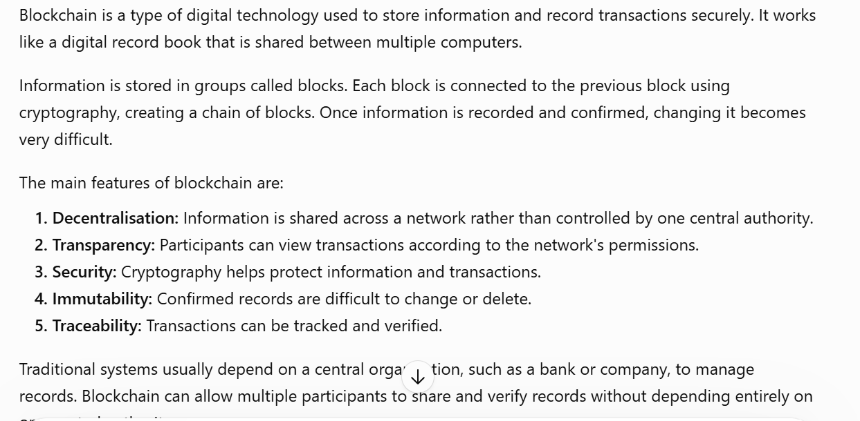
Prompt 2
Explain how blockchain technology can be used in food traceability, voting systems, insurance claims, or hotel booking. What are the main benefits and challenges of using blockchain in these areas? Give simple real-world examples to help me understand.
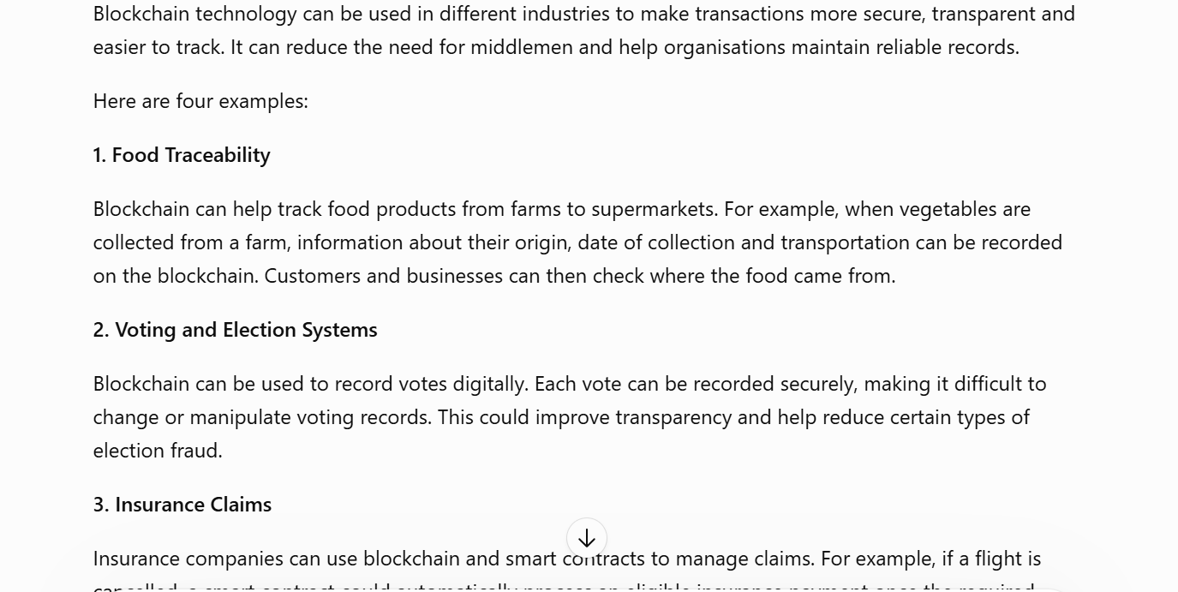
Prompt 3
Help me understand how to design a blockchain-based business solution for my selected scenario. Explain the main components required, how users will interact with the system, how transactions will be recorded, and how blockchain can improve the existing process. Give me a simple example and explain it step by step.
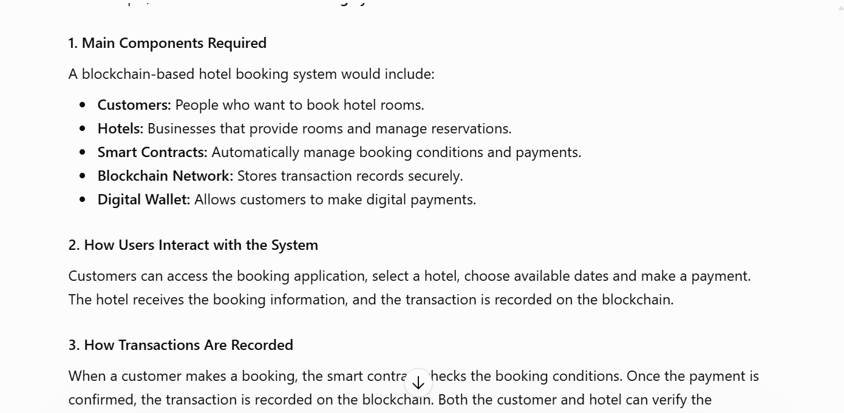

Prompt 4

Explain the role of cryptography in blockchain technology. What are hashing and digital signatures, and how do they help protect transactions and keep information secure? Explain in simple English with practical examples related to my assignment.
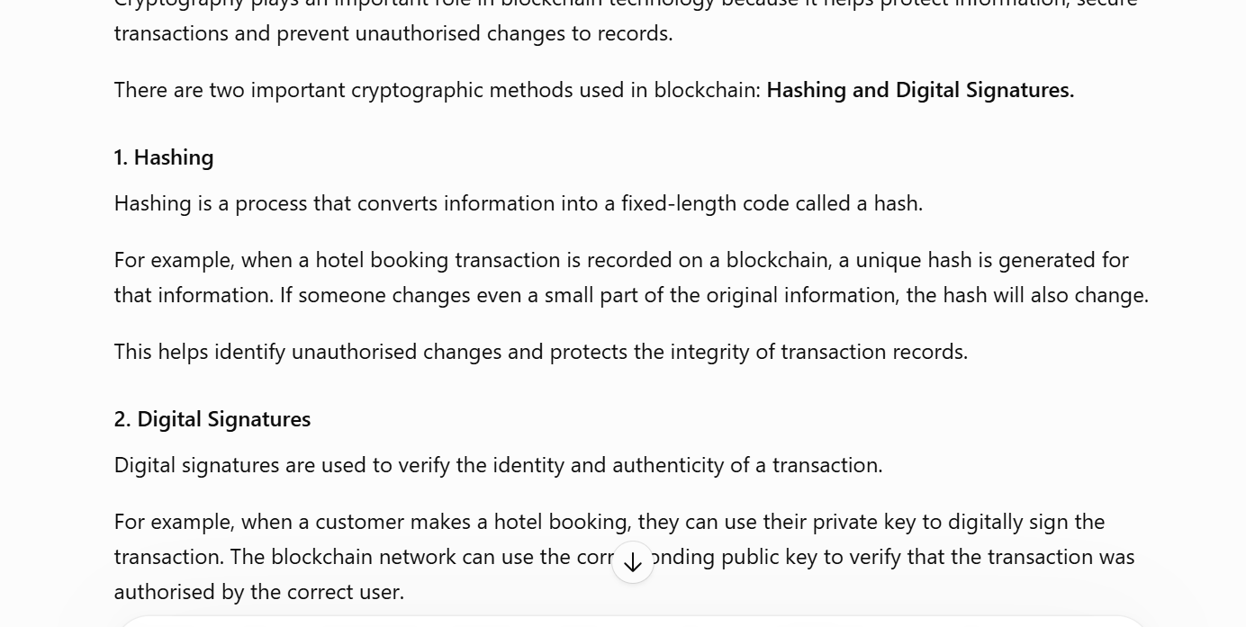

Prompt 5
Explain Solidity programming and smart contracts for a beginner. How can I create a simple smart contract involving a sender and receiver, and what is the purpose of each part of the code? Give me a step-by-step explanation with a simple example related to my hotel booking project.
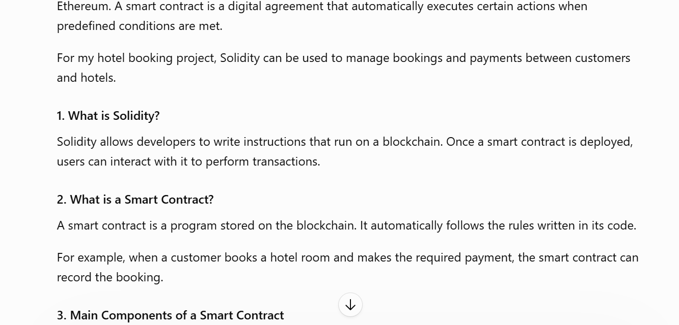

Prompt 6
To test a smart contract, developers can use tools such as Remix IDE and Ganache. These tools help create, deploy and test smart contracts before using them in a real blockchain application can you help me with the usage of there.
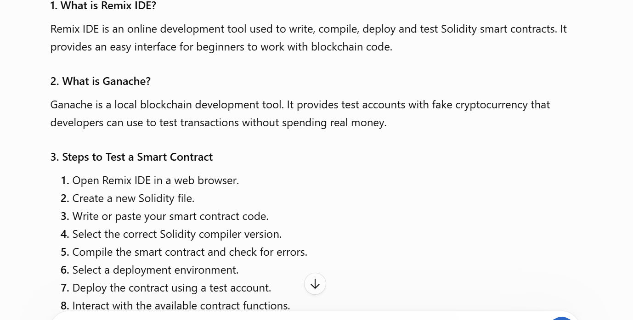
Prompt 7
Help me understand how to organise my blockchain assignment into a PowerPoint poster presentation. What important information should I include, such as the project introduction, proposed solution, blockchain architecture, smart contract implementation, cryptographic security, benefits and challenges? Also explain what screenshots, diagrams and technical evidence I should include to make my poster clear and professional.
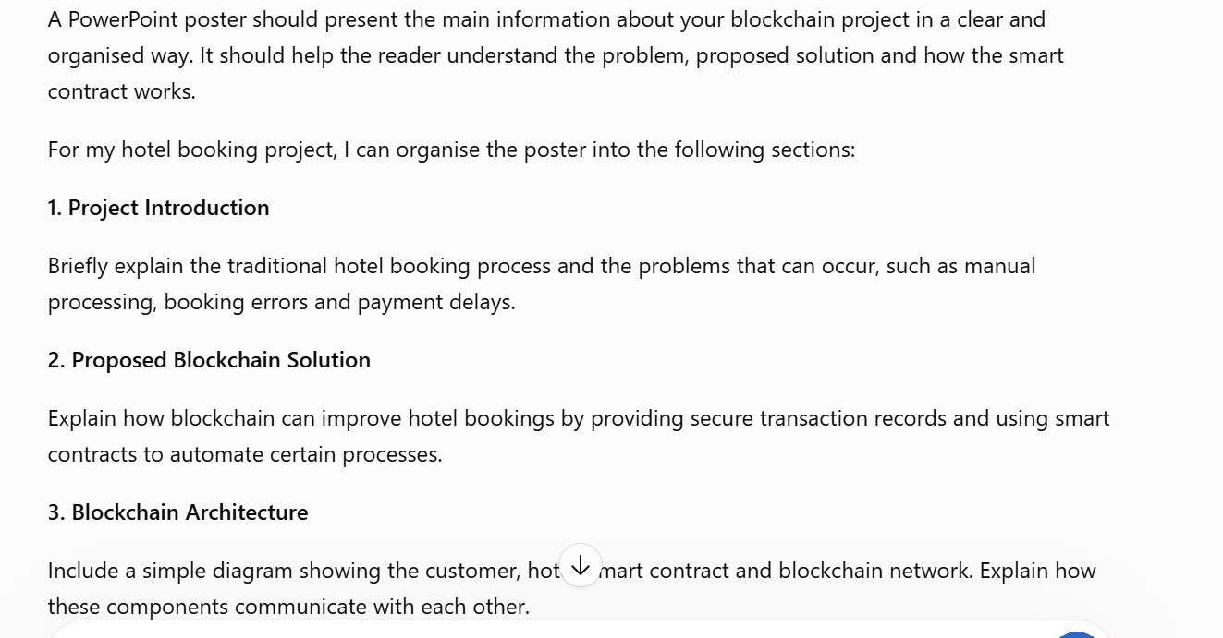

Prompt 9
"Explain the long-term benefits of using blockchain technology in hotel booking systems. How can blockchain improve customer trust, payment security and booking management? Also explain how technologies such as smart contracts could improve hotel booking systems in the future."


