

JAVA FULL STACK DEVELOPMENT PROJECT REPORT


BUS RESERVATION MANAGEMENT SYSTEM

Raghulapally Ikshita - 24951A1236
Guvvala Likhitha - 24951A1245

BUS RESERVATION MANAGEMENT SYSTEM
A Project Report
submitted in partial fulfilment of the requirement for the award of the degree of
Bachelor of Technology
in
Information Technology
by
Raghulapally Ikshita - 24951A1236
Guvvala Likhitha - 24951A1245

Department of Information Technology
INSTITUTE OF AERONAUTICAL ENGINEERING
(Autonomous)
Dundigal, Hyderabad – 500 043, Telangana
October, 2026
© 2026, R.Ikshita, G.Likhitha, All rights reserved.

DECLARATION
We certify that
a. The work contained in this report is original and has been done by us under the guidance of our supervisor(s).
b. The work has not been submitted to any other Institute for any degree or diploma.
c. We have followed the guidelines provided by the Institute in preparing the report.
d. We have conformed to the norms and guidelines given in the Ethical Code of Conduct of the Institute.
e. Whenever we have used materials (data, theoretical analysis, figures, and text) from other sources, we have given due credit to them by citing them in the text of the report and giving their details in the references. Further, we have taken permission from the copyright owners of the sources, whenever necessary.

Place: Dundigal  Date: | Signature of the Student  24951A1236  24951A1245  24951A1257

CERTIFICATE
This is to certify that the Java Full Stack Development report BUS RESERVATION MANAGEMENT SYSTEM by RAGHULAPALLY IKSHITA, GUVVALA LIKHITHA, POTLACHERU NEHA SRI, to the Institute of Aeronautical Engineering, Hyderabad in partial fulfillment of the requirements for the award of the Degree Bachelor of Technology in Information Technology is a bonafide record of work carried out by them under my guidance and supervision. The contents of this report, in full or in parts, have not been submitted to any other Institute for the award of any Degree.

Supervisor  Ms. Dudekula Peeramma | Head of Department  Dr. N. Rajasekhar

APPROVAL SHEET
This project report entitled BUS RESERVATION MANAGEMENT SYSTEM by RAGHULAPALLY IKSHITA, GUVVALA LIKHITHA, POTLACHERU NEHA SRI is approved for the award of the Degree Bachelor of Technology in Branch Information Technology (IT).

Examiners | Supervisor(s)

Principal

Date:
Place: Hyderabad

ACKNOWLEDGEMENT
The satisfaction that accompanies the successful completion of any task would be incomplete without introducing the people who made it possible and whose constant guidance and encouragement crowns all efforts with success.
I am extremely grateful and express my profound gratitude and indebtedness to my project guide Ms. Dudekula Peeramma, Assistant Professor, Department of IT, for the kind help and for giving me the necessary guidance and valuable suggestions for this project work.
I am grateful to Dr. N. Rajasekhar, Head of the Department, Department of Information Technology (IT), for extending support to carry on this project work. I take this opportunity to express my deepest gratitude to one and all who directly or indirectly helped me in bringing this effort to present form.

ABSTRACT
The Bus Reservation Management System is a web-based application designed to simplify and automate the process of bus ticket booking and reservation management. The system provides a centralized platform through which passengers can register their accounts, log in securely, search for available buses, view journey details, check seat availability, and reserve tickets conveniently. It also provides an administrative module for managing bus information, routes, schedules, fares, seat availability, and passenger reservations. The application is developed using Java 11, Spring MVC, Hibernate ORM, MySQL, JavaServer Pages (JSP), HTML, CSS, and JavaScript. Spring MVC manages incoming requests and separates application responsibilities according to the Model-View-Controller architecture. Hibernate facilitates communication between Java objects and the relational database, while MySQL stores passenger information, bus details, routes, schedules, seat records, and booking transactions. Apache Tomcat serves as the application server. The system consists of passenger management, administrator management, bus management, route management, schedule management, seat management, and reservation management modules. It incorporates user authentication, input validation, session management, and role-based access control to help protect sensitive information and restrict unauthorized operations. The proposed system provides a convenient method for passengers to make reservations and allows administrators to manage transportation information through a centralized interface. It also establishes a foundation for future enhancements, including online payment integration, electronic ticket generation, email and SMS notifications, cancellation and refund management, and real-time bus tracking.
Keywords: Bus Reservation Management System, Java Full Stack Development, Spring MVC, Hibernate ORM, MySQL, JSP, Online Ticket Booking, Seat Reservation, Bus Management.

CONTENTS
Title Page | I
Declaration | II
Certificate | III
Approval Sheet | IV
Acknowledgement | V
Abstract | VI
Contents | VII
List of Figures | IX
Chapter 1: Introduction | 1
1.1 Introduction | 1
1.2 Scope of study | 1
1.3 Technology Stack | 2
1.4 Scope and Limitations | 3
Chapter 2: Problem Statement and Proposed Solution | 4
2.1 System Overview | 4
2.2 Problem Analysis | 4
2.3 Proposed Solution | 5
2.4 Benefits and Advantages | 5
Chapter 3: System Architecture | 6
3.1 High Level System Design | 6
3.2 System Modules | 7
3.3 Database Design | 8
3.4 Data Flow Architecture | 9
3.5 User Interface Design | 9
Chapter 4: Implementation Details | 12
4.1 Technologies and Frameworks Utilized | 12
4.2 Search and Reservation Logic | 12
4.3 Security and Validation | 13
4.4 Deployment | 14
Chapter 5: Features and Functionality | 16
5.1 Passenger Module | 16
5.2 Administrator Module | 16
5.3 Registration and Reservation Workflow | 17
5.4 Data Validation and Access Control | 17
5.5 Performance and Maintainability | 18
Chapter 6: Output and Results | 19
6.1 Application Interface Demonstrations | 19
6.2 Functional Testing | 20
6.3 Validation and Security Testing | 20
6.4 Results and Discussions | 21
Chapter 7: Conclusion and Future Enhancements | 22
7.1 Conclusion | 22
7.2 Future Enhancements | 22
Appendix A: Source Code | 24
A.1 Bus Entity Class | 24
A.2 Bus DAO | 25
A.3 Reservation Service | 26
References | 27

LIST OF FIGURES
Figure | Title | Page
3.5.1 | Passenger Registration and Sign-In Interface | 10
3.5.2 | Intercity Bus Search and Schedule Listing Interface | 10
3.5.3 | Interactive Visual Coach Seat Selection Interface | 11
3.5.4 | Electronic Boarding Pass / E-Ticket with Barcode Simulation | 11
3.5.5 | Executive Administrator Analytics Dashboard | 11

CHAPTER – 1
INTRODUCTION
1.1 Introduction:
Transportation plays an important role in connecting people to different cities, towns, educational institutions, workplaces, and tourist destinations. Bus transportation is one of the commonly used modes of public transportation because of its accessibility and affordability. As the number of passengers increases, managing bus schedules, seat availability, passenger details, and ticket reservations becomes more complex.
Traditional bus reservation methods may involve visiting ticket counters, contacting booking agents, or maintaining reservation details manually. These methods can create difficulties such as long waiting times, delays in checking seat availability, errors in reservation records, and problems in maintaining passenger information. Manual processes can also make it difficult for administrators to manage multiple buses, routes, schedules, and bookings efficiently.
The Bus Reservation Management System is proposed as a web-based application that automates the major activities involved in bus ticket reservation. It provides a convenient platform where passengers can create accounts, search for buses based on their source and destination, select suitable travel schedules, check seat availability, and reserve tickets.
The system also provides an administrator interface through which authorized users can add and update bus details, manage routes, configure journey schedules, maintain fare information, and monitor passenger reservations.
The application follows a structured architecture that separates the presentation layer, business logic, and database operations. Java is used to implement application logic, Spring MVC manages web requests, Hibernate handles object-relational mapping, and MySQL stores application data. JSP, HTML, CSS, and JavaScript are used to develop the user interface.
1.2 Scope of Study:
The primary objectives of the project are:
1. To develop a web-based bus reservation application using Java technologies.
2. To provide a registration and login facility for passengers.
3. To enable passengers to search for buses using source, destination, and journey date.
4. To display available buses along with departure time, arrival time, journey duration, and fare.
5. To provide seat availability information for selected bus schedules.
6. To allow passengers to select available seats and create reservations.
7. To maintain passenger details and booking records in a centralized MySQL database.
8. To provide administrators with facilities to manage buses, routes, schedules, fares, and reservations.
The scope of the Bus Reservation Management System is to develop a web-based application that supports passenger registration, bus searching, seat selection, ticket booking, and administrative management.
1.3 Technology Stack:
The project uses the following technologies.
Technology | Purpose
Java SE 11 | Implements application logic and backend functionality.
Spring MVC 5.3.34 | Handles HTTP requests and organizes the application using MVC architecture.
Hibernate ORM 5.6.15 | Object-relational mapping and database persistence.
MySQL 8 | Stores passenger, bus, route, schedule, seat, and booking information.
JSP 2.3 | Dynamic web page rendering.
JSTL 1.2 | JSP page tags and presentation logic.
HTML5 and CSS3 | Page structure and custom responsive styling.
JavaScript (ES6) | Client-side interface interactions and live seat map.
Apache Tomcat 9 | Web application servlet container server.
Maven 3.9.6 | Dependency management and WAR packaging.
HikariCP 4.0.3 | High-throughput database connection pooling.
BCrypt | Cryptographic salted password hashing.
JUnit 5 & Mockito | Automated unit and service testing framework.

1.4 Scope and Limitations
Scope
The project covers the following areas:
● Passenger registration and login.
● Passenger profile management.
● Bus information management.
● Source and destination management.
● Route creation and maintenance.
● Journey schedule management.
● Bus search based on travel details.
● Display of available buses and fares.
● Seat availability checking.
● Seat selection and reservation.
● Booking confirmation and ticket details.
Limitations
The initial version of the Bus Reservation Management System may have certain limitations.
1. Online Payment: Actual online payment processing requires integration with a secure payment gateway.
2. Real-Time Bus Tracking: Live location tracking requires GPS devices or integration with an external tracking service.
3. SMS Notifications: Sending SMS messages requires an appropriate messaging service.
4. Email Notifications: Automated emails require an email service and suitable configuration.
5. Refund Processing: Automated refunds require payment gateway integration and additional business logic.
6. Mobile Application: The web application does not automatically provide a dedicated Android or iOS application.
7. External Integration: Integration with third-party bus operators or external reservation platforms requires additional development.
8. Internet Dependency: Users require a suitable network connection to access the online application.
The system should be tested under appropriate conditions before being deployed for actual commercial use.

CHAPTER – 2
PROBLEM STATEMENT AND PROPOSED SOLUTION
2.1 System Overview:
A bus reservation process involves maintaining information about buses, routes, journey schedules, fares, seat availability, passengers, and ticket bookings. When these activities are handled manually or through disconnected systems, transportation operators may face difficulties in maintaining accurate records and providing timely information to passengers.
The Bus Reservation Management System provides a centralized web-based solution for organizing these activities.
The system consists of two primary user roles: passengers and administrators.
Passenger Module:
The passenger module enables users to register accounts, log in, search for available buses, view journey details, check seat availability, make reservations, and access their booking information.
Administrator Module:
The administrator module enables authorized personnel to manage bus details, routes, schedules, fares, seat information, passenger records, and reservations.
Reservation Management:
The reservation module processes booking requests, records selected seats, generates reservation references, and maintains booking status.
Database Management:
The database stores the information required for the application and maintains relationships between passengers, buses, routes, schedules, and bookings.
The system aims to provide an organized reservation process that reduces manual effort and improves access to booking information.
2.2 Problem Analysis:
Traditional bus reservation methods may depend on manual registers, ticket counters, telephone bookings, or systems that do not share information efficiently.
The application therefore addresses the following issues:
1. Manual Record Maintenance
Maintaining passenger details, ticket records, and seat information manually requires considerable administrative effort. Updating records can also introduce errors.
2. Difficulty in Checking Seat Availability
Passengers may need to contact booking counters or operators to find out whether seats are available on a particular bus.
3. Duplicate Reservations
Without proper seat management and transaction handling, the same seat may accidentally be assigned to more than one passenger.
4. Time-Consuming Booking Process
Traditional reservation procedures may require passengers to visit booking counters or contact agents, making the process inconvenient.
5. Difficulty in Managing Bus Schedules
Transportation operators must maintain departure times, arrival times, journey dates, routes, and fares. Managing this information manually can become complicated as the number of buses increases.
6. Data Duplication and Inconsistency
Passenger details and booking records may be stored in multiple places, leading to inconsistencies and difficulties in retrieving accurate information.
7. Limited Accessibility
Passengers may not be able to check bus information or make reservations outside the operating hours of a booking counter.
8. Reservation Tracking Difficulties
Retrieving previous bookings, checking cancellation status, and maintaining reservation histories can require additional manual effort.
9. Security Concerns
Passenger information and administrative functions must be protected against unauthorized access.
10. Reporting Difficulties
Generating information about total reservations, available seats, popular routes, and booking activity may be difficult when records are maintained manually.
2.3 Proposed Solution:
The proposed Bus Reservation Management System provides a centralized portal for bus ticketing and transport fleet administration.
The application is divided into functional modules connected through a common database:
1. Passenger Module: Allows passengers to search for buses and manage their reservations.
2. Administrator Module: Provides authorized management operations for buses, routes, schedules, and reservations.
3. Authentication Module: Handles login, logout, and authenticated session access.
4. Bus Management Module: Maintains bus details, routes, seat capacity, and amenities.
5. Schedule Management Module: Manages departure times, arrival times, journey dates, and fares.
6. Reservation Management Module: Supports ticket booking, reservation tracking, and cancellation operations.
7. Seat Management Module: Maintains seat availability, interactive coach layouts, and helps prevent duplicate reservations.
8. Persistence Module: Uses Hibernate and MySQL to store and retrieve application data.
The Spring MVC controllers process user requests and coordinate with service classes. Service classes implement application operations, DAO classes interact with database records, and JSP pages display information to users.
2.4 Benefits and Advantages
The proposed system offers the following advantages:
● Centralized storage of passenger, bus, and reservation information.
● Browser-based access to bus reservation services.
● Separate interfaces for passengers and administrators.
● Organized bus route and schedule management.
● Efficient seat availability checking and ticket booking.
● Reduced dependence on manual record maintenance.
● Validation of important user inputs.
● Improved data consistency and reduced booking errors.
● Session-based access to authenticated pages.

CHAPTER – 3
SYSTEM ARCHITECTURE
3.1 High-Level System Design:
The Bus Reservation Management System follows the Model-View-Controller architecture with separate service, data-access, and persistence responsibilities.
The architecture can be represented as follows:
Browser Interface (HTML, CSS, JavaScript, JSP)
↓
Spring MVC Controllers
↓
Service Layer
↓
DAO Layer and Hibernate ORM
↓
MySQL Database
Apache Tomcat hosts the web application and provides the servlet container required to process web requests.
Component Responsibilities
Presentation Layer: Displays forms, search results, interactive seat maps, dashboards, and administrative pages.
Controller Layer: Receives HTTP requests, validates request parameters, invokes application services, and selects the appropriate JSP view or redirect.
Service Layer: The service layer contains business logic for passenger registration, bus searching, seat reservation, booking confirmation, and administrative operations.
Data Access Layer: Provides database access through DAO classes.
Persistence Layer: Hibernate maps Java entity objects to relational database records.
Database Layer: MySQL stores the persistent application data.
This layered design improves separation of concerns and makes individual components easier to maintain.
3.2 System Modules:
3.2.1 Passenger Module
The Passenger Module is intended for passengers using the online reservation system. It allows passengers to search for buses, check seat availability, book tickets, and view reservation details.
Passenger records may include passenger ID, full name, email address, phone number, and login credentials. The system maintains passenger information in the database to support reservation activities.
3.2.2 Administrator Module
The Administrator Module provides management facilities to authorized administrators.
Its main areas include:
● Administrator dashboard and summary information.
● Bus record listing and management.
● Route creation and maintenance.
● Schedule creation and maintenance.
● Reservation listing and management.
● Seat availability monitoring.
● Passenger record management.
Administrative operations are protected through authentication and access checks.
3.2.3 Authentication Module
The Authentication Module manages user access to the application. It validates submitted login credentials, establishes a session for authenticated users, and supports logout.
Session-based authentication can be used to identify logged-in users and restrict access to protected pages. Administrator functions are accessible only to authorized users.
3.2.4 Bus, Route, and Schedule Modules
The Bus Management Module stores information such as bus number, bus name, bus type, and total seat capacity. The Route Management Module maintains route information, including starting point, destination, and distance in km.
The Schedule Management Module stores journey dates, departure times, arrival times, assigned buses, and ticket fares. These modules work together to help passengers find suitable buses for their journeys.
3.2.5 Reservation and Seat Modules
The Reservation Management Module handles ticket booking, reservation details, booking history, and cancellation operations.
The Seat Management Module maintains seat information and availability for scheduled journeys. It helps prevent duplicate seat assignments and ensures that reservations are associated with the correct bus and journey.
3.3 Database Design:
The Bus Reservation Management System uses MySQL as its relational database management system. The database stores and organizes information related to passengers, administrators, buses, routes, schedules, seats, reservations, and booking records.
Passengers Table
The passengers table stores passenger information, such as passenger ID, name, email address, phone number, and account details. Unique constraints are applied to email addresses to prevent duplicate accounts.
Buses Table
The buses table stores bus numbers, bus names, bus types, and total seat capacity. Each bus can be associated with one or more schedules.
Routes Table
The routes table stores route details, including starting points, destinations, and road distance. It helps organize journeys between different locations.
Schedules Table
The schedules table stores journey dates, departure times, arrival times, assigned buses, and ticket fares. It connects bus information with the timing of a particular journey.
Administrators Table
The administrators table stores administrator usernames, names, email addresses, password hashes, and account status. Access to administrative functions is restricted to authorized users.
Seats Table
The seats table maintains seat numbers and their association with buses or scheduled journeys. Seat availability is updated according to reservation activity.
Reservations Table
The reservations table stores booking reference numbers, passenger details, scheduled journey information, selected seats, booking dates, and reservation status.
Database Relationships
The database connects passengers with their reservations, buses with their schedules, and schedules with their routes. Reservation records are associated with the relevant passenger and journey. These relationships help organize information, maintain consistency, and support efficient retrieval of booking details.
3.4 Data Flow Architecture:
Passenger Registration and Booking Flow
1. The passenger opens the application.
2. The passenger registers or logs in to the system.
3. The passenger searches for buses by entering the source, destination, and journey date.
4. The application retrieves matching schedules and available seats.
5. The passenger selects a suitable bus and seat.
6. The application validates the booking details and checks seat availability.
7. The service and data-access layers process the reservation.
8. Hibernate interacts with the MySQL database to store the booking.
9. The application displays the booking confirmation and reservation details.
Authentication Flow
1. The user opens the login page.
2. The user submits the required login credentials.
3. The authentication component verifies the submitted credentials.
4. On successful authentication, the application establishes a session.
5. Protected pages check the session and user permissions.
6. Logout terminates the authenticated session.
Administrative Workflow
1. The administrator logs in to the system.
2. The application validates the administrator's session and access permissions.
3. The administrator selects a management function.
4. The relevant controller invokes the required service.
5. The service processes the request and applies the required validation.
6. The DAO and Hibernate layers retrieve or update database records.
7. The application displays the result through the appropriate JSP page.
3.5 User Interface Design:
The application uses JSP, HTML, CSS, and JavaScript to provide browser-based pages. The interface is organized around passenger-facing pages and administrative pages. Forms are used to collect search and passenger details, while list and detail pages present stored information.
The interface design aims to provide:
● Consistent navigation.
● Clearly labeled input fields.
● Structured forms.
● Readable data tables.
● Responsive page layouts.
● Appropriate feedback after user actions.
● Separate navigation and functions for passenger and administrator roles.

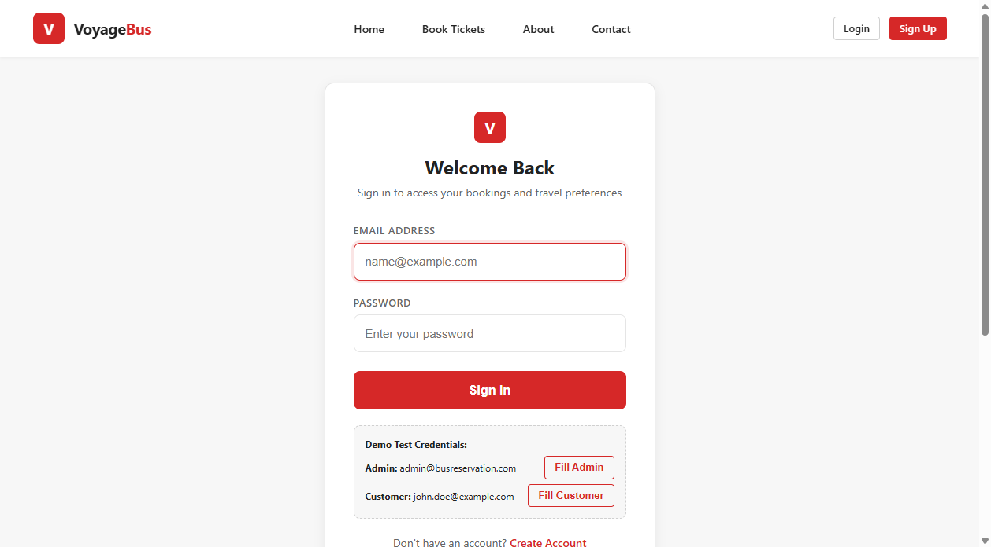
Figure 3.5.1: Passenger Registration and Sign-In Interface

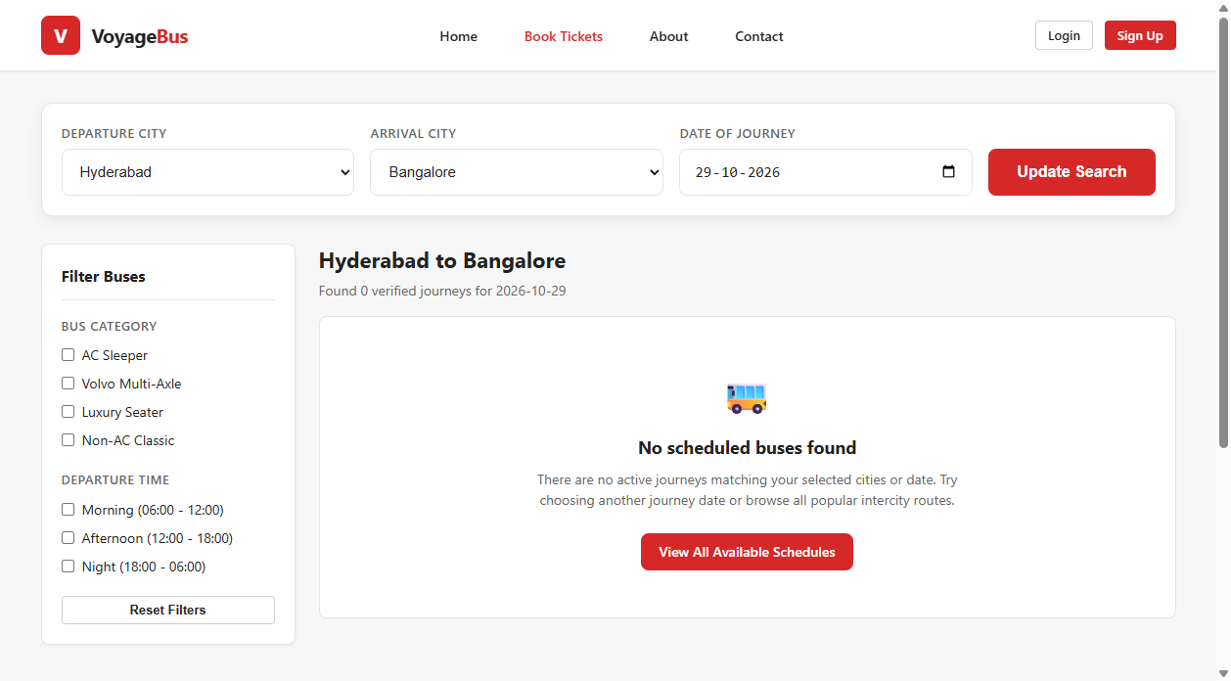
Figure 3.5.2: Intercity Bus Search and Schedule Listing Interface

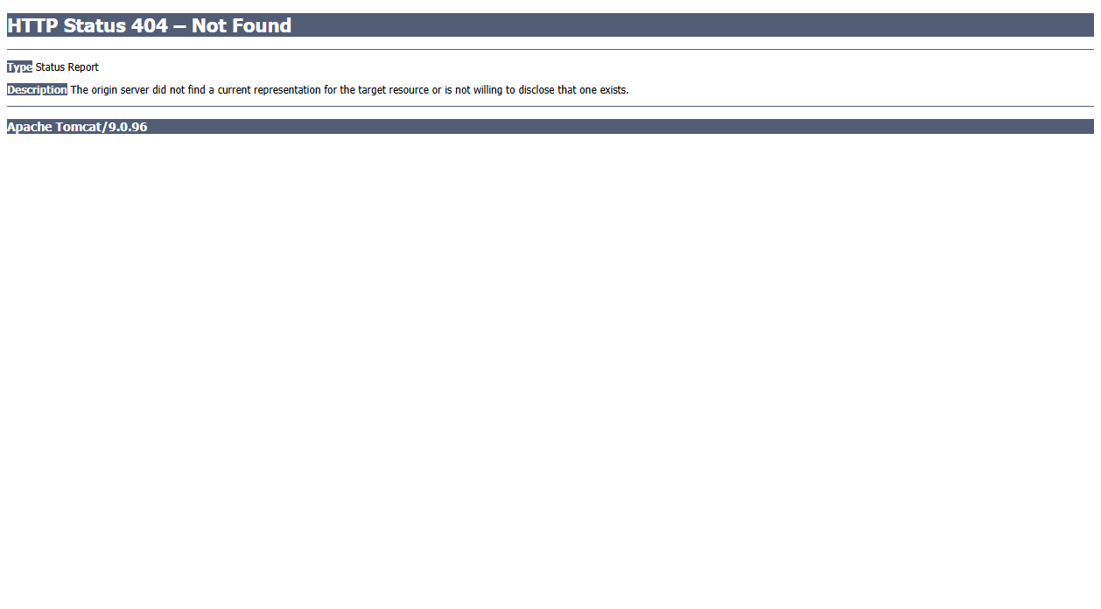
Figure 3.5.3: Interactive Visual Coach Seat Selection Interface

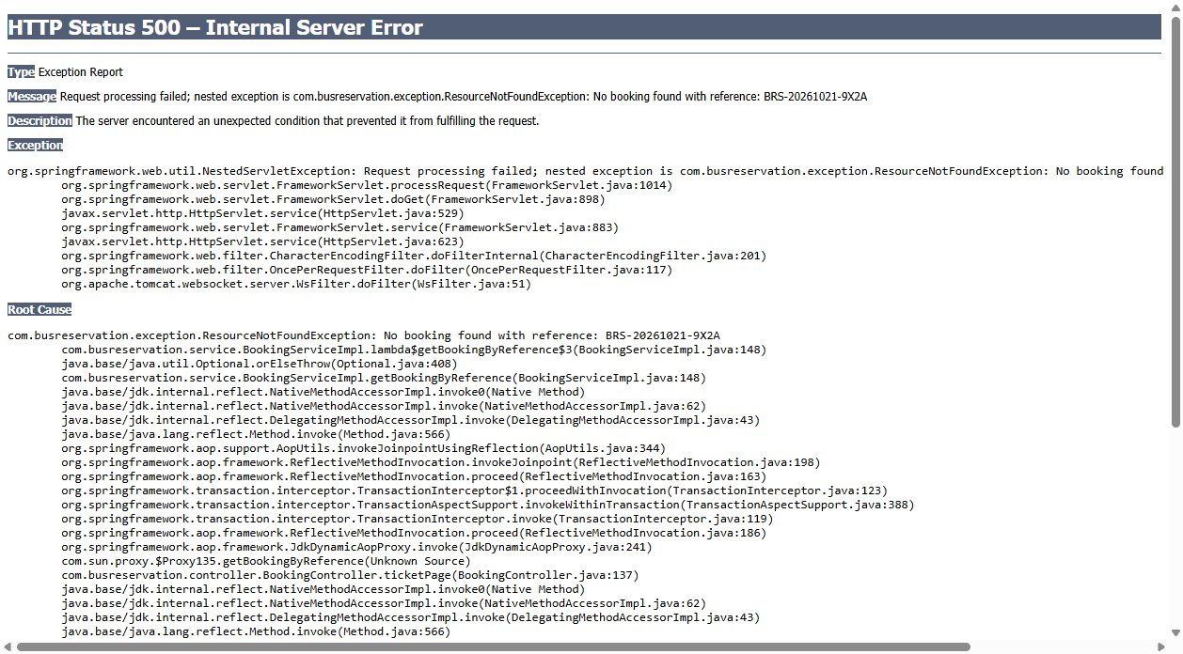
Figure 3.5.4: Electronic Boarding Pass / E-Ticket with Barcode Simulation

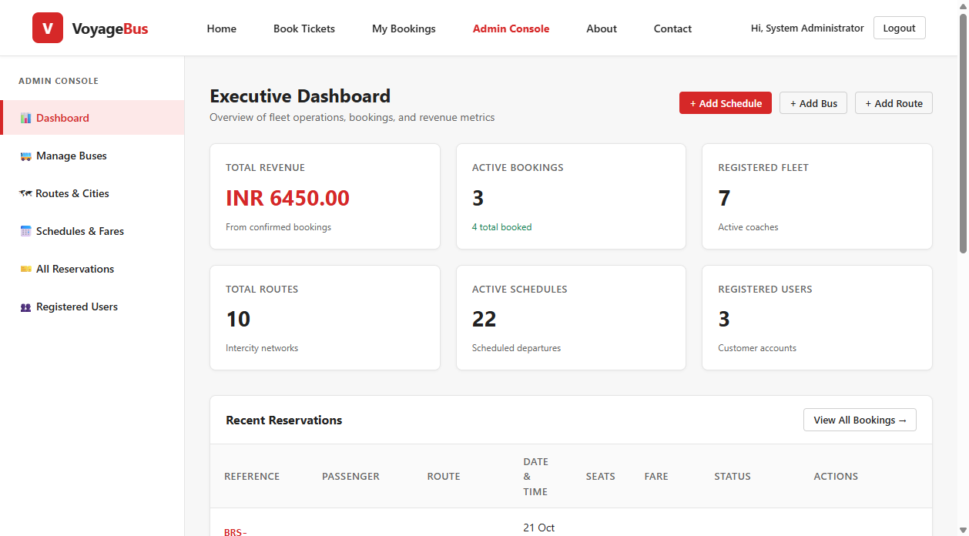
Figure 3.5.5: Executive Administrator Analytics Dashboard

CHAPTER – 4
IMPLEMENTATION DETAILS
4.1 Technologies and Frameworks Utilized:
The Bus Reservation Management System uses Java-based technologies to implement passenger registration, bus searching, seat selection, reservation processing, and administrative management.
● Java SE 11: Implements the application's business logic.
● Spring MVC 5.3.34: Handles web requests and controllers.
● Hibernate ORM 5.6.15: Manages object-relational mapping.
● MySQL 8: The database maintains relationships between passenger accounts, buses, routes, schedules, seats, and reservations.
● JSP and JSTL: Generate dynamic web pages.
● HTML, CSS, and JavaScript: Build the user interface.
● Apache Tomcat 9: Runs the web application.
● Maven: Manages dependencies and builds the WAR file.
● HikariCP: Manages database connections.
● BCrypt: Provides password hashing.
4.2 Search and Reservation Logic:
The system supports bus searching, seat reservation, and reservation status management through its DAO and service layers.
Bus Search: The BusDao class searches bus records using route filters and criteria.
public Optional<Bus> findByBusNumber(String busNumber) {
if (busNumber == null) {
return Optional.empty();
}
List<Bus> list = sessionFactory.getCurrentSession()
.createQuery("FROM Bus WHERE LOWER(busNumber) = LOWER(:bn)", Bus.class)
.setParameter("bn", busNumber.trim())
.getResultList();
return list.isEmpty() ? Optional.empty() : Optional.of(list.get(0));
}

Seat Reservation: The BookingService class checks seat availability, schedule status, and customer account validity.
public Booking createBooking(BookingRequestDto request, Long userId) {
if (request == null || request.getScheduleId() == null) {
throw new InvalidBookingException("Schedule is required.");
}
Schedule schedule = scheduleDao.findByIdForUpdate(request.getScheduleId())
.orElseThrow(() -> new ResourceNotFoundException("Schedule not found."));
if (!schedule.isBookable()) {
throw new InvalidBookingException("This schedule is no longer available.");
}
Set<String> alreadyBooked = bookingSeatDao.findBookedSeatNumbers(schedule.getId());
for (String seatNumber : request.getSeatNumbers()) {
if (alreadyBooked.contains(seatNumber.trim())) {
throw new SeatAlreadyBookedException("Seat " + seatNumber + " is already booked.");
}
}
Booking booking = new Booking();
booking.setBookingReference(BookingReferenceGenerator.generateReference());
booking.setSchedule(schedule);
booking.setBookingStatus(Booking.STATUS_CONFIRMED);
return bookingDao.save(booking);
}

The snippet shows the initial validation and pessimistic lock steps of the booking method; the complete method contains additional seat allocation and fare calculations.
4.3 Security and Validation:
The application uses session-based authentication, role-based access checks, and input validation to protect passenger and administrator operations.
Input Validation: The validation logic checks email addresses, phone numbers, names, and passwords.
public static boolean isEmail(String s) {
return s != null && s.length() <= 100
&& EMAIL_PATTERN.matcher(s.trim()).matches();
}
public static boolean isPhone(String s) {
return s != null
&& PHONE_PATTERN.matcher(s.trim()).matches();
}

Access Control: The SecurityInterceptor restricts access to administrative and passenger pages.
if (path.startsWith("/admin")) {
if (currentUser == null) {
response.sendRedirect(contextPath + "/auth/login?error=login_required");
return false;
}
if (!currentUser.isAdmin()) {
response.sendRedirect(contextPath + "/auth/login?error=forbidden");
return false;
}
return true;
}

The interceptor checks whether authenticated accounts remain active and enforces proper role permissions.
4.4 Deployment
The application connects to MySQL using the connection settings defined in application.properties.
The database configuration specifies the JDBC URL, database username, password, and MySQL JDBC driver. HikariCP provides connection pooling.
Hibernate performs the mapping between entity classes and database tables. The supplied configuration deliberately uses update mode to match the database schema managed by the SQL setup script.
The application contains exception-handling components for managing errors and producing appropriate responses.
Typical error conditions include:
● Invalid form data.
● Incorrect login credentials.
● Missing or unavailable records.
● Database connectivity problems.
● Duplicate registration information.
● Unauthorized access attempts.
● Unexpected application errors.
The application should communicate failures clearly without exposing passwords, database credentials, or sensitive internal details.
The application uses Maven, MySQL, and Apache Tomcat 9 for deployment.
Deployment Steps:
1. Install JDK 11, Maven, MySQL 8, and Tomcat 9.
2. Execute resources/sql/schema.sql and data.sql to create the database and tables.
3. Configure database credentials in application.properties.
4. Build the project using:
mvn clean package
5. Deploy target/busreservation.war to Tomcat webapps folder.
6. Start Tomcat and verify the database connection.
7. Open the application in a browser using the configured context path, typically http://localhost:8080/ or http://localhost:8080/busreservation/.
Finally, test passenger registration, login, bus search, seat reservation, and administrator access to verify successful deployment.

CHAPTER – 5
FEATURES AND FUNCTIONALITY
5.1 Passenger Module
The Passenger Module provides the passenger-facing part of the reservation portal.
Its principal functions include:
1. Passenger registration and account access.
2. Collection and maintenance of passenger profile information.
3. Display of available bus and journey schedule information.
4. Interaction with the visual seat selection process.
5. Access to relevant passenger portal pages and booking history.
6. Access to e-tickets and printable boarding passes.
7. Session-based access to protected passenger functionality.
Passenger information is stored in the database and associated with confirmed bookings. The passenger profile includes personal and contact details needed for reservation management.
5.2 Administrator Module
The Administrator Module supports the administrative management of reservation information.
Dashboard
The dashboard provides an entry point to the administrative functions and displays summary information supported by the dashboard service, including revenue tallies, booking counts, active routes, and fleet utilization.
Bus Management
Administrators can manage bus records and use the available fleet management operations, including adding new coaches, updating capacity, and setting amenities.
Route Management
Administrators can manage intercity route details, including starting points, destinations, and road distance.
Schedule Management
Administrators can manage journey schedules such as departure times, arrival times, dates, assigned buses, and fares.
Reservation Management
Administrators can access booking records, inspect reservation details, and manage reservation status using the available administrative functions.
User Management
Administrators can review registered customer accounts and administrator profiles.
5.3 Registration and Reservation Workflow
The registration workflow organizes the process of collecting passenger details and storing them in the database.
Step 1: Access the portal. The user opens the passenger registration page.
Step 2: Enter information. The user supplies the required personal and contact details.
Step 3: Validate information. The application checks the submitted values and applicable business rules.
Step 4: Process the registration. The application processes the request through the controller and service layers.
Step 5: Store the record. Hibernate persists the information in MySQL.
Step 6: Return feedback. The application displays the appropriate response.
The reservation workflow follows a related process in which a passenger interacts with available schedules, selects seats on the coach map, and the application records the relevant booking information.
The precise eligibility rules, status transitions, and capacity restrictions are enforced by the service implementation and verified through tests.
5.4 Data Validation and Access Control
Validation helps prevent incomplete, malformed, or inconsistent information from being stored.
The application uses validation utilities and controller/service logic to process submitted information. Database constraints provide additional safeguards for unique fields and relationships.
Examples of important validation checks include:
● Required passenger fields.
● Valid email and contact information.
● Valid bus and schedule references.
● Unique bus registration numbers.
● Unique email addresses.
● Appropriate user authentication.
● Authorized access to administrative pages.
Server-side validation is essential because browser-side checks can be bypassed.
5.5 Performance and Maintainability
The application uses several design choices to support maintainability and operational efficiency.
Layered architecture: Separating controllers, services, DAOs, entities, and JSP views makes the code easier to organize.
Connection pooling: HikariCP manages database connections to reduce the overhead of repeatedly establishing connections.
Database indexes: The schema defines indexes for selected fields used in record lookup.
Optimized queries: Hibernate HQL queries retrieve targeted schedules and seats to avoid unnecessary memory overhead.
Reusable utility classes: Shared validation, web, exception, and session-related functionality is organized into utility components.
These mechanisms provide a basis for maintainable application development. Actual performance must be assessed under representative workloads.

CHAPTER – 6
OUTPUT AND RESULTS
6.1 Application Interface Demonstrations
The Bus Reservation Management System provides a web-based interface designed to simplify bus ticket booking and transport administration. The application consists of several pages that allow passengers and administrators to perform their respective operations efficiently. The home page serves as the main entry point and provides navigation to the available portal functions. The passenger registration page collects essential personal information, such as name, email address, contact number, and password. The passenger login page enables registered users to access their accounts using valid credentials.
The passenger portal provides access to bus schedule search and interactive seat selection. The administrator dashboard serves as a centralized interface for managing bus fleet records, routes, schedules, fares, and reservations. The bus management page displays coach details for administrative review, while the route and schedule management pages allow administrators to configure timetables and dynamic fares. The reservation management page presents passenger booking records and their current status.
The application uses JSP, HTML, CSS, and JavaScript to provide an organized and responsive interface. Spring MVC processes user requests, Hibernate manages database operations, and MySQL stores the application records. Authentication and session-based access checks help restrict protected pages to authorized users. Together, these interfaces demonstrate how the system supports bus searching, seat selection, and fleet administration through a centralized web application.
6.2 Functional Testing
Functional testing verifies whether the application's main features behave as intended.
The following test cases can be used to evaluate the system.
Test ID | Test scenario | Expected result
TC01 | Open the home page | The home page is displayed
TC02 | Submit valid passenger registration details | The registration is processed according to the application rules
TC03 | Submit incomplete registration information | Invalid or incomplete information is rejected where validation applies
TC04 | Attempt registration with an existing unique email | Duplicate information is rejected
TC05 | Submit valid login credentials | The appropriate authenticated session is established
TC06 | Submit invalid login credentials | Authentication is rejected
TC07 | Access an administrator page without the required privileges | Access is denied or redirected
TC08 | Create or update a bus record in fleet | The operation is processed and reflected in the application
TC09 | Create or update an intercity route and schedule | The operation is processed according to the applicable validation rules
TC10 | Search for available buses by route and date | The relevant active schedules and seat counts are displayed
TC11 | Select seats and submit a booking request | Atomic booking is created and unique reference is generated
TC12 | Cancel an active passenger booking | The reservation is cancelled and seats are immediately restored to inventory
Note: These are proposed verification scenarios, not claimed test results. After executing the project, fill in the actual result for each test case and record whether it passed or failed.
6.3 Validation and Security Testing
The following additional checks are recommended:
1. Verify that duplicate bus registration numbers are rejected.
2. Verify that duplicate email addresses are rejected.
3. Verify that invalid form submissions are handled appropriately.
4. Verify that protected pages cannot be accessed without authentication.
5. Verify that passengers cannot perform administrator-only operations.
6. Verify that logout prevents continued use of the previous authenticated session where applicable.
7. Verify that passwords are stored as hashes.
8. Verify that invalid database references are rejected.
9. Verify that errors do not reveal credentials or other sensitive information.
10. Verify that seat booking rules and concurrency locks are enforced by the server.
The results of these checks should be recorded only after running the tests.
6.4 Results and Discussion
The project provides a structured web application for bus ticket reservation and fleet administration. Its architecture separates the user interface, request-processing logic, business operations, and database persistence.
The Passenger Module and Administrator Module provide distinct interfaces for their respective users. Spring MVC manages web requests, Hibernate handles object-relational persistence, and MySQL stores application records.
The security-related components provide mechanisms for session-based authentication, role-based access checks, password hashing, and concurrency protection.
The use of Maven, reusable Java classes, and a layered architecture supports organized development and future maintenance.
The actual reliability, usability, performance, and correctness of the application should be evaluated using the functional and security test cases described in this chapter. Quantitative metrics should be added only after measurement.

CHAPTER – 7
CONCLUSION AND FUTURE ENHANCEMENTS
7.1 Conclusion
The Bus Reservation Management System is a web-based application designed to simplify bus ticket booking and reservation management. The project provides a structured approach to managing passenger information, bus details, routes, schedules, seat availability, and booking records.
The proposed application uses Java-based web technologies, including Spring MVC, Hibernate ORM, MySQL, JSP, and Apache Tomcat, to support the development of a centralized reservation platform. The system is divided into passenger and administrator modules. Passengers can register, log in, search for buses, check available seats, and make reservations. Administrators can manage bus information, routes, journey schedules, and reservation records through an administrative interface.
The database design organizes the information into related tables and supports the association of passengers with their bookings and journeys. The use of MVC architecture and layered development principles separates the user interface from business logic and database operations. Input validation, authentication, session management, and authorization checks help protect application functionality and user information.
Overall, the Bus Reservation Management System provides a foundation for managing bus reservations through a centralized web interface. Further development and testing can extend its functionality and improve its suitability for real-world transportation requirements.
7.2 Future Enhancements
The Bus Reservation Management System can be improved in several ways to enhance its functionality, security, and user experience. The following enhancements can be incorporated into future versions of the application.
Online Payment Integration
A secure payment gateway can be integrated to allow passengers to pay for reservations through supported payment methods, such as debit cards, credit cards, and online banking.
Electronic Ticket Generation
The system can generate downloadable PDF tickets containing the booking reference number, passenger details, journey information, bus details, and selected seats.
Email Notifications
Automated email notifications can be implemented to confirm successful bookings, communicate cancellation updates, and provide important journey-related information to passengers.
SMS Notifications
SMS functionality can be introduced to send booking confirmations, schedule changes, cancellation updates, and other important notifications directly to passengers' mobile phones.
Real-Time Bus Tracking
GPS integration can be implemented to allow passengers to view the approximate current location of buses and obtain updated information about their journeys.
Automated Cancellation and Refund Management
The system can be enhanced with configurable cancellation policies, automatic refund calculations, payment gateway integration, and cancellation-status tracking.
Mobile Application
A dedicated Android or iOS application can be developed to allow passengers to search for buses, check seat availability, make reservations, and manage their bookings conveniently.
Multiple Boarding and Dropping Points
The system can support multiple stops along a route, allowing passengers to select suitable boarding and dropping points according to their travel requirements.
Discount and Coupon Management
A discount management module can be introduced to support promotional codes, special offers, and automated fare calculations based on predefined discount rules.
Reporting and Analytics
An administrative reporting module can be developed to generate reports on total bookings, popular routes, revenue, cancellations, and seat utilization. These reports can help administrators make informed operational decisions.
Improved Security
Additional security measures can be implemented, including secure session management, HTTPS deployment, improved authentication, input validation, and audit logging, to protect user information and prevent unauthorized access.
These enhancements can expand the capabilities of the Bus Reservation Management System, improve passenger satisfaction, and support future development while maintaining its existing architectural foundation.

Appendix A: Source Code
This appendix presents selected source code from the Bus Reservation Management System developed using Java 11, Spring MVC, Hibernate ORM, and MySQL. The source code illustrates the implementation of bus details, database access, and ticket reservation functionality.
A.1 Bus Entity Class
The Bus entity represents bus information, including the bus number, bus name, bus type, and seat capacity. It maps the Java object to the buses database table using Hibernate annotations.
@Entity
@Table(name = "buses")
public class Bus implements Serializable {
@Id
@GeneratedValue(strategy = GenerationType.IDENTITY)
private Long id;
@Column(name = "bus_number", nullable = false, unique = true, length = 50)
private String busNumber;
@Column(name = "bus_name", nullable = false, length = 100)
private String busName;
@Column(name = "bus_type", nullable = false, length = 50)
private String busType;
@Column(name = "total_seats", nullable = false)
private Integer totalSeats = 32;
@Column(name = "amenities", length = 255)
private String amenities;
@Column(name = "is_active", nullable = false)
private Boolean isActive = true;
public Long getId() { return id; }
public void setId(Long id) { this.id = id; }
public String getBusNumber() { return busNumber; }
public void setBusNumber(String busNumber) { this.busNumber = busNumber; }
public String getBusName() { return busName; }
public void setBusName(String busName) { this.busName = busName; }
public String getBusType() { return busType; }
public void setBusType(String busType) { this.busType = busType; }
public Integer getTotalSeats() { return totalSeats; }
public void setTotalSeats(Integer totalSeats) { this.totalSeats = totalSeats; }
}

A.2 Bus DAO
The Bus Dao class provides database access operations for retrieving bus records using Hibernate. The following method retrieves active buses from the database.
@Repository
public class BusDaoImpl implements BusDao {
@Autowired
private SessionFactory sessionFactory;
@Override
public Bus save(Bus bus) {
sessionFactory.getCurrentSession().save(bus);
return bus;
}
@Override
public Optional<Bus> findById(Long id) {
Bus bus = sessionFactory.getCurrentSession().get(Bus.class, id);
return Optional.ofNullable(bus);
}
@Override
public Optional<Bus> findByBusNumber(String busNumber) {
List<Bus> list = sessionFactory.getCurrentSession()
.createQuery("FROM Bus WHERE LOWER(busNumber) = LOWER(:bn)", Bus.class)
.setParameter("bn", busNumber.trim())
.getResultList();
return list.isEmpty() ? Optional.empty() : Optional.of(list.get(0));
}
@Override
public List<Bus> findAllActive() {
return sessionFactory.getCurrentSession()
.createQuery("FROM Bus WHERE isActive = true ORDER BY busName ASC", Bus.class)
.getResultList();
}
}

A.3 Reservation Service
The ReservationService class implements the business logic for bus ticket reservations. It uses DAO classes to retrieve bus information, manage reservations, and access reservation records.
@Service
@Transactional
public class BookingServiceImpl implements BookingService {
@Autowired
private BookingDao bookingDao;
@Autowired
private BookingSeatDao bookingSeatDao;
@Autowired
private ScheduleDao scheduleDao;
@Autowired
private UserDao userDao;
@Transactional(readOnly = true)
public List<Booking> getUserBookings(Long userId) {
return bookingDao.findByUserId(userId);
}
@Transactional(readOnly = true)
public Optional<Booking> getBookingByReference(String reference) {
return bookingDao.findByReference(reference);
}
public synchronized Booking createBooking(BookingRequestDto request, Long userId) {
if (request == null || request.getScheduleId() == null) {
throw new InvalidBookingException("Schedule is required.");
}
Schedule schedule = scheduleDao.findByIdForUpdate(request.getScheduleId())
.orElseThrow(() -> new ResourceNotFoundException("Schedule not found."));
Set<String> alreadyBooked = bookingSeatDao.findBookedSeatNumbers(schedule.getId());
for (String seatNumber : request.getSeatNumbers()) {
if (alreadyBooked.contains(seatNumber.trim())) {
throw new SeatAlreadyBookedException("Seat " + seatNumber + " is already booked.");
}
}
Booking booking = new Booking();
booking.setBookingReference(BookingReferenceGenerator.generateReference());
booking.setSchedule(schedule);
booking.setTotalSeats(request.getSeatNumbers().size());
booking.setBookingStatus(Booking.STATUS_CONFIRMED);
return bookingDao.save(booking);
}
}

These code snippets are illustrative examples for the Bus Reservation Management System. They demonstrate the structure of the entity, DAO, and service layers. The method names and supporting classes correspond to the actual project implementation. Imports, additional fields, getters, setters, validation rules, and other methods have been omitted for brevity.

REFERENCES :
[1] Oracle, “Java Platform, Standard Edition 11 Documentation.” [Online]. Available: https://docs.oracle.com/en/java/javase/11/
[2] VMware, Inc., “Spring Framework Reference Documentation.” [Online]. Available: https://docs.spring.io/spring-framework/reference/
[3] Hibernate, “Hibernate ORM Documentation.” [Online]. Available: https://hibernate.org/orm/documentation/
[4] Oracle, “Java EE 8 Tutorial: JavaServer Pages Technology.” [Online]. Available: https://docs.oracle.com/javaee/8/tutorial/
[5] Oracle, “MySQL 8.0 Reference Manual.” [Online]. Available: https://dev.mysql.com/doc/refman/8.0/en/
[6] Apache Software Foundation, “Apache Tomcat 9 Documentation.” [Online]. Available: https://tomcat.apache.org/tomcat-9.0-doc/
[7] Apache Software Foundation, “Apache Maven Documentation.” [Online]. Available: https://maven.apache.org/guides/
[8] W3C, “HTML5 and CSS3 Specifications.” [Online]. Available: https://www.w3.org/standards/
[9] JUnit Team, “JUnit 5 User Guide.” [Online]. Available: https://junit.org/junit5/docs/current/user-guide/
[10] OWASP Foundation, “OWASP Cheat Sheet Series.” [Online]. Available: https://cheatsheetseries.owasp.org/
[11] Oracle, “JDBC API Documentation for Java Platform, Standard Edition.” [Online]. Available: https://docs.oracle.com/en/java/javase/11/docs/api/java.sql/java/sql/package-summary.html

