Theme: Futuristic

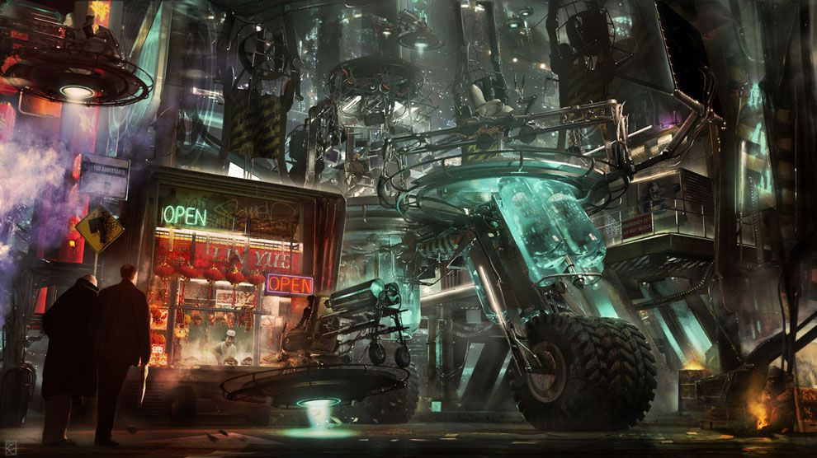

Player: Delivery person

Goal: Deliver the package