**Rabbit Music**

User Manual

Installation:

In the current state of the project it must be view from Ionic View. A user will need to install Ionic View on their phone and then can view the app. In the future the app will be put onto the app marketplace and users will be able to install it from there. For testing purposes of senior project you will need to have the folder that I have provided and then open command prompt and change into that directory and then type “ionic lab”. You may also use “ionic serve” but lab formats it to look like it would on a phone which is how I tried to format it while coding

Use:

There is only one type of user in Rabbit Music at this point in time but admins and regular users will be different in the very near future. Admins will have the ability to add, update, or delete music. The developer will be the only admin for this app. He will be responsible for maintaining the app and keeping the music up to date. Regular users are able to view all music that was released recently by searching through each genre. They are also able to push comments about that music. Users will be brought to the home screen when they open the app.

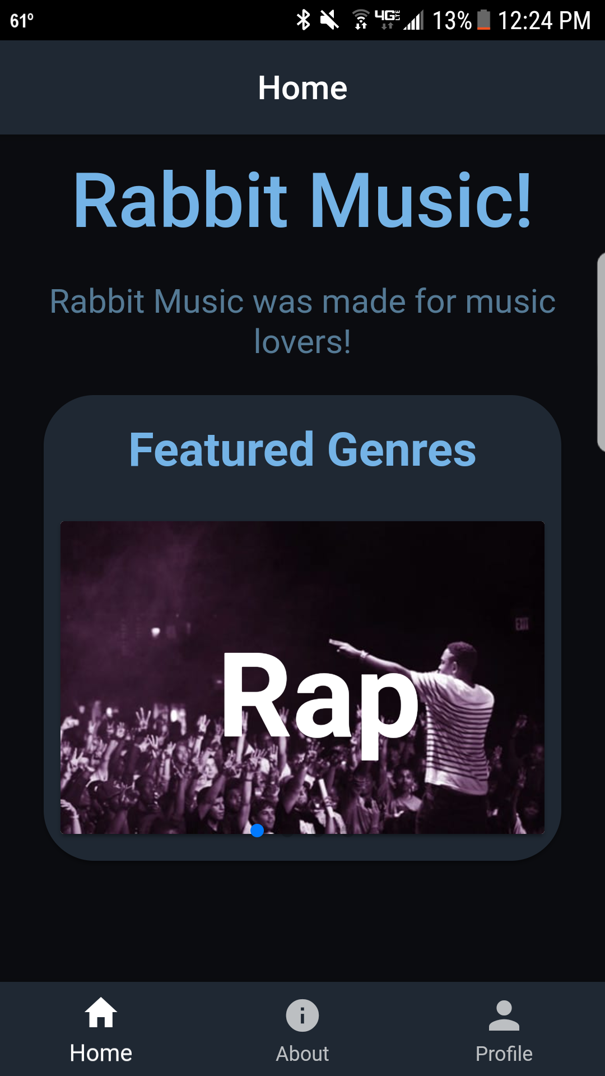

Once users see the home screen they will have a few options. They can go to the about page by clicking on the middle tab on the bottom of the screen which will take them to a message from the developer and a picture of the developer. This message is subject to change depending on which stage of development the app is in so look there for important updates and time goes on. They can go to create their profile by clicking the bottom right button that says “Profile”

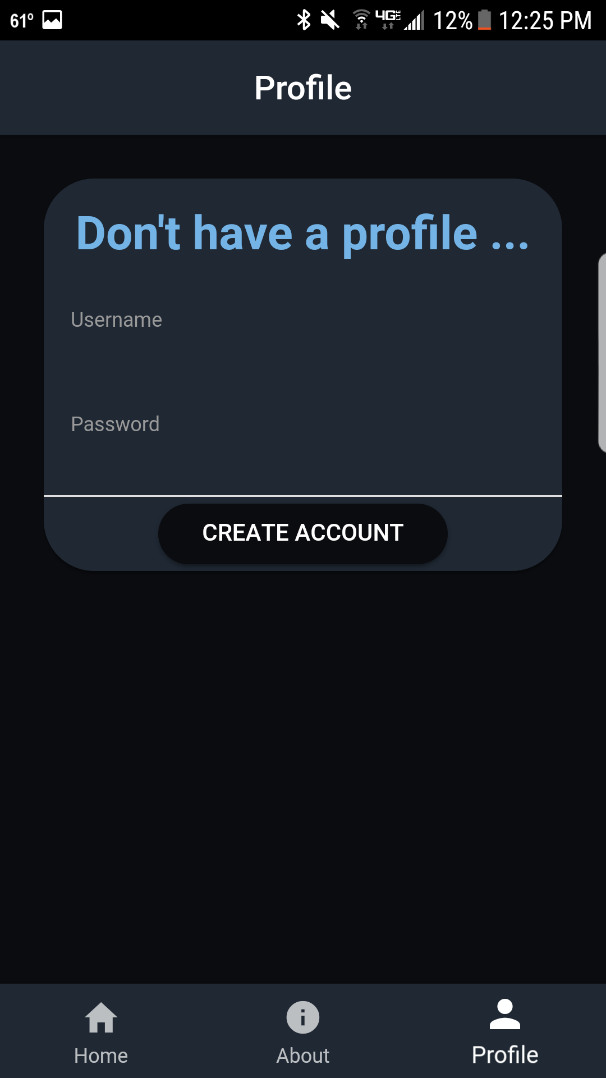

Once users are on the profile page they will be able to input their username and password to create an account. The profile system is subject to undergo changes in the future. Users do not have to create an account to be able to view any music in the app but they will have to create an account to be able to comment on the music. Users can then go back to the home page and start to search through their favorite music. The block in the middle of the home page slides to the right to reveal different genres of music that Rabbit Music has to offer. Users can click on the block and it will take them to that genre. From there they will be able to view any music that was released recently.

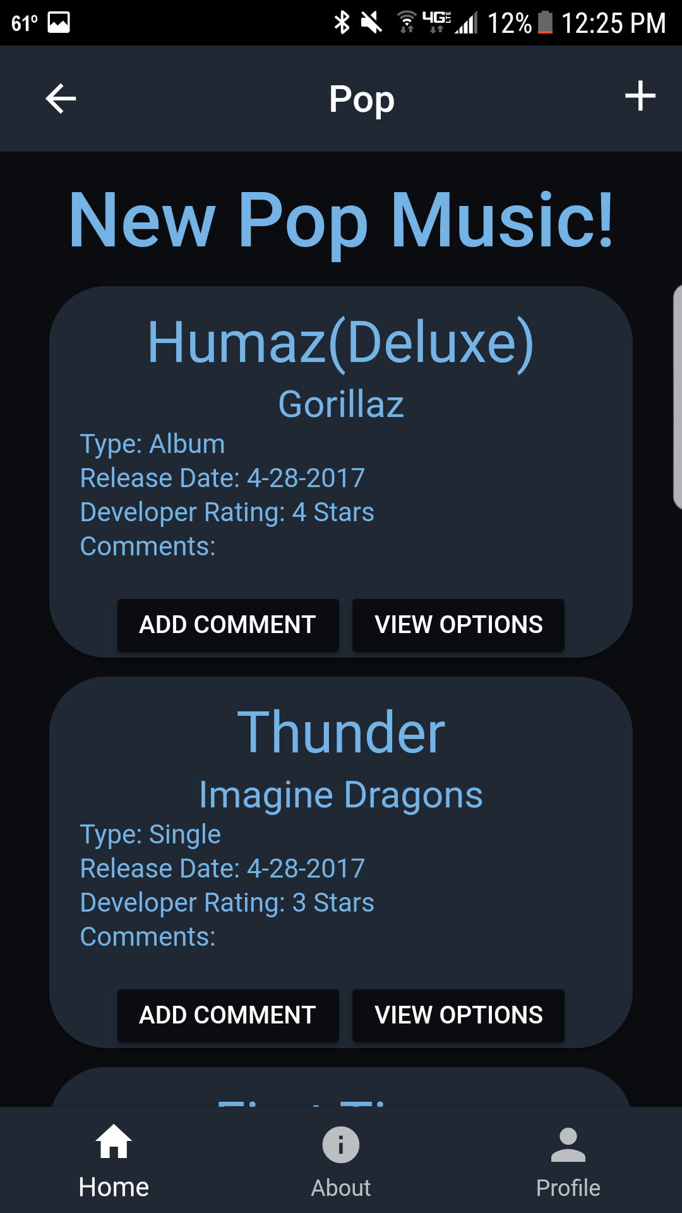

Once on the page for any genre users can then scroll down to view the music that is listed. From here users will be able to see the name of the song or album along with the artist name, release date, developer star rating, and any comments that a user has pushed. Users can also hit the “Add Comment” button to push a comment to that article of music.

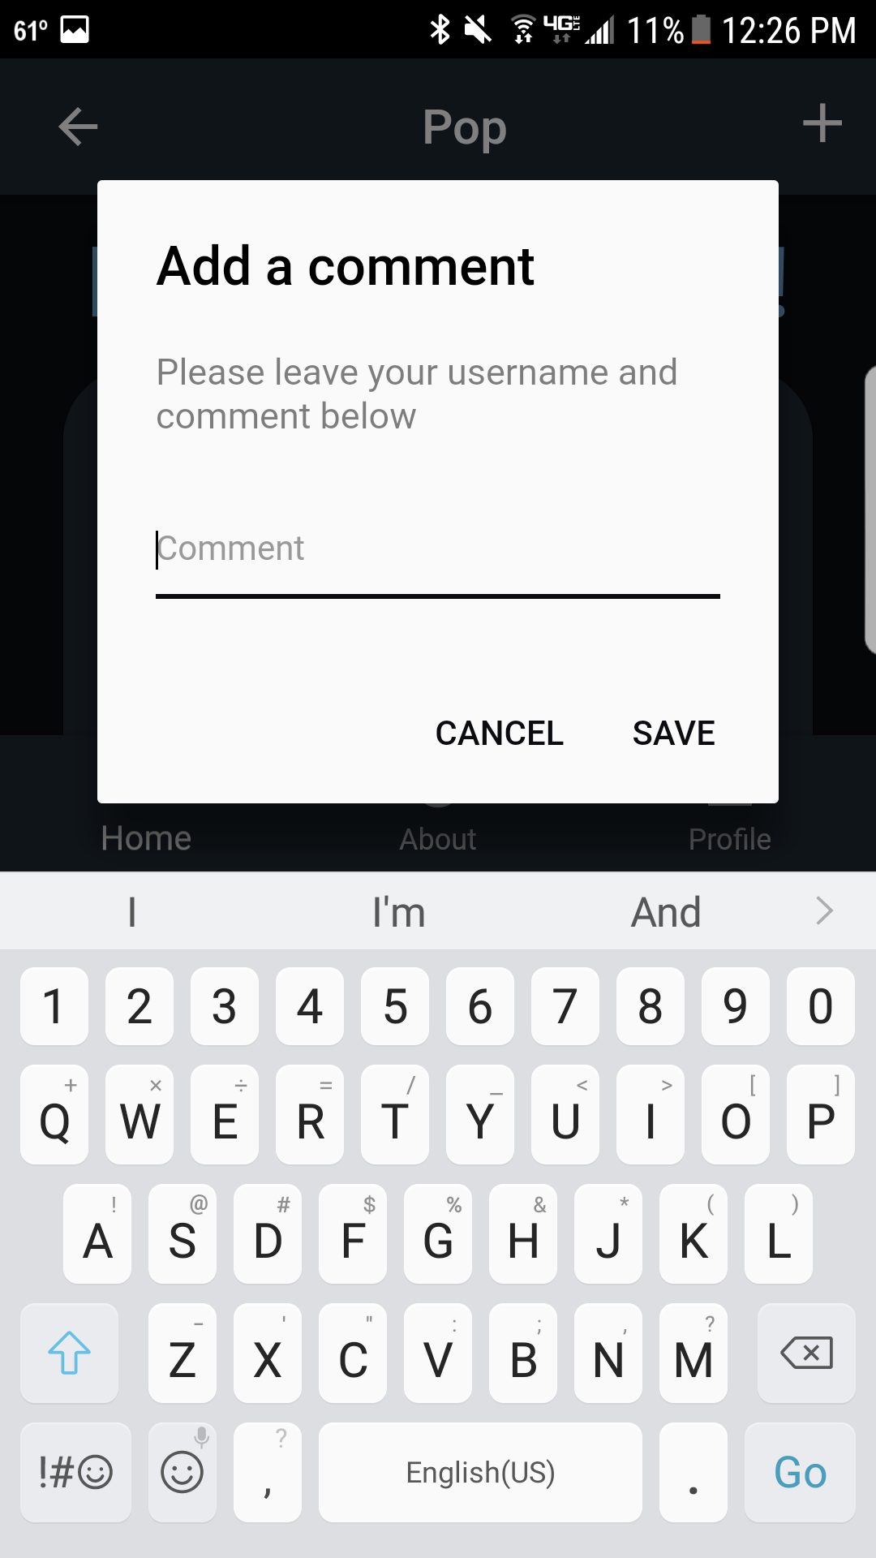

Admins will also be able to perform some functions here as well. In the top corner of the page is a “+” button that will be available to admins only. They will be able to click on this button and then be prompted to add another music item.

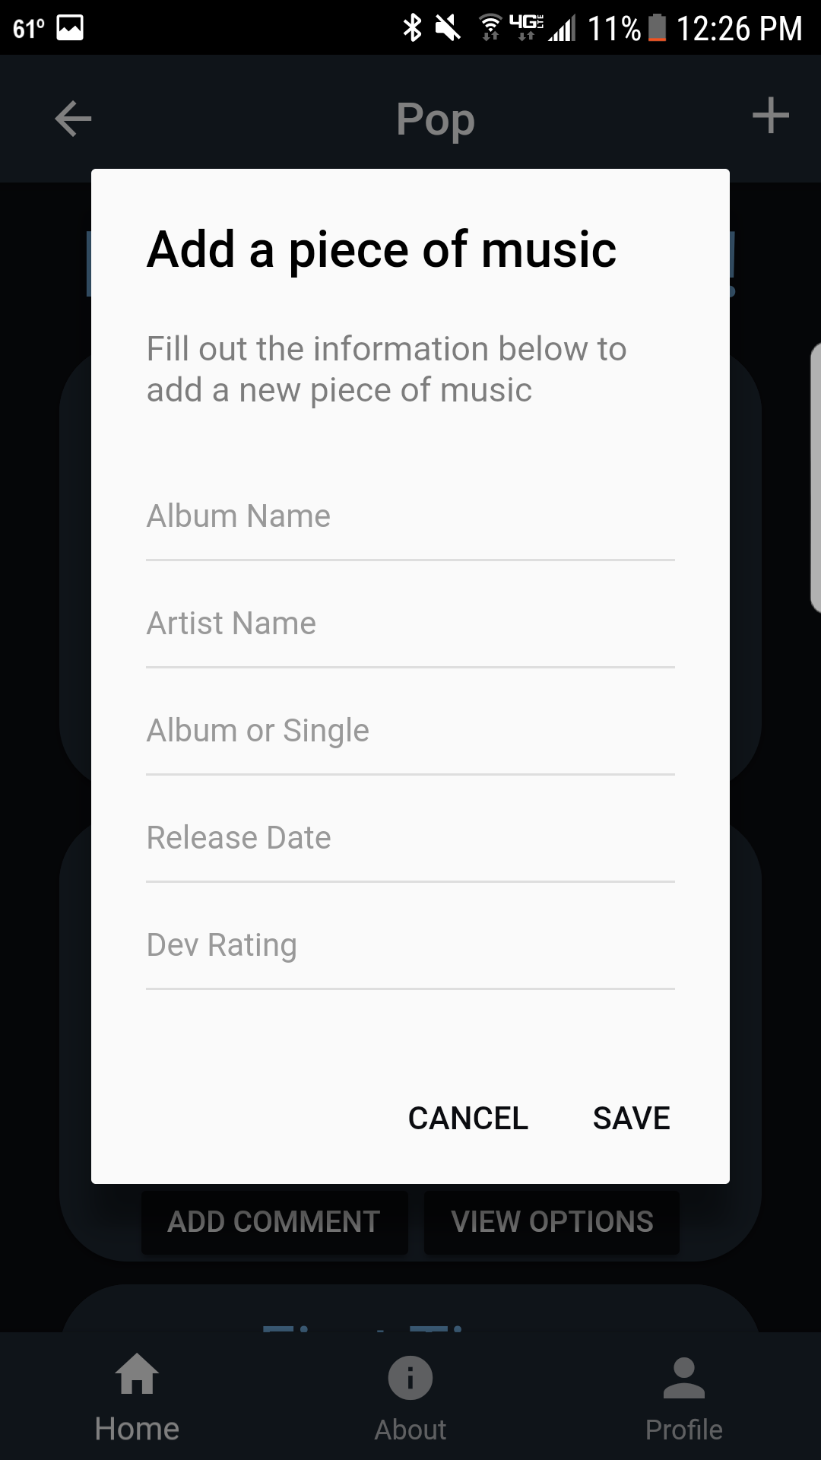

When prompted admins will then enter the information about the music including title, artist, whether it is an album or a single, release date, and then the developer rating. Once added the music will then be added to the bottom of the page. Admins will also be able to edit or delete music from this page as well. The “View Options” button on the bottom right of each music item will be for admins only as well. Once clicked on a pop-up menu will display offering the “Update”, “Delete”, and “Cancel”.

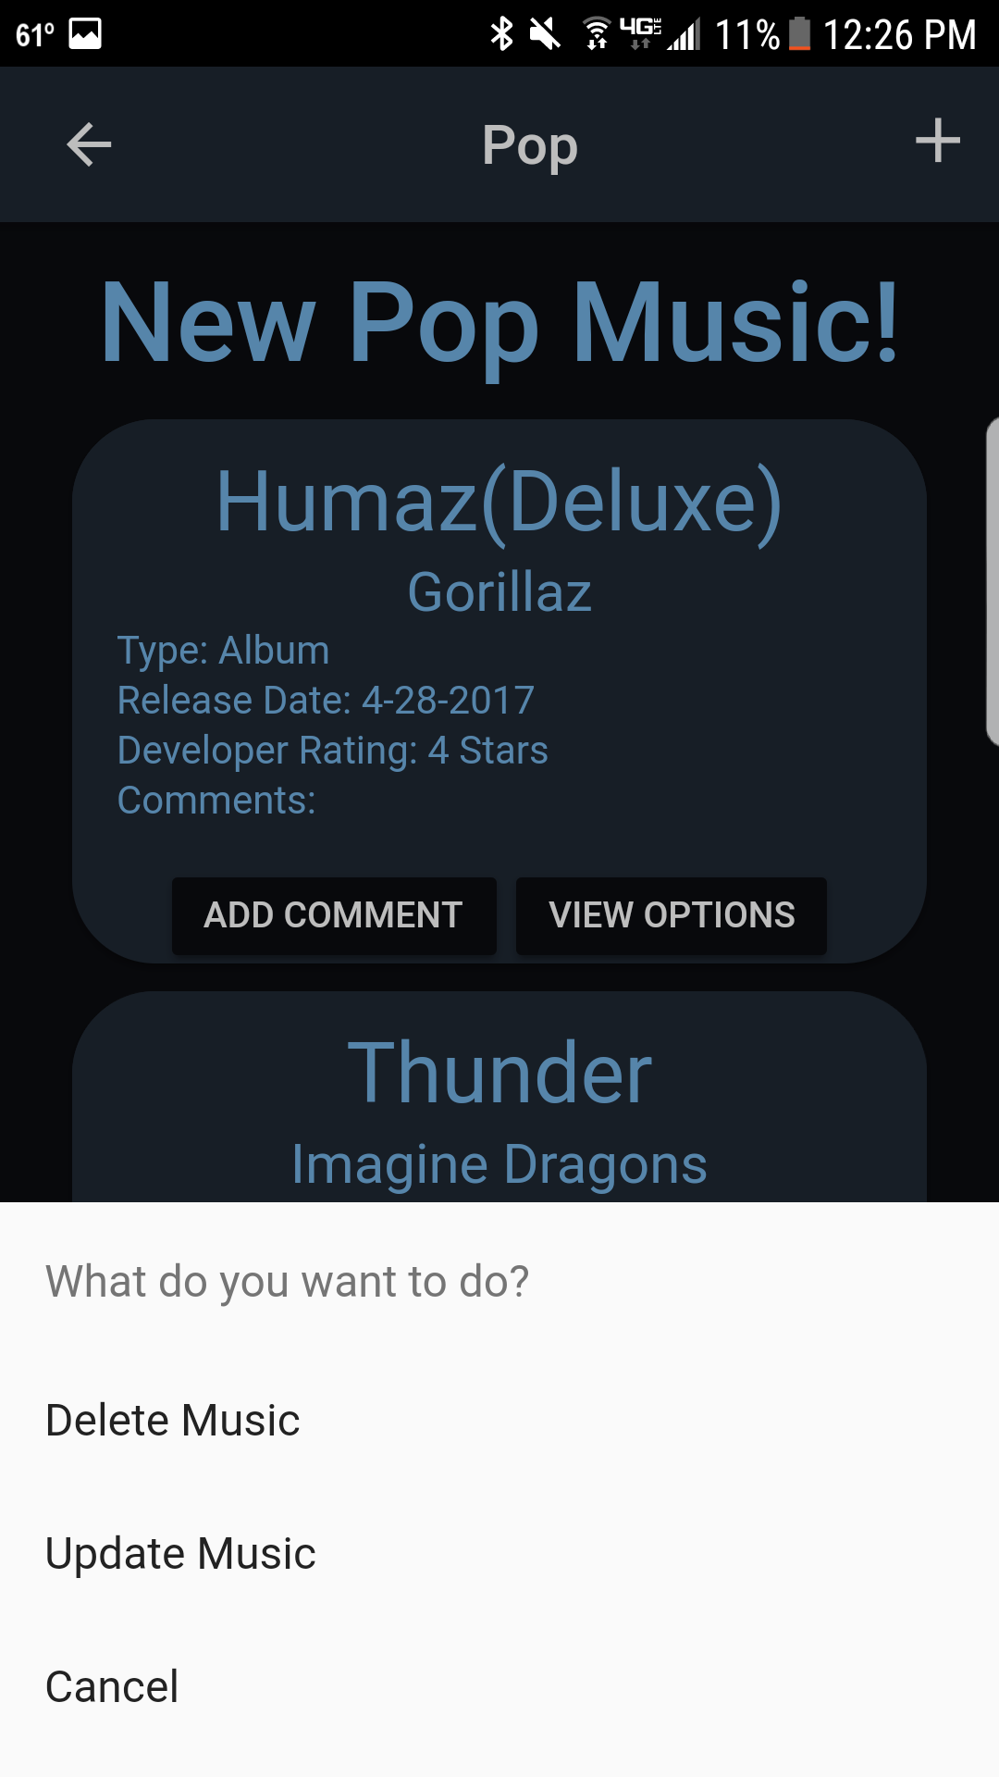

Administration and Maintenance:

Admins will need to update the music in the app every week. New music is released every Friday so that is the day that the admin will upload all the new music for that week.

Future plans:

In the future I have a lot of plans for this app. I want to continue to work on this project throughout the summer and in the coming future. Some of the things I plan on doing very soon are making admins and regular users differ. As mentioned above admins and users have very different roles in the use of this app so this is my top priority at the moment with this app. I am having a hard time with users but am currently working to fix those issues. Also will be working out the comment system. I have a plan on how to fix this and will start on this as soon as I am done with my finals for my other classes. Next I want to incorporate the Spotify API. I want to do this to allow users to listen to a sample of any song and then also have a link to take users to the Spotify page for that song or album. I chose Spotify because it is the most used music service today. I am going to work on this project a lot throughout the summer and hope to have it on the Play Store and possibly Itunes by the end of the summer around August.