|  |
| --- |
| SOUTHERN CROSS UNIVERSITY |

**ASSIGNMENT COVER SHEET**

For use with online submission of assignments

Please complete all of the following details and then make this sheet the **first page of each file of your assignment – do not send it as a separate document.**

Your assignments must be submitted as either **Word documents, text documents with .rtf extension or as .pdf documents**. If you wish tosubmit in any other file format please discuss this with your lecturer well before theassignment submission date.

|  |  |
| --- | --- |
| Student Name: | **Jennifer Doherty** |
| Student ID No.: | **22223707** |
| Unit Name: | **Web Development II** |
| Unit Code: | **CSC10217** |
| Tutor’s name: | **George Coles** |
| Assignment No.: | **1** |
| Assignment Title: | **Portfolio Design Documentation** |
| Due date: | **18 August 2017** |
| Date submitted: | **20 August 2017 (extension granted)** |

Declaration:

*I have read and understand the Rules Relating to Awards (*[*Rule 3 Section 18 – Academic Misconduct Including Plagiarism*](http://policies.scu.edu.au/view.current.php?id=00140#s18)*) as contained in the SCU Policy Library. I understand the penalties that apply for plagiarism and agree to be bound by these rules. The work I am submitting electronically is entirely my own work.*

|  |  |
| --- | --- |
| Signed:  (please type your name) | Jennifer Doherty |
| Date: | 20 August 2017 |

Edge of Tomorrow   
DVD Rentals Website

Design Documentation

Table of Contents

Design Brief 4

Concept Map 5

CSS Design 6

CSS Layout Plan 6

Screen Layout 7

Print Layout 8

CSS Text Plan 9

Screen 9

Print 13

Navigation Map (Logical) 16

STRUCTURE CHART (PHYSICAL) 17

Storyboards 18

Testing Plan 29

# Design Brief

This document contains the design documentation for the hypothetical DVD rental store “Edge of Tomorrow DVD Rentals”.

.

# Concept Map

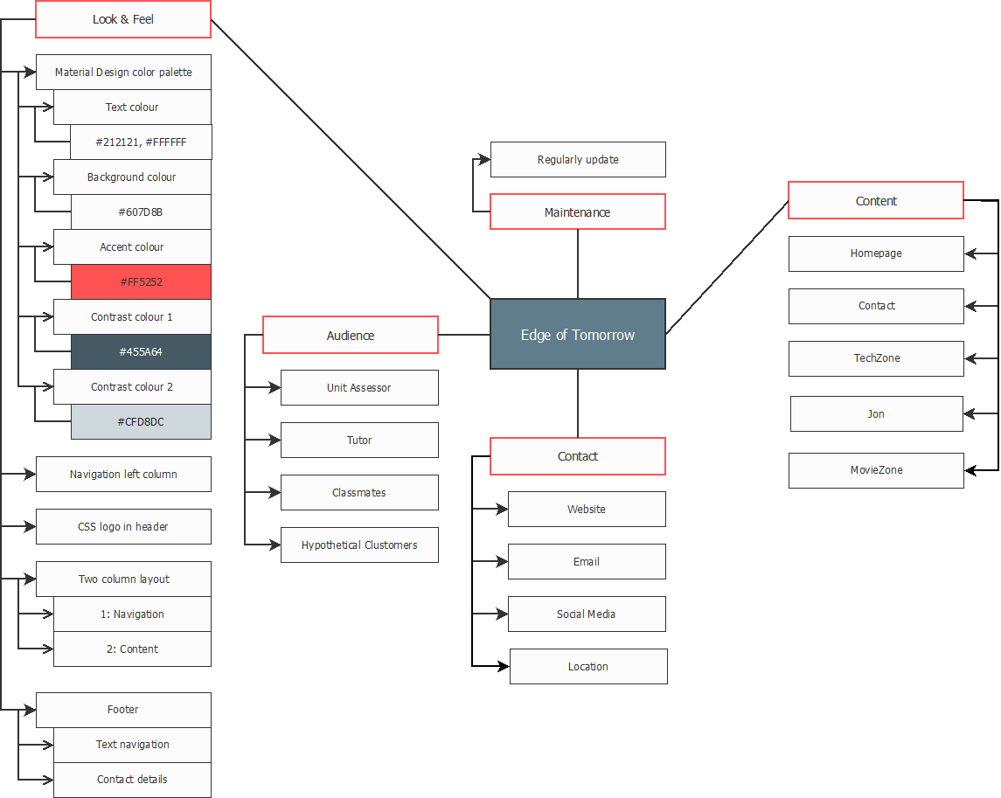

# CSS Design

## CSS Layout Plan

The layout of the site is set using the CSS box model. Sections of the page are created using divs, which can be styled and arranged easily across the website by changing the shared CSS style sheets.

### Screen Layout

## CSS Text Plan

### Screen

| styles.css | Font Family Text | Colour/Special Characteristics | Size | Align |
| --- | --- | --- | --- | --- |
|  |  |  |  |  |
|  |  |  |  |  |

# Navigation Map (Logical)

# Structure Chart (Physical)

# Storyboards

|  |  |  |  |
| --- | --- | --- | --- |
| **Title: Home – index.html** | | **Screen ID: 1.0** | **Date: 15/08/2017** |
| Web Page Diagram: | | | |
|  | | | |
| Graphics: | | | |
| Text: | | | |
| Multimedia: | | | |
| Notes: | | | |
| **Description:** |  | | |
| **Content:** |  | | |
| **Interactions:** |  | | |
| **Media Creation:** |  | | |
| **Navigation:** |  | | |

# Testing Plan

This website will need to be extensively tested, as follows.

* Validation of files
  + All HTML files validated to HTML5 using   
    <https://validator.w3.org/nu/#file>
  + All CSS files validated to CSS3 using   
    <https://jigsaw.w3.org/css-validator/#validate_by_upload>
* Test look and feel on multiple screen resolutions
  + 640 x 480 pixels
  + 800 x 600 pixels
  + 1024 x 768 pixels
  + 1280 x 1024 pixels
  + 1440 x 900 pixels
  + 1280 x 854 pixels
  + 1600 x 1024 pixels
  + 1920 x 1080 pixels
  + 1680 x 1050 pixels
* Test look and feel on multiple browser viewport sizes
  + 1280 x 890 pixels
  + 1920 x 965 pixels
  + 1680 x 935 pixels
  + 836 x 913 pixels
  + 956 x 943 pixels
  + Various manually set browser width and height ratios
* Test look and feel in different browsers (latest version)
  + Chrome
  + Firefox
  + Internet Explorer
  + Edge
  + Safari (if available)
* Test links
  + Internal links (site navigation)
  + External links
* Test media
  + Images
* Test JavaScript
  + Form Javascript