|  |
| --- |
| SOUTHERN CROSS UNIVERSITY |

**ASSIGNMENT COVER SHEET**

For use with online submission of assignments

Please complete all of the following details and then make this sheet the **first page of each file of your assignment – do not send it as a separate document.**

Your assignments must be submitted as either **Word documents, text documents with .rtf extension or as .pdf documents**. If you wish tosubmit in any other file format please discuss this with your lecturer well before theassignment submission date.

|  |  |
| --- | --- |
| Student Name: | **Jennifer Doherty** |
| Student ID No.: | **22223707** |
| Unit Name: | **Web Development II** |
| Unit Code: | **CSC10217** |
| Tutor’s name: | **George Coles** |
| Assignment No.: | **2** |
| Assignment Title: | **Design Documentation** |
| Due date: | **8 October 2017** |
| Date submitted: | **8 October 2017** |

Declaration:

*I have read and understand the Rules Relating to Awards (*[*Rule 3 Section 18 – Academic Misconduct Including Plagiarism*](http://policies.scu.edu.au/view.current.php?id=00140#s18)*) as contained in the SCU Policy Library. I understand the penalties that apply for plagiarism and agree to be bound by these rules. The work I am submitting electronically is entirely my own work.*

|  |  |
| --- | --- |
| Signed:  (please type your name) | Jennifer Doherty |
| Date: | 8 October 2017 |

Edge of Tomorrow   
DVD Rentals Website

Design Documentation

Table of Contents

Design Brief 4

Concept Map 5

CSS Design 6

CSS Layout Plan 6

Screen Layout 7

Print Layout 8

CSS Text Plan 9

Screen 9

Print 13

Navigation Map (Logical) 16

STRUCTURE CHART (PHYSICAL) 17

Storyboards 18

Testing Plan 29

# Design Brief

This document contains the design documentation for the hypothetical DVD rental store “Edge of Tomorrow DVD Rentals”.

# Concept Map

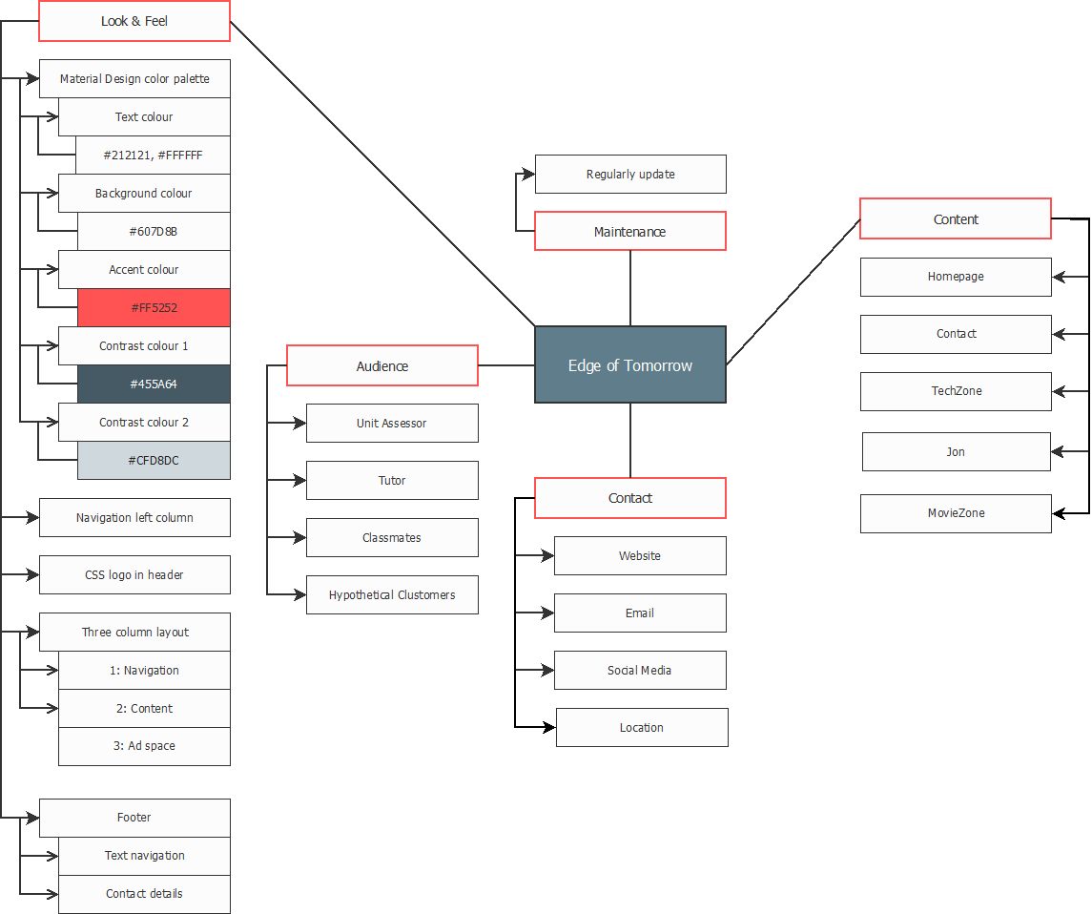

# CSS Design

## CSS Layout Plan

The layout of the site is set using the CSS box model. Sections of the page are created using divs, which can be styled and arranged easily across the website by changing the shared CSS style sheets.

### Screen Layout

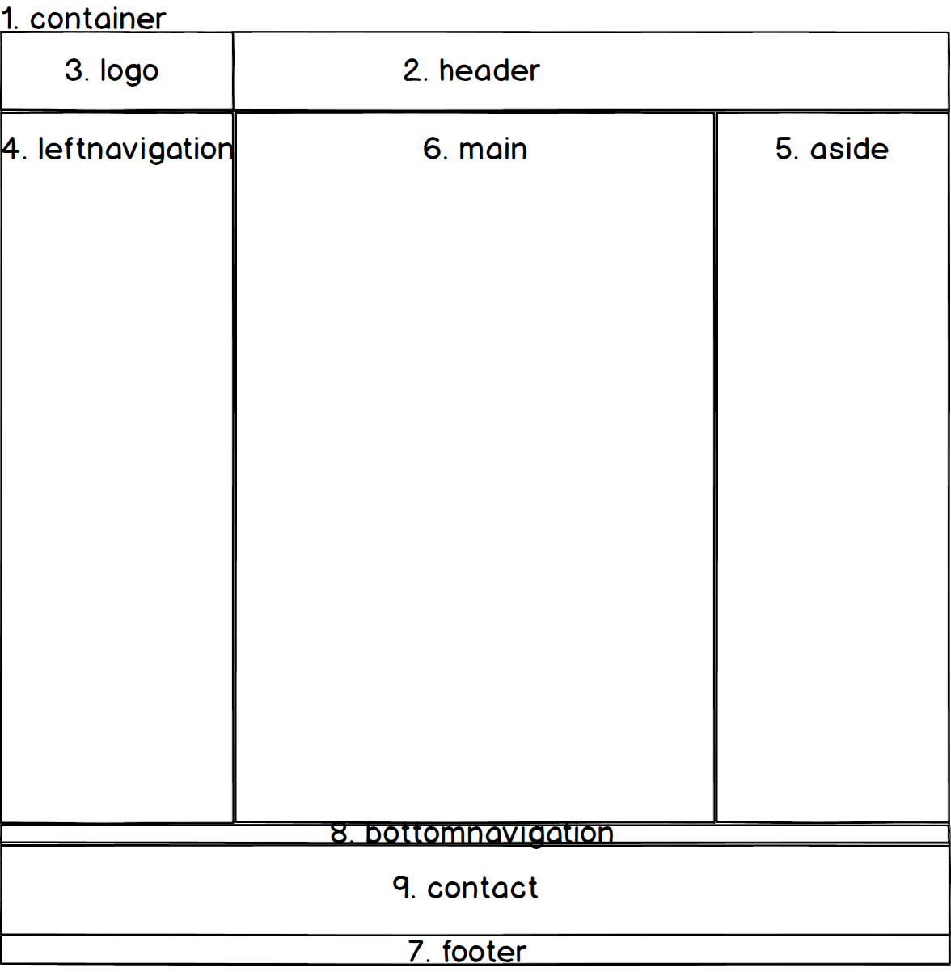

## CSS Text Plan

### Screen

| styles.css | Font Family Text | Colour/Special Characteristics | Size | Align |
| --- | --- | --- | --- | --- |
| header, nav, main, footer, aside (Legacy browser support) | N/A | Display block |  |  |
| body | Roboto, Noto Sans, sans-serif | Text colour #212121 (dark grey)  Background colour #FAFAFA (grey-white)  Overflow-y scroll |  |  |
| #container | As body | Background colour #CFD8DC (light blue-grey)  Margin left/right auto | Minimum width 960px |  |
| #leftnavigation | As body | Float left  Padding 10px | Width 270px |  |
| #bottomnavigation | As body | Right margin -20px  Font size 0.8em |  | Centre |
| aside | As body | Float right  Padding 10px | Width 270px | Right |
| main | As body | Margin top/bottom 0  Margin left/right 290px  Padding top/bottom 10px  Padding left/right 20px  Background colour #FAFAFA (grey-white) | Minimum height 1000px |  |
| header | As body | Background colour #455A64 (dark blue-grey) | Minimum height 100px |  |
| #logo | As body | Positioning absolute  (Note: logo is created with CSS, see below: #logobackground, #logoshape, #logotext) | Width 290px  Height 100px |  |
| #logobackground (part of CSS logo) | As body | Positioning absolute  Background colour #FAFAFA (grey-white)  Padding 0  Border bottom 5px solid #FF5252 (red)  Border right 5px solid #FF5252 (red) | Width 285px  Height 95px | Centre |
| #logoshape (part of CSS logo) | As body | Positioning absolute  Margin 5px  Background colour #FF5252 (red)  Border radius top-left/bottom-right 5px  Border radius top-right/bottom-left 30px | Width 85px  Height 85px |  |
| #logotext (part of CSS logo) | As body | Positioning absolute | Width 285px  Height 95px |  |
| #logotext h1 (part of CSS logo) | As body | Padding left 40px  Text colour #212121 (dark grey)  No border  Font size 1.7em |  |  |
| figcaption a | As body | Float right  Margin top -15px  Margin left 15px |  | Centre |
| h1 | As body | Text colour #212121 (dark grey)  Border bottom 5px solid #FF5252 (red)  Padding bottom 5px |  | Centre |
| h2, h3, h4, h5, h6 | As body | Text colour #212121 (dark grey)  Border left 5px solid #FF5252 (red)  Padding left 5px |  |  |
| aside h3 | As body | Border right 5px solid #FF5252 (red)  Padding right 5px |  |  |
| .leftnavigationparent | As body | List style none  Padding 0  Margin top 10px  Margin right/bottom/left -10px  Font weight bold |  |  |
| .leftnavigationchild | As body | List style none  Padding 0 |  |  |
| .leftnavigationparent a | As body | Text decoration none  Font size 1.2em  Padding 20px  Display block  Background colour #607D8B (blue-grey)  Border bottom 2px solid #FF5252 (red) |  |  |
| .leftnavigationchild a | As body | Font size 0.8em  Text indent 30px |  |  |
| #leftnavigation a:link | As body | Text colour #FFFFFF (white) |  |  |
| #leftnavigation a:visited | As body | Text colour #FFFFFF (white) |  |  |
| #leftnavigation a:hover | As body | Background colour #FF5252 (red) |  |  |
| .contacttable | As body | Margin left 0  Border left 5px solid #FF5252 (red) | Width 90% |  |
| .contacttable caption | As body | Padding bottom 1em |  | Left |
| .contacttable th | As body | Display none |  |  |
| .contacttable tbody td:first-of-type | As body | Padding top/bottom 1px  Padding left/right 5px | Width 83px |  |
| .contacttable tbody td:last-of-type | As body | Font size 0.8em |  |  |
| form | As body | Padding 10px |  |  |
| label | As body | Float left  Padding right 10px  Margin top 10px | Width 150px | Right |
| input | As body | Margin top 10px  Display block |  |  |
| textarea | As body | Margin top 20px  Display block |  |  |
| fieldset | As body | Margin top/bottom 10px  Margin right 0  Margin left 160px  Padding top 10px  Border style none | Width 419px |  |
| input[type=radio]  input[type=checkbox] | As body | Display inline |  |  |
| #submit | As body | Margin left 160px  Display inline |  |  |
| #reset | As body | Margin left 10px  Display inline |  |  |
| footer | As body | Clear floats  Border right 5px solid #FF5252 (red)  Padding right 5px  Margin right 10px |  | Right |
| #contact h1 | As body | Border none  Font size 1.2em |  | Right |
| #contactdetails | As body | Line height 200%  List style none |  |  |
| .copyrightnotice | As body | Margin top/bottom 0.5em  Margin left/right 0  Font size 0.5em |  |  |

# Navigation Map (Logical)

# Structure Chart (Physical)

# Storyboards

|  |  |  |  |
| --- | --- | --- | --- |
| **Title: Home – index.html** | | **Screen ID: 1.0** | **Date: 15/08/2017** |
| Web Page Diagram: | | | |
|  | | | |
| Graphics: CSS logo, movie image | | | |
| Text: Brief welcome message explaining site under construction | | | |
| Multimedia: Future randomised movie display | | | |
| Notes: | | | |
| **Description:** | Home page | | |
| **Content:** | Introduction to the site, link to new release movie | | |
| **Interactions:** | Left and bottom navigation, movie link | | |
| **Media Creation:** | CSS logo | | |
| **Navigation:** | Left and bottom | | |

|  |  |  |  |
| --- | --- | --- | --- |
| **Title: Contact – contact.html** | | **Screen ID: 2.1** | **Date: 15/08/2017** |
| Web Page Diagram: | | | |
|  | | | |
| Graphics: CSS logo, movie image, embedded map | | | |
| Text: Contact details | | | |
| Multimedia: Future randomised movie display, embedded map | | | |
| Notes: | | | |
| **Description:** | Contact page | | |
| **Content:** | Contact details, link to new release movie | | |
| **Interactions:** | Left and bottom navigation, movie link, contact form, map | | |
| **Media Creation:** | CSS logo | | |
| **Navigation:** | Left and bottom | | |

|  |  |  |  |
| --- | --- | --- | --- |
| **Title: TechZone – techzone.html** | | **Screen ID: 2.2** | **Date: 15/08/2017** |
| Web Page Diagram: | | | |
|  | | | |
| Graphics: CSS logo, movie image | | | |
| Text: TechZone essay | | | |
| Multimedia: TechZone rep phot | | | |
| Notes: | | | |
| **Description:** | TechZone page | | |
| **Content:** | TechZone essay, TechZone rep photo | | |
| **Interactions:** | Left and bottom navigation | | |
| **Media Creation:** | CSS logo | | |
| **Navigation:** | Left and bottom | | |

|  |  |  |  |
| --- | --- | --- | --- |
| **Title: Join – join.html** | | **Screen ID: 2.3** | **Date: 15/08/2017** |
| Web Page Diagram: | | | |
|  | | | |
| Graphics: CSS logo, movie image | | | |
| Text: Join form | | | |
| Multimedia: Future randomised movie display | | | |
| Notes: | | | |
| **Description:** | Join page | | |
| **Content:** | Join form, link to new release movie | | |
| **Interactions:** | Left and bottom navigation, movie link | | |
| **Media Creation:** | CSS logo | | |
| **Navigation:** | Left and bottom | | |

|  |  |  |  |
| --- | --- | --- | --- |
| **Title: MovieZone – moviezone.html** | | **Screen ID: 2.4** | **Date: 15/08/2017** |
| Web Page Diagram: | | | |
|  | | | |
| Graphics: CSS logo, movie image | | | |
| Text: Brief message explaining page under construction | | | |
| Multimedia: Future randomised movie display, movie database | | | |
| Notes: | | | |
| **Description:** | MovieZone page | | |
| **Content:** | Movie database | | |
| **Interactions:** | Left and bottom navigation, movie link | | |
| **Media Creation:** | CSS logo | | |
| **Navigation:** | Left and bottom | | |

# Testing Plan

This website will need to be extensively tested, as follows.

* Validation of files
  + All HTML files validated to HTML5 using   
    <https://validator.w3.org/nu/#file>
  + All CSS files validated to CSS3 using   
    <https://jigsaw.w3.org/css-validator/#validate_by_upload>
* Test look and feel on multiple screen resolutions
  + 640 x 480 pixels
  + 800 x 600 pixels
  + 1024 x 768 pixels
  + 1280 x 1024 pixels
  + 1440 x 900 pixels
  + 1280 x 854 pixels
  + 1600 x 1024 pixels
  + 1920 x 1080 pixels
  + 1680 x 1050 pixels
* Test look and feel on multiple browser viewport sizes
  + 1280 x 890 pixels
  + 1920 x 965 pixels
  + 1680 x 935 pixels
  + 836 x 913 pixels
  + 956 x 943 pixels
  + Various manually set browser width and height ratios
* Test look and feel in different browsers (latest version)
  + Chrome
  + Firefox
  + Internet Explorer
  + Edge
  + Safari (if available)
* Test links
  + Internal links (site navigation)
  + External links
* Test media
  + Images
* Test JavaScript
  + Form Javascript