|  |
| --- |
| SOUTHERN CROSS UNIVERSITY |

**ASSIGNMENT COVER SHEET**

For use with online submission of assignments

Please complete all of the following details and then make this sheet the **first page of each file of your assignment – do not send it as a separate document.**

Your assignments must be submitted as either **Word documents, text documents with .rtf extension or as .pdf documents**. If you wish tosubmit in any other file format please discuss this with your lecturer well before theassignment submission date.

|  |  |
| --- | --- |
| Student Name: | **Jennifer Doherty** |
| Student ID No.: | **22223707** |
| Unit Name: | **Web Development I** |
| Unit Code: | **ISY10209** |
| Tutor’s name: | **George Coles** |
| Assignment No.: | **3** |
| Assignment Title: | **Portfolio Design Documentation** |
| Due date: | **11 January 2016** |
| Date submitted: | **10 January 2016** |

Declaration:

*I have read and understand the Rules Relating to Awards (*[*Rule 3 Section 18 – Academic Misconduct Including Plagiarism*](http://policies.scu.edu.au/view.current.php?id=00140#s18)*) as contained in the SCU Policy Library. I understand the penalties that apply for plagiarism and agree to be bound by these rules. The work I am submitting electronically is entirely my own work.*

|  |  |
| --- | --- |
| Signed:  (please type your name) | Jennifer Doherty |
| Date: | 10 January 2016 |

Personal Portfolio

Design Documentation



Table of Contents

Design Brief 4

Concept Map 5

CSS Design 6

CSS Layout Plan 6

Screen Layout 7

Print Layout 8

CSS Text Plan 9

Screen 9

Print 13

Navigation Map (Logical) 16

STRUCTURE CHART (PHYSICAL) 17

Storyboards 18

Testing Plan 29

# Design Brief

This document contains the design documentation for my personal portfolio website. The website is being developed through the assignments set in ISY10209: Web Development I, a class I am completing as part of my Bachelor of Information Technology degree. Certain aspects of the website and design are required in the assignment specifications, while other aspects are left to the student.

The purpose of this portfolio website is to showcase my skills and personality to potential employers and clients. It needs to be professional, appealing, and personalised.

The overall feel of the website is clean, fresh, and modern. A monochromatic colour scheme with a single highlight colour, and a limited font selection, will keep the website simple and uncluttered.

# Concept Map

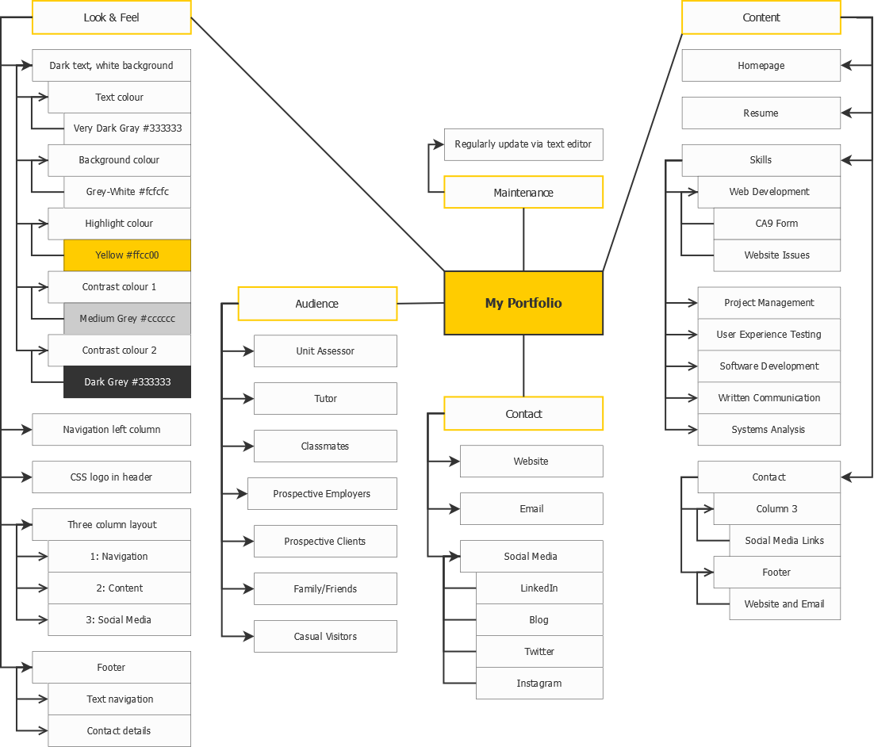

# CSS Design

## CSS Layout Plan

The layout of the site is set using the CSS box model. Sections of the page are created using divs, which can be styled and arranged easily across the website by changing the shared CSS style sheets.

A separate CSS stylesheet is used for print layout. The main differences are:

* Change of colour scheme to black, white, and dark grey only
* Removal of #leftnavigation, #bottomnavigation, aside, and figure divs
* Change of logo to a monochromatic version
* Increased font size

### Screen Layout

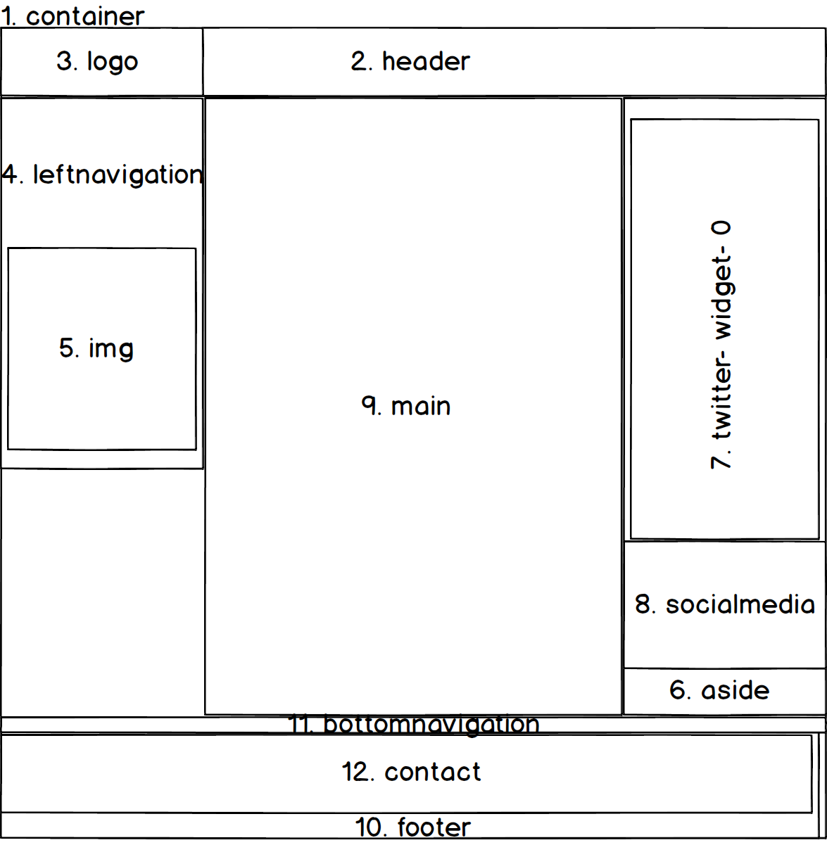

### Print Layout

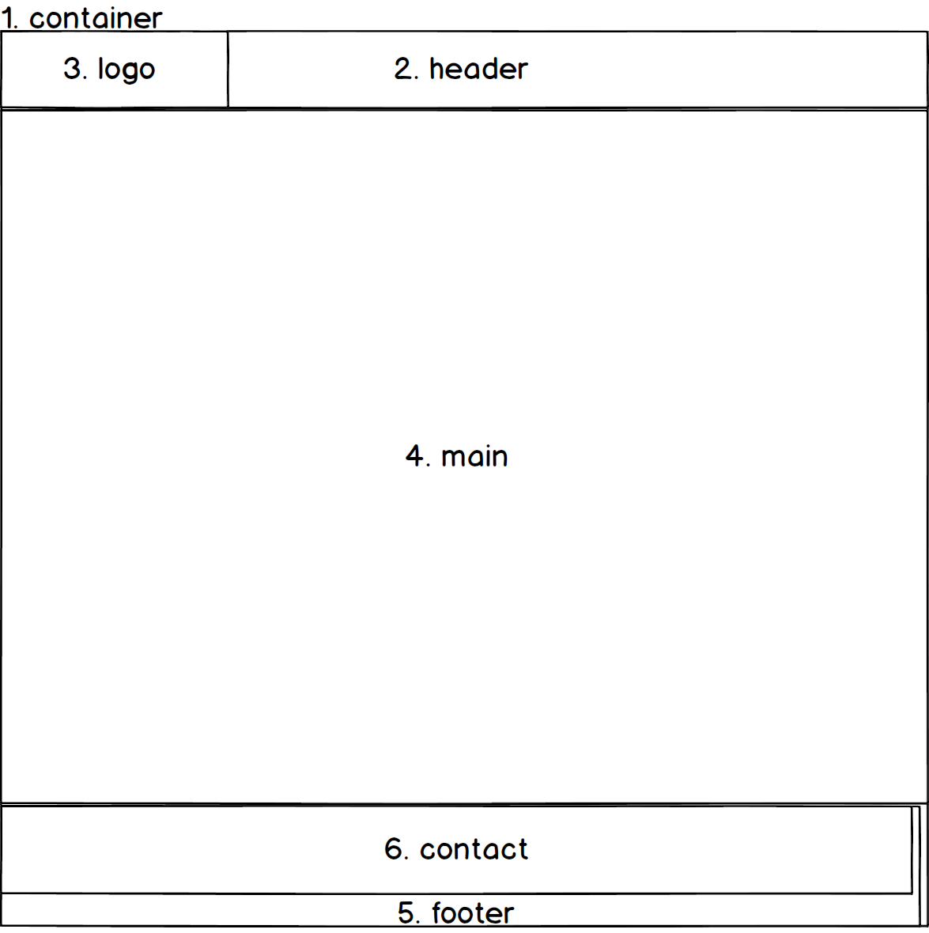

## CSS Text Plan

### Screen

| styles.css | Font Family Text | Colour/Special Characteristics | Size | Align |
| --- | --- | --- | --- | --- |
| header, nav, main, footer, aside (Legacy browser support) | N/A | Display block |  |  |
| body | Lucida Sans Unicode, Verdana, Geneva, sans-serif | Text colour #333333 (dark grey)  Background colour #fcfcfc (grey-white)  Overflow-y scroll |  |  |
| #container | As body | Background colour #cccccc (light grey)  Margin left/right auto | Minimum width 960px |  |
| #widecontainer | As body | Background colour #cccccc (light grey)  Margin left/right auto | Minimum width 1240px |  |
| #leftnavigation | As body | Float left  Padding 10px | Width 270px |  |
| #bottomnavigation | As body | Right margin -20px  Font size 0.8em |  | Centre |
| aside | As body | Float right  Padding 10px | Width 270px | Right |
| main | As body | Margin top/bottom 0  Margin left/right 290px  Padding top/bottom 10px  Padding left/right 20px  Background colour #fcfcfc (grey-white) | Minimum height 1000px |  |
| header | As body | Background colour #333333 (dark grey) | Minimum height 100px |  |
| #logo | As body | Positioning absolute  (Note: logo is created with CSS, see below: #logobackground, #logoshape, #logotext) | Width 290px  Height 100px |  |
| #logobackground (part of CSS logo) | As body | Positioning absolute  Background colour #fcfcfc (grey-white)  Padding 0  Border bottom 5px solid #ffcc00 (yellow)  Border right 5px solid #ffcc00 (yellow) | Width 285px  Height 95px | Centre |
| #logoshape (part of CSS logo) | As body | Positioning absolute  Margin 5px  Background colour #ffcc00 (yellow)  Border radius top-left/bottom-right 5px  Border radius top-right/bottom-left 30px | Width 85px  Height 85px |  |
| #logotext (part of CSS logo) | As body | Positioning absolute | Width 285px  Height 95px |  |
| #logotext h1 (part of CSS logo) | As body | Padding left 40px  Text colour #333333 (dark grey)  No border  Font size 1.7em |  |  |
| #leftnavigation img | As body | Padding top 30px  Padding bottom 0  Padding left/right 7px  Margin auto | Width 256px  Height 256px |  |
| figcaption a | As body | Float right  Margin top -15px  Margin left 15px |  | Centre |
| h1 | As body | Text colour #333333 (dark grey)  Border bottom 5px solid #ffcc00 (yellow)  Padding bottom 5px |  | Centre |
| h2, h3, h4, h5, h6 | As body | Text colour #333333 (dark grey)  Border left 5px solid #ffcc00 (yellow)  Padding left 5px |  |  |
| aside h3 | As body | Border right 5px solid #ffcc00 (yellow)  Padding right 5px |  |  |
| dt | As body | Font style italic  Font size 1.2em |  |  |
| #petlist dd | As body | Margin top -15px | Minimum height 130px |  |
| .leftnavigationparent | As body | List style none  Padding 0  Margin top 10px  Margin right/bottom/left -10px  Font weight bold |  |  |
| .leftnavigationchild | As body | List style none  Padding 0 |  |  |
| .leftnavigationparent a | As body | Text decoration none  Font size 1.2em  Padding 20px  Display block  Background colour #cccccc (light grey)  Border bottom 2px solid #ffcc00 (yellow) |  |  |
| .leftnavigationchild a | Lucida Console, Andale Mono, monospace | Font size 0.8em  Text indent 30px |  |  |
| #socialmedia | As body | List style none  Margin top/bottom none  Margin right/left -10px  Padding none |  |  |
| #socialmedia a | As body | Text decoration none  Padding 10px  Display block  Background colour #cccccc (light grey)  Border bottom 2px solid #ffcc00 (yellow) |  |  |
| #leftnavigation a:link  #socialmedia a:link | As body | Text colour #666666 (medium grey) |  |  |
| #leftnavigation a:visited  #socialmedia a:link | As body | Text colour #333333 (dark grey) |  |  |
| #leftnavigation a:hover  #socialmedia a:link | As body | Background colour #ffcc00 (yellow)  Text colour #333333 (dark grey) |  |  |
| .stripedtable | As body | Border 5px solid #ffcc00 (yellow)  Border spacing none | Width 90% |  |
| .stripedtable caption | As body | Font weight bold  Font size 1.2em  Padding bottom 0.5em |  |  |
| .stripedtable th | As body | Border none  Padding 0.5em |  |  |
| .stripedtable tbody td | As body | Border top/bottom none  Border left/right 1px solid #ffcc00 (yellow)  Border spacing none |  | Centre |
| .stripedtable tbody td:first-of-type | As body |  |  | Left |
| .stripedtable tbody tr:nth-of-type(even) | As body | Background colour #cccccc (light grey) |  |  |
| .stripedtable thead | As body | Background colour #ffcc00 (yellow) |  |  |
| .stripedtable tfoot | As body | Font weight bold |  |  |
| .stripedtable tfoot td | As body | Border top 3px solid #ffcc00 (yellow) |  |  |
| .contacttable | As body | Margin left 0  Border left 5px solid #ffcc00 (yellow) | Width 90% |  |
| .contacttable caption | As body | Padding bottom 1em |  | Left |
| .contacttable th | As body | Display none |  |  |
| .contacttable tbody td:first-of-type | As body | Padding top/bottom 1px  Padding left/right 5px | Width 83px |  |
| .contacttable tbody td:last-of-type | As body | Font size 0.8em |  |  |
| form | Lucida Console, Andale Mono, monospace | Padding 10px  Background colour #f3f3f3 (very light grey) |  |  |
| label | As form | Float left  Padding right 10px  Margin top 10px | Width 150px | Right |
| input | As form | Margin top 10px  Display block |  |  |
| textarea | As form | Margin top 20px  Display block |  |  |
| fieldset | As form | Margin top/bottom 10px  Margin right 0  Margin left 160px  Padding top 10px  Border style none | Width 419px |  |
| input[type=radio]  input[type=checkbox] | As form | Display inline |  |  |
| #submit | As form | Margin left 160px  Display inline |  |  |
| #reset | As form | Margin left 10px  Display inline |  |  |
| #skillsgrid | As body | Margin auto | Width 620px  Height 1000px |  |
| #skillscolumn1 | As body | Float left  Margin 0  Padding 0 | Width 50% |  |
| #skillscolumn2 | As body | Float right  Margin 0  Padding 0 | Width 50% |  |
| .skillcard | As body | Margin top/right/left 0  Margin bottom 30px  Padding 0 |  |  |
| .skillcard img | As body | Margin top/bottom 10px  Margin left/right 22px  Padding 0 | Width 256px  Height 256px |  |
| .skillcard figcaption | Lucida Console, Andale Mono, monospace | Font size 1.2em  Font weight bold |  | Centre |
| footer | As body | Clear floats  Border right 5px solid #ffcc00 (yellow)  Padding right 5px  Margin right 10px |  | Right |
| #contact h1 | As body | Border none  Font size 1.2em |  | Right |
| #contactdetails | As body | Line height 200%  List style none |  |  |
| .copyrightnotice | As body | Margin top/bottom 0.5em  Margin left/right 0  Font size 0.5em |  |  |

### Print

| styles_ print.css | Font Family Text | Colour/Special Characteristics | Size | Align |
| --- | --- | --- | --- | --- |
| header, nav, main, footer, aside (Legacy browser support) | N/A | Display block |  |  |
| body | Lucida Sans Unicode, Verdana, Geneva, sans-serif | Text colour #000000 (black)  Background colour #ffffff (white) |  |  |
| #container  #widecontainer | As body | Margin left/right auto |  |  |
| #leftnavigation | As body | Display none |  |  |
| #bottomnavigation | As body | Display none |  |  |
| aside | As body | Display none |  |  |
| header | As body |  | Minimum height 100px |  |
| #logo | As body | Positioning absolute  (Note: logo is created with CSS, see below: #logobackground, #logoshape, #logotext) | Width 290px  Height 100px |  |
| #logobackground (part of CSS logo) | As body | Positioning absolute  Background colour #fcfcfc (grey-white)  Padding 0  Border bottom 5px solid #333333 (dark grey)  Border right 5px solid #333333 (dark grey) | Width 285px  Height 95px | Centre |
| #logoshape (part of CSS logo) | As body | Positioning absolute  Margin 5px  Border 1px solid #333333 (dark grey)  Border radius top-left/bottom-right 5px  Border radius top-right/bottom-left 30px | Width 85px  Height 85px |  |
| #logotext (part of CSS logo) | As body | Positioning absolute | Width 285px  Height 95px |  |
| #logotext h1 (part of CSS logo) | As body | Padding left 40px  Text colour #333333 (dark grey)  No border  Font size 1.7em |  |  |
| figure | As body | Display none |  |  |
| .skillexample | As body | Display initial  Margin top/bottom 0  Margin left right auto | Width 611px |  |
| .skillexample img | As body |  | Width 611px  Height369px |  |
| .skillexample figcaption | As body |  |  | Left |
| .youtubevideo | As body | Display none |  |  |
| h1 | As body | Text colour #333333 (dark grey)  Border bottom 5px solid #333333 (dark grey)  Padding bottom 5px |  | Centre |
| h2, h3, h4, h5, h6 | As body | Text colour #333333 (dark grey)  Border left 5px solid #333333 (dark grey)  Padding left 5px |  |  |
| main p | As body | Font size 1.2em |  |  |
| .listparent | As body | Font size 1.2em |  |  |
| dt | As body | Font style italic  Font size 1.5em  Avoid page break after |  |  |
| dd | As body | Font size 1.2em  Avoid page break inside |  |  |
| .stripedtable | As body | Border 5px solid #333333 (dark grey)  Border spacing none | Width 90% |  |
| .stripedtable caption | As body | Font weight bold  Font size 1.2em  Padding bottom 0.5em |  |  |
| .stripedtable td, th | As body | Border 1px solid #333333 (dark grey)  Padding 0.5em |  |  |
| .stripedtable tbody td | As body |  |  | Centre |
| .stripedtable tbody td:first-of-type | As body |  |  | Left |
| .stripedtable tfoot | As body | Font weight bold |  |  |
| .contacttable | As body | Margin left 0  Border left 5px solid #333333 (dark grey) | Width 90% |  |
| .contacttable caption | As body | Padding bottom 1em |  | Left |
| .contacttable th | As body | Display none |  |  |
| form | Lucida Console, Andale Mono, monospace | Padding 10px |  |  |
| label | As form | Float left  Padding right 10px  Margin top 10px | Width 150px | Right |
| input | As form | Margin top 10px  Display block |  |  |
| textarea | As form | Margin top 20px  Display block |  |  |
| fieldset | As form | Margin top/bottom 10px  Margin right 0  Margin left 160px  Padding top 10px  Border style none | Width 419px |  |
| input[type=radio]  input[type=checkbox] | As form | Display inline |  |  |
| #submit | As form | Margin left 160px  Display inline |  |  |
| #reset | As form | Margin left 10px  Display inline |  |  |
| .backlink | As form | Display none |  |  |
| #skillsgrid | As body | Margin auto |  |  |
| #skillscolumn1 | As body | Float left  Margin 0  Padding 0 | Width 50% |  |
| #skillscolumn2 | As body | Float right  Margin 0  Padding 0 | Width 50% |  |
| .skillcard | As body | Display initial  Margin top/right/left 0  Margin bottom 30px  Padding 0 |  |  |
| .skillcard img | As body | Margin top/bottom 10px  Margin left/right 22px  Padding 0 | Width 256px  Height 256px |  |
| .skillcard figcaption | Lucida Console, Andale Mono, monospace | Font size 1.2em  Font weight bold |  | Centre |
| footer | As body | Clear floats  Border right 5px solid #333333 (dark grey)  Padding right 5px  Margin right 10px |  | Right |
| #contact h1 | As body | Border none  Font size 1.2em |  | Right |
| #contactdetails | As body | Line height 200%  List style none |  |  |
| .copyrightnotice | As body | Font size 0.8em  Margin top/bottom 0.5em  Margin left/right 0 |  |  |

# Navigation Map (Logical)

# Structure Chart (Physical)

# Storyboards

|  |  |  |  |
| --- | --- | --- | --- |
| **Title: Home – index.html** | | **Screen ID: 1.0** | **Date: 13/12/2015** |
| Web Page Diagram: | | | |
| G:\Libraries\Documents\University 2014-\2015\Session 3\ISY10209 (Web Dev)\ISY10209 Assignments\Assignment 2\index.html.png | | | |
| Graphics: Logo (created in CSS), headshot (div 5), photos supporting main text (in div 9). | | | |
| Text: My introduction, some information about hobbies and interests, pets, etc. | | | |
| Multimedia: The Twitter widget in div 7 uses scripting provided by Twitter | | | |
| Notes: Standard three column layout with navigation in the left column (div 4), text-only footer navigation (div 11), and a header (div 2). The site overall is entirely contained in a container (div 1). Social media links are contained in the aside (div 8). | | | |
| **Description:** | Homepage | | |
| **Content:** | Brief introduction of myself | | |
| **Interactions:** | Navigation and social media links, Twitter widget (follow, tweet) | | |
| **Media Creation:** | Nil | | |
| **Navigation:** | Left and bottom | | |

|  |  |  |  |
| --- | --- | --- | --- |
| **Title: Resume - resume.html** | | **Screen ID: 2.1** | **Date: 13/12/2015** |
| Web Page Diagram: | | | |
| G:\Libraries\Documents\University 2014-\2015\Session 3\ISY10209 (Web Dev)\ISY10209 Assignments\Assignment 2\resume.html.png | | | |
| Graphics: Logo (created in CSS), headshot (div 5). | | | |
| Text: Work and education history, including table showing classes in my degree. | | | |
| Multimedia: Nil. | | | |
| Notes: Standard two column layout with navigation in the left column (div 4), text-only footer navigation (div 11), and a header (div 2). The site overall is entirely contained in a container (div 1). | | | |
| **Description:** | Resume | | |
| **Content:** | Work and education history | | |
| **Interactions:** | Navigation links | | |
| **Media Creation:** | Nil | | |
| **Navigation:** | Left and bottom | | |

|  |  |  |  |
| --- | --- | --- | --- |
| **Title: Skills - skills.html** | | **Screen ID: 2.2** | **Date: 13/12/2015** |
| Web Page Diagram: | | | |
|  | | | |
| Graphics: Logo (created in CSS), headshot (div 5), graphics representing each skill (div 10-15). | | | |
| Text: Name of each skill. | | | |
| Multimedia: The Twitter widget in div 7 uses scripting provided by Twitter. | | | |
| Notes: Standard three column layout with navigation in the left column (div 4), text-only footer navigation (div 11), and a header (div 2). The site overall is entirely contained in a container (div 1). Social media links are contained in the aside (div 8). | | | |
| **Description:** | Skills overview | | |
| **Content:** | Skill card for each skill being showcased | | |
| **Interactions:** | Navigation and social media links, Twitter widget (follow, tweet), skill card links | | |
| **Media Creation:** | Skill card graphics | | |
| **Navigation:** | Left and bottom | | |

|  |  |  |  |
| --- | --- | --- | --- |
| **Title: Web Development - skillsweb.html** | | **Screen ID: 3.1** | **Date: 13/12/2015** |
| Web Page Diagram: | | | |
| G:\Libraries\Documents\University 2014-\2015\Session 3\ISY10209 (Web Dev)\ISY10209 Assignments\Assignment 2\skillsweb.html.png | | | |
| Graphics: Logo (created in CSS), skill image (div 5), graphics supporting main text (div 9). | | | |
| Text: Text detailing web development skills, with supporting graphics. Links to child pages kingsmusicstore.html and siteissues.html. | | | |
| Multimedia: Nil. | | | |
| Notes: Standard three column layout with navigation in the left column (div 4), text-only footer navigation (div 11), and a header (div 2). The site overall is entirely contained in a container (div 1). Social media links are contained in the aside (div 8). | | | |
| **Description:** | Web development skills | | |
| **Content:** | Details of web development skills and experience | | |
| **Interactions:** | Navigation links, links to child pages, Twitter widget (follow, tweet) | | |
| **Media Creation:** | Supporting graphics | | |
| **Navigation:** | Left and bottom, links to child pages in main content. | | |

|  |  |  |  |
| --- | --- | --- | --- |
| **Title: Project Management - skillsprojects.html** | | **Screen ID: 3.2** | **Date: 13/12/2015** |
| Web Page Diagram: | | | |
| G:\Libraries\Documents\University 2014-\2015\Session 3\ISY10209 (Web Dev)\ISY10209 Assignments\Assignment 2\skillsweb.html.png | | | |
| Graphics: Logo (created in CSS), skill image (div 5), graphics supporting main text (div 9). | | | |
| Text: Text detailing project management skills, with supporting graphics. | | | |
| Multimedia: Nil. | | | |
| Notes: Standard three column layout with navigation in the left column (div 4), text-only footer navigation (div 11), and a header (div 2). The site overall is entirely contained in a container (div 1). Social media links are contained in the aside (div 8). | | | |
| **Description:** | Project management skills | | |
| **Content:** | Details of project management skills and experience | | |
| **Interactions:** | Navigation links, Twitter widget (follow, tweet) | | |
| **Media Creation:** | Supporting graphics | | |
| **Navigation:** | Left and bottom | | |

|  |  |  |  |
| --- | --- | --- | --- |
| **Title: User Experience Testing: skillsuserexperience.html** | | **Screen ID: 3.3** | **Date: 13/12/2015** |
| Web Page Diagram: | | | |
| G:\Libraries\Documents\University 2014-\2015\Session 3\ISY10209 (Web Dev)\ISY10209 Assignments\Assignment 2\skillsweb.html.png | | | |
| Graphics: Logo (created in CSS), skill image (div 5), graphics supporting main text (div 9). | | | |
| Text: Text detailing user experience testing skills, with supporting graphics. | | | |
| Multimedia: User testing demo video. | | | |
| Notes: Standard three column layout with navigation in the left column (div 4), text-only footer navigation (div 11), and a header (div 2). The site overall is entirely contained in a container (div 1). Social media links are contained in the aside (div 8). | | | |
| **Description:** | User experience testing skills | | |
| **Content:** | Details of user experience testing skills and experience | | |
| **Interactions:** | Navigation links, Twitter widget (follow, tweet) | | |
| **Media Creation:** | Supporting graphics | | |
| **Navigation:** | Left and bottom | | |

|  |  |  |  |
| --- | --- | --- | --- |
| **Title: Software Development: skillssoftware.html** | | **Screen ID: 3.4** | **Date: 13/12/2015** |
| Web Page Diagram: | | | |
| G:\Libraries\Documents\University 2014-\2015\Session 3\ISY10209 (Web Dev)\ISY10209 Assignments\Assignment 2\skillsweb.html.png | | | |
| Graphics: Logo (created in CSS), skill image (div 5), graphics supporting main text (div 9). | | | |
| Text: Text detailing software development skills, with supporting graphics. | | | |
| Multimedia: Nil. | | | |
| Notes: Standard three column layout with navigation in the left column (div 4), text-only footer navigation (div 11), and a header (div 2). The site overall is entirely contained in a container (div 1). Social media links are contained in the aside (div 8). | | | |
| **Description:** | Software development skills | | |
| **Content:** | Details of software development skills and experience | | |
| **Interactions:** | Navigation links, Twitter widget (follow, tweet) | | |
| **Media Creation:** | Supporting graphics | | |
| **Navigation:** | Left and bottom | | |

|  |  |  |  |
| --- | --- | --- | --- |
| **Title: Written Communication: skillswritten.html** | | **Screen ID: 3.5** | **Date: 13/12/2015** |
| Web Page Diagram: | | | |
| G:\Libraries\Documents\University 2014-\2015\Session 3\ISY10209 (Web Dev)\ISY10209 Assignments\Assignment 2\skillsweb.html.png | | | |
| Graphics: Logo (created in CSS), skill image (div 5), graphics supporting main text (div 9). | | | |
| Text: Text detailing written communication skills, with supporting graphics. | | | |
| Multimedia: Nil. | | | |
| Notes: Standard three column layout with navigation in the left column (div 4), text-only footer navigation (div 11), and a header (div 2). The site overall is entirely contained in a container (div 1). Social media links are contained in the aside (div 8). | | | |
| **Description:** | Written communication skills | | |
| **Content:** | Details of written communication skills and experience | | |
| **Interactions:** | Navigation links, Twitter widget (follow, tweet) | | |
| **Media Creation:** | Supporting graphics | | |
| **Navigation:** | Left and bottom | | |

|  |  |  |  |
| --- | --- | --- | --- |
| **Title: Systems Analysis: skillssystems.html** | | **Screen ID: 3.6** | **Date: 13/12/2015** |
| Web Page Diagram: | | | |
| G:\Libraries\Documents\University 2014-\2015\Session 3\ISY10209 (Web Dev)\ISY10209 Assignments\Assignment 2\skillsweb.html.png | | | |
| Graphics: Logo (created in CSS), skill image (div 5), graphics supporting main text (div 9). | | | |
| Text: Text detailing systems analysis skills, with supporting graphics. | | | |
| Multimedia: Nil. | | | |
| Notes: Standard three column layout with navigation in the left column (div 4), text-only footer navigation (div 11), and a header (div 2). The site overall is entirely contained in a container (div 1). Social media links are contained in the aside (div 8). | | | |
| **Description:** | Systems analysis skills | | |
| **Content:** | Details of systems analysis skills and experience | | |
| **Interactions:** | Navigation links, Twitter widget (follow, tweet) | | |
| **Media Creation:** | Supporting graphics | | |
| **Navigation:** | Left and bottom | | |

|  |  |  |  |
| --- | --- | --- | --- |
| **Title: Kings Music Store - kingsmusicstore.html** | | **Screen ID: 4.1** | **Date: 13/12/2015** |
| Web Page Diagram: | | | |
| G:\Libraries\Documents\University 2014-\2015\Session 3\ISY10209 (Web Dev)\ISY10209 Assignments\Assignment 2\kingsmusicstore.html.png | | | |
| Graphics: Logo (created in CSS). | | | |
| Text: Email newsletter sign-up form for King’s Music Store. | | | |
| Multimedia: Nil. | | | |
| Notes: Standard two column layout with navigation in the left column (div 4), text-only footer navigation (div 11), and a header (div 2). The site overall is entirely contained in a container (div 1). | | | |
| **Description:** | King’s Music Store email newsletter sign-up | | |
| **Content:** | Form allowing users to sign up for an email newsletter | | |
| **Interactions:** | Navigation links, form post to infotech | | |
| **Media Creation:** | Nil | | |
| **Navigation:** | Left and bottom | | |

|  |  |  |  |
| --- | --- | --- | --- |
| **Title: Website issues – website_issues.html** | | **Screen ID: 4.2** | **Date: 13/12/2015** |
| Web Page Diagram: | | | |
| G:\Libraries\Documents\University 2014-\2015\Session 3\ISY10209 (Web Dev)\ISY10209 Assignments\Assignment 2\kingsmusicstore.html.png | | | |
| Graphics: Logo (created in CSS). | | | |
| Text: Details of changes made to site after review. | | | |
| Multimedia: Nil. | | | |
| Notes: Standard two column layout with navigation in the left column (div 4), text-only footer navigation (div 11), and a header (div 2). The site overall is entirely contained in a container (div 1). | | | |
| **Description:** | List of website issues | | |
| **Content:** | Website issues and changes made after review. | | |
| **Interactions:** | Navigation links | | |
| **Media Creation:** | Supporting graphics | | |
| **Navigation:** | Left and bottom | | |

# Testing Plan

This website will need to be extensively tested, as follows.

* Validation of files
  + All HTML files validated to HTML5 using   
    <https://validator.w3.org/nu/#file>
  + All CSS files validated to CSS3 using   
    <https://jigsaw.w3.org/css-validator/#validate_by_upload>
* Test look and feel on multiple screen resolutions
  + 640 x 480 pixels
  + 800 x 600 pixels
  + 1024 x 768 pixels
  + 1280 x 1024 pixels
  + 1440 x 900 pixels
  + 1280 x 854 pixels
  + 1600 x 1024 pixels
  + 1920 x 1080 pixels
  + 1680 x 1050 pixels
* Test look and feel on multiple browser viewport sizes
  + 1280 x 890 pixels
  + 1920 x 965 pixels
  + 1680 x 935 pixels
  + 836 x 913 pixels
  + 956 x 943 pixels
  + Various manually set browser width and height ratios
* Test look and feel in different browsers (latest version)
  + Chrome
  + Firefox
  + Internet Explorer
    - Also Internet Explorer 8 if available
  + Edge
  + Safari (if available)
* Test links
  + Internal links (site navigation)
  + External links
* Test media
  + Images
  + Video
* Test JavaScript
  + Form Javascript
* Test Twitter widget