About Me Project

Prototype Documentation

|  |
| --- |
| Southern Cross University  Unit: ISY10221 Computing Project II |



Project Supervisor: Bruce Armstrong

Project Client: Jean Stevens on behalf of Elucidate

Project Team: Jennifer Doherty and Stephen Manning

# Executive Summary

The Prototype Documentation expands on and revises previous documentation for the About Me Project. A software prototype is now complete, and revisions were required to the storyboards and navigation maps based on the prototype structure.

This Prototype Documentation includes information about prototyping objectives; specifically, that the prototype’s objectives are to elicit the client’s feedback on functional requirements, operation sequences, user support needs, required representations, and the look and feel of the interface.

The About Me Project has been split into two “portals”: a user portal and an administration portal. Details about individual design items, including security requirements, are also included. Accompanying this section are revised navigation maps and storyboards for the user portal and administrator portal.

Contents

Executive Summary 2

Section 1. Introduction 6

Section 2. Product overview 7

Section 3. Prototyping objectives and individual design items 8

3.1. Prototyping objectives 8

3.2. Design brief 8

3.3. Individual design items 8

3.4. Navigation map 10

3.4.1. User portal 10

3.4.2. Administrator portal 10

3.5. Storyboards 11

3.5.1. User portal 12

3.5.1.1. Home: Screen ID 1.1 12

3.5.1.2. Login: Screen ID 2.1 13

3.5.1.3. Terms of use: Screen ID 2.2 14

3.5.1.4. Privacy statement: Screen ID 2.3 15

3.5.1.5. About / contact: Screen ID 2.4 16

3.5.1.6. Forgot password: Screen ID 3.1 17

3.5.1.7. Join: Screen ID 3.2 18

3.5.1.8. Author menu: Screen ID 3.3 19

3.5.1.9. View profile: Screen ID 4.1 20

3.5.1.10. Edit profile: Screen ID 4.2 21

3.5.1.11. Share profile: Screen ID 4.3 22

3.5.1.12. Edit settings: Screen ID 4.4 23

3.5.1.13. Upgrade: Screen ID 4.5 24

3.5.1.14. Report profile: Screen ID 5.1 25

3.5.1.15. Add extra page: Screen ID 5.2 26

3.5.1.16. Edit extra page: Screen ID 5.3 27

3.5.2. Administrator portal 28

3.5.2.1. Login: Screen ID 1.1 28

3.5.2.2. Join: Screen ID 2.1 29

3.5.2.3. Administrator menu: Screen ID 2.2 30

3.5.2.4. Accounts: Screen ID 3.1 31

3.5.2.5. Planning templates: Screen ID 3.2 32

3.5.2.6. Database: Screen ID 3.3 33

3.5.2.7. Create planning template: Screen ID 4.1 34

3.5.2.8. Edit planning template: Screen ID 4.2 35

3.5.2.9. Delete planning template: Screen ID 4.3 36

Appendices 38

Appendix 1. Client feedback form 38

Appendix 2. Project timeline 39

Appendix 3. References 44

Figures

Figure 1: User portal navigation map 10

Figure 2: Administrator portal navigation map 10

Figure 3: Project timeline 1 39

Figure 4: Project timeline 2 40

Figure 5: Project timeline 3 41

Figure 6: Project timeline 4 42

Figure 7: Project timeline 5 43

# Introduction

Shine is a proof-of-concept, cross-platform system that allows individuals with disabilities to elucidate their needs to carers, family, friends and the multitude of other people they come across in day-to-day life.

The development team, Stephen Manning and Jennifer Doherty, have spent several months preparing to develop the system. This has involved eliciting business requirements from the client, Jean Stephens, a research consultant and founder of Elucidate. Elucidate is an organisation dedicated to helping individuals with a disability and their employers.

After working with the client to establish requirements, the team developed use-cases, application logic, and data architecture, and familiarised themselves with the development tools and coding and scripting languages required for the project.

The next step in making Shine a reality is to develop a prototype and present it to the client for feedback. The purpose of this is to confirm that functional requirements have been accurately understood, and that that the system is user-friendly (U.S. Department of Health & Human Services 2017).

The prototype should be quickly and cheaply developed (Cao 2015). To this end, it won’t contain any meaningful data and some or all processes will produce dummy output.

The client’s feedback will be elicited and recorded in a client feedback form (refer to Appendix 1).

# Product overview

The primary purpose of Shine is for individuals with a disability to create a profile with details of their disability and needs. Profiles may also be created by the individual’s primary caregiver, if the individual is not able to create their own profile. The profile can be shared with other people in the individual’s support network, such as teachers, employers, neighbours, shopkeepers, and so on.

Once an individual has created their profile, they will be able to expand it with either blank pages or by using planning templates. It is envisaged that access to these templates will require a paid membership, however the proof-of-concept system will not include a payment gateway.

Other users of the system can view a profile, to understand the individual’s communication needs and other needs.

Administrators can view profiles and edit planning templates. They can also remove profiles by hiding them, and review abuse reports.

The user-base includes individuals with varying levels of disabilities (including cognitive disabilities), as well as children. For this reason, the design must be clean, simple, and uncluttered. To achieve this, the development team is planning on implementing Google Material Design Guidelines (Google 2017) on the final proof-of-concept product. However, these guidelines have not been implemented at this early prototyping stage.

One of the chief non-functional requirements of the system is accessibility. In addition to the Google Material Design Guidelines, the layout should make use of semantic HTML in order to make the system accessible to screen readers, and accessibility should be at the forefront of all design decisions.

Initial planning documentation included a hybrid “wrapper” app alongside the responsive website (Budiu 2013). However, this native app was dropped due to time constraints. The responsive website will be programmed using best practice guidelines, including reusable code and appropriate code comments, to allow for a potential future wrapper app.

# Prototyping objectives and individual design items

## Prototyping objectives

The objectives of the Shine prototype are to elicit the client’s feedback on:

* Functional requirements
* Operation sequences
* User support needs
* Required representations
* Look and feel of interface (including layouts, colours, fonts)

## Design brief

The client has requested that the app be upbeat and on-trend but not childish. The design should be clean and minimalist so that the inevitable white space created by a responsive design does not stand out. There should be minimal use of colour and animation, so that the design is not overwhelming for the user base. The layout should be logical and make use of semantic HTML layout and heading hierarchy, to be accessible to screen readers.

It is imperative that the app have accessibility “baked in”, that is, accessibility should be at the forefront of any design decisions, including decisions around page layout, graphics, animation, colours, and fonts.

## Individual design items

The Shine prototype includes both a user portal and an administrator portal. Both portals include login pages, data entry pages, and access to view profiles.

The user portal also includes a “splash” screen to enter the site, which can be used by the client in future for displaying relevant recent news articles, site updates, or other items like inspirational messages. This portal also allows a user to share their profile with others, to change their settings, and to change their membership level by upgrading. The upgrade page is designed to allow for future monetisation by the client.

The administrator portal allows the administrator to manage the templates available to users for expanding their profile. It also offers database administration functions.

The development team will follow best practice security guidelines to protect user data and to protect the site from SQL injection attacks and other security vulnerabilities. The client will need to purchase an SSL certificate so that the website can be served over HTTPS, which is also security best practice and is recommended by Google (Google Security Blog 2016).

## Navigation map

The previous navigation map has been split in two, to illustrate the separation of the administrator portal from the user portal.

### User portal

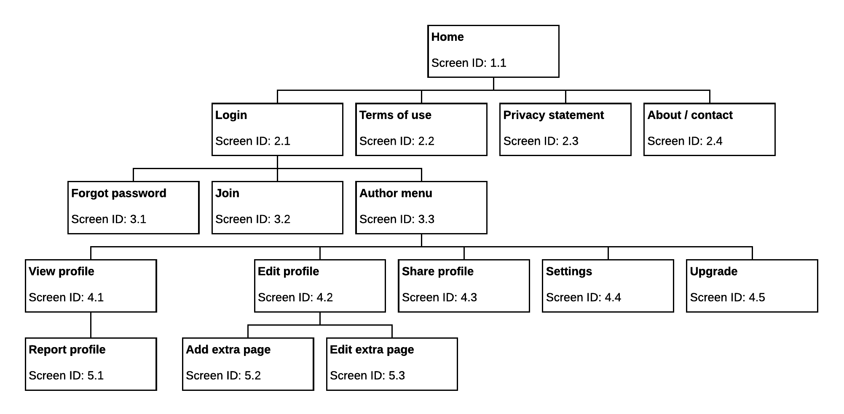

Figure : User portal navigation map

### Administrator portal

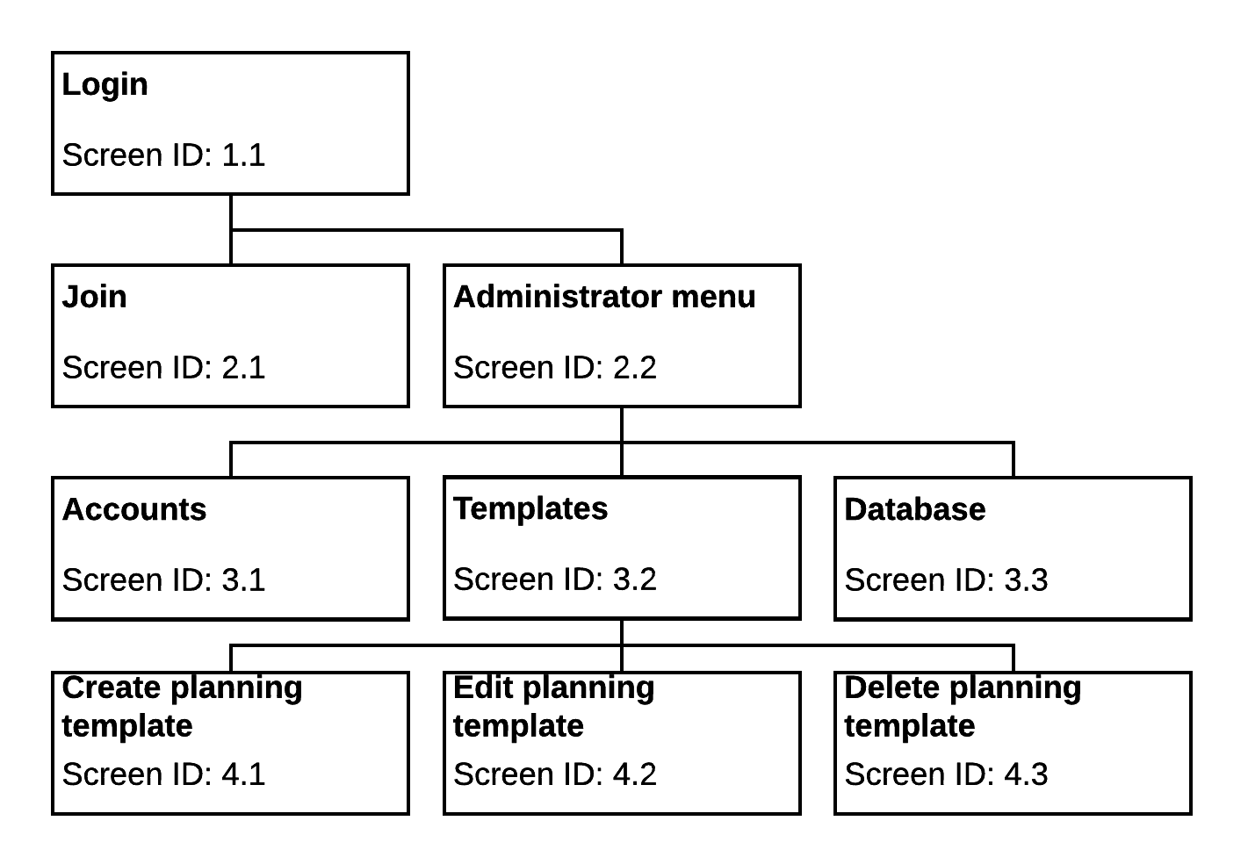

Figure : Administrator portal navigation map

## Storyboards

The team identified 16 user screens and 9 administrator screens to be designed. The storyboards have been slightly revised from the previous versions included in the System Design Specification document.

Within each diagram, the HTML divs for each section of the page are numbered and their names are indicated with red text. It is important to note that these names are for design purposes only and will not be visible on the page (i.e., they are not headings).

### User portal

#### Home: Screen ID 1.1

|  |  |  |
| --- | --- | --- |
| Title: Home | | Screen ID: 1.1 |
| Web Page Diagram: | | |
|  | | |
| Graphics: Logo, photos supporting main text (in div 4) | | |
| Text: A welcome message, with space for additional news/updates/quotes etc. | | |
| Multimedia: N/A | | |
| Notes: The bottom navigation (div 6) has links to terms of use and privacy statement. Links to the contact page and other contact options (e.g. social media) are in div 7. The footer includes the copyright statement. | | |
| Description: | Homepage | |
| Content: | Brief introduction to app concept | |
| Interactions: | Navigation and contact links | |
| Media Creation: | Logo | |
| Navigation: | Top and bottom | |

#### Login: Screen ID 2.1

|  |  |  |
| --- | --- | --- |
| Title: Login | | Screen ID: 2.1 |
| Web Page Diagram: | | |
|  | | |
| Graphics: Logo | | |
| Text: Login form. | | |
| Multimedia: N/A | | |
| Notes: The header (div 2) includes a link to the home screen. The bottom navigation (div 8) has links to terms of use and privacy statement. Links to the contact page and other contact options (e.g. social media) are in div 9. The footer includes the copyright statement. | | |
| Description: | Login landing page | |
| Content: | Login form, join button | |
| Interactions: | Link to registration page, navigation and contact links | |
| Media Creation: | N/A | |
| Navigation: | Top and bottom | |

#### Terms of use: Screen ID 2.2

|  |  |  |
| --- | --- | --- |
| Title: Terms of use | | Screen ID: 2.2 |
| Web Page Diagram: | | |
|  | | |
| Graphics: Logo | | |
| Text: In div 4, terms of use | | |
| Multimedia: N/A | | |
| Notes: The header (div 2) includes a link to the login screen. The bottom navigation (div 6) has links to login, terms of use, and privacy statement. Links to the contact page and other contact options (e.g. social media) are in div 7. The footer includes the copyright statement. | | |
| Description: | Terms of use | |
| Content: | Legal terms of use of site/app | |
| Interactions: | Navigation and contact links | |
| Media Creation: | N/A | |
| Navigation: | Top and bottom | |

#### Privacy statement: Screen ID 2.3

|  |  |  |
| --- | --- | --- |
| Title: Privacy statement | | Screen ID: 2.3 |
| Web Page Diagram: | | |
|  | | |
| Graphics: Logo | | |
| Text: In div 4, privacy statement | | |
| Multimedia: N/A | | |
| Notes: The header (div 2) includes a link to the login screen. The bottom navigation (div 6) has links to login, terms of use, and privacy statement. Links to the contact page and other contact options (e.g. social media) are in div 7. The footer includes the copyright statement. | | |
| Description: | Privacy statement | |
| Content: | Legal privacy statement of site/app | |
| Interactions: | Navigation and contact links | |
| Media Creation: | N/A | |
| Navigation: | Top and bottom | |

#### About / contact: Screen ID 2.4

|  |  |  |
| --- | --- | --- |
| Title: About / contact | | Screen ID: 2.4 |
| Web Page Diagram: | | |
|  | | |
| Graphics: Logo | | |
| Text: In div 5, blurb about site/app and contact details. In div 6, a contact form. | | |
| Multimedia: N/A | | |
| Notes: The header (div 2) includes a link to the login screen. The bottom navigation (div 9) has links to login, terms of use, and privacy statement. Links to the contact page and other contact options (e.g. social media) are in div 8. The footer includes the copyright statement. | | |
| Description: | About / Contact page | |
| Content: | Brief blurb about site/app, contact details, contact form | |
| Interactions: | Contact form, contact links, navigation links | |
| Media Creation: | N/A | |
| Navigation: | Top and bottom | |

#### Forgot password: Screen ID 3.1

|  |  |  |
| --- | --- | --- |
| Title: Forgot password | | Screen ID: 3.1 |
| Web Page Diagram: | | |
|  | | |
| Graphics: Logo | | |
| Text: In div 5, forgot password form | | |
| Multimedia: N/A | | |
| Notes: The header (div 2) includes a link to the login screen. The bottom navigation (div 7) has links to terms of use and privacy statement. Links to the contact page and other contact options (e.g. social media) are in div 8. The footer includes the copyright statement. | | |
| Description: | Forgot password | |
| Content: | Forgot password form | |
| Interactions: | Forgot password form, navigation and contact links | |
| Media Creation: | N/A | |
| Navigation: | Top and bottom | |

#### Join: Screen ID 3.2

|  |  |  |
| --- | --- | --- |
| Title: Join | | Screen ID: 3.2 |
| Web Page Diagram: | | |
|  | | |
| Graphics: Logo | | |
| Text: In div 4, a registration form | | |
| Multimedia: N/A | | |
| Notes: The header (div 2) includes a link to the login screen. The bottom navigation (div 6) has links to login, terms of use, and privacy statement. Links to the contact page and other contact options (e.g. social media) are in div 7. The footer includes the copyright statement. | | |
| Description: | Registration | |
| Content: | Registration form | |
| Interactions: | Registration form, navigation and contact links | |
| Media Creation: | N/A | |
| Navigation: | Top and bottom | |

#### Author menu: Screen ID 3.3

|  |  |  |
| --- | --- | --- |
| Title: Author menu | | Screen ID: 3.3 |
| Web Page Diagram: | | |
|  | | |
| Graphics: Logo, image placeholder (if no profile photo available) | | |
| Text: Navigation menu, generated profile activity | | |
| Multimedia: Profile activity generated via script | | |
| Notes: The bottom navigation (div 9) has links to terms of use and privacy statement. Links to the contact page and other contact options (e.g. social media) are in div 10. The footer includes the copyright statement. | | |
| Description: | Author menu | |
| Content: | Menu navigation, profile photo (or placeholder), profile activity stream | |
| Interactions: | Menu links, navigation and contact links | |
| Media Creation: | Image placeholder | |
| Navigation: | Bottom, menu | |

#### View profile: Screen ID 4.1

|  |  |  |
| --- | --- | --- |
| Title: View profile | | Screen ID: 4.1 |
| Web Page Diagram: | | |
|  | | |
| Graphics: Logo, image placeholder | | |
| Text: In div 8, disclaimer text (in red boxes). | | |
| Multimedia: N/A | | |
| Notes: The header includes a “home” link. The bottom navigation (div 10) has links to terms of use and privacy statement. Links to the contact page and other contact options (e.g. social media) are in div 11. The footer includes the copyright statement. | | |
| Description: | Profile view | |
| Content: | Profile | |
| Interactions: | Navigation and contact links | |
| Media Creation: | N/A | |
| Navigation: | Bottom, menu | |

#### Edit profile: Screen ID 4.2

|  |  |  |
| --- | --- | --- |
| Title: Edit profile | | Screen ID: 4.2 |
| Web Page Diagram: | | |
|  | | |
| Graphics: Logo, image placeholder (if no profile photo available) | | |
| Text: In div 8, disclaimer text and hints (in red boxes) | | |
| Multimedia: N/A | | |
| Notes: The header includes a “home” link. The bottom navigation (div 10) has links to terms of use and privacy statement. Links to the contact page and other contact options (e.g. social media) are in div 11. The footer includes the copyright statement. | | |
| Description: | Edit profile form | |
| Content: | Edit profile form, add/edit photo widget, edit contact info form | |
| Interactions: | Navigation and contact links, forms | |
| Media Creation: | N/A | |
| Navigation: | Bottom, menu | |

#### Share profile: Screen ID 4.3

|  |  |  |
| --- | --- | --- |
| Title: Share profile | | Screen ID: 4.3 |
| Web Page Diagram: | | |
|  | | |
| Graphics: Logo | | |
| Text: Share profile options | | |
| Multimedia: N/A | | |
| Notes: The header includes a “home” link. The bottom navigation (div 6) has links to terms of use and privacy statement. Links to the contact page and other contact options (e.g. social media) are in div 7. The footer includes the copyright statement. | | |
| Description: | Share profile form to share via various methods | |
| Content: | Share profile form | |
| Interactions: | Navigation and contact links, form | |
| Media Creation: | N/A | |
| Navigation: | Bottom, menu | |

#### Edit settings: Screen ID 4.4

|  |  |  |
| --- | --- | --- |
| Title: Edit settings | | Screen ID: 4.4 |
| Web Page Diagram: | | |
|  | | |
| Graphics: Logo | | |
| Text: Settings options | | |
| Multimedia: N/A | | |
| Notes: The header includes a “home” link. The bottom navigation (div 6) has links to terms of use and privacy statement. Links to the contact page and other contact options (e.g. social media) are in div 7. The footer includes the copyright statement. | | |
| Description: | Edit settings form | |
| Content: | Settings form | |
| Interactions: | Settings form, navigation and contact links | |
| Media Creation: | N/A | |
| Navigation: | Bottom, menu | |

#### Upgrade: Screen ID 4.5

|  |  |  |
| --- | --- | --- |
| Title: Edit settings | | Screen ID: 4.5 |
| Web Page Diagram: | | |
|  | | |
| Graphics: Logo | | |
| Text: Upgrade options | | |
| Multimedia: N/A | | |
| Notes: The header includes a “home” link. The bottom navigation (div 6) has links to terms of use and privacy statement. Links to the contact page and other contact options (e.g. social media) are in div 7. The footer includes the copyright statement. | | |
| Description: | Upgrade form | |
| Content: | Upgrade form, upgrade options descriptions | |
| Interactions: | Upgrade form, navigation and contact links | |
| Media Creation: | N/A | |
| Navigation: | Bottom, menu | |

#### Report profile: Screen ID 5.1

|  |  |  |
| --- | --- | --- |
| Title: Report profile | | Screen ID: 5.1 |
| Web Page Diagram: | | |
|  | | |
| Graphics: Logo, image placeholder (if no profile photo available) | | |
| Text: Report profile options | | |
| Multimedia: N/A | | |
| Notes: The header includes a “home” link. The bottom navigation (div 9) has links to terms of use and privacy statement. Links to the contact page and other contact options (e.g. social media) are in div 10. The footer includes the copyright statement. | | |
| Description: | Report profile for abuse form | |
| Content: | Report profile form | |
| Interactions: | Navigation and contact links, form | |
| Media Creation: | N/A | |
| Navigation: | Bottom, menu | |

#### Add extra page: Screen ID 5.2

|  |  |  |
| --- | --- | --- |
| Title: Add extra page | | Screen ID: 5.2 |
| Web Page Diagram: | | |
|  | | |
| Graphics: Logo | | |
| Text: If a template is chosen, the template text | | |
| Multimedia: N/A | | |
| Notes: The header includes a “home” link. The bottom navigation (div 9) has links to terms of use and privacy statement. Links to the contact page and other contact options (e.g. social media) are in div 10. The footer includes the copyright statement. | | |
| Description: | Add extra page form | |
| Content: | Add extra page form, including template text if applicable | |
| Interactions: | Navigation and contact links | |
| Media Creation: | N/A | |
| Navigation: | Bottom, menu | |

#### Edit extra page: Screen ID 5.3

|  |  |  |
| --- | --- | --- |
| Title: Edit extra page | | Screen ID: 5.3 |
| Web Page Diagram: | | |
|  | | |
| Graphics: Logo | | |
| Text: Pre-filled with text user has already added | | |
| Multimedia: N/A | | |
| Notes: The header (div 2) includes a “home” link. The bottom navigation (div 9) has links to terms of use and privacy statement. Links to the contact page and other contact options (e.g. social media) are in div 10. The footer includes the copyright statement. | | |
| Description: | Edit extra page form | |
| Content: | Edit page form | |
| Interactions: | Navigation and contact links, form | |
| Media Creation: | N/A | |
| Navigation: | Top and bottom | |

### Administrator portal

#### Login: Screen ID 1.1

|  |  |  |
| --- | --- | --- |
| Title: Login | | Screen ID: 1.1 |
| Web Page Diagram: | | |
|  | | |
| Graphics: Logo | | |
| Text: Login form. | | |
| Multimedia: N/A | | |
| Notes: The header (div 2) includes a link to the home screen. The bottom navigation (div 8) has links to terms of use and privacy statement. Links to the contact page and other contact options (e.g. social media) are in div 9. The footer includes the copyright statement. | | |
| Description: | Login landing page | |
| Content: | Login form, join button | |
| Interactions: | Link to registration page, navigation and contact links | |
| Media Creation: | N/A | |
| Navigation: | Top and bottom | |

#### Join: Screen ID 2.1

|  |  |  |
| --- | --- | --- |
| Title: Join | | Screen ID: 2.1 |
| Web Page Diagram: | | |
|  | | |
| Graphics: Logo | | |
| Text: Join form. | | |
| Multimedia: N/A | | |
| Notes: The header (div 2) includes a link to the home screen. The bottom navigation (div 6) has links to terms of use and privacy statement. Links to the contact page and other contact options (e.g. social media) are in div 7. The footer includes the copyright statement. | | |
| Description: | Join form | |
| Content: | Join form | |
| Interactions: | Navigation and contact links | |
| Media Creation: | N/A | |
| Navigation: | Top and bottom | |

#### Administrator menu: Screen ID 2.2

|  |  |  |
| --- | --- | --- |
| Title: Administrator menu | | Screen ID: 2.2 |
| Web Page Diagram: | | |
|  | | |
| Graphics: Logo | | |
| Text: Recent activity/action items | | |
| Multimedia: N/A | | |
| Notes: The header (div 2) includes a link to the home screen. The bottom navigation (div 7) has links to terms of use and privacy statement. Links to the contact page and other contact options (e.g. social media) are in div 8. The footer includes the copyright statement. | | |
| Description: | Administrator landing page | |
| Content: | Activity stream, menu | |
| Interactions: | Navigation and contact links | |
| Media Creation: | N/A | |
| Navigation: | Bottom, menu | |

#### Accounts: Screen ID 3.1

|  |  |  |
| --- | --- | --- |
| Title: Accounts | | Screen ID: 3.1 |
| Web Page Diagram: | | |
|  | | |
| Graphics: Logo | | |
| Text: Buttons to take action on a specific account. | | |
| Multimedia: N/A | | |
| Notes: The header (div 2) includes a link to the home screen. The bottom navigation (div 7) has links to terms of use and privacy statement. Links to the contact page and other contact options (e.g. social media) are in div 8. The footer includes the copyright statement. | | |
| Description: | Account administration | |
| Content: | Account action buttons | |
| Interactions: | Action buttons, navigation and contact links | |
| Media Creation: | N/A | |
| Navigation: | Bottom, menu | |

#### Planning templates: Screen ID 3.2

|  |  |  |
| --- | --- | --- |
| Title: Planning templates | | Screen ID: 3.2 |
| Web Page Diagram: | | |
|  | | |
| Graphics: Logo | | |
| Text: Buttons to take actions on planning templates. | | |
| Multimedia: N/A | | |
| Notes: The header (div 2) includes a link to the home screen. The bottom navigation (div 7) has links to terms of use and privacy statement. Links to the contact page and other contact options (e.g. social media) are in div 8. The footer includes the copyright statement. | | |
| Description: | Planning template administration | |
| Content: | Planning template action buttons | |
| Interactions: | Action buttons, navigation and contact links | |
| Media Creation: | N/A | |
| Navigation: | Bottom, menu | |

#### Database: Screen ID 3.3

|  |  |  |
| --- | --- | --- |
| Title: Database | | Screen ID: 3.3 |
| Web Page Diagram: | | |
|  | | |
| Graphics: Logo | | |
| Text: Buttons to take actions on database. | | |
| Multimedia: N/A | | |
| Notes: The header (div 2) includes a link to the home screen. The bottom navigation (div 7) has links to terms of use and privacy statement. Links to the contact page and other contact options (e.g. social media) are in div 8. The footer includes the copyright statement. | | |
| Description: | Database administration | |
| Content: | Database action buttons | |
| Interactions: | Action buttons, navigation and contact links | |
| Media Creation: | N/A | |
| Navigation: | Bottom, menu | |

#### Create planning template: Screen ID 4.1

|  |  |  |
| --- | --- | --- |
| Title: Create planning template | | Screen ID: 4.1 |
| Web Page Diagram: | | |
|  | | |
| Graphics: Logo | | |
| Text: Planning template form. | | |
| Multimedia: N/A | | |
| Notes: The header (div 2) includes a link to the home screen. The bottom navigation (div 8) has links to terms of use and privacy statement. Links to the contact page and other contact options (e.g. social media) are in div 9. The footer includes the copyright statement. | | |
| Description: | Planning template creation form. | |
| Content: | Form, button | |
| Interactions: | Navigation and contact links, form | |
| Media Creation: | N/A | |
| Navigation: | Bottom, menu | |

#### Edit planning template: Screen ID 4.2

|  |  |  |
| --- | --- | --- |
| Title: Edit planning template | | Screen ID: 4.2 |
| Web Page Diagram: | | |
|  | | |
| Graphics: Logo | | |
| Text: Pre-filled with template text | | |
| Multimedia: N/A | | |
| Notes: The header (div 2) includes a “home” link. The bottom navigation (div 8) has links to login, terms of use, and privacy statement. Links to the contact page and other contact options (e.g. social media) are in div 9. The footer includes the copyright statement. | | |
| Description: | Edit planning template form | |
| Content: | Edit page form | |
| Interactions: | Navigation and contact links, form | |
| Media Creation: | N/A | |
| Navigation: | Bottom, menu | |

#### Delete planning template: Screen ID 4.3

|  |  |  |
| --- | --- | --- |
| Title: Login | | Screen ID: 4.3 |
| Web Page Diagram: | | |
|  | | |
| Graphics: Logo | | |
| Text: Delete template form. | | |
| Multimedia: N/A | | |
| Notes: The header (div 2) includes a link to the home screen. The bottom navigation (div 8) has links to terms of use and privacy statement. Links to the contact page and other contact options (e.g. social media) are in div 9. The footer includes the copyright statement. | | |
| Description: | Delete template form | |
| Content: | Delete template form | |
| Interactions: | Navigation and contact links, form | |
| Media Creation: | N/A | |
| Navigation: | Bottom, menu | |

###### Appendices

1. Client feedback form

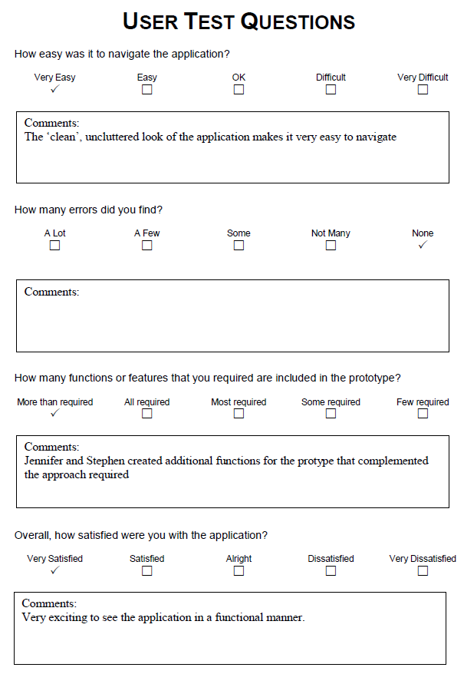

1. Project timeline

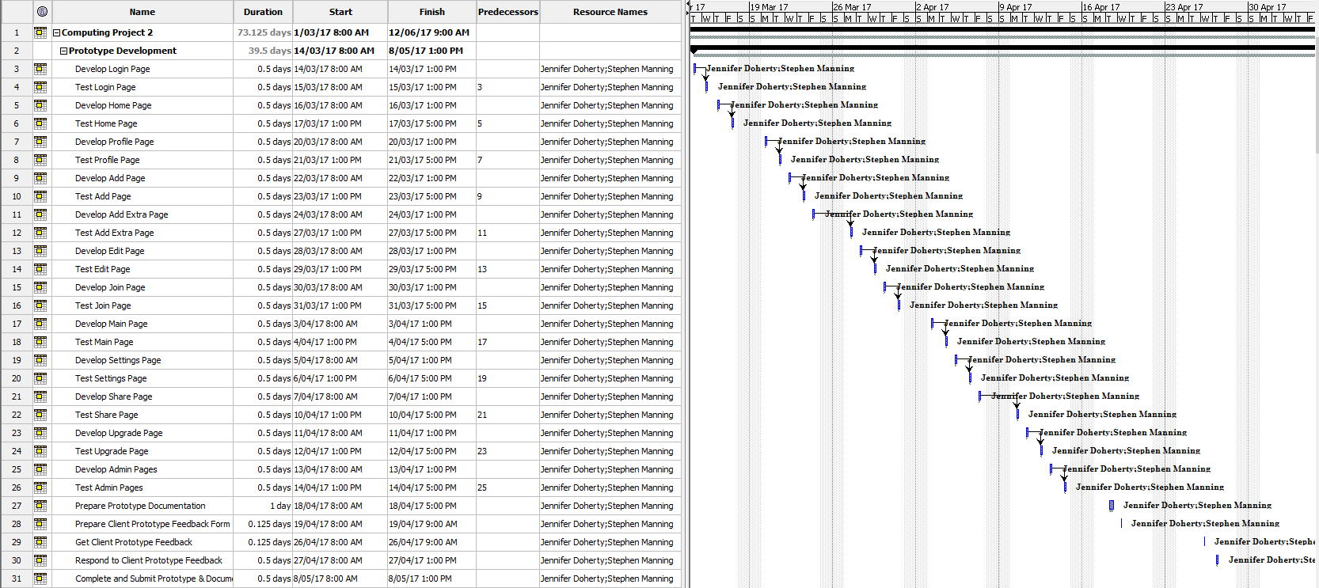

Figure : Project timeline 1

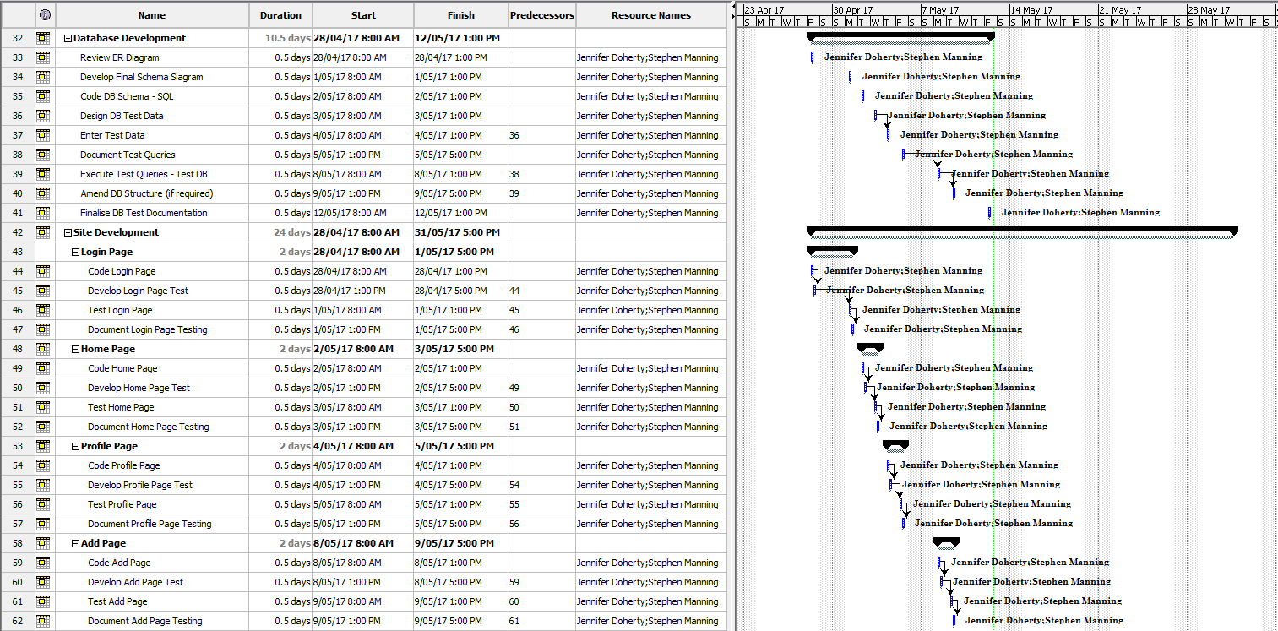

Figure : Project timeline 2

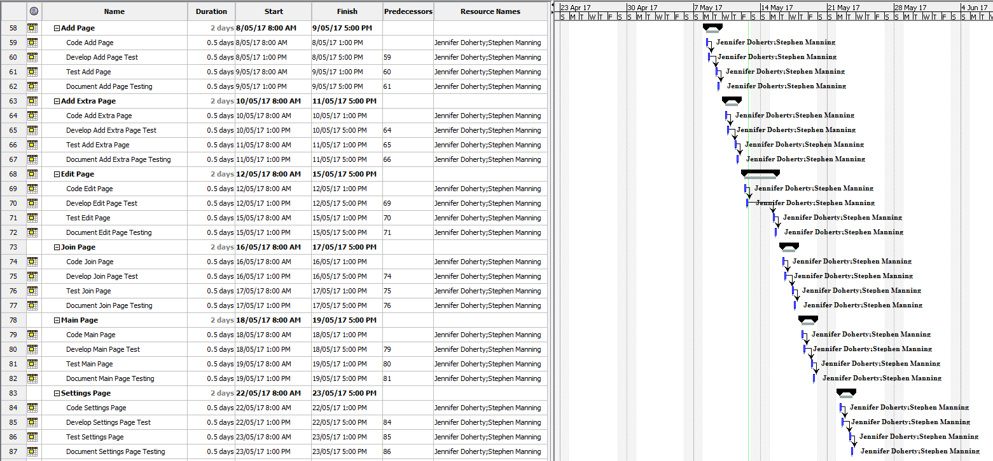

Figure : Project timeline 3

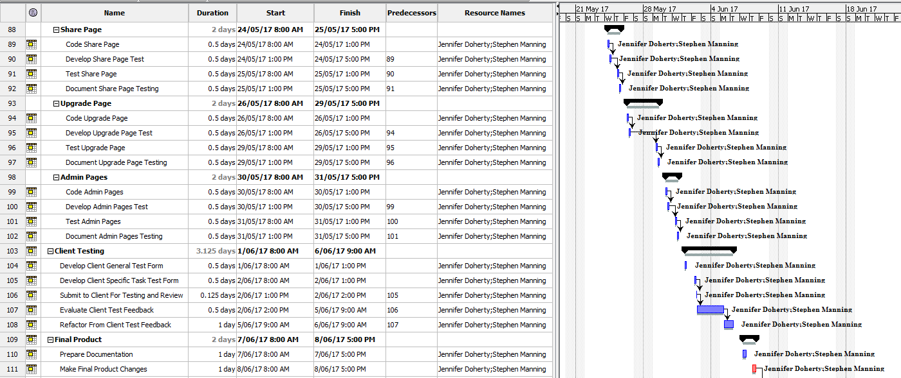

Figure : Project timeline 4

Please note: the below section of the timeline does not include the graph as this section stretches the length of the project.

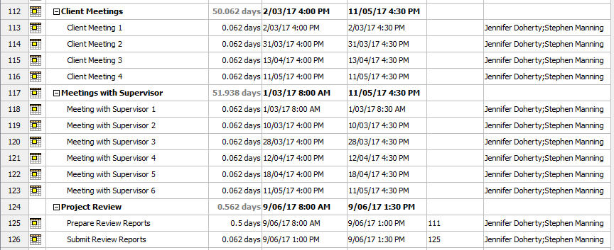

Figure : Project timeline 5

1. References

Budiu, R 2013, *Mobile: Native apps, web apps, and hybrid apps*, Viewed 9 May 2017, <<https://www.nngroup.com/articles/mobile-native-apps/>>.

Cao, J 2015, *How & why prototypes are mandatory for good design*, Viewed 28 March 2017, <<https://designshack.net/articles/graphics/how-why-prototypes-are-mandatory-for-good-design/>>.

Google 2017, *Material design*, Viewed 9 May 2017, <<https://material.io/guidelines/>>.

Google Security Blog 2016, *Moving towards a more secure web*, Viewed 6 February 2017, <<https://security.googleblog.com/2016/09/moving-towards-more-secure-web.html>>.

U.S. Department of Health & Human Services 2017, *Prototyping*, Viewed 28 March 2017, <<https://www.usability.gov/how-to-and-tools/methods/prototyping.html>>.