About Me Project

System Design Specification

|  |
| --- |
| Southern Cross University  Unit: ISY10221 Computing Project I |



Project Supervisor: Paul Woods

Project Client: Jean Stevens on behalf of Elucidate

Project Team: Jennifer Doherty and Stephen Manning

# Executive Summary

The System Design Specification expands on previous documentation for the About Me Project by specifying how the app should function. Diagrams included in previous documentation, such as the System Requirements Specification, have been revised and are included in this document.

This Systems Design Specification document includes detailed diagrams and descriptions for various aspects of the About Me Project app. Process algorithms in structured English are detailed for processes for each profile level and user type. Data storage specifications, including a normalised Entity Relationship Diagram, are included. Interface design details, such as the design brief from the client and a site navigation map, are also included. There is a Storyboards section, with screen diagrams and detailed descriptions of each screen.

Best practice recommendations for reliability, mobile design, and usability design are also included in their own sections.

Contents

[Executive Summary 2](#_Toc474768605)

[Section 1. Introduction 9](#_Toc474768606)

[Section 2. System functionality 10](#_Toc474768607)

[2.1. Revised use case diagrams 10](#_Toc474768608)

[2.1.1. Revised use cases: simple profile 10](#_Toc474768609)

[2.1.2. Revised use cases: in-depth profile 11](#_Toc474768610)

[2.1.3. Revised planning-plus profile (with planning templates) 11](#_Toc474768611)

[2.2. Revised class diagram 12](#_Toc474768612)

[2.3. Revised activity diagrams 12](#_Toc474768613)

[2.4. Revised sequence diagrams 12](#_Toc474768614)

[Section 3. Program design 13](#_Toc474768615)

[3.1. Simple profile (level 1) processes 13](#_Toc474768616)

[3.1.1. Sign In 13](#_Toc474768617)

[3.1.2. SignOut 15](#_Toc474768618)

[3.1.3. SignUp 16](#_Toc474768619)

[3.1.4. ChangePassword 18](#_Toc474768620)

[3.1.5. ResetPassword 20](#_Toc474768621)

[3.1.6. GoToMainScreen 22](#_Toc474768622)

[3.1.7. ViewActivityHistory 23](#_Toc474768623)

[3.1.8. ViewProfile 24](#_Toc474768624)

[3.1.9. CreateProfile 25](#_Toc474768625)

[3.1.10. EditProfile 27](#_Toc474768626)

[3.1.11. DeleteProfile 29](#_Toc474768627)

[3.1.12. HideProfile 30](#_Toc474768628)

[3.1.13. UnhideProfile 31](#_Toc474768629)

[3.1.14. ConfirmProfileRead 32](#_Toc474768630)

[3.1.15. ReportProfile 33](#_Toc474768631)

[3.1.16. ShareprofileApp 35](#_Toc474768632)

[3.1.17. ShareProfileEmail 36](#_Toc474768633)

[3.1.18. ShareProfileSocial 37](#_Toc474768634)

[3.1.19. ShareProfilePDF 38](#_Toc474768635)

[3.1.20. UpgradeLevel 39](#_Toc474768636)

[3.1.21. ChangePreferences 41](#_Toc474768637)

[3.1.22. ExitWithNativeGesture 42](#_Toc474768638)

[3.2. In-depth profile (level 2) processes 43](#_Toc474768639)

[3.2.1. Downgrade 43](#_Toc474768640)

[3.2.2. ViewAdditionalPage 45](#_Toc474768641)

[3.2.3. ConfirmAdditionalPageRead 46](#_Toc474768642)

[3.2.4. CreateAdditionalPage 47](#_Toc474768643)

[3.2.5. EditAdditionalPage 49](#_Toc474768644)

[3.2.6. DeleteAdditionalPage 51](#_Toc474768645)

[3.3. Planning-plus profile with planning templates (level 3) processes 52](#_Toc474768646)

[3.3.1. ViewPlanningTemplate 52](#_Toc474768647)

[3.4. Contributor processes 54](#_Toc474768648)

[3.4.1. CreatePlanningTemplate 54](#_Toc474768649)

[3.4.2. ViewPlanningTemplate 55](#_Toc474768650)

[3.4.3. EditPlanningTemplate 56](#_Toc474768651)

[3.5. Administrator processes 57](#_Toc474768652)

[3.5.1. Search 57](#_Toc474768653)

[3.5.2. EditProfile 58](#_Toc474768654)

[3.5.3. EditAccount 59](#_Toc474768655)

[3.5.4. BackupSystem 60](#_Toc474768656)

[3.5.5. RestoreSystem 61](#_Toc474768657)

[Section 4. Data storage 62](#_Toc474768658)

[4.1. Entity Relationship Diagram 63](#_Toc474768659)

[4.2. Field data types and null values 64](#_Toc474768660)

[4.3. Normalisation 69](#_Toc474768661)

[Section 5. Interface design 71](#_Toc474768662)

[5.1. Design brief 71](#_Toc474768663)

[5.2. Navigation map 72](#_Toc474768664)

[5.3. Storyboards 73](#_Toc474768665)

[5.3.1. Home: Screen ID 1.1 74](#_Toc474768666)

[5.3.2. Join: Screen ID 2.1 75](#_Toc474768667)

[5.3.3. Login: Screen ID 2.2 76](#_Toc474768668)

[5.3.4. Terms of use: Screen ID 2.3 77](#_Toc474768669)

[5.3.5. Privacy statement: Screen ID 2.4 78](#_Toc474768670)

[5.3.6. About / contact: Screen ID 2.5 79](#_Toc474768671)

[5.3.7. Author registration: Screen ID 3.1 80](#_Toc474768672)

[5.3.8. Staff / contributor registration: Screen ID 3.2 81](#_Toc474768673)

[5.3.9. Author menu: Screen ID 3.3 82](#_Toc474768674)

[5.3.10. Staff / contributor menu: Screen ID 3.4 83](#_Toc474768675)

[5.3.11. Create profile: Screen ID 4.1 84](#_Toc474768676)

[5.3.12. Edit settings: Screen ID 4.2 85](#_Toc474768677)

[5.3.13. Edit profile: Screen ID 4.3 86](#_Toc474768678)

[5.3.14. Add extra page: Screen ID 4.4 87](#_Toc474768679)

[5.3.15. Edit extra page: Screen ID 4.5 88](#_Toc474768680)

[5.3.16. Edit planning template: Screen ID 4.6 89](#_Toc474768681)

[5.3.17. View profile: Screen ID 4.7 90](#_Toc474768682)

[5.3.18. Add blank page: Screen ID 5.1 91](#_Toc474768683)

[5.3.19. Add page from planning template: Screen ID 5.2 92](#_Toc474768684)

[5.3.20. Report profile: Screen ID 5.3 93](#_Toc474768685)

[5.3.21. Share profile: Screen ID 5.4 94](#_Toc474768686)

[Section 6. Architecture design 95](#_Toc474768687)

[6.1. Reliability 95](#_Toc474768688)

[6.1.1. Low maintenance 95](#_Toc474768689)

[6.1.2. Robust app/website 95](#_Toc474768690)

[6.1.3. Security 95](#_Toc474768691)

[Section 7. Design for other requirements 96](#_Toc474768692)

[7.1. Mobile use 96](#_Toc474768693)

[7.2. Usability design 96](#_Toc474768694)

[Appendices 98](#_Toc474768695)

[Appendix 1. Revised use case diagrams 98](#_Toc474768696)

[1.1. Simple profile 98](#_Toc474768697)

[1.2. In-depth profile 99](#_Toc474768698)

[1.3. Planning-plus profile (with planning templates) 100](#_Toc474768699)

[Appendix 2. Revised class diagram 101](#_Toc474768700)

[Appendix 3. Revised activity diagrams 102](#_Toc474768701)

[3.1. Login 102](#_Toc474768702)

[3.2. Sign out 103](#_Toc474768703)

[3.3. Sign up 104](#_Toc474768704)

[3.4. Reset password 105](#_Toc474768705)

[3.5. View activity history 106](#_Toc474768706)

[3.6. Create profile 107](#_Toc474768707)

[3.7. Edit profile 108](#_Toc474768708)

[3.8. Hide profile 109](#_Toc474768709)

[3.9. Report profile 110](#_Toc474768710)

[3.10. Downgrade 111](#_Toc474768711)

[3.11. Upgrade 112](#_Toc474768712)

[Appendix 4. Revised sequence diagrams 113](#_Toc474768713)

[4.1. Sign up, create profile, edit profile 113](#_Toc474768714)

[4.2. Login, reset password 114](#_Toc474768715)

[4.3. Report user 115](#_Toc474768716)

[4.4. Create and edit planning template page 116](#_Toc474768717)

[4.5. Share profile 117](#_Toc474768718)

[4.6. Remove profile 118](#_Toc474768719)

[Appendix 5. Project timeline 119](#_Toc474768720)

[Appendix 6. References 123](#_Toc474768721)

Tables and Figures

[Table 1: Field data types and null values 65](#_Toc474217025)

[Table 2: Database normalisation 70](#_Toc474217026)

[Figure 1: Entity Relationship Diagram 64](#_Toc474217027)

[Figure 2: Revised simple profile use case diagram 98](#_Toc474217028)

[Figure 3: Revised in-depth profile use case diagram 99](#_Toc474217029)

[Figure 4: Revised planning-plus profile (with planning templates) use case diagram 100](#_Toc474217030)

[Figure 5: Revised class diagram 101](#_Toc474217031)

[Figure 6: Revised login activity diagram 102](#_Toc474217032)

[Figure 7: Revised sign out activity diagram 103](#_Toc474217033)

[Figure 8: Revised sign up activity diagam 104](#_Toc474217034)

[Figure 9: Reset password activity diagram 105](#_Toc474217035)

[Figure 10: Revised view activity history activity diagram 106](#_Toc474217036)

[Figure 11: Revised create profile activity diagram 107](#_Toc474217037)

[Figure 12: Revised edit profile activity diagram 108](#_Toc474217038)

[Figure 13: Revised hide profile activity diagram 109](#_Toc474217039)

[Figure 14: Revised report profile activity diagram 110](#_Toc474217040)

[Figure 15: Revised downgrade activity diagram 111](#_Toc474217041)

[Figure 16: Revised upgrade activity diagram 112](#_Toc474217042)

[Figure 17: Sign up, create profile, edit profile sequence diagram 113](#_Toc474217043)

[Figure 18: Login, reset password sequence diagram 114](#_Toc474217044)

[Figure 19: Report user sequence diagram 115](#_Toc474217045)

[Figure 20: Create and edit planning template page sequence diagram 116](#_Toc474217046)

[Figure 21: Share profile sequence diagram 117](#_Toc474217047)

[Figure 22: Remove profile sequence diagram 118](#_Toc474217048)

[Figure 23: Project timeline 1 119](#_Toc474217049)

[Figure 24: Project timeline 2 120](#_Toc474217050)

[Figure 25: Project timeline 3 121](#_Toc474217051)

[Figure 26: Project timeline 4 122](#_Toc474217052)

# Introduction

The System Requirements Specification document previously compiled consisted of logical models which described *what* functions the AMP app and website will be able to perform. The System Design Specification adds to, and elaborates upon, the previous document by describing *how* the system will do what is required of it.

While producing this document, the development team made revisions and improvements to elements of the System Requirements Specification, including the class diagram, sequence diagrams and use cases. Updated documentation for these elements has been included in this report.

# System functionality

As the team produced this document, more efficient and logical approaches came to light, requiring the team to revise and expand diagrams previously created for the System Requirements Specification document. For example, it was initially decided that a connection to the database should be established each time a query needs to be executed, and that the connection should be destroyed straight afterwards. In the process of researching best security practices, the team discovered an improved approach in which database connection is handled by a secure script that requires a single connection to be made, rather than multiple connections being established and destroyed throughout the session (Lionite 2014).

The revised diagrams in this section are based on the original diagrams from the System Requirements Specification document.

## Revised use case diagrams

Please refer to Appendix 1 for the revised use case diagrams.

### Revised use cases: simple profile

The use cases for the simple profile (level 1) have been simplified as below:

* All processes for changing settings have been combined into a single use case, Change Settings, which includes processes for changing settings for colours, font size, notifications (in-app, push and email), sound (on or off) and volume.
* Processes for saving, publishing, cancelling changes to and deleting a profile are now included under the Edit Profile use case.
* Processes for upgrading to Levels 2 and 3 have been aggregated under a single Upgrade use case.
* Both Authors and Viewers are now able to report a profile.
* Under the use case for sharing a profile, a process has been included for sharing the profile via printable PDF.

### Revised use cases: in-depth profile

The use cases for the in-depth profile (level 2) have been revised and simplified as below:

* Processes for downgrading to level 1 and level 2 have been combined into a single use case, Downgrade.
* Both Authors and Viewers now have access to the use case Confirm Additional Page has been read.
* Processes for cancelling, saving and publishing an additional page have been aggregated under the process Edit Additional Page, which is now accessible from the View Additional Page screen.
* Similarly, Delete Additional Page is now accessible from the View Additional Page screen, and includes the Cancel use case.

Please note that the use cases for Level 1 Profile are included in the set of use cases for Level 2 Profile.

### Revised planning-plus profile (with planning templates)

The use cases for the planning-plus profile (level 3) have been revised and simplified as below:

* View Planning Template replaces the Download Planning Template use case and includes Edit Additional Page, which aggregates processes for deleting, saving, publishing or cancelling changes to an additional page based off a planning template.
* An additional use case, Reset, allows an Author to undo all changes made to a planning template.
* Contributors now have a use case for managing and searching templates.

Please note that the use cases for Level 2 Profile are included in the set of use cases for Level 3 Profile.

## Revised class diagram

The class diagram from the System Requirements Specification has been significantly reworked, to make the Profile class the central class. Please refer to Appendix 2 for the revised class diagram.

## Revised activity diagrams

Whilst developing process algorithms and in the process of researching best coding practices, the team devised improved processes. Please refer to Appendix 3 for the revised activity diagrams.

## Revised sequence diagrams

The revision of the use cases and class diagrams also required revision of the sequence diagrams. Please refer to Appendix 4 for the revised sequence diagrams.

# Program design

In preparation for developing the actual code for the software, the team produced process algorithms which describe the actions to be executed and the order in which these actions should be executed. This section includes process algorithms for each possible process at each profile level.

## Simple profile (level 1) processes

### Sign In

|  |  |
| --- | --- |
| Process name | SignIn |
| Purpose | Authenticate a user and connect to database |
| Inputs | * Click or press Sign In * Enter username and password |
| Entry criteria | * App or website is running * User is not already signed in * User has clicked or pressed Sign In |
| Process | If username or password fields are blank  Display onscreen error  Else if username and password are non-blank  If username isn’t found or password doesn’t match  Display error “unable to log you in with that combination”  Enable option to reset password  Else  Authenticate user  Update Log attribute of ProfileHistory object  Display login confirmation  Ask user if they wish to remain signed in  If user wishes to remain signed in  Dispatch continual sign-in cookie  Display Main Screen |
| Exit criteria | The process will terminate upon one of the following conditions being met:   * The user has been authenticated * The user has clicked or pressed Cancel |
| Outputs | * In-app login confirmation upon successful authentication * Error and reset-password prompt upon unsuccessful login attempt |

### SignOut

|  |  |
| --- | --- |
| Process name | SignOut |
| Purpose | Sign out a user |
| Inputs | Click or press SignOut icon |
| Entry Criteria | * App or website is running * User is already signed in * User has clicked or pressed Sign Out |
| Process | Update profile history  Sign out user  Display sign-out confirmation  Close database connection  Destroy session  Return to landing screen |
| Exit criteria | The process will terminate upon the following conditions being met:   * The user has been signed out from the system * The user’s profile history has been updated * The database connection has been closed * The session has been destroyed * The user has been redirected to the landing screen |
| Outputs | In-app signout confirmation |

### SignUp

|  |  |
| --- | --- |
| Process name | SignUp |
| Purpose | Register a user in the AMP database |
| Inputs | * Email address * Password * Password confirmation * Click link in confirmation email * Press OK in onscreen confirmation message |
| Entry Criteria | * The app or website is running * The user has clicked or pressed the SignUp button on the landing screen |
| Process | Display SignUp form  If user presses Submit button on SignUp form  Check username and password fields are non-blank  If username or password fields are blank  Alert user  Else if username and password are not blank  If email address already exists in database  Alert user and prompt to log in with existing account, or try another address  If password does not meet complexity requirements  Display requirements and prompt user to try again  If user hasn’t ticked checkboxes for Terms of Use and Privacy Policy  Prompt user to tick mandatory checkboxes  Create new Author Object with user’s details and set IsActive attribute to FALSE  Send verification email  Mark account as ACTIVE  Send welcome email  Display activation confirmation  Return to login screen |
| Exit criteria | The method will terminate upon one of the following conditions being met:   * A user has signed up with a unique email address, and a corresponding Author object has been created and populated with the user’s sign-up details * User has clicked or pressed Cancel |
| Outputs | * In-app message asking use to check email * Welcome email * In-app confirmation after link in activation email has been invoked * N/A (if user has cancelled sign up process) |

### ChangePassword

|  |  |
| --- | --- |
| Process name | ChangePassword |
| Purpose | Changes a user’s password |
| Inputs | * User’s old password * New password * Confirmation of new password * Click or press Continue, Cancel or OK buttons |
| Entry Criteria | * A signed-in user has invoked the Change Password method |
| Process | Load Change Password form  Do  Read new password and confirmation of new password  If new password and confirmation don’t match  Display error “passwords don’t match”  Else if new password doesn’t meet complexity requirements  Display error “password needs to be 8 characters long with at least one uppercase character  While user hasn’t pressed Submit button  Read old password  If old password is correct  Update password attribute of Author object  Display in-app confirmation  Send confirmation email  Return to main screen  Else  Display in-app error message  Return to password reset screen |
| Exit criteria | The method will terminate upon one of the following conditions being met:   * Password has been successfully changed * User has clicked or pressed Cancel |
| Outputs | * In-app confirmation * Confirmation email * In-app error (for unsuccessful password change) * NA (for cancelling password change) |

### ResetPassword

|  |  |
| --- | --- |
| Process name | ResetPassword |
| Purpose | Resets a user’s forgotten password |
| Inputs | * User’s email address * Click or press Continue, Cancel or OK buttons * Click or press links to Reactivate a dormant account or Create a new account |
| Entry Criteria | * An unauthenticated user has invoked the password reset method |
| Process | Prompt user to enter email address  Retrieve Author object from database  If email address is registered in list of inactive Authors  Display in-app error message with Reactivate Account button  If user presses or clicks Reactivate Account button  Advise user that a reactivation email has been sent  If user clicks reactive link in reactivation email  Send email notification to Administrator  Display in-app confirmation of pending account re-activation  Else if user presses Cancel  Return to login screen  Else if email is registered to an active account OR is not registered  Display message advising user that if the email has been registered, a password reset email has been sent to that address  If user clicks link from password reset email  Display reset password screen (with fields for new password and confirmation of new password)  If user leaves password field  If password is blank or doesn’t meet complexity requirements  Display on-screen error  If user leaves confirmation field  If confirmation doesn’t match password  Display on-screen error  If user presses submit  Update password field of User object  Display onscreen confirmation of password reset |
| Exit criteria | The method will terminate upon one of the following conditions being met:   * User has clicked or pressed OK after successfully changing password * User has clicked or pressed Create or Reactivate to create a new account or reactivate a dormant one, respectively * User has clicked or pressed Cancel |
| Outputs | * In-app confirmation and email confirmation (for successful password reset) * In-app error message (for unsuccessful password reset) * NA (for cancellation) |

### GoToMainScreen

|  |  |
| --- | --- |
| Process name | GotoMainScreen |
| Purpose | Navigate to main screen from another screen within the app or website |
| Inputs | Click or press Home icon |
| Entry Criteria | * User has been authenticated * User has clicked or pressed Home icon |
| Process | Navigate to Home screen |
| Exit Criteria | Home screen has been invoked |
| Outputs | NA |

### ViewActivityHistory

|  |  |
| --- | --- |
| Process name | ViewActivityHistory |
| Purpose | Show the activity history of a Profile |
| Inputs | Click or press History icon to invoke History Click or press Close icon to close History |
| Entry Criteria | * User has been authenticated * User has a profile, and has clicked or pressed the **History** icon |
| Process | Retrieve ProfileHistory object from database  Display log attribute of ProfileHistory |
| Exit Criteria | The method will terminate after the user has clicked or pressed Close |
| Outputs | List of activity history including time spent in app or website, profile shares and profile reads |

### ViewProfile

|  |  |
| --- | --- |
| Process name | ViewProfile |
| Purpose | View a profile that has been shared via an in-app invitation |
| Inputs | * Click or press View Profile link |
| Entry Criteria | * User has clicked or pressed an invitation to view a Profile |
| Process | Get profile from database If isHidden, isSuspended or IsDeleted attributes are false  Display in-app error message  Else  Display profile  Update log attribute of ProfileHistory object for target Profile  Invoke ConfirmProfileRead process |
| ExitCriteria | Target-profile has been loaded for viewing, or in-app error displayed |
| Outputs | Target-profile or In-app error |

### CreateProfile

|  |  |
| --- | --- |
| Process name | CreateProfile |
| Purpose | Create a new profile |
| Inputs | * Mandatory and nonmandatory text fields * Upload profile picture (optional) * Press OK or cancel |
| Entry Criteria | User has signed-in and the app or website is running |
| Process | Invoke profile creation screen  If user presses OK  If non-mandatory fields are incomplete  Prompt user to complete mandatory fields  If user chooses option to upload photo  Allow user to select file from device or url  Copy file to server  Link file to profile  If user selects Cancel  Ask user to confirm cancellation (Yes/No)  If user selects Yes  Return to main screen  Else  Remain on profile creation screen  If user selects Save  Save changes to profile  Display in-app confirmation  If user selects Publish  Ask user to confirm (Yes/No)  If user selects No  Remain on profile creation screen  Else  Publish profile  Display in-app confirmation  Update log attribute of ProfileHistory object  Return to main screen |
| Exit Criteria | Profile has been created and optionally published, or profile creation has been cancelled by the user |
| Output | Confirmation message for saving profile  Confirmation message for publishing profile |

### EditProfile

|  |  |
| --- | --- |
| Process name | EditProfile |
| Purpose | Edit the photo or paragraphs of an existing Profile |
| Inputs | * Insertion, deletion or modification of text in paragraph fields * Linking or unlinking of extra pages * Uploading or deletion of Profile picture * Clicking or pressing of Save, Cancel or Publish buttons |
| Entry Criteria | User has invoked Edit button from within Profile or Extra Page screen |
| Process | Display Edit Profile screen  If changes have been made to paragraph fields or photo  Enable Save and Publish buttons  If Save is clicked or pressed  Save edited content to draft fields of Profile object  Display in-app confirmation  If notifyNetwork is enabled  Send notification to linked Profiles  If Publish is clicked or pressed  Replace published fields of Profile object with draft fields  Display in-app confirmation  If notifyNetwork is enabled  Send notification to linked Profiles  Update log attribute of ProfileHistory object  Else if Cancel has been clicked or pressed  Ask user to confirm  If user confirms  Return to Profile screen  Else  Remain on Edit Profile screen |
| Exit Criteria | The method will terminate upon one of the following conditions being met:   * User has clicked or pressed Cancel and Confirm * User has navigated away from Edit Profile screen (and pressed Cancel and Confirm if appropriate) * User has exited the AMP software |
| Output | If no changes have been made   * NA   If changes have been saved, published or cancelled   * In-app confirmation |

### DeleteProfile

|  |  |
| --- | --- |
| Process name | DeleteProfile |
| Purpose | Delete an existing Profile |
| Inputs | * N/A |
| Entry Criteria | User has clicked or pressed Delete from within Edit Profile screen |
| Process | Ask user to confirm Profile deletion  If user clicks or presses Confirm  Change IsDeleted attribute of Profile object to True  Update log attribute of ProfileHistory object  Else  Return to Profile screen |
| Exit criteria | The method will terminate upon one of the following conditions being met:   * User has clicked or pressed Cancel and Confirm * User has navigated away from Edit Profile screen (and pressed Cancel and Confirm if appropriate) * User has exited the AMP software |
| Output | When user initiates Profile deletion:   * Warning message   If user follows through with Profile deletion:   * In-app confirmation of Profile deletion * Email confirmation of Profile deletion   If user cancels Profile deletion   * NA |

### HideProfile

|  |  |
| --- | --- |
| Process name | HideProfile |
| Purpose | Hide a profile from public view |
| Inputs | Click or press Hide and Cancel or Confirm buttons |
| Entry Criteria | User has invoked Hide option from Edit Profile screen |
| Process | Ask user to confirm that Profile is to be hidden  If user confirms  Change isHidden attribute of Profile object to True  Display in-app confirmation  Update log attribute of ProfileHistory object  Change Hide icon to Unhide icon  Else  Return to Profile screen |
| Exit Criteria | The process will terminate upon one of the following conditions being met:   * User has clicked or pressed OK or Cancel after clicking or pressing Hide * User has exited the AMP software |
| Output | If user confirms profile should be hidden   * In-app and email confirmation * Hide icon changes to Unhide icon   If user cancels profile hiding   * NA |

### UnhideProfile

|  |  |
| --- | --- |
| Process name | UnhideProfile |
| Purpose | Reveal a hidden profile for public viewing |
| Inputs | Click or press Unhide and Cancel or Confirm buttons |
| Entry Criteria | User has invoked Unhide option from Edit Profile screen |
| Process | Ask user to confirm that Profile is to be unhidden  If user confirms  Change isHidden attribute of Profile object to False  Display in-app confirmation  Update log attribute of ProfileHistory object  Change Unhide icon to Hide icon  Else  Return to Profile screen |
| Exit Criteria | The process will terminate upon one of the following conditions being met:   * User has clicked or pressed OK or Cancel after clicking or pressing Unhide * User has exited the AMP software |
| Output | If user confirms profile should be unhidden   * In-app and email confirmation * Unhide icon changes to Hide icon   If user cancels profile unhiding   * NA |

### ConfirmProfileRead

|  |  |
| --- | --- |
| Process name | ConfirmProfileRead |
| Purpose | Alert a Profile’s Author that a Viewer has acknowledged reading it |
| Inputs | OK button on in-app alert |
| Entry Criteria | * A Profile has been acknowledged by a Viewer * The user is signed in |
| Process | Get Profile object  Display in-app notification  If pushNotification attribute is set to TRUE  Display push notification  If emailNotification attribute is set to TRUE  Send email notification  If soundNotification attribute is set to TRUE  Sound in-app chime  Update log attribute of ProfileHistory object |
| Exit Criteria | The process will terminate upon one of the following conditions being met:   * Viewer has clicked or pressed Acknowledge |
| Output | For all settings   * In-app notification   Additionally, if sounds are turned on   * In-app chime   If push notifications are turned on   * Push notification   If email notifications are turned on   * Email notificaiton |

### ReportProfile

|  |  |
| --- | --- |
| Process name | ReportProfile |
| Purpose | Allows the reader of a profile to report a profile that violates the acceptable use policy to the administrator |
| Inputs | * Mandatory text-box in which the viewer can comment on the profile’s violation of the acceptable use policy * Press OK to confirm |
| Entry Criteria | A viewer is currently in the view-profile screen of a profile they’ve been invited to view |
| Process | Invoke Report Profile Screen  If user presses Report  If mandatory fields are incomplete  Prompt user to complete all mandatory fields  Else  Prompt user to confirm or cancel  If user confirms  Write report to database  Flag incident on suspect’s profile  Send email to administrator Display in-app confirmation  Else if user cancels  Confirm that user wishes to cancel  If user confirms cancellation  Return to profile-viewing screen  Else  Remain on Report screen |
| Exit Criteria | * Mandatory fields have been completed * Viewer has pressed Confirm |
| Output | * Email sent to administrator * In-app confirmation |

### ShareprofileApp

|  |  |
| --- | --- |
| Process name | ShareProfileApp |
| Purpose | Share profile with another app user |
| Inputs | * Target profile ID * Accompanying brief message (or default message) * Press OK or Cancel |
| Entry Criteria | * User is logged in and app is running * User has invoked the Share Profile function for their Profile page, and selected the option to share with another app user (as compared to sharing over social media or via email) |
| Process | Get target profile  If isHiddenAttribute, isSuspended or isDeleted attributes are true  Display error  Return to user’s Profile page  Else  If pushNotification attribute is set to TRUE  Display push notification on target Profile  If emailNotification attribute is set to TRUE  Send email notification to Author of target Profile  If soundNotification attribute is set to TRUE  Sound in-app chime on target Profile |
| ExitCriteria | * Profile has been successfully shared, user has pressed or clicked Cancel, or an error has been encountered |
| Outputs | * Email, push, in-app alert and/or chime sent to target user (depending on target user’s preferences) * Confirmation or Error message on user’s screen, confirming outcome of Profile share |

### ShareProfileEmail

|  |  |
| --- | --- |
| Process name | ShareProfileEmail |
| Purpose | Share profile over email. This process is aimed at sharing profiles with non-app users |
| Inputs | * Target email address * Accompanying brief message (or default message) * Press or click OK or Cancel buttons |
| Entry Criteria | * User is logged in and app is running * User has invoked the Share Profile function for their Profile page, and selected the option to share via email (as compared to sharing with another app user) |
| Process | Get target profile  If isHiddenAttribute, isSuspended or isDeleted attributes are true  Display error  Return to user’s Profile page  Else  If pushNotification attribute is set to TRUE  Display push notification on target Profile  If emailNotification attribute is set to TRUE  Send email notification to Author of target Profile  If soundNotification attribute is set to TRUE  Sound in-app chime on target Profile |
| Exit criteria | * Profile has been successfully shared, user has pressed or clicked Cancel, or an error has been encountered |
| Outputs | * Confirmation or Error message on user’s screen, confirming outcome of Profile share * Email sent to target’s email address |

### ShareProfileSocial

|  |  |
| --- | --- |
| Process name | ShareProfileSocial (For future iteration) |
| Purpose | Share profile on social media |
| Inputs | * Social media type (Twitter, Facebook) * Accompanying brief message * Press or click OK or Cancel buttons |
| Entry Criteria | * User is logged in and app is running * User has invoked the Share Profile function for their Profile page, and selected the option to share via social media (as compared to sharing with another app user or via email) |
| Process | Interface with social media API  Update activity history  Display in-app confirmation message  If emailNotification attribute is set to TRUE  Send email notification to Author of target Profile  If soundNotification attribute is set to TRUE  Sound in-app chime on target Profile |
| Exit Criteria | * Social media API has been invoked |
| Outputs | * Confirmation message |

### ShareProfilePDF

|  |  |
| --- | --- |
| Process name | ShareProfilePDF |
| Purpose | Create a printable PDF of the profile for analogue sharing |
| Inputs | * Click or press PDF icon in Share Profile screen * Click or press OK to confirm, or Cancel to abort |
| Entry Criteria | * User is logged in and app is running * User has invoked the Share Profile function for their Profile page, and selected the option to share via PDF |
| Process | Display PDF screen with OK and Cancel buttons  If user presses OK  Convert Profile to PDF  If level attribute of Profile object is greater than 1 and Profile has Extra Pages  Convert Extra Pages to PDF and append to Profile PDF  Display PDF  Else (if user presses Cancel)  Return to Profile Screen |
| Exit Criteria | * A printable PDF of the Profile (and extra pages, if applicable) has been created |
| Outputs | * PDF version of Profile (and extra pages, if applicable) |

### UpgradeLevel

|  |  |
| --- | --- |
| Process name | UpgradeLevel  NOTE: In a future iteration, this process will involve a payment gateway. The current iteration of this process is for proof-of-concept. |
| Purpose | Upgrade from Basic Profile to Level 2 or 3 |
| Inputs | * Click or press Upgrade under Profile Settings * Click or press Level 2 or Level 3 * Click or press Confirm or Cancel |
| Entry Criteria | * A Profile is upgradable (i.e. on Level 1 or 2) * The user is signed in * The user has invoked the Upgrade button from the Profile settings screen |
| Process | If Level attribute of Profile object is set to 1  Display splash screen with benefits of upgrading and confirm whether user wishes to upgrade to Level 2, Level 3 or whether they wish to cancel  If user selects Cancel  Return to main screen  Else if user selects Level 2  Set level attribute of profile to 2  Else if user selects level 3  Set level attribute of profile to 3  Else if Level attribute of Profile object is set to 2  Display splash screen with benefits of upgrading and confirm whether user wishes to upgrade to Level 3 or whether they wish to cancel  If user selects Cancel  Return to main screen  Else if user selects level 3  Set level attribute of profile to 3  Display in-app confirmation  If emailNotification attribute is set to TRUE  Send email notification to Author of target Profile  If soundNotification attribute is set to TRUE  Sound in-app chime on target Profile |
| Exit Criteria | The process will terminate upon one of the following conditions being met:   * Profile has been upgraded * User has cancelled operation |
| Outputs | * Splash screen with benefits of upgrading * In-app confirmation * Email confirmation |

### ChangePreferences

|  |  |
| --- | --- |
| Process name | ChangePreferences |
| Purpose | Change user preferences for:   * Color scheme (this is for a future iteration) * Text size * Sound (on or off) * Volume * Push notifications * Email notifications |
| Inputs | * Color scheme (this is for a future iteration) – drop-down lists for *normal* and *high contrast* colors * Text size – drop-down list for *normal* and *large* * Notifications – drop-down list for *push*, *email*, or *both* * Sound on/off- button for toggling sound on/off * Volume – slider for adjusting volume |
| Entry Criteria | * User is signed in and app is running |
| Process | If change to preferences made  Enable Save Button  If Save pressed  Update preferences attribute of Profile object  Display in-app confirmation  Return to preferences screen  Else if Cancel pressed  Go back to preferences screen |
| Exit criteria | The process will terminate upon one of the following conditions being met:   * Preferences have been saved * User has cancelled process |
| Outputs | In-app confirmation |

### ExitWithNativeGesture

|  |  |
| --- | --- |
| Process name | ExitWithNativeGesture (App version only) |
| Purpose | To exit the app version of the About Me Project using the native gesture of a touch-screen device, leaving the user signed in until the app is next required |
| Inputs | Native swiping gesture |
| Entry Criteria | App is currently running |
| Process | Take snapshot of app  Remove app from stack |
| Exit criteria | The process will terminate upon one of the following conditions being met:   * A snapshot of the app has been taken * App has been removed from stack |
| Outputs | NA |

## In-depth profile (level 2) processes

Please note that the processes for the Level 1 Profile are included in the set of use cases for the Level 2 Profile.

### Downgrade

|  |  |
| --- | --- |
| Process name | Downgrade NOTE: In a future iteration, this process will involve a payment gateway. The current iteration is for proof-of-concept. |
| Purpose | Downgrade from Level 2 or 3 to Basic profile |
| Inputs | * Click or press Downgrade under Profile Settings * Click or press Level1 or Level 2 * Click or press Confirm or Cancel |
| Entry Criteria | * A Profile is downgradable (i.e., on Level 2 or 3) * The user is signed in * The user has invoked the Downgrade button from the Profile settings screen |
| Process | Display Downgrade screen  If Level attribute of Profile object is set to 3  Display brief, regretful message and ask user to Cancel or Confirm  If user selects Cancel  Return to main screen  Else if user selects a downgrade to Level 2  Set level attribute of profile to 2  Else if user selects a downgrade to level 1  Set level attribute of profile to 1  Else if Level attribute of Profile object is set to 2  Display brief, regretful message and ask user to Cancel or Confirm  If user selects Cancel  Return to main screen  Else if user selects level 1  Set level attribute of profile to 1  Display in-app confirmation  If emailNotification attribute is set to TRUE  Send email notification to Author of target Profile  If soundNotification attribute is set to TRUE  Sound in-app chime on target Profile |
| Exit Criteria | The process will terminate upon one of the following conditions being met:   * Profile has been downgraded * User has cancelled the operation |
| Outputs | * Splash screen with brief regretful message asking user to Cancel or Confirm * In-app confirmation * Email confirmation |

### ViewAdditionalPage

|  |  |
| --- | --- |
| Process name | ViewAdditionalPage |
| Purpose | View an additional page that has been linked to a Level 2 or Level 3 profile |
| Inputs | Click or press View More button |
| Entry Criteria | User has clicked or pressed the View More button on a Level 2 or Level 3 profile |
| Process | Get profile from database If isHidden, isSuspended or IsDeleted attributes are false  Display in-app error message  Else if isPublished attribute of ExtraPage object is set to true  Display profile  Update log attribute of ProfileHistory object for target Profile  Invoke ConfirmProfileRead process  Else  Display in-app error |
| ExitCriteria | Additional page has been loaded, or in-app error displayed |
| Outputs | Additional page or In-app error |

### ConfirmAdditionalPageRead

|  |  |
| --- | --- |
| Process name | ConfirmAdditionalPageRead |
| Purpose | Alert a Level 2 or Level 3 Profile’s Author that a Viewer has acknowledged reading an additional page linked to that Profile |
| Inputs | OK button on in-app alert |
| Entry Criteria | An extra Page linked to a Level 2 or 3 Profile has been acknowledged by a Viewer |
| Process | Get Profile object and E  Display in-app notification  If pushNotification attribute is set to TRUE  Display push notification  If emailNotification attribute is set to TRUE  Send email notification  If soundNotification attribute is set to TRUE  Sound in-app chime  Update log attribute of ProfileHistory object |
| Exit Criteria | The process will terminate upon one of the following conditions being met:   * Viewer has clicked or pressed Acknowledge |
| Output | For all settings   * In-app notification   Additionally, if sounds are turned on   * In-app chime   If push notifications are turned on   * Push notification   If email notifications are turned on   * Email notification |

### CreateAdditionalPage

|  |  |
| --- | --- |
| Process name | CreateAdditionalPage |
| Purpose | Create additional page on Level 2 or Level 3 Profile |
| Inputs | * Mandatory and non-mandatory text fields * Press OK or cancel |
| Entry Criteria | * User has clicked or pressed Create in the Profile screen on a Level 2 or Level 3 Profile |
| Process | Invoke page creation form  If user presses submit  If non-mandatory fields are incomplete  Prompt user to complete mandatory fields  If user selects Cancel  Ask user to confirm cancellation (Yes/No)  If user selects Yes  Return to main screen  Else  Remain on profile creation screen  If user selects Save  Save changes to profile  Display in-app confirmation  If user selects Publish  Ask user to confirm (Yes/No)  If user selects No  Remain on profile creation screen  Else  Publish profile  Display in-app confirmation  Update log attribute of ProfileHistory object  Return to main screen |
| Exit Criteria | The process will terminate upon one of the following conditions being met:   * User has pressed OK after creating (and optionally publishing) an additional page * User has pressed cancel to abort the process |
| Output | Confirmation message for saving profile  Confirmation message for publishing profile |

### EditAdditionalPage

|  |  |
| --- | --- |
| Process name | EditAdditionalPage |
| Purpose | Edit an additional page of a Level 2 or Level 3 Profile |
| Inputs | * Insertion, deletion or modification of text in paragraph fields * Clicking or pressing of Save, Cancel or Publish buttons |
| Entry Criteria | User has invoked Edit button from within Extra Page screen of Level 2 or Level 3 Profile |
| Process | Display Edit additional page form  If changes have been made to paragraph fields or photo  Enable Save and Publish buttons  If Save is clicked or pressed  Save edited content to ExtraPage object  Display in-app confirmation  If notifyNetwork is enabled  Send notification to linked Profiles  If Publish is clicked or pressed  Replace published fields of Profile object with draft fields  Display in-app confirmation  If notifyNetwork is enabled  Send notification to linked Profiles  Update log attribute of ProfileHistory object  Else if Cancel has been clicked or pressed  Ask user to confirm  If user confirms  Return to Profile screen  Else  Remain on Edit Profile screen |
| Exit Criteria | The process will terminate upon one of the following conditions being met:   * User has clicked or pressed Cancel and Confirm (in order to cancel amendments to additional page) * User has navigated away from Edit Profile screen (and pressed Cancel and Confirm if appropriate) |
| Output | * NA (If no changes have been made) * In-app confirmation (If changes have been saved, published or cancelled) |

### DeleteAdditionalPage

|  |  |
| --- | --- |
| Process name | DeleteAdditionalPage |
| Inputs | Press OK or Cancel to proceed with or cancel deletion of additional page |
| Entry Criteria | User has clicked or pressed Delete from within the additional page screen of a Level 2 or 3 Profile |
| Process | Ask user to confirm additional page deletion  If user clicks or presses Confirm  Delete ExtraPage object from database  Update log attribute of ProfileHistory object  Else  Return to Profile screen |
| Exit criteria | The method will terminate upon one of the following conditions being met:   * User has clicked or pressed Cancel and Confirm (to cancel deletion of extra page) * User has navigated away from Delete screen (and pressed Cancel and Confirm if appropriate) |
| Output | * Warning message (when user initiates extra page deletion) * In-app confirmation and email confirmation (if user follows through with extra page deletion) * NA (If user cancels extra page deletion) |

## Planning-plus profile with planning templates (level 3) processes

### ViewPlanningTemplate

|  |  |
| --- | --- |
| Process name | ViewPlanningTemplate |
| Purpose | View a Planning Template that has been pre-prepared by a Contributor |
| Inputs | * Click or press View Planning Templates icon from Edit Profile screen of Level 3 Profile * Click or press Edit, Save and Publish to edit, save and publish changes respectively * Press Cancel to cease editing a Planning Template * Press Reset to undo all changes to a Planning Template |
| Entry Criteria | * A Profile has been upgraded to Level 3 * The user has invoked the View Templates icon from the Edit Profile screen |
| Process | Create an instance of ExtraPage  Link page to user’s Profile  Set value of isPublished attribute to FALSE  Copy contents of PlanningTemplate to the Paragraph1-5 fields  Display Planning Template screen  If user clicks or presses Edit  Make fields of Planning Template editable  If user clicks or presses Save  Save edits to Planning Template  If user clicks or presses Publish  Display message asking user to Confirm or Cancel  If user presses Confirm  Set IsHidden attribute to False  Else (if user clicks or presses Cancel)  Return to View Planning Template screen  If user clicks or presses Delete  Display message asking user to Confirm or Cancel  If user presses Confirm  Set IsHidden attribute to False  Else (if user clicks or presses Cancel)  Return to View Planning Template screen  If user clicks or presses Reset  Display message asking user to Confirm or Cancel  If user presses Confirm  Copy contents of PlanningTemplate to the Paragraph1-5 fields  Display Planning Template screen  Else (if user clicks or presses Cancel)  Return to View Planning Template screen |
| Exit Criteria | The process will terminate upon one of the following conditions being met:   * User navigates away from Planning Template screen * User clicks or presses Edit to edit the Planning Template |
| Outputs | * Planning Template screen * Confirmation message (after saving or publishing Planning Template) |

## Contributor processes

Contributor processes will be accessible from the web version of the app only.

### CreatePlanningTemplate

|  |  |
| --- | --- |
| Process name | CreatePlanningTemplate |
| Purpose | Create a Planning Template for viewing and editing by Level 3 Profile users |
| Inputs | * Text in mandatory fields * Press Save, Publish or Cancel to save, publish or cancel Planning Template respectively * Press Delete to delete a Planning Template |
| Entry Criteria | * Contributor has invoked Create Planning Template button |
| Process | Display Create Planning Template form  If Contributor clicks or presses Save  Save edits to Planning Template  If Contributor clicks or presses Publish  Set IsHidden attribute of Planning Template to False  Naviagate to Main screen of Contributor Page |
| Exit Criteria | The process will terminate upon one of the following conditions being met:   * Contributor navigates away from Planning Template screen (clicking Save or Cancel as appropriate) * Contributor |
| Outputs | * Planning Template screen (upon invoking Create Planning Template screen) * Confirmation messages (upon saving or publishing a template) * NA (upon cancelling) |

### ViewPlanningTemplate

|  |  |
| --- | --- |
| Process name | ViewPlanningTemplate |
| Purpose | View a Planning Template that has been created for viewing and editing by Level 3 Profile users |
| Inputs | * Select a Planning Template to view from the Contributor screen * Text in mandatory fields (if editing the Planning Template that has been chosen) * Press Save, Publish or Cancel to save, publish or cancel Planning Template respectively * Press Delete to delete a Planning Template |
| Entry Criteria | Contributor has selected a Planning Template to view |
| Process | Display Create Planning Template form  If Contributor clicks Edit  Make fields of Planning Template editable  If Contributor clicks or presses Save  Save edits to Planning Template  If Contributor clicks or presses Publish  Set IsHidden attribute of Planning Template to False  Naviagate to Main screen of Contributor Page |
| Exit Criteria | The process will terminate upon one of the following conditions being met:   * Contributor navigates away from Planning Template screen (clicking Save, Edit or Cancel as appropriate) * Contributor |
| Outputs | * Planning Template screen (upon invoking View Planning Template screen) * Confirmation messages (upon saving or publishing a template) * NA (upon cancelling) |

### EditPlanningTemplate

|  |  |
| --- | --- |
| Process name | EditPlanningTemplate |
| Purpose | Edit a Planning Template from within the View Planning Template screen |
| Inputs | * Select the Edit button from within the View Planning Template screen * Text in mandatory fields (if editing the Planning Template that has been chosen) * Press Save, Publish or Cancel to save, publish or cancel Planning Template respectively |
| Entry Criteria | Contributor has selected the Edit button from within the View Planning Template screen |
| Process | Display Editable Planning Template form  If Contributor clicks Save  Save edits to Planning Template  If Contributor clicks Publish  Set IsHidden attribute of Planning Template to False  Naviagate to Main screen of Contributor Page |
| Exit Criteria | The process will terminate upon one of the following conditions being met:   * Contributor clicks Publish or Cancel * Contributor navigates away from Planning Template screen (clicking Save or Cancel if appropriate) |
| Outputs | * Planning Template screen (upon invoking View Planning Template screen) * Confirmation messages (upon saving or publishing a template) * Warning message (upon trying to navigate away from template with unsaved changes) * NA (upon cancelling) |

## Administrator processes

Administrator processes will be accessible from the web version of the app only.

### Search

|  |  |
| --- | --- |
| Process name | Search |
| Purpose | Allows an Administrator to find any object in the database |
| Inputs | * Search parameters * Press OK to proceed with search |
| Entry Criteria | * Contributor has invoked Create Planning Template button |
| Process | Display Create Planning Template form  If Contributor clicks or presses Save  Save edits to Planning Template  If Contributor clicks or presses Publish  Set IsHidden attribute of Planning Template to False  Naviagate to Main screen of Contributor Page |
| Exit Criteria | The process will terminate upon one of the following conditions being met:   * Contributor navigates away from Planning Template screen (clicking Save or Cancel as appropriate) * Contributor |
| Outputs | * Planning Template screen (upon invoking Create Planning Template screen) * Confirmation messages (upon saving or publishing a template) * NA (upon cancelling) |

### EditProfile

|  |  |
| --- | --- |
| Process name | EditProfile |
| Purpose | Edit a user’s Profile(s) |
| Inputs | * Text in mandatory fields * Press Save, Publish or Cancel to save, publish or cancel Planning Template respectively * Press Delete to delete a Planning Template |
| Entry Criteria | * Contributor has invoked Create Planning Template button |
| Process | Display Create Planning Template form  If Contributor clicks or presses Save  Save edits to Planning Template  If Contributor clicks or presses Publish  Set IsHidden attribute of Planning Template to False  Naviagate to Main screen of Contributor Page |
| Exit Criteria | The process will terminate upon one of the following conditions being met:   * Contributor navigates away from Planning Template screen (clicking Save or Cancel as appropriate) * Contributor |
| Outputs | * Planning Template screen (upon invoking Create Planning Template screen) * Confirmation messages (upon saving or publishing a template) * NA (upon cancelling) |

### EditAccount

|  |  |
| --- | --- |
| Process name | EditAccount |
| Purpose | Create a Planning Template for viewing and editing by Level 3 Profile users |
| Inputs | * Text in mandatory fields * Press Save, Publish or Cancel to save, publish or cancel Planning Template respectively * Press Delete to delete a Planning Template |
| Entry Criteria | * Contributor has invoked Create Planning Template button |
| Process | Display Create Planning Template form  If Contributor clicks or presses Save  Save edits to Planning Template  If Contributor clicks or presses Publish  Set IsHidden attribute of Planning Template to False  Naviagate to Main screen of Contributor Page |
| Exit Criteria | The process will terminate upon one of the following conditions being met:   * Contributor navigates away from Planning Template screen (clicking Save or Cancel as appropriate) * Contributor |
| Outputs | * Planning Template screen (upon invoking Create Planning Template screen) * Confirmation messages (upon saving or publishing a template) * NA (upon cancelling) |

### BackupSystem

|  |  |
| --- | --- |
| Process name | BackupSystem |
| Purpose | Create a Planning Template for viewing and editing by Level 3 Profile users |
| Inputs | * Text in mandatory fields * Press Save, Publish or Cancel to save, publish or cancel Planning Template respectively * Press Delete to delete a Planning Template |
| Entry Criteria | * Contributor has invoked Create Planning Template button |
| Process | Display Create Planning Template form  If Contributor clicks or presses Save  Save edits to Planning Template  If Contributor clicks or presses Publish  Set IsHidden attribute of Planning Template to False  Naviagate to Main screen of Contributor Page |
| Exit Criteria | The process will terminate upon one of the following conditions being met:   * Contributor navigates away from Planning Template screen (clicking Save or Cancel as appropriate) * Contributor |
| Outputs | * Planning Template screen (upon invoking Create Planning Template screen) * Confirmation messages (upon saving or publishing a template) * NA (upon cancelling) |

### RestoreSystem

|  |  |
| --- | --- |
| Process name | RestoreSystem |
| Purpose | Create a Planning Template for viewing and editing by Level 3 Profile users |
| Inputs | * Text in mandatory fields * Press Save, Publish or Cancel to save, publish or cancel Planning Template respectively * Press Delete to delete a Planning Template |
| Entry Criteria | * Contributor has invoked Create Planning Template button |
| Process | Display Create Planning Template form  If Contributor clicks or presses Save  Save edits to Planning Template  If Contributor clicks or presses Publish  Set IsHidden attribute of Planning Template to False  Naviagate to Main screen of Contributor Page |
| Exit Criteria | The process will terminate upon one of the following conditions being met:   * Contributor navigates away from Planning Template screen (clicking Save or Cancel as appropriate) * Contributor |
| Outputs | * Planning Template screen (upon invoking Create Planning Template screen) * Confirmation messages (upon saving or publishing a template) * NA (upon cancelling) |

# Data storage

In order to design a data architecture for the AMP Project, the Development Team began by identifying real-world things that are of interest in the problem domain (Kroenke and Auer 2013), based on the discussions they had with, and the requirements they elicited from Jean.

The team took the extra step of implementing a proof of concept in MySQL, which they populated with sample data and ran some queries against, in order to satisfy themselves that the model works (Kroenke and Auer 2013).

## Entity Relationship Diagram

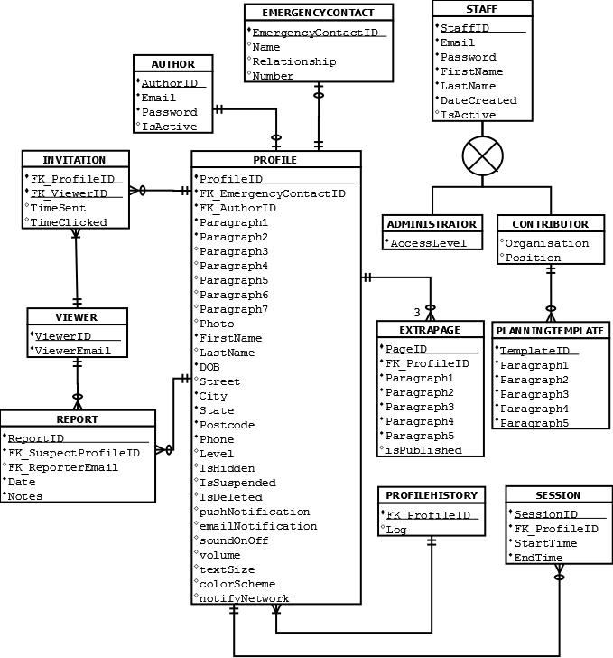

Figure 1: Entity Relationship Diagram

## Field data types and null values

In determining data values and field types for the software, the team were cognizant of the need for scalability, so that future updates to the software can be developed efficiently. Performance was also considered, and the team strived to reach a balance between both ideals.

Table 1: Field data types and null values

|  |  |  |  |  |
| --- | --- | --- | --- | --- |
| Entity | Attribute | Data Type | NULL | Notes |
| PROFILE | ProfileID | INT(7) | NO | Surrogate PRIMARY KEY  AUTO INCREMENT |
| EmergencyContactID | INT(7) | YES | FOREIGN KEY - Points to EmergencyContact |
| AuthorID | INT(7) | NO | FOREIGN KEY - Points to Author |
| Level | INT(1) | NO | Level of Profile (Basic, In-Depth, or In-Depth with Planning Templates) |
| IsHidden | BOOLEAN | NO | Boolean Value indicating whether or not Profile is hidden |
| IsSuspended | BOOLEAN | NO | Boolean Value indicating whether or not Profile is suspended |
| IsDeleted | BOOLEAN | NO | Boolean Value indicating whether or not Profile is deleted |
| Paragraph | VARCHAR (255) | YES | Text box containing information about the individual |
| Photo | VARCHAR (255) | YES | URL of individual’s photo |
| FirstName | VARCHAR(20) | NO | First name |
| LastName | VARCHAR(20) | NO | Last name |
| DOB | DATE | NO | Date of birth |
| Street | VARCHAR(40) | NO | Street address |
| City | VARCHAR(20) | NO | City |
| State | VARCHAR(3) | NO | State |
| Postcode | INT(4) | NO | Postcode |
| Email | VARCHAR (40) | NO | Email address |
| AUTHOR | AuthorID | INT(7) | NO | Surrogate PRIMARY KEY |
| Email | VARCHAR(40) | NO | Email address |
| Password | VARCHAR(40) | NO | Password |
| IsActive | BOOLEAN | YES | Boolean value indicating whether or not Author object is active |
| EMERGENCYCONTACT | EmergencyContactID | INT(7) | NO | Surrogate PRIMARY KEY |
| Name | VARCHAR(40) | NO | First name |
| Relationship | VARCHAR(20) | YES | Last name |
| Number | VARCHAR(15) | NO | Emergency contact number (landline or mobile) |
| VIEWER | ViewerID | INT(7) | NO | Surrogate PRIMARY KEY |
| ProfileID | INT(7) | NO | FOREIGN KEY - Points to Profile that Viewer has permission to view |
| ViewerEmail | VARCHAR(40) | NO | Email address of viewer |
| INVITATION | InvitationID | INT(7) | NO | PRIMARY KEY |
| ViewerID | INT(7) | NO | FOREIGN KEY - Points to ViewerID in VIEWER |
| ProfileID | INT(7) | NO | FOREIGN KEY - Points to ProfileID in PROFILE |
| TimeSent | DATE | NO | Time stamp indicating when URL was sent |
| TimeClicked | DATE | YES | Time stamp indicating when URL was invoked by recipient. If TimeClicked is null, the Profile hasn’t been viewed yet |
| REPORT | ReportID | INT(7) | NO | Surrogate PRIMARY KEY |
| SuspectProfileID | INT(7) | NO | FOREIGN KEY - Points to Profile being reported |
| ReporterEmail | VARCHAR(40) | NO | FOREIGN KEY - Points to Viewer filing the Report |
| Date | Date | NO | Time stamp indicating when Report was filed |
| Notes | VARCHAR(255) | NO | Notes about suspect Profile |
| SESSION | SessionID | INT(255) | NO | Surrogate PRIMARY KEY |
| ProfileID | INT(7) | NO | FOREIGN KEY - Points to Profile invoking the Session |
| StartTime | DATE | NO | Start time (DDMMYYHHSS) |
| EndTime | DATE | YES | End time (DDMMYYHHSS) |
| PROFILEHISTORY | ProfileID | INT(7) | NO | PRIMARY KEY  FOREIGN KEY - Points to ProfileID in PROFILE |
| Log | LONGTEXT | YES | Stores a log-file of PROFILE history. By using the LONGTEXT data type, up to 4Gb of history can be stored |
| EXTRAPAGE | PageID | INT(7) | NO | Surrogate PRIMARY KEY |
| FK\_ProfileID | INT(7) | NO | FOREIGN KEY - Points to ProfileID of PROFILE that EXTRAPAGE belongs to |
| Paragraph | VARCHAR (255) | YES | Text boxe containing information about the individual |
| PLANNINGTEMPLATE | TemplateID | INT(7) | NO | Surrogate PRIMARY KEY |
| Paragraph | VARCHAR (255) | NO | Text box containing templates that guide an individual through completing each paragraph |
| ADMINISTRATOR | AccessLevel | INT(1) | NO | Indicates level of system access, such that:  0 = superuser access (able to perform database admin tasks, such as backing up a database)  1 = contributor access (able to create, update and delete planning templates) |
| CONTRIBUTOR | Organisation | VARCHAR(40) | YES | Organisation that contributor works for |
| Position | VARCHAR(40) | YES | Position held by contributor in organisation |
| STAFF | StaffID | INT(7) | NO | Surrogate PRIMARY KEY |
| Email | VARCHAR(40) | NO | Email address of staff member |
| Password | VARCHAR(40) | NO | Password of staff member |
| FirstName | VARCHAR(40) | NO | First name of staff member |
| LastName | VARCHAR(40) | NO | Last name of staff member |
| DateCreated | DATE | NO | Date of staff-member’s account creation |
| IsActive | BOOLEAN | YES | Boolean value indicating whether or not Staff object is active |

## Normalisation

In order to normalise the database, the team identified all candidate keys for each entity, identified all functional dependencies, and for each functional dependency, ensured that no determinants were candidate keys (Kroenke and Auer 2013). The results of the normalisation process are outlined below.

Table 2: Database normalisation

|  |  |  |  |
| --- | --- | --- | --- |
| ENTITY | CANDIDATE KEYS | FUNCTIONAL DEPENDENCIES | NOTES |
| VIEWER | ViewerID | ViewerID → ViewerEmail | No issues |
| REPORT | ReportID | ReportID → (SuspectProfileID, ReporterEmail, Date, Notes) | No issues |
| INVITATION | (ProfileID, ViewerID) | (ProfileID, ViewerID) → (TimeSent, DateClicked) | No issues |
| AUTHOR | AuthorID | AuthorID→ (Email, Password, IsActive) | No issues.  The team have assumed that email isn’t a candidate key, as two authors might share the same email address |
| EMERGENCYCONTACT | EmergencyContactID | EmergencyContactID → (Name, Relationship, Number) | No issues  The team have assumed that number isn’t a candidate key, as two emergency contacts might share the same number |
| STAFF | StaffID  (FirstName, LastName, Email) | StaffID → (Email, Password, FirstName, LastName, DateCreated, IsActive)  (FirstName, LastName, Email) → (StaffID, Password, DateCreated, IsActive) | No issues, as the determinant (FirstName, LastName, Email) is a candidate key  The team have assumed that email isn’t a candidate key, as two staff members might share the same email address |
| PLANNINGTEMPLATE | TemplateID | TemplateID → (Paragraph1, Paragraph2, Paragraph3, Paragraph4, Paragraph5) | No issues |
| EXTRAPAGE | PageID | PageID → (ProfileID, Paragraph1, Paragraph2, Paragraph3, Paragraph4, Paragraph5) | No issues |
| SESSION | SessionID | SessionID → (ProfileID, StartTime, EndTime) | No issues |
| PROFILEHISTORY | ProfileID | ProfileID → Log | No issues |
| PROFILE | ProfileID | ProfileID → (EmergencyContactID, AuthorID, Level, IsHidden, IsSuspended, IsDeleted, Photo, , Paragraph, FirstName, LastName, DOB, Street, City, State, Postcode, Phone)  (FirstName, LastName, DOB) → (EmergencyContactID, AuthorID, Level, IsHidden, IsSuspended, IsDeleted, Photo, , Paragraph, Street, City, State, Postcode, Phone) | (FirstName, LastName, DOB) is a arguably a determinant (as it’s unlikely that two people with the same name and date of birth exist in the database), but since it’s also a candidate key, this doesn’t cause any issues |

# Interface design

## Design brief

The client has requested that the app be upbeat and on-trend but not childish. The design should be clean and minimalist so that the inevitable white space created by a responsive design does not stand out. There should be minimal use of colour and animation, so that the design is not overwhelming for the user base. The layout should be logical and make use of semantic HTML layout and heading hierarchy, to be accessible to screen readers.

It is imperative that the app have accessibility “baked in”, that is, accessibility should be at the forefront of any design decisions, including decisions around page layout, graphics, animation, colours, and fonts.

## Navigation map

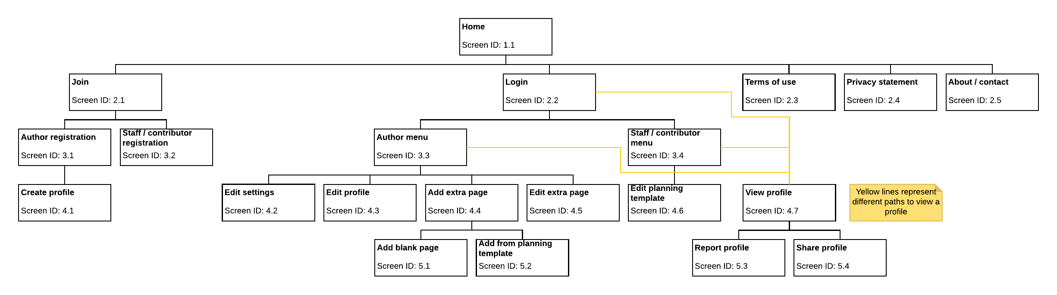

## Storyboards

The team identified 21 screens to be designed. These storyboards are intended to give a basic overview of the expected layout of each screen.

Within each diagram, the HTML divs for each section of the page are numbered and their names are indicated with red text. It is important to note that these names are for design purposes only and will not be visible on the page (i.e., they are not headings).

### Home: Screen ID 1.1

|  |  |  |
| --- | --- | --- |
| Title: Home | | Screen ID: 1.1 |
| Web Page Diagram: | | |
| G:\Libraries\Documents\University 2014-\2016\Session 3 2016\ISY10221\Assessment Files\Deliverable 4 - Software Design Specification\Screens\1.1 Home.png | | |
| Graphics: Logo, photos supporting main text (in div 4) | | |
| Text: A blurb about the app, its intended audience, and why they should join | | |
| Multimedia: N/A | | |
| Notes: The header (div 2) includes a link to the login screen. The bottom navigation (div 6) has links to login, terms of use, and privacy statement. Links to the contact page and other contact options (e.g. social media) are in div 7. The footer includes the copyright statement. | | |
| Description: | Homepage | |
| Content: | Brief introduction to app concept | |
| Interactions: | Navigation and contact links | |
| Media Creation: | Logo | |
| Navigation: | Top and bottom | |

### Join: Screen ID 2.1

|  |  |  |
| --- | --- | --- |
| Title: Join | | Screen ID: 2.1 |
| Web Page Diagram: | | |
| G:\Libraries\Documents\University 2014-\2016\Session 3 2016\ISY10221\Assessment Files\Deliverable 4 - Software Design Specification\Screens\2.1 Join.png | | |
| Graphics: Logo | | |
| Text: In div 5, a blurb about who should sign up as an author. In div 6, a blurb about who should sign up as a contributor. | | |
| Multimedia: N/A | | |
| Notes: The header (div 2) includes a link to the login screen. The bottom navigation (div 6) has links to login, terms of use, and privacy statement. Links to the contact page and other contact options (e.g. social media) are in div 7. The footer includes the copyright statement. | | |
| Description: | Registration landing page | |
| Content: | Brief description of different types of users | |
| Interactions: | Links to appropriate registration pages, navigation and contact links | |
| Media Creation: | N/A | |
| Navigation: | Top and bottom | |

### Login: Screen ID 2.2

|  |  |  |
| --- | --- | --- |
| Title: Login | | Screen ID: 2.2 |
| Web Page Diagram: | | |
| G:\Libraries\Documents\University 2014-\2016\Session 3 2016\ISY10221\Assessment Files\Deliverable 4 - Software Design Specification\Screens\2.2 Login.png | | |
| Graphics: Logo | | |
| Text: In div 5, explanation of “guest”. in div 6, explanation of “member”. | | |
| Multimedia: N/A | | |
| Notes: The header (div 2) includes a link to the home screen. The bottom navigation (div 6) has links to login, terms of use, and privacy statement. Links to the contact page and other contact options (e.g. social media) are in div 7. The footer includes the copyright statement. | | |
| Description: | Login page | |
| Content: | Brief explanation of guest and member logins login forms | |
| Interactions: | Login forms, navigation and contact links | |
| Media Creation: | N/A | |
| Navigation: | Top and bottom | |

### Terms of use: Screen ID 2.3

|  |  |  |
| --- | --- | --- |
| Title: Terms of use | | Screen ID: 2.3 |
| Web Page Diagram: | | |
| G:\Libraries\Documents\University 2014-\2016\Session 3 2016\ISY10221\Assessment Files\Deliverable 4 - Software Design Specification\Screens\2.3 Terms of use.png | | |
| Graphics: Logo | | |
| Text: In div 4, terms of use | | |
| Multimedia: N/A | | |
| Notes: The header (div 2) includes a link to the login screen. The bottom navigation (div 6) has links to login, terms of use, and privacy statement. Links to the contact page and other contact options (e.g. social media) are in div 7. The footer includes the copyright statement. | | |
| Description: | Terms of use | |
| Content: | Legal terms of use of site/app | |
| Interactions: | Navigation and contact links | |
| Media Creation: | N/A | |
| Navigation: | Top and bottom | |

### Privacy statement: Screen ID 2.4

|  |  |  |
| --- | --- | --- |
| Title: Privacy statement | | Screen ID: 2.4 |
| Web Page Diagram: | | |
| G:\Libraries\Documents\University 2014-\2016\Session 3 2016\ISY10221\Assessment Files\Deliverable 4 - Software Design Specification\Screens\2.4 Privacy statement.png | | |
| Graphics: Logo | | |
| Text: In div 4, privacy statement | | |
| Multimedia: N/A | | |
| Notes: The header (div 2) includes a link to the login screen. The bottom navigation (div 6) has links to login, terms of use, and privacy statement. Links to the contact page and other contact options (e.g. social media) are in div 7. The footer includes the copyright statement. | | |
| Description: | Privacy statement | |
| Content: | Legal privacy statement of site/app | |
| Interactions: | Navigation and contact links | |
| Media Creation: | N/A | |
| Navigation: | Top and bottom | |

### About / contact: Screen ID 2.5

|  |  |  |
| --- | --- | --- |
| Title: About / contact | | Screen ID: 2.5 |
| Web Page Diagram: | | |
| G:\Libraries\Documents\University 2014-\2016\Session 3 2016\ISY10221\Assessment Files\Deliverable 4 - Software Design Specification\Screens\2.5 About _ contact.png | | |
| Graphics: Logo | | |
| Text: In div 5, blurb about site/app and contact details. In div 6, a contact form. | | |
| Multimedia: N/A | | |
| Notes: The header (div 2) includes a link to the login screen. The bottom navigation (div 9) has links to login, terms of use, and privacy statement. Links to the contact page and other contact options (e.g. social media) are in div 8. The footer includes the copyright statement. | | |
| Description: | About / Contact page | |
| Content: | Brief blurb about site/app, contact details, contact form | |
| Interactions: | Contact form, contact links, navigation links | |
| Media Creation: | N/A | |
| Navigation: | Top and bottom | |

### Author registration: Screen ID 3.1

|  |  |  |
| --- | --- | --- |
| Title: Author registration | | Screen ID: 3.1 |
| Web Page Diagram: | | |
| G:\Libraries\Documents\University 2014-\2016\Session 3 2016\ISY10221\Assessment Files\Deliverable 4 - Software Design Specification\Screens\3.1 Author registration.png | | |
| Graphics: Logo | | |
| Text: In div 4, registration form | | |
| Multimedia: N/A | | |
| Notes: The header (div 2) includes a link to the login screen. The bottom navigation (div 6) has links to login, terms of use, and privacy statement. Links to the contact page and other contact options (e.g. social media) are in div 7. The footer includes the copyright statement. | | |
| Description: | Author registration | |
| Content: | Registration form | |
| Interactions: | Registration form, navigation and contact links | |
| Media Creation: | N/A | |
| Navigation: | Top and bottom | |

### Staff / contributor registration: Screen ID 3.2

|  |  |  |
| --- | --- | --- |
| Title: Staff / contributor registration | | Screen ID: 3.2 |
| Web Page Diagram: | | |
| G:\Libraries\Documents\University 2014-\2016\Session 3 2016\ISY10221\Assessment Files\Deliverable 4 - Software Design Specification\Screens\3.2 Staff _ contributor registration.png | | |
| Graphics: Logo | | |
| Text: In div 4, a registration form | | |
| Multimedia: N/A | | |
| Notes: The header (div 2) includes a link to the login screen. The bottom navigation (div 6) has links to login, terms of use, and privacy statement. Links to the contact page and other contact options (e.g. social media) are in div 7. The footer includes the copyright statement. | | |
| Description: | Staff / contributor registration | |
| Content: | Registration form | |
| Interactions: | Registration form, navigation and contact links | |
| Media Creation: | N/A | |
| Navigation: | Top and bottom | |

### Author menu: Screen ID 3.3

|  |  |  |
| --- | --- | --- |
| Title: Author menu | | Screen ID: 3.3 |
| Web Page Diagram: | | |
| G:\Libraries\Documents\University 2014-\2016\Session 3 2016\ISY10221\Assessment Files\Deliverable 4 - Software Design Specification\Screens\3.3 Author menu.png | | |
| Graphics: Logo, image placeholder (if no profile photo available) | | |
| Text: Navigation menu, generated profile activity | | |
| Multimedia: Profile activity generated via script | | |
| Notes: The bottom navigation (div 6) has links to terms of use and privacy statement. Links to the contact page and other contact options (e.g. social media) are in div 7. The footer includes the copyright statement. | | |
| Description: | Author menu | |
| Content: | Menu navigation, profile photo (or placeholder), profile activity stream | |
| Interactions: | Menu links, navigation and contact links | |
| Media Creation: | Image placeholder | |
| Navigation: | Bottom, menu | |

### Staff / contributor menu: Screen ID 3.4

|  |  |  |
| --- | --- | --- |
| Title: Staff / contributor menu | | Screen ID: 3.4 |
| Web Page Diagram: | | |
| G:\Libraries\Documents\University 2014-\2016\Session 3 2016\ISY10221\Assessment Files\Deliverable 4 - Software Design Specification\Screens\3.4 Staff _ contributor menu.png | | |
| Graphics: Logo | | |
| Text: Navigation menu | | |
| Multimedia: N/A | | |
| Notes: The bottom navigation (div 6) has links to terms of use and privacy statement. Links to the contact page and other contact options (e.g. social media) are in div 7. The footer includes the copyright statement. | | |
| Description: | Staff / contributor menu | |
| Content: | Menu navigation | |
| Interactions: | Menu links, navigation and contact links | |
| Media Creation: | N/A | |
| Navigation: | Bottom, menu | |

### Create profile: Screen ID 4.1

|  |  |  |
| --- | --- | --- |
| Title: Create profile | | Screen ID: 4.1 |
| Web Page Diagram: | | |
| G:\Libraries\Documents\University 2014-\2016\Session 3 2016\ISY10221\Assessment Files\Deliverable 4 - Software Design Specification\Screens\4.1 Create profile.png | | |
| Graphics: Logo, image placeholder | | |
| Text: In div 7, disclaimer text (in red box). | | |
| Multimedia: N/A | | |
| Notes: The header includes a “home” link. The bottom navigation (div 9) has links to terms of use and privacy statement. Links to the contact page and other contact options (e.g. social media) are in div 10. The footer includes the copyright statement. | | |
| Description: | Create profile form | |
| Content: | Contact form, add photo widget, profile form | |
| Interactions: | Navigation and contact links, forms | |
| Media Creation: | N/A | |
| Navigation: | Top and bottom | |

### Edit settings: Screen ID 4.2

|  |  |  |
| --- | --- | --- |
| Title: Edit settings | | Screen ID: 4.2 |
| Web Page Diagram: | | |
| G:\Libraries\Documents\University 2014-\2016\Session 3 2016\ISY10221\Assessment Files\Deliverable 4 - Software Design Specification\Screens\4.2 Edit settings.png | | |
| Graphics: Logo | | |
| Text: Settings options | | |
| Multimedia: N/A | | |
| Notes: The header includes a “home” link. The bottom navigation (div 9) has links to terms of use and privacy statement. Links to the contact page and other contact options (e.g. social media) are in div 10. The footer includes the copyright statement. | | |
| Description: | Edit settings form | |
| Content: | Settings form | |
| Interactions: | Settings form, navigation and contact links | |
| Media Creation: | N/A | |
| Navigation: | Top and bottom | |

### Edit profile: Screen ID 4.3

|  |  |  |
| --- | --- | --- |
| Title: Edit profile | | Screen ID: 4.3 |
| Web Page Diagram: | | |
| G:\Libraries\Documents\University 2014-\2016\Session 3 2016\ISY10221\Assessment Files\Deliverable 4 - Software Design Specification\Screens\4.3 Edit profile.png | | |
| Graphics: Logo, image placeholder (if no profile photo available) | | |
| Text: In div 7, disclaimer text (in red box) | | |
| Multimedia: N/A | | |
| Notes: The header includes a “home” link. The bottom navigation (div 9) has links to terms of use and privacy statement. Links to the contact page and other contact options (e.g. social media) are in div 10. The footer includes the copyright statement. | | |
| Description: | Edit profile form | |
| Content: | Contact form, add/edit photo widget, profile form | |
| Interactions: | Navigation and contact links, forms | |
| Media Creation: | N/A | |
| Navigation: | Top and bottom | |

### Add extra page: Screen ID 4.4

|  |  |  |
| --- | --- | --- |
| Title: Add extra page | | Screen ID: 4.4 |
| Web Page Diagram: | | |
| G:\Libraries\Documents\University 2014-\2016\Session 3 2016\ISY10221\Assessment Files\Deliverable 4 - Software Design Specification\Screens\4.4 Add extra page.png | | |
| Graphics: Logo | | |
| Text: Blurbs about how to use a blank page or a template page in divs 5 and 6 | | |
| Multimedia: N/A | | |
| Notes: The header includes a “home” link. The bottom navigation (div 8) has links to terms of use and privacy statement. Links to the contact page and other contact options (e.g. social media) are in div 9. The footer includes the copyright statement. | | |
| Description: | Add extra page options | |
| Content: | Blurbs about how to use different extra page options | |
| Interactions: | Navigation and contact links | |
| Media Creation: | N/A | |
| Navigation: | Top and bottom | |

### Edit extra page: Screen ID 4.5

|  |  |  |
| --- | --- | --- |
| Title: Edit extra page | | Screen ID: 4.5 |
| Web Page Diagram: | | |
| G:\Libraries\Documents\University 2014-\2016\Session 3 2016\ISY10221\Assessment Files\Deliverable 4 - Software Design Specification\Screens\4.5 Edit extra page.png | | |
| Graphics: Logo | | |
| Text: Pre-filled with text user has already added | | |
| Multimedia: N/A | | |
| Notes: The header (div 2) includes a “home” link. The bottom navigation (div 6) has links to login, terms of use, and privacy statement. Links to the contact page and other contact options (e.g. social media) are in div 7. The footer includes the copyright statement. | | |
| Description: | Edit extra page form | |
| Content: | Edit page form | |
| Interactions: | Navigation and contact links, form | |
| Media Creation: | N/A | |
| Navigation: | Top and bottom | |

### Edit planning template: Screen ID 4.6

|  |  |  |
| --- | --- | --- |
| Title: Edit planning template | | Screen ID: 4.6 |
| Web Page Diagram: | | |
| G:\Libraries\Documents\University 2014-\2016\Session 3 2016\ISY10221\Assessment Files\Deliverable 4 - Software Design Specification\Screens\4.6 Edit planning template.png | | |
| Graphics: Logo | | |
| Text: Pre-filled with template text | | |
| Multimedia: N/A | | |
| Notes: The header (div 2) includes a “home” link. The bottom navigation (div 6) has links to login, terms of use, and privacy statement. Links to the contact page and other contact options (e.g. social media) are in div 7. The footer includes the copyright statement. | | |
| Description: | Edit planning template form | |
| Content: | Edit page form | |
| Interactions: | Navigation and contact links, form | |
| Media Creation: | N/A | |
| Navigation: | Top and bottom | |

### View profile: Screen ID 4.7

|  |  |  |
| --- | --- | --- |
| Title: View profile | | Screen ID: 4.7 |
| Web Page Diagram: | | |
| G:\Libraries\Documents\University 2014-\2016\Session 3 2016\ISY10221\Assessment Files\Deliverable 4 - Software Design Specification\Screens\4.7 View profile.png | | |
| Graphics: Logo, image placeholder (if no profile photo available) | | |
| Text: Disclaimers on contact and profile info | | |
| Multimedia: N/A | | |
| Notes: The header (div 2) includes a “home” link. The bottom navigation (div 10) has links to login, terms of use, and privacy statement. Links to the contact page and other contact options (e.g. social media) are in div 11. The footer includes the copyright statement. Div 8 includes menu options like print and report. The profile details in div 7 will vary depending on the profile level and may include links to extra pages (if any). | | |
| Description: | Profile view | |
| Content: | Profile details and photo, profile actions menu, disclaimer text | |
| Interactions: | Navigation and contact links, profile action links | |
| Media Creation: | N/A | |
| Navigation: | Top and bottom | |

### Add blank page: Screen ID 5.1

|  |  |  |
| --- | --- | --- |
| Title: Add blank page | | Screen ID: 5.1 |
| Web Page Diagram: | | |
| G:\Libraries\Documents\University 2014-\2016\Session 3 2016\ISY10221\Assessment Files\Deliverable 4 - Software Design Specification\Screens\5.1 Add blank page.png | | |
| Graphics: Logo | | |
| Text: N/A | | |
| Multimedia: N/A | | |
| Notes: The header (div 2) includes a “home” link. The bottom navigation (div 6) has links to login, terms of use, and privacy statement. Links to the contact page and other contact options (e.g. social media) are in div 7. The footer includes the copyright statement. | | |
| Description: | Add extra page form | |
| Content: | Extra page form | |
| Interactions: | Navigation and contact links, form | |
| Media Creation: | N/A | |
| Navigation: | Top and bottom | |

### Add page from planning template: Screen ID 5.2

|  |  |  |
| --- | --- | --- |
| Title: Add page from planning template | | Screen ID: 5.2 |
| Web Page Diagram: | | |
| G:\Libraries\Documents\University 2014-\2016\Session 3 2016\ISY10221\Assessment Files\Deliverable 4 - Software Design Specification\Screens\5.2 Add from planning template.png | | |
| Graphics: Logo | | |
| Text: Template text (blurbs, questions, links to external resources) | | |
| Multimedia: N/A | | |
| Notes: The header (div 2) includes a “home” link. The bottom navigation (div 6) has links to login, terms of use, and privacy statement. Links to the contact page and other contact options (e.g. social media) are in div 7. The footer includes the copyright statement. The form in div 4 will be a combination of template blurbs/questions/links and free text form boxes. | | |
| Description: | Add extra page from planning template form | |
| Content: | Extra page form | |
| Interactions: | Navigation and contact links, form | |
| Media Creation: | N/A | |
| Navigation: | Top and bottom | |

### Report profile: Screen ID 5.3

|  |  |  |
| --- | --- | --- |
| Title: Report profile | | Screen ID: 5.3 |
| Web Page Diagram: | | |
| G:\Libraries\Documents\University 2014-\2016\Session 3 2016\ISY10221\Assessment Files\Deliverable 4 - Software Design Specification\Screens\5.3 Report profile.png | | |
| Graphics: Logo, image placeholder (if no profile photo available) | | |
| Text: Report profile options | | |
| Multimedia: N/A | | |
| Notes: The header includes a “home” link. The bottom navigation (div 9) has links to terms of use and privacy statement. Links to the contact page and other contact options (e.g. social media) are in div 10. The footer includes the copyright statement. Div 5 includes the basic profile info (name, age, etc.). | | |
| Description: | Report profile for abuse form | |
| Content: | Report profile form | |
| Interactions: | Navigation and contact links, form | |
| Media Creation: | N/A | |
| Navigation: | Top and bottom | |

### Share profile: Screen ID 5.4

|  |  |  |
| --- | --- | --- |
| Title: Share profile | | Screen ID: 5.4 |
| Web Page Diagram: | | |
| G:\Libraries\Documents\University 2014-\2016\Session 3 2016\ISY10221\Assessment Files\Deliverable 4 - Software Design Specification\Screens\5.4 Share profile.png | | |
| Graphics: Logo, image placeholder (if no profile photo available) | | |
| Text: Share profile options | | |
| Multimedia: N/A | | |
| Notes: The header includes a “home” link. The bottom navigation (div 9) has links to terms of use and privacy statement. Links to the contact page and other contact options (e.g. social media) are in div 10. The footer includes the copyright statement. Div 5 includes the basic profile info (name, age, etc.). | | |
| Description: | Share profile form to share via various methods | |
| Content: | Share profile form | |
| Interactions: | Navigation and contact links, form | |
| Media Creation: | N/A | |
| Navigation: | Top and bottom | |

# Architecture design

## Reliability

### Low maintenance

The AMP Project will be implemented using a Virtual Private Hosting solution on a Linux server running MySQL and PHP. By using this approach, the task of keeping PHP and MySQL up to date and keeping the server maintained falls under the jurisdiction of the hosting provider.

Configuration settings will be stored in separate file outside of the document root, so that changes can be made in a single place. The alternative is to store settings (such as database names, hostnames and usernames) within the scripts themselves, which aside from making maintenance more tedious, is less secure (Lionite 2014).

### Robust app/website

Rather than using a development framework like Bootstrap, the team will hand-code the project using responsive design principles. This will have the benefit of efficient code, as compared to bloated code if Bootstrap were used (K. 2015), resulting in better performance.

The team will also be developing an extensive test plan. This will include blackbox testing to examine fundamental features of the software with minimal regard for its logical structure, to ensure the software meets all user requirements. Whitebox testing will also be employed, to test modules within the system.

### Security

Rather than storing all files within the document root, the software will store PHP “include” files and configuration files outside of the document root, making them accessible to code whilst protecting any sensitive information contained within the files. Using this approach has less overhead than protecting sensitive files within the document root using .htaccess (StackOverflow 2010). As an added layer of protection, the sensitive details contained in the database connection script will be placed inside a function, which will further protect the data through the use of local variables (Lionite 2014).

Additionally, the software will make use of the mysqli\_real\_escape\_string() function of PHP, and prepared statements, to escape user input and guard against SQL injection attacks (Lionite 2014).

A password complexity requirement will be discussed with the client. It is recommended that passwords be at least 6 characters long, not include the user’s name or parts thereof, and include a mixture of upper- and lowercase letters, numbers, and symbols (TechNet Magazine 2017).

The client will also need to purchase an SSL certificate so that the website can be served over HTTPS. Google Chrome is currently undertaking a project to explicitly mark HTTP websites as non-secure (Google Security Blog 2016), and it is best practice to serve the website via HTTP.

# Design for other requirements

## Mobile use

The team have employed responsive design principles and mobile web design best practices to allow the software to display and function on mobile devices. Specifically, the software has been optimised for both large and small screen sizes and low bandwidth (the software consists mostly of text, which will be rendered quickly by a mobile browser). Common font typefaces have been utilised and a good contrast will be chosen between text and background colour. The mobile version of the software will use a single column page layout that will be easy to control by touch, and which will facilitate page tabbing.

## Usability design

The software will use several forms, so the team have employed techniques to increase the accessibility of form controls, including the label element, fieldset element, legend element, tabindex attribute and accesskey attribute. These measures make it easier for individuals with mobility or visibility challenges to use the several forms contained within the software. Further, the use of label, fieldset and legend elements may increase the readability and usability of the software’s web forms for all users (Felke-Morris 2015, p. 416).

Meanwhile, hyperlinks to important site features have been placed directly under the header, and a search feature will be provided.

###### Appendices

1. Revised use case diagrams
   1. Simple profile

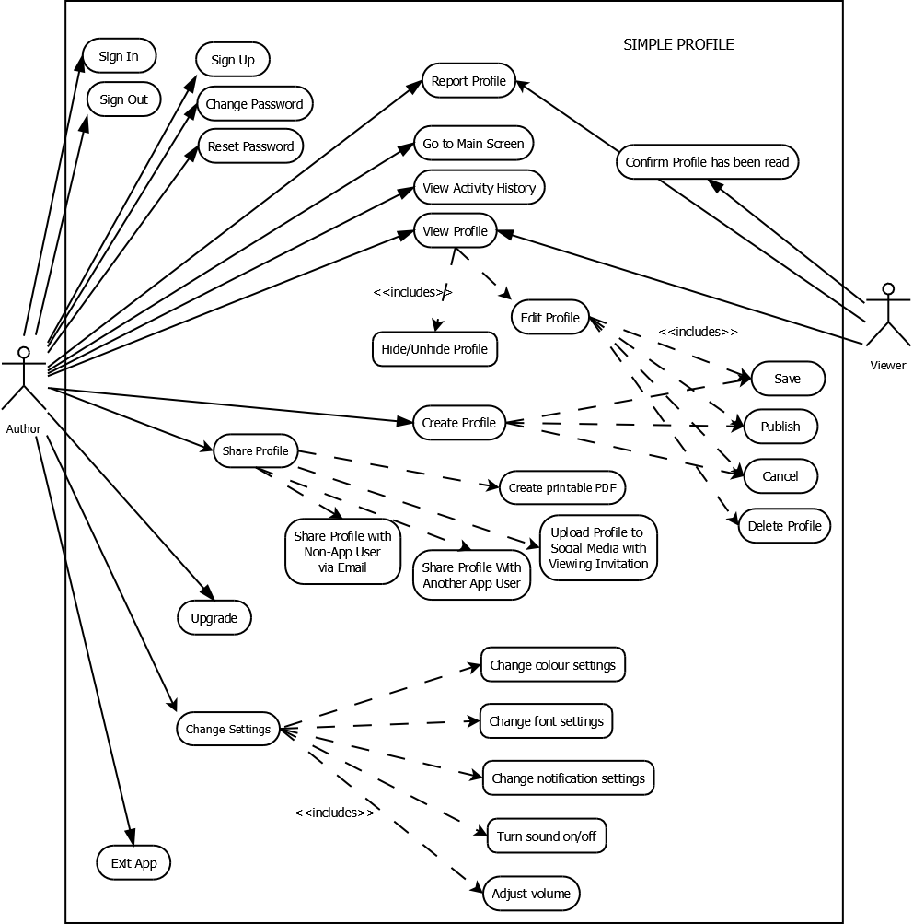

Figure 2: Revised simple profile use case diagram

* 1. In-depth profile

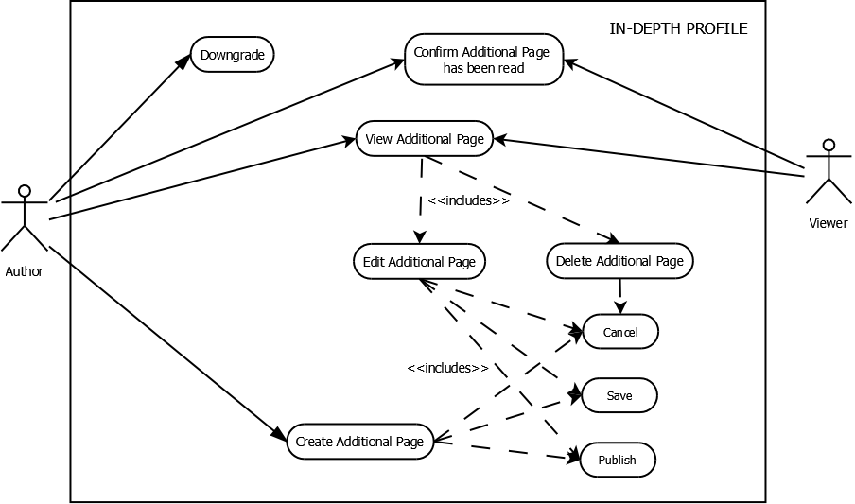

Figure 3: Revised in-depth profile use case diagram

* 1. Planning-plus profile (with planning templates)

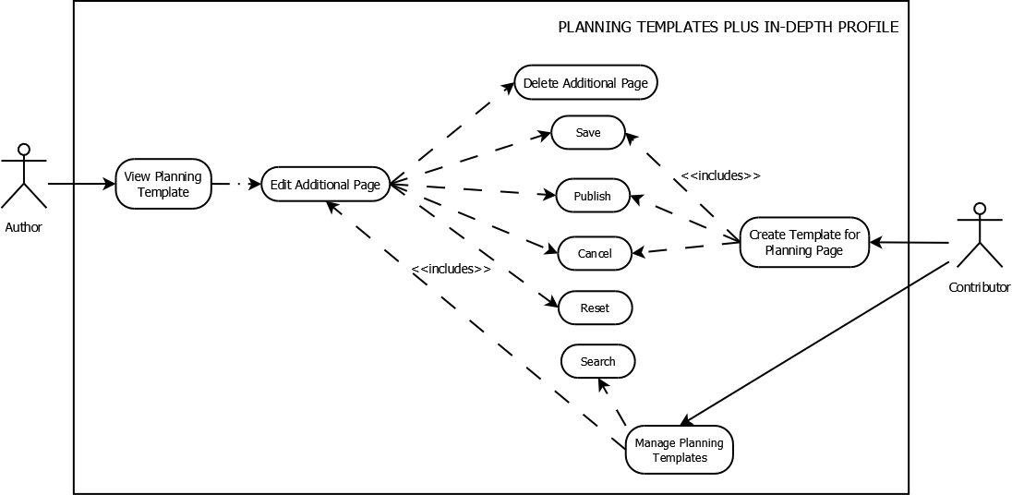

Figure 4: Revised planning-plus profile (with planning templates) use case diagram

1. Revised class diagram

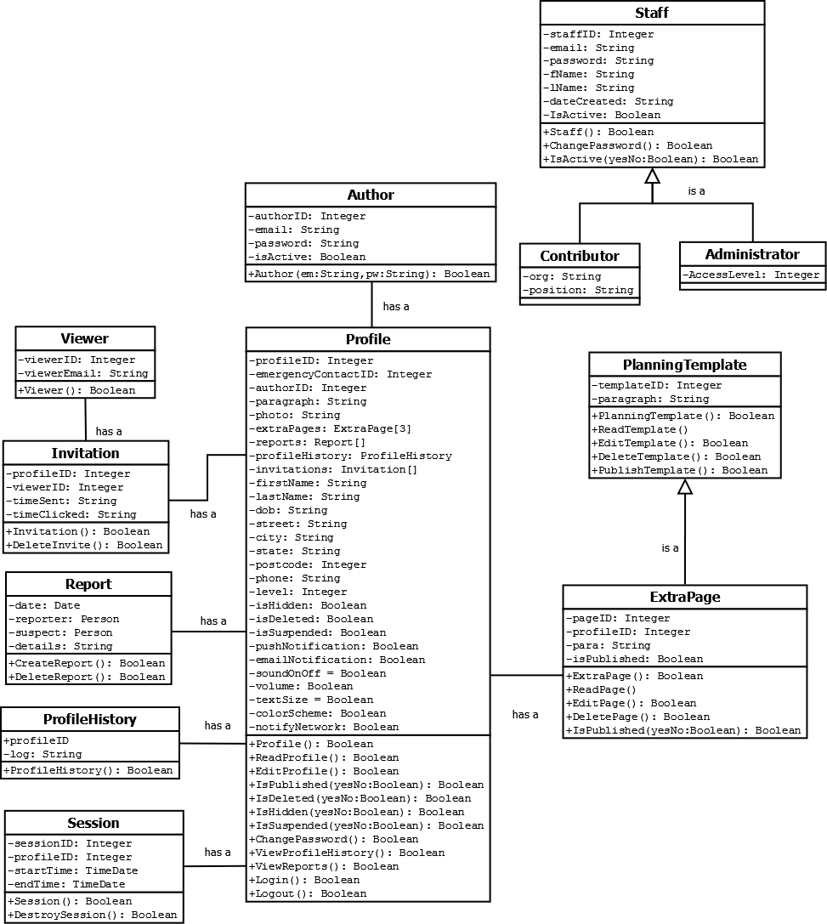

Figure 5: Revised class diagram

1. Revised activity diagrams
   1. Login

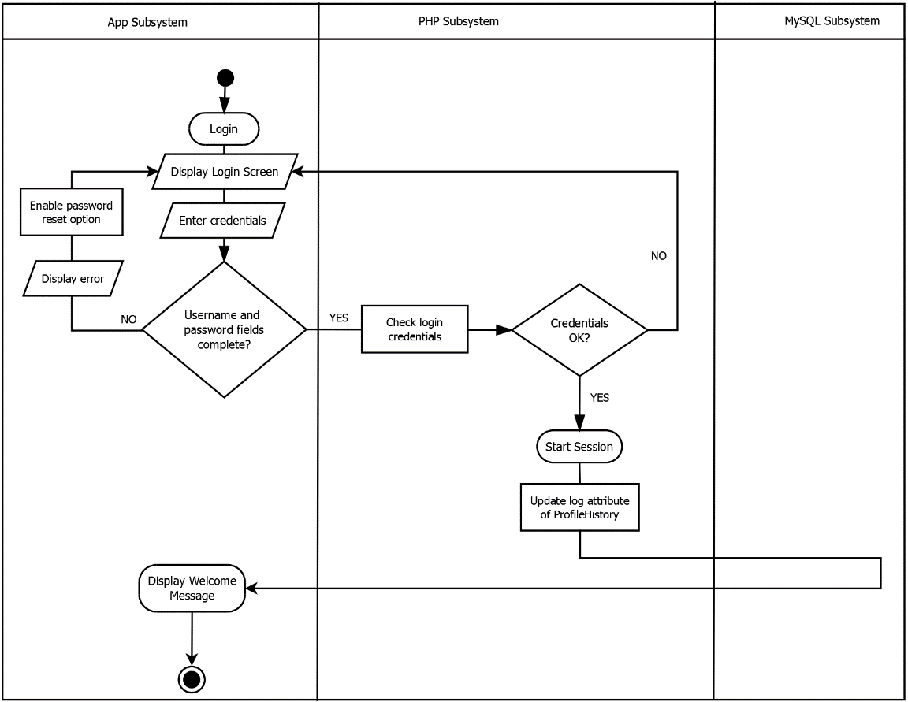

Figure 6: Revised login activity diagram

* 1. Sign out

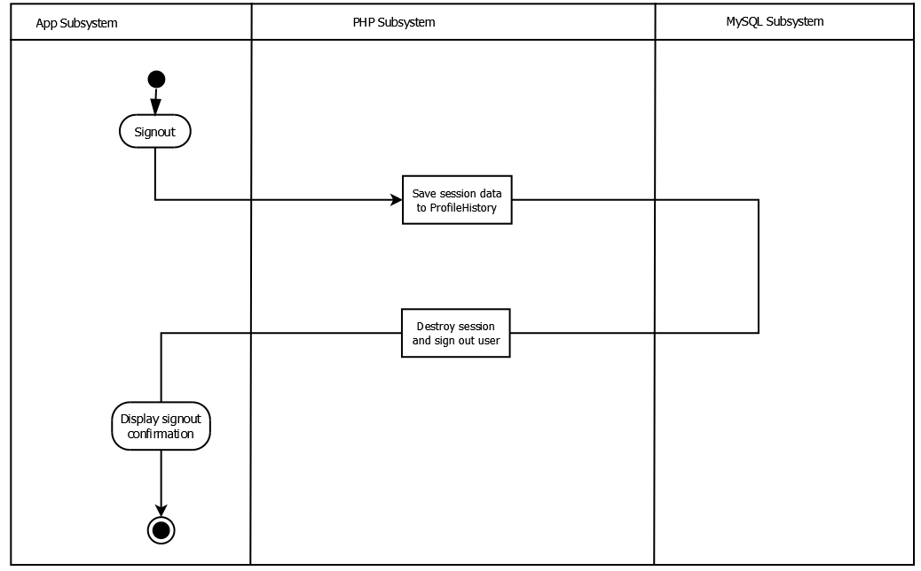

Figure 7: Revised sign out activity diagram

* 1. Sign up

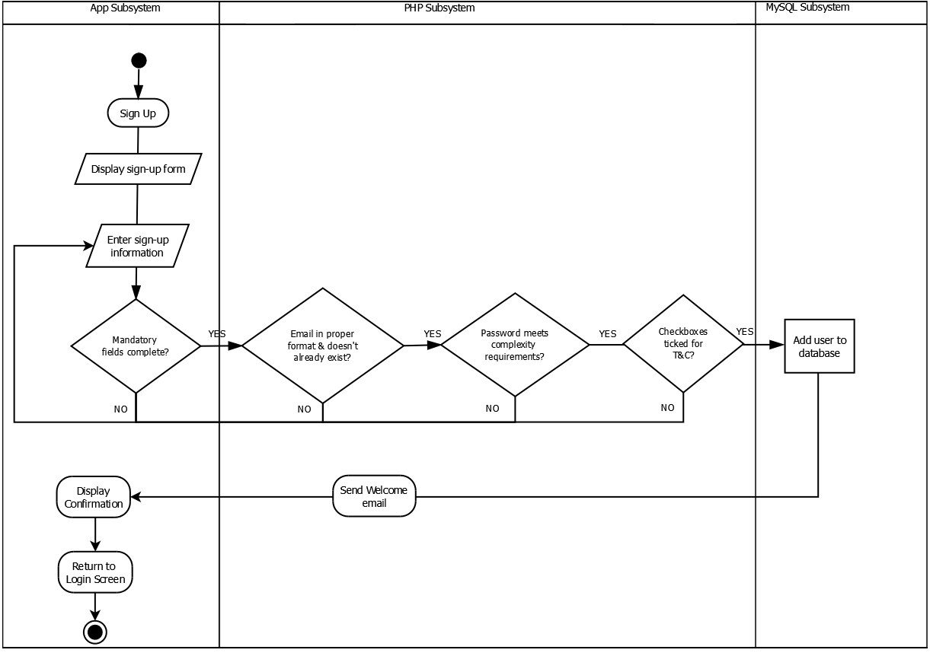

Figure 8: Revised sign up activity diagam

* 1. Reset password

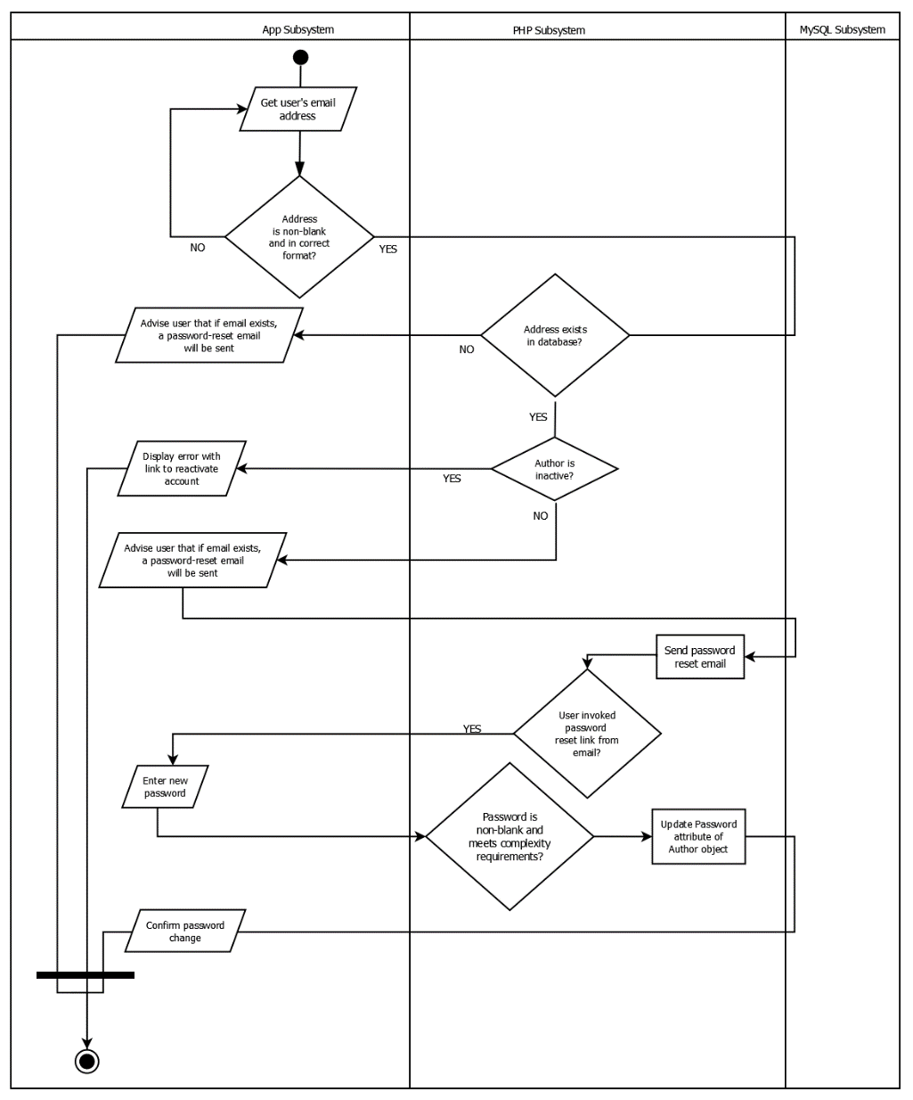

Figure 9: Reset password activity diagram

* 1. View activity history

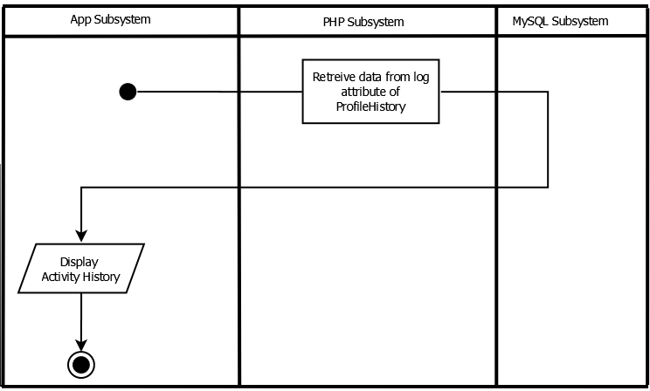

Figure 10: Revised view activity history activity diagram

* 1. Create profile

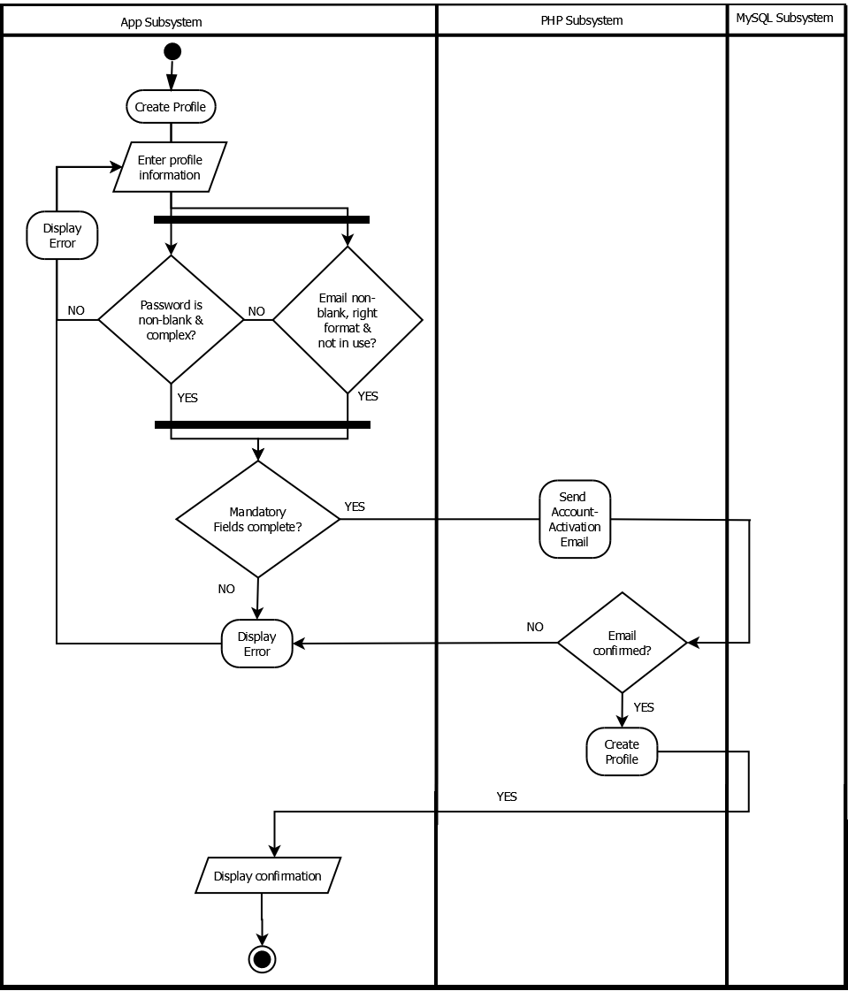

Figure 11: Revised create profile activity diagram

* 1. Edit profile

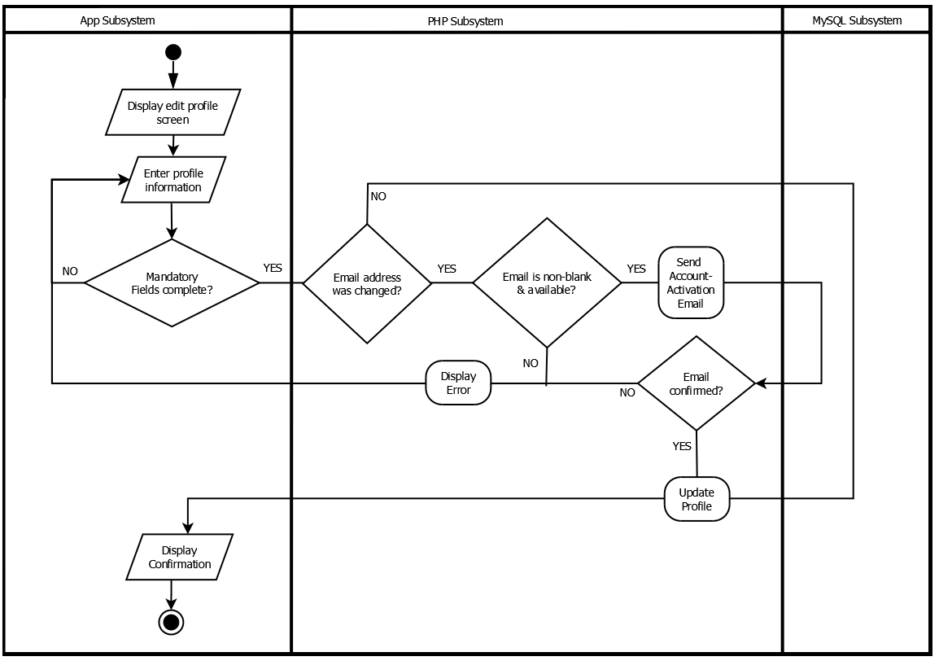

Figure 12: Revised edit profile activity diagram

* 1. Hide profile

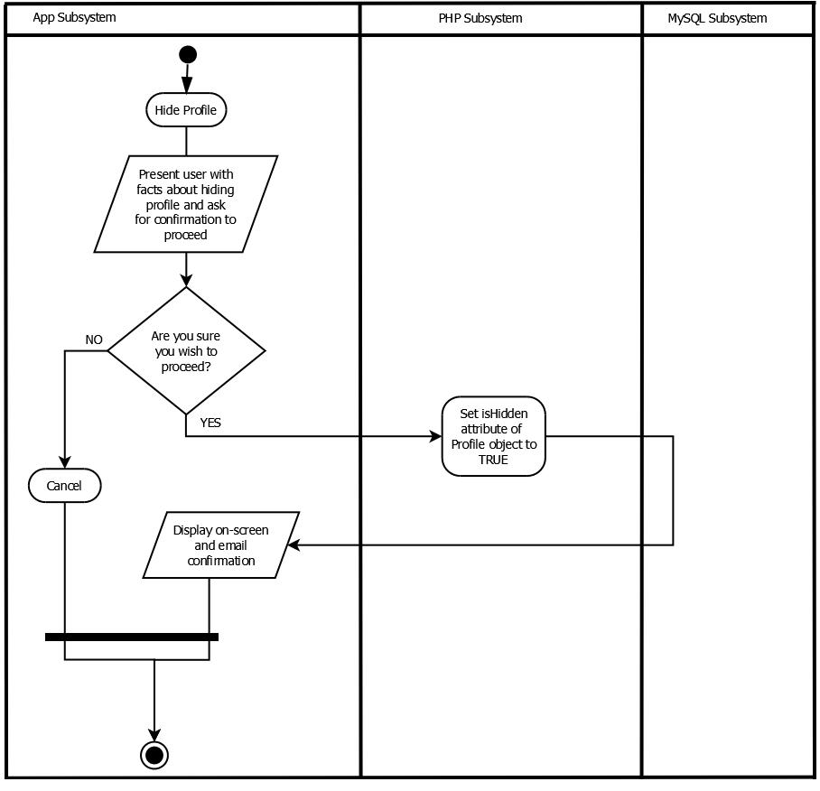

Figure 13: Revised hide profile activity diagram

* 1. Report profile

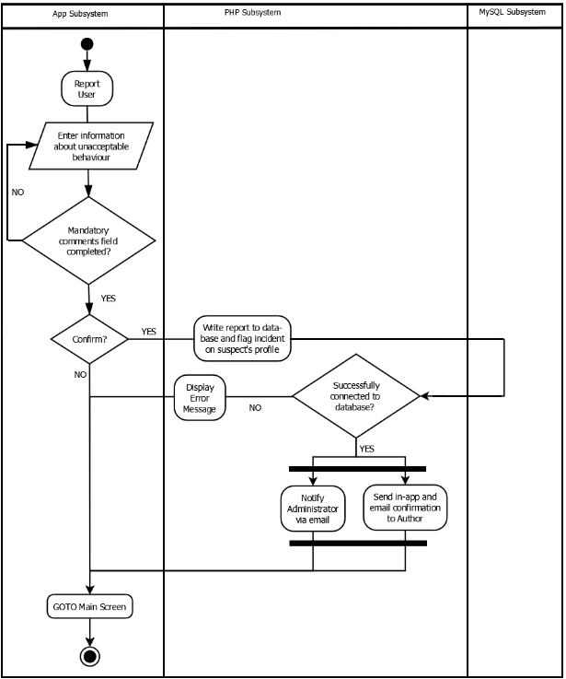

Figure 14: Revised report profile activity diagram

* 1. Downgrade

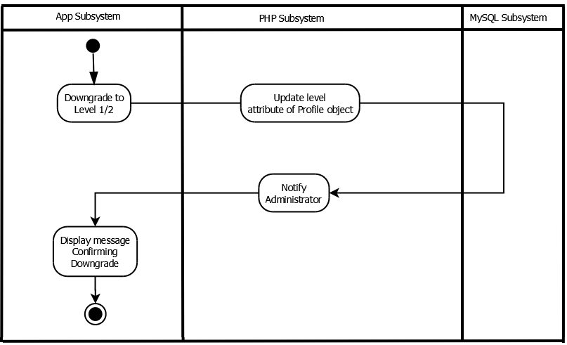

Figure 15: Revised downgrade activity diagram

* 1. Upgrade

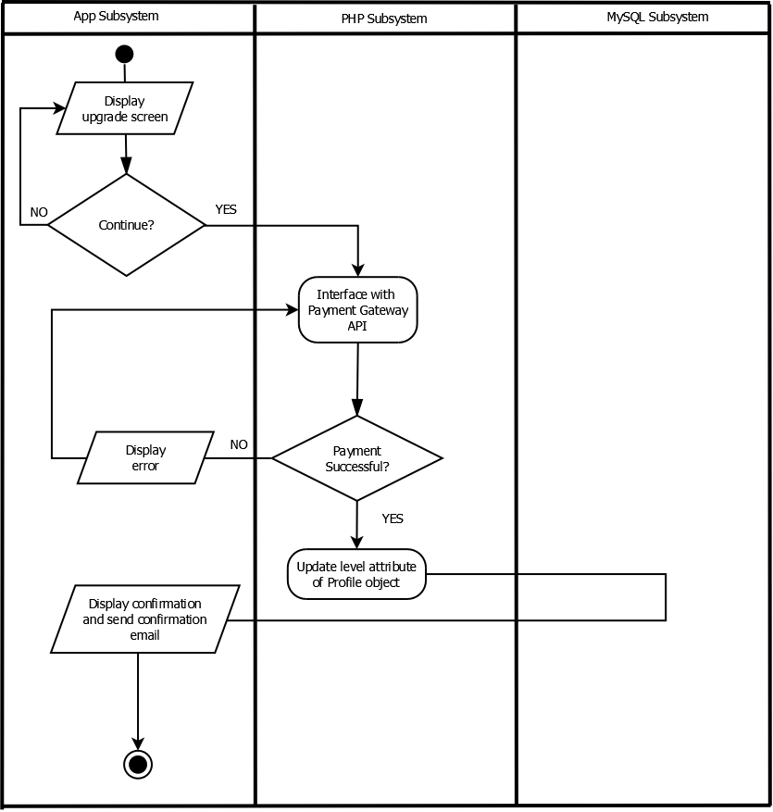

Figure 16: Revised upgrade activity diagram

1. Revised sequence diagrams
   1. Sign up, create profile, edit profile

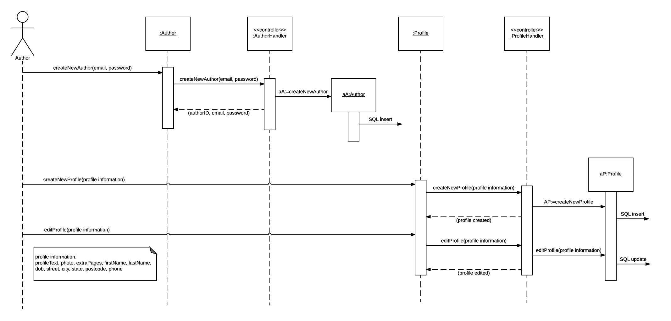

Figure 17: Sign up, create profile, edit profile sequence diagram

* 1. Login, reset password

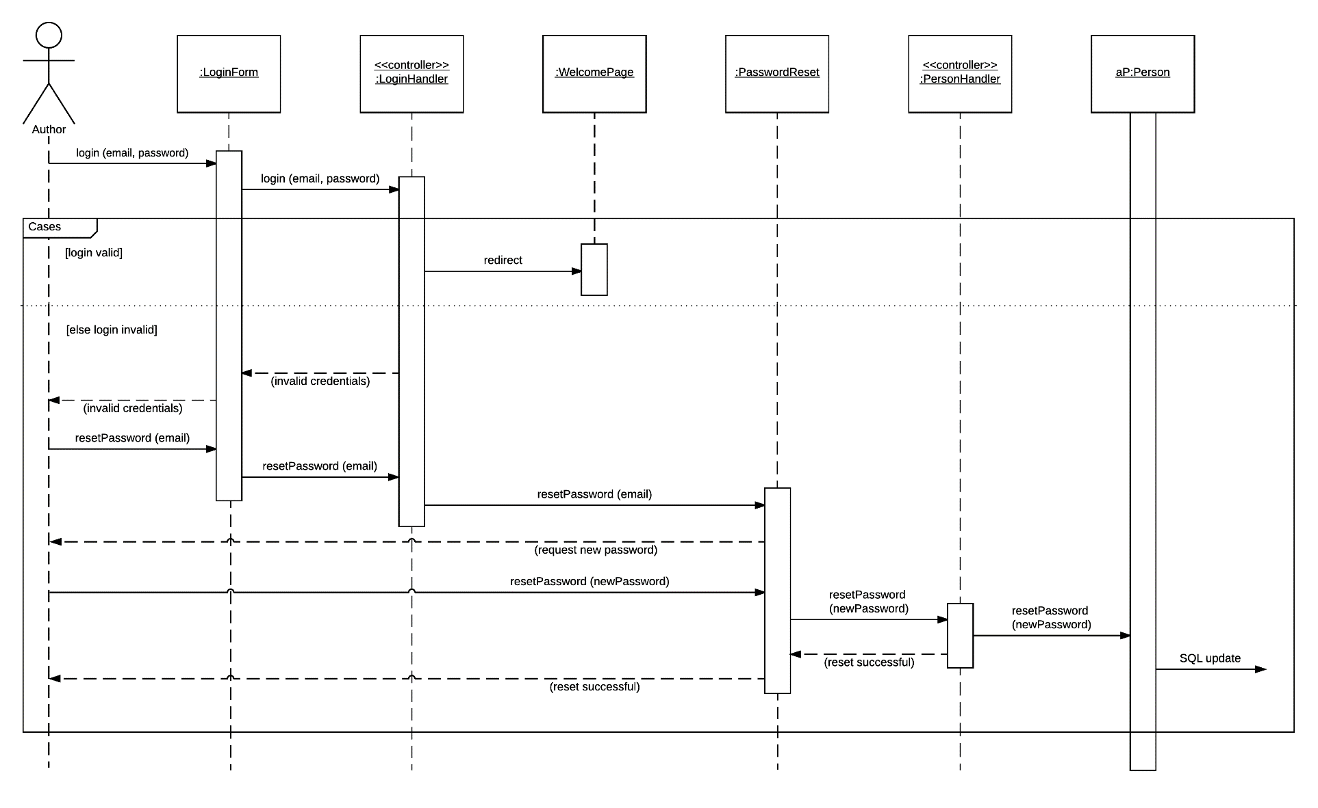

Figure 18: Login, reset password sequence diagram

* 1. Report user

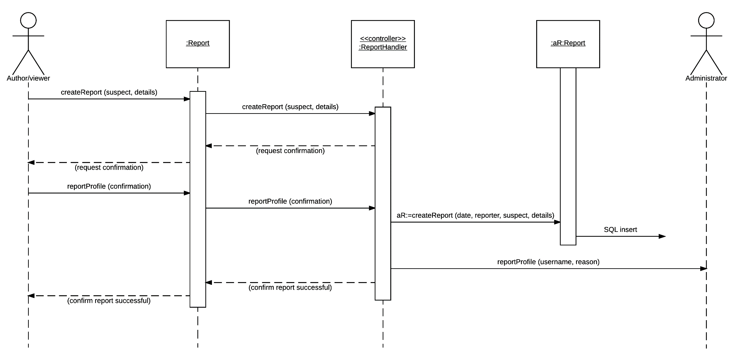

Figure 19: Report user sequence diagram

* 1. Create and edit planning template page

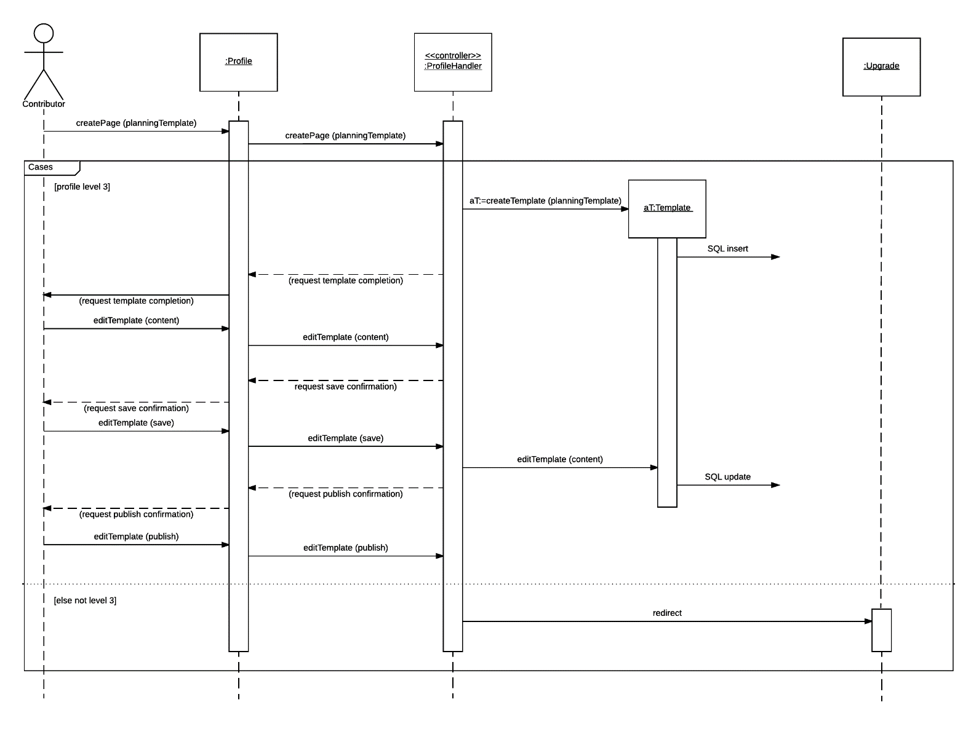

Figure 20: Create and edit planning template page sequence diagram

* 1. Share profile

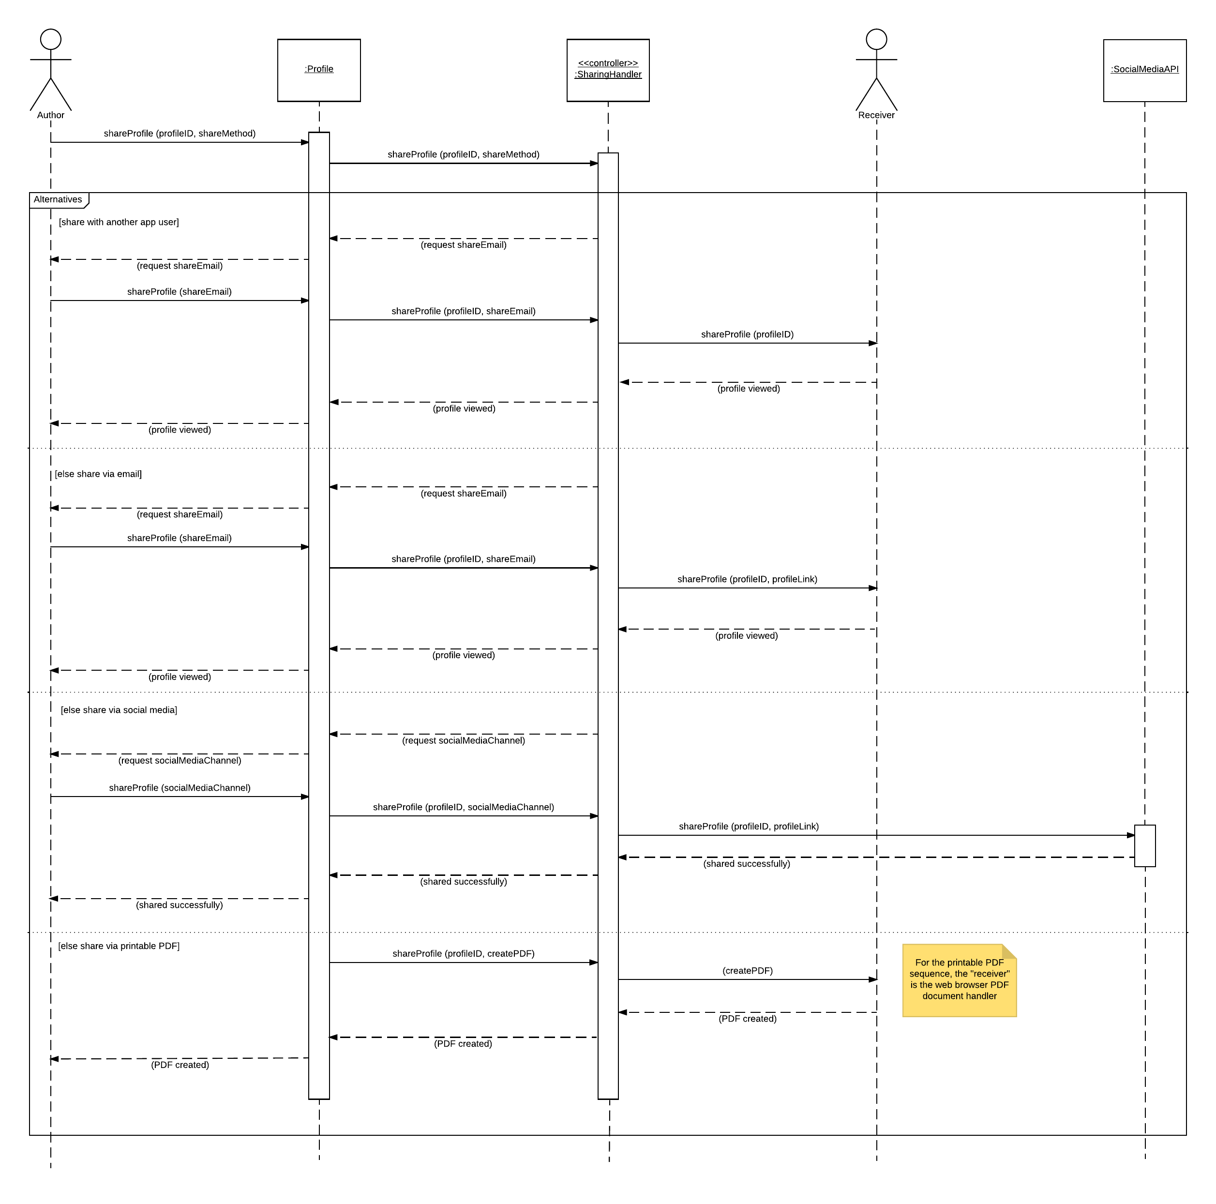

Figure 21: Share profile sequence diagram

* 1. Remove profile

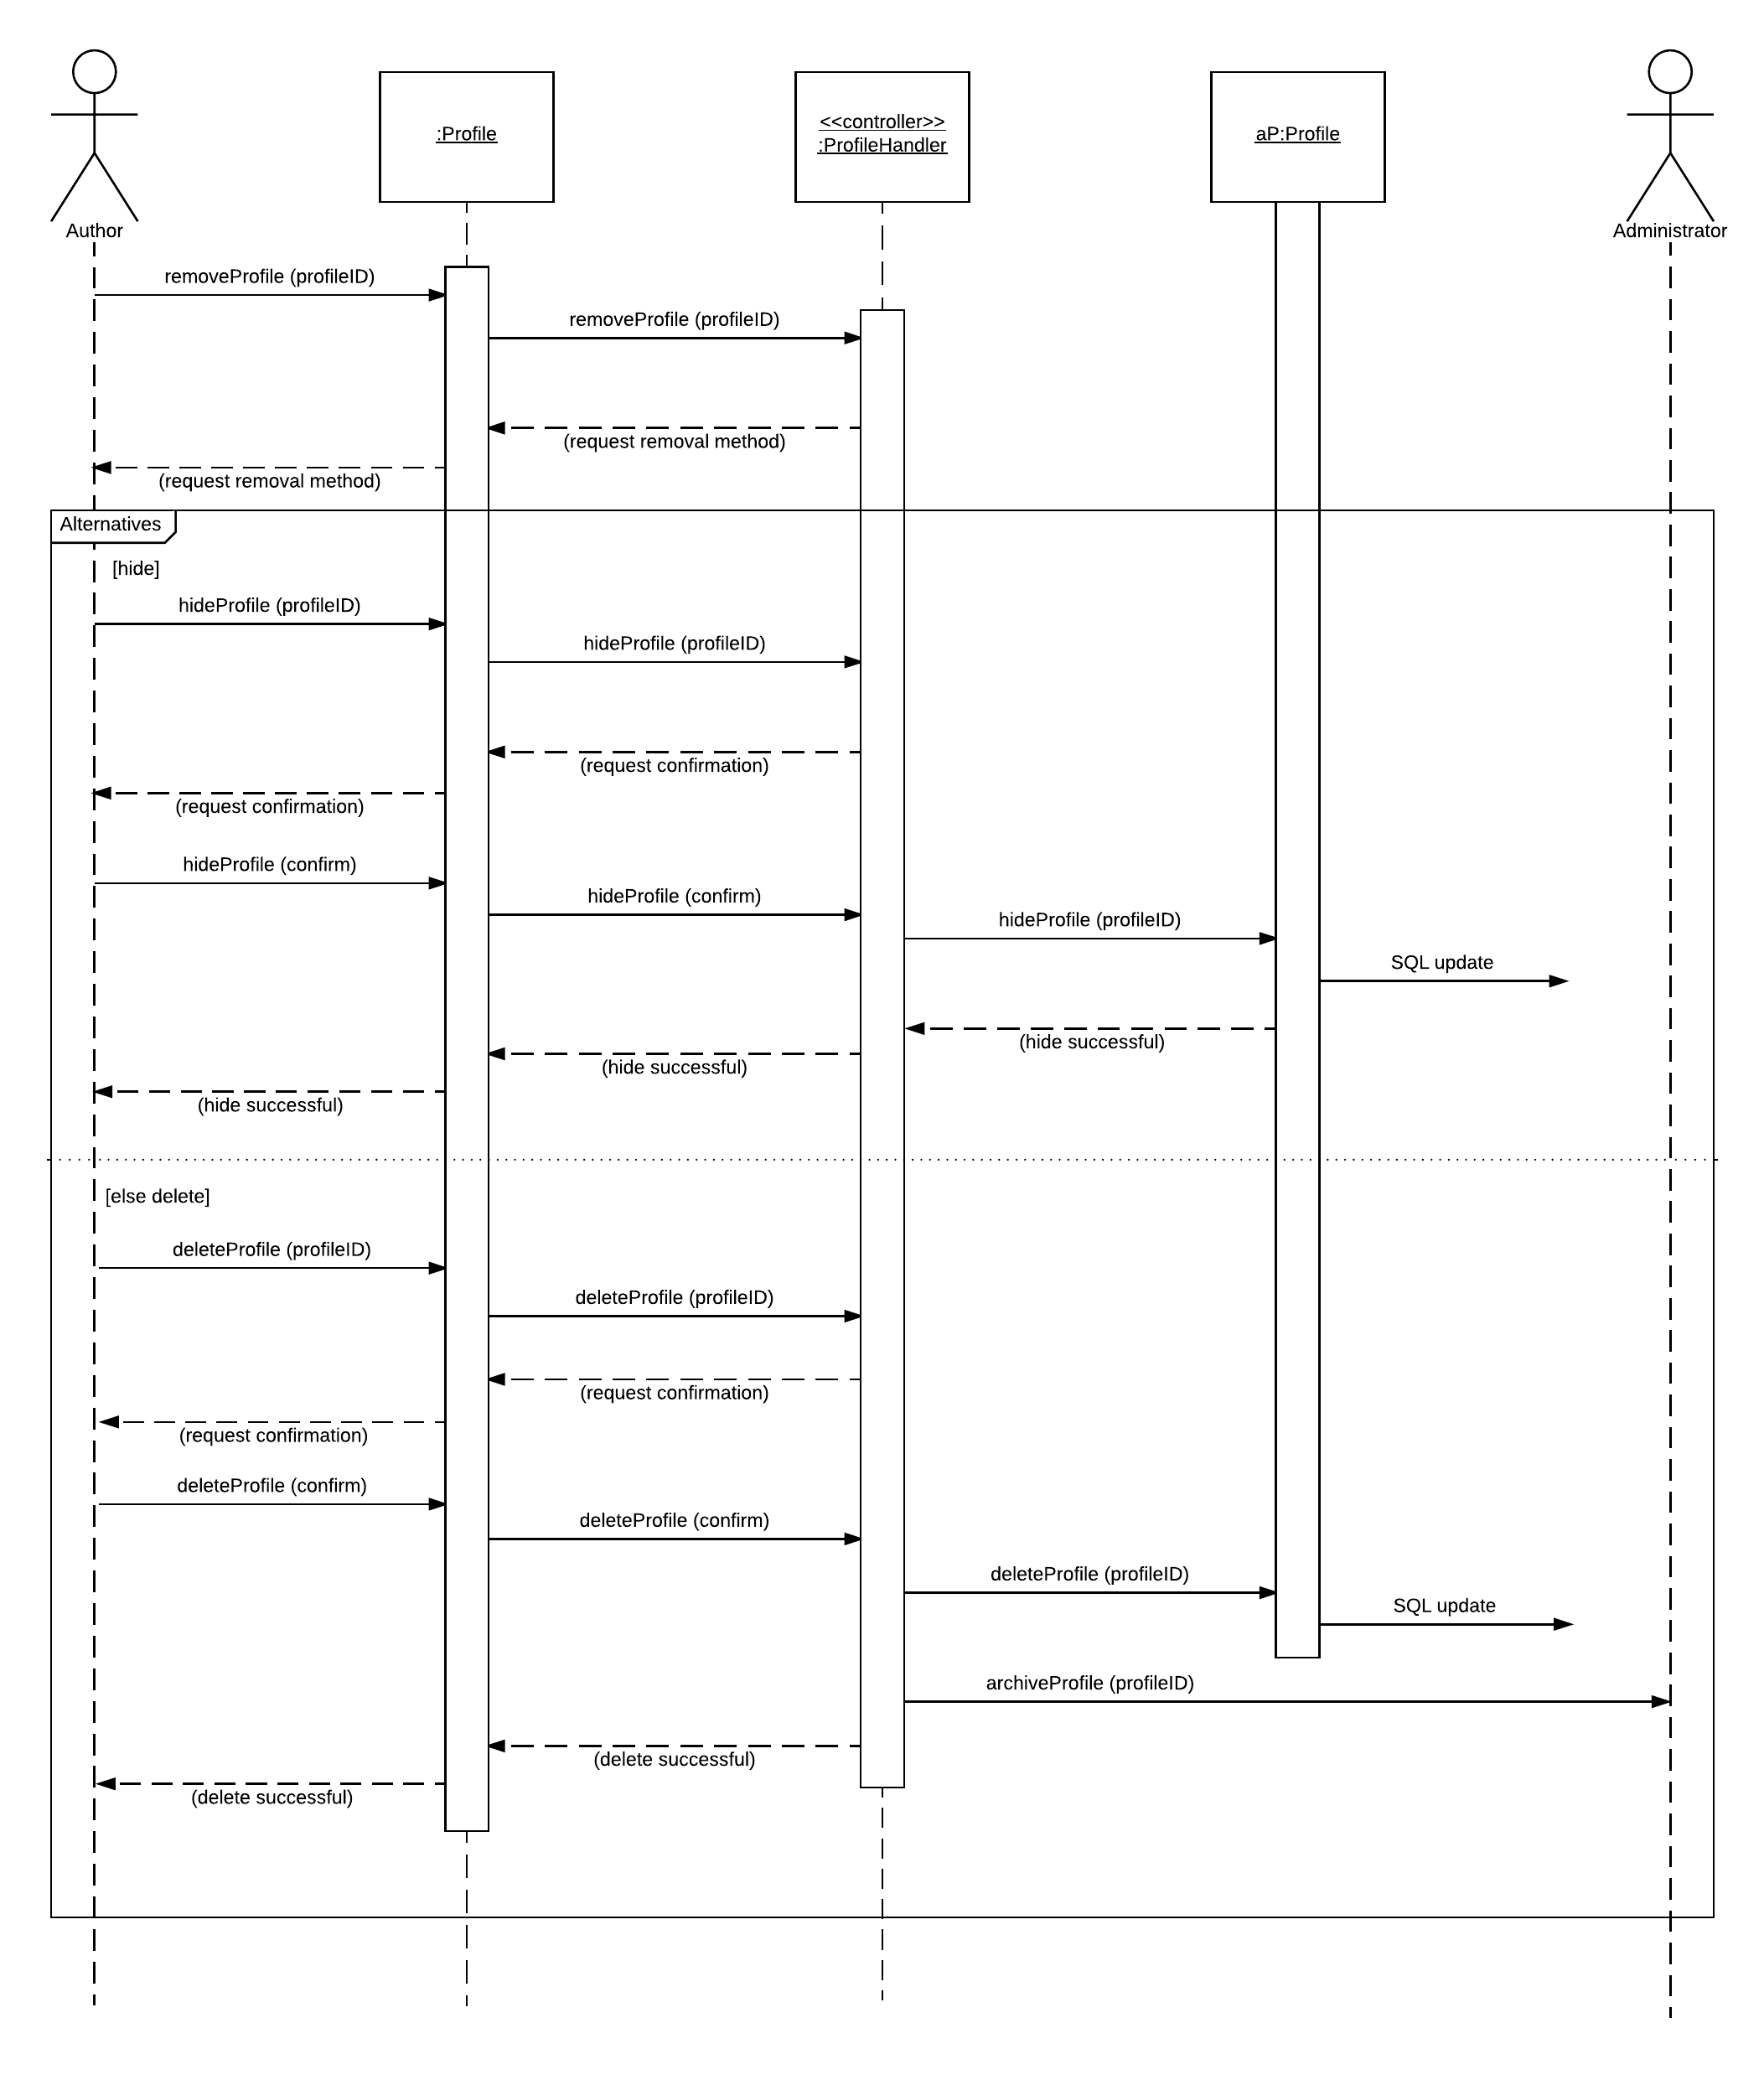

Figure 22: Remove profile sequence diagram

1. Project timeline

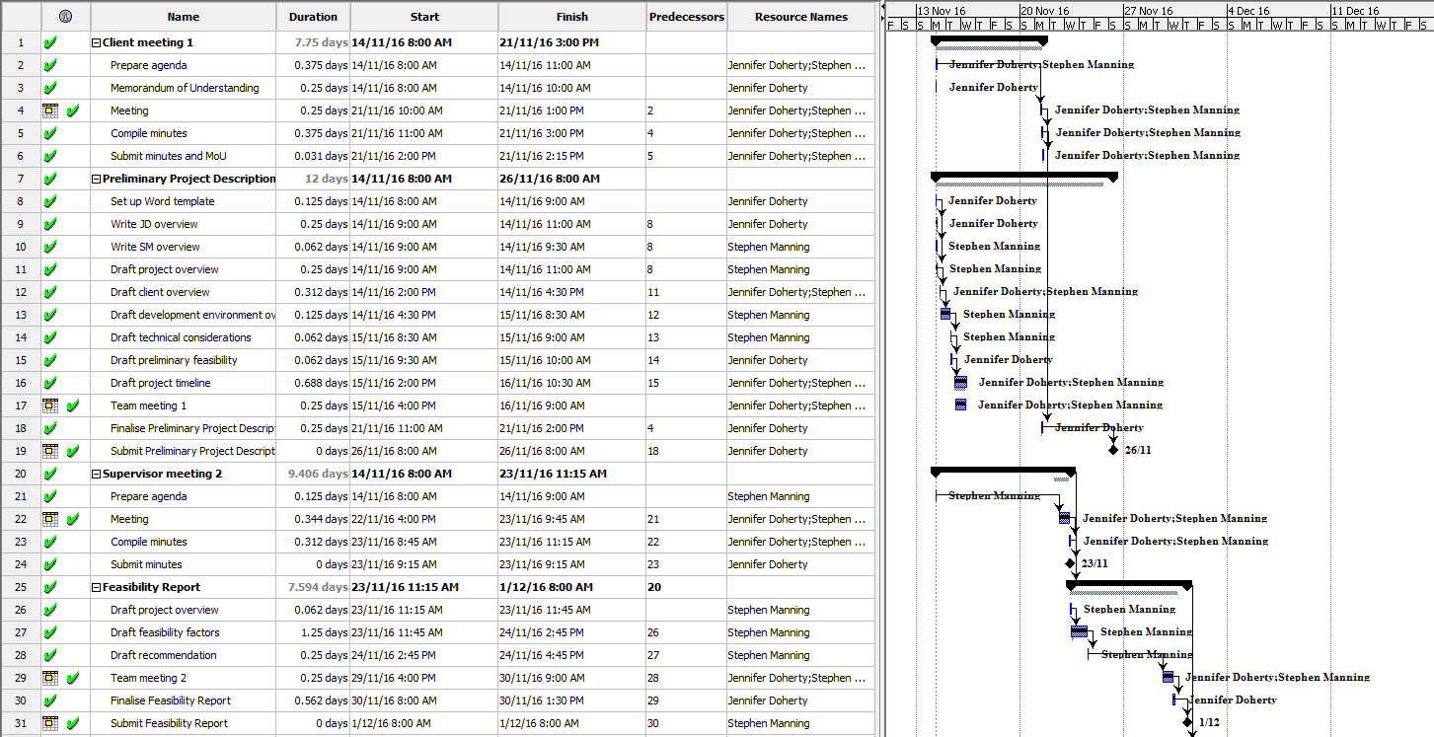

Figure 23: Project timeline 1

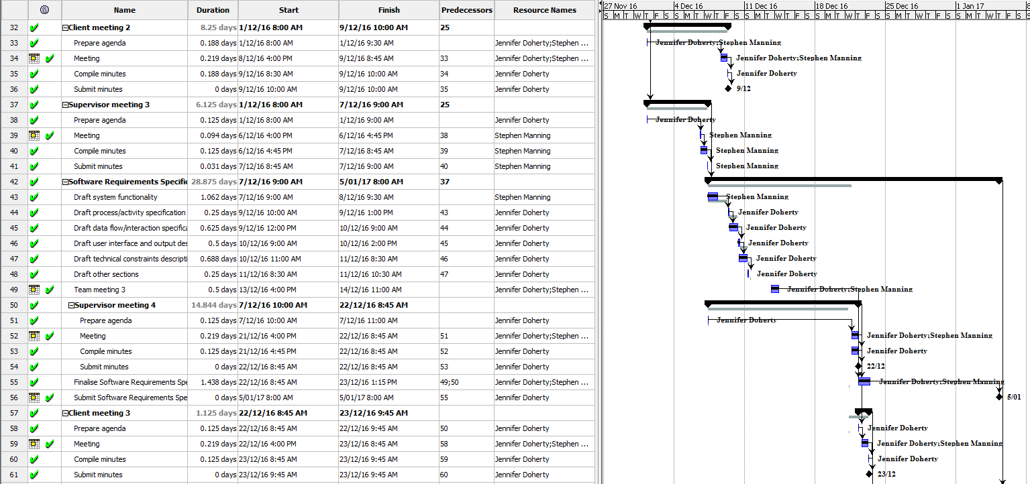

Figure 24: Project timeline 2

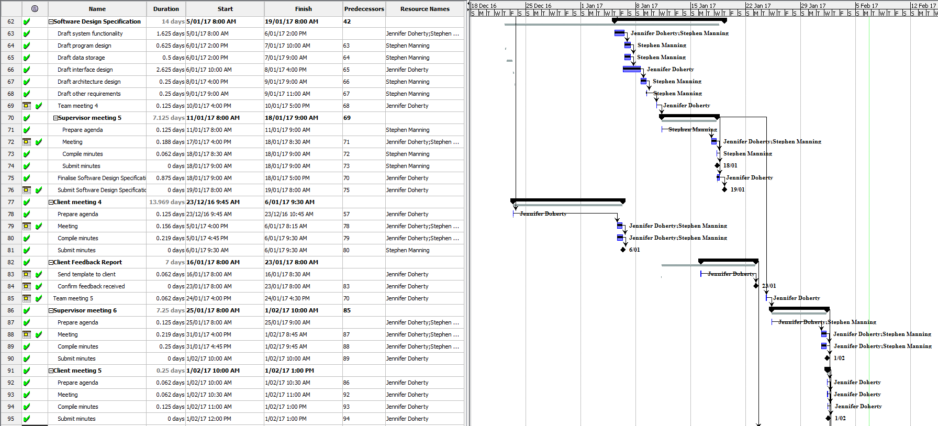

Figure 25: Project timeline 3

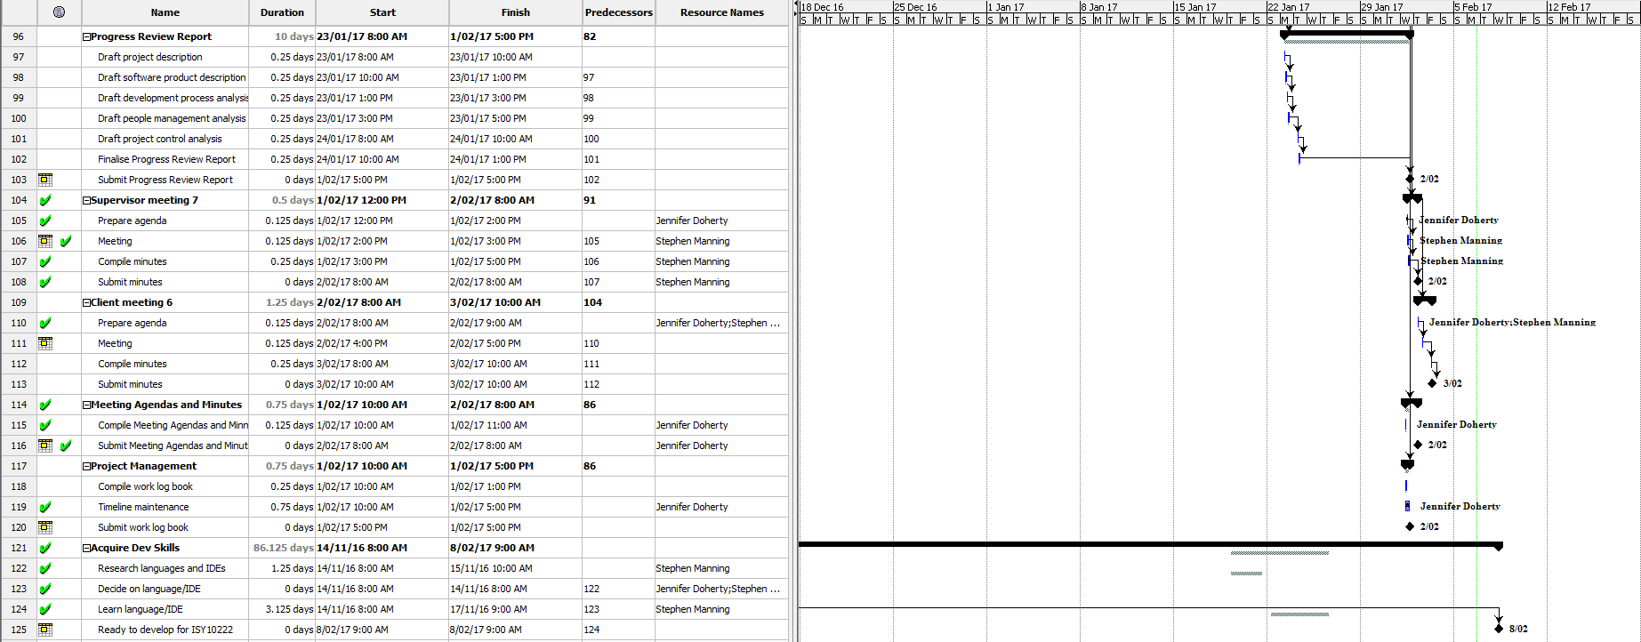

Figure 26: Project timeline 4

1. References

Felke-Morris, T 2015, *Web development and design foundations with HTML5,* Essex, Pearson.

Google Security Blog 2016, *Moving towards a more secure web*, Viewed 6 February 2017, <https://security.googleblog.com/2016/09/moving-towards-more-secure-web.html>.

K., K 2015, *The Bootstrap framework controversy ... should you use it or not?*, Viewed 5 February 2017, <http://www.htmlcenter.com/blog/the-bootstrap-framework-controversy-should-you-use-it-or-not/>.

Kroenke and Auer, 2013, *Database concepts*, New Jersey, Pearson.

Lionite 2014, *Using PHP with MySQL - the right way*, Viewed 5 February 2017, <https://www.binpress.com/tutorial/using-php-with-mysql-the-right-way/17>.

StackOverflow 2010, *Storing script files outside web root*, Viewed 5 February 2017, <http://stackoverflow.com/questions/3034474/storing-script-files-outside-web-root>.

TechNet Magazine 2017, *Tip: Best Practices for Enforcing Password Policies*, Viewed 6 February 2017, <https://technet.microsoft.com/en-us/library/ff741764.aspx>.