About Me Project

System Requirements Specification

|  |
| --- |
| Southern Cross University  Unit: ISY10221 Computing Project I |



Project Supervisor: Paul Woods

Project Client: Jean Stevens on behalf of Elucidate

Project Team: Jennifer Doherty and Stephen Manning

# Executive Summary

The System Requirements Specification models a software system that provides solutions to the problems highlighted in the About Me Project Team’s discussions with the client and in the Preliminary Project Description and Feasibility Study. Specifically, this report models functional and non-functional requirements through the use of various diagrams.

This report will detail the client’s needs, how the client’s business processes are carried out, and how the system will be used to support these processes. Technical constraints are also discussed, including supported browsers and operating systems.

Contents

Executive Summary 2

Section 1. Introduction 9

Section 2. System functionality 10

2.1. Use case diagrams 11

2.2. Class diagram 11

Section 3. Process / interaction specifications 13

3.1. Activity diagrams 13

Section 4. Data-flow / activity specifications 14

4.1. Sequence diagrams 14

Section 5. User interface and output report descriptions 15

5.1. Screen formats 15

5.2. Screen layouts 15

5.2.1. Simple profile: view profile screen 16

5.2.1.1. Screen functions and data 17

5.2.2. In-depth profile: view profile screen 18

5.2.2.1. Screen functions and data 19

5.2.3. Planning-plus profile: view profile screen 20

5.2.3.1. Screen functions and data 21

5.2.4. Planning-plus profile: template screen 22

5.2.4.1. Screen functions and data 23

5.2.5. Administrator screen 24

5.2.5.1. Screen functions and data 24

5.2.6. Main menu 25

5.2.6.1. Screen functions and data 26

5.3. Reports 26

Section 6. Technical constraints descriptions 27

6.1. Usability requirements 27

6.2. Hardware limitations 27

6.2.1. Web app supported browsers and versions – desktop 28

6.2.2. Web app supported browsers and versions – mobile 29

6.2.3. Native app supported OS versions 30

6.3. Reliability requirements 31

6.4. Safety and security requirements 32

Section 7. Other relevant information 33

7.1.1. Profile and Planning Templates 33

7.2. Special Terms 33

Appendices 34

Appendix 1. Use case diagrams 34

1.1. Simple profile 34

1.2. In-depth profile 35

1.3. Planning-plus profile (with planning templates) 36

1.4. Administrator 37

Appendix 2. List of use cases 38

2.1. Use cases – level 1 – simple profile 38

2.2. Use cases – level 2 – in-depth profile 40

2.3. Use cases – level 3 – in-depth profile plus planning templates 41

2.4. Use cases – administrator 41

Appendix 3. Class diagram 43

3.1. Classes and inheritance 44

3.2. Class attribute and method descriptions 45

Appendix 4. Activity diagrams 55

4.1. Login 55

4.2. Sign up 56

4.3. Sign out 57

4.4. Exit without signing out 58

4.5. Report user 59

4.6. View profile 60

4.7. Share profile to social media with invitation for viewing 61

4.8. Share profile with another app user 62

4.9. Receive invitation to view another app user’s profile 63

4.10. Share profile via email 64

4.11. Upgrade to level 2/3 65

4.12. Downgrade to level 1/2 66

4.13. View activity history 67

4.14. Change password 68

4.15. Reset password 69

4.16. Create profile 70

4.17. Edit profile 71

4.18. Delete profile 72

4.19. Hide profile 73

4.20. Change preferences 74

4.21. Read profile 75

4.22. Acknowledge that profile has been read 76

4.23. Create additional page 77

4.24. Edit additional page 78

4.25. Delete additional page 79

4.26. Acknowledge that additional page has been read 80

4.27. View planning template 81

4.28. Edit planning template 82

4.29. Delete planning template 83

Appendix 5. Sequence diagrams 84

5.1. Sign up, add author information, edit information 84

5.2. Login, reset password 85

5.3. Share profile 86

5.4. Report user 87

5.5. Create and edit planning template page 88

5.6. Remove profile 89

Appendix 6. Profile and planning templates 90

6.1. Simple profile template 90

6.2. In-depth profile template 91

Appendix 7. Glossary 94

Appendix 8. Project timeline 95

Appendix 9. References 99

Tables and Figures

Table 1: Levels and functionality 11

Table 2: Users and functionality 12

Table 3: Web app supported browsers and versions – desktop 29

Table 4: Web app supported browsers and versions – mobile 30

Table 5: Native app supported OS versions 31

Table 6: Use cases – level 1 – simple profile 39

Table 7: Use cases – level 2 – in-depth profile 41

Table 8: Use cases – level 3 – in-depth profile plus planning templates 42

Table 9: Use cases – administrator 42

Table 10: Class attribute and method descriptions 46

Figure 1: Simple profile: view profile screen 18

Figure 2: In-depth profile: view profile screen 20

Figure 3: Planning-plus profile: view profile screen 22

Figure 4: Planning-plus profile: template screen 24

Figure 5: Administrator screen 26

Figure 6: Main menu screen 27

Figure 7: Simple profile use case diagram 36

Figure 8: In-depth profile use case diagram 37

Figure 9: Planning-plus profile (with planning templates) use case diagram 38

Figure 10: Administrator use case diagram 39

Figure 11: Class diagram 45

Figure 12: Login activity diagram 57

Figure 13: Sign up activity diagram 58

Figure 14: Sign out activity diagram 59

Figure 15: Exit without signing out activity diagram 60

Figure 16: Report user activity diagram 61

Figure 17: View profile activity diagram 62

Figure 18: Share profile to social media with invitation for viewing activity diagram 63

Figure 19: Share profile with another app user activity diagram 64

Figure 20: Receive invitation to view another app user's profile activity diagram 65

Figure 21: Share profile via email activity diagram 66

Figure 22: Upgrade to level 2/3 activity diagram 67

Figure 23: Downgrade to level 1/2 activity diagram 68

Figure 24: View activity history activity diagram 69

Figure 25: Change password activity diagram 70

Figure 26: Reset password activity diagram 71

Figure 27: Create profile activity diagram 72

Figure 28: Edit profile activity diagram 73

Figure 29: Delete profile activity diagram 74

Figure 30: Hide profile activity diagram 75

Figure 31: Change preferences activity diagram 76

Figure 32: Read profile activity diagram 77

Figure 33: Acknowledge that profile has been read activity diagram 78

Figure 34: Create additional page activity diagram 79

Figure 35: Edit additional page activity diagram 80

Figure 36: Delete additional page activity diagram 81

Figure 37: Acknowledge that additional page has been read activity diagram 82

Figure 38: View planning template activity diagram 83

Figure 39: Edit planning template activity diagram 84

Figure 40: Sign up, add author information, edit information sequence diagram 86

Figure 41: Login, reset password sequence diagram 87

Figure 42: Share profile sequence diagram 88

Figure 43: Report user sequence diagram 89

Figure 44: Create and edit planning template page sequence diagram 90

Figure 45: Remove profile sequence diagram 91

Figure 46: Simple profile template 92

Figure 47: In-depth profile template 1 93

Figure 48: In-depth profile template 2 94

Figure 49: In-depth profile template 3 95

Figure 50: Project timeline 1 97

Figure 51: Project timeline 2 98

Figure 52: Project timeline 3 99

Figure 53: Project timeline 4 100

# Introduction

The About Me Project (AMP) is a cross-platform app that aims to address the communication challenges faced by individuals with disabilities by helping them to elucidate their needs and consolidate their communications with those involved in their care.

AMP will be offered as both a web app and a native app (please refer to Appendix 7, Glossary for more information). The native app will be a “wrapper” version of the web app and therefore both versions will offer the same functionality. Unless a distinction between the web and native versions of the app is required, this report will simply refer to AMP as an app.

The objective of this System Requirements Specification report is to understand the client’s needs, how their business processes are carried out, and how the system will be used to support these processes (Satzinger et al. 2012, p. 5).

The intended audience for this report is programmers and designers.

# System functionality

The About Me Project app consists of three levels, with each level adding a layer of functionality to the previous level, as outlined in Table 1: Levels and functionality.

Table 1: Levels and functionality

|  |  |  |
| --- | --- | --- |
| Level | Name | Functionality |
| 1 | Simple Profile | Contains a single “About Me” page which outlines things like an individual’s likes, motivations, struggles, needs, medication and preferred method of communication.  Additionally, the Simple Profile contains basic information: name, age, carer’s name, emergency contact number and a single passport-style photo. |
| 2 | In-Depth Profile | Same as Simple Profile, but with the ability to link to more detailed “About Me” pages. |
| 3 | Planning-Plus Profile with Planning Templates | Same as In-Depth Profile, but with the ability to access Planning Templates before linking them to the Profile as additional “About Me” pages. |

The About Me Project accommodates four classes of users, with each having different attributes and permissions, as outlined in Table 2: Users and functionality.

Table 2: Users and functionality

|  |  |  |
| --- | --- | --- |
| User | Description | Permission |
| Author | The owner of a profile; an individual with a disability (or their primary carer on their behalf) | Can Create, Read, Update and Delete (CRUD) their own profile, and view and acknowledge profiles they’ve been invited to. |
| Contributor | A member of the individual’s care team, such as a doctor or psychologist | Can contribute to detailed “About Me” pages for authors who have invited to do so. |
| Viewer | A member of the individual’s care team or community, such as a neighbour or local store owner | Can view the profile of an author who has invited them to do so. |
| Administrator | The administrator of the app | Can Create, Read, Update, and Delete any profile; suspend and unsuspend any profile; Create, Read, Update, and Delete planning templates; and backup production data and restore from backup. |

## Use case diagrams

In order to establish functional requirements, the AMP Team identified use cases by interviewing the client and using the user goal and CRUD (Create, Read, Update, Delete) techniques (please refer to Appendix 7, Glossary for more information), before graphically describing these use cases with use case diagrams.

Please refer to Appendix 1 for these use case diagrams, and Appendix 2 for lists of use cases.

## Class diagram

The AMP team identified objects in the problem domain using the brainstorm technique to consider tangible “things” (e.g. profiles, pages) as well as the intangible (e.g. sessions, roles) (Satzinger et al. 2012, p. 96).

The team then used the noun technique to distinguish between classes and attributes (Satzinger et al. 2012, p. 96).

Please refer to Appendix 3 for the resulting class diagram, and to Appendix 7, Glossary for more information on terminology.

# Process / interaction specifications

## Activity diagrams

The AMP team created activity diagrams to develop workflows, which show all the steps within a use-case (Satzinger et al. 2012, p. 18).

Please refer to Appendix 4 for the resulting activity diagrams.

# Data-flow / activity specifications

## Sequence diagrams

The AMP team created detailed sequence diagrams for key use cases to show the sequence of messages sent between objects (Satzinger et al. 2012, p. 332).

Please refer to Appendix 5 for the sequence diagrams.

# User interface and output report descriptions

## Screen formats

Screens will be written in HTML, styled in CSS, and manipulated and processed with JavaScript and PHP.

Screens will be designed to be responsive, so the app is useable on all screen sizes. The primary screen orientation will be portrait, to accommodate mobile devices. This will result in excess white space on desktop devices (or mobile devices in landscape orientation). It is important that the screens are clean and minimalist so that the white space doesn’t stand out.

Screens will be simple and uncluttered, with minimal use of colour or animation, so that they are not overwhelming for the user base and so that they are accessible to screen readers (see 6.1, Usability requirements for more details).

## Screen layouts

Each “view profile” screen will have an “edit profile” screen that is visually identical, except that the fields will be editable. Therefore, mock-ups have not been created for those screens.

### Simple profile: view profile screen

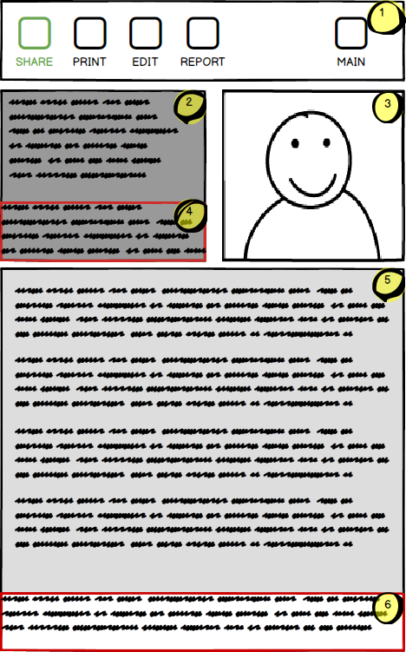

Figure 1: Simple profile: view profile screen

#### Screen functions and data

1. Main header menu
   * Main: return to main menu
   * Share: share profile using various sharing methods
   * Print: print profile (to PDF or to printer)
   * Edit: edit profile (only visible to profile author)
   * Report: report profile (hidden when viewing one’s own profile)
   * Administrators will also have additional functions to suspend or unsuspend the account
2. Basic profile information
   * Includes name, age, primary carer’s name, relationship to primary carer, and emergency contact
3. Profile photo
4. Static disclaimer text
5. Profile blurb text
6. Static disclaimer text

### In-depth profile: view profile screen

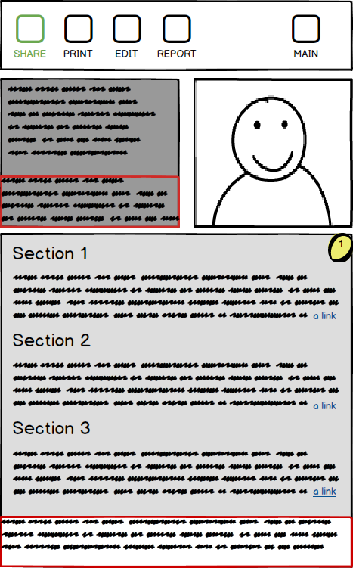

Figure 2: In-depth profile: view profile screen

#### Screen functions and data

The majority of this screen is similar to the simple profile above. Additionally:

1. The profile blurb text is divided into larger sections and may include internal or external links (please refer to Appendix 7, Glossary for more information).

### Planning-plus profile: view profile screen

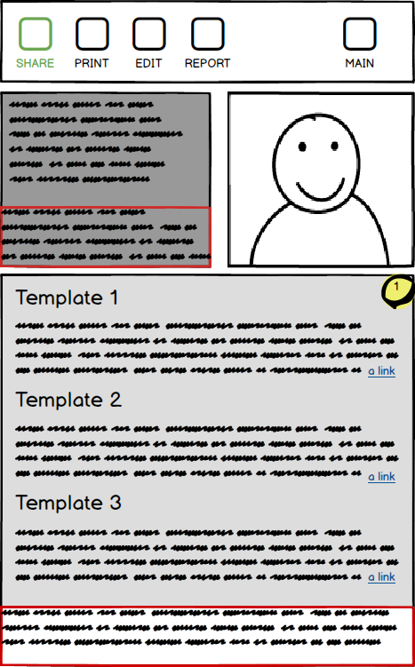

Figure 3: Planning-plus profile: view profile screen

#### Screen functions and data

The majority of this screen is similar to the in-depth profile above. Additionally:

1. The profile blurb text is separated into sections related to each planning template. Each section contains a link to the relevant planning template.

### Planning-plus profile: template screen

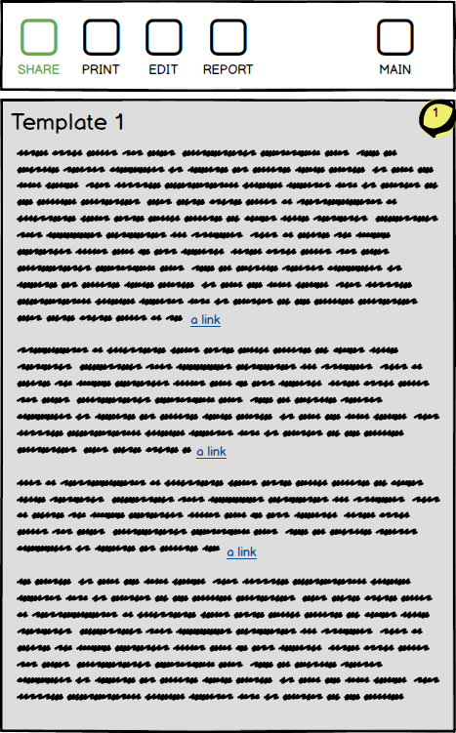

Figure 4: Planning-plus profile: template screen

#### Screen functions and data

The template screen includes the main header menu but omits the other sections, to focus on the template text.

1. The template may include a series of questions or suggested headings, and also may include links to external resources.

### Administrator screen

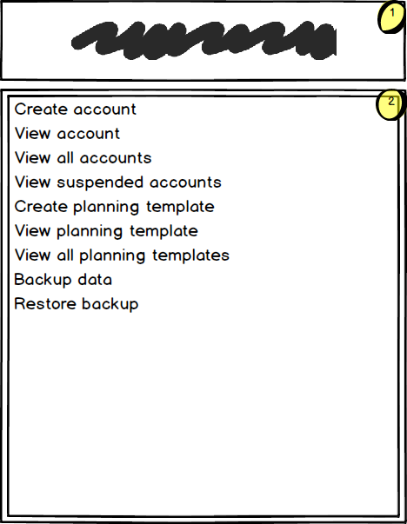

Figure 5: Administrator screen

#### Screen functions and data

The administrator screen includes the following sections:

1. A header with a welcome message
2. The administrator menu

### Main menu

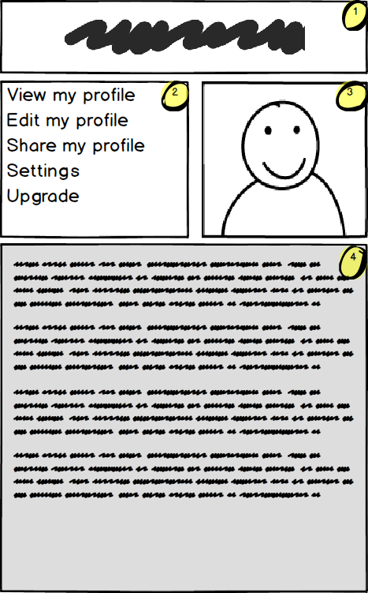

Figure 6: Main menu screen

#### Screen functions and data

The main/welcome menu includes the following sections:

1. A header with a welcome message
2. The user menu
3. The user’s photo
4. A Twitter-feed-like record of changes and notifications to the profile.

## Reports

The administrator can run the following stock reports:

1. View all active accounts
2. View suspended/hidden/deleted accounts
3. View all planning templates

Additionally, the administrator can use parameters to filter reports, for example:

1. Accounts created/deleted/suspended/hidden within a certain timeframe
2. Accounts active/inactive/hidden/suspended/deleted for a certain length of time
3. Find users of a certain demographic

# Technical constraints descriptions

## Usability requirements

The web app must be accessible to screen readers (WebAIM 2014). The following features should be included to facilitate this:

* Links should have useful names with distinguishing information at the start of the link, for example, “available planning templates”, not just “click here”.
* Content should be arranged with logical headings following a logical hierarchy using HTML header tags.
* Page sections should be defined with appropriate HTML sectioning elements, for example, <main>, <nav>, <header>. ARIA landmark roles should also be used where appropriate (WebAIM 2013a).
* Paragraphs should have distinguishing information at the start, in the first sentence or two, to facilitate skimming content.
* Skip navigation links should be included to allow users to jump straight to the main page content (WebAIM 2013b).
* Correct semantic HTML structure should be used for all page elements.
* All images should include alt text.

Usability and accessibility must be considered for all design decisions, including:

* Page layout
* Graphics
* Animation
* Colours
* Fonts

## Hardware limitations

Due to the difficulty in supporting every possible hardware / operating system / browser combination and their versions, the app will offer three levels of support:

* Full: all features will function as intended. The web and native apps will be thoroughly tested to ensure support requirements are met.
* Limited: most feature will function as intended. Some features may require a fallback solution with limited functionality. The web and native apps will be tested as thoroughly as possible using available devices and tools.
* None: no support available. The web app is offered on an as-is basis. It may not function correctly, or at all, and a native app will not be available.

The following tables outline various hardware / operating system / browser combinations and their levels of support.

### Web app supported browsers and versions – desktop

Table 3: Web app supported browsers and versions – desktop

|  |  |  |  |
| --- | --- | --- | --- |
| Browser | Version | Support level | Notes |
| Google Chrome | Latest release | Full | Chrome automatically updates, no support for earlier versions required |
| Mozilla Firefox | Latest release | Full | Firefox automatically updates, no support for earlier versions required |
| Microsoft Internet Explorer | 11+ | Full | Supported for Windows 7+ only (Goretsky 2016) |
|  | 9+ | Limited | Supported for certain Windows versions only |
|  | <9 | None | Older versions are no longer supported by Microsoft |
| Microsoft Edge | 14+ | Full | Replaces Internet Explorer for Windows 10+ |
|  | <14 | Limited | Older versions do not support all features of HTML5 |
| Apple Safari | 9+ | Full | Safari is only supported for macOS |
|  | <9 | None | Older versions do not support all features of HTML5 |
| Opera | Latest release | Full | Opera automatically updates, no support for earlier versions required |
| Other minor browsers | Any | None | No support is offered for other minor browsers |

### Web app supported browsers and versions – mobile

Table 4: Web app supported browsers and versions – mobile

|  |  |  |  |  |
| --- | --- | --- | --- | --- |
| OS | Browser | Version | Support level | Notes |
| iOS | Apple Safari | Latest release | Full | Safari updates when iOS updates |
|  | Other major browsers (e.g. Chrome, Opera Mini, UC Browser, Firefox) | Latest release | Limited | Limited support will be offered for major browsers. |
|  | Other minor browsers | Any | None | No support is offered for other minor browsers |
| Android | Google Chrome | Latest release | Full | Chrome users should update regularly |
|  | Native default phone model / carrier browsers[1] | Latest release | Limited | These browsers may not support all features of HTML5 |
|  | Other major browsers (e.g. Firefox, Opera Mini, UC Browser) | Latest release | Limited | Limited support will be offered for major browsers |
|  | Other minor browsers | Any | None | No support is offered for other minor browsers |
| Other mobile operating systems (e.g. Windows Phone, Blackberry) | Any | Any | None | Extremely small market share and difficulty of support means no support is offered |

### Native app supported OS versions

Table 5: Native app supported OS versions

|  |  |  |  |
| --- | --- | --- | --- |
| OS | Version | Support level | Notes |
| iOS | 9+ | Full | iOS users quickly update to new releases of iOS – 95% of iOS devices are on iOS 9 or higher (Mixpanel 2017) |
|  | <9 | None | Older versions of iOS can have stability issues |
| Android[2] | 5.0+ | Full | Represents about 60% of Android users (Android Open Source Project 2016) |
|  | 4.4 | Limited | Represents about 25% of Android users, but has known support issues, including with photo and camera access[3] |
|  | <4.4 | None | Represents about 15% of Android users, but is very difficult to support |
| Other | Any | None | No native app support for other mobile operating systems |

## Reliability requirements

The app will add a layer of functionality to an underlying hosting solution, which will provide virtual private hosting and a LAMP (Linux, Apache, MySQL, PHP) or equivalent Windows stack. The team will ensure that the recommended underlying solution has a high uptime guarantee and high mean-time between failures relative to the ongoing subscription free.

The client is from a non-technical background and does not employ an IT Consultant, so low maintenance is an important requirement. Generally, PHP and MySQL do not need to be upgraded between minor versions (unless one wishes to enable new functionality), as security vulnerabilities are more likely to exist in the server itself (ServerFault 2011). The team will be recommending a plan with Virtual Private Hosting, meaning upgrades and security of the host server will be taken care of by the hosting provider.

The app itself is required to be as robust (i.e. significantly bug free) as possible for stakeholders, within the given time and resource constraints. An extensive test plan will be developed in future documentation to facilitate this.

## Safety and security requirements

The amount of personal information being collected is minimal and low risk, with the only pieces of personally-identifiable information being emergency contact number and email address.

The development team must follow best security practices when implementing the solution, which will include taking measures like limiting the execution of PHP extensions in writeable folders on the server.

# Other relevant information

### Profile and Planning Templates

The client, Jean Stevens, is in the process of providing (at the time of writing) a number of profile and planning templates to the development team.

The templates are based on Jean’s many years of experience in helping children and adults, and their carers, in the special education and special needs sectors, and they provide a framework for succinctly articulating the struggles, needs and personalities of individuals with a disability.

These templates will play a key role in envisioning the look, feel and functionality of the final product during the design and development phases.

Please refer to Appendix 6 for the Profile and Planning Templates.

## Special Terms

Please refer to Appendix 7 for a glossary of special terms.



###### Appendices

* + 1. Use case diagrams
       1. Simple profile

Note: **Upload Profile to Social Media with Viewing Invitation**, and aspects of **Change notification settings** and **Change colour/font settings**, are planned for a future iteration.

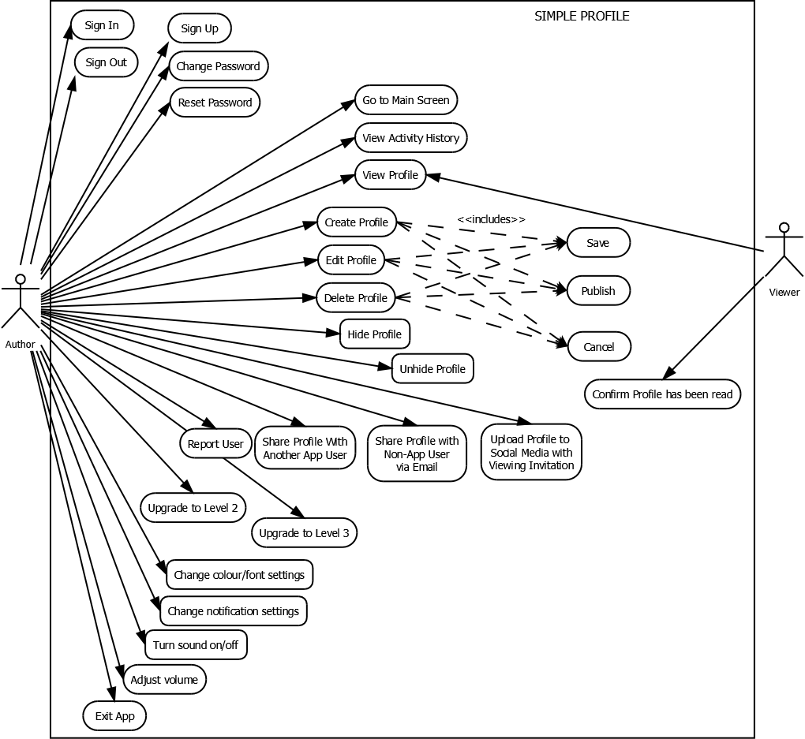

Figure 7: Simple profile use case diagram

* + - 1. In-depth profile

Note: The below use-cases are in addition to those described in the Simple Profile

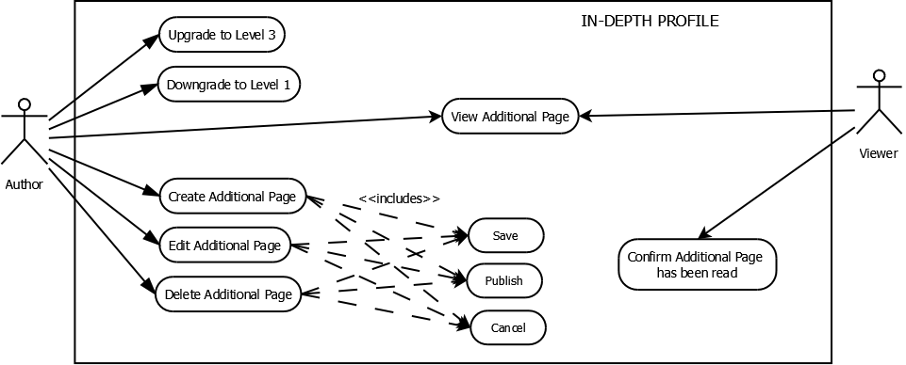

Figure 8: In-depth profile use case diagram

* + - 1. Planning-plus profile (with planning templates)

Note: The below use-cases are in addition to those described in the Simple and In-depth Profiles.

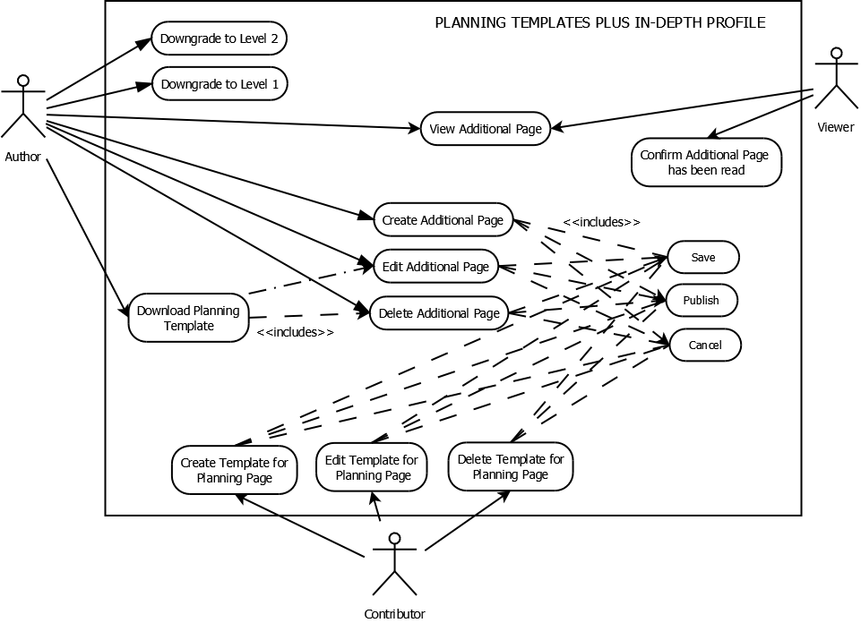

Figure 9: Planning-plus profile (with planning templates) use case diagram

* + - 1. Administrator

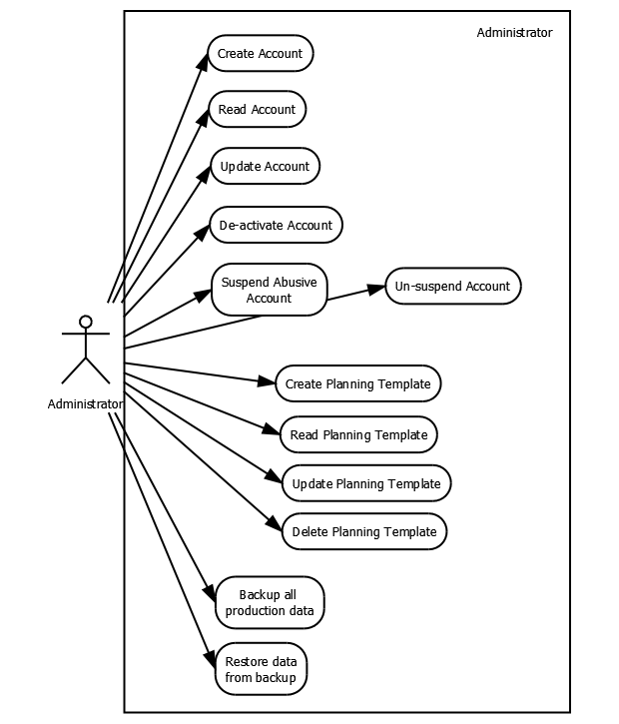

Figure 10: Administrator use case diagram

* + 1. List of use cases

The tables in this Appendix include the following classes of actor:

* Author (person who creates profile) – individual with a disability or somebody acting on their behalf
* Viewer – somebody who views profile, who forms part of the support network for the individual with a disability
* Contributor (health care professional – for Level 3 only)
* Administrator – somebody who maintains the system
  + - 1. Use cases – level 1 – simple profile

Table 6: Use cases – level 1 – simple profile

|  |  |
| --- | --- |
| Use cases | Actors |
| First landing screen – sign up/login | Author |
| Report another app user to administrator to flag for review (e.g., being offensive, fake users) | Author |
| Go to Main Screen | Author |
| Sign-Out | Author |
| View Profile | Author, Viewer |
| Share Profile   * Upload Profile to Social Media with invitation for viewing (later phase) * Share Profile with somebody else who has the app * Share Profile via email with somebody else who may not have the app | Author |
| Exit without signing out (using native gesture) | Author |
| Upgrade to Level 2 or 3 | Author |
| View activity history | Author |
| Change Password / Reset Password | Author |
| Create Profile   * Save / Cancel / Publish | Author |
| Edit Profile   * Save / Cancel / Publish | Author |
| “Delete” Profile (i.e. flag profile for being made inactive by administrator) | Author |
| Hide Profile (Temporarily) | Author |
| Change preferences   * Colours / Font Size * Alerts * In-App notifications vs. Email Notifications vs. Push (these options are planned for a future iteration) * Sounds (chimes when alerts go off) * Sounds * On / Off * Volume | Author |
| Read profile | Viewer |
| Acknowledge that profile has been read | Viewer |

* + - 1. Use cases – level 2 – in-depth profile

Note: The below use-cases are in addition to those described in the Simple Profile.

Table 7: Use cases – level 2 – in-depth profile

|  |  |
| --- | --- |
| Use cases | Actors |
| Create additional page   * Save / Cancel / Publish * Text-only (images – phase 2) | Author |
| Edit additional page   * Save / Cancel / Publish * Text-only (images – phase 2) | Author |
| Delete additional page | Author |
| Acknowledge that additional page has been read | Viewer |

* + - 1. Use cases – level 3 – in-depth profile plus planning templates

Note: The below use-cases are in addition to those described in the Simple and In-Depth Profiles.

Table 8: Use cases – level 3 – in-depth profile plus planning templates

|  |  |
| --- | --- |
| Use cases | Actors |
| View / edit / save / delete / publish a copy of a planning template (various ready-made templates available to choose from) | Author |
| View / edit / save / delete / publish contributor’s planning page (contributor’s planning pages created by health professionals) | Author |
| Create / edit / save / delete / publish planning page   * Upload/delete attachment (e.g. PDF report) | Contributor |

* + - 1. Use cases – administrator

Table 9: Use cases – administrator

|  |  |
| --- | --- |
| Use cases | Actors |
| Maintain user database (author database, contributor database, content database)   * Create/Read/Update/Delete Account (Author, Contributor, Administrator)   + Note: “Delete” user (i.e. make user inactive)   + Automatically delete user after x years (Phase 2)   Suspend/Reactivate Profile (for violation of Terms and Conditions) – manual for now, could be automated in Phase 2 | Administrator |
| Maintain planning templates database   * Create/Read planning template * Edit planning template * Delete planning template | Administrator |
| Archive/Restore   * Archive all production data * Restore production data from archive | Administrator |

* + 1. Class diagram

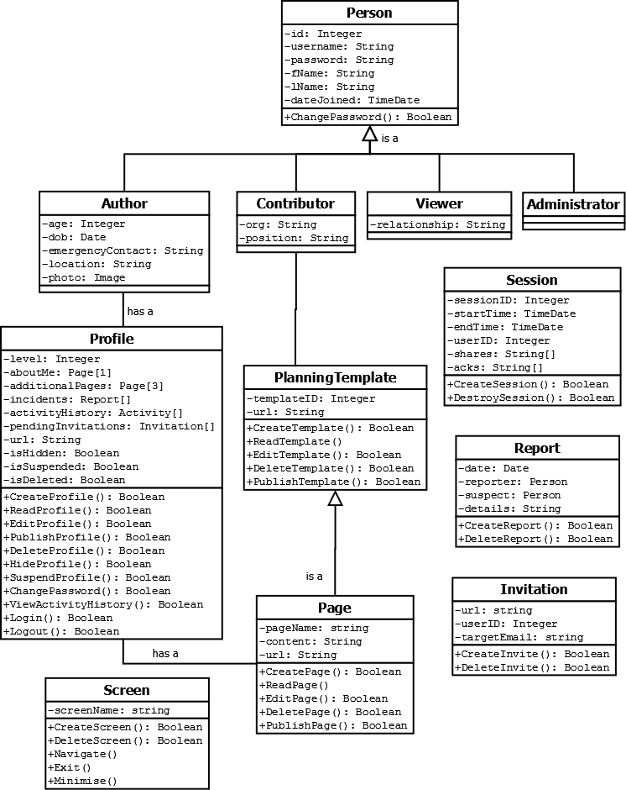

Figure 11: Class diagram

* + - 1. Classes and inheritance

There are four classes of users – Author, Contributor, Viewer, Administrator – who all inherit from class Person.

Authors can have pages. The Page class inherits from the PlanningTemplate class.

Each time a user logs in to the app they create a session.

A user can create a report of another user, to report them for abuse.

A user can create an invitation.

A screen is created each time a user navigates in the app.

* + - 1. Class attribute and method descriptions

Table 10: Class attribute and method descriptions

|  |  |  |  |
| --- | --- | --- | --- |
| Class | Attribute | Method | Description |
| Person | id |  | Unique, auto-incrementing identifier for each user. Necessary because email address is not necessarily a unique identifier (people in the same family, for example, might share the same email), and a user might change their email address |
| username |  | This field will contain a unique email address that the user enters upon registration |
| password |  | Contains a password chosen by the user. Password complexity requirements have yet to be determined. |
| fName |  | First name of user |
| lName |  | Last name of user |
| dateJoined |  | Date of user profile creation |
|  | ChangePassword | Change user’s password |
| Author | age |  | Age of user, automatically calculated from dob |
| dob |  | Date of Birth |
| emergencyContact |  | Emergency contact number |
| location |  | General location of user |
| photo |  | Passport-size portrait of user (413 x 413 pixels) |
| Contributor | org |  | Organisation of contributor |
|  | position |  | Contributor’s position with the organisation |
| Viewer | relationship |  | Viewer’s relationship to the profile owner |
| Profile | level |  | Integer indicating profile level, such that:  1 = Simple Profile  2 = In-depth Profile  3 = In-depth Profile with Planning Templates |
| aboutMe |  | Contains a page that consists of several sections of hypertext describing who users are, what they like, what their struggles are, how they prefer to communicate, and what medication they require |
| additionalPages |  | Contains up to three additional hypertext pages which elaborate upon the information in the aboutMe field |
| incidents |  | Array for storing Reports of unacceptable use submitted by other users. Storing these reports in the Profile object allows the Administrator to easily extract all reports that have been filed against the user |
| activityHistory |  | Array of Activity objects (time-stamped records of significant events – e.g., logins, session-lengths, shares, acknowledgements) which gets displayed at the bottom of the main menu (see section 5.2.6). |
| pendingInvitations |  | Array of Invitations received by the user which have yet to be viewed |
| url |  | URL of Profile object |
| isHidden |  | Boolean attribute indicating whether a profile should be visible to viewers or other users. Hidden profiles are still visible to profile owners and administrators |
| isSuspended |  | Boolean attribute indicating whether a profile has been suspended for unacceptable use |
| isDeleted |  | Boolean attribute indicating whether a profile has been “deleted”. In reality, “deleted” profiles are kept in the system for a fixed number of years for legal requirements |
|  | CreateProfile | Creates an instance of the Profile class and initialises its fields |
|  | ReadProfile | Displays Profile object |
|  | EditProfile | Edits Profile object |
|  | PublishProfile | Publishes an edited profile |
|  | DeleteProfile | “Deletes” a profile (i.e. marks profile for archival) by setting isDeleted attribute to “true” |
|  | HideProfile | Hides a profile by setting isHidden attribute to “true” |
|  | SuspendProfile | Suspends profile by setting isSuspended attribute to “true” |
|  | ChangePassword | Changes password |
|  | ViewActivityHistory | Displays a user’s activity history by extracting data from the activityHistory array |
|  | Login | Authenticates the user |
|  | Logout | Signs-out the user |
| PlanningTemplate | templateID |  | Unique, auto-incrementing identifier for each planning template |
| url |  | URL of PlanningTemplate object |
|  | CreateTemplate | Create a template |
|  | ReadTemplate | Display a template |
|  | EditTemplate | Edit a template |
|  | DeleteTemplate | Delete a template |
|  | PublishTemplate | Published an edited template |
| Session | sessionID |  | Unique identifier for each session |
| startTime |  | Start-time of session |
| endTime |  | End-time of session |
| userID |  | id of user who invoked session |
| shares |  | Array of strings, with each string recording a profile-share that the user has dispatched during the session. |
| acks |  | Array of strings, with each string recording a profile-acknowledgement that the user has initiated during the session. |
|  | CreateSession | Creates (starts) a session |
|  | DestroySession | Destroys (ends) a session |
| Report | date |  | Date that report was filed |
| reporter |  | ID of user (author, contributor, viewer or administrator) who filed the report |
| suspect |  | ID of user (author) being reported |
| details |  | String describing details of unacceptable use |
|  | CreateReport | Create a Report object |
|  | DeleteReport | Delete a Report object |
| Invitation | url |  | URL of Profile object |
| userID |  | ID of user sending invitation |
| targetEmail |  | Email address of recipient of invitation |
|  | CreateInvite | Create an invitation |
|  | DeleteInvite | Delete an invitation |
| Page | pageName |  | Unique name for each page |
| content |  | String containing URL of included content |
| url |  | URL of Page object |
|  | CreatePage | Creates a page |
|  | ReadPage | Reads the contents of a page |
|  | EditPage | Edits a page |
|  | DeletePage | Deletes a page |
|  | PublishPage | Publishes an edited page |
| Screen | screenName |  | Unique name for each string |
|  | CreateScreen | Create a new screen |
|  | DeleteScreen | Delete an existing screen |
|  | Navigate | Navigate to a new screen |
|  | Exit | Exit the screen |
|  | Minimise | Minimise the screen |

* + 1. Activity diagrams
       1. Login

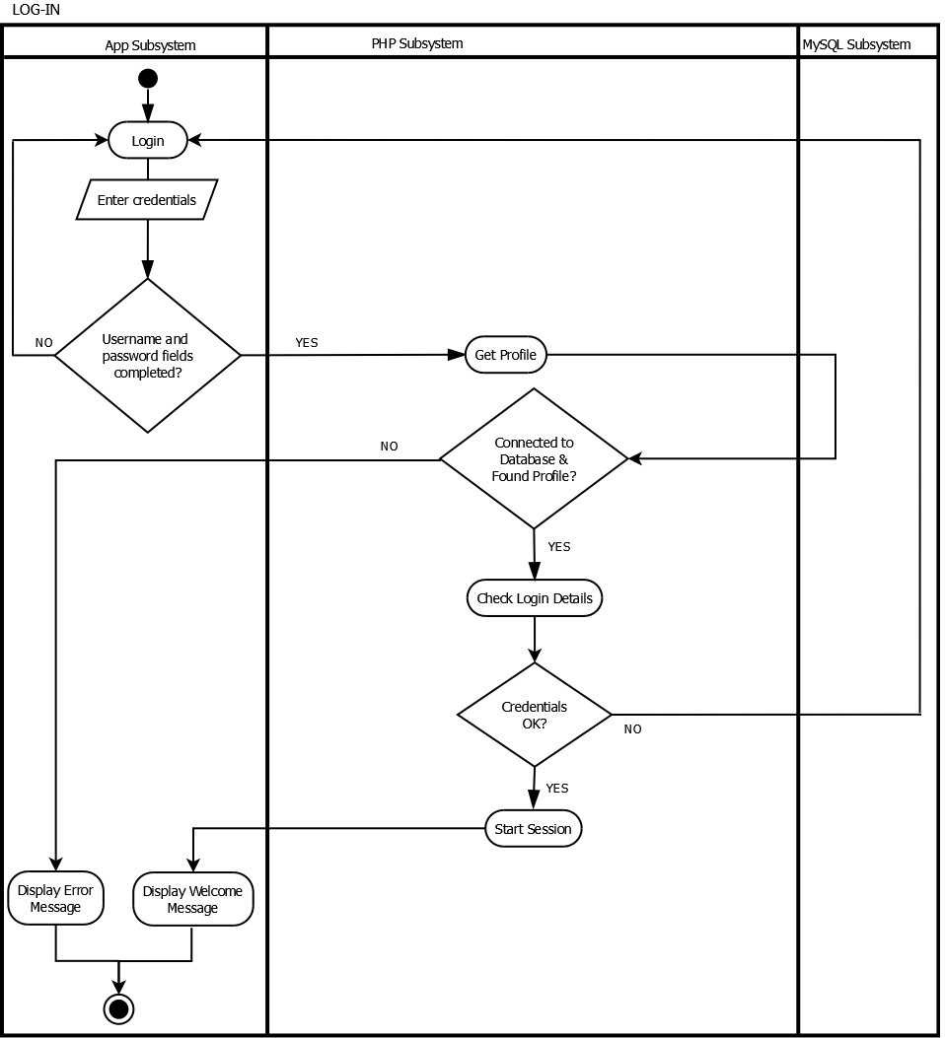

Figure 12: Login activity diagram

* + - 1. Sign up

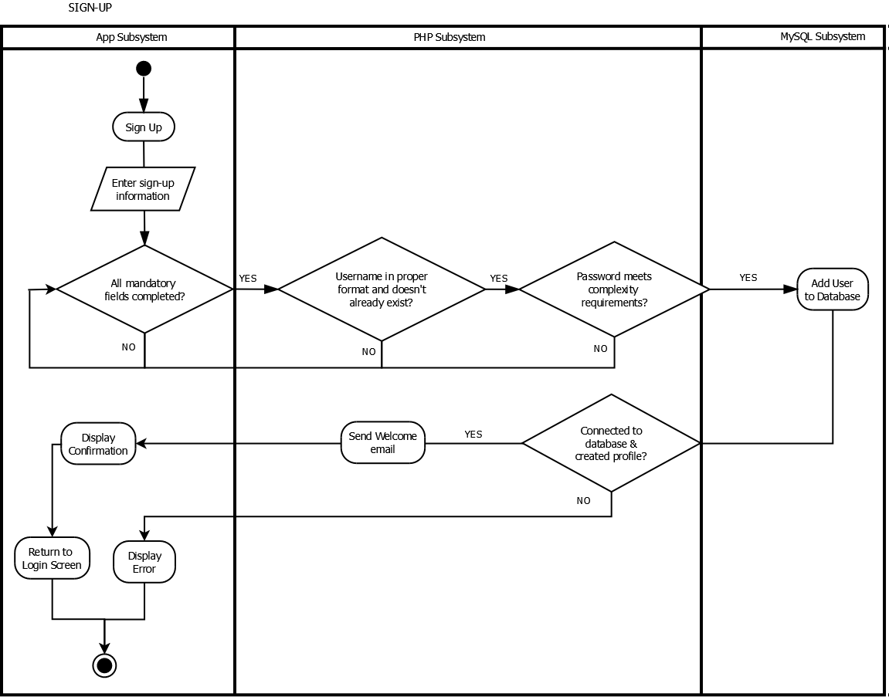

Figure 13: Sign up activity diagram

* + - 1. Sign out

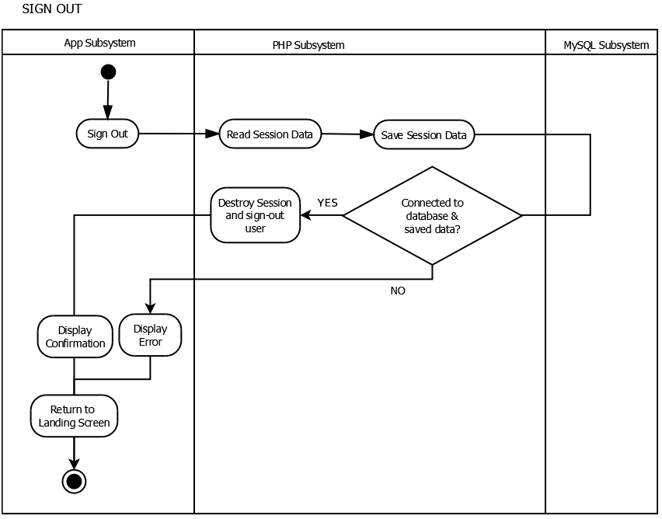

Figure 14: Sign out activity diagram

* + - 1. Exit without signing out

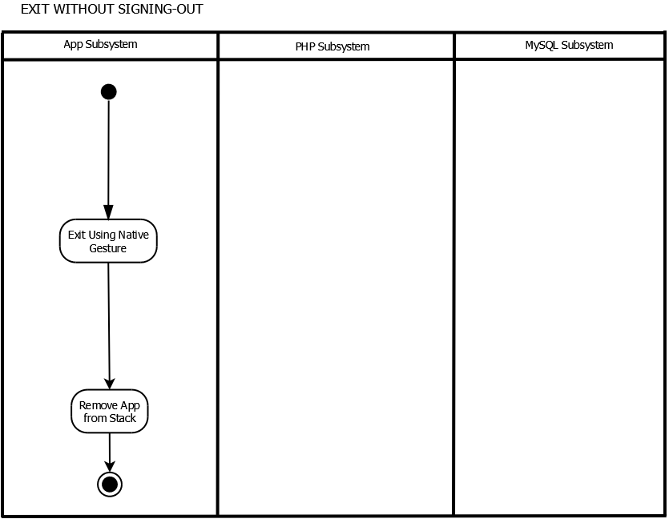

Figure 15: Exit without signing out activity diagram

* + - 1. Report user

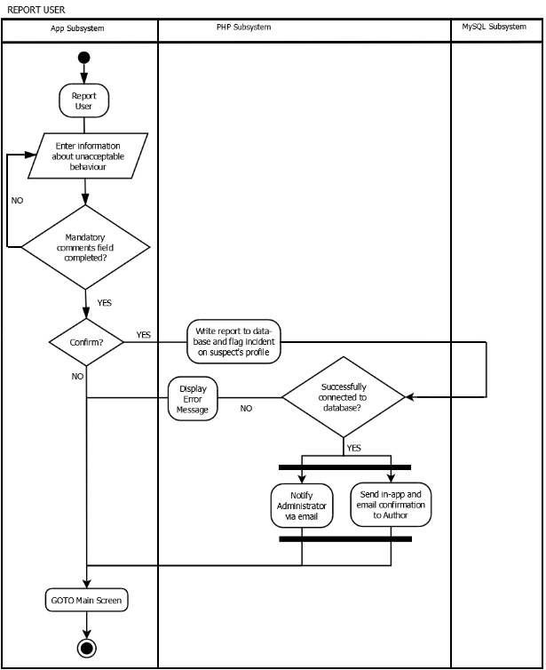

Figure 16: Report user activity diagram

* + - 1. View profile

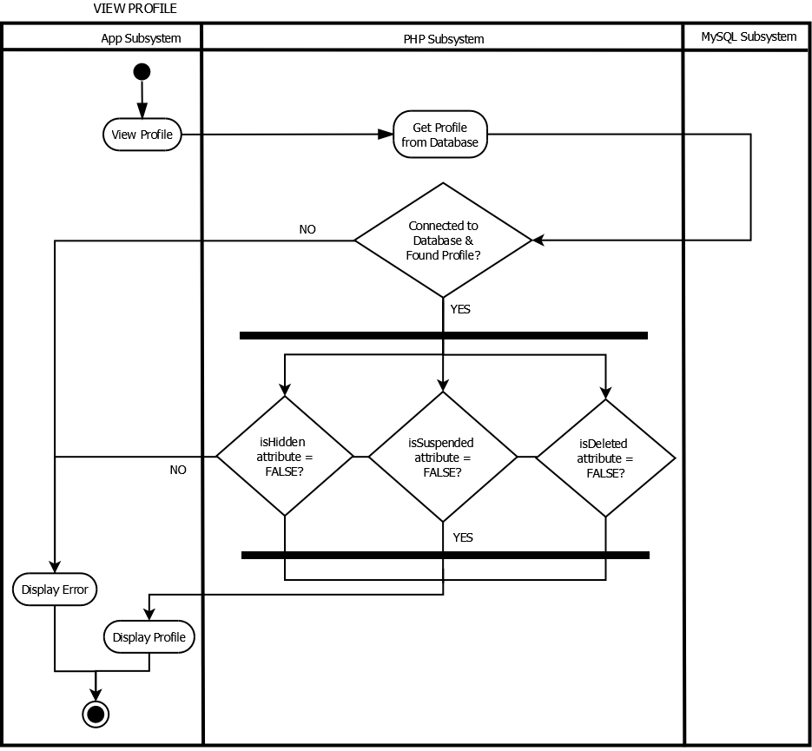

Figure 17: View profile activity diagram

* + - 1. Share profile to social media with invitation for viewing

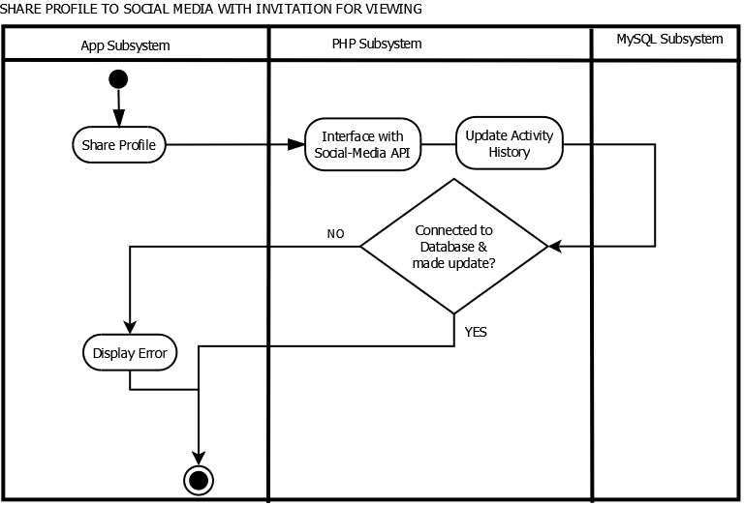

Note: This functionality is planned for a future iteration

Figure 18: Share profile to social media with invitation for viewing activity diagram

* + - 1. Share profile with another app user

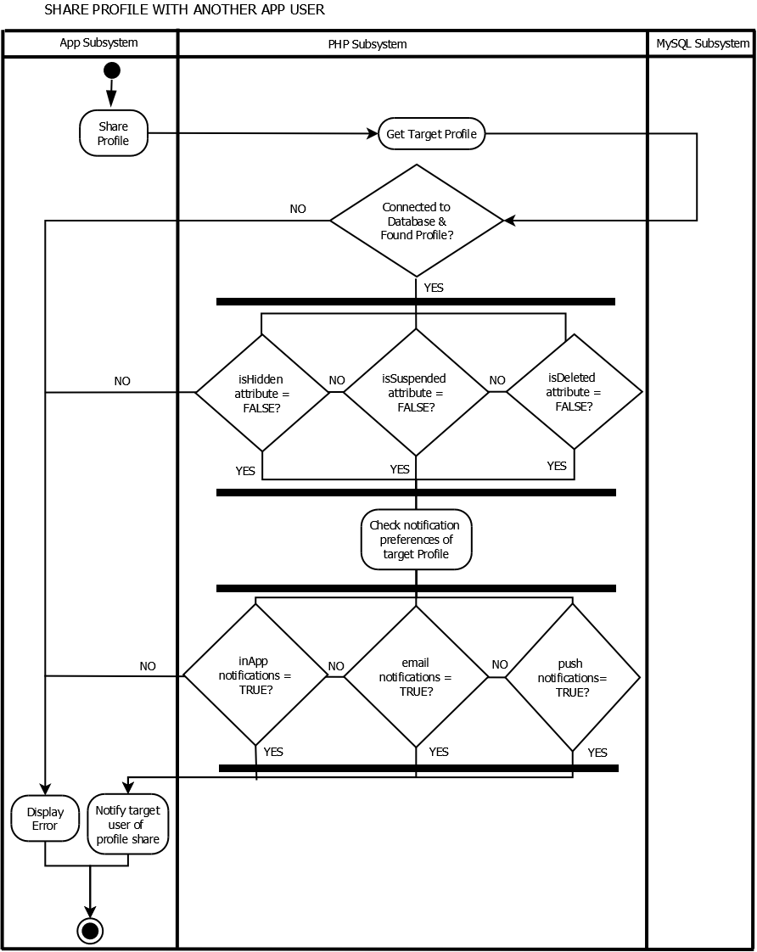

Figure 19: Share profile with another app user activity diagram

* + - 1. Receive invitation to view another app user’s profile

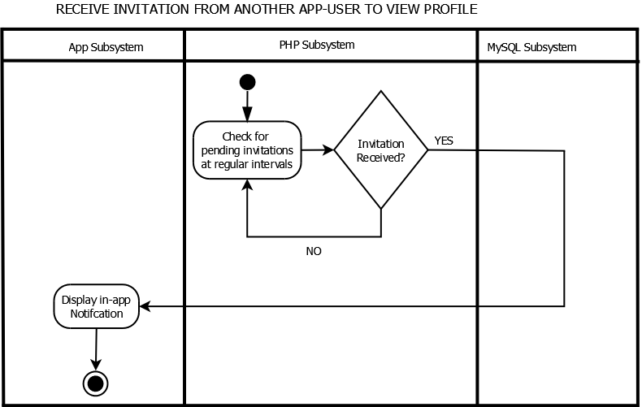

Figure 20: Receive invitation to view another app user's profile activity diagram

* + - 1. Share profile via email

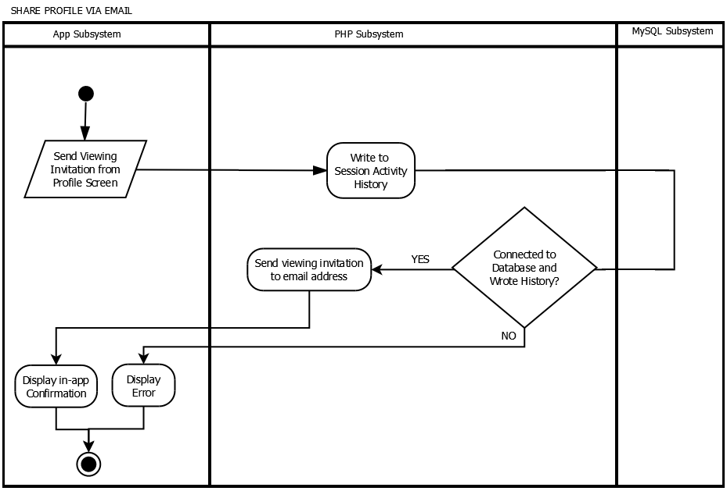

Figure 21: Share profile via email activity diagram

* + - 1. Upgrade to level 2/3

Note: In subsequent iterations, this activity will involve interfacing with a payment gateway.

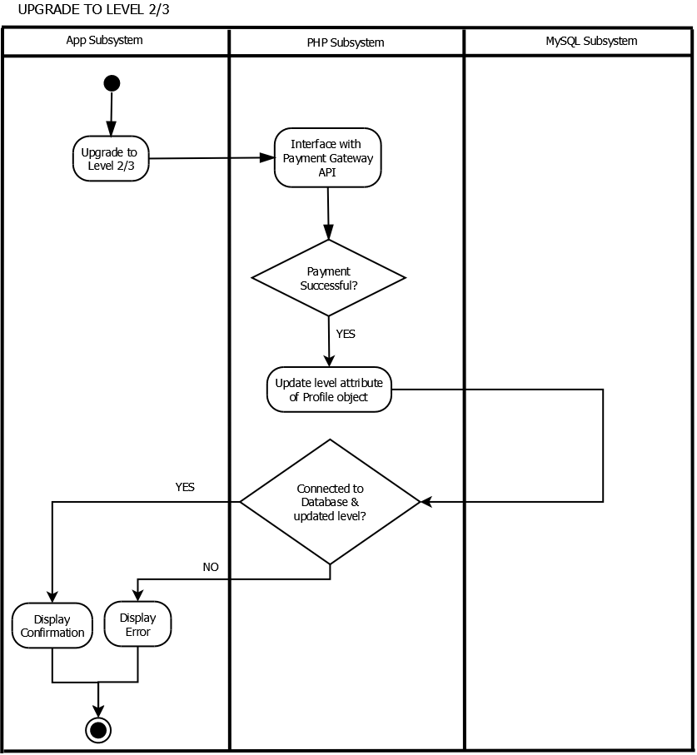

Figure 22: Upgrade to level 2/3 activity diagram

* + - 1. Downgrade to level 1/2

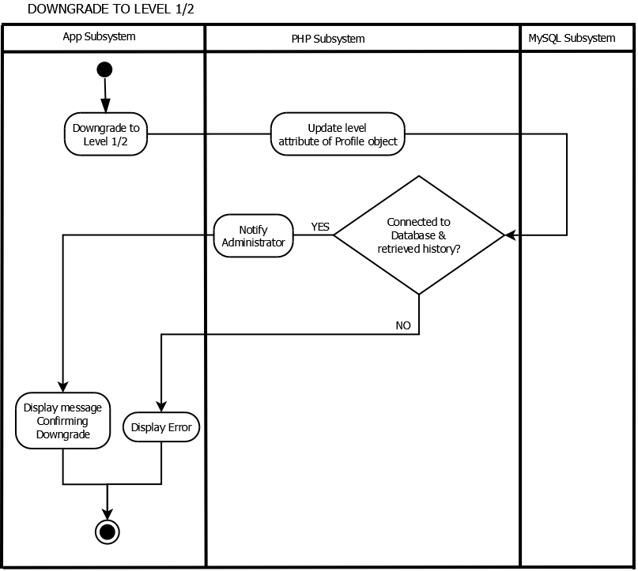

Figure 23: Downgrade to level 1/2 activity diagram

* + - 1. View activity history

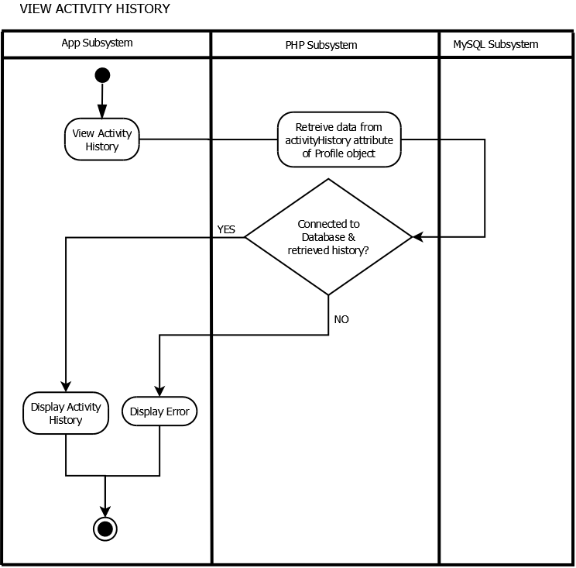

Figure 24: View activity history activity diagram

* + - 1. Change password

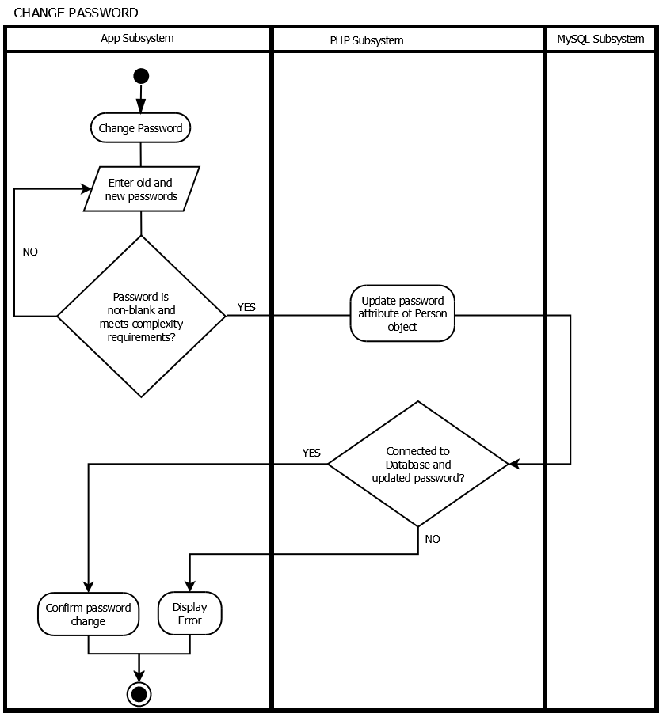

Figure 25: Change password activity diagram

* + - 1. Reset password

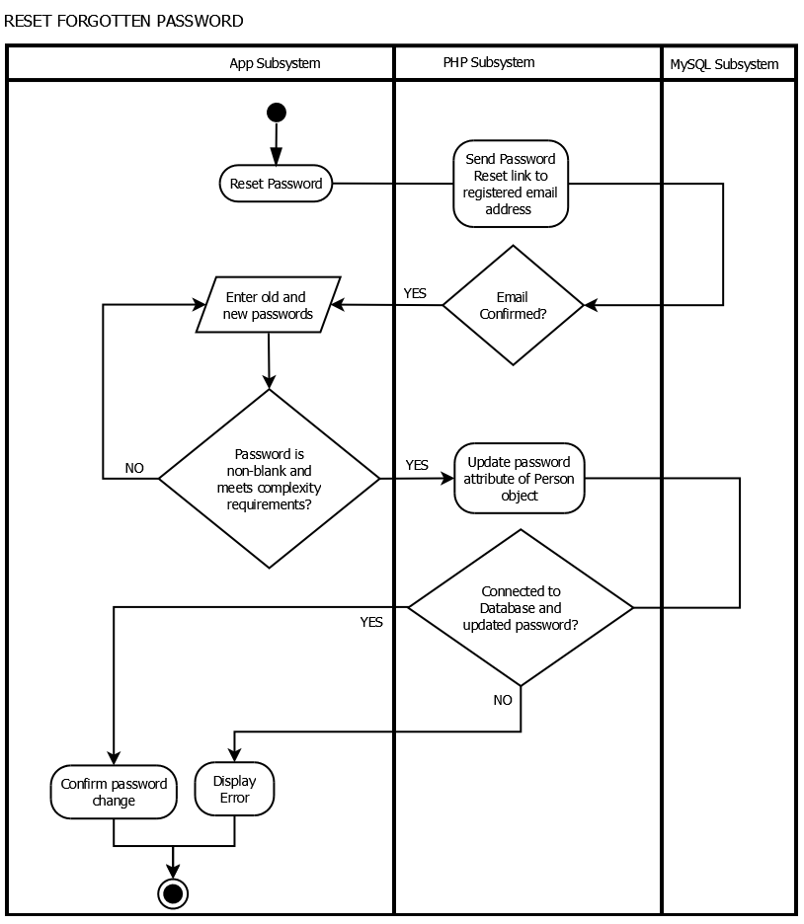

Figure 26: Reset password activity diagram

* + - 1. Create profile

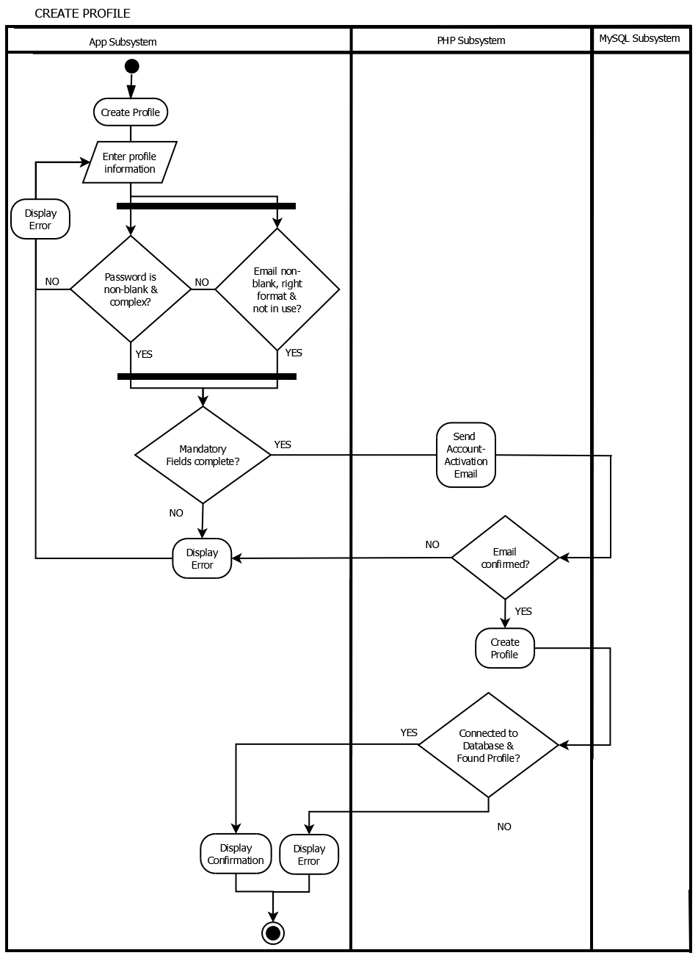

Figure 27: Create profile activity diagram

* + - 1. Edit profile

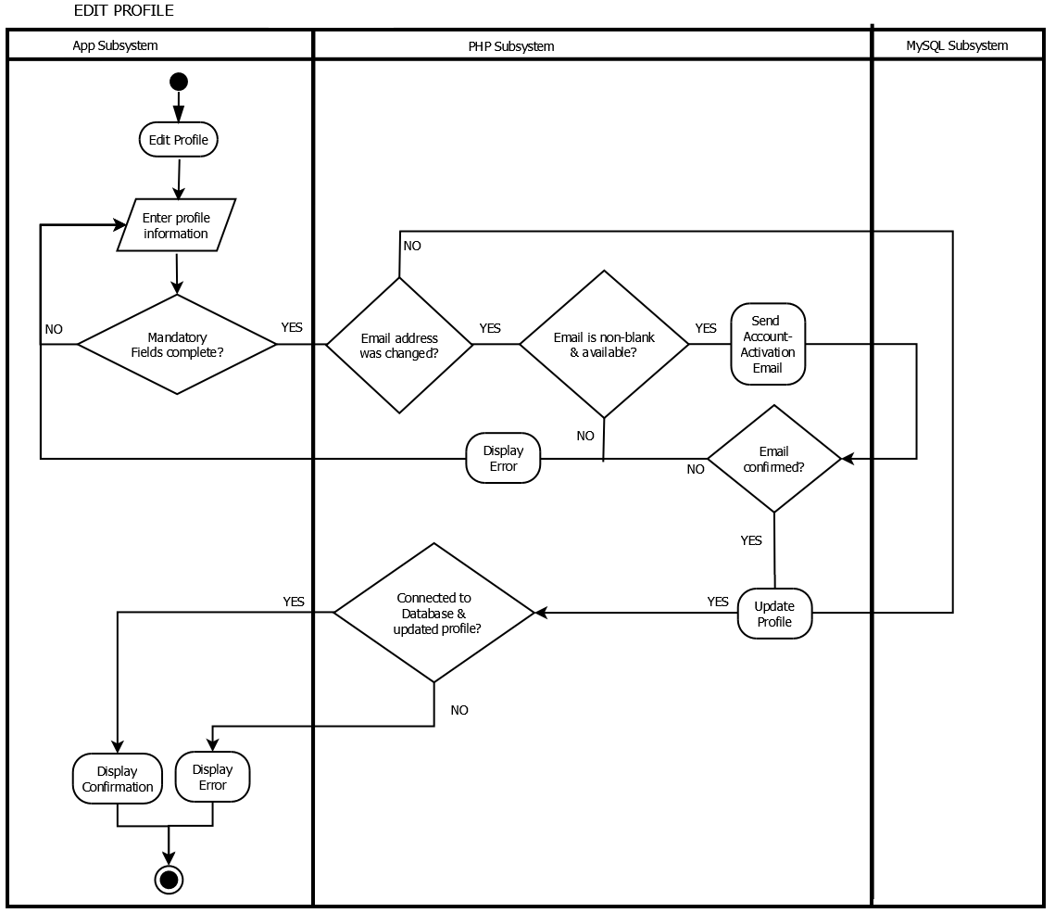

Figure 28: Edit profile activity diagram

* + - 1. Delete profile

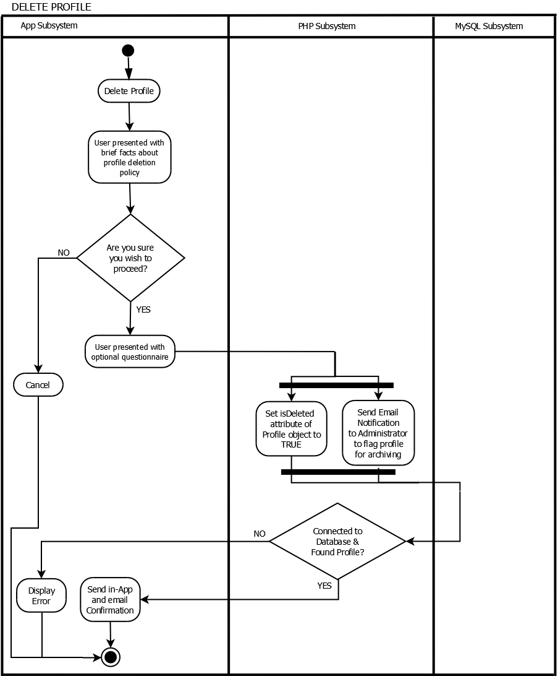

Figure 29: Delete profile activity diagram

* + - 1. Hide profile

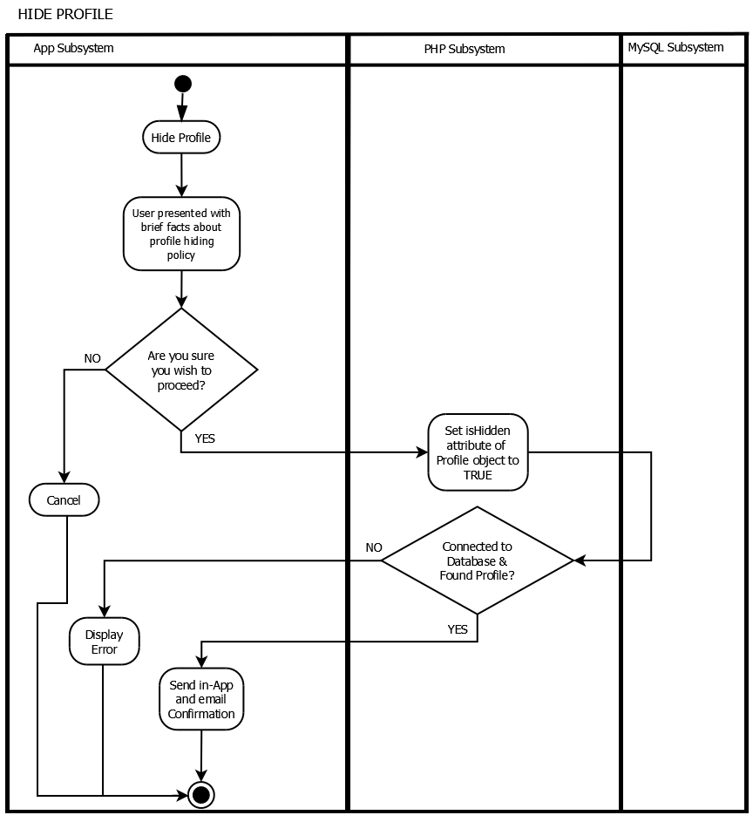

Figure 30: Hide profile activity diagram

* + - 1. Change preferences

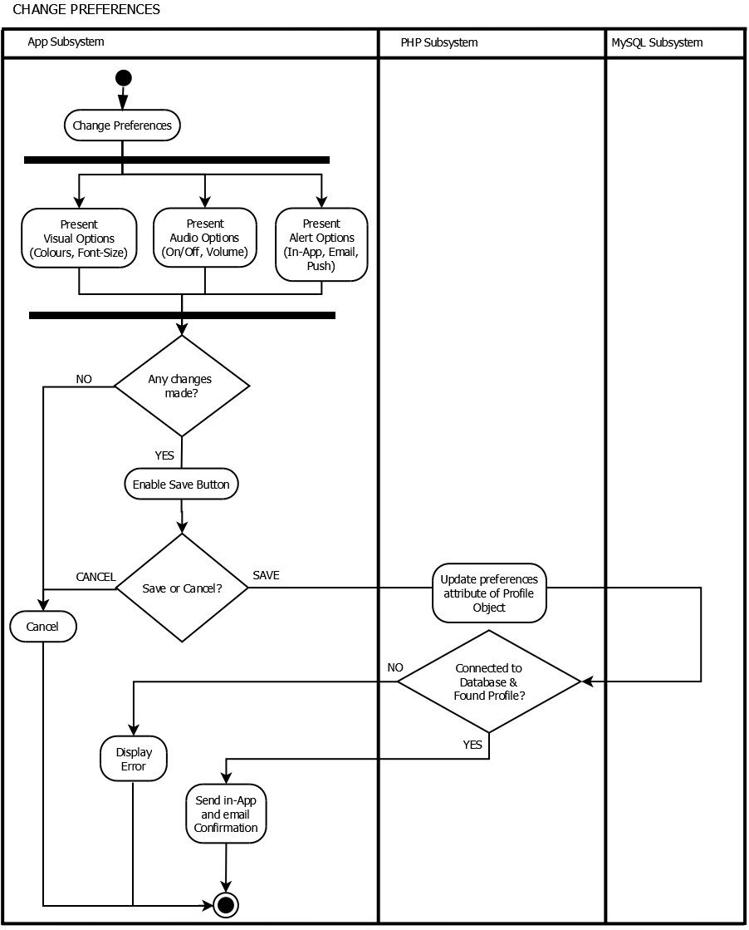

Figure 31: Change preferences activity diagram

* + - 1. Read profile

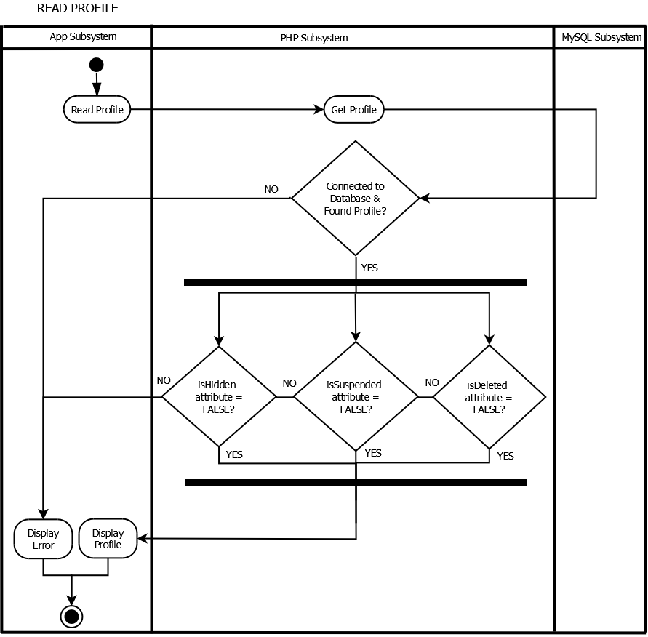

Figure 32: Read profile activity diagram

* + - 1. Acknowledge that profile has been read

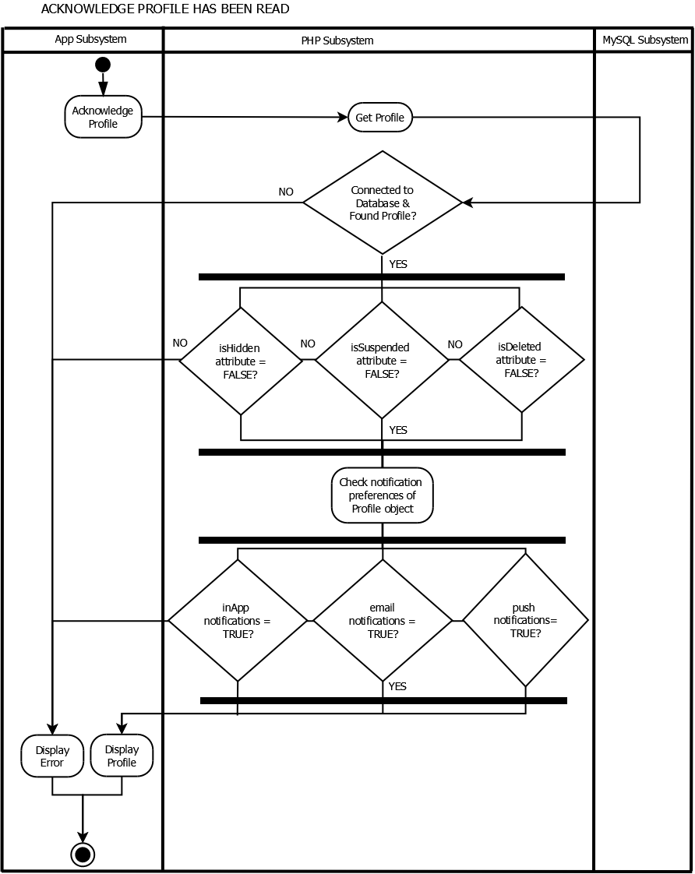

Figure 33: Acknowledge that profile has been read activity diagram

* + - 1. Create additional page

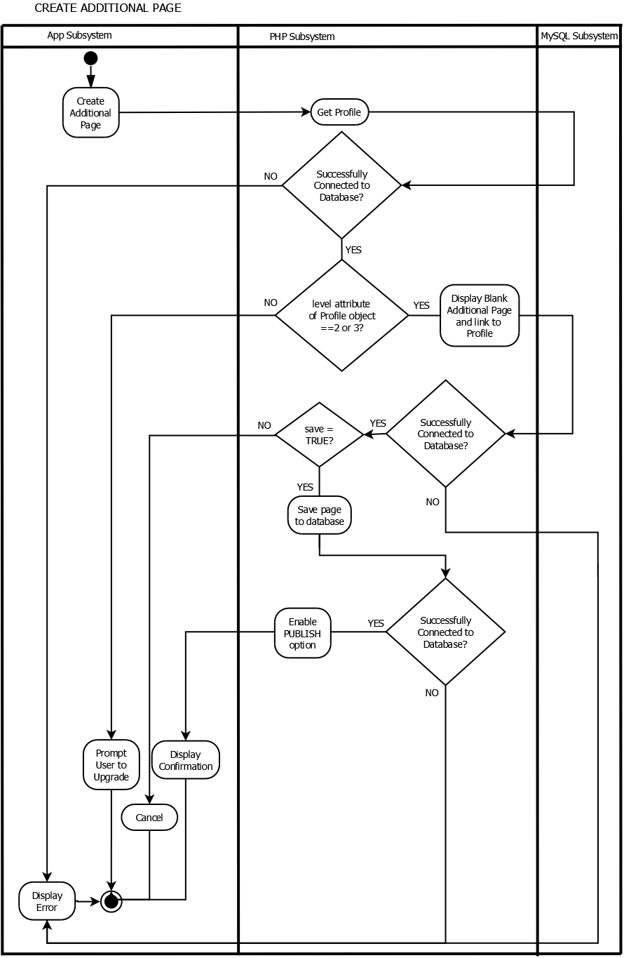

Figure 34: Create additional page activity diagram

* + - 1. Edit additional page

Note: Level of profile is checked before allowing edits to be made, as it’s possible that a user has downgraded after previously creating additional pages.

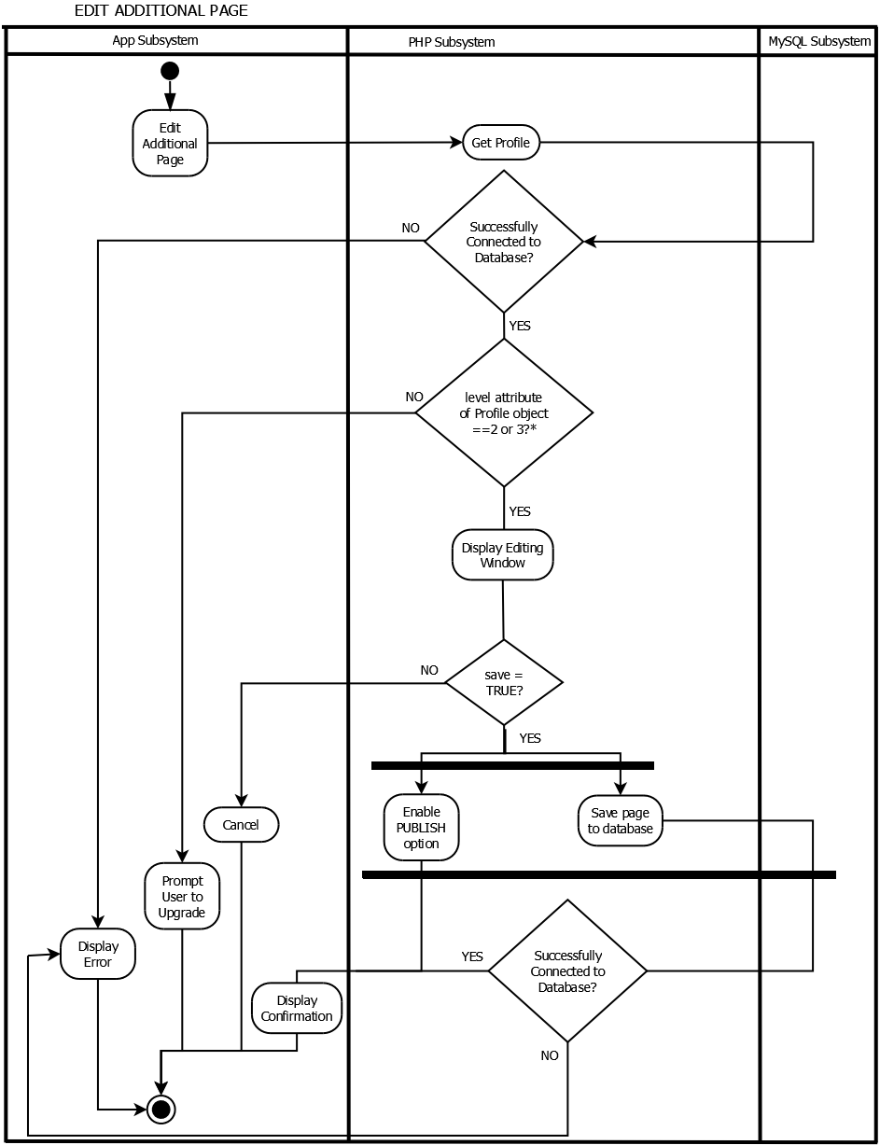

Figure 35: Edit additional page activity diagram

* + - 1. Delete additional page

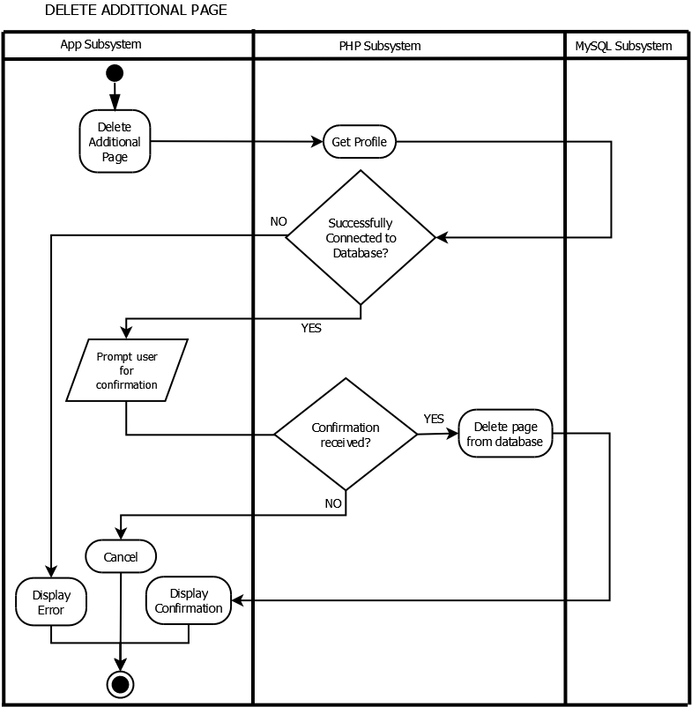

Figure 36: Delete additional page activity diagram

* + - 1. Acknowledge that additional page has been read

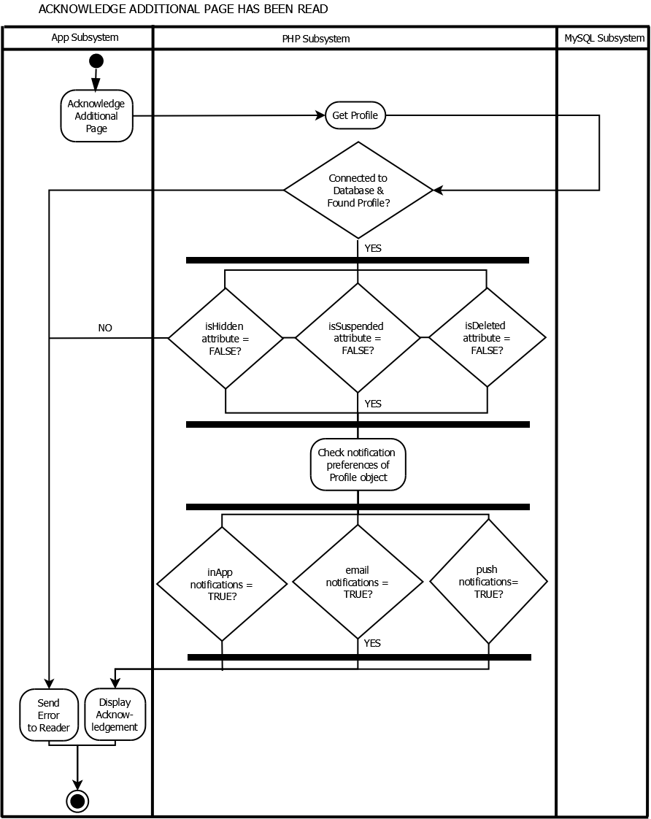

Figure 37: Acknowledge that additional page has been read activity diagram

* + - 1. View planning template

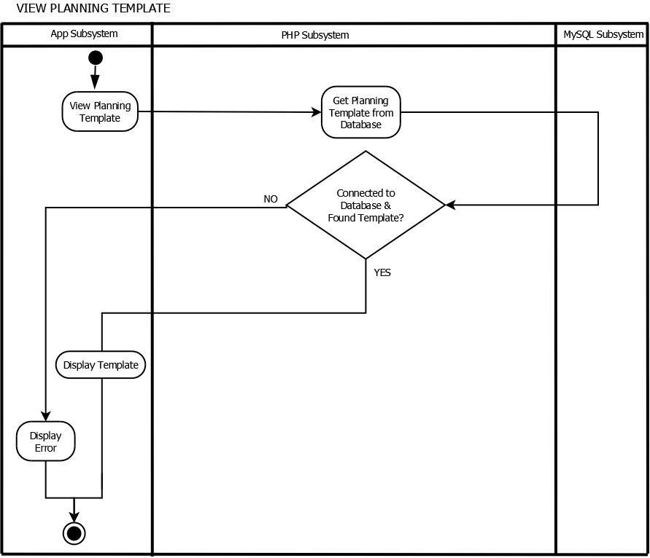

Figure 38: View planning template activity diagram

* + - 1. Edit planning template

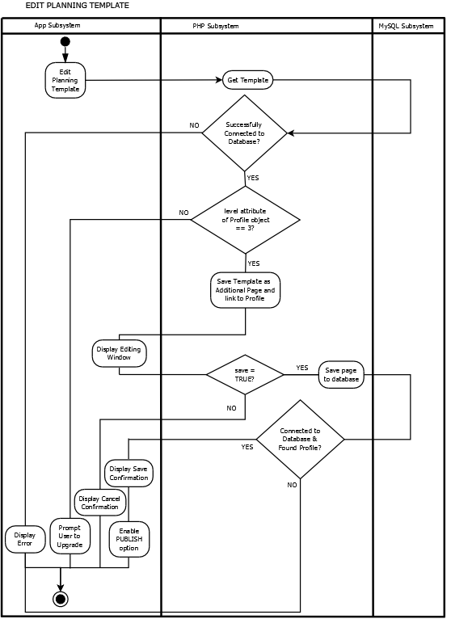

Figure 39: Edit planning template activity diagram

* + - 1. Delete planning template

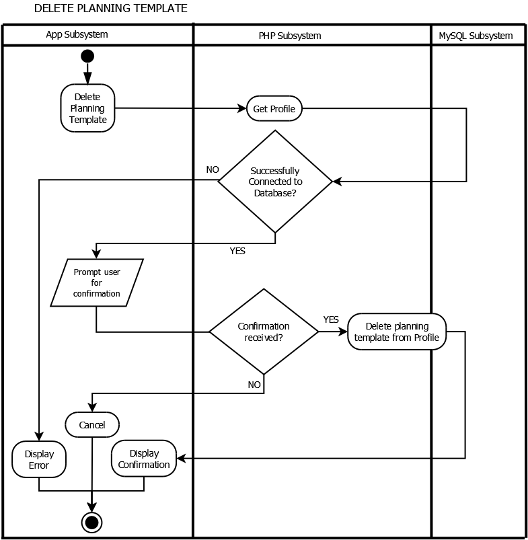

* + 1. Sequence diagrams
       1. Sign up, add author information, edit information

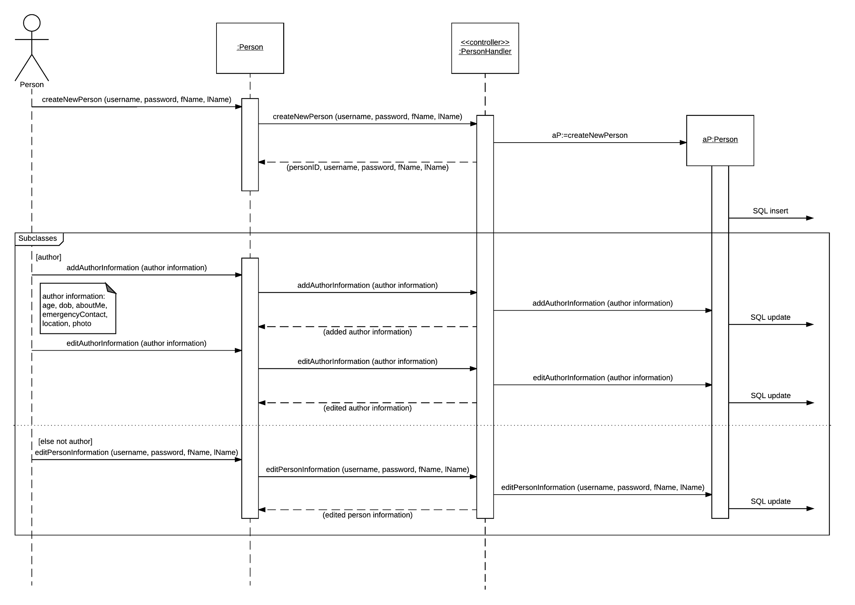

Figure 40: Sign up, add author information, edit information sequence diagram

* + - 1. Login, reset password

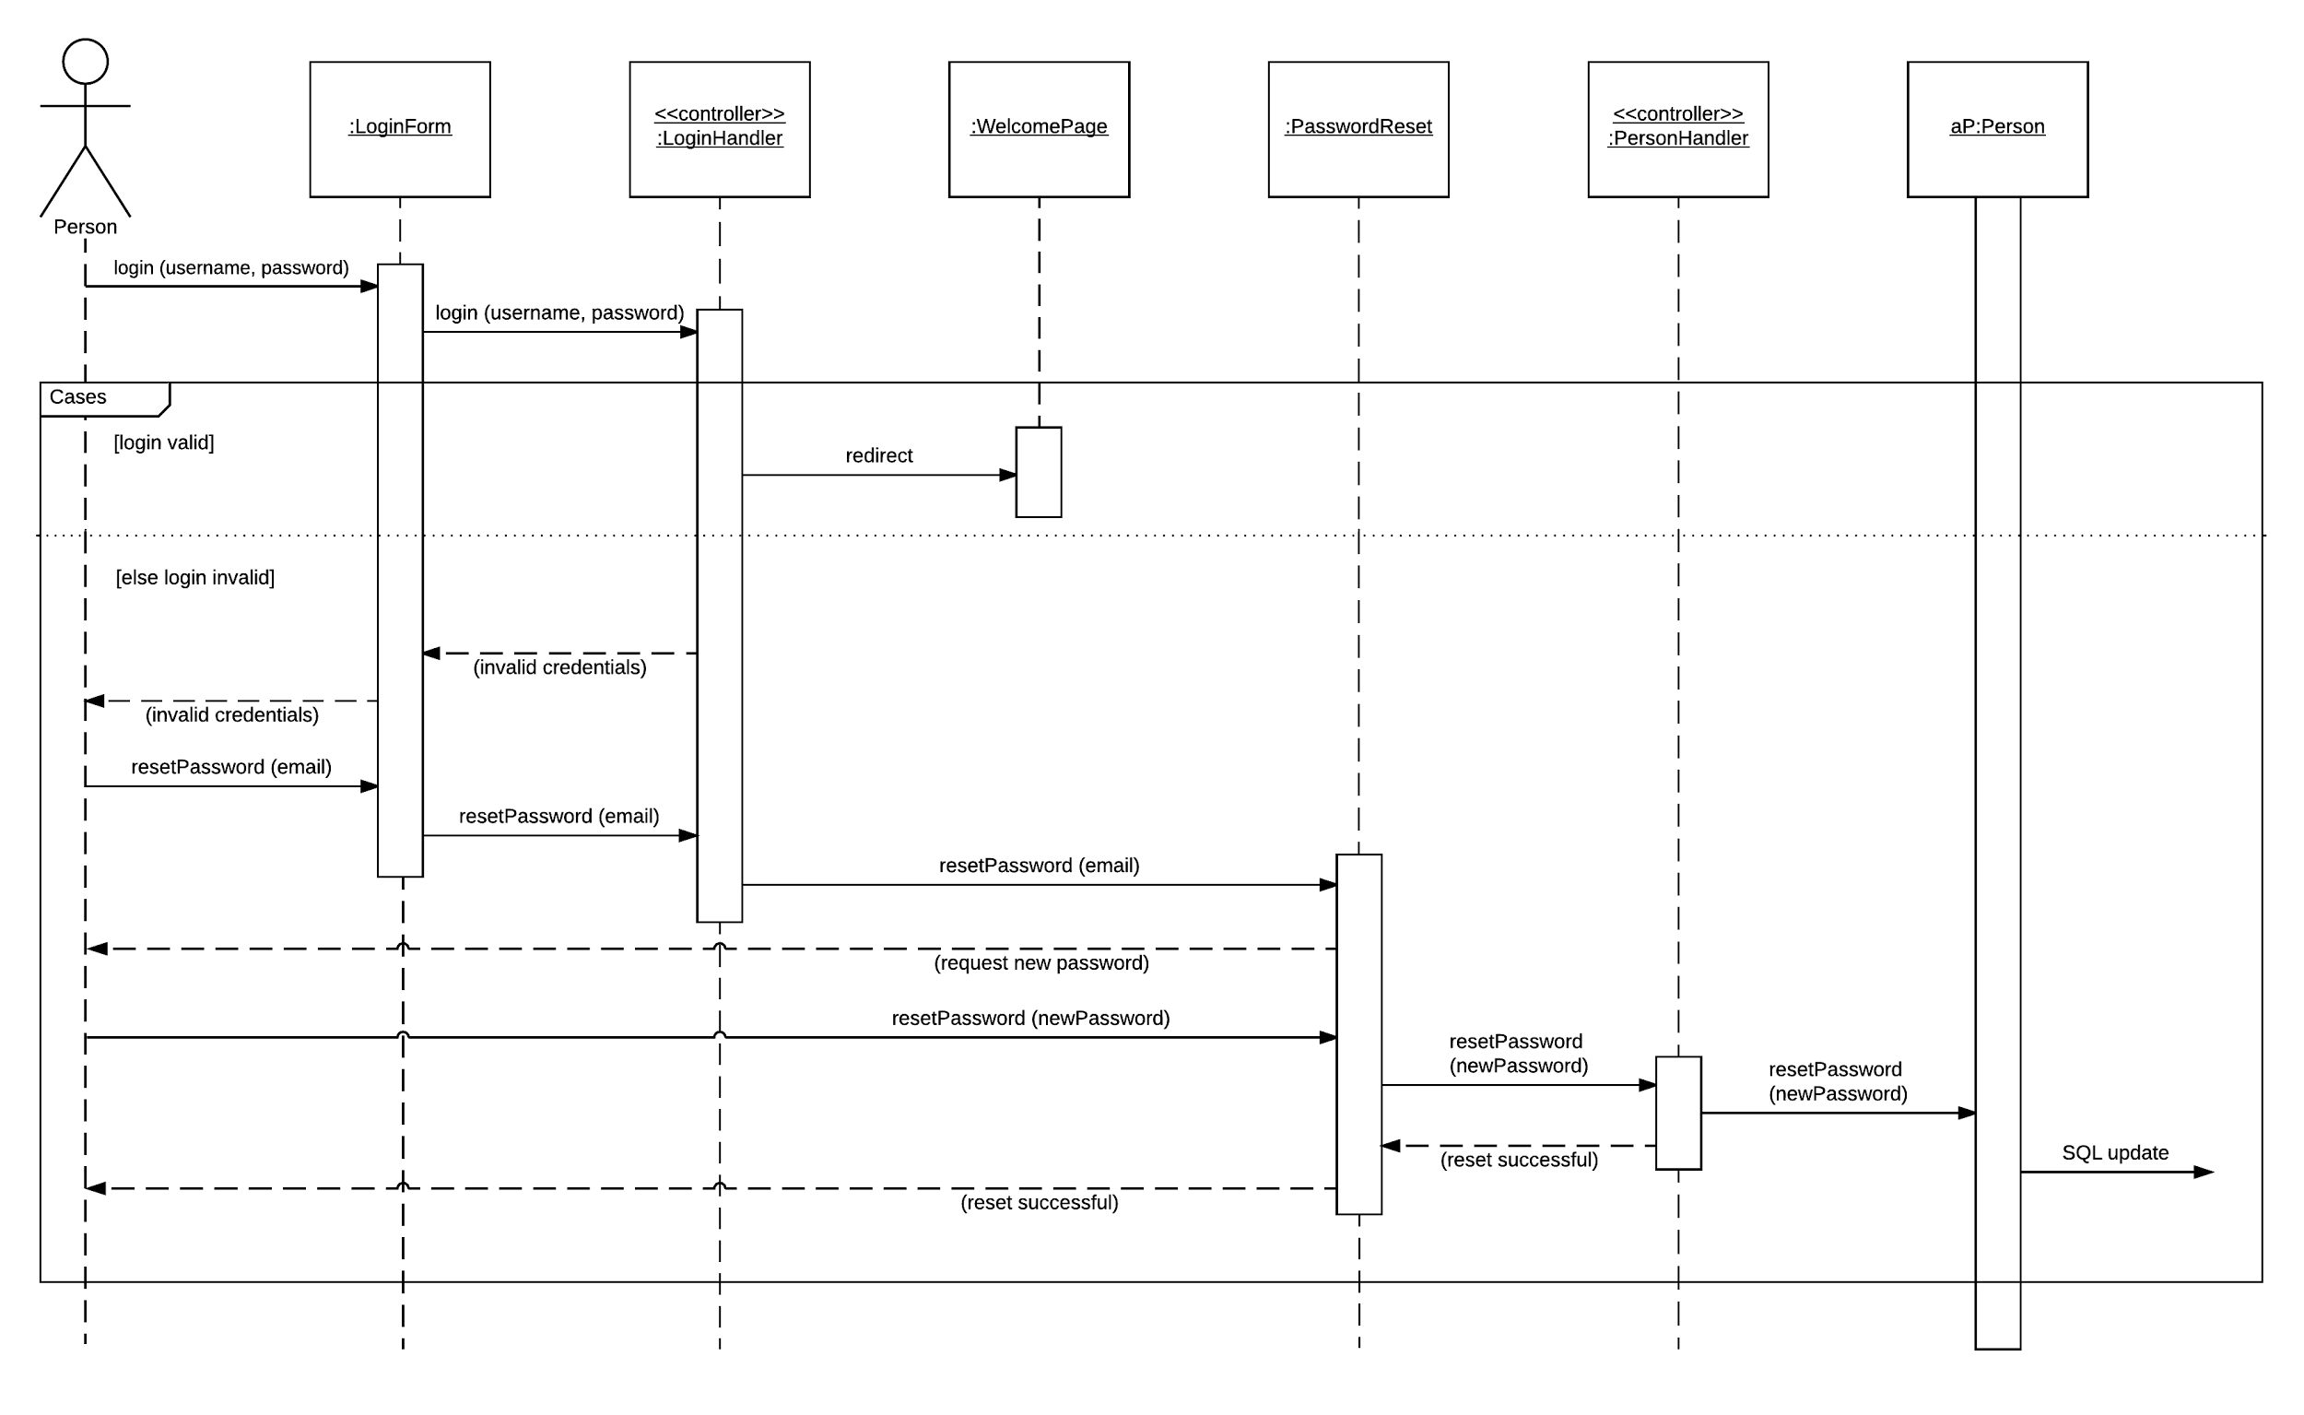

Figure 41: Login, reset password sequence diagram

* + - 1. Share profile

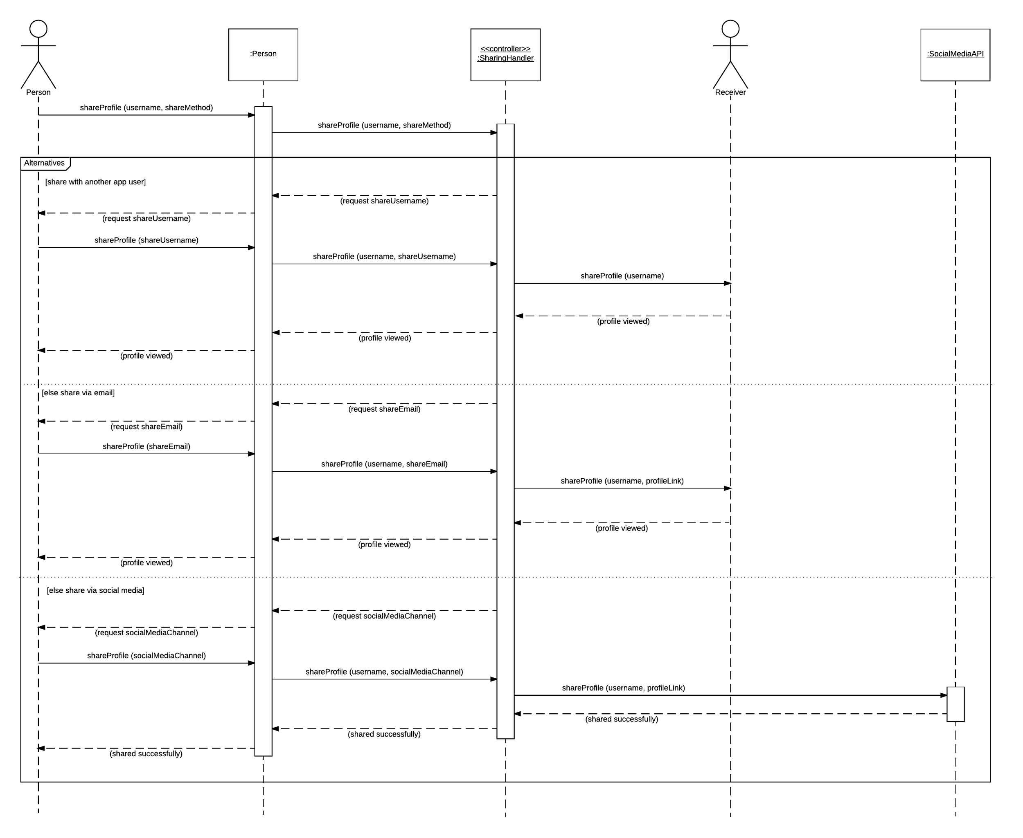

Figure 42: Share profile sequence diagram

* + - 1. Report user

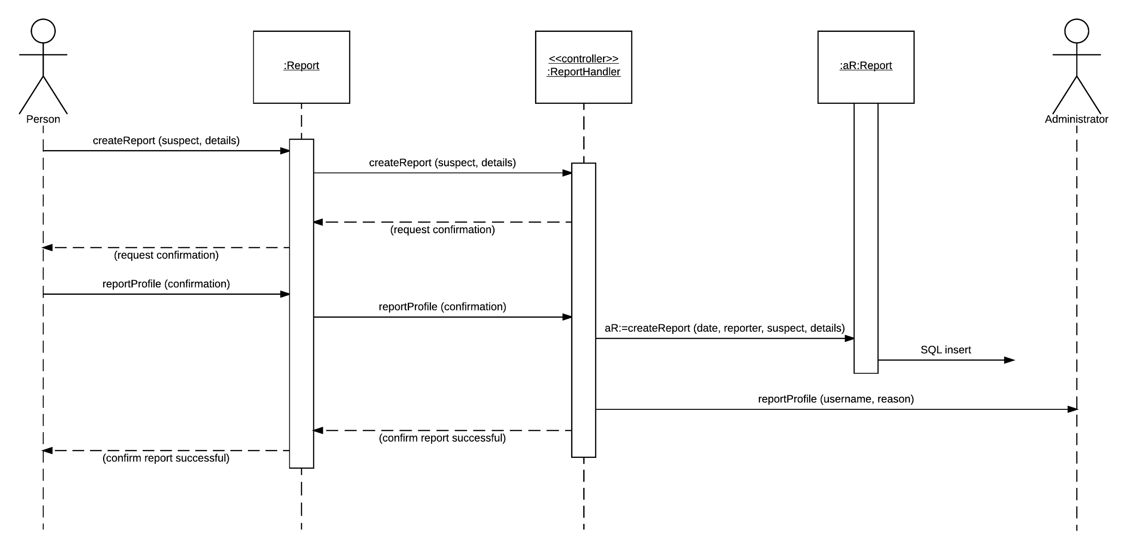

Figure 43: Report user sequence diagram

* + - 1. Create and edit planning template page

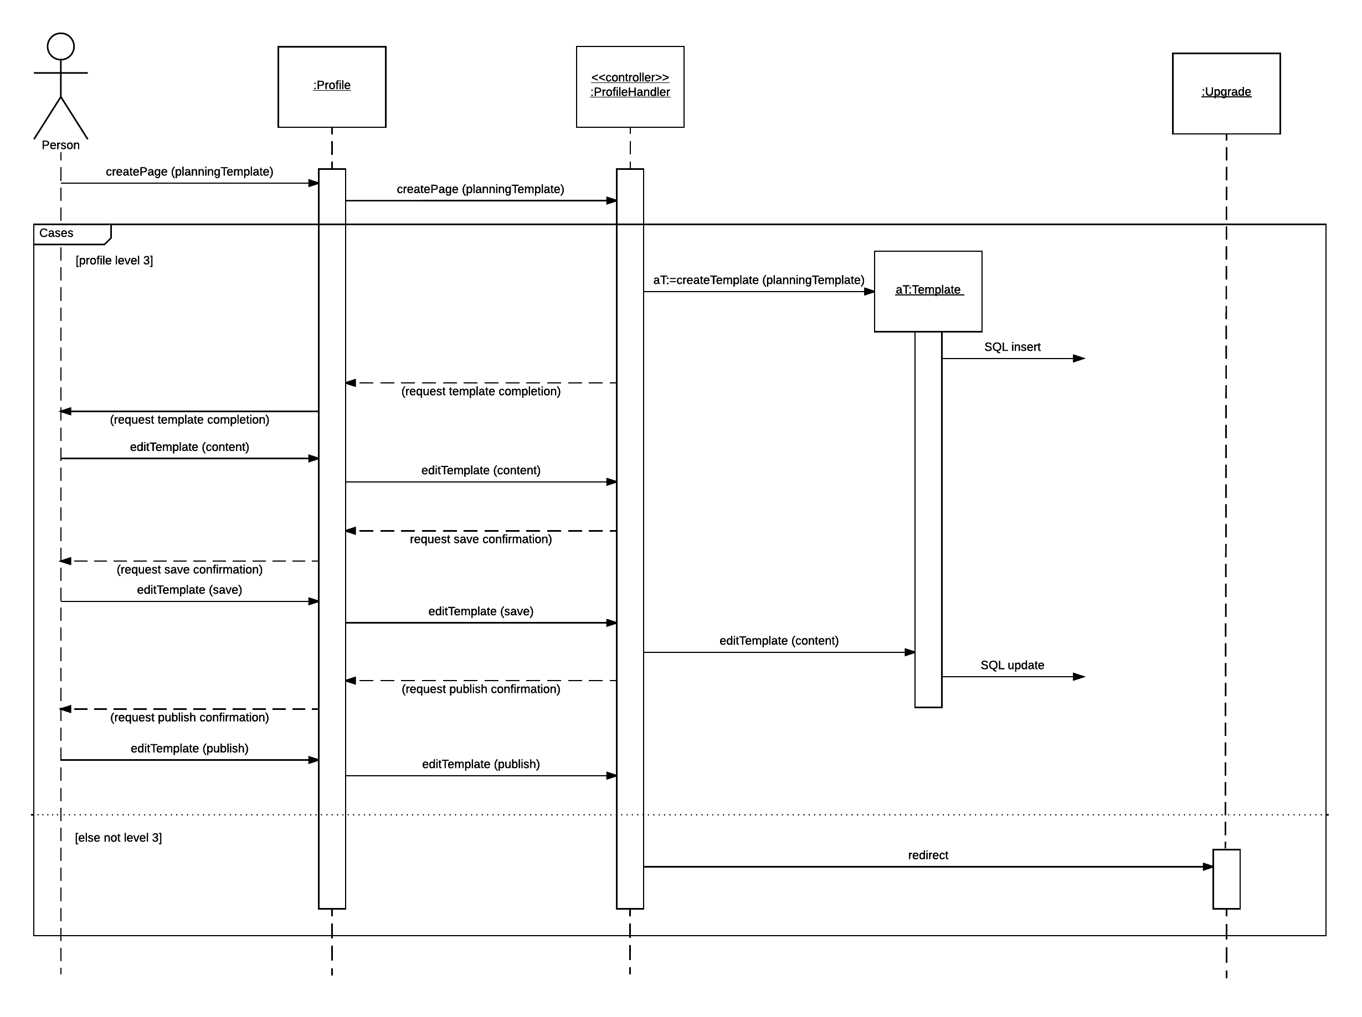

Figure 44: Create and edit planning template page sequence diagram

* + - 1. Remove profile

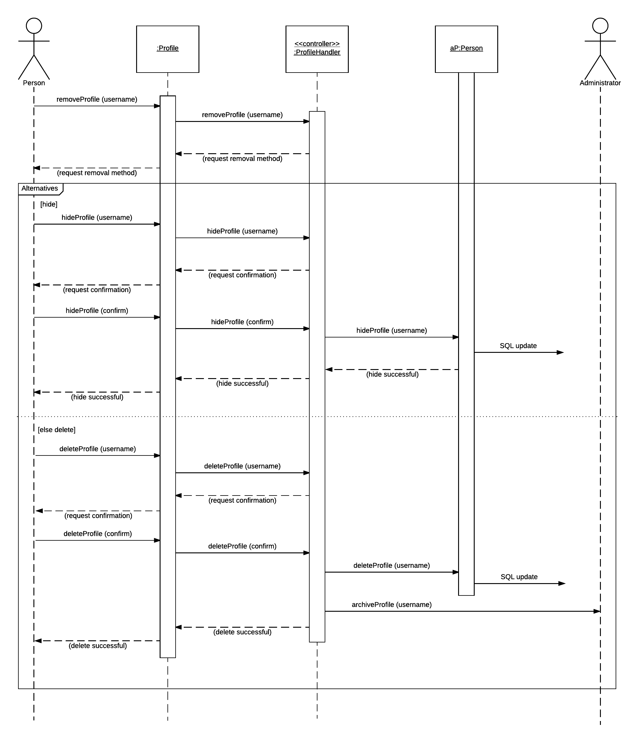

Figure 45: Remove profile sequence diagram

* + 1. Profile and planning templates
       1. Simple profile template

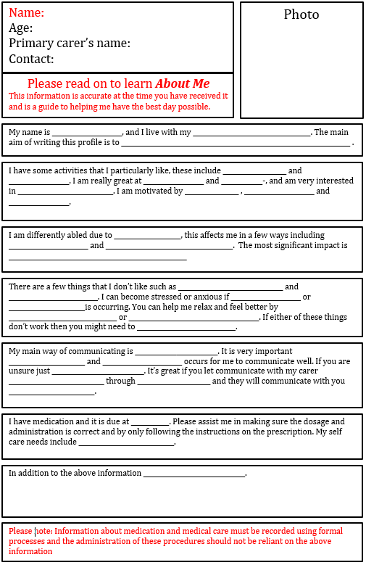

Figure 46: Simple profile template

* + - 1. In-depth profile template

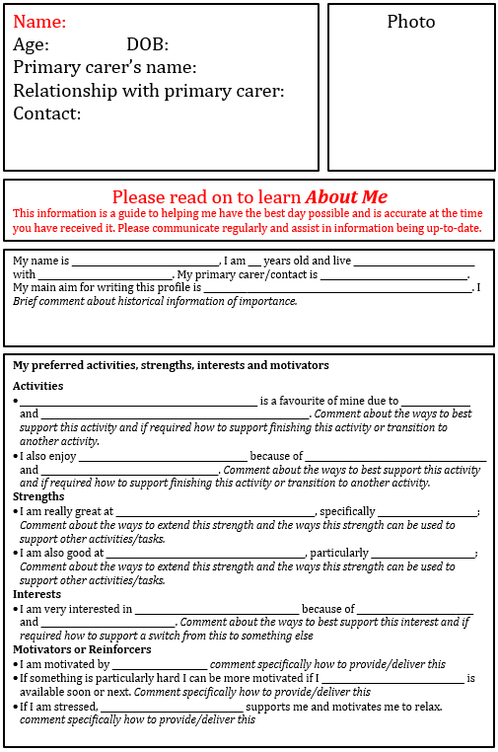

Figure 47: In-depth profile template 1

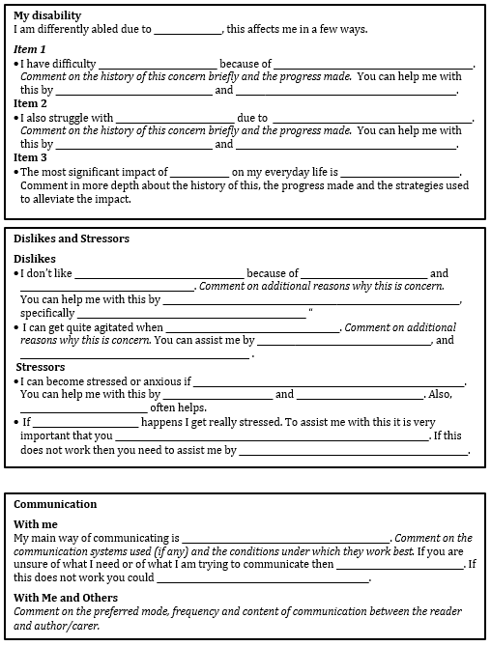

Figure 48: In-depth profile template 2

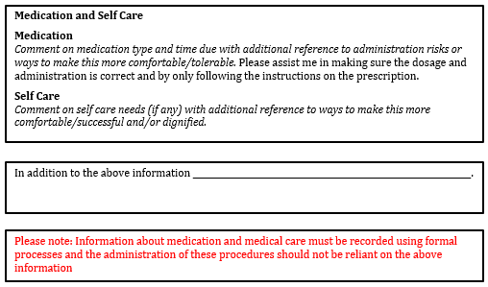

Figure 49: In-depth profile template 3

* + 1. Glossary

|  |  |
| --- | --- |
| Term | Meaning |
| Brainstorming technique | A technique to identify problem domain objects through working with users (Satzinger et al. 2012, p. 93). |
| CRUD | An acronym for Create, Read/Report, Update, Delete. A technique to validate and refine use cases (Satzinger et al. 2012, p. 77). |
| External link | Link to a third party site. |
| Internal link | Link to another page within the app. |
| Native app | The app which is available via the iOS App Store or Android Play Store. |
| Noun technique | A technique to identify problem domain objects through classifying nouns in the description of the system (Satzinger et al. 2012, p. 94). |
| URL | Uniform Resource Locator – uniquely identifies a resource on the Internet (Felke-Morris 2015, p. 31) |
| User goal technique | A technique to identify use cases through user interviews (Satzinger et al. 2012, p. 69) |
| Web app | The website version of the app, which is available via the web browser on the device. |

* + 1. Project timeline

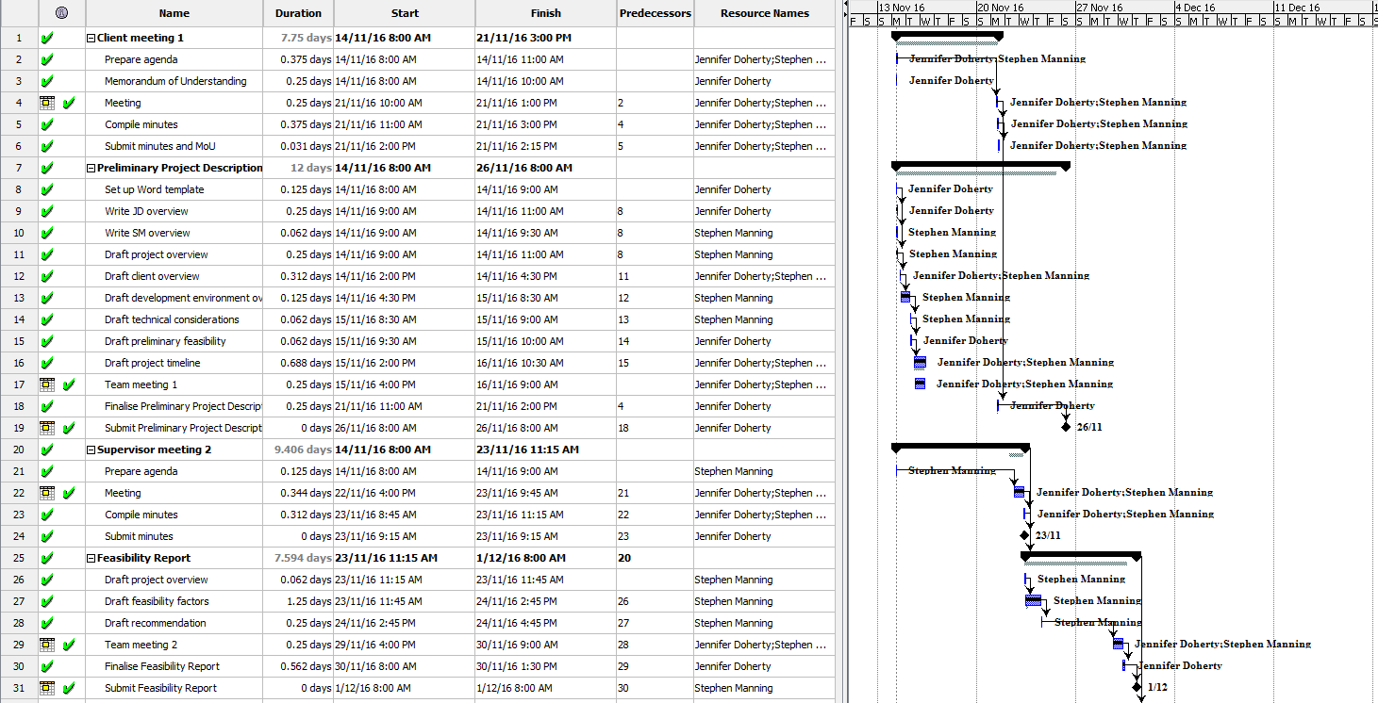

Figure 50: Project timeline 1

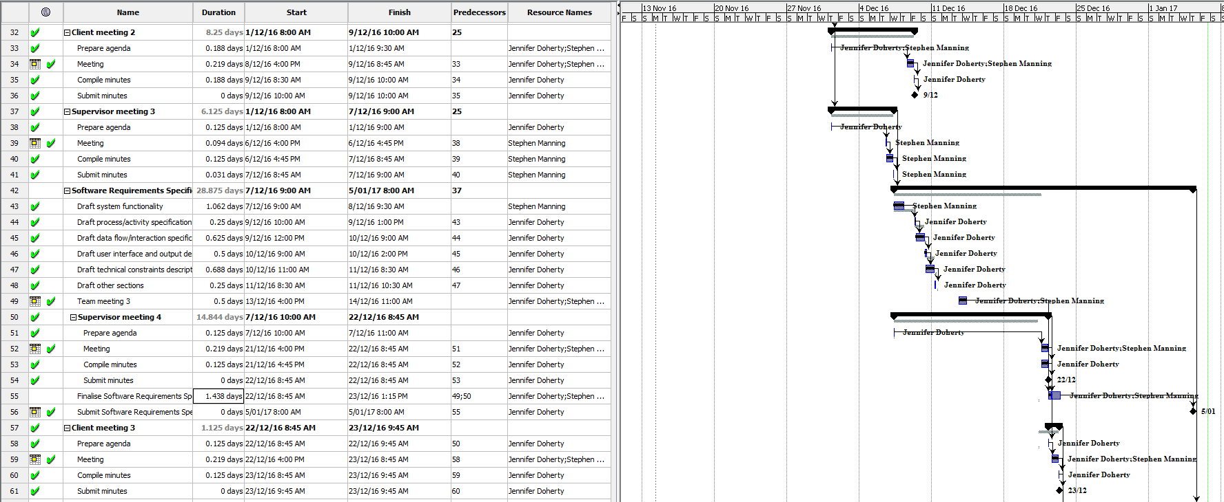

Figure 51: Project timeline 2

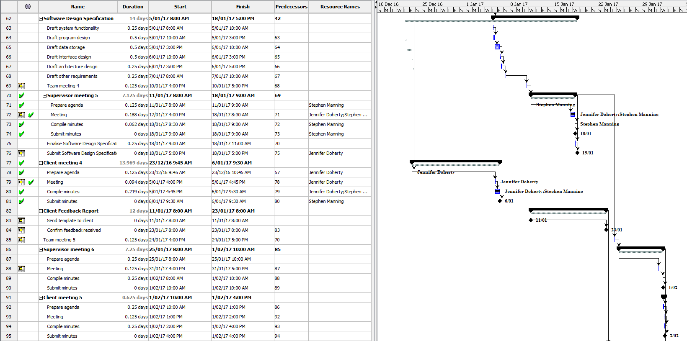

Figure 52: Project timeline 3

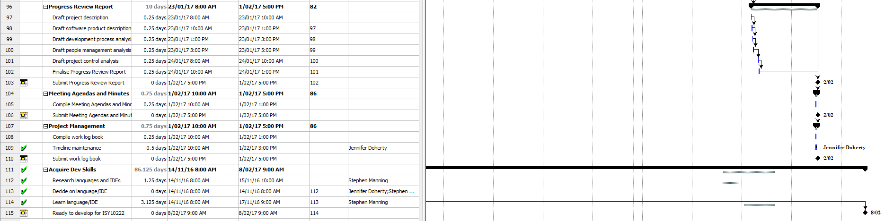

Figure 53: Project timeline 4

* + 1. References

Android Open Source Project 2016, *Dashboards*, Viewed 1 January 2017, <<https://developer.android.com/about/dashboards/index.html>>.

Felke-Morris, T 2015, *Web development and design foundations with HTML5,* Essex, Pearson.

Goretsky, A 2016, *Microsoft ends support for old Internet Explorer versions*, Viewed 1 January 2017, <<http://www.welivesecurity.com/2016/01/12/microsoft-ends-support-for-old-internet-explorer-versions/>>.

Mixpanel 2017, *How quickly are users updating to iOS 10?*, Viewed 1 January 2017, <<https://mixpanel.com/trends/#report/ios_10>>.

Satzinger, J, Jackson, R & Burd, S 2012, *Systems analysis and design in a changing world,* Boston, MA, Course Technology, Cengage Learning.

ServerFault 2011, *How often to upgrade PHP & MySQL*, Viewed 6 January 2017, <<http://serverfault.com/questions/265090/how-often-to-upgrade-php-mysql>>.

WebAIM 2013a, *Accessibility of rich internet applications*, Viewed 1 January 2017, <<http://webaim.org/techniques/aria/>>.

WebAIM 2013b, *"Skip navigation" links*, Viewed January 6 2017, <<http://webaim.org/techniques/skipnav/>>.

WebAIM 2014, *Designing for screen reader compatibility*, Viewed 1 January 2017, <<http://webaim.org/techniques/screenreader/>>.

1. Certain phone models and phone carriers provide different native default browsers (e.g. Samsung phones have their own browser by default). Some of these browsers do not receive updates very often and are therefore difficult to support.
2. Android users often cannot update their OS at all, depending on their phone model and/or carrier. The uptake for new Android versions is therefore much slower than for new iOS versions.
3. Depending on the severity of issues found during development, it may not be viable to offer the native app to 4.4 users in the Play Store.