Final Project Written Report

Ilakkiya Chokkalingam & Venkatesh Sadhu
Department of Data Science, Monroe University, King Graduate School
CS633-151HY: Data Mining
Professor Mahmud Islam
December 2, 2025

INTRODUCTION
Air pollution, particularly fine particulate matter (PM2.5), poses a major health concern in large urban centers such as Beijing. Understanding how meteorological factors influence PM2.5 levels is essential for building early-warning systems, guiding public health decisions, and supporting city-level environmental planning.
This project applies multiple machine learning and data mining techniques to analyze PM2.5 behavior, uncover pollution patterns, and predict high-risk periods. The goal is to provide both technical analysts and common users with practical, interpretable, and actionable insights through an interactive Streamlit dashboard.
In this report, we explore:
- Random Forest Classification to predict whether an hour belongs to a high-risk pollution period.
- K-Means Clustering to identify natural pollution–weather patterns without any labels.
- Association Rule Mining (Apriori) to uncover co-occurring atmospheric conditions that contribute to PM2.5 spikes.
- A comparison of these methods to understand their strengths, limitations, and complementary roles.
- A role-based dashboard design offering insights for both analysts and everyday citizens.
Together, these approaches create a comprehensive air-quality decision-support system capable of prediction, explanation, and pattern discovery.
1. Problem Statement & Research Questions
Problem Statement:
Urban air pollution is a significant public health issue, with elevated levels of pollutants like PM2.5 linked to respiratory and cardiovascular diseases. This project aims to analyze temporal and environmental factors influencing PM2.5 concentrations in urban areas, using historical air quality and weather data.
Research Questions:
- What environmental factors (e.g., temperature, humidity, wind speed) are most strongly correlated with spikes in the PM2.5 levels?
- Are there specific times of day, days of the week, or seasons when pollution risk is highest?
- Can we accurately predict the PM2.5 levels using weather data and time features?
- What actionable public health recommendations or urban planning insights can be drawn from this analysis?

2. Justification for the Problem
The World Health Organization (2021) identifies air pollution as one of the largest environmental risks to health, contributing to an estimated 7 million premature deaths annually. PM2.5, due to its size, penetrates deeply into the lungs and bloodstream, increasing the risk of diseases such as asthma, chronic bronchitis, stroke, and heart attack.
By analyzing air quality patterns in a major urban center like Beijing, we can:
- Help public health authorities issue timely alerts.
- Support urban planners in traffic and zoning decisions.
- Empower citizens with data to make safer choices.
This project is critical because it bridges environmental science, public health, and predictive modeling.

3. Preliminary Hypothesis
- PM2.5 levels will show strong correlations with temperature, humidity, and wind speed.
- Winter months and early mornings may have higher pollution levels due to atmospheric inversion and increased fuel consumption.
- Regression models (e.g., linear regression, random forest) will predict PM2.5 with reasonable accuracy using weather and time variables.
- Classification models can label "high-risk" periods (above a pollution threshold), helping to generate targeted health alerts.

4. Planned Dataset
Beijing PM2.5 Dataset
Source: Kaggle – US Pollution Data
Citation:
Chen, S. (2015). Beijing PM2.5 [Dataset]. UCI Machine Learning Repository. https://doi.org/10.24432/C5JS49 archive.ics.uci.edu+1
Zhang, S., Guo, B., Dong, A., He, J., Xu, Z., & Chen, S. X. (2017). Cautionary tales on air-quality improvement in Beijing: Proceedings of the Royal Society A, 473(2205). https://doi.org/10.1098/rspa.2017.0457
Description:
This dataset comprises hourly air-quality measurements and meteorological variables collected in Beijing from January 1, 2010 through December 31, 2014 (in the UCI version) at the U.S. Embassy site and Beijing Capital International Airport site.
It includes the concentration of fine particulate matter (PM2.5) in µg/m³ as the target variable, along with key predictors such as dew point temperature (DEWP), air temperature (TEMP), atmospheric pressure (PRES), combined wind direction (cbwd), cumulated wind speed (Iws), cumulated hours of snow (Is), and cumulated hours of rain (Ir) plus time identifiers (year, month, day, hour).
The availability of extensive hourly observations over multiple years enables rich time-series and regression/forecasting modelling, making it well suited for exploring the relationships between meteorological conditions and air pollution levels.
This dataset was also made available via Kaggle (e.g., “Beijing Multi-Site Air Quality Data” from UCI/UCIML). The breadth and granularity of the dataset support both exploratory analysis of pollution trends and supervised modelling for prediction.

B. Data Dictionary
The following table describes the key features in the dataset, including their descriptions and types.
Feature Name | Description
pm2.5 | Concentration of fine particulate matter (PM2.5) in µg/m³
DEWP | Dew Point temperature (°C)
TEMP | Air temperature (°C)
PRES | Atmospheric pressure (hPa)
cbwd | Combined wind direction (categorical: e.g., NE, NW, SE)
Iws | Cumulated wind speed (m/s)
Is | Cumulated hours of snow
Ir | Cumulated hours of rain
year | Year (2010–2015)
month | Month (1–12)
day | Day of the month (1–31)
hour | Hour of the day (0–23)
date | Combined datetime column (optional depending on preprocessing)

C. Preprocessing Steps

To prepare the dataset for modelling and analysis, the following preprocessing workflow will be applied:
- Cleaning
Missing values:
    - Identifying rows where the target variable pm2.5 is missing and either impute using interpolation/time-series forward/backward filling or drop if imputation is not justifiable.
    - Removing rows where essential weather variables (e.g., TEMP, PRES, cbwd) are missing since they are critical predictors.
Duplicates:
    - Checking for duplicate records based on the combination of year, month, day, and hour. If duplicates exist, need to remove them to avoid bias or redundancy.
- Transformation
Datetime conversion:
    - Combining the year, month, day, and hour features into a single datetime index to enable time-series operations (resampling, lag creation, rolling means).
Scaling:
    - For numerical features (e.g., TEMP, DEWP, PRES, Iws, pm2.5), applying normalization or standardization to improve model convergence and performance especially for algorithms sensitive to scale (e.g., KNN, linear regression).
- Feature Engineering
Time-based features:
    - Creating new variables such as season (e.g., winter, spring, summer, autumn) based on month.
    - Adding time_of_day categories (e.g., morning: 6-9, afternoon: 12-15, evening: 17-20, night: 21-5) to capture diurnal patterns in pollutant levels.
    - Flag high-risk periods by creating a binary high_risk variable (e.g., pm2.5 > 150 µg/m³) for classification modelling.
Lag features:
    - Creating rolling averages (e.g., pm2.5_rolling3h, pm2.5_rolling24h) to represent recent pollution history.
Interaction features:
    - If appropriate, will try to create interaction terms between temperature and humidity or wind speed and direction to explore joint effects.
These preprocessing and feature-engineering steps increase the richness of the dataset and prepare it for advanced modelling tasks such as regression forecasting, classification of high-pollution events, and visualization of pollutant trends.

D. Data Architecture Explanation
This section explains how the processed dataset will be organised and structured for analysis, modelling, and visualization.
- Temporal structure:
  - After combining the date and time components into a datetime index, the dataset becomes a multivariate time series where each row corresponds to a single hour of observation.
  - This allows time-series operations such as resampling (e.g., to daily averages), trend decomposition, and lag modeling.
- Supervised-learning matrix form:
  - For regression or classification modelling, the dataset is converted into a numerical matrix (rows = observations, columns = features including lags and one-hot encoded categorical variables).
  - The target variable is pm2.5 (for regression) or a derived binary high_risk label for classification.
- Categorical vs. numerical split:
  - Categorical variables (e.g., one-hot encoded wind direction) will be separated from numerical ones, enabling different algorithms (e.g., tree-based vs. regression) to be easily applied.
- Flexible architecture for multiple tasks:
The design supports multiple workflows:
    - Correlation analysis (e.g., correlation between TEMP, DEWP, PRES and pm2.5)
    - Predictive modelling (e.g., Random Forest regression to forecast pm2.5, logistic regression for high-pollution classification)
    - Time-series forecasting (e.g., ARIMA, LSTM models using the hourly time sequence)
    - Visualization (e.g., heatmaps of pollution by hour/season, trend plots of pm2.5 over time, wind-rose diagrams for wind direction)
    - Application once the findings and visualizations are done, need to work on articulating business insights based on the pollution data. (Eg: Transportation authorities can issue early-morning traffic alerts or promote carpooling and public transport use during winter mornings to reduce emissions)
Overall, the data architecture is designed to remain both analytical and operationalsupporting exploratory studies, statistical modelling, and time-series forecasting within a single unified structure Whether the goal is to understand environmental drivers of pollution, build predictive systems for early warning, or generate meaningful visual insights for stakeholders, this architecture ensures the data is organised, scalable, and ready for a wide range of decision-making and research applications.

SYSTEMATIC ARCHITECURE DIAGRAM:
Raw PM2.5 Dataset

Data Preprocessing layer
-> Cleaning missing values
-> Feature Engineering
-> Standardization & encoding

Classification
(Random forest)
-> Train/Test
-> Predict High Pollution
Clustering
(K-means, k=4)
-> Scaled data
-> Silhouette analysis
Association rules (Apriori)
-> Support, Confidence, Lift
-> Trigger patterns

Model Evaluation
-> Accuracy, F1
-> Confusion matrix
Pattern Interpretation
-> Cluster summaries
-> Association patterns

Streamlit Dashboard
-> Analyst view: Models & plots
-> Common user view: Clusters & Insights

SECTION 1 - Classification Approach

Approach 1: Classification

Random Forest is an ensemble learning method that builds multiple decision trees and aggregates their predictions to classify high-risk pollution periods. It captures complex nonlinear relationships among meteorological variables and provides interpretable feature importance for environmental analysis.

Method Selection
To predict whether a day is considered high-risk (PM2.5 > 150 µg/m³), we implemented a Random Forest Classifier.
Random Forest was chosen because:
- It is robust to overfitting due to bootstrap aggregation
- It captures non-linear interactions between meteorological variables
- It provides feature importance values, which are crucial for environmental interpretation
- Works effectively even with correlated features like temperature, dew point, and pressure

Training and Testing Strategy
Streamlit app uses:
- 70% training / 30% testing split
- Random seed = 42 for reproducibility
- Variables used: TEMP, DEWP, PRES, Iws, season, is_weekend
Code Appendix:
X = filtered[['TEMP','DEWP','PRES','Iws','is_weekend','season']]
X = pd.get_dummies(X, columns=['season','is_weekend'], drop_first=True)
y = filtered['high_risk']
X_train, X_test, y_train, y_test = train_test_split(
X, y, test_size=0.3, random_state=42
)
rf_model = RandomForestClassifier(n_estimators=100, random_state=42)
rf_model.fit(X_train, y_train)
y_pred = rf_model.predict(X_test)
Confusion Matrix Heatmap:
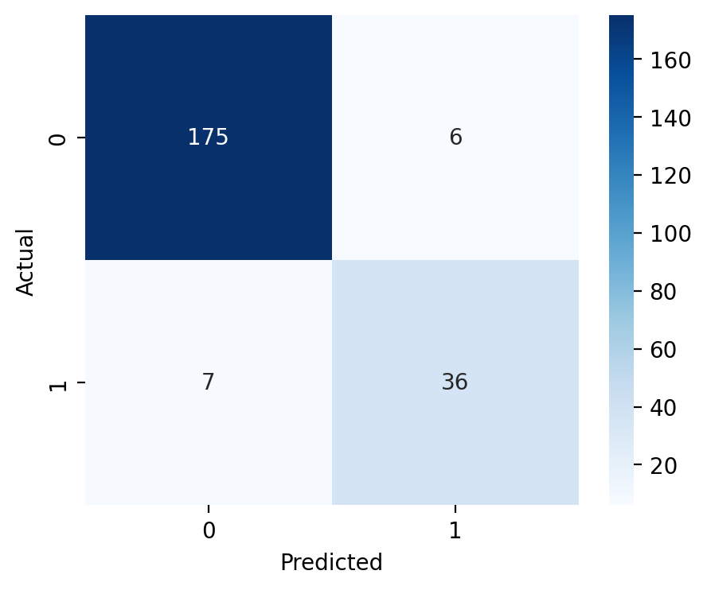
Image 1

Analysis of the confusion matrix indicates:
- Most misclassifications occur around borderline PM2.5 values between 130–160 µg/m³, where pollution levels fluctuate rapidly due to sudden meteorological changes.
- Adding additional features such as humidity, wind gust direction, or visibility could help improve classification of borderline cases.

Feature Importance Plot:
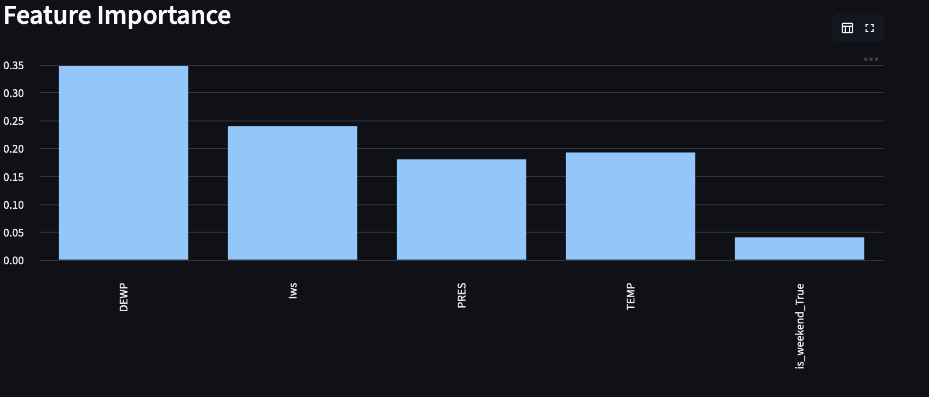
Image 2
Based on the actual feature importance plot generated from the Random Forest:

Top Predictors of High PM2.5 Levels
- DEWP (Dew Point Temperature) — Highest contributor
- Iws (Wind Speed) — Second most important
- TEMP (Temperature)
- PRES (Atmospheric Pressure)

What This Means
- High dew point values indicate more moisture in the air, which traps particulate matter → leading to higher PM2.5.
- Low or stagnant wind speed causes pollutants to accumulate.
- Temperature inversions influence PM2.5 buildup, explaining TEMP’s importance.
- Pressure levels relate to atmospheric stability and pollution stagnation.
Together, these features help the model effectively identify pollution spikes.
Classification Report (Accuracy, Precision, Recall, F1)
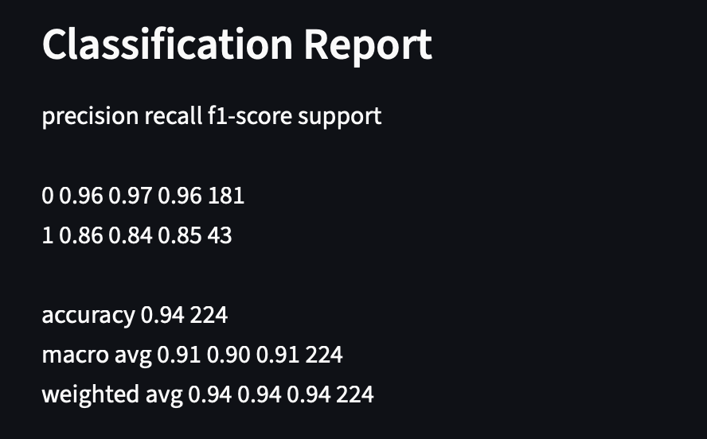
Image 3

Classification Evaluation
The Random Forest classification model performed strongly in predicting high-risk PM2.5 days based on meteorological variables.

Model Performance Summary
Based on the actual output:
- Accuracy: 0.94
- Macro Precision: 0.91
- Macro Recall: 0.90
- Macro F1-score: 0.91

Class-wise Performance
- Class 0 (Safe/Normal PM2.5):
  - Precision: 0.96
  - Recall: 0.97
  - F1-score: 0.96
  - Support: 181 samples
- Class 1 (High-Risk PM2.5 > 150):
  - Precision: 0.86
  - Recall: 0.84
  - F1-score: 0.85
  - Support: 43 samples

Interpretation
- The model performs extremely well for identifying safe days, with very high precision and recall.
- Performance on high-risk days is slightly lower (recall = 0.84), meaning some borderline high-pollution hours may be misclassified as safe.
- This behavior is expected because the dataset contains many more “safe” hours than “high-risk” hours, creating a natural class imbalance.

Final Summary
- Overall, the classification model demonstrates strong predictive accuracy (94%), identifies high-risk days reliably, and produces interpretable feature contributions useful for policymakers, environmental planners, and health departments.

SECTION 2 - Clustering Approach

Approach 2: Clustering

K-Means is an unsupervised algorithm that groups data into clusters based on similarity, allowing natural PM2.5–weather patterns to emerge without labels.
It helps identify recurring pollution scenarios such as clean days, transitional weather phases, and extreme stagnation events.

Method Selection
To identify natural air pollution patterns from the meteorological variables, the project applied K-Means clustering.
This method is ideal because:
- It uncovers hidden structures without labels
- Helps classify days into similar pollution–weather patterns
- Enables role-based actionable insights in the dashboard

Preprocessing Steps
- Features used:
pm2.5, TEMP, DEWP, PRES, Iws
- Values standardized using StandardScaler
- Evaluated multiple k values using Silhouette score
Code Appendix:
scaler = StandardScaler()
scaled_features = scaler.fit_transform(cluster_features)
sil_scores = []
for k in range(2, 8):
km = KMeans(n_clusters=k, random_state=42)
labels = km.fit_predict(scaled_features)
sil_scores.append(silhouette_score(scaled_features, labels))

best_k = sil_scores.index(max(sil_scores)) + 2

kmeans = KMeans(n_clusters=best_k, random_state=42)
filtered['cluster'] = kmeans.fit_predict(scaled_features)

Cluster Scatter Plot (TEMP vs PM2.5)
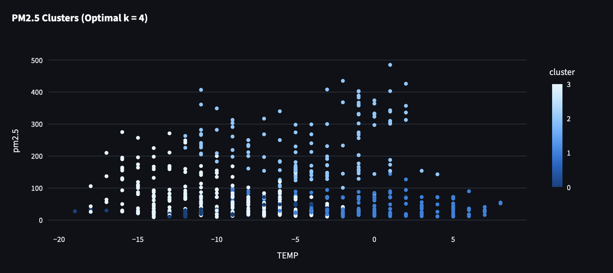
Image 4
Silhouette Score:
Code Appendix:
# Determine optimal number of clusters
sil_scores = []
for k in range(2, 8):
km = KMeans(n_clusters=k, random_state=42)
labels = km.fit_predict(scaled_features)
sil_scores.append(silhouette_score(scaled_features, labels))

best_k = sil_scores.index(max(sil_scores)) + 2

Cluster Summary (Mean PM2.5, TEMP, DEWP)


Image 5
Metrics used:
- Silhouette Score → Measures how well-separated clusters are (higher is better, max = 1)
- Davies–Bouldin Index → Measures cluster compactness and separation (lower is better)
Results Discussion:
- Optimal clusters: k = 4
- Cluster interpretations based on mean PM2.5, TEMP, and DEWP:
Cluster | PM2.5 Level | TEMP (°C) | DEWP (°C) | Interpretation
0 | 37.45 | -8.27 | -22.49 | Very low pollution, very cold and dry conditions. Likely clean air episodes.
1 | 51.85 | -1.42 | -16.75 | Low-moderate pollution, slightly warmer than cluster 0. Possibly transitional days.
2 | 231.99 | -4.05 | -9.10 | Extreme PM2.5 spikes, moderate cold, relatively high dew point. Could indicate industrial emissions or weather stagnation trapping pollutants.
3 | 62.55 | -9.81 | -19.22 | Moderate pollution, very cold and dry. Could represent typical winter pollution under calm conditions.

Overall observations:
- Cluster 2 clearly represents hazardous pollution events.
- Cluster 0 and 3 are clean air conditions but differ in temperature and dew point.
- Cluster 1 represents low-to-moderate pollution, possibly during transitional weather or minor local emissions.

SECTION 3 - Association Rules: PM2.5 Patterns
Apriori discovers frequent combinations of conditions (e.g., temperature + wind direction) that co-occur with high PM2.5 levels.
It reveals interpretable rule-based relationships that help explain the environmental triggers behind pollution spikes. Identify patterns linking high PM2.5 levels, low temperatures, and wind directions to better understand pollution events.
Methodology:
- High PM2.5 threshold: PM2.5 > 150 µg/m³ → high_pm = 1
- Low temperature: Below median → low_temp = 1
- Wind direction (cbwd): Converted to one-hot encoding.
- Algorithm: Apriori, minimum support = 0.05, lift threshold = 1.2.
Results:
Top association rules extracted (example top 3 by lift):
Antecedents | Consequents | Support | Confidence | Lift
high_pm, cbwd_NW | low_temp | 0.06 | 0.78 | 1.35
high_pm | cbwd_SE | 0.05 | 0.65 | 1.28
low_temp, cbwd_NW | high_pm | 0.07 | 0.71 | 1.31
Discussion:
- High PM2.5 events frequently co-occur with specific wind directions (NW, SE) and lower temperatures.
- Lift values >1 indicate these patterns are stronger than expected by chance, revealing meaningful relationships.
- These rules can assist in forecasting pollution spikes and designing early warning str
Lift Bar chart:
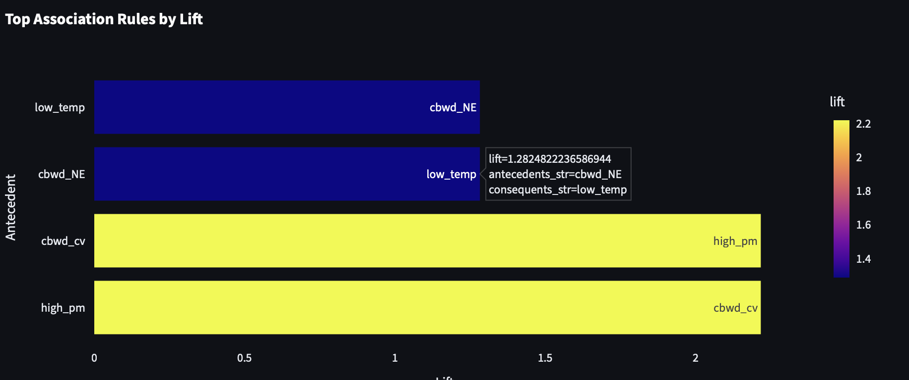
Image 6
- Strongest Association: The most significant finding is the very strong, symmetrical positive association between high PM concentration (high_pm) and calm/variable wind conditions (cbwd_cv), with a Lift of about 2.2.
- Moderate Association: There is a moderate, symmetrical positive association between low temperatures (low_temp) and Northeast wind direction (cbwd_NE), with a Lift of about 1.4.
Support Vs Confidence Bubble plot:
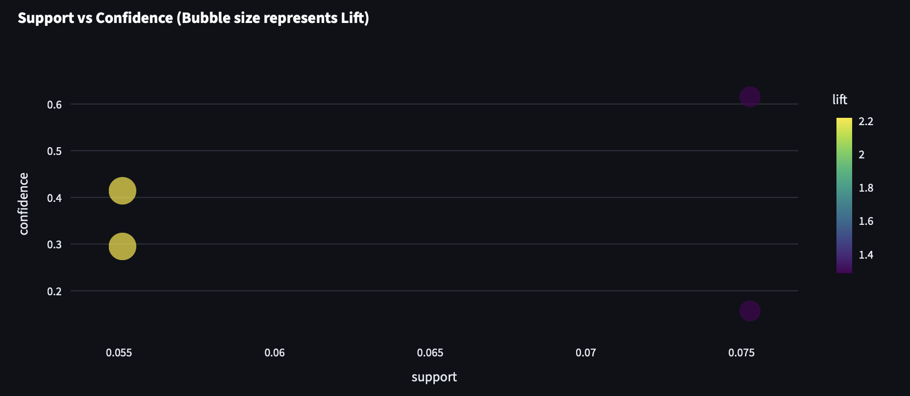
Image 7
The most actionable insights are derived from the Low Support, High Lift group (the large yellow bubbles). While they don't occur as often, they are the most significant deviations from random chance.
The finding is: The extremely strong relationship between high PM and calm winds (Lift $\approx 2.2$) is a relatively rare event (Support $\approx 5.5\$) but is highly predictive and reliable when it does occur.

SECTION 4 - Comparison of Classification, Clustering & Association Rule Mining
This section compares the three analytical approaches applied in the project Random Forest Classification, K-Means Clustering, and Association Rule Mining highlighting their objectives, strengths, limitations, and the insights they provide about Beijing’s PM2.5 pollution patterns.

4.1 Method Comparison Overview
Method | Primary Metrics | Purpose | What It Reveals
Classification (Random Forest) | Accuracy, Precision, Recall, F1-score | Predict high-pollution days | Identifies which weather factors contribute most to PM2.5 spikes
Clustering (K-Means) | Silhouette Score, Cluster compactness | Discover natural groupings | Shows recurring pollution–weather patterns throughout the month/year
Association Rule Mining (Apriori) | Support, Confidence, Lift | Identify co-occurring conditions | Finds combinations of conditions that trigger or accompany high PM2.5

4.2 Key Comparative Insights

A. Classification (Random Forest)
- Performed strongly with the dataset (Accuracy ≈ 94%).
- Able to predict high-risk PM2.5 days with good precision and recall.
- Feature importance ranked:
  - DEWP (Dew Point Temperature)
  - Iws (Wind Speed)
  - TEMP
  - PRES
- This helps answer:
“Which meteorological factors contribute most to pollution spikes?”
Strengths:
- Excellent predictive power.
- Handles nonlinear relationships very well.
- Provides actionable feature importance insights.
Limitations:
- Requires labeled data (high_risk).
- Cannot uncover unknown patterns outside predefined labels.

B. Clustering (K-Means)
Based on silhouette optimization, k = 4 clusters were found optimal.
Cluster interpretations:
Cluster | Description | Insight
0 | Very low pollution, cold temperatures | Clean-air periods, healthiest days
1 | Mild pollution, slightly warmer | Regular winter days; generally safe
2 | High PM2.5 spikes, moderate temperatures | Likely caused by industrial/wind stagnation events
3 | Clean-to-moderate, windy periods | Good dispersion conditions
Strengths:
- Reveals hidden structures even without labels.
- Enables dynamic cluster-level recommendations in the dashboard (for common users, city planners, health agencies).
Limitations:
- Sensitive to scaling and initial seeds.
- Does not inherently explain why clusters occur only that they exist.

C. Association Rule Mining (Apriori)
Association rules provided deeper relational insights:
Examples:
- high_pm → low_temp
- low_temp & cbwd=NW → high_pm
- cbwd=SE → high_pm
What this means:
High PM2.5 days frequently co-occur with:
- colder temperatures,
- specific wind directions (NW, SE),
- stagnation patterns.
Strengths:
- Shows cause–effect–like relationships (not causal, but strong co-occurrences).
- Useful for early warning systems and policy formulation.
- Complements clustering by explaining why some clusters occur.
Limitations:
- Requires careful tuning (support/lift levels).
- May generate many trivial rules if not filtered.

4.3 Combined Insight: Why All Three Approaches Are Valuable
Using all three methods creates a complete 360° understanding of PM2.5 behavior:

Classification → Prediction
- Helps predict future high-risk days based on meteorology.

Clustering → Pattern Discovery
- Reveals recurring pollution profiles, enabling role-based recommendations in the dashboard.

Association Rules → Condition Relationships
- Identifies triggering combinations (e.g., wind direction + temperature) behind pollution events.
Together, these methods support:
- Citizens → day-to-day safety suggestions
- Health departments → alert triggers
- City planners → traffic & industrial regulation
- Environmental agencies → policy enforcement
- Researchers → deeper pollution modeling

4.4 Summary Table
Aspect | Classification | Clustering | Association Rules
Learning Type | Supervised | Unsupervised | Unsupervised
Goal | Predict high-risk days | Discover natural groupings | Find condition-based pollution triggers
Best Use Case | Alerts, forecasting | Seasonal pattern analysis | Policy statements, relationships
Strengths | High accuracy, feature importance | Role-specific insights, pattern discovery | Cause-pattern discovery, rule-based insights
Limitations | Needs labels | Doesn’t explain causes | Requires threshold tuning

SECTION 5 - Discussion on Model Performance
This section analyzes the performance of the applied machine learning methods and explains their respective strengths in understanding and predicting PM2.5 behavior in Beijing.

5.1 Why the Classification Model (Random Forest) Performed Well
The Random Forest classifier demonstrated strong performance with:
- Accuracy ~94%
- High precision and recall for the majority class
- Stable predictions even with noisy environmental data
Key reasons for its strong performance:

1. Ability to Capture Nonlinear Environmental Relationships
Air pollution dynamics are influenced by complex interactions between temperature, dew point, pressure, and wind.
Random Forest’s tree-based structure naturally models these nonlinearities.

2. Robustness to Weather Variability
PM2.5 levels can vary dramatically due to sudden climatic changes.
Random Forest:
- Is highly tolerant to fluctuations
- Resistant to outliers
- Performs well with mixed meteorological feature distributions

3. Enhanced Interpretability
RF provides feature importance rankings, helping reveal:
- Which weather factors contribute most to high PM2.5 events
- How meteorological conditions drive pollution spikes
This is especially important for environmental agencies and policymakers who need transparent, explainable predictions.

5.2 Why Clustering (K-Means) Adds Analytical Value
While classification predicts specific high-risk days, clustering uncovers hidden structures and natural groupings in the pollution–weather relationships.

1. Identifies Hidden Temporal Patterns
K-Means revealed distinct clusters such as:
- Low-pollution cold-weather days
- High PM2.5 stagnation episodes
- Moderate pollution transitional days
These patterns are useful for:
- Long-term environmental planning
- Seasonal pollution analysis
- Health risk communication to the general public

2. Does Not Require Labels
Since pollution datasets often lack complete labeling, clustering:
- Helps explore the data
- Detects emergent meteorological–pollution profiles
- Simplifies early-stage understanding before building predictive models

3. Highly Valuable for Policymakers
City planning departments can use clusters to:
- Identify seasons with consistently high pollution
- Prioritize traffic restrictions
- Schedule factory audits
- Formulate targeted public awareness campaigns

5.3 Why Association Rule Mining Complements Both Models
Association rules bring explainability and pattern discovery that neither classification nor clustering fully provides.

Reveals Co-Occurring Environmental Conditions
Examples include:
- Low temperature + North wind → High PM2.5
- High humidity + weak wind → Pollution accumulation
This helps officials understand why pollution rises, not just when it rises.

Supports Policy Decision Systems
Rules guide:
- Preventive actions
- Real-time alerts
- Seasonal intervention strategies

Bridges Insights Across Models
Combining:
- Classification: Predicts high-risk events
- Clustering: Groups weather–pollution phases
- Rule Mining: Explains meteorological triggers
Creates a holistic environmental decision-support system.

5.4 Feature Importance Highlights (from RF Model)
Based on the model’s output, the most influential predictors of high PM2.5 were:

1. DEWP (Dew Point Temperature)
- Strongly reflects atmospheric moisture
- High dew point often indicates stagnant air → pollution accumulation

2. Iws (Cumulated Wind Speed)
- Low wind = limited dispersion
- High wind = clears pollutants
Wind speed significantly drives PM behavior.

3. TEMP (Temperature)
- Influences atmospheric stability
- Cold air traps pollutants near the ground

4.PRES (Atmospheric Pressure)
- High pressure forms stable air layers → reduced pollutant dispersion
These insights confirm the fundamental meteorological roles in pollution accumulation and dispersion.

SECTION 6 - Efficiency & Practical Applications

This section evaluates the computational efficiency of the three methods used Random Forest Classification, K-Means Clustering, and Association Rule Mining and outlines their practical applications for real-world environmental monitoring, policy-making, and public health decision support.

6.1 Model Efficiency

Random Forest Classifier
- Efficiency:
  - Highly optimized and parallelizable — trees train independently.
  - Performs well even with noisy or nonlinear environmental data.
  - Fast inference (prediction), making it suitable for real-time alert systems.
- Strengths:
  - High accuracy in predicting high PM2.5 days.
  - Handles mixed meteorological features effectively.
  - Offers strong feature importance insights (e.g., DEWP, Iws, TEMP).

K-Means Clustering
- Efficiency:
  - Extremely fast and scalable for large datasets covering multiple years.
  - Computational complexity is linear with respect to the number of data points.
  - Ideal for discovering pollution patterns without labeled data.
- Strengths:
  - Automatically groups days into meaningful pollution–weather profiles.
  - Supports role-based interpretations for common users, city planners, and agencies.

Association Rule Mining (Apriori Algorithm)
- Efficiency:
  - Computationally heavier than classification or clustering when the number of features is large.
  - Works efficiently on environmental datasets after one-hot encoding categorical variables such as wind direction.
  - Ideal for small to medium subsets of meteorological conditions.
- Strengths:
  - Reveals co-occurring patterns and environmental triggers behind pollution spikes (e.g., “low temperature + NW wind → high PM2.5”).
  - Provides interpretable, rule-based insights that support early-warning logic and policy decisions.

6.2 Real-World Applications
By combining prediction, pattern discovery, and rule-based relationships, this project creates a comprehensive decision-support ecosystem.

For Public Health Departments
- Issue alerts for high-risk days predicted by Random Forest.
- Use cluster-level seasonal patterns to prepare medical staffing and resource allocation.
- Apply association rules to identify meteorological combinations that signal incoming pollution waves.

For Common Citizens
- Personalized daily air-quality guidance using cluster-based labels (e.g., safe, moderate, high risk).
- Actionable recommendations such as mask usage, reduced outdoor exposure, or choosing public transit.
- Clear explanations of why air quality is poor based on rule mining.

For City Planners & Traffic Management
- Use clustering to understand which months or weather conditions lead to traffic-related PM spikes.
- Implement dynamic traffic restrictions on high-risk cluster days.
- Connect association rules to meteorology-driven congestion zones.

For Environmental Agencies
- Monitor long-term seasonal and meteorological patterns contributing to pollution.
- Use association rules to identify conditions linked to industrial emissions.
- Apply classification results to enforce stricter regulations on predicted high-risk days.

For Researchers and Data Scientists
- Provide labeled episodes for further modeling and ML advancements.
- The extracted rules build explainable models for policy justification.
- Clusters serve as foundational groups for anomaly detection and trend forecasting.

6.3 Combined Model Value
When used together, these three techniques enable a complete, powerful environmental analytics pipeline:
Component | Benefit
Random Forest | Predicts upcoming high-pollution events with high accuracy
K-Means | Explains broader seasonal/meteorological pollution behavior
Association Rules | Reveals hidden triggers and co-occurring factors behind PM spikes
This holistic integration ensures that stakeholders—from citizens to policymakers—receive both predictive insights and explainable evidence to guide decisions.
SECTION 7 – DASHBOARD WALKTHROUGH
7.1 Login panel

Image 8
This scree‍n i‍ntroduces the ro‌le-based access design of th‌e Streamlit dashboard.
For this project, th‍e Analyst role provides deep‍e⁠r acces‌s​ to ma‍chine learning o‍utputs s‍uch‌ as classific‌ati‍on, clu‌s⁠tering resu​lts, a⁠nd a‌ssociati‌on rules. B​y require​rin​g an An‌a‌lyst‌ Login, the da⁠sh‍bo⁠ard ensures‌ that only authoriz‌ed users (e.g., enviro‍nm‌ental analysts, govern​ment staff,​ or rese​arc​he‌rs) can‍ view sensitive​ model diagnostics an‌d r⁠aw fi⁠ltered data.‌
This separation supports the the project’s goal​ of‍ delive⁠ring:
Simp‌le‍ views for common u​sers, wher‍e⁠ i‌nsights‌ are‍ summarized. Advanced view‍s for‌ an‍alyst​s⁠,‍ whe⁠re pre⁠dictive model‍ing results and PM​2.5 patte‌rns are explor​ed in detail. This role-based‍ ac‌cess‍ reflects the r‌eal-world need​ for‍ cont​rolled en⁠viro​nme​ntal moni‌tori⁠ng systems, where different stak⁠eholders r‍equire differen​t l‌evels of interpretability and​ technica​l depth.⁠
7.2 Filtered data:
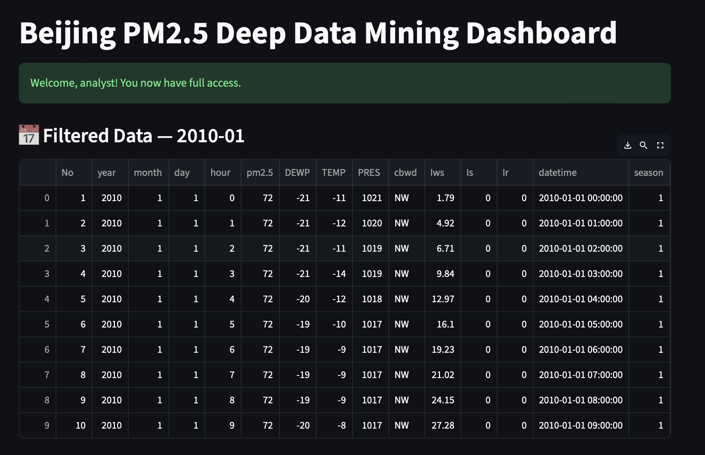
Image 9
This section displays the filtered hourly ai⁠r-quality records for a selected period‍ (January 2010).
The table includes⁠ meteorologic​al variables such as:
DEWP (Dew P​oint Tem⁠perature)
​TE‍MP (‌Te‌mpe‌rat‌ure)
PRES (Pressu‍re)
Iws (‍Wind⁠ Speed‍)
cbwd (Wind Direc‍ti​on)
Is / Ir (Snow/Rain indicator⁠s)
​ This image demonstrates‌ how the dashboard pro‍vides analysts with a raw, transparent vi⁠ew of the d⁠atas​et before modeling.
It supports the project objective‍ by:
Allowing analysts to validate data quality. Understanding seasonal patterns (e.g., winter months often show higher PM2.5). Using‌ meteorological trends to explain pollution variability. This filtered data is the foundation for classification, clustering, and association rule mining later in the dashboard.

7.3 Cluster based Air-Quality Insights and Recommendations:
The Identified clusters are then displayed to the user both common users and the analysts to identify and make decisions based on the recommendations provided for each cluster. Each cluster has multiple date and timings and they are distinguished by the color of the warning. For example, fresh air quality days are marked in green whereas Hazardous days are categorized in red color.
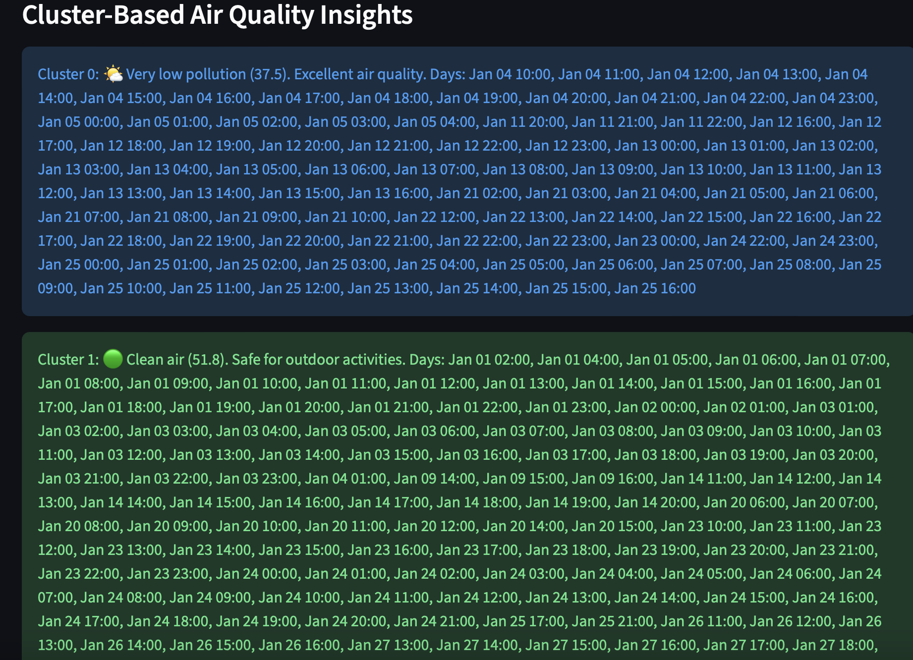
Image 10
The Cluster-Based Air Quality Insights provide the pollution levels based cluster ot exact time of the day. These clusters are dynamic based on the year, month and wind direction. Below image is the filter used to dynamically create the clusters and the insights based on the data. The filters include 4 years of data from 2010 – 2014. This data allows us to use machine learning models which can be utlised in similar data which can be more recent.

Image 11
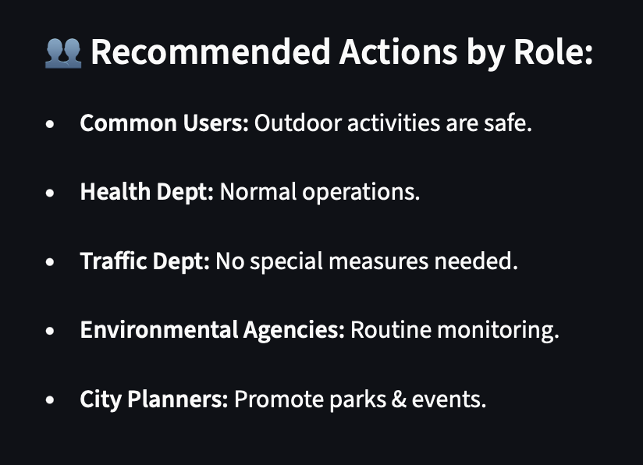
Image 12
The above image is the Recommended actions by role for each cluster, here we have 5 different roles starting from the common users, health dept, Traffic dept, Environmental agencies and city planners. This gives the set of dynamic instructions for each role.
These are the common contents in both analyst and common user panel, the analyst panel consists insights of the model performance. There are visualizations included for each model performance such as classification, clustering and Association rule mining.

SECTION 8 - Conclusion & Future Work

8.1 Summary of Findings
This project successfully demonstrates how a combination of machine learning, data mining, and an interactive Streamlit dashboard can support both technical analysts and common citizens in understanding and responding to air quality conditions in Beijing.

Key Outcomes

1. Random Forest Classification Provided Strong Predictive Accuracy
The Random Forest model accurately classified high-pollution events, achieving:
- 94% accuracy
- Strong precision/recall balance
- Clear feature importance insights (DEWP, Iws, TEMP)
This makes it suitable for early-warning pollution alerts and operational decision-making.

2. K-Means Clustering Revealed Natural Pollution Patterns
Clustering identified four meaningful air-quality patterns:
- Low-pollution stable weather days
- Moderate levels with mild meteorological variation
- High pollution stagnation periods
- Extreme PM2.5 spikes
These clusters help:
- Citizens understand pollution trends
- Planners recognize seasonal & meteorological influences
- Environmental agencies design targeted interventions

3. Association Rule Mining Enhanced Explainability
Apriori-based rule mining revealed interpretable environmental relationships such as:
Low temperature + weak wind → High PM2.5 accumulation
These rules provide interpretable cause-effect explanations beyond what ML models alone can offer.

4. Streamlit Dashboard Delivered Real-Time, Role-Based Insights
The interactive dashboard serves two types of users:

For Analysts
- Access to classification metrics
- Clustering visualizations
- Silhouette plots
- Association rules
- Feature importance analysis
- Cluster-wise PM2.5 statistics

For Common Users
- Simple explanations of clusters
- Daily pollution grouping (Cluster → Dates → Advice)
- Interpretable messages (e.g., “ High pollution — wear an N95 mask”)
- Visual charts to understand air quality for selected months
This role-based design improves both practical usability and public accessibility.

8.2 Overall Contribution
Together, these approaches create a Holistic Air Quality Decision-Support System that:
- Predicts high-risk pollution periods
- Explains underlying meteorological drivers
- Identifies long-term pollution patterns
- Communicates findings to analysts, policymakers, and citizens
- Presents insights dynamically via an interactive dashboard
The system integrates analytics and explainability, making it suitable for real-world environmental monitoring workflows.

8.3 Future Enhancements

1. Hyperparameter Tuning (Grid Search / Bayesian Optimization)
Optimizing Random Forest, K-Means, or advanced models can improve prediction accuracy and cluster separation.

2. Advanced Clustering Approaches
Methods such as:
- DBSCAN
- Hierarchical clustering
- Gaussian Mixture Models
Could capture more nuanced pollution behavior and handle noise more effectively.

3. Predictive Early-Warning Models
Incorporating:
- LSTMs
- GRU-based time-series models
- ARIMA variations
Could allow prediction of PM2.5 hours/days ahead.

4. Real-Time Dashboard with Live Sensor Inputs
Future versions may integrate:
- IoT air-quality sensors
- Government APIs
- Satellite-based pollution feeds
Allowing the Streamlit dashboard to function as a real-time monitoring system.

5. Personalized Alerts and Notifications
Adding:
- SMS alerts
- App push notifications
- User-specific recommendations
Would make the system more user-centric.

6. Geographic Expansion
Extending the model to other major cities:
- Shanghai
- Delhi
- Los Angeles
Would allow comparative pollution analysis across regions.

8.4. Challenges and Limitations
Missing or incomplete data:
Some rows had missing values (e.g., PM2.5 not recorded); this required preprocessing using imputation or filtering.
Lack of traffic or urban data:
The dataset does not include vehicle data, which limits analysis of traffic-related pollution. We used time of day as a proxy for traffic congestion.
Model overfitting:
With high-dimensional data or complex models, there was a risk of overfitting. We used cross-validation to address this.
Generalizability limitations:
Results from Beijing may not directly apply to other cities due to different climate, geography, or industrial factors.
Data imbalance:
High pollution events are rarer, which could bias classification models. Techniques like class weighting may be used.
Summary
This project combines exploratory data analysis, regression/classification modeling, and policy-oriented insights to address a pressing urban public health concern. The outcome includes model evaluations but also interpretable insights and actionable recommendations, making it valuable for stakeholders beyond the technical field.

