Recurring Face Identification and Occurrence Analysis in Video

Technical Project Report
Prepared By: Ilangkumaran Yogamani
Date: 19 June 2026
Source video: https://www.youtube.com/watch?v=d2g9HlwoC-s

Executive Summary
This project implements a computer-vision pipeline that processes a single video, extracts frames at a fixed rate, detects faces, generates face embeddings, groups recurring individuals, estimates the number of unique people, computes per-person appearance statistics, and identifies the most frequently appearing person.
Detection uses SCRFD-10GF and embedding uses ArcFace (ResNet-50), both from the InsightFace buffalo_l model pack. Grouping is performed at the track level using constrained complete-linkage agglomerative clustering over cosine distance, with a co-occurrence “cannot-link” constraint and a best-shot cross-scene linking pass. From 1,415 extracted frames, the system detected 435 face crops, formed 359 tracks, and produced 154 face groups, of which 21 are a “featured cast” (groups with ≥5 frames of presence). The most frequently appearing identity is Face_01 (21 frames; 9 distinct appearances; 21.0 s).
Because no independent human-labeled ground truth is available, accuracy/precision/ recall against ground truth are Not Measured. Quality is instead reported via two label-free objective checks implemented in the project: a co-occurrence precision check and a tracking-continuity recall check.

1. Problem Statement
The goal is to determine who appears in a video and how often, without prior knowledge of the people present or their number. Concretely, the system must:
- extract frames from the video,
- detect and crop faces,
- represent each face numerically (embedding),
- group faces of the same person together,
- estimate the number of unique individuals, and
- report appearance statistics and the most frequently appearing person.
Recurring-face identification of this kind is useful for content indexing, screen-time measurement, and summarisation. The number of people is unknown in advance, so the grouping method must not require a predefined cluster count. Expected outcomes are a set of grouped identities with occurrence statistics and supporting visualisations.

2. System Architecture
Video Input (1080p)
|
Frame Extraction (1 FPS)
|
Face Detection (SCRFD-10GF)
|
Landmark Alignment + Face Cropping (112x112)
|
Embedding Generation (ArcFace, 512-D)
|
Multi-frame Tracking (ByteTrack)
|
Per-track Template (quality-weighted)
|
Complete-linkage Clustering + co-occurrence cannot-link
|
Best-shot Cross-scene Linking
|
Corroboration Backstop (identities)
|
Occurrence Statistics + Visual / HTML Outputs
Figure 1: Overall system architecture. Each stage is a separate, independently runnable module orchestrated as a single end-to-end pipeline. An optional clothing/body re-identification stage (disabled by default) can be inserted before clustering as an additional cross-scene signal.

3. Methodology

3.1 Frame Extraction Pipeline
Frames are sampled from the downloaded video at 1 frame per second (the project’s configured rate) using the supervision video utilities, with a stride derived from the true source FPS so that timestamps are accurate. Each frame is stored and recorded with its frame index and timestamp. The source is acquired at up to 1080p to preserve detail for small faces. 1,415 frames were extracted.

3.2 Face Detection Pipeline
Face Detection Model Used: SCRFD-10GF (InsightFace buffalo_l model pack), run via ONNX Runtime on CPU.
- Selection rationale: SCRFD is a single-shot, anchor-based detector that returns bounding boxes, 5-point landmarks, and confidence scores, and is markedly more robust to pose, lighting, and scale than a classic Haar cascade. It is bundled with the matching ArcFace recogniser, simplifying the stack.
- Process / thresholds: input size 1024×1024; confidence threshold 0.4; detections smaller than 36 px (width or height) are discarded.
- Cropping: each kept face is aligned to a 112×112 crop using its landmarks (norm_crop) and saved.
- Multiple faces: all faces per frame are detected and processed independently.
Advantages: robust multi-pose detection; landmarks enable alignment. Limitations: at the chosen threshold some low-confidence/marginal detections (incl. non-faces) are admitted, which are handled downstream by a corroboration backstop; true detection recall is Not Measured (no ground-truth bounding boxes).

3.3 Face Recognition / Embedding Pipeline
Face Recognition / Embedding Model Used: ArcFace (ResNet-50, trained on WebFace600K; InsightFace buffalo_l model pack).
- Preprocessing: landmark-aligned 112×112 crops.
- Embedding: each crop is mapped to a 512-dimensional, L2-normalised vector.
- Representation / similarity: because vectors are unit-norm, similarity is the cosine (dot product); same-person faces yield high similarity, different people low.
- Matching: comparisons are done on per-track template embeddings (see §3.4), not raw per-crop vectors, to suppress per-frame noise.
This approach suits the project because it requires no per-video training and produces a fixed-length, comparable representation for an unknown number of people.

3.4 Face Grouping Methodology
- Tracking & templating. Faces are linked across frames with ByteTrack; each track is reduced to one quality-weighted, outlier-trimmed mean embedding.
- Similarity. Cosine distance between track templates.
- Clustering. Complete-linkage agglomerative grouping (every member pair must be within the distance threshold, 0.50), which prevents the “chaining” that merges dissimilar faces. A co-occurrence cannot-link constraint forbids merging two faces seen in the same frame (they must be different people).
- Cross-scene linking. A best-shot pass merges clusters whose most frontal, highest-quality faces match (complete-linkage, threshold 0.50), consolidating a person’s appearances across scene cuts.
- Identity consolidation. A corroboration backstop keeps a cluster as a real identity only if it has ≥2 faces, a high-quality face, or a confidently-detected face; otherwise its tracks are labelled unknown. Surviving clusters are named Face_NN, ranked by screen-time.
- Threshold selection. Thresholds were chosen by an internal sweep maximising cluster cohesion and the label-free checks (§6); see Limitations regarding the absence of authoritative ground-truth tuning.
NOTE — Optional Clothing / Body Re-Identification (disabled by default). Face embeddings sampled at 1 FPS cannot reliably link the same person across large pose changes or scene cuts. As an optional, orthogonal signal, the system can additionally embed each person’s clothing/body region — the torso below the detected face — using a dedicated person re-identification model, and compare it across groups. Because an individual’s outfit is consistent within a short video and is independent of face pose, this can consolidate cross-scene appearances that face matching alone misses.
The stage is applied conservatively: a merge requires both clothing agreement and a plausible face match, and can never join two faces seen in the same frame. Rather than merging automatically, proposed cross-scene merges are surfaced for human confirmation. It is disabled by default because its characteristic failure mode — different people wearing similar outfits or sharing a background — is not detectable by the automatic quality checks, so enabling it is recommended only in combination with human review. In internal testing it correctly consolidated a recurring individual across three separate scenes.

4. Alternative Approaches Considered
Approach | Potential Advantages | Potential Limitations | Reason Not Selected
OpenCV Haar cascade (detection) | Fast, simple | Weak on side/blurred/small faces | Lower-quality detection than SCRFD
MTCNN / RetinaFace (detection) | Good accuracy | Not bundled with the chosen recogniser | SCRFD in buffalo_l already adequate and integrated
Dlib / face_recognition (embedding) | Easy to use | Older representation | ArcFace expected to generalise better
FaceNet512 (embedding) | Common alternative | Heavy extra dependency; re-tuning | Considered and rejected in favour of bundled ArcFace
K-Means clustering | Simple | Requires number of people in advance | Count of people is unknown
DBSCAN (single-linkage) clustering | No preset cluster count | Single-linkage chains dissimilar faces into incoherent groups | Replaced by complete-linkage after this was observed in the project

5. Challenges Encountered
Grouping — chaining / false merges. An initial DBSCAN (single-linkage) approach produced an incoherent “junk” group (very low within-group similarity), i.e. different people merged together. Mitigation: switched to complete-linkage, which guarantees all members are mutually within threshold. Remaining: none of this specific failure mode after the change.
Grouping — over-fragmentation. At 1 FPS, the same person across scene cuts has no temporal bridge, so their appearances can split into several groups. Mitigation: the best-shot cross-scene pass recovers frontal recurrences. Remaining: profile-only cross-scene recurrence is not resolved by face embeddings; the total group count is therefore an over-estimate of distinct people.
Recognition / face quality. Many crops are small or non-frontal; gender/age and embedding quality degrade on these. Mitigation: quality-weighted templates, a minimum-size filter, and the corroboration backstop. Remaining: small/profile faces remain harder to match.
Validation. No ground-truth labels are available. Mitigation: two label-free objective checks (co-occurrence precision, tracking-continuity recall). Remaining: these do not measure cross-cut grouping correctness; see §9.
Computational. Detection runs on CPU. Hardware acceleration via CoreML was tested and measured slower for this model, so it was disabled. Processing is batch, not real-time.

6. Results and Analysis

6.1 Frame Statistics
Metric | Value
Source resolution | 1080p
Sampling rate | 1 FPS
Total extracted frames | 1,415
Approx. sampled duration | ≈ 1,415 s (~23.6 min), inferred from frame count at 1 FPS

6.2 Face Detection Statistics
Metric | Value
Total face crops detected | 435
Average faces per frame | ≈ 0.31 (435 / 1,415)
Detection threshold | 0.4
Minimum face size kept | 36 px
Detection rate vs. ground truth | Not Measured (no ground-truth boxes)

6.3 Face Occurrence Statistics
Metric | Value
Total face tracks | 359
Total face groups (named identities) | 154
Featured cast (≥5 frames present) | 21
Crops assigned to unknown (backstop) | 31
Largest group size | 21 frames
Average crops per named group | ≈ 2.62
Estimated unique identities | 154 (upper bound) / 21 featured — see note
Note on “unique identities”: the raw group count (154) over-counts real people because of cross-cut over-fragmentation and a long tail of one-off/background faces. The featured cast (21) is the more meaningful estimate. The true number is Not Available (no ground-truth validation).

6.4 Most Frequent Face Analysis
The most frequently appearing identity is Face_01 — 21 frames, 9 distinct appearances (tracks), 21.0 s of screen time, estimated male, ~51. It was consolidated across three separate scenes by the best-shot cross-scene linker and visually corresponds to one consistent person.
Relative frequency: 21 of 435 detected crops (≈4.8%); it is the top group by both frame count and screen time. Because there is no ground-truth labelling, this is the most-frequent group as grouped by the system, not a ground-truth-verified claim.
Top identities by screen time:
Face ID | Screen time | Appearances | Frames | Demographics (est.)
Face_01 | 21.0 s | 9 | 21 | M ~51
Face_25 | 18.0 s | 11 | 18 | M ~32
Face_02 | 17.0 s | 6 | 17 | F ~24
Face_03 | 15.0 s | 6 | 14 | M ~47
Face_05 | 13.0 s | 7 | 13 | F ~30
Face_06 | 12.0 s | 4 | 12 | F ~23
Face_15 | 12.0 s | 7 | 12 | F ~27
Face_07 | 10.0 s | 4 | 10 | M ~46

6.5 Sample Visualizations
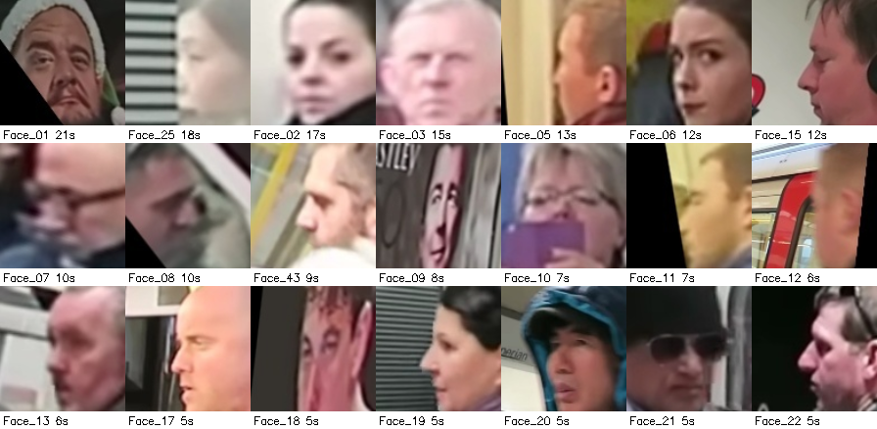
Featured-cast representative faces
Figure 2: Featured-cast overview. One representative crop per featured identity (the 21 groups with ≥5 frames of presence), labelled with screen time.
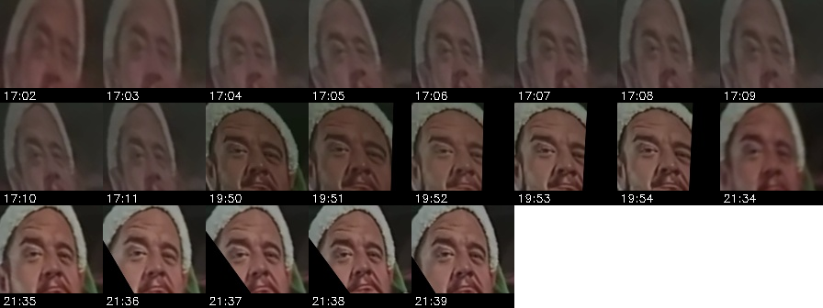
Most frequent face grouped samples
Figure 3: Most frequently appearing face (Face_01). Grouped crops of the highest-appearance identity, shown with timestamps across three scenes.
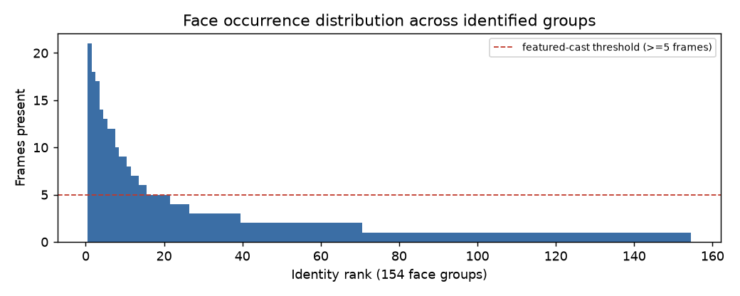
Occurrence distribution
Figure 4: Face occurrence distribution. Frames-present per group across all 154 groups (descending); the dashed line marks the featured-cast threshold and the long tail reflects one-off/background detections.

6.6 Quality / Validation Summary (label-free)
Check | Result | Meaning
Co-occurrence precision | 1.0000 | No two faces in the same frame share an identity
Tracking-continuity recall | 0.83 | Intra-shot completeness (briefly-broken tracks regrouped)

7. Conclusion
The project delivers a complete, modular pipeline that turns a raw video into grouped face identities with occurrence statistics. From 1,415 frames it detected 435 faces, formed 359 tracks, and produced 154 face groups (21 featured), identifying Face_01 as the most frequently appearing person. The grouping is built on SCRFD detection and ArcFace embeddings, with a complete-linkage clustering scheme and a co-occurrence constraint that, by construction, keeps groups internally coherent and free of same-frame merges (co-occurrence precision 1.0000; intra-shot continuity recall 0.83).
The system is suitable for content indexing and screen-time analysis where an unknown number of people must be grouped without training. Its principal limitation is the absence of ground-truth validation and the residual cross-cut fragmentation inherent to face-only matching at 1 FPS — both stated honestly as measured constraints rather than resolved claims.

