TO: Dr. Simmons and Dr. Curtarolo
FROM: Paint Killers (S. Drillings, S. DiGabriele, I. Jordan, C. Quintenz, and M. Grimaldi)
DATE: 10/5/2025
SUBJECT: Selecting a Solution for EGR 101 Paintbrush Cleaner

Overview
We have decided to move forward with a cylindrical machine with a textured, hilly base and a rotating top that the brushes attach to. This solution is evaluated to be the safest, holds the maximum number of brushes, and minimizes the risk of damaging bristles.
We reached this conclusion by prioritizing the request of James Keul, a local artist, who emphasized the importance of an automatic oil paint brush cleaner. Most existing products are manual, often requiring direct hand contact, which can cause health issues like blisters. Additionally, most can only clean one brush at a time, limiting efficiency.
To decide on a solution, we decomposed the problem, created a Morph Chart to visualize design options, used a screening matrix to narrow our choices, and applied a scoring matrix to evaluate final concepts.
The outcome of this process concluded that we should move forward with the design mentioned above, which we are confident will create a functional, market-ready product suitable for artists like Mr. Keul and beyond.

Ideation and Selection Process
To begin brainstorming, we, as a group, broke down the design into design blocks, also known as decomposition. As seen in the decomposition chart in Appendix Image 1, we broke down the paintbrush cleaner into materials, power, size, accessibility, and functions. We then transitioned this activity onto notecards. We wrote each design block on a note card and then listed all possible designs that fit into that category, as seen in Appendix Image 2. Altogether, we filled out about 50 notecards. This tool helped us create a morph chart, as seen in Appendix Table 1. We chose the most practical options to include in the morph chart, which allows us to combine one or more options from each design block to form any combination of a completed design. With many ideas of components, we each took a large notecard and drew out an idea. We compared these ideas and worked together to form new ones. In total, we decided on our 7 favorite ideas (as seen in Appendix Image 3) to compare using a Pugh screening matrix, shown in Appendix Image 4. The first time we did the Pugh screening matrix, our standard was actually our best design, so the scores were off. So, we redid it, comparing every solution to a relatively standard solution - a servo motor that pulls brushes across bumps of silicone. The result of this allowed us to see which solutions shouldn’t move onto the scoring matrix, and which solutions are relatively similar and can be combined for the scoring matrix. So, we then moved on to completing the Pugh scoring matrix (which is shown in the text in Table 1) together in order to decide on one final solution we are going to prototype. Our plans consist of prototyping parts to decide what works best, and then we will put it all together for a more sophisticated prototype, and then a final product.

Pugh Scoring Matrix - See Table 1
For our scoring matrix, we decided on 4 solutions, labeled A-E. Note that solutions A and D are combined and scored the same due to their similarity. The drawn depictions of the solutions are shown in Appendix Image 3.
- A/D: Both of these solutions are combined as they incorporate the same ridge mechanism to clean the paintbrushes—design A uses ridges spread horizontally or accommodates paintbrushes ordered horizontally, while design D incorporates a single ridge with paintbrushes spread out across that single ridge. They both apply the same pressure and move in a linear fashion.
- B: Design B incorporates the ridges of design A/D but rotates 360 degrees instead of having the brushes move back and forth across the ridges.
- C: Solution C is similar to solution B in that there is rotation involved; however, the base rotates rather than the top with the brushes, and the base has silicone dots rather than ridges.
- E: Design E incorporates a rotating wheel that then rotates a bar with paintbrushes attached to it. This allows for pressure to be applied to the side of the paintbrush bristles to clean the brush.

We assigned each design criterion a specific weighting; this is a percentage that indicates the relative importance of each criterion in comparison to the rest when evaluating priorities. We determined that “Safety” (to the user) required the highest weight at 25% with “No damage to bristles” at a close second with 23%. The least important design criteria were simplicity in manufacturing at 7% and cleaning time at 10%. After performing the scoring matrix and calculating the weighted scores, Solutions A/D, B, and C all scored very closely, with B performing the best at a weighted score of 3.88. Solution E was an outlier in that it was only 2.06, almost 50% lower than the next lowest score, as well as being the only design to not break 3.00 after weighting. Ultimately, we decided to continue with design B as our final design to begin prototyping and testing.

Table 1: Pugh Scoring Matrix
Design Criteria | Weight | Solution A/D |  | Solution B |  | Solution C |  | Solution E
Design Criteria | Weight | rating | Weight score | rating | Weight score | rating | Weight score | rating | Weight score
Time | 10% | 3 | .3 | 3 | .3 | 4 | .4 | 2 | .2
Capacity | 20% | 3 | .6 | 5 | 1.0 | 5 | 1.0 | 1 | .2
Ease of Use | 15% | 4 | .6 | 5 | .75 | 5 | .75 | 4 | .6
No Damage to bristles | 23% | 4 | .92 | 3 | .69 | 1 | .23 | 2 | .46
Safety | 25% | 3 | .75 | 4 | 1.0 | 4 | 1.0 | 1 | .25
Simplicity in manufacturing | 7% | 3 | .21 | 2 | .17 | 3 | .21 | 5 | .35
Total Score | 100% | 3.38 |  | 3.88 |  | 3.59 |  | 2.06
Rank |  | 3 |  | 1 |  | 2 |  | 4
Continue? |  | NO |  | YES |  | NO |  | NO

Conclusion
Solution B is the recommended solution because of its increased capacity, ease of use, and how it doesn’t pose a major threat to the brush bristles: the round shape of the device allows us to hold a greater number of paintbrushes as they can be spread throughout the circumference of the device, while a more linear design would need to be extended to hold more bristles (it would require a larger total footprint); the device is easy to use given that it is fully sealed and the solvent is easy to pour in and out, therefore, there should be no damage to surrounding objects or the mechanics of the device; finally, the design is optimized to be safer for the brush bristles given that the cleaning force is always applied to the edge of the brush rather than face down (like solution C and E).

Appendix
Image 1: Decomposition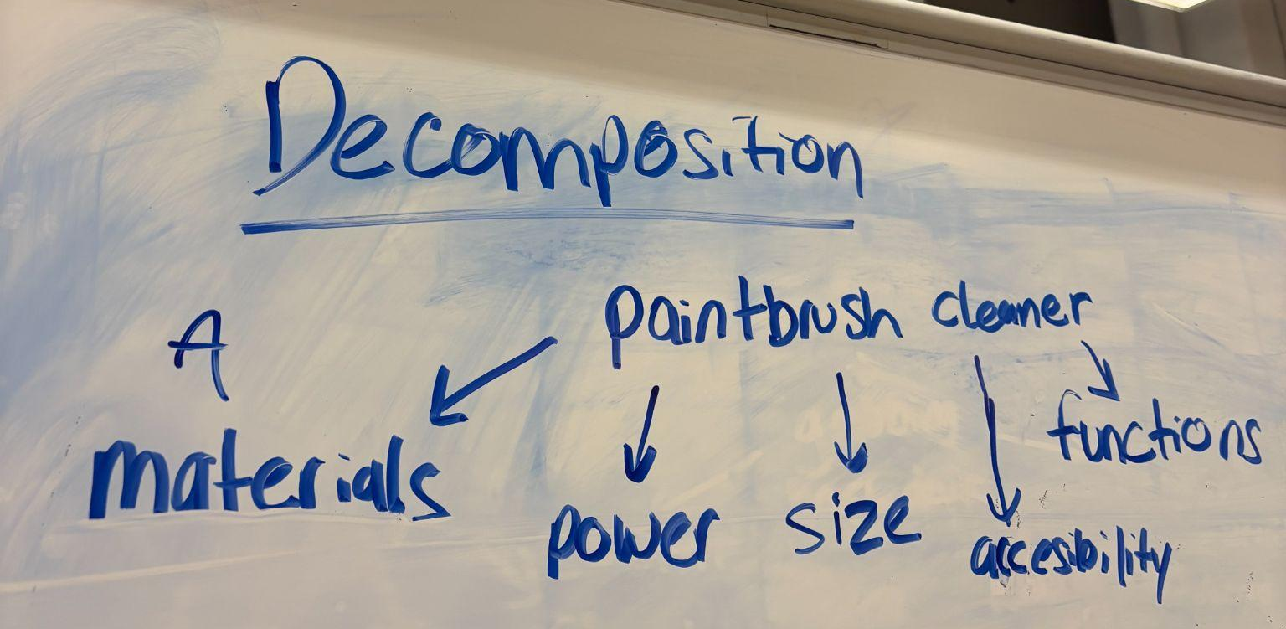

Image 2: Brainstorming Notecards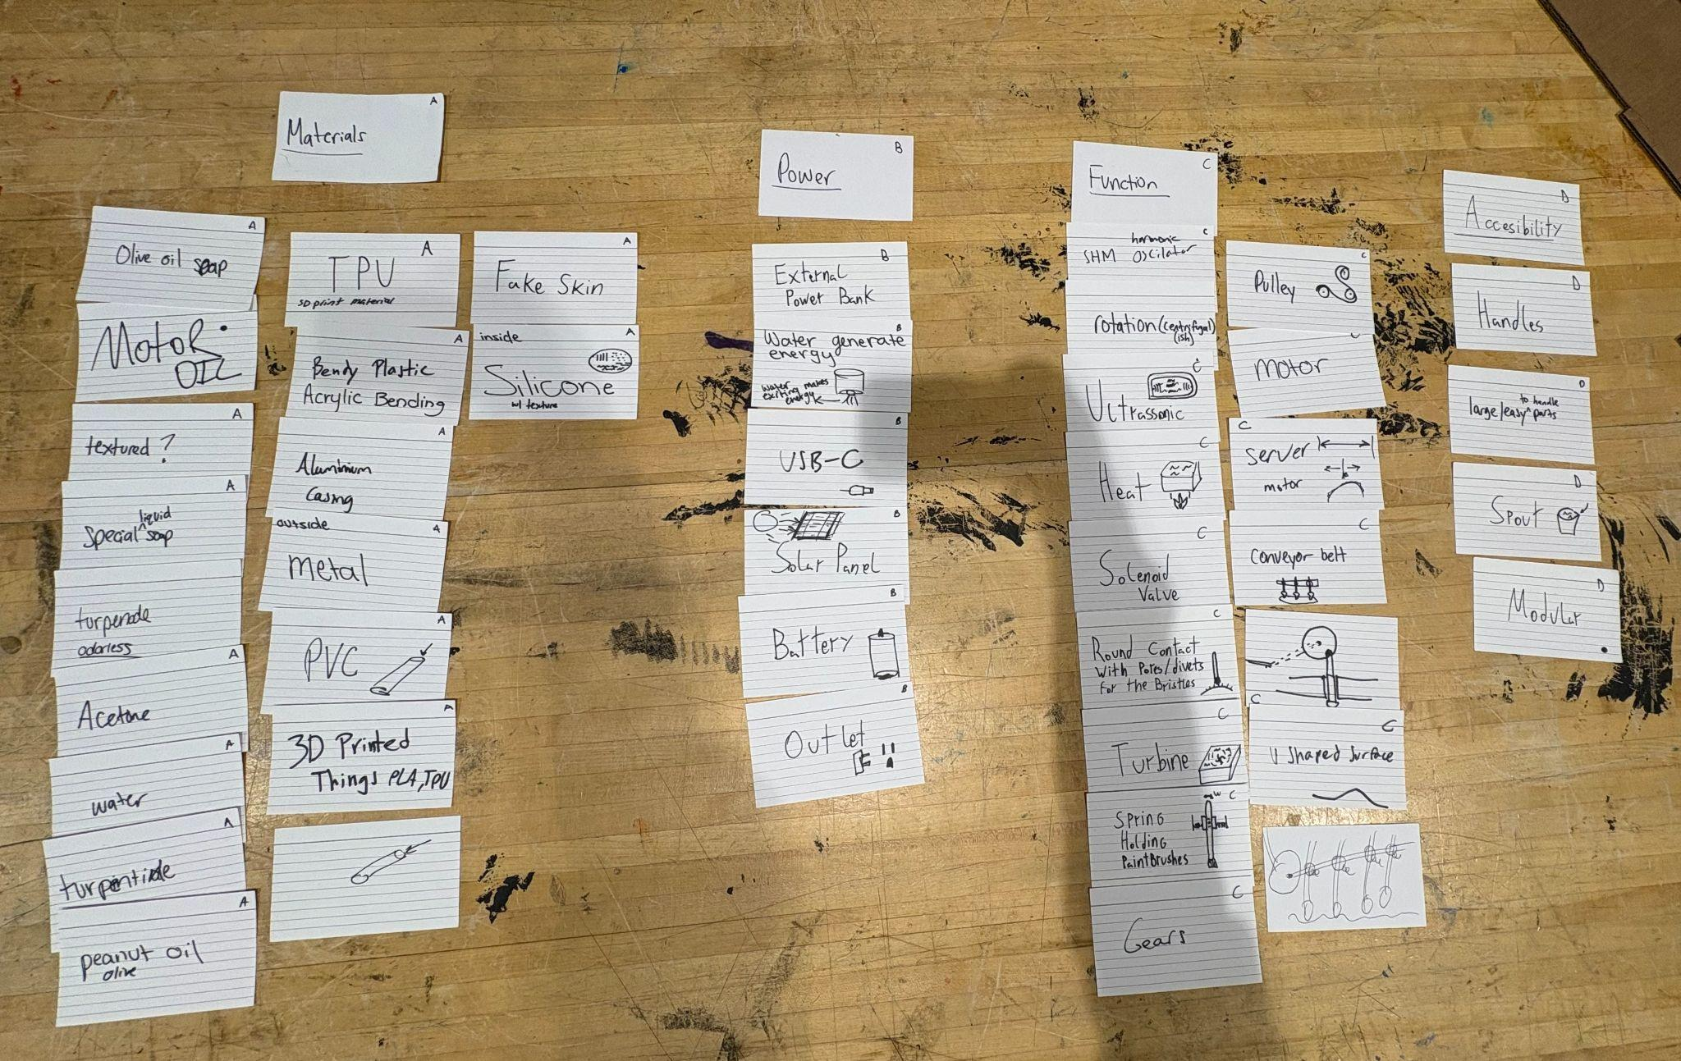

Table 1: Morph Chart
Design Blocks | Option 1 | Option 2 | Option 3 | Option 4
Movement | Rotation | SHM | Sweeping | Centrifuge
Power Source | Battery | Solar | Hydroelectric | Outlet
Base Material | Silicone | Fake Skin | Rubber | Molding/Cast Material
Structure Material | Metal | PVC | Acrylic | PLA/TPU

Image 3: Design Ideas A-E
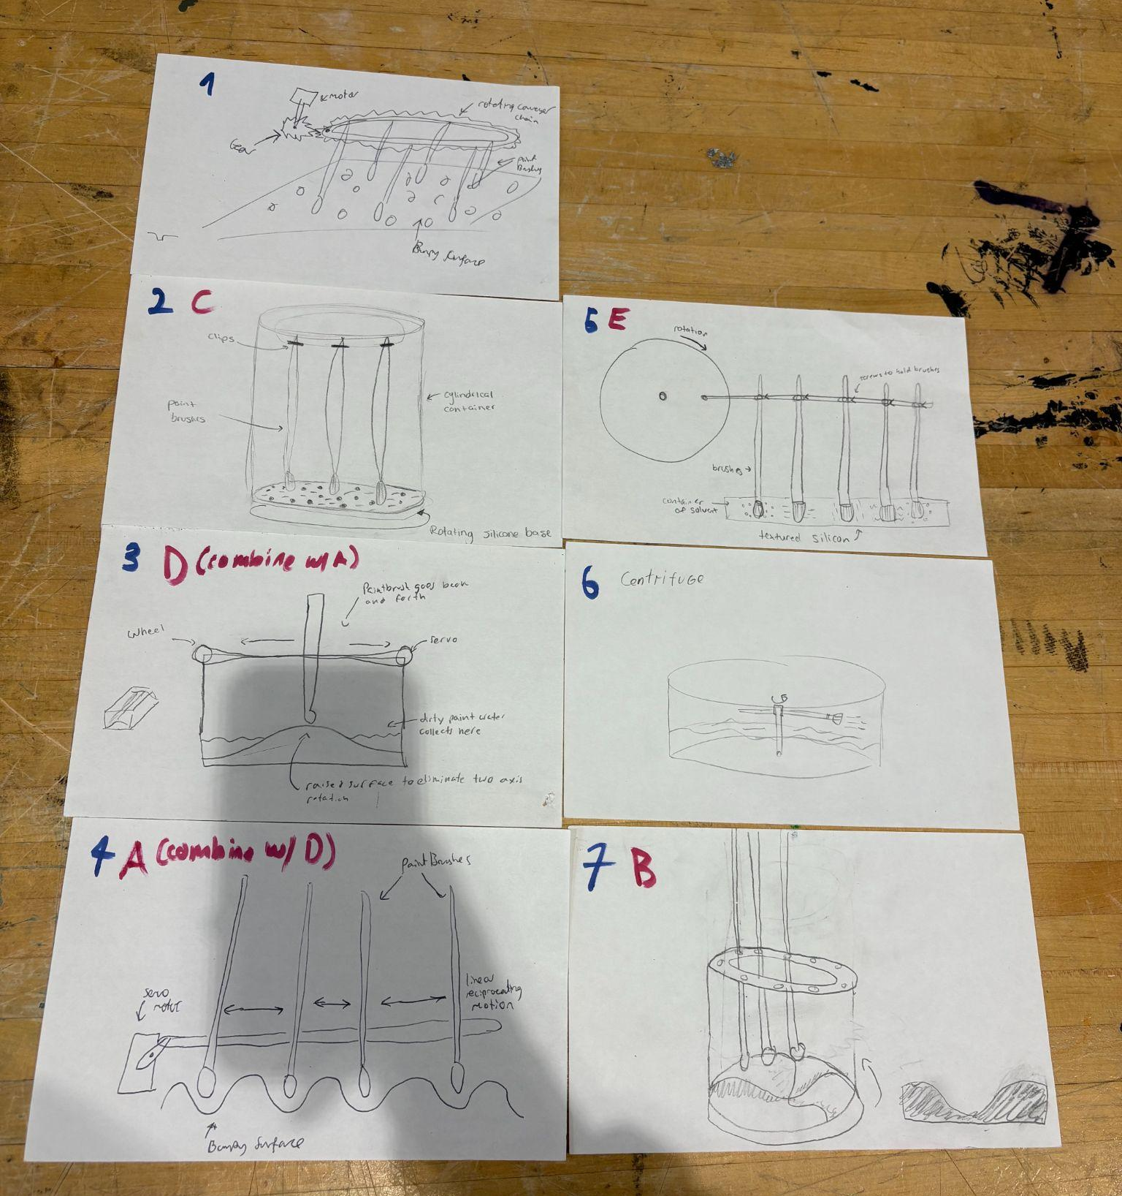
Blue numbers represent Pugh Screening, Red letters represent Pugh Scoring

Image 4: Pugh Screening Matrix
