CHEM 300X Discussion Questions 1 – Buffers & Titrations
Ilana Berlin
(1a) Make a titration plot of Buffer 1 using pH vs equivalents. Use Excel to plot a visible point at your initial pH.
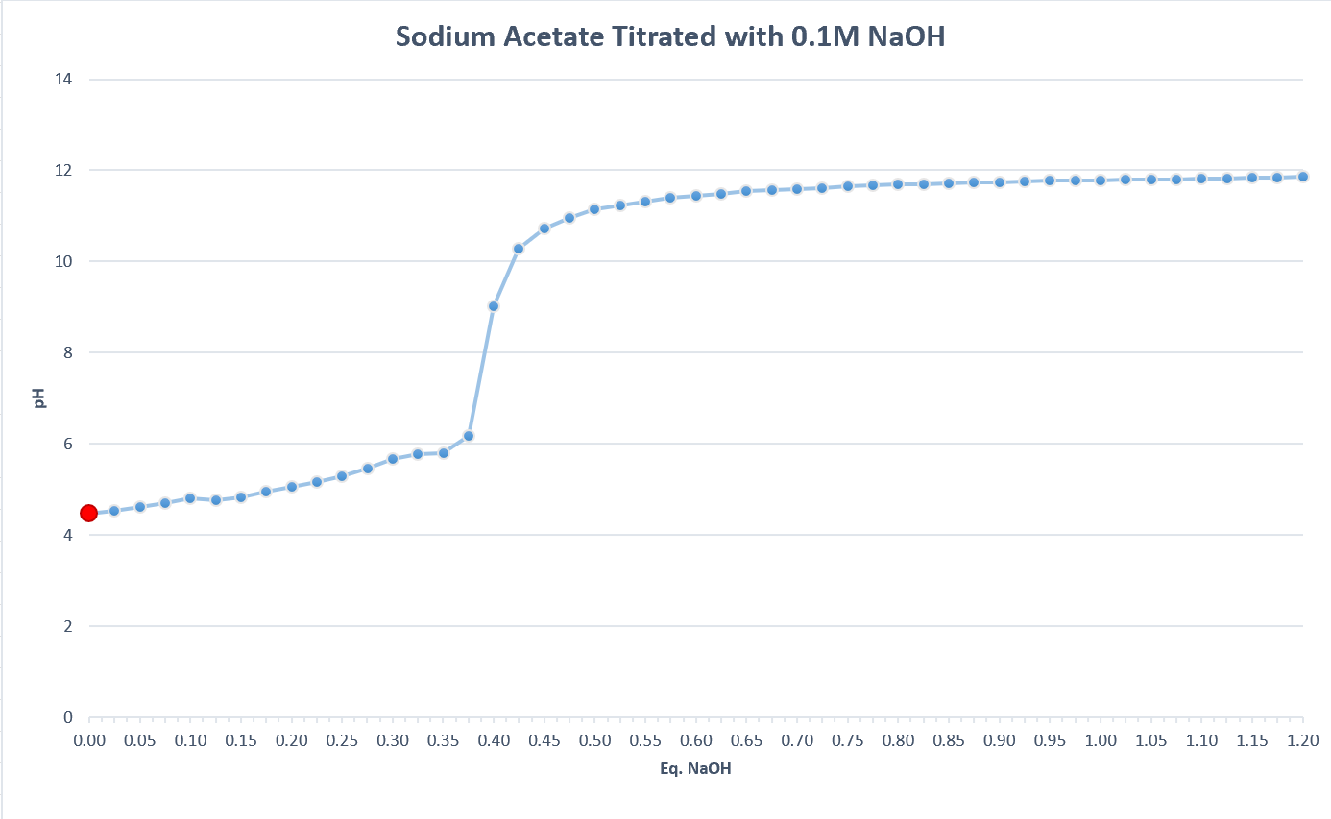
(1b) Determine where the equivalence point is, then and a plot a vertical line to show where it is.
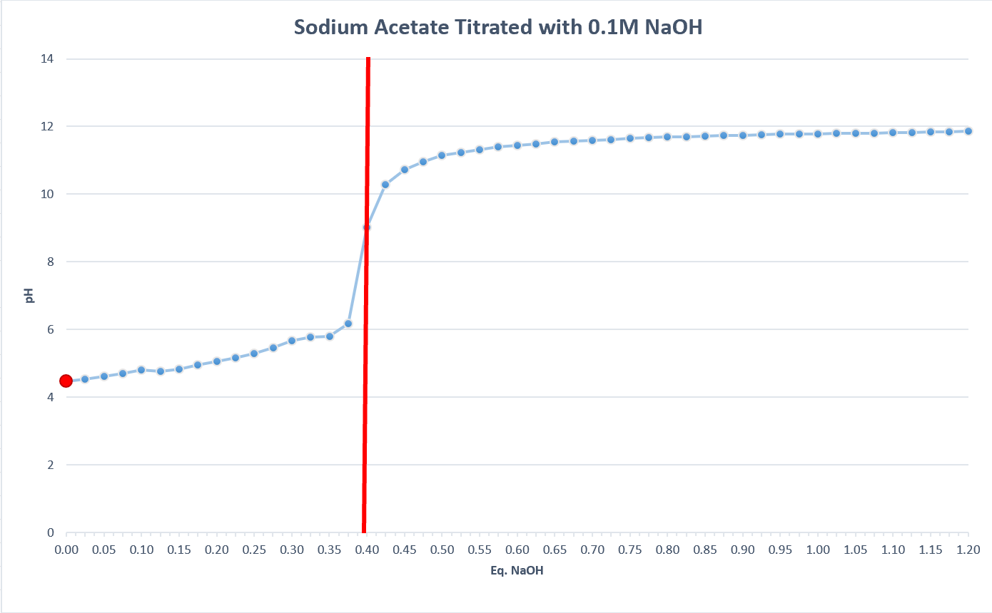

(1c) How many equivalent units should the 1/2 equivalence point be from the equivalence point?
Since the equivalence point is 0.425 equivalent units from starting point, the 1/2 equivalence should be 0.2 equivalent units away
Find the 1/2 equivalence point and determine the pKa. Plot a visible point on the curve at the 1/2 equivalence point. What is the percent error for your determined pKa?
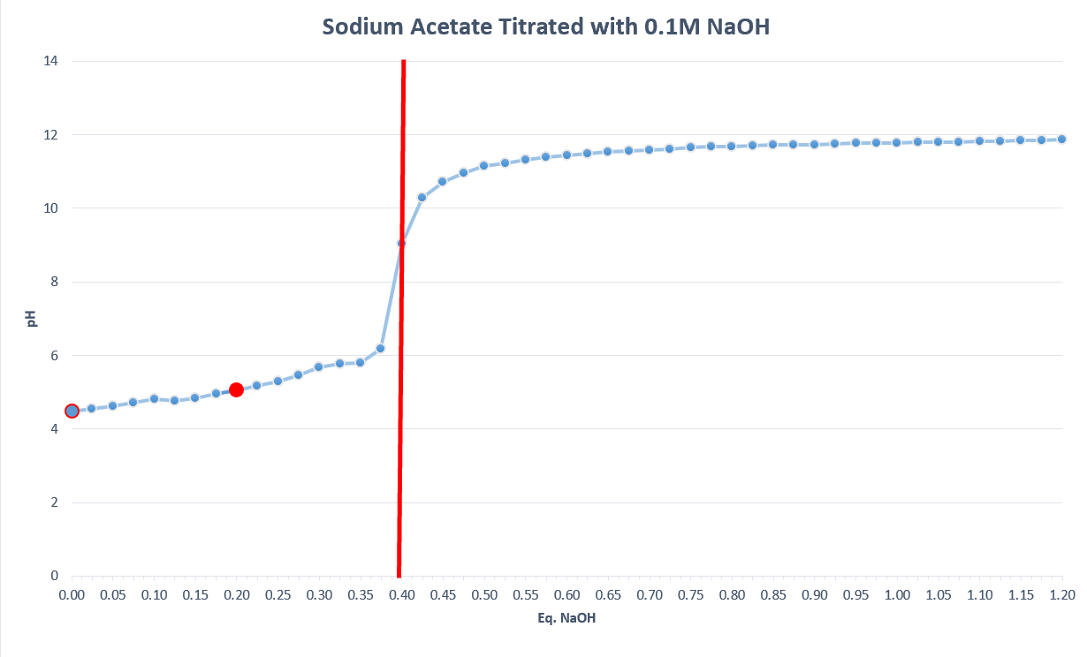
At the half equivalence point, pK_{a} = pH = 5.06. When a pK_{a} of 4.76, the true pK_{a} of sodium acetate in water according to the slides from lecture, the percent error is 6.2%.
(1d) Using Excel tools, make a box around your pKa showing the buffering region (0.1 equivalents to 0.9 equivalents). Two corners of the box will lie on the curve. How many pH units does the buffering region span?
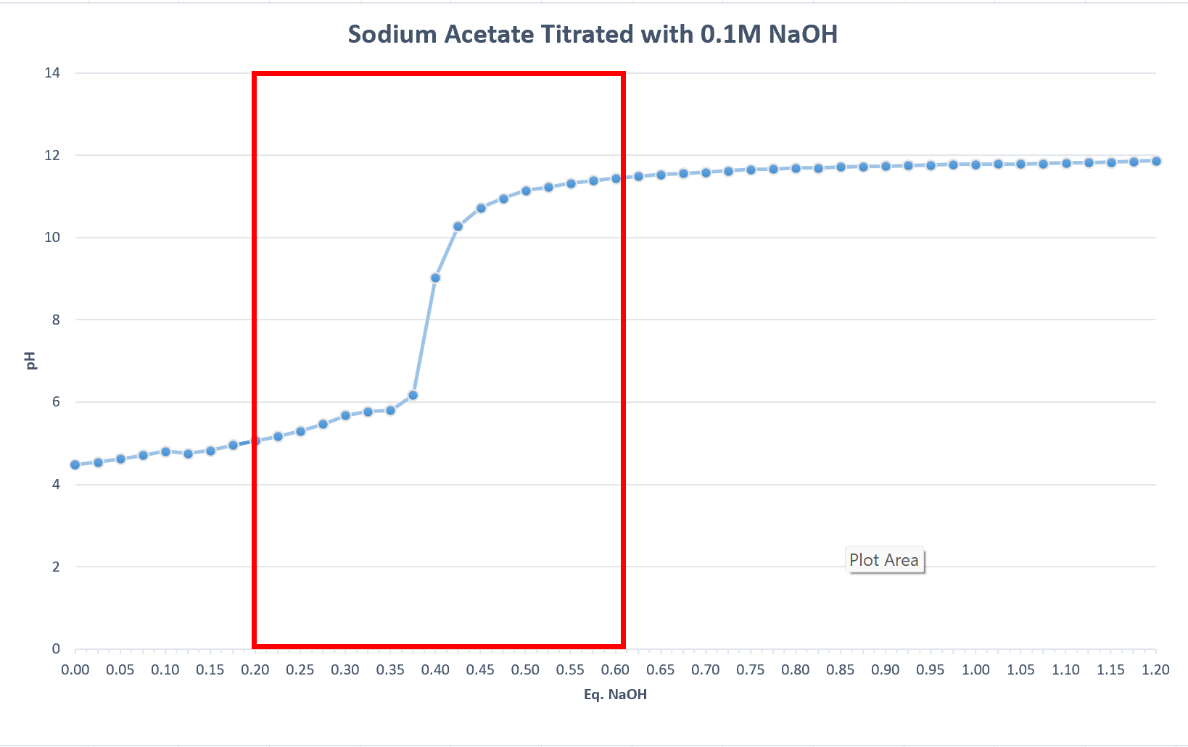
The buffering region spans from a pH of 5.06 to a pH of 11.45. This encompasses a total of 6.39 units of pH.
(1e) If you were to add 20 ml of 0.1 M HCl or 20 mL of 0.1 M NaOH to Buffer 1, which would change the pH more? Explain your answer according to the plot.
Adding 20mL of 0.1M HCl would have a larger affect on the pH of sodium acetate is the starting pH is 4.20. This is because adding more acid would further lower the pH, moving in the opposite direction from the buffering region, and areas outside the buffering region are subject to more drastic changes. Unfortunately, due to time constraints the effects of acid on the buffer are not shown in the plot above however in theory there would be a sharp drop in the pH to the left of the graph.
(2) During the titration, you are instructed to add approximately 60 ml of dH2O. What is the purpose of that dH2O?
The DI water just increased the volume of the solution so it is easier to fully submerge the pH probe.
Why is the volume approximate? In other words, why would you get the same result with 50 or 90 ml of dH2O?
The same result would be achieved regardless of wether 50 mL or 90 mL of DI water was added because moles of sodium acetate, and therefore the ratio of (HA) t0 (A-), stay the same regardless.
(3) Depict your titration curve of Buffer 1 and Buffer 2 on the same graph with number equivalents as the x-axis.
Ran out of time to complete the rest of the titrations.
(4) Depict your titration curve of Buffer 1 and Buffer 2 on the same graph with volume titrant as the x-axis.
Ran out of time to complete the rest of the titrations.
(5) Depict the ions in your beaker at 0.1, 0.5 and 0.9 equivalents. Assume you have approximately 8–12 molecules of your weak acid or base. Explain why your buffer is most effective at regulating pH at 0.5 equivalents.
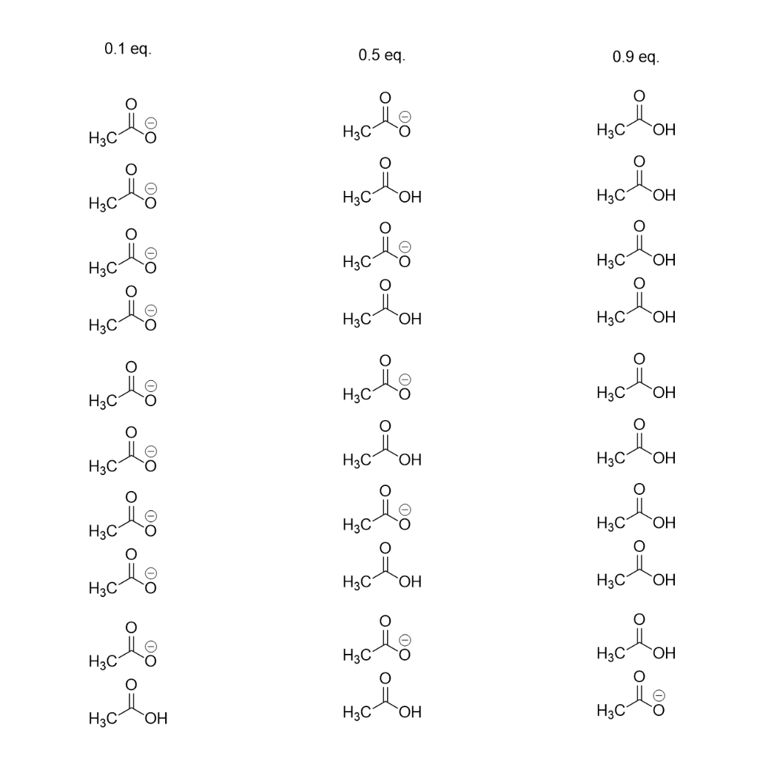
The buffer is most effective at regulating pH at 0.5 equivalents because it exists as an acid and a base in equal concentrations. This means it has an equal ability to resist change in either direction.
(6) Which has more buffering capacity, Buffer 1 or Buffer 2? Support your answer with evidence and reasoning.
Buffer 1 has a higher buffering capacity than Buffer 2. This is because Buffer 1 has a larger number of moles than Buffer 2 so there are more molecules to buffer the pH change.

