CHEM 300X Lab Report 1 – Buffers & Titrations

Ilana Berlin Purpose
Generate a titration curve of two buffer solutions by titrating sodium acetate with a monoprotic base, NaOH, to determine buffer region, and the apparent pK_{a} using the Henderson-Hasselbalch equation.

Methods
pH Measurments
pH was measured using a Thermoscientific pH/mV meter with an error of ±0.005.
Data Visualization
Data was visualized using Microsoft Excel

Procedure
Calibrate pH meter with 3 points, 10.01, 7.00, and 4.01 for a slope of 95.3%
2.061g of sodium acetate was dissolved in less than 250mL of DI water.
Adjust pH from 8.06 to 4.20 using 6M and 0.1M HCl.
Soln. was transferred to a 250mL graduated cylinder and vol. was increased up to 250mL with DI water to form a 0.1M soln.
25mL of soln. (measured by serological pipette) was mixed with --- mL of DI water in a 100mL graduated cylinder to form a 0.025M soln.
10mL (measured with graduated cylinder) and 60mL of DI water were added to a beaker with a stir bar.
Buffer soln. was titrated with 0.1M NaOH. The pH was recorded for every 0.25mL titrant added until 1.2 eq of NaOH were addded.
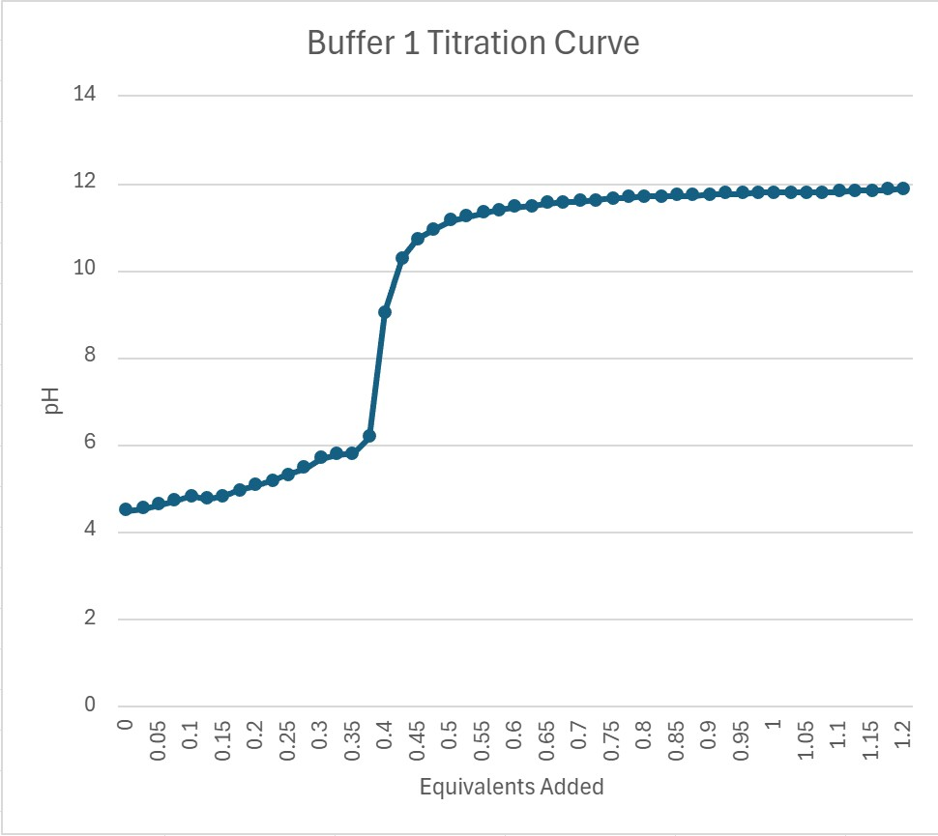
Figure 1. Titration curve made from adding NaOH to buffer solution of sodium acetate starting at a pH of 4.2 and adding up to 1.2 equivalence of NaOH.
Ran out of time to complete the rest of the titrations.
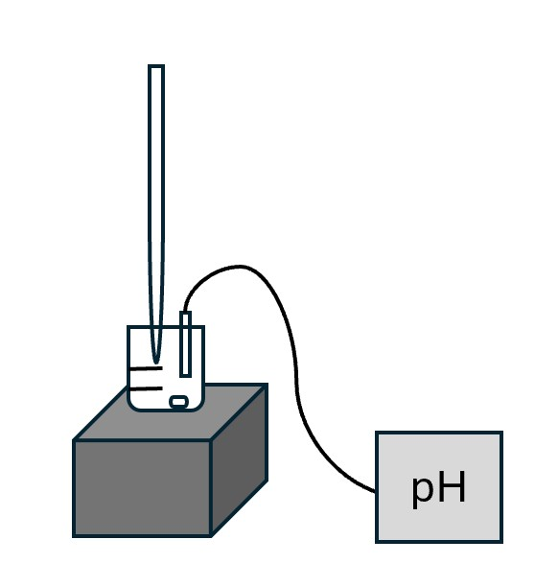 Figure 2. Cartoon depiction of titration apparatus with burette, stir plate, stir bar, beaker containing soln. and pH meter pictured.
Burette stand not pictured.

References
Nelson, David L, and Michael M Cox. Lehninger Principles of Biochemistry. 8th ed., Macmillan Higher Education, Basingstoke, 2017, p. Chap. 2 Sect 3.

