Lab 2: Amino Acid Discussion Questions
  - Ilana Berlin
- Using the computer, prepare a titration curve for each amino acid, plotting pH on the vertical axis and equivalent of base (OH–) on the horizontal axis. Again, using the computer, prepare a titration curve for each amino acid, plotting pH on the vertical axis and volume (mL) of base (OH–) on the horizontal axis. Label the pKas and the pI (show calculation for pI). Identify what each unknown amino acid is. Use descriptive titles and properly label axes for the graphs. Box all buffering regions. Show dominant structures between all pKas. (remember at each pKa, there is an equal amount of two different structures).
Titrations Curves Below (see page 4)
pI= (pK_{a1} + pK_{a2}) / 2 where the pK_{a} are on either side of a net 0 zwitterion
pI_{H} = (6.16 + 9.23) / 2 = 7.70
pI_{E} = (2.84 + 4.55) / 2 = 3.70
pI_{K} = (6.2 + 10.01) / 2 = 8.11
- Prepare a summary table in which amino acid structures at each pKa and pI are given and at what ratio, along experimental pKa and pI values.
Histidine (H)
pK_{a}/pI | Ions | Ratio
2.79 | 1:2 | 50:50
6.16 | 2:3 | 50:50
7.7 (pI) | 3 | 100
9.23 | 3:4 | 50:50

Glutamate (G)
pK_{a}/pI | Ions | Ratio
2.84 | 1:2 | 50:50
3.7 (pI) | 2 | 100
4.55 | 2:3 | 50:50
9.98 | 3:4 | 50:50

Lysine (K)
pK_{a}/pI | Ions | Ratio
2.58 | 1:2 | 50:50
6.2 | 2 | 100
8.1 (pI) | 2:3 | 50:50
10.01 | 3:4 | 50:50

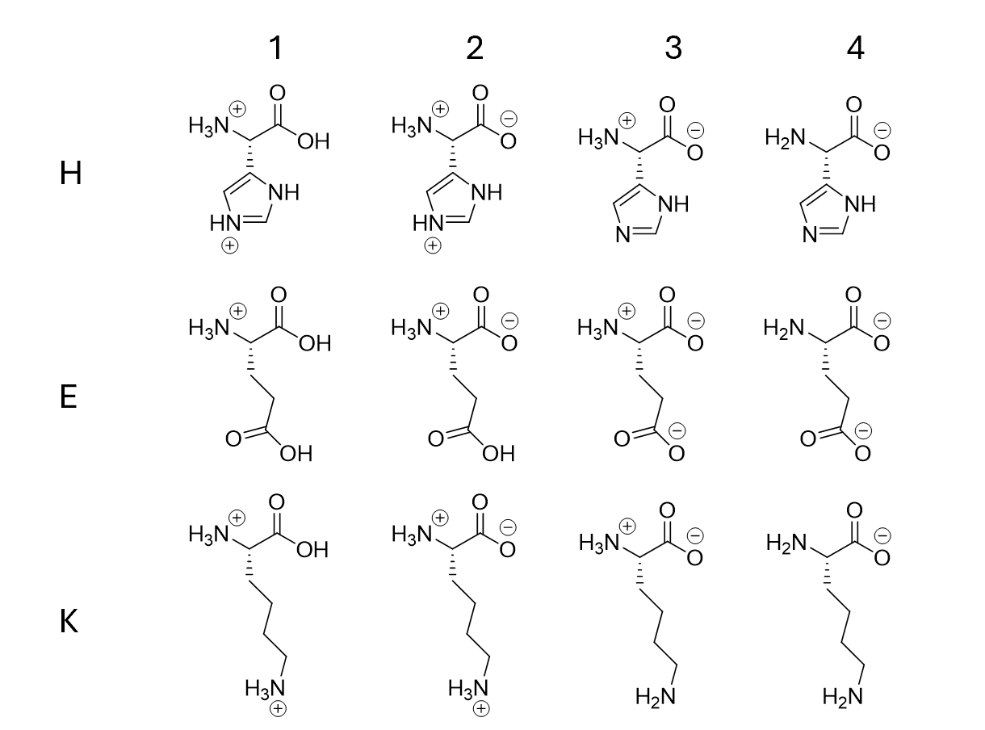

- Compare experimental and literature values of pKa and pI. Include % error.
Histidine (H)
Experimental pK_{a}/pI | Actual pK_{a}/pI* | % Error
2.79 | 1.82 | 53%
6.16 | 6.00 | 2.7%
7.7 | 7.59 | 1.4%
9.23 | 9.17 | 6.5%
Glutamate (G)
Experimental pK_{a}/pI | Actual pK_{a}/pI* | % Error
2.84 | 2.19 | 30%
3.7 (pI) | 3.22 | 15%
4.55 | 4.25 | 7.1%
9.98 | 9.67 | 3.2%

Lysine (K)
Experimental pK_{a}/pI | Actual pK_{a}/pI* | % Error
2.58 | 2.18 | 18%
6.2 | 8.95 | 44%
8.1 (pI) | 9.87 | 22%
10.01 | 10.79 | 7.2%

*From Lehninger Principles of Biochemistry 7th Ed. by Nelson and Cox
- In the discussion, please describe how you identified each amino acid, how you calculated the pKa and pI values.
The pKa values were determined by looking at the graphs to identify buffer regions, with a low rate of change, and finding the points between the lowest rates of change that was near an equivalence. Since equivalents of base consumed to neutralize excess acid, it was harder to determine the pKa values for each amino acid since equivalence was not exact. The pI was calculated by averaging the pKas on either side of the zwitterion.
- ) Include an analysis of any potential sources of operative error (including human error)
Sources of error include human errors in reading the burette and errors in the volume of 0.1M amino acid solution added as it was measured with a graduated cylinder instead of a more precise instrument. Errors in the concentration of the 0.1M solutions as they were made with a low number of significant figures. Errors in the pH probe or the calibration of the pH probe. Errors caused by starting the pH too low and consuming equivalents of NaOH to quench excess acid and missing data due do non-continuous data collection.
