Lysozyme Isolation Discussion Questions
Ilana Berlin
10/1/2025

- What is the Flow Through? What proteins, molecules, etc. do you expect to be in the Flow Through. Do you expect lysozyme to be in the Flow Through (consider the pH of the Column Buffer)? What is the chemical explanation for this? (1 pt)
The flow through is a runoff of buffer solution as the protein gets loaded on to the resin. There should not be any lysozyme in the flow through at the negative resin should hold onto the positive protein at the given pH of 8.2.

- In the following solutions and fractions, where do you expect to see lysozyme? Give a brief explanation for each.
a. In the Buffered Egg White Solution. (0.5 pts):

There will be lysozyme in the buffered egg white solution, this is the original source of the lysozyme before it is purified.
b. In the Flow Through Fraction. In the Wash Fractions. (1.0 pts):

There should not be lysozyme in the flow through or the wash at it is loaded on to the resin in the column.
c. In the first Elution Fraction (0.5 pts):

There will be lysozyme in first elution fraction although it will be lower than the following elution fractions as the lysozyme is just starting to be released as the charge on the resin changes.
d. In Elution Fractions 2 through 5. (1.0 pts):

The purified lysozyme is eluted from the column during these fractions so it will be in these fractions.

- Go to the Protein Database and look at 1DPX (Hen egg white lysozyme) and display the FASTA sequence
a. The sequence is displayed in one-letter codes. Copy the sequence and calculate the pI using a free online protein pI calculator (such as Prot pI). Using this, what did you find the pI of lysozyme to be? Please drop in a screenshot of the online results. (1 pt)
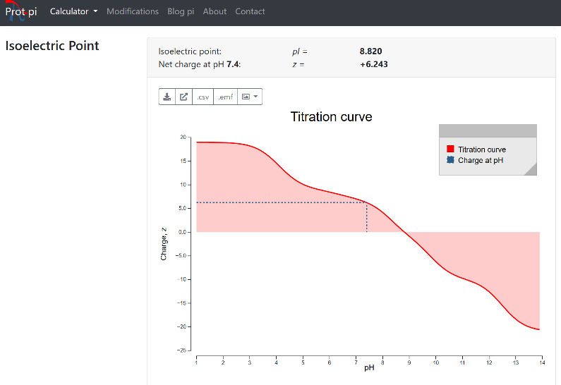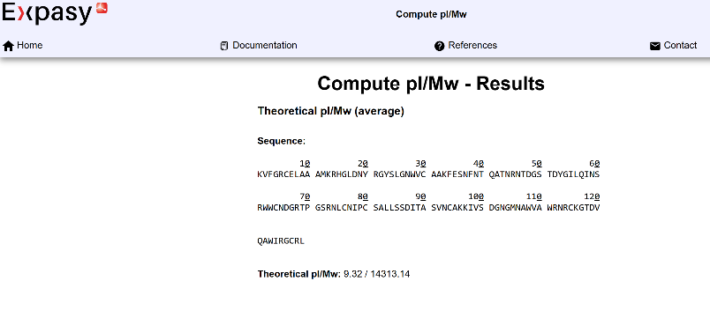
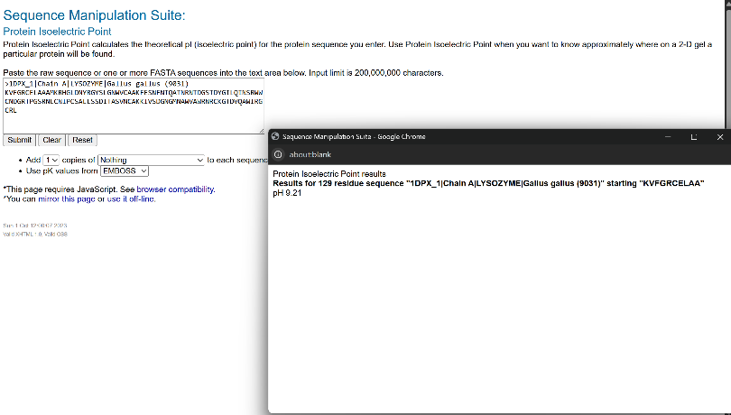
I check three different pI calculator which estimated the pI to be 8.820, 9.32, and 9.21 respectively.
b. What was the charge of lysozyme in the Column Buffer? (1 pt)

The lysozyme was positively charged in the column buffer
c. What is the charge of lysozyme in the Carbonate Elution Buffer? (1 pt)

The lysozyme was neutral in the carbonate elution buffer.
d. What type of ion exchange did you use (cationic or anionic)? (1 pt)

We used cationic ion exchange.
e. How would changing the pH of your Column Buffer or Elution Buffer effect the purification? (1 pt)

The pH of the buffer is responsible for changing the protonation state of lysozyme and of the resin. Changing the pH could change everything about the purifications. It could change when the lysozyme eluted.

- Provide at least one reason why you may not have collected purified protein? What would be a good way to collect fractions that contain purer lysozyme? (1 pt)
The pH of the buffer may have been off and the lysozyme may have flowed through the buffer. There may have also been other contaminates in the buffered egg white solution that were positive at the same pH as the lysozyme and, therefore like the lysozyme, stayed in the column and did not elute until washed with the high pH carbonate buffer solution.

