Lysozyme Isolation
Ilana Berlin
10/1/2025

Purpose:
Use CM–Sephadex Resin in a column for cation exchange chromatography to purify lysozyme.
Figure 1. Chemical Structure of CM-Sephadex Resin and lysozyme.

Methods
Resin was prepared by washing twice with ~20 mL of preprepared 0.05 M Tris soln.
Column was prepared by securing frit at the bottom and washing with nano-pure water. The column was capped and filled up to ¼ with 0.05 M Tris soln and then filled up to ½ with resin. Tris soln was drained and column was packed with resin till there was a layer of ~3cm with a thin layer of Tris soln above the top of the resin. The column was recapped. Volumes of Tris soln were measured using a 50 mL graduated cylinder.
An organic egg was selected, and the egg white was separated out using a strainer. 2.4 mL of egg white was separated into 2 1.5 mL Eppendorf tubes, 1.2 mL each, and centrifuged for – min at 13,200 rpm. 1 mL of supernatant was extracted from each centrifuge tube using an pasture pipette from the top of the tube and combined with 4 mL of Tris soln in a 15 mL conical tube. Tube was placed on ice.
3 mL of egg soln was diluted with 3 mL of Tris soln were combined in we conical tube and added to the column. An extra 1 mL of Tris soln. was used twice to rinse the sides of the column. The runoff was collected in a test tube, FT. The column was washed 4 times using 4 mL of Tris soln and each wash was collected in a separate test tube, W1, W2, W3, and W4. The column wash washed 5 time with 4 mL a prepared carbonate elution buffer and elution was collected in separate test tubes, E1, E2, E3, E4, and E5. 4 mL of water was measured into a space test tube and used as reference for the volume of the washes and the elutions.
Save for later (? ) The result was assayed using changes in turbidity of a suspension of dried Micrococcus lysodeikticus cells. Absorbance vs. time was read at 450 nm. Standard assay was prepared by combining 0.5 mL of 3 mg/mL cells to a dry cuvette with 0.5 mL of phosphate buffer and 200 μL of protein fraction. Data was collected for egg soln, FT, and the first 3 elations. The absorbance of the flow through had a large increase which was not an expected result.
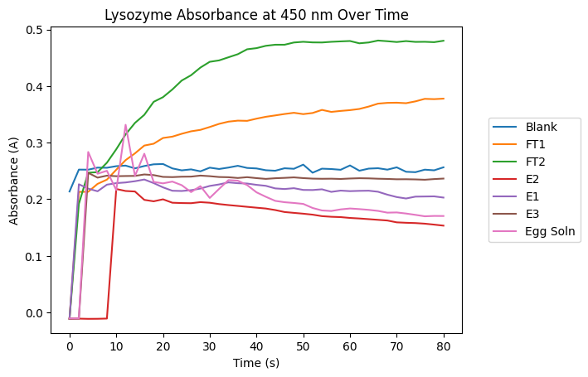
Figure 2 Absorbance of fractions over time at 450 nm.

