SDS-PAGE Gel Electrophoresis and Dialysis Discussion Questions
Ilana Berlin
10/8/2025

- Go to the protein database again, fetch the primary sequence just like last week, but now instead of pI, find the mass of hen egg-white lysozyme. Free online protein calculators (for instance Prot pI) can calculate. What is the mass of lysozyme? Drop in a screen shot of your results. (2 pts)
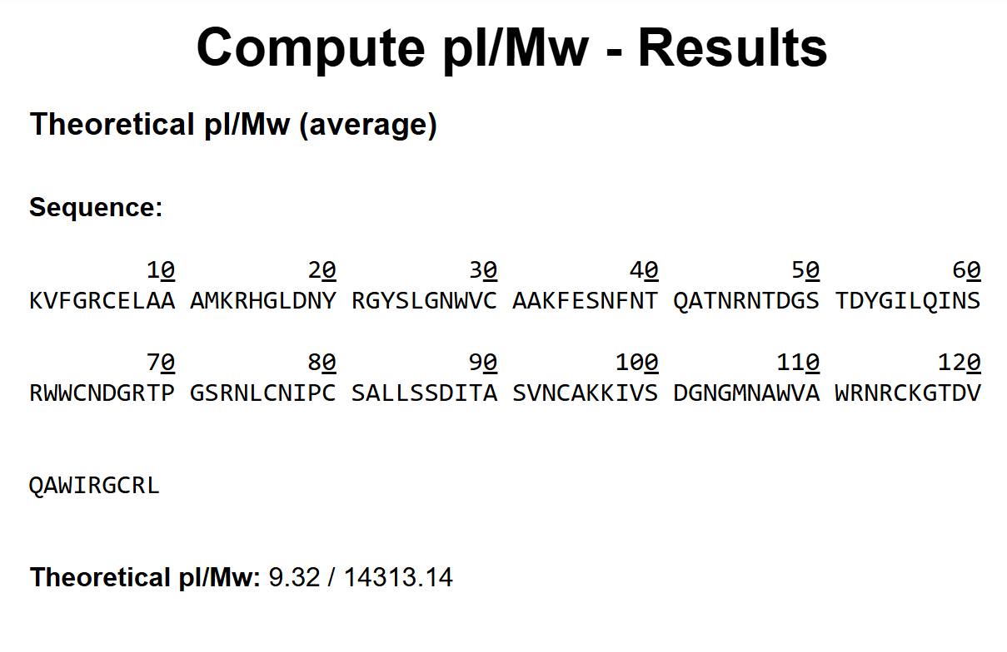

- Please insert an annotated image of your protein gel. Make sure it is easy to read. Be sure to include the protein ladder, name and number of each lane, and identify lysozyme if present in any fractions. (4 pts)
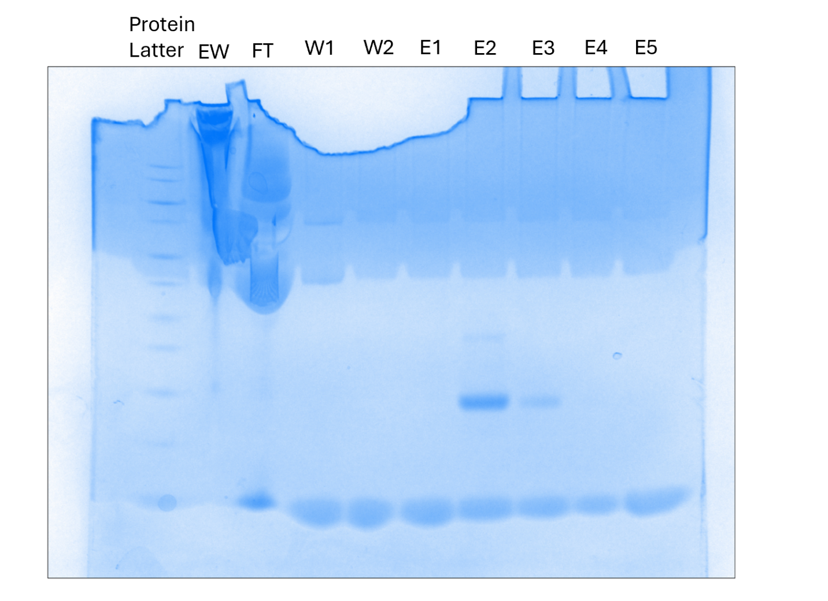
Lysozyme is present in E2 and, in a lower concentration, in E3. Interestingly there does not seem to be lysozyme present in the buffered egg white solution (EW)

- What is the purpose of SDS? How is an SDS-PAGE gel different from a native PAGE gel? (2 pts)
SDS correlates the MW of a molecule with its charge and denature proteins. It helps provide better separation of proteins with different charges and ensures that large proteins are not able to more easily because they are balled up. Native PAGE gels do not affect the native state of the protein.

- What will dialysis achieve? (1 pt)

Dialysis will bring the protein solution to a physiological pH, around 7, without diluting the protein solutions.

- What are some sources of error? What would you change prior to your next protein gel to help increase pure protein? (1 pt)
We struggled a lot with getting the protein samples into the gel wells. Even some of the later samples were much more successful then the first few we pipetted because of this. If the experiment where repeated then I would agitate the fractions before preparing them and I would be more careful with the pipetting.

