SDS-PAGE Gel Electrophoresis and Dialysis
Ilana Berlin
10/1/2025

Purpose:
Identify which proteins are present and which sample contain lysozyme in previously purified lysozyme fractions using 1D SDS-PAGE Gel Electrophoresis. Prepare samples containing lysozyme for kinetic assays by neutralizing pH with dialysis with a 0.1M phosphate buffer.

Methods

10 PCT tubes were loaded with 12.5 µL of 1X LDS Buffer diluted from 4X. 10 µL of a protein latter standard was added to the first tube and 25 µL of fractions FT, W1, W2, E1, E2, E3, E4, and E5 were added to corresponding tubes. The tubes were gently mixed and heated using the boil 90 program on an Eppendorf thermocycler. A buffer core was loaded into the gel box and SDS gel running buffer diluted from 20X was added to the chamber until the core was covered.
Table 1. Dilution calculation for creating gel running buffer from 20X solution and loading buffer from 4X solution.
MES SDS Gel Running Buffer
Original Molarity -- | 20
Final Molarity -- | 1
Original Volume of water for dil (mL) -- | 475
Original Volume of Concentrate (mL) -- | 25
Final Total Solution Volume (mL) -- | 500
LDS Loading Buffer
Original Molarity -- | 4
Final Molarity -- | 1
Original Volume of water for dil (mL) -- | 0.75
Original Volume of Concentrate (mL) -- | 0.25
Final Total Solution Volume (mL) -- | 1

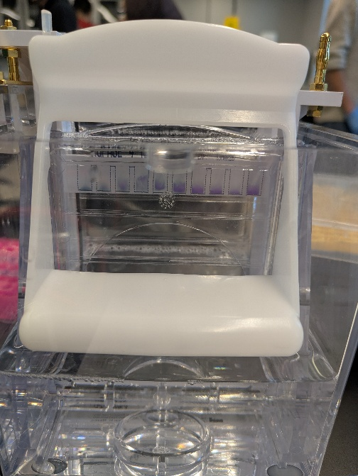
25 µL of protein dye solution was added into each well. The gel was supplied with 120 volts until the column neared the bottom of the gel. The gel unit was disassembled, and the gel was rinsed with DI water and photographed.
Figure 1. Samples loaded into gel electrophoresis before apparatus was powered. From left to right samples are the standard, egg buffer, W1, W2, E1, E2, E3, E4 and E5.
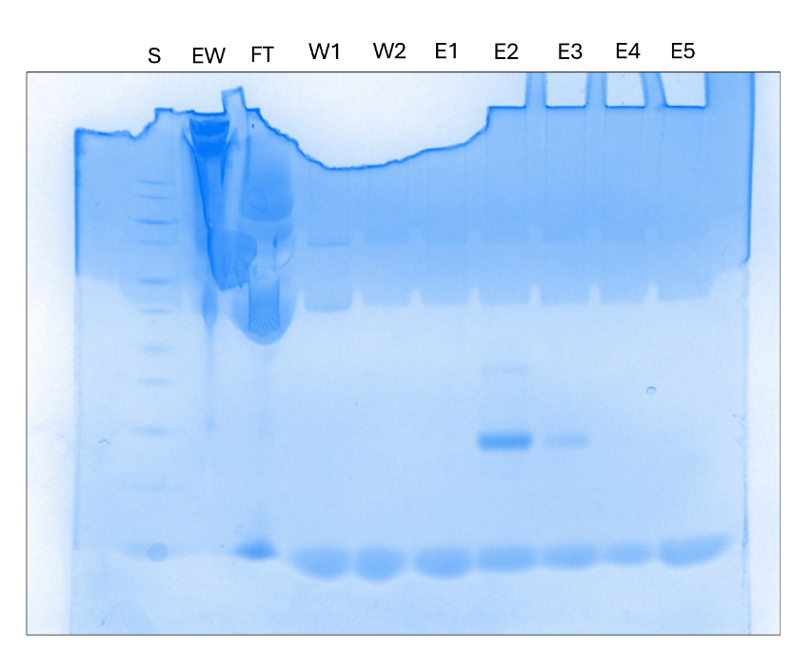
Figure 2. Imaging of stained gel. Lysozyme is visible in fractions E2 and E3/.
2L of phosphate buffer, measured in a 2L beaker, was made from a combination of 16.850 g potassium phosphate monobasic and 13.491 g of dibasic. pH was adjusted from 6.63 to 7.22 with 6M NaOH. pH meter was calibrated to a slope of 96.7%.
E2 and E3 were dialyzed. A few centimeters of tubing was soaked in chilled 0.1M phosphate buffer.

