1. Read the lab manual for Lysozyme: SDS-PAGE Gel Electrophoresis and Dialysis

2. Write a purpose statement for Lysozyme: SDS-PAGE Gel Electrophoresis and Dialysis

Neutralize the pH of solution containing protein using dialysis and identify what proteins are present using 1D SDS-PAGE Gel Electrophoresis. Identify which samples contain lysozyme and which contain contamination with the electrophoresis.

3. a) Calculate the masses of the HA salt and the A– salt that is needed to make 2 liters of the Phosphate Buffer. (Remember, this method should get the solution close to the desired pH)
Double previous calculation for 1 L:
HA: 16.688 g

A-: 13.476 g

b) Alternatively, calculate using the mass of just the HA salt or the mass of just the A– salt that is needed to make 2 liters of the Phosphate Buffer. (Remember, this method will need significant pH adjustments before being brought to volume.)
Using just HA:
2 L ( 0.1 mol/ 1L) (136.09 g / 1 mol) = 27.218 g

Using just A-:
2 L ( 0.1 mol/ 1L) (174.18 g/ 1 mol) = 34.836 g

4. Write a detailed procedure for making the above buffer. (HINT: Look at what you did in Lab 1)

Dissolve HA in under 2 L of DI water. Dissolve A- in the same solution. Adjust pH with 6 M and 0.1 M NaOH. Raise volume to 2 L.

5. Draw a detailed and labeled expected SDS-PAGE gel for the following samples in the numbered wells…
1. protein ladder (Look this up to see what it is!)
2. Buffered Egg White Solution
3. Flow Through
4. Wash 1
5. Wash 2
6. Elution 1
7. Elution 2
8. Elution 3
9. Elution 4
10. Elution 5

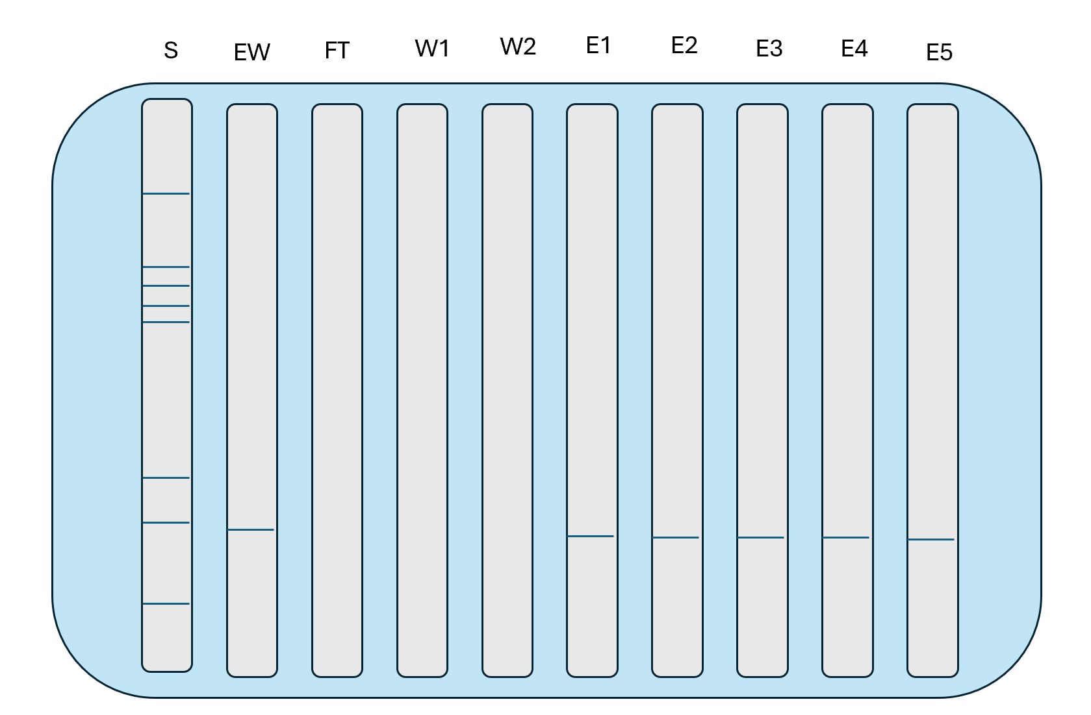

6. Create a checklist for the lab.

- Label Tubes
- Load Gel
- Load Samples
- Stain Gel
- Analyze
- Soak in Phosphate Buffer

