Lysozyme Bradford Assay
Ilana Berlin
10/22/2025

Purpose:
Use Beer’s Law with BSA to determine the concentration of lysozyme previously solution of previously isolated egg white lysozyme. Perform a kinetic assay of the lysozyme using Micrococcus lysodeikticus bacterial cells to construct a Lineweaver-Burke plot. Use the Lineweaver-Burke plot to determine the V_{max} and the K_{M} of the lysozyme.
References:
Nelson, David L, and Michael M Cox. Lehninger Principles of Biochemistry. 8th ed., Macmillan Higher Education, Basingstoke, 2017.
Vernier Software \& Technology Version 4.12 Vernier Software \& Technology. 2023

Methods
Data was collected using a Vernier UV-vis spectrometer with a curvet with a pathlength of 1cm.
A total of 1550µL was added to each cuvette, 1500µL of Bradford reagent and 50µL of varying combination of phosphate buffer and protein. The blank contained no protein, only 50µL of phosphate buffer. An unknown was made with 50µL of previously isolated and dialyzed lysozyme. The concentration was calculated based on the overall concentration in the burette. The absorbance at 600nm was collected for all concentrations.

Table 1. Values of Bradford Reagent, phosphate buffer, and protein added to each cuvette and their resulting absorbance.
 | BR (uL) | Buffer (uL) | Protein (uL) | Total (uL) | BSA Conc (mg/mL) | Abs
Blank | 1500 | 50 | 0 | 1550 | 0 | NaN
2 | 1500 | 37.5 | 12.5 | 1550 | 0.02 | 0.534
3 | 1500 | 25 | 25 | 1550 | 0.03 | 0.814
4 | 1500 | 12.5 | 37.5 | 1550 | 0.05 | 1.192
5 | 1500 | 0 | 50 | 1550 | 0.06 | 1.421
Unknown | 1500 | 0 | 50 | 1550 | NA | 0.199

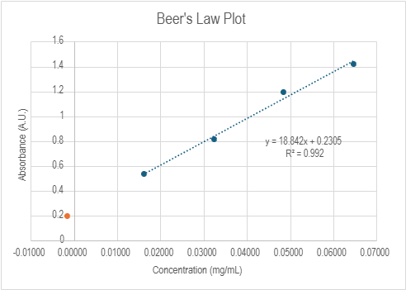

Figure 1. Graph Beer’s Law Plot of Concentration vs Absorbance. The unknown is marked in orange.

The concentration of the lysozyme solution was calculated to be -0.00167 mg/mL. The pH of the lysozyme was confirmed to be approximately 7. A previous A280 experiment calculated the concentration to be 1.214 mg/mL. This was used as the concentration for the kinetics calculations.

Table 2. Concentration of bacterial cell stock and lysozyme used in kinetics calculations.
Bacterial Cell Stock Concentration (mg/mL) | 0.57
Lysozyme Concentration (mg/mL)) | 1.124

The concentration of lysozyme was kept constant, at 0.04496mg/mL, while the concentration of bacterial stock solution was varied to observe the change in absorption at 450nm over time. Phosphate buffer was added as necessary, so each cuvette contained a constant volume of 1250µL. A blank containing phosphate buffer was used to calibrate the Vernier UV-Vis Spectrophotometer.

Table 3. Ratios of solutions and final concentration of bacteria and lysozyme in cuvettes used to observe kinetics.
Cuvet Number | Bacterial Cell Stock Volume (μL) | Lysozyme Stock Volume (μL) | Phosphate Buffer Volume (μL) | Total Volume (μL) | Lysozyme Concentration [E] | Bacteria concentration [S]
1 | 280 | 50 | 920 | 1250 | 0.04496 | 0.128
2 | 245 | 50 | 955 | 1250 | 0.04496 | 0.112
3 | 210 | 50 | 990 | 1250 | 0.04496 | 0.096
4 | 175 | 50 | 1025 | 1250 | 0.04496 | 0.08
5 | 140 | 50 | 1060 | 1250 | 0.04496 | 0.064
6 | 105 | 50 | 1095 | 1250 | 0.04496 | 0.048
7 | 70 | 50 | 1130 | 1250 | 0.04496 | 0.032
8 | 35 | 50 | 1165 | 1250 | 0.04496 | 0.016

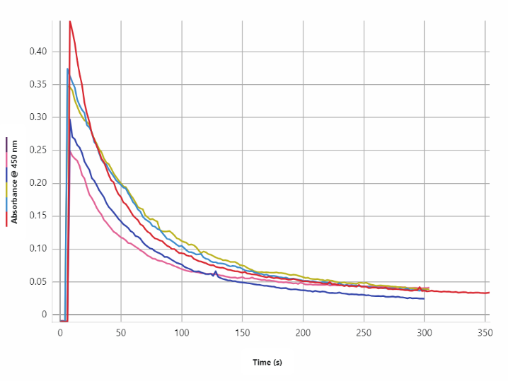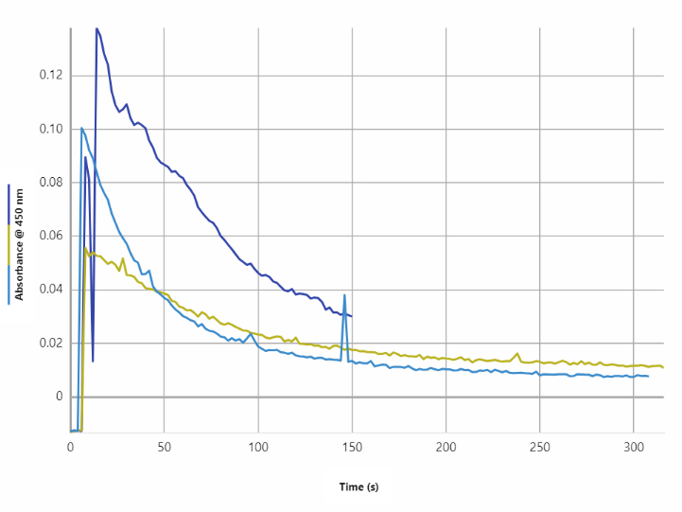

Figure 2. Absorbance at 450nm over time. The program crashed halfway through running trials, so the left contains data from cuvettes 1 through 5 and the graph on the right contains data from cuvettes 6 through 8.

A line was fit the start of each absorption curve, from approximately 5 seconds to 25 seconds, and the resulting slope and y-intercept were used to calculate 1/V₀ and 1/[S]

Table 4. Slope of each absorption curve and resulting calculated values of V₀, 1/[S], and 1/V₀.
Cuvet Number | Slope | Vo | 1/[S] | 1/Vo
1 | -0.008266 | 0.008266 | 1 | 120.9774982
2 | -0.004806 | 0.004806 | 0.5 | 208.0732418
3 | -0.003692 | 0.003692 | 0.333333333 | 270.8559047
4 | -0.004365 | 0.004365 | 0.25 | 229.0950745
5 | -0.0024 | 0.0024 | 0.2 | 416.6666667
6 | -0.003291 | 0.003291 | 0.166666667 | 303.8590094
7 | -0.002148 | 0.002148 | 0.142857143 | 465.5493482
8 | -0.0004145 | 0.0004145 | 0.125 | 2412.545235

A Lineweaver-Burke plot was constructed by plotting 1/[S] vs 1/V₀ . From this plot V_{max} was calculated to be -0.00356 µL/sec and K_{M} was calculated to be 7.728 µL.

Figure 3. Lineweaver-Burke Plot of 1/[S] vs 1/V₀

