Inhibitor Kinetics Discussion Questions
Ilana Berlin
11/19/2025
What mode of inhibition do the inhibitors use? Rationalize using what you know about the enzyme active site pocket and substrate binding (what do the inhibitors look like? would you expect they would or wouldn't bind to the active site? why/why not?) What errors occurred, what was the cause of these errors and what would you do differently. What do you conclude from your data?

Oxamate – Competitive/Mixed Inhibition

Figure 1. Lineweaver-Burke plot of pyruvate with oxamate inhibitor
Oxamate affected both the K_{m} and the V_{max} of the enzyme, which indicated mixed inhibition, however the differences in the V_{max} may be due to experimental error as they are small which would make it competitive inhibition.

Oxalate – Mixed Inhibition

Figure 2. Lineweaver-Burke plot of pyruvate with oxalate inhibitor.
Oxalate affected both the K_{m} and the V_{max} of the enzyme at different rates which indicated mixed inhibition.

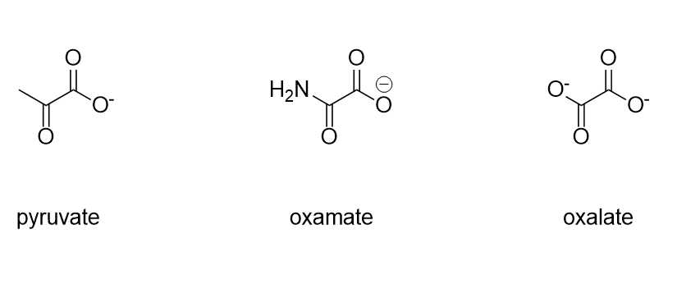
Figure 3. Chemical structure of pyruvate, oxamate, and oxalate

Both oxamate and oxalate have a very similar structure to the substrate, pyruvate, so both of the could be acting as substrate analogs that can bind to the free enzyme, which would lead to competitive inhibition, and the enzyme substrate complex, which would lead to mixed inhibition.
There were many errors that could have caused problems. A key error was the function of the pipettes, the pipettes were not always functional and the same pipettes were not always used for measurements. If the experiment were to be repeated, then the pipettes should be calibrated beforehand, and we would use the same pipettes for each measurement to ensure consistency even if the exact measurement is off. It would also be better to do both inhibitors on the same day to make sure that the pyruvate, NAHD, and LDH solutions are the same. It was good to figure out the kinetics of the enzyme before hand but with improved understanding of the goal of the lab, both inhibitors could be done on the same day.
From our data, we can conclude that oxalate and oxamate are inhibiting the enzyme function. It is hard to say which type of inhibition each inhibitor displayed due to other possible errors with the experiment. α/α’ values for inhibition are also unclear as they widely varied within the Lineweaver-Burke’s of each inhibitor.
Table 1. α and α’ values of oxalate and oxamate inhibitors.
Oxalate | α | α′
LDH - 0.5 I | 4.885 | 5.709
LDH - 0.3 I | 1.089 | 28.882
LDH - 0.1 I | 0.942 | 8.647
Oxamate | α | α′
LDH - 0.5 I | 7.923 | 12.444
LDH - 0.3 I | 8.881 | 1.787
LDH - 0.1 I | 3.286 | 4.715

