EXPERIMENT 6
DATA VISUALIZATION USING POWER BI

Aim
To import, transform, analyze, and visualize data using Power BI Desktop and create interactive dashboards and reports for decision-making.

Software Requirements
- Microsoft Power BI Desktop
- Microsoft Excel
- CSV Dataset
- Windows Operating System

Algorithm 1
Importing Data into Power BI Step 1
Open Power BI Desktop Step 2
Select:
Home → Get Data Step 3
Choose Excel or CSV Step 4
Browse dataset Step 5
Click Load

Step 6
Verify imported data

Procedure
Home Screen Home
|
|-- Get Data
|-- Excel
|-- CSV
|-- SQL Server

Output
Imported dataset displayed in Data View.
Product Region Sales
Laptop | North | 50000
Mobile | South | 35000
Printer | East | 25000

Algorithm 2
Data Transformation using Power Query Step 1
Select Transform Data Step 2
Open Power Query Editor Step 3
Remove duplicates Step 4
Handle null values Step 5
Rename columns Step 6
Apply changes

Example Transformation Before
Product Sales Laptop 50000 Mobile Null Printer 25000 After
Product Sales Laptop 50000
Mobile 35000
Printer 25000

Output
Cleaned dataset loaded successfully.

Algorithm 3 Creating a Bar Chart Step 1
Choose Bar Chart Visualization Step 2
Drag Product → Axis Step 3
Drag Sales → Values Step 4
Format chart

Output Visualization Product-wise Sales
Sales comparison across products.

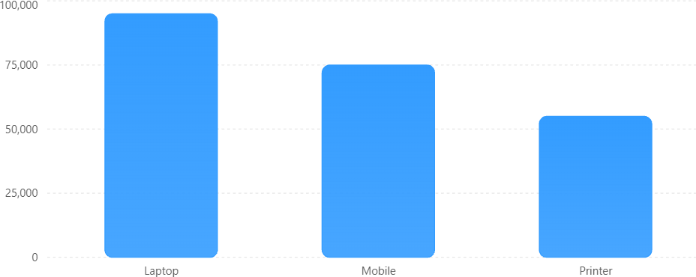

Interpretation
Laptop generated highest sales. Printer generated lowest sales.

Algorithm 4 Creating a Pie Chart Step 1
Select Pie Chart Step 2
Drag Product → Legend Step 3
Drag Sales → Values Step 4
Apply Data Labels Output Visualization Sales Contribution
Percentage contribution of each product.
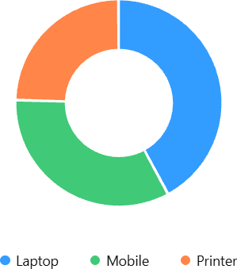
Interpretation
Laptop contributes the highest share of total sales.

Algorithm 5 Creating a KPI Card Step 1
Select Card Visualization Step 2
Drag Sales Field Step 3
Apply Formatting

DAX Formula Total Sales
Total Sales = ∑𝑺𝒂𝒍𝒆𝒔

DAX Measure
Total Sales = SUM(Sales[Sales])

Output
KPI Value Total Sales 225000
Algorithm 6 Creating Slicers Step 1
Select Slicer Visualization Step Step 2
Drag Region Field Step 3
Enable Single Selection Step 4
Apply Filters

Output Available Filters:
- North
- South
- East
- West Dashboard Behavior When North is selected:
Product Sales Laptop 50000
Mobile 40000
Dashboard automatically updates.

Algorithm 7
Creating DAX Calculations Average Sales
Average Sales = AVERAGE(Sales[Sales])

Maximum Sales

Maximum Sales = MAX(Sales[Sales])

Minimum Sales
Minimum Sales = MIN(Sales[Sales])
Output
Measure Value
Average Sales 37500
Maximum Sales 50000
Minimum Sales 25000

Algorithm 8 Creating Dashboard Step 1
Add KPI Card Step 2
Add Bar Chart Step 3
Add Pie Chart Step 4
Add Slicer Step 5
Arrange Visuals Step 6
Save Dashboard

Dashboard Layout

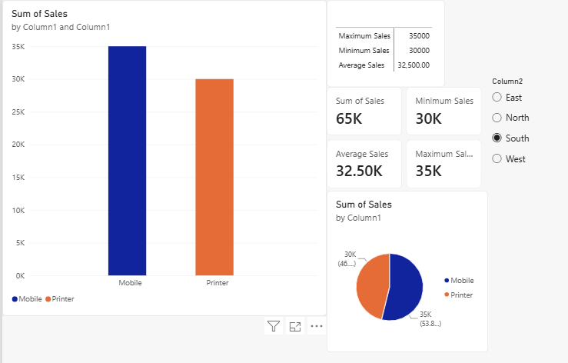

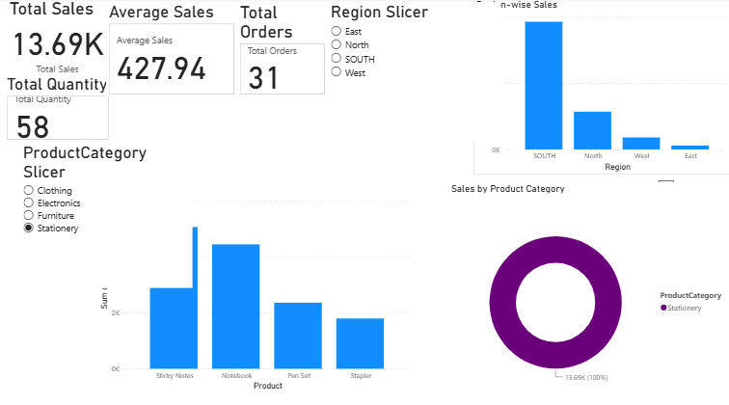

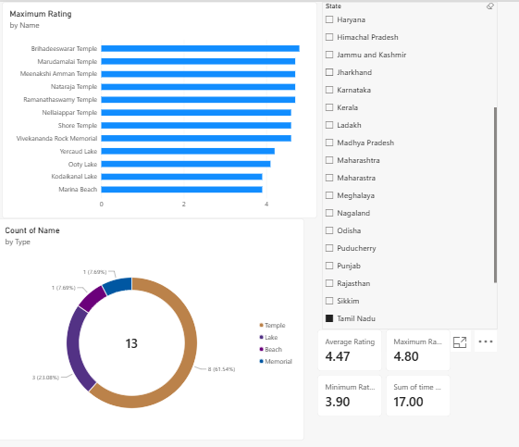

Result:
Data visualization using Power BI has been done successfully.

