EXPERIMENT 7 DATA VISUALIZATION USING TABLEAU

Aim
To connect, analyze, visualize, and create interactive dashboards using Tableau for effective business intelligence and data analytics.

Procedure

Dataset
Student Performance Dataset Student Department Marks
Arun | CSE | 85
Bala | IT | 78
Divya | CSE | 95
Priya | AI&DS | 90
Ravi | IT | 72
Karthik | AI&DS | 88

Algorithm 1
Connecting Data Source Step 1
Open Tableau Desktop Step 2
Select Connect Step 3
Choose Excel File Step 4
Browse Dataset Step 5

Open Dataset Step 6
Verify Imported Data

Procedure
Tableau
↓ Connect
↓
Microsoft Excel
↓ Student.xlsx
↓ Open
Output

Dataset loaded into Tableau successfully.
Student Department Marks

Arun | CSE | 85
Bala | IT | 78
Divya | CSE | 95

Algorithm 2 Creating Worksheet Step 1
Open Sheet 1
Step 2
Drag Department to Columns Step 3
Drag Marks to Rows Step 4
Select Visualization Step 5

Analyze Results
Output
Worksheet created successfully. Algorithm 3
Bar Chart Creation Step 1
Drag Student → Columns Step 2
Drag Marks → Rows Step 3
Select Bar Chart Step 4
Apply Labels Step 5
Format Visualization Output Visualization

Student Marks Analysis
Comparison of marks scored by students.
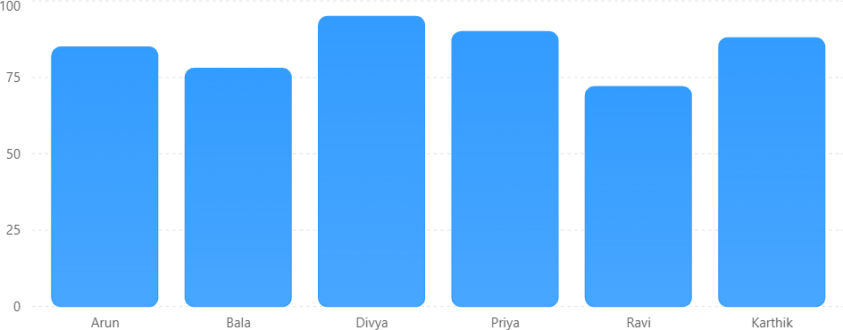

Interpretation
Highest Marks = Divya (95) Lowest Marks = Ravi (72)

Algorithm 4
Pie Chart Creation Step 1
Drag Department Step 2
Drag Marks Step 3
Select Pie Chart Step 4
Show Labels Step 5
Analyze Distribution

Output Visualization
Department-wise Marks Contribution Contribution of departments to total marks.
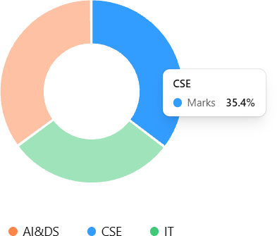

Interpretation
CSE contributes highest marks. IT contributes lowest marks.

Algorithm 5
Line Chart Creation Step 1

Drag Student Step 2
Drag Marks Step 3
Select Line Chart Step 4
Apply Formatting

Output Visualization Student Performance Trend
Marks trend among students.

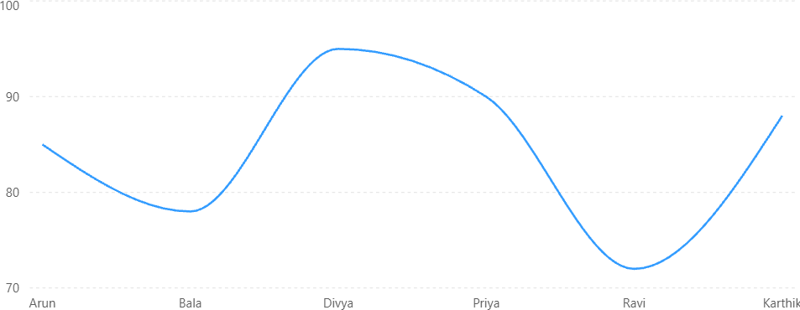

Algorithm 6
Creating Calculated Field Objective
Calculate Percentage Marks

Formula
(Marks / 100) * 100

Procedure

Analysis → Create Calculated Field Name: Percentage
Formula: [Marks]

Output
Student Marks Percentage

Arun | 85 | 85%
Bala | 78 | 78%
Divya | 95 | 95%

Algorithm 7 Applying Filters Step 1
Drag Department to Filters Step 2
Select Department Step 3
Apply Filter Step 4
Observe Updated Charts

Example Filter:
Department = AI&DS

Output
Student Department Marks Priya AI&DS 90
Karthik AI&DS 88

Algorithm 8 Creating Parameter Step 1
Create Parameter Step 2
Specify Minimum Marks Step 3
Apply Parameter Step 4
Display Matching Records

Example
Minimum Marks = 85

Output
Student Marks

Arun | 85
Divya | 95
Priya | 90
Karthik 88

Algorithm 9 Dashboard Creation Step 1
Create Multiple Worksheets Step 2
Select Dashboard Step 3
Drag Worksheets Step 4
Arrange Components

Step 5
Add Filters Step 6
Save Dashboard

Dashboard Layout

| Student Performance Dashboard |

| KPI Card |

| Bar Chart Pie Chart |

| Filter Panel |

Dashboard Analysis
Total Students 6
Average Marks 84.67
Highest Marks 95
Lowest Marks 72

Algorithm 10
Story Creation Step 1
Create Dashboard Step 2
Select Story Step 3
Add Dashboard Step 4
Add Story Points Step 5
Present Insights

Example Story
Story Point 1

Overall Student Performance
Story Point 2

Department-wise Analysis
Story Point 3

Top Performing Students
Story Point 4
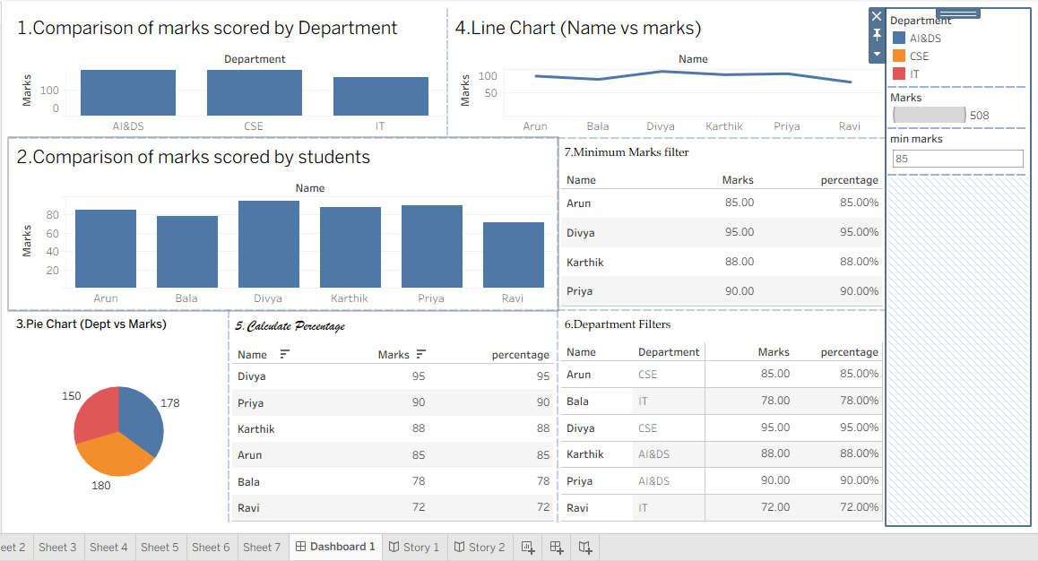
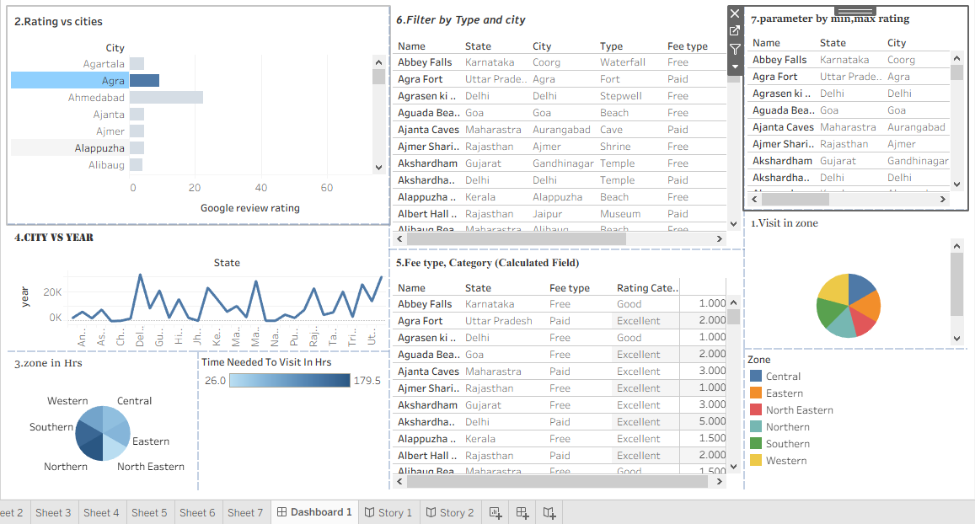

Result:
Thus, Tableau was used successfully to connect datasets, create worksheets, apply filters and parameters, generate visualizations, build dashboards, and create stories for business intelligence and analytical decision-making

