Ex.no:3 | Data Cleaning

Aim:

Algorithm:
Check Missing Values:
Step 1: Start.
Step 2: Import the pandas library.
Step 3: Load the dataset into a DataFrame (df).
Step 4: Display dataset information using df.info().
Step 5: Check missing values using df.isnull().
Step 6: Count missing values using df.isnull().sum().
Step 7: Check missing values using df.isna().
Step 8: Check non-missing values using df.notnull().
Step 9: Display the results.

Drop Missing Values
Step 1: Start.
Step 2: Import the pandas library.
Step 3: Load the dataset into a DataFrame (df).
Step 4: Drop missing rows using dropna().
Step 5: Drop rows (axis=0) or columns (axis=1).
Step 6: Use how='any' to remove rows/columns containing any missing value.
Step 7: Use how='all' to remove rows/columns only if all values are missing.
Step 8: Use thresh=N to keep rows/columns with at least N non-missing values.
Step 9: Use subset=['column_name'] to drop rows based on specific columns.
Step 10: Use inplace=True to modify the original DataFrame.
Step 11: Display the cleaned DataFrame.

Program:
import pandas as pd
df = pd.read_csv("Top Indian Places to Visit.csv")
print("\n========== FIRST 5 ROWS ==========")
print(df.head())
print("\n========== SHAPE ==========")
print(df.shape)
print("\n========== COLUMN NAMES ==========")
print(df.columns)
print("\n========== DATAFRAME INFO ==========")
df.info()
print("\n========== SUMMARY ==========")
print(df.describe(include='all'))
print("\n========== NULL VALUES (COLUMN-WISE) ==========")
print(df.isnull().sum())
print("\n========== TOTAL NULL VALUES ==========")
print(df.isnull().sum().sum())

Output:

========== FIRST 5 ROWS ==========
Unnamed: 0 Zone State City Name Type \
0 0 Northern Delhi Delhi India Gate War Memorial
1 1 Northern Delhi Delhi Humayun's Tomb Tomb
2 2 Northern Delhi Delhi Akshardham Temple Temple
3 3 Northern Delhi Delhi Waste to Wonder Park Theme Park
4 4 Northern Delhi Delhi Jantar Mantar Observatory

Establishment Year time needed to visit in hrs Google review rating \
0 1921 0.5 4.6
1 1572 2.0 4.5
2 2005 5.0 4.6
3 2019 2.0 4.1
4 1724 2.0 4.2

Entrance Fee in INR Airport with 50km Radius Weekly Off Significance \
0 0 Yes NaN Historical
1 30 Yes NaN Historical
2 60 Yes NaN Religious
3 50 Yes Monday Environmental
4 15 Yes NaN Scientific

DSLR Allowed Number of google review in lakhs Best Time to visit
0 Yes 2.60 Evening
1 Yes 0.40 Afternoon
2 No 0.40 Afternoon
3 Yes 0.27 Evening
4 Yes 0.31 Morning

========== SHAPE ==========
(325, 16)

========== COLUMN NAMES ==========
Index(['Unnamed: 0', 'Zone', 'State', 'City', 'Name', 'Type',
'Establishment Year', 'time needed to visit in hrs',
'Google review rating', 'Entrance Fee in INR',
'Airport with 50km Radius', 'Weekly Off', 'Significance',
'DSLR Allowed', 'Number of google review in lakhs',
'Best Time to visit'],
dtype='str')

========== DATAFRAME INFO ==========
<class 'pandas.DataFrame'>
RangeIndex: 325 entries, 0 to 324
Data columns (total 16 columns):
# Column Non-Null Count Dtype
--- ------ -------------- -----
0 Unnamed: 0 325 non-null int64
1 Zone 325 non-null str
2 State 325 non-null str
3 City 325 non-null str
4 Name 325 non-null str
5 Type 325 non-null str
6 Establishment Year 325 non-null str
7 time needed to visit in hrs 325 non-null float64
8 Google review rating 325 non-null float64
9 Entrance Fee in INR 325 non-null int64
10 Airport with 50km Radius 325 non-null str
11 Weekly Off 32 non-null str
12 Significance 325 non-null str
13 DSLR Allowed 325 non-null str
14 Number of google review in lakhs 325 non-null float64
15 Best Time to visit 325 non-null str
dtypes: float64(3), int64(2), str(11)
memory usage: 26.7 KB

========== SUMMARY ==========
Unnamed: 0 Zone State City Name Type \
count 325.000000 325 325 325 325 325
unique NaN 6 33 214 321 78
top NaN Southern Uttar Pradesh Delhi City Palace Temple
freq NaN 98 23 16 2 59
mean 162.000000 NaN NaN NaN NaN NaN
std 93.963645 NaN NaN NaN NaN NaN
min 0.000000 NaN NaN NaN NaN NaN
25% 81.000000 NaN NaN NaN NaN NaN
50% 162.000000 NaN NaN NaN NaN NaN
75% 243.000000 NaN NaN NaN NaN NaN
max 324.000000 NaN NaN NaN NaN NaN

Establishment Year time needed to visit in hrs Google review rating \
count 325 325.000000 325.000000
unique 162 NaN NaN
top Unknown NaN NaN
freq 111 NaN NaN
mean NaN 1.807692 4.486154
std NaN 0.971398 0.274580
min NaN 0.500000 1.400000
25% NaN 1.000000 4.400000
50% NaN 1.500000 4.500000
75% NaN 2.000000 4.600000
max NaN 7.000000 4.900000

Entrance Fee in INR Airport with 50km Radius Weekly Off Significance \
count 325.000000 325 32 325
unique NaN 2 5 25
top NaN Yes Monday Historical
freq NaN 227 23 78
mean 115.809231 NaN NaN NaN
std 530.859785 NaN NaN NaN
min 0.000000 NaN NaN NaN
25% 0.000000 NaN NaN NaN
50% 0.000000 NaN NaN NaN
75% 40.000000 NaN NaN NaN
max 7500.000000 NaN NaN NaN

DSLR Allowed Number of google review in lakhs Best Time to visit
count 325 325.000000 325
unique 2 NaN 7
top Yes NaN All
freq 265 NaN 164
mean NaN 0.408438 NaN
std NaN 0.646668 NaN
min NaN 0.010000 NaN
25% NaN 0.059000 NaN
50% NaN 0.170000 NaN
75% NaN 0.500000 NaN
max NaN 7.400000 NaN

========== NULL VALUES (COLUMN-WISE) ==========
Unnamed: 0 0
Zone 0
State 0
City 0
Name 0
Type 0
Establishment Year 0
time needed to visit in hrs 0
Google review rating 0
Entrance Fee in INR 0
Airport with 50km Radius 0
Weekly Off 293
Significance 0
DSLR Allowed 0
Number of google review in lakhs 0
Best Time to visit 0
dtype: int64

========== TOTAL NULL VALUES ==========
293

Program:
import pandas as pd
df = pd.read_csv("Top Indian Places to Visit.csv")
num = [
"Establishment Year",
"time needed to visit in hrs",
"Google review rating",
"Entrance Fee in INR",
"Number of google review in lakhs"
]
for i in num:
df[i] = pd.to_numeric(df[i], errors="coerce")
constant = df.fillna("Unknown")
mean = df.copy()
for i in num:
mean[i] = mean[i].fillna(mean[i].mean())
median = df.copy()
for i in num:
median[i] = median[i].fillna(median[i].median())
mode = df.fillna(df.mode().iloc[0])
forward = df.ffill()
backward = df.bfill()
print("Constant")
print(constant.head())
print("Mean")
print(mean.head())
print("Median")
print(median.head())
print("Mode")
print(mode.head())
print("Forward Fill")
print(forward.head())
print("Backward Fill")
print(backward.head())

Output:
Constant
Unnamed: 0 Zone State City Name Type \
0 0 Northern Delhi Delhi India Gate War Memorial
1 1 Northern Delhi Delhi Humayun's Tomb Tomb
2 2 Northern Delhi Delhi Akshardham Temple Temple
3 3 Northern Delhi Delhi Waste to Wonder Park Theme Park
4 4 Northern Delhi Delhi Jantar Mantar Observatory

Establishment Year time needed to visit in hrs Google review rating \
0 1921.0 0.5 4.6
1 1572.0 2.0 4.5
2 2005.0 5.0 4.6
3 2019.0 2.0 4.1
4 1724.0 2.0 4.2

Entrance Fee in INR Airport with 50km Radius Weekly Off Significance \
0 0 Yes Unknown Historical
1 30 Yes Unknown Historical
2 60 Yes Unknown Religious
3 50 Yes Monday Environmental
4 15 Yes Unknown Scientific

Program:
import pandas as pd
df = pd.read_csv("Top Indian Places to Visit.csv")
print(df.shape)
df1 = df.dropna()
print(df1)
df2 = df.dropna(axis=0)
print(df2)
df3 = df.dropna(axis=1)
print(df3)
df4 = df.dropna(how="all")
print(df4)
df5 = df.dropna(thresh=10)
print(df5)
df6 = df.dropna(subset=["Google review rating"])
print(df6)
df7 = df.dropna(subset=[
"Google review rating",
"Entrance Fee in INR"
])
print(df7)
df.dropna(inplace=True)
print(df)

Output:
Unnamed: 0 Zone State City \
3 3 Northern Delhi Delhi
5 5 Northern Delhi Delhi
6 6 Northern Delhi Delhi
12 12 Northern Delhi Delhi
13 13 Northern Delhi Delhi
19 19 Western Maharastra Mumbai
26 26 Western Maharastra Lonavala
27 27 Southern Karnataka Bangalore

Name Type Establishment Year \
3 Waste to Wonder Park Theme Park 2019
5 Chandni Chowk Market 1700
6 Lotus Temple Temple 1986
12 National Gallery of Modern Art Museum 1954
13 National Zoological Park Zoo 1959
19 Sanjay Gandhi National Park National Park 1996
26 Imagicaa Amusement Park 2013
27 Bangalore Palace Palace 1878
32 Charminar Landmark 1591
42 Victoria Memorial Museum 1921
44 Indian Museum Museum 1814
70 Laxmi Vilas Palace Palace 1890
73 Statue of Unity Monument 2018
78 Science City Science 2002
109 Kerala Folklore Museum Cultural 2009
124 Ajanta Caves Cave 200
131 Karla Caves Cave 200
135 Ellora Caves Cave 600

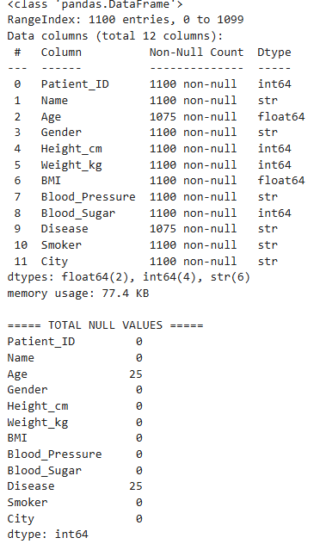

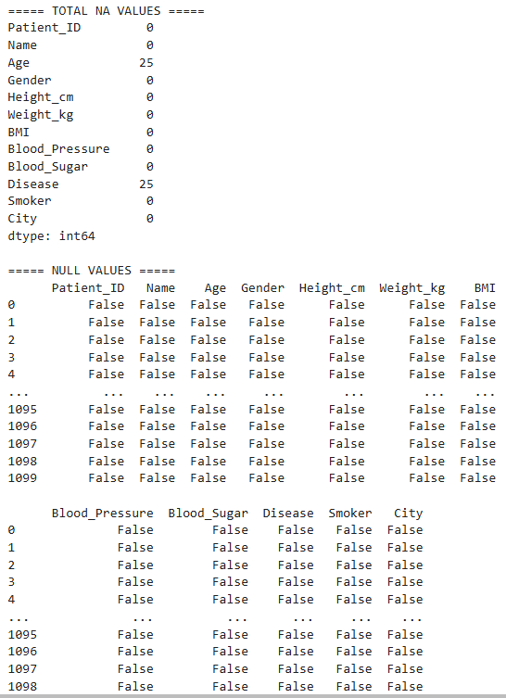

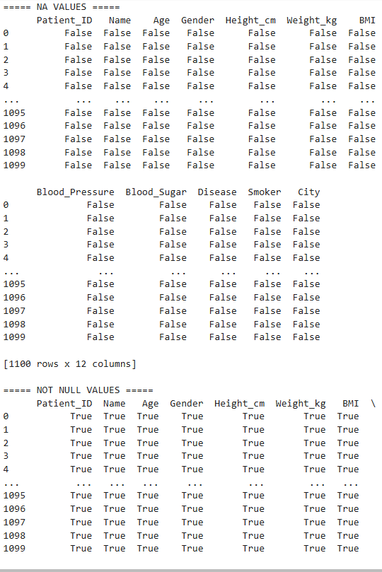

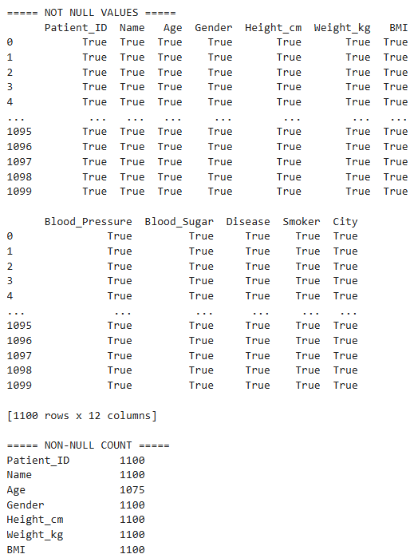
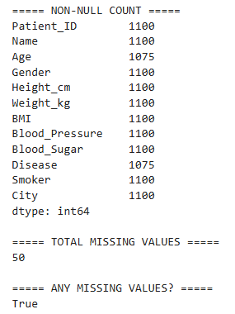
After cleaning:
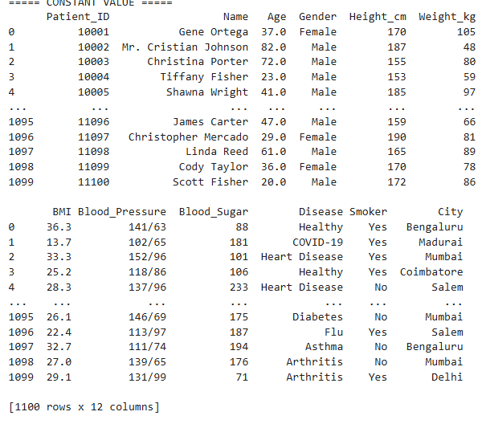
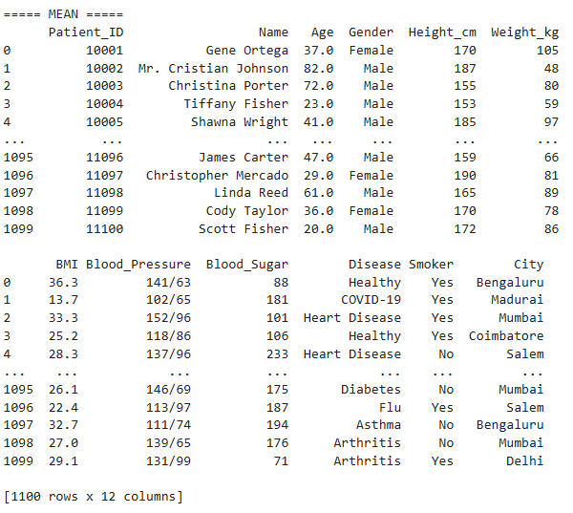

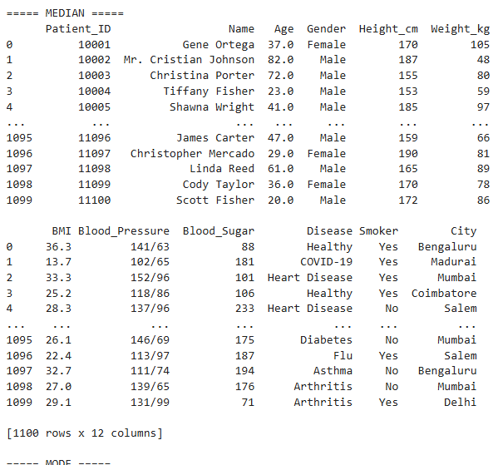

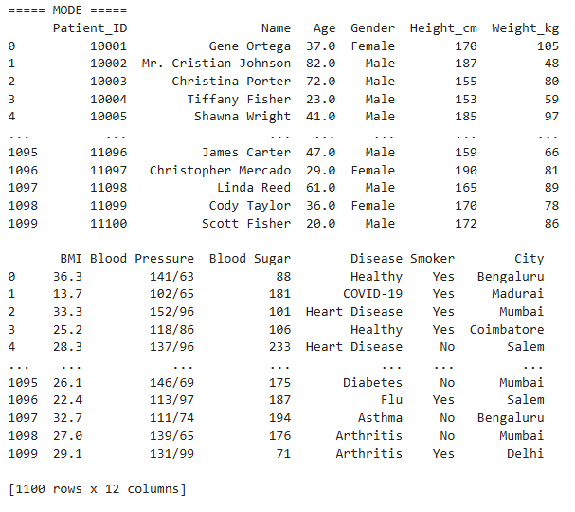

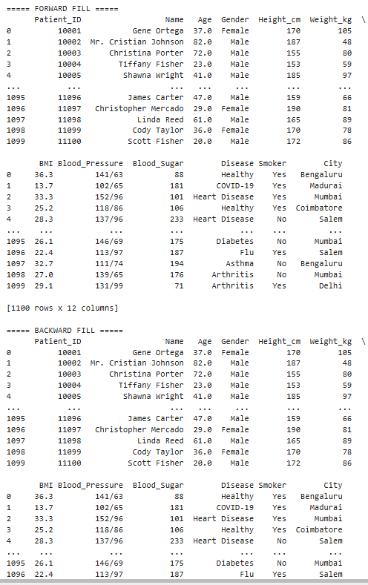

Drop Missing:
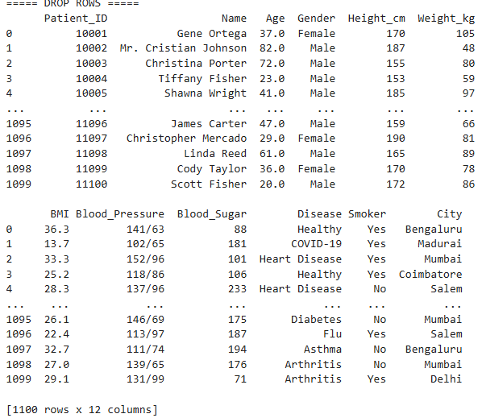

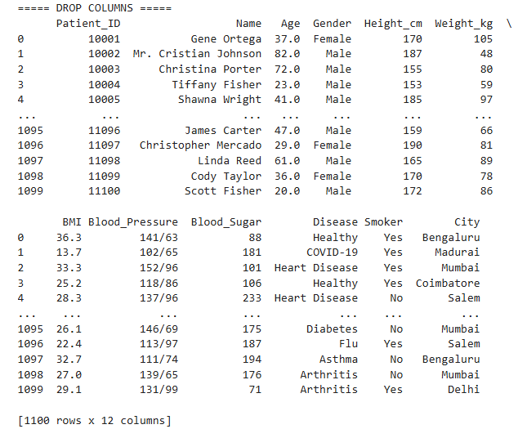

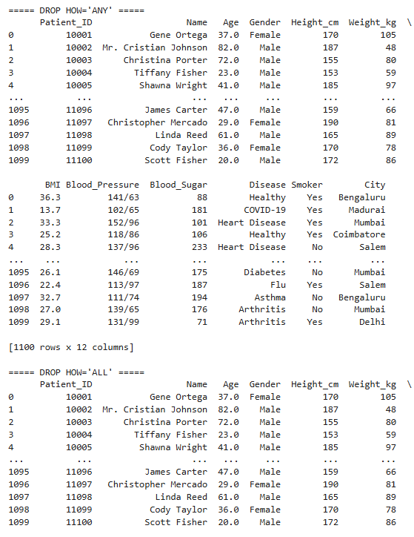

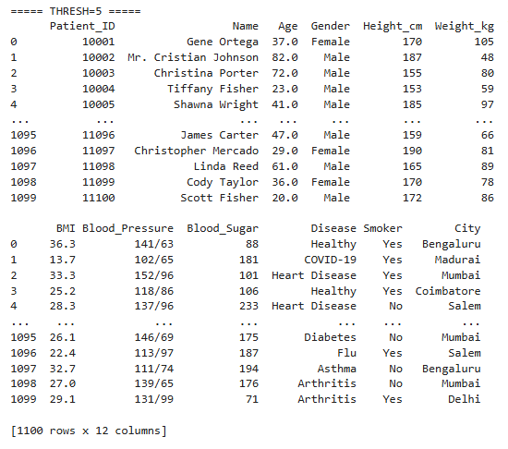

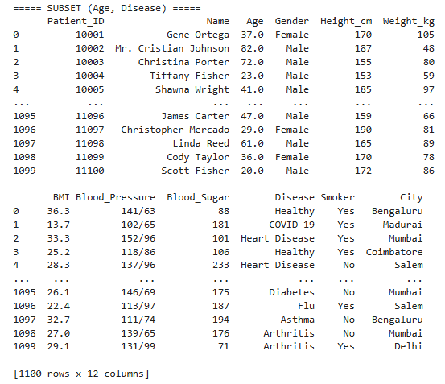

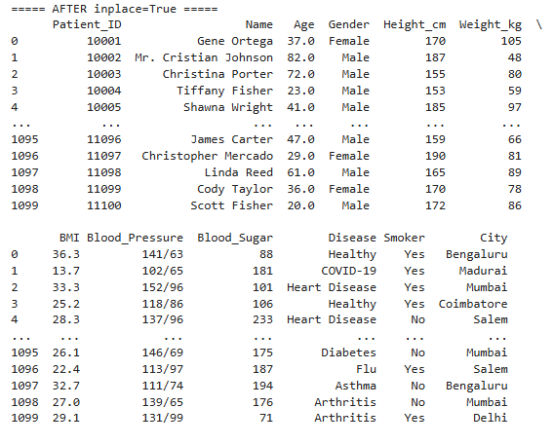

Result:

