Ex.No:8 | Mini Project – Soccer Dataset

Aim:
Soccer Data Analytics using Python, Pandas, Matplotlib, and Exploratory Data Analysis

Algorithm:

Step 1: Start the Program
Start the Python program.
Import the required libraries such as Pandas, NumPy, Matplotlib, and Seaborn.
Import SQLite3 to connect to the soccer database.

Step 2: Load the Dataset
Connect to the European Soccer SQLite database.
Read the required tables such as Match, League, Country, and Team.
Store the data in DataFrames named match, league, country, and team.

Step 3: Create a Working DataFrame
Create a copy of the Match DataFrame.
Store the copy in match_data.
This allows the original dataset to remain unchanged.

Step 4: Inspect the Dataset
Display the first few records using head().
Display the last few records using tail().
Check the number of rows and columns using shape.
Display column names and data types.

Step 5: Clean the Data
Check missing values using isna().sum().
Identify duplicate records using duplicated().
Remove duplicate records using drop_duplicates().
Convert numerical columns such as home goals and away goals into appropriate data types.
Handle missing values where required.

Step 6: Perform Statistical Analysis
Use describe() to calculate statistical values.
Find mean, minimum, maximum, and standard deviation.

Analyze numerical soccer statistics such as home goals, away goals, and total goals.
Calculate the average number of goals per match.

Step 7: Filter, Sort and Group Data
Filter matches according to required conditions.
Sort matches based on total goals or other important measures.
Group the data using suitable categorical fields such as season, league, and match result.
Calculate total matches and total goals for comparison.
Identify home wins, away wins, and draws.

Step 8: Create Visualizations
Create suitable charts using Matplotlib and Seaborn.
Generate bar charts, line charts, histograms, box plots, scatter plots, and count plots.
Create a match-result distribution chart.
Create a correlation heatmap for numerical variables.

Step 9: Analyze the Results
Compare soccer performance across different seasons and leagues.
Identify seasons with higher numbers of matches and goals.
Analyze home wins, away wins, and draws.
Analyze the relationship between home goals, away goals, and total goals.
Identify important trends and patterns from the visualizations.

Step 10: Display and Store the Final Results
Display the cleaned soccer dataset and analysis results.
Save the cleaned soccer dataset if required.
Export the processed data to CSV or Excel format.
Use the cleaned data for Power BI/Tableau dashboard development.
Present the final soccer data insights.
Stop.

Program:

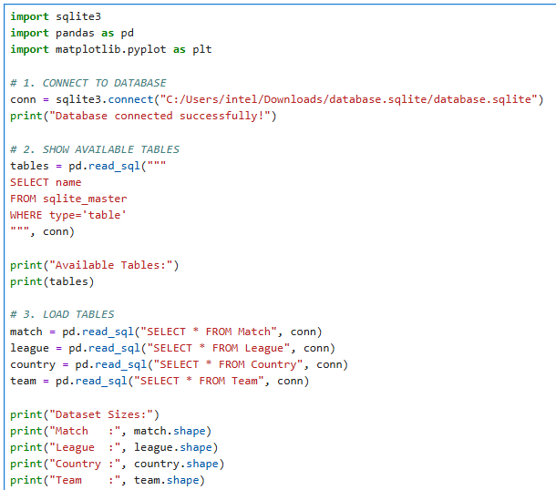

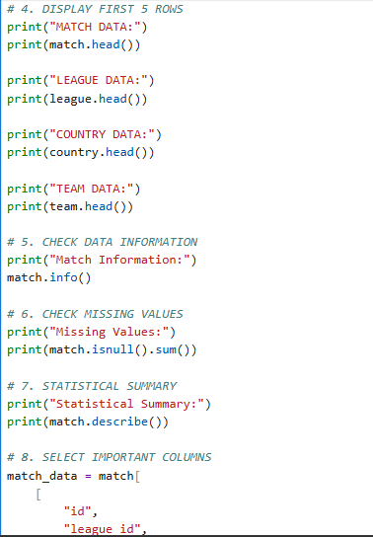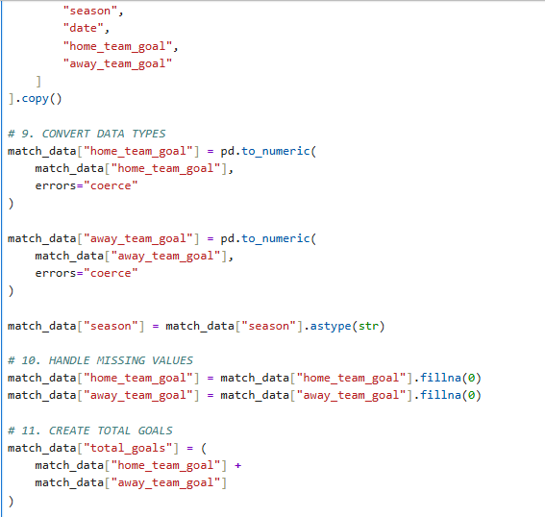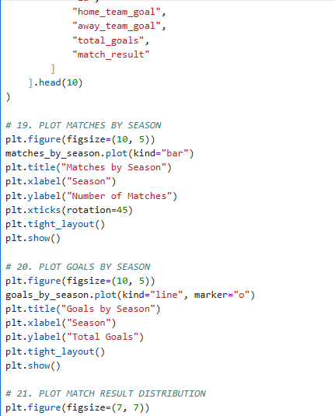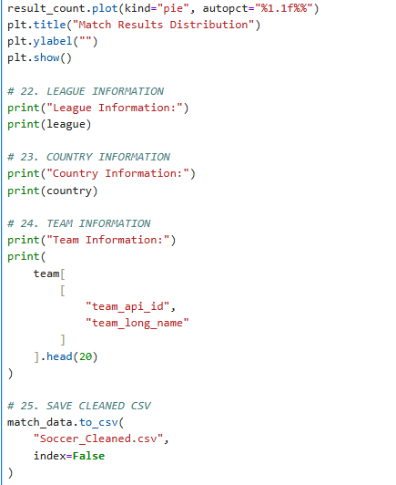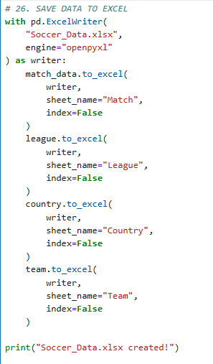

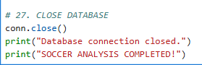

Output:

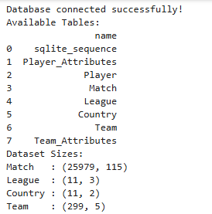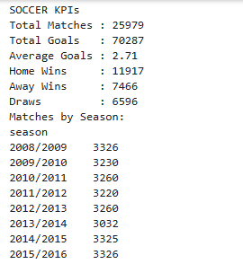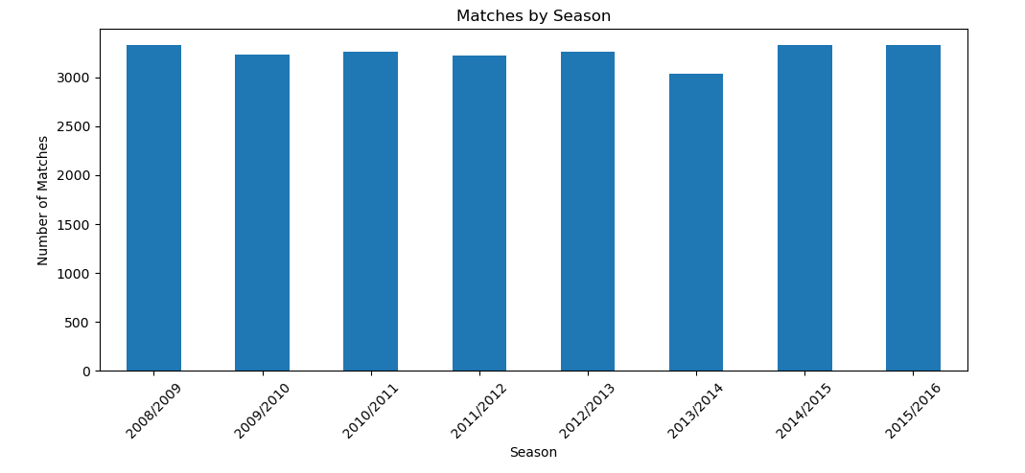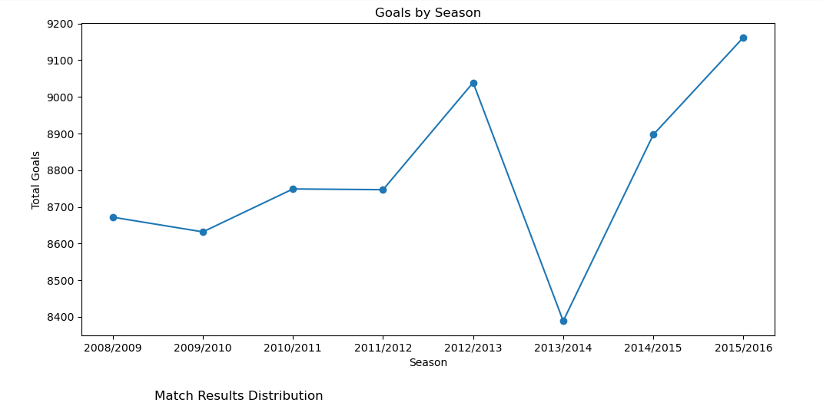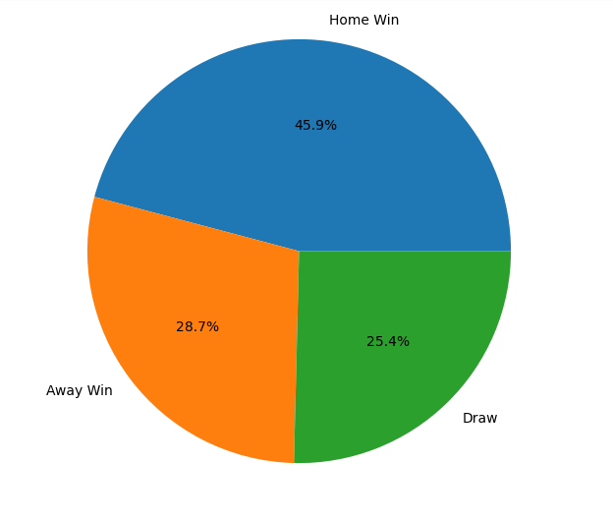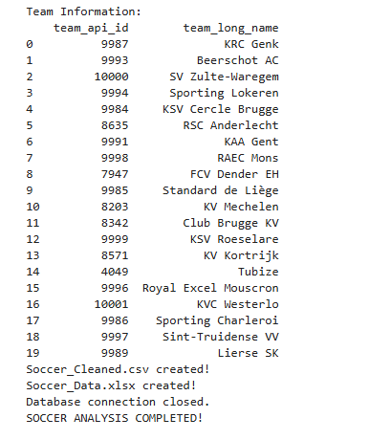

Power bi
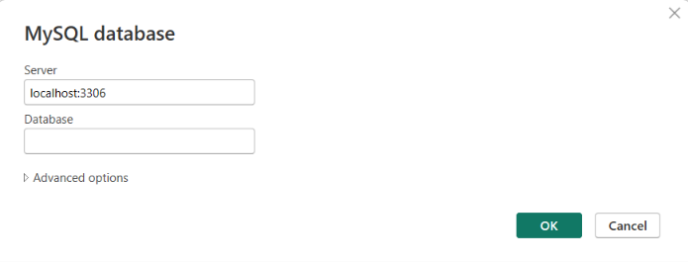

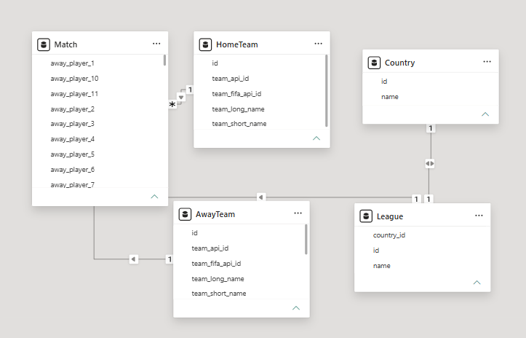

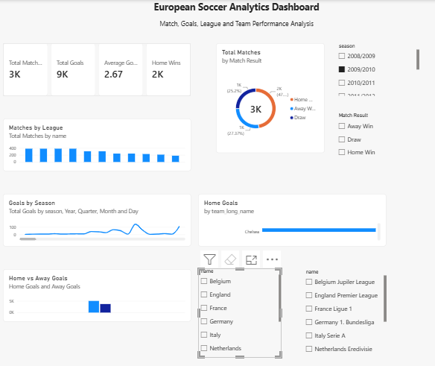

Tabelu:

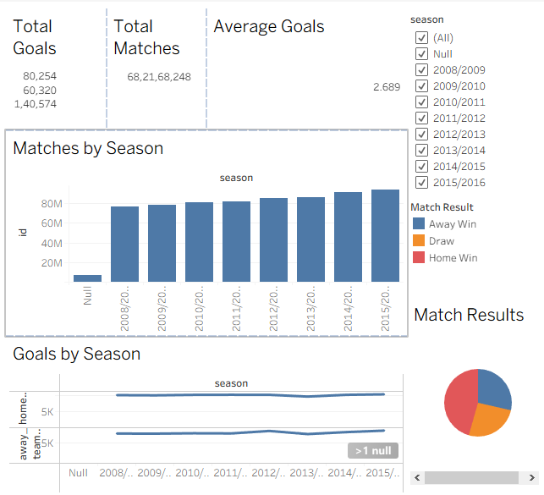

Result:
Thus the data visualization was successfully completed in jupyter,Power BI,Tabelu

