Ex.no:4 | EDA – DATA INSPECTION, FILTERING, STATISTICAL ANALYSIS AND CORRELATION

Aim:

Algorithm:
• Start.
• Import libraries.
• Read/Create the dataset.
• Display dataset information.
• Filter required records.
• Sort the data.
• Calculate statistical measures.
• Generate summary statistics.
• Group data and calculate averages.
• Find correlation.
• Create graphs (Scatter Plot and Bar Chart).
• Stop.

Program:
import pandas as pd
import matplotlib.pyplot as plt
# Create DataFrame
data = {
"Roll No": [101,102,103,104,105,106],
"Name": ["Arun","Bala","Divya","Priya","Ravi","Karthik"],
"Department": ["CSE","IT","CSE","AI&DS","IT","AI&DS"],
"Marks": [85,78,95,90,72,88],
"Attendance": [92,88,96,94,85,91]
}
df = pd.DataFrame(data)
# View Data
print("First 5 Rows")
print(df.head())
print("\nShape")
print(df.shape)
print("\nData Types")
print(df.dtypes)
# Filter Marks > 85
print("\nStudents with Marks > 85")
high_marks = df[df["Marks"] > 85]
print(high_marks)
# Filter IT Department
print("\nIT Department Students")
it_students = df[df["Department"] == "IT"]
print(it_students)
# Sort by Marks
print("\nSorted by Marks")
sorted_df = df.sort_values(by="Marks", ascending=False)
print(sorted_df)
# Statistics
print("\nMean =", df["Marks"].mean())
print("Median =", df["Marks"].median())
print("Mode =")
print(df["Marks"].mode())
print("Standard Deviation =", df["Marks"].std())
# Summary
print("\nSummary Statistics")
print(df.describe())
# Group By
print("\nAverage Marks by Department")
dept_avg = df.groupby("Department")["Marks"].mean()
print(dept_avg)
# Correlation
print("\nCorrelation")
corr = df[["Marks","Attendance"]].corr()
print(corr)
# Scatter Plot
plt.scatter(df["Attendance"], df["Marks"])
plt.title("Marks vs Attendance")
plt.xlabel("Attendance")
plt.ylabel("Marks")
plt.grid(True)
plt.show()
# Bar Plot
dept_avg.plot(kind="bar")
plt.title("Average Marks by Department")
plt.xlabel("Department")
plt.ylabel("Average Marks")
plt.show()

Output:
First 5 Rows
Roll No Name Department Marks Attendance
0 101 Arun CSE 85 92
1 102 Bala IT 78 88
2 103 Divya CSE 95 96
3 104 Priya AI&DS 90 94
4 105 Ravi IT 72 85
Shape
(6, 5)

Data Types
Roll No int64
Name str
Department str
Marks int64
Attendance int64
dtype: object

Students with Marks > 85
Roll No Name Department Marks Attendance
2 103 Divya CSE 95 96
3 104 Priya AI&DS 90 94
5 106 Karthik AI&DS 88 91

IT Department Students
Roll No Name Department Marks Attendance
1 102 Bala IT 78 88
4 105 Ravi IT 72 85

Sorted by Marks
Roll No Name Department Marks Attendance
2 103 Divya CSE 95 96
3 104 Priya AI&DS 90 94
5 106 Karthik AI&DS 88 91
0 101 Arun CSE 85 92
1 102 Bala IT 78 88
4 105 Ravi IT 72 85

Mean = 84.66666666666667
Median = 86.5
Mode =
0 72
1 78
2 85
3 88
4 90
5 95
Name: Marks, dtype: int64
Standard Deviation = 8.382521498133285

Summary Statistics
Roll No Marks Attendance
count 6.000000 6.000000 6.00
mean 103.500000 84.666667 91.00
std 1.870829 8.382521 4.00
min 101.000000 72.000000 85.00
25% 102.250000 79.750000 88.75
50% 103.500000 86.500000 91.50
75% 104.750000 89.500000 93.50
max 106.000000 95.000000 96.00

Average Marks by Department
Department
AI&DS 89.0
CSE 90.0
IT 75.0
Name: Marks, dtype: float64
Correlation
Marks Attendance
Marks 1.000000 0.978226
Attendance 0.978226 1.000000

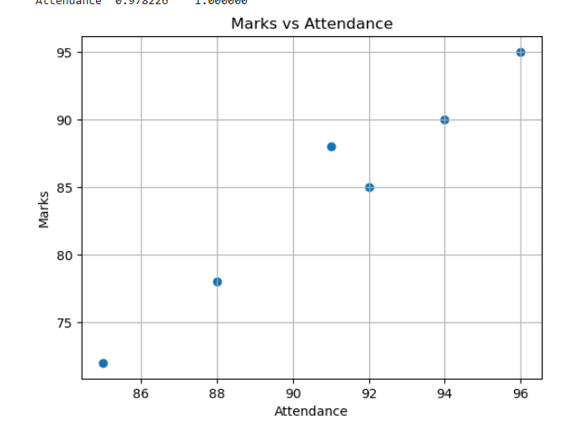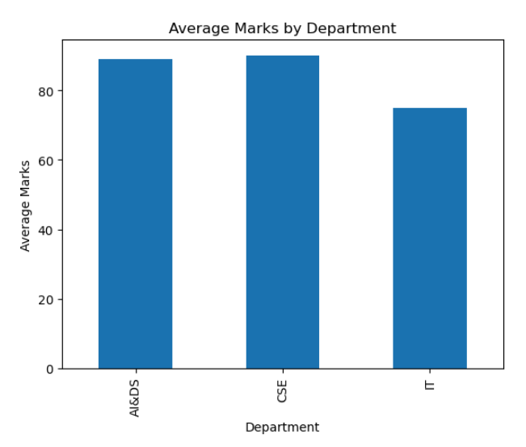

Program:
import pandas as pd
import matplotlib.pyplot as plt
# Read Dataset
df = pd.read_csv("Top Indian Places to Visit.csv")
# Use only first 10 rows
df = df.head(10)
# Convert numeric columns
num = [
"Google review rating",
"Entrance Fee in INR",
"time needed to visit in hrs",
"Number of google review in lakhs"
]
for col in num:
df[col] = pd.to_numeric(df[col], errors="coerce")
# View Data
print("First 5 Rows")
print(df.head())
print("\nShape")
print(df.shape)
print("\nData Types")
print(df.dtypes)
# Filter Rating > 4.5
print("\nPlaces with Rating > 4.5")
high_rating = df[df["Google review rating"] > 4.5]
print(high_rating)
# Filter Free Entry Places
print("\nFree Entry Places")
free_places = df[df["Entrance Fee in INR"] == 0]
print(free_places)
# Sort by Rating
print("\nSorted by Rating")
sorted_df = df.sort_values(by="Google review rating", ascending=False)
print(sorted_df)
# Statistics
print("\nMean =", df["Google review rating"].mean())
print("Median =", df["Google review rating"].median())
print("Mode =")
print(df["Google review rating"].mode())
print("Standard Deviation =", df["Google review rating"].std())
# Summary
print("\nSummary Statistics")
print(df.describe())
# Group By State
print("\nAverage Rating by State")
state_avg = df.groupby("State")["Google review rating"].mean()
print(state_avg)
# Correlation
print("\nCorrelation")
corr = df[["Google review rating","Entrance Fee in INR"]].corr()
print(corr)
# Scatter Plot
plt.scatter(df["Entrance Fee in INR"], df["Google review rating"])
plt.title("Rating vs Entrance Fee")
plt.xlabel("Entrance Fee (INR)")
plt.ylabel("Google Rating")
plt.grid(True)
plt.show()
# Bar Plot
state_avg.plot(kind="bar")
plt.title("Average Rating by State")
plt.xlabel("State")
plt.ylabel("Average Rating")
plt.show()

Output:
First 5 Rows
Unnamed: 0 Zone State City Name Type \
0 0 Northern Delhi Delhi India Gate War Memorial
1 1 Northern Delhi Delhi Humayun's Tomb Tomb
2 2 Northern Delhi Delhi Akshardham Temple Temple
3 3 Northern Delhi Delhi Waste to Wonder Park Theme Park
4 4 Northern Delhi Delhi Jantar Mantar Observatory

Establishment Year time needed to visit in hrs Google review rating \
0 1921 0.5 4.6
1 1572 2.0 4.5
2 2005 5.0 4.6
3 2019 2.0 4.1
4 1724 2.0 4.2

Entrance Fee in INR Airport with 50km Radius Weekly Off Significance \
0 0 Yes NaN Historical
1 30 Yes NaN Historical
2 60 Yes NaN Religious
3 50 Yes Monday Environmental
4 15 Yes NaN Scientific

DSLR Allowed Number of google review in lakhs Best Time to visit
0 Yes 2.60 Evening
1 Yes 0.40 Afternoon
2 No 0.40 Afternoon
3 Yes 0.27 Evening
4 Yes 0.31 Morning

Shape
(10, 16)

Data Types
Unnamed: 0 int64
Zone str
State str
City str
Name str
Type str
Establishment Year str
time needed to visit in hrs float64
Google review rating float64
Entrance Fee in INR int64
Airport with 50km Radius str
Weekly Off str
Significance str
DSLR Allowed str
Number of google review in lakhs float64
Best Time to visit str
dtype: object

Places with Rating > 4.5
Unnamed: 0 Zone State City Name Type \
0 0 Northern Delhi Delhi India Gate War Memorial
2 2 Northern Delhi Delhi Akshardham Temple Temple
9 9 Northern Delhi Delhi Sunder Nursery Park

Establishment Year time needed to visit in hrs Google review rating \
0 1921 0.5 4.6
2 2005 5.0 4.6
9 1600 2.0 4.6

Entrance Fee in INR Airport with 50km Radius Weekly Off Significance \
0 0 Yes NaN Historical
2 60 Yes NaN Religious
9 0 Yes NaN Botanical

DSLR Allowed Number of google review in lakhs Best Time to visit
0 Yes 2.60 Evening
2 No 0.40 Afternoon
9 Yes 0.16 Afternoon

Free Entry Places
Unnamed: 0 Zone State City Name Type \
0 0 Northern Delhi Delhi India Gate War Memorial
5 5 Northern Delhi Delhi Chandni Chowk Market
6 6 Northern Delhi Delhi Lotus Temple Temple
8 8 Northern Delhi Delhi Agrasen ki Baoli Stepwell
9 9 Northern Delhi Delhi Sunder Nursery Park

Establishment Year time needed to visit in hrs Google review rating \
0 1921 0.5 4.6
5 1700 3.0 4.2
6 1986 1.0 4.5
8 1400 1.0 4.2
9 1600 2.0 4.6

Entrance Fee in INR Airport with 50km Radius Weekly Off Significance \
0 0 Yes NaN Historical
5 0 Yes Sunday Market
6 0 Yes Monday Religious
8 0 Yes NaN Historical
9 0 Yes NaN Botanical

DSLR Allowed Number of google review in lakhs Best Time to visit
0 Yes 2.60 Evening
5 Yes 0.25 Afternoon
6 Yes 0.59 Evening
8 Yes 0.41 Afternoon
9 Yes 0.16 Afternoon

Sorted by Rating
Unnamed: 0 Zone State City Name Type \
0 0 Northern Delhi Delhi India Gate War Memorial
2 2 Northern Delhi Delhi Akshardham Temple Temple
9 9 Northern Delhi Delhi Sunder Nursery Park
1 1 Northern Delhi Delhi Humayun's Tomb Tomb
6 6 Northern Delhi Delhi Lotus Temple Temple
7 7 Northern Delhi Delhi Red Fort Fort
4 4 Northern Delhi Delhi Jantar Mantar Observatory
5 5 Northern Delhi Delhi Chandni Chowk Market
8 8 Northern Delhi Delhi Agrasen ki Baoli Stepwell
3 3 Northern Delhi Delhi Waste to Wonder Park Theme Park

Establishment Year time needed to visit in hrs Google review rating \
0 1921 0.5 4.6
2 2005 5.0 4.6
9 1600 2.0 4.6
1 1572 2.0 4.5
6 1986 1.0 4.5
7 1648 2.0 4.5
4 1724 2.0 4.2
5 1700 3.0 4.2
8 1400 1.0 4.2
3 2019 2.0 4.1

Entrance Fee in INR Airport with 50km Radius Weekly Off Significance \
0 0 Yes NaN Historical
2 60 Yes NaN Religious
9 0 Yes NaN Botanical
1 30 Yes NaN Historical
6 0 Yes Monday Religious
7 35 Yes NaN Historical
4 15 Yes NaN Scientific
5 0 Yes Sunday Market
8 0 Yes NaN Historical
3 50 Yes Monday Environmental

DSLR Allowed Number of google review in lakhs Best Time to visit
0 Yes 2.60 Evening
2 No 0.40 Afternoon
9 Yes 0.16 Afternoon
1 Yes 0.40 Afternoon
6 Yes 0.59 Evening
7 Yes 1.50 Afternoon
4 Yes 0.31 Morning
5 Yes 0.25 Afternoon
8 Yes 0.41 Afternoon
3 Yes 0.27 Evening

Mean = 4.4
Median = 4.5
Mode =
0 4.2
1 4.5
2 4.6
Name: Google review rating, dtype: float64
Standard Deviation = 0.19999999999999987

Summary Statistics
Unnamed: 0 time needed to visit in hrs Google review rating \
count 10.00000 10.000000 10.000
mean 4.50000 2.050000 4.400
std 3.02765 1.257201 0.200
min 0.00000 0.500000 4.100
25% 2.25000 1.250000 4.200
50% 4.50000 2.000000 4.500
75% 6.75000 2.000000 4.575
max 9.00000 5.000000 4.600

Entrance Fee in INR Number of google review in lakhs
count 10.000000 10.000000
mean 19.000000 0.689000
std 23.190036 0.771441
min 0.000000 0.160000
25% 0.000000 0.280000
50% 7.500000 0.400000
75% 33.750000 0.545000
max 60.000000 2.600000

Average Rating by State
State
Delhi 4.4
Name: Google review rating, dtype: float64

Correlation
Google review rating Entrance Fee in INR
Google review rating 1.000000 0.011978
Entrance Fee in INR 0.011978 1.000000
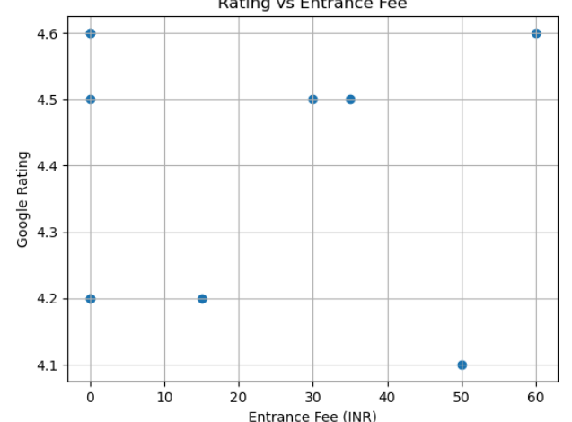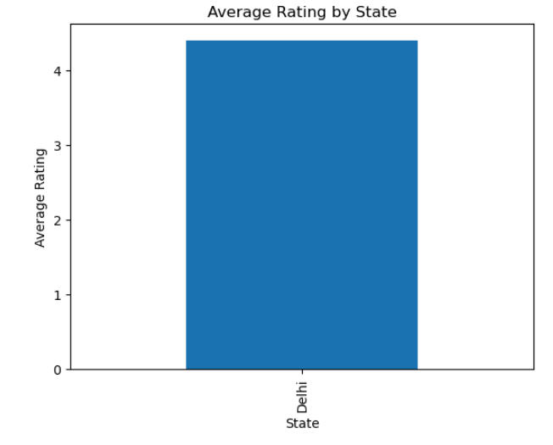

Result:

