Ex.no:5 | DATA VISUALIZATION USING MATPLOTLIB

Aim:

Algorithm:
• Start.
• Import the matplotlib.pyplot library.
• Create sample data for the charts.
• Draw a Line Chart to show the trend.
• Draw a Bar Chart to compare values.
• Draw a Pie Chart to show percentage distribution.
• Draw a Box Plot to display data distribution.
• Draw a Multiple Line Chart to compare two datasets.
• Display each chart using plt.show().
• Stop.

Program:
import matplotlib.pyplot as plt
months = ["Jan","Feb","Mar","Apr","May","Jun"]
sales = [120,150,180,170,220,250]
plt.plot(months,sales)
plt.title("Monthly Sales")
plt.xlabel("Months")
plt.ylabel("Sales")
plt.show()
plt.bar(months,sales)
plt.title("Monthly Sales")
plt.xlabel("Months")
plt.ylabel("Sales")
plt.show()
departments = ["HR","IT","Finance","Sales"]
employees = [25,40,20,15]
plt.pie(employees,
labels=departments,
autopct='%1.1f%%')
plt.show()
salary=[25000,27000,30000,
32000,35000,
40000,150000]
plt.boxplot(salary)
plt.show()
months=["Jan","Feb","Mar","Apr"]
sales=[120,150,180,200]
profit=[20,30,40,50]
plt.plot(months,sales,label="Sales")
plt.plot(months,profit,label="Profit")
plt.legend()
plt.show()

Output:
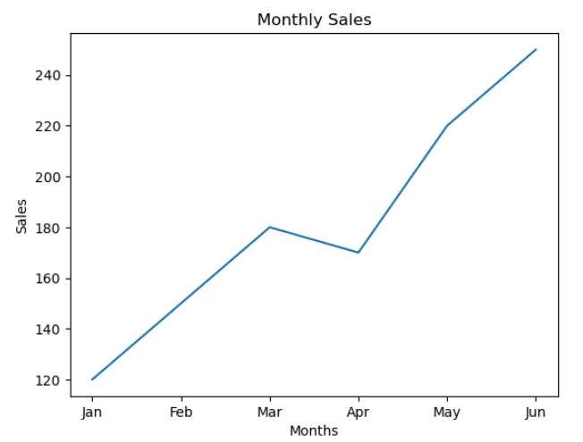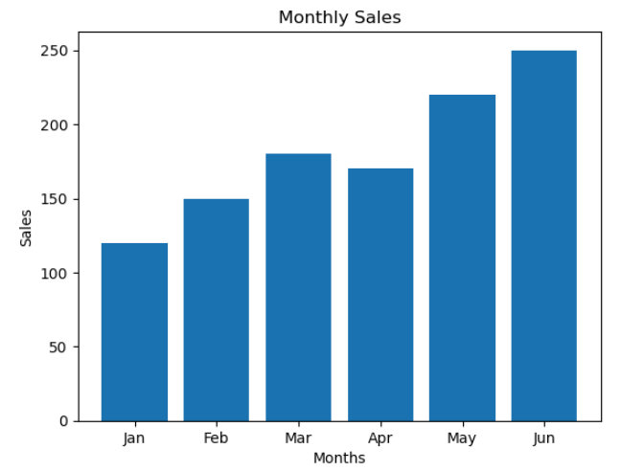

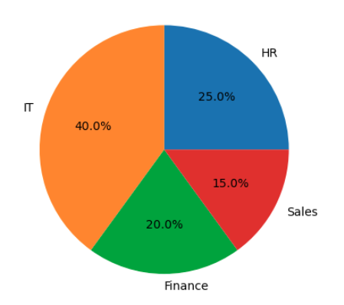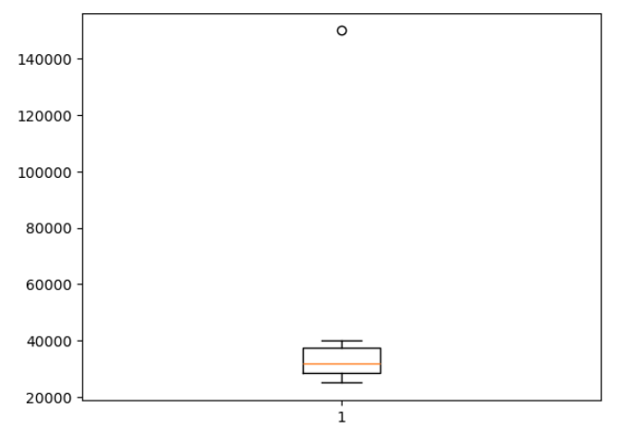

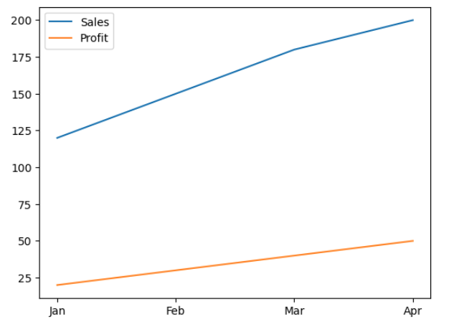

Algorithm:
• Start.
• Import the required libraries (pandas, matplotlib, and seaborn).
• Load the dataset and select the first few rows.
• Convert the required columns to numeric values.
• Select the columns needed for visualization.
• Create different charts:
- Line Chart
- Bar Chart
- Histogram
- Box Plot
- Scatter Plot
- Violin Plot
- Pie Chart
- 2×2 Subplots
- Pair Plot
- Heatmap
- Seaborn Multi-panel Plot
• Display each chart.
• Stop.
Program:
import pandas as pd
import matplotlib.pyplot as plt
import seaborn as sns
# Read first 10 rows
df = pd.read_csv("Top Indian Places to Visit.csv").head(10)

# Convert numeric columns
cols = ["Google review rating",
"Entrance Fee in INR",
"time needed to visit in hrs"]
for c in cols:
df[c] = pd.to_numeric(df[c], errors="coerce")
# Replace "Place Name" with your actual place column if different
x = df["Name"]
# 1. Line Chart
plt.figure(figsize=(6,3))
plt.plot(x, df["Google review rating"], marker="o")
plt.title("Line Chart")
plt.xticks(rotation=45)
plt.show()
# 2. Bar Chart
plt.figure(figsize=(6,3))
plt.bar(x, df["Entrance Fee in INR"])
plt.title("Bar Chart")
plt.xticks(rotation=45)
plt.show()
# 3. Histogram
plt.figure(figsize=(6,3))
plt.hist(df["Google review rating"], bins=5)
plt.title("Histogram")
plt.show()
# 4. Box Plot
plt.figure(figsize=(4,4))
plt.boxplot(df["Google review rating"].dropna())
plt.title("Box Plot")
plt.show()
# 5. Scatter Plot
plt.figure(figsize=(6,3))
plt.scatter(df["Entrance Fee in INR"],
df["Google review rating"])
plt.xlabel("Entrance Fee")
plt.ylabel("Rating")
plt.title("Scatter Plot")
plt.show()
# 6. Violin Plot
plt.figure(figsize=(4,4))
sns.violinplot(y=df["Google review rating"])
plt.title("Violin Plot")
plt.show()
# 7. Pie Chart
plt.figure(figsize=(5,5))
plt.pie(df["Entrance Fee in INR"],
labels=x,
autopct="%1.1f%%")
plt.title("Pie Chart")
plt.show()
# 8. Subplots (2x2)
fig, ax = plt.subplots(2,2, figsize=(10,8))
ax[0,0].plot(x, df["Google review rating"])
ax[0,0].set_title("Line")

ax[0,1].bar(x, df["Entrance Fee in INR"])
ax[0,1].set_title("Bar")

ax[1,0].hist(df["Google review rating"])
ax[1,0].set_title("Histogram")

ax[1,1].scatter(df["Entrance Fee in INR"],
df["Google review rating"])
ax[1,1].set_title("Scatter")
for a in ax.flat:
a.tick_params(axis='x', rotation=45)
plt.tight_layout()
plt.show()
# 9. Pair Plot
sns.pairplot(df[cols])
plt.show()
# 10. Heatmap
plt.figure(figsize=(5,4))
sns.heatmap(df[cols].corr(),
annot=True,
cmap="coolwarm")
plt.title("Heatmap")
plt.show()
# 11. Seaborn 3-Panel Plot
fig, ax = plt.subplots(1,3, figsize=(15,4))
sns.histplot(df["Google review rating"], ax=ax[0])
ax[0].set_title("Histogram")
sns.boxplot(y=df["Google review rating"], ax=ax[1])
ax[1].set_title("Box Plot")
sns.scatterplot(
x=df["Entrance Fee in INR"],
y=df["Google review rating"],
ax=ax[2]
)
ax[2].set_title("Scatter Plot")
plt.tight_layout()
plt.show()

Output:
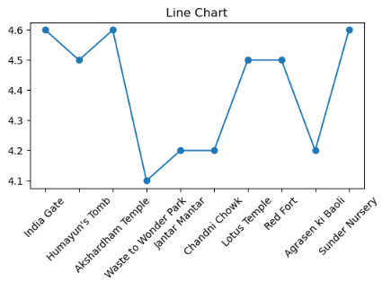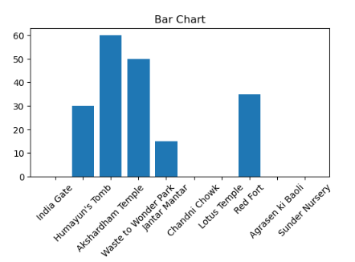
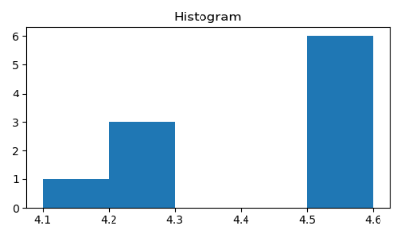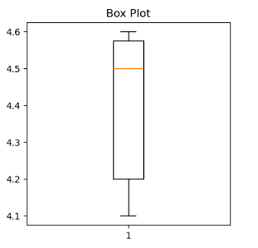
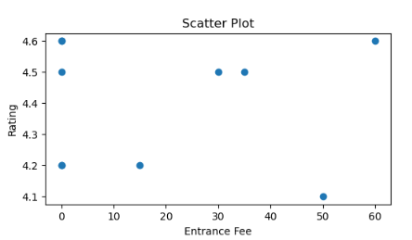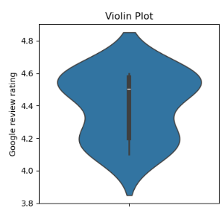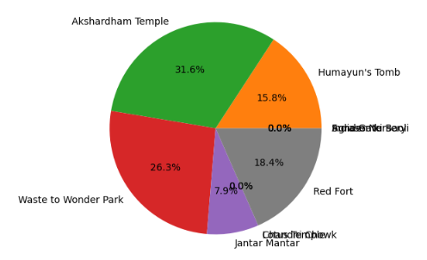
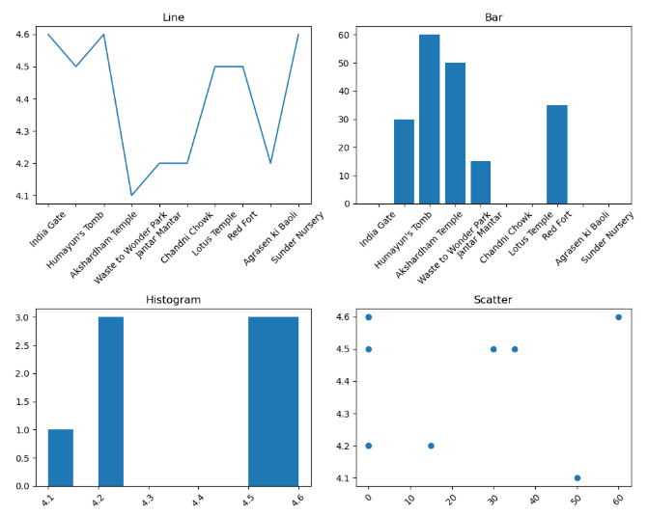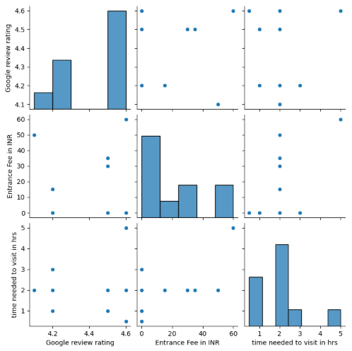
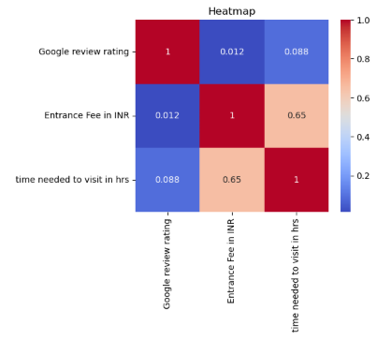
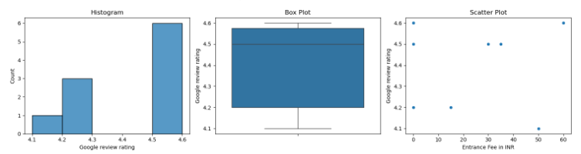

Result:

