EX No:1 | EDA-Data Cleaning
Aim:

Algorithm:
- Start
- Collect Data
  - Load the dataset from a CSV/database/file.
- Understand Data
  - Display dataset information.
  - Check data types, missing values, and statistics.
- Clean Data
  - Handle missing values.
  - Remove duplicate or inconsistent records.
- Transform Data
  - Convert categorical data into numerical form.
  - Normalize or standardize numerical values.
  - Select required features.
- Analyze Data
  - Perform data exploration.
  - Apply statistical analysis and visualization techniques.
- Apply Data Mining / Modeling
  - Select a suitable algorithm.
  - Train the model using prepared data.
  - Generate patterns, clusters, or predictions.
- Evaluate Results
  - Measure model performance.
  - Validate the discovered patterns.
- Present Results
  - Generate charts, graphs, reports, and insights.
- Save Output
- Export processed data and results.
- Stop

Program:
#KDD
import pandas as pd
from sklearn.preprocessing import LabelEncoder, StandardScaler
from sklearn.cluster import KMeans
# STEP 1: DATA SELECTION & COLLECTION
input_filename = "Top Indian Places to Visit.csv"
df = pd.read_csv(input_filename)
print("--- Step 1: Dataset Loaded Successfully ---")
print(df.head())
# STEP 2: DATA CLEANING
print("\n--- Step 2: Data Cleaning ---")
df_clean = df.dropna().copy()
print("Rows after cleaning:", len(df_clean))
# STEP 3: DATA TRANSFORMATION
print("\n--- Step 3: Data Transformation ---")
# Label Encoders
le_zone = LabelEncoder()
le_state = LabelEncoder()
le_city = LabelEncoder()
le_type = LabelEncoder()
le_airport = LabelEncoder()
le_weeklyoff = LabelEncoder()
le_significance = LabelEncoder()
le_dslr = LabelEncoder()
le_besttime = LabelEncoder()
# Encode categorical columns
df_clean["Zone_Encoded"] = le_zone.fit_transform(df_clean["Zone"])
df_clean["State_Encoded"] = le_state.fit_transform(df_clean["State"])
df_clean["City_Encoded"] = le_city.fit_transform(df_clean["City"])
df_clean["Type_Encoded"] = le_type.fit_transform(df_clean["Type"])
df_clean["Airport_Encoded"] = le_airport.fit_transform(df_clean["Airport with 50km Radius"])
df_clean["WeeklyOff_Encoded"] = le_weeklyoff.fit_transform(df_clean["Weekly Off"])
df_clean["Significance_Encoded"] = le_significance.fit_transform(df_clean["Significance"])
df_clean["DSLR_Encoded"] = le_dslr.fit_transform(df_clean["DSLR Allowed"])
df_clean["BestTime_Encoded"] = le_besttime.fit_transform(df_clean["Best Time to visit"])
# Convert numerical columns
numeric_columns = [
"Establishment Year",
"time needed to visit in hrs",
"Google review rating",
"Entrance Fee in INR",
"Number of google review in lakhs"
]
for col in numeric_columns:
df_clean[col] = pd.to_numeric(df_clean[col], errors="coerce")
df_clean.dropna(inplace=True)
# Features for clustering
features = [
"Establishment Year",
"time needed to visit in hrs",
"Google review rating",
"Entrance Fee in INR",
"Number of google review in lakhs",
"Type_Encoded",
"Significance_Encoded",
"BestTime_Encoded"
]
X = df_clean[features]
# Standardization
scaler = StandardScaler()
X_scaled = scaler.fit_transform(X)
print("Features scaled successfully.")
# STEP 4: DATA MINING (K-Means)
print("\n--- Step 4: K-Means Clustering ---")
kmeans = KMeans(
n_clusters=3,
random_state=42,
n_init=10
)
df_clean["Cluster"] = kmeans.fit_predict(X_scaled)
print("Clusters generated successfully.")
# STEP 5: OUTPUT
output_filename = "tourism_kmeans_output.csv"
df_clean.to_csv(output_filename, index=False)
print("\nOutput saved as:", output_filename)
print(df_clean[[
"Name",
"State",
"City",
"Type",
"Google review rating",
"Entrance Fee in INR",
"Cluster"
]])

Output:
--- Step 1: Dataset Loaded Successfully ---
Unnamed: 0 Zone State City Name Type \
0 0 Northern Delhi Delhi India Gate War Memorial
1 1 Northern Delhi Delhi Humayun's Tomb Tomb
2 2 Northern Delhi Delhi Akshardham Temple Temple
3 3 Northern Delhi Delhi Waste to Wonder Park Theme Park
4 4 Northern Delhi Delhi Jantar Mantar Observatory

Establishment Year time needed to visit in hrs Google review rating \
0 1921 0.5 4.6
1 1572 2.0 4.5
2 2005 5.0 4.6
3 2019 2.0 4.1
4 1724 2.0 4.2

Entrance Fee in INR Airport with 50km Radius Weekly Off Significance \
0 0 Yes NaN Historical
1 30 Yes NaN Historical
2 60 Yes NaN Religious
3 50 Yes Monday Environmental
4 15 Yes NaN Scientific

DSLR Allowed Number of google review in lakhs Best Time to visit
0 Yes 2.60 Evening
1 Yes 0.40 Afternoon
2 No 0.40 Afternoon
3 Yes 0.27 Evening
4 Yes 0.31 Morning

--- Step 2: Data Cleaning ---
Rows after cleaning: 32

--- Step 3: Data Transformation ---
Features scaled successfully.

--- Step 4: K-Means Clustering ---
Clusters generated successfully.

#semma
import pandas as pd
from sklearn.preprocessing import LabelEncoder, StandardScaler
from sklearn.cluster import KMeans
from sklearn.metrics import silhouette_score
# 1. SAMPLE
df = pd.read_csv("Top Indian Places to Visit.csv")
print("----- SAMPLE -----")
print("Total Records:", len(df))
# 2. EXPLORE
print("\n----- EXPLORE -----")
print(df.info())
print(df.describe(include="all"))
# 3. MODIFY
df = df.dropna().copy()
cat = [
"Zone",
"State",
"City",
"Type",
"Airport with 50km Radius",
"Weekly Off",
"Significance",
"DSLR Allowed",
"Best Time to visit"
]
for c in cat:
le = LabelEncoder()
df[c] = le.fit_transform(df[c])
num = [
"Establishment Year",
"time needed to visit in hrs",
"Google review rating",
"Entrance Fee in INR",
"Number of google review in lakhs"
]
for c in num:
df[c] = pd.to_numeric(df[c], errors="coerce")
df = df.dropna()
X = df[
[
"Establishment Year",
"time needed to visit in hrs",
"Google review rating",
"Entrance Fee in INR",
"Number of google review in lakhs",
"Type",
"Significance"
]
]
scaler = StandardScaler()
X = scaler.fit_transform(X)
print("Data Modified Successfully")
# 4. MODEL
model = KMeans(n_clusters=3, random_state=42, n_init=10)
df["Cluster"] = model.fit_predict(X)
print("K-Means Model Created")
# 5. ASSESS
print(df[[
"Name",
"State",
"City",
"Google review rating",
"Entrance Fee in INR",
"Cluster"
]])
score = silhouette_score(X, df["Cluster"])
print("Silhouette Score:", score)
df.to_csv("tourism_semma_output.csv", index=False)
print("Output Saved Successfully")

output:
Total Records: 325

----- EXPLORE -----
<class 'pandas.DataFrame'>
RangeIndex: 325 entries, 0 to 324
Data columns (total 16 columns):
# Column Non-Null Count Dtype
--- ------ -------------- -----
0 Unnamed: 0 325 non-null int64
1 Zone 325 non-null str
2 State 325 non-null str
3 City 325 non-null str
4 Name 325 non-null str
5 Type 325 non-null str
6 Establishment Year 325 non-null str
7 time needed to visit in hrs 325 non-null float64
8 Google review rating 325 non-null float64
9 Entrance Fee in INR 325 non-null int64
10 Airport with 50km Radius 325 non-null str
11 Weekly Off 32 non-null str
12 Significance 325 non-null str
13 DSLR Allowed 325 non-null str
14 Number of google review in lakhs 325 non-null float64
15 Best Time to visit 325 non-null str
dtypes: float64(3), int64(2), str(11)
memory usage: 26.7 KB
None
Unnamed: 0 Zone State City Name Type \
count 325.000000 325 325 325 325 325
unique NaN 6 33 214 321 78
top NaN Southern Uttar Pradesh Delhi City Palace Temple
freq NaN 98 23 16 2 59
mean 162.000000 NaN NaN NaN NaN NaN
std 93.963645 NaN NaN NaN NaN NaN
min 0.000000 NaN NaN NaN NaN NaN
25% 81.000000 NaN NaN NaN NaN NaN
50% 162.000000 NaN NaN NaN NaN NaN
75% 243.000000 NaN NaN NaN NaN NaN
max 324.000000 NaN NaN NaN NaN NaN

Establishment Year time needed to visit in hrs Google review rating \
count 325 325.000000 325.000000
unique 162 NaN NaN
top Unknown NaN NaN
freq 111 NaN NaN
mean NaN 1.807692 4.486154
std NaN 0.971398 0.274580
min NaN 0.500000 1.400000
25% NaN 1.000000 4.400000
50% NaN 1.500000 4.500000
75% NaN 2.000000 4.600000
max NaN 7.000000 4.900000

Entrance Fee in INR Airport with 50km Radius Weekly Off Significance \
count 325.000000 325 32 325
unique NaN 2 5 25
top NaN Yes Monday Historical
freq NaN 227 23 78
mean 115.809231 NaN NaN NaN
std 530.859785 NaN NaN NaN
min 0.000000 NaN NaN NaN
25% 0.000000 NaN NaN NaN
50% 0.000000 NaN NaN NaN
75% 40.000000 NaN NaN NaN
max 7500.000000 NaN NaN NaN

DSLR Allowed Number of google review in lakhs Best Time to visit
count 325 325.000000 325
unique 2 NaN 7
top Yes NaN All
freq 265 NaN 164
mean NaN 0.408438 NaN
std NaN 0.646668 NaN
min NaN 0.010000 NaN
25% NaN 0.059000 NaN
50% NaN 0.170000 NaN
75% NaN 0.500000 NaN
max NaN 7.400000 NaN
Data Modified Successfully
K-Means Model Created
Name State City Google review rating \
3 Waste to Wonder Park 2 9 4.1
5 Chandni Chowk 2 9 4.2
6 Lotus Temple 2 9 4.5
12 National Gallery of Modern Art 2 9 4.5
13 National Zoological Park 2 9 4.1
19 Sanjay Gandhi National Park 9 20 4.3
26 Imagicaa 9 18 1.4
27 Bangalore Palace 5 5 4.2
32 Charminar 11 13 4.5
42 Victoria Memorial 14 17 4.6
44 Indian Museum 14 17 4.6
70 Laxmi Vilas Palace 3 24 4.4
73 Statue of Unity 3 15 4.6
78 Science City 3 2 4.4
109 Kerala Folklore Museum 6 16 4.4
124 Ajanta Caves 9 4 4.6
131 Karla Caves 9 18 4.4
135 Ellora Caves 8 3 4.7
181 Taj Mahal 13 1 4.6
183 Bara Imambara 13 19 4.4
194 Allen Forest Zoo 13 14 4.2
219 Hazarduari Palace 14 21 4.5
223 Cooch Behar Palace 14 8 4.5
263 Indira Gandhi Zoological Park 1 25 4.1
282 Ujjayanta Palace 12 0 4.5
290 Cellular Jail 0 23 4.7
302 Kingdom of Dreams 4 12 4.4
310 Nandankanan Zoological Park 10 7 4.4
315 Buddh International Circuit 13 11 4.6
318 Rail Museum 2 22 4.4
320 Akshardham 3 10 4.6
322 Madhya Pradesh Tribal Museum 7 6 4.7

Entrance Fee in INR Cluster
3 50 0
5 0 0
6 0 0
12 20 0
13 80 0
19 50 0
26 1149 2
27 500 0
32 25 0
42 30 0
44 50 0
70 200 0
73 350 0
78 500 0
109 100 0
124 30 0
131 25 0
135 30 0
181 50 0
183 50 0
194 150 0
219 10 0
223 20 0
263 20 0
282 10 0
290 30 0
302 1100 0
310 50 0
315 1500 1
318 50 0
320 0 0
322 10 0
Silhouette Score: 0.5581005944920934
Output Saved Successfully

#crisp DM
import pandas as pd
from sklearn.preprocessing import StandardScaler, LabelEncoder
from sklearn.cluster import KMeans
from sklearn.metrics import silhouette_score
print("--- PHASE 1: Business Understanding ---")
print("Objective: Segment tourist places based on features and visitor ratings.")
print("\n--- PHASE 2: Data Understanding ---")
df = pd.read_csv("Top Indian Places to Visit.csv")
print("Dataset Shape:", df.shape)
print(df.head())
df.info()
print("\n--- PHASE 3: Data Preparation ---")
df_prepared = df.dropna().copy()
cat_cols = [
"Zone",
"State",
"City",
"Type",
"Airport with 50km Radius",
"Weekly Off",
"Significance",
"DSLR Allowed",
"Best Time to visit"
]
for col in cat_cols:
le = LabelEncoder()
df_prepared[col] = le.fit_transform(df_prepared[col])
num_cols = [
"Establishment Year",
"time needed to visit in hrs",
"Google review rating",
"Entrance Fee in INR",
"Number of google review in lakhs"
]
for col in num_cols:
df_prepared[col] = pd.to_numeric(df_prepared[col], errors="coerce")

df_prepared.dropna(inplace=True)
features = [
"Establishment Year",
"time needed to visit in hrs",
"Google review rating",
"Entrance Fee in INR",
"Number of google review in lakhs",
"Type",
"Significance"
]
X = df_prepared[features]
scaler = StandardScaler()
X_scaled = scaler.fit_transform(X)
print("Data Preparation Completed")
print("\n--- PHASE 4: Modeling ---")
kmeans = KMeans(
n_clusters=3,
random_state=42,
n_init=10
)

df_prepared["Cluster"] = kmeans.fit_predict(X_scaled)
print("K-Means Clustering Completed")
print("\n--- PHASE 5: Evaluation ---")

score = silhouette_score(
X_scaled,
df_prepared["Cluster"]
)
print("Silhouette Score:", score)
print("\nCluster Profile:")
print(
df_prepared.groupby("Cluster")[
[
"Establishment Year",
"time needed to visit in hrs",
"Google review rating",
"Entrance Fee in INR"
]
].mean()
)
print("\n--- PHASE 6: Deployment ---")
output_file = "tourism_crisp_dm_output.csv"
df_prepared.to_csv(output_file, index=False)
print("Output saved:", output_file)

OUTPUT:
--- PHASE 1: Business Understanding ---
Objective: Segment tourist places based on features and visitor ratings.

--- PHASE 2: Data Understanding ---
Dataset Shape: (325, 16)
Unnamed: 0 Zone State City Name Type \
0 0 Northern Delhi Delhi India Gate War Memorial
1 1 Northern Delhi Delhi Humayun's Tomb Tomb
2 2 Northern Delhi Delhi Akshardham Temple Temple
3 3 Northern Delhi Delhi Waste to Wonder Park Theme Park
4 4 Northern Delhi Delhi Jantar Mantar Observatory

Establishment Year time needed to visit in hrs Google review rating \
0 1921 0.5 4.6
1 1572 2.0 4.5
2 2005 5.0 4.6
3 2019 2.0 4.1
4 1724 2.0 4.2

Entrance Fee in INR Airport with 50km Radius Weekly Off Significance \
0 0 Yes NaN Historical
1 30 Yes NaN Historical
2 60 Yes NaN Religious
3 50 Yes Monday Environmental
4 15 Yes NaN Scientific

DSLR Allowed Number of google review in lakhs Best Time to visit
0 Yes 2.60 Evening
1 Yes 0.40 Afternoon
2 No 0.40 Afternoon
3 Yes 0.27 Evening
4 Yes 0.31 Morning
<class 'pandas.DataFrame'>
RangeIndex: 325 entries, 0 to 324
Data columns (total 16 columns):
# Column Non-Null Count Dtype
--- ------ -------------- -----
0 Unnamed: 0 325 non-null int64
1 Zone 325 non-null str
2 State 325 non-null str
3 City 325 non-null str
4 Name 325 non-null str
5 Type 325 non-null str
6 Establishment Year 325 non-null str
7 time needed to visit in hrs 325 non-null float64
8 Google review rating 325 non-null float64
9 Entrance Fee in INR 325 non-null int64
10 Airport with 50km Radius 325 non-null str
11 Weekly Off 32 non-null str
12 Significance 325 non-null str
13 DSLR Allowed 325 non-null str
14 Number of google review in lakhs 325 non-null float64
15 Best Time to visit 325 non-null str
dtypes: float64(3), int64(2), str(11)
memory usage: 26.7 KB

--- PHASE 3: Data Preparation ---
Data Preparation Completed

--- PHASE 4: Modeling ---
K-Means Clustering Completed

--- PHASE 5: Evaluation ---
Silhouette Score: 0.5581005944920934

Cluster Profile:
Establishment Year time needed to visit in hrs \
Cluster
0 1752.8 2.283333
1 2011.0 2.000000
2 2013.0 5.000000

Google review rating Entrance Fee in INR
Cluster
0 4.436667 119.666667
1 4.600000 1500.000000
2 1.400000 1149.000000

--- PHASE 6: Deployment ---
Output saved: tourism_crisp_dm_output.csv

# visualization
import pandas as pd
import numpy as np
import matplotlib.pyplot as plt
import seaborn as sns
from sklearn.preprocessing import StandardScaler, LabelEncoder
from sklearn.cluster import KMeans
# ==========================================
# STEP 1: LOAD AND PROCESS DATA
# ==========================================
# Reading input dataset
input_file = 'tourism_dataset.csv'
df = pd.read_csv(input_file)
# Create a copy for processing
df_processed = df.copy()
# Convert potential non-numeric entries in 'Visitors', 'Rating', 'Revenue' to numeric, coercing errors to NaN
for col in ['Visitors', 'Rating', 'Revenue']:
df_processed[col] = pd.to_numeric(df_processed[col], errors='coerce')

# Drop rows where 'Visitors', 'Rating', or 'Revenue' became NaN after coercion
df_processed.dropna(subset=['Visitors', 'Rating', 'Revenue'], inplace=True)

# Preprocessing & Label Encoding
le_country = LabelEncoder()
le_category = LabelEncoder()
le_accom = LabelEncoder()

df_processed['Country_Encoded'] = le_country.fit_transform(df_processed['Country'])
df_processed['Category_Encoded'] = le_category.fit_transform(df_processed['Category'])
df_processed['Accommodation_Encoded'] = le_accom.fit_transform(df_processed['Accommodation_Available'])

# Standardizing features and running K-Means Clustering
features = ['Visitors', 'Rating', 'Revenue', 'Category_Encoded', 'Accommodation_Encoded']
X_scaled = StandardScaler().fit_transform(df_processed[features])

kmeans = KMeans(n_clusters=2, random_state=42, n_init=10)
df_processed['Cluster'] = kmeans.fit_predict(X_scaled)
df_processed['Cluster_Name'] = df_processed['Cluster'].apply(lambda x: f"Cluster {x}")

# ==========================================
# STEP 2: GENERATE VISUALIZATIONS
# ==========================================

# 1. Scatter Plot: Visitors vs Revenue segmented by Clusters
fig1, ax1 = plt.subplots(figsize=(8, 5))
sns.scatterplot(
data=df_processed,
x='Visitors',
y='Revenue',
hue='Cluster_Name',
style='Category',
s=200,
palette='Set1',
ax=ax1
)
ax1.set_title('Destination Segmentation: Visitors vs Revenue')
ax1.set_xlabel('Number of Visitors')
ax1.set_ylabel('Revenue (USD)')
ax1.grid(True, linestyle='--', alpha=0.5)
plt.tight_layout()
plt.savefig('visitors_vs_revenue.png')
plt.close()

# 2. Sorted Bar Chart: Total Revenue by Country
revenue_by_country = df_processed.groupby('Country')['Revenue'].sum().reset_index().sort_values(by='Revenue', ascending=False)

fig2, ax2 = plt.subplots(figsize=(6, 4))
sns.barplot(
data=revenue_by_country,
x='Country',
y='Revenue',
hue='Country', # Assign x variable to hue
palette='Blues_r',
legend=False, # Set legend=False
ax=ax2
)
ax2.set_title('Total Revenue by Country (Sorted)')
ax2.set_xlabel('Country')
ax2.set_ylabel('Total Revenue (USD)')
ax2.grid(axis='y', linestyle='--', alpha=0.5)
plt.tight_layout()
plt.savefig('revenue_by_country.png')
plt.close()

# 3. Sorted Bar Chart: Total Visitors by Destination Category
visitors_by_category = df_processed.groupby('Category')['Visitors'].sum().reset_index().sort_values(by='Visitors', ascending=False)

fig3, ax3 = plt.subplots(figsize=(6, 4))
sns.barplot(
data=visitors_by_category,
x='Category',
y='Visitors',
hue='Category', # Assign x variable to hue
palette='Oranges_r',
legend=False, # Set legend=False
ax=ax3
)
ax3.set_title('Total Visitors by Category (Sorted)')
ax3.set_xlabel('Category')
ax3.set_ylabel('Total Visitors')
ax3.grid(axis='y', linestyle='--', alpha=0.5)
plt.tight_layout()
plt.savefig('visitors_by_category.png')
plt.close()

print("All charts generated and saved successfully.")

OUTPUT:
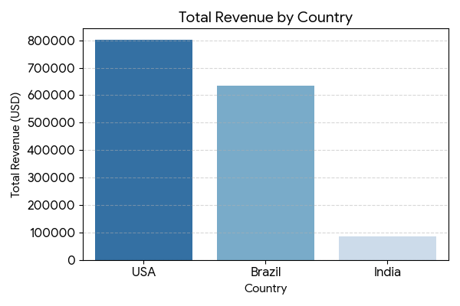
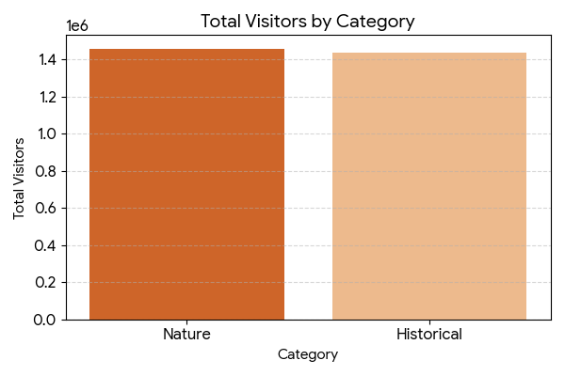
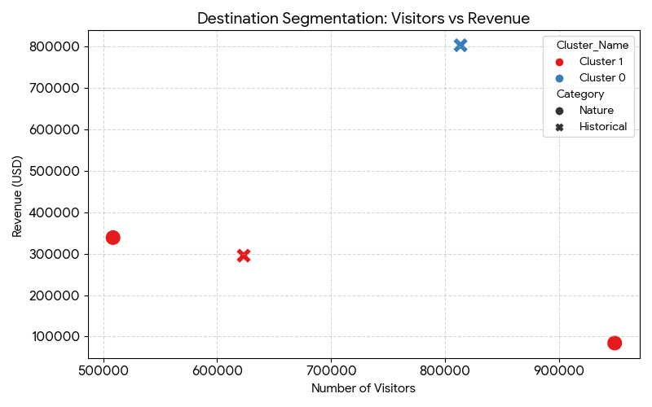

Result:

