Ex.No:9 | Mini Project – Airlines dataset

Aim:
Airline Data Analytics using Python, Pandas, Matplotlib, and Exploratory Data Analysis
Algorithm:

Step 1: Start the Program
· Start the Python program.
· Import the required libraries such as Pandas, NumPy, Matplotlib, and Seaborn.
· Import SQLite3 to connect to the airline database.
Step 2: Load the Dataset
· Read the Airline SQLite database.
· Store the required tables such as flights, ticket_flights, bookings, tickets, and airports_data in DataFrames.
Step 3: Create a Working DataFrame
· Create a copy of the flights DataFrame.
· Store the copy in flight_data.
· This allows the original dataset to remain unchanged.
Step 4: Inspect the Dataset
· Display the first few records using head().
· Display the last few records using tail().
· Check the number of rows and columns using shape.
· Display column names and data types.
Step 5: Clean the Data
· Check missing values using isna().sum().
· Identify duplicate records using duplicated().
· Remove duplicate records using drop_duplicates().
· Convert date and numerical columns into appropriate data types.
· Standardize column names into lowercase and underscore format.
Step 6: Perform Statistical Analysis
· Use describe() to calculate statistical values.
· Find mean, minimum, maximum, and standard deviation.
· Analyze numerical airline statistics such as flight count, ticket amount, booking amount, and fare.
· Calculate total revenue and average fare.
Step 7: Filter, Sort and Group Data
· Filter records according to required conditions.
· Sort flights based on important measures such as flight status, fare, or revenue.

· Group the data using suitable categorical fields such as flight status, departure airport, arrival airport, and fare condition.
· Calculate totals and averages for comparison.
Step 8: Create Visualizations
· Create suitable charts using Matplotlib and Seaborn.
· Generate bar charts, line charts, histograms, box plots, scatter plots, and count plots.
· Create charts for flight status, departure airports, arrival airports, and fare conditions.
· Create a correlation heatmap for numerical variables.
Step 9: Analyze the Results
· Compare airline flight performance.
· Identify airports with higher numbers of departures and arrivals.
· Analyze flight status and fare conditions.
· Identify flights, tickets, and bookings with higher revenue.
· Analyze relationships between numerical variables.
· Identify important trends and patterns from the visualizations.
Step 10: Display and Store the Final Results
· Display the cleaned airline dataset and analysis results.
· Save the cleaned airline dataset if required.
· Export the processed data to CSV or Excel format.
· Use the cleaned data for Power BI/Tableau dashboard development.
· Present the final airline data insights.
Stop.

Program:

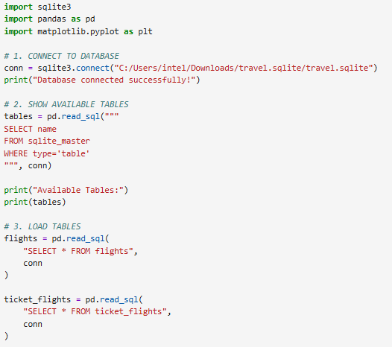

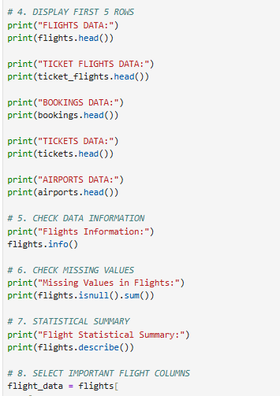

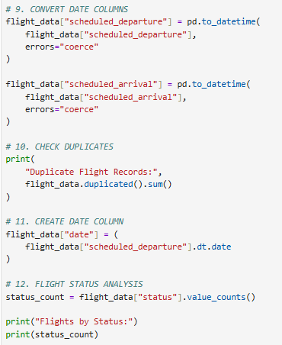

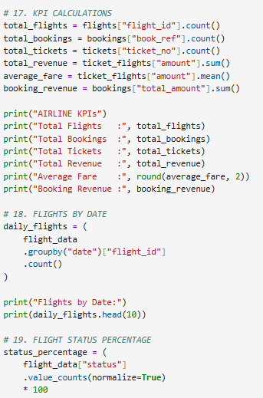

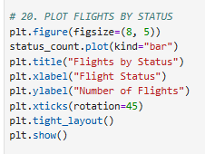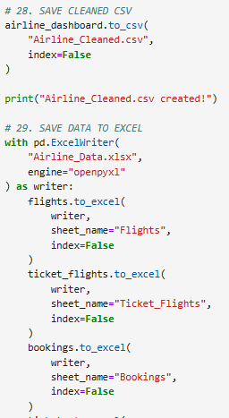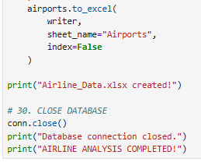

output:

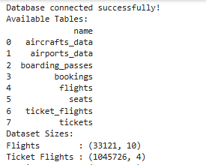

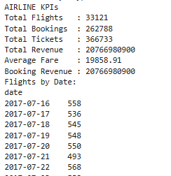

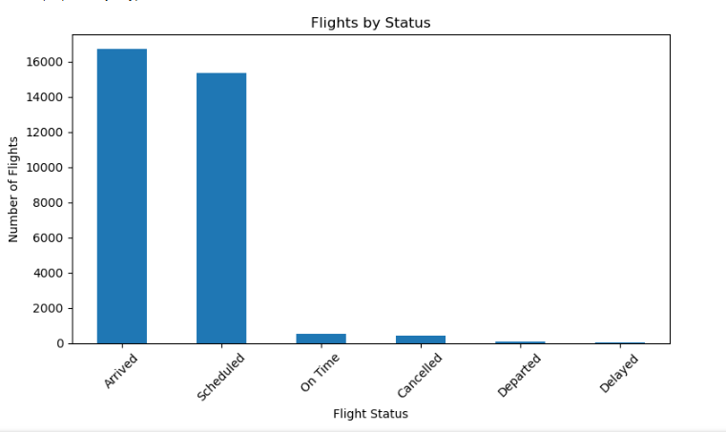

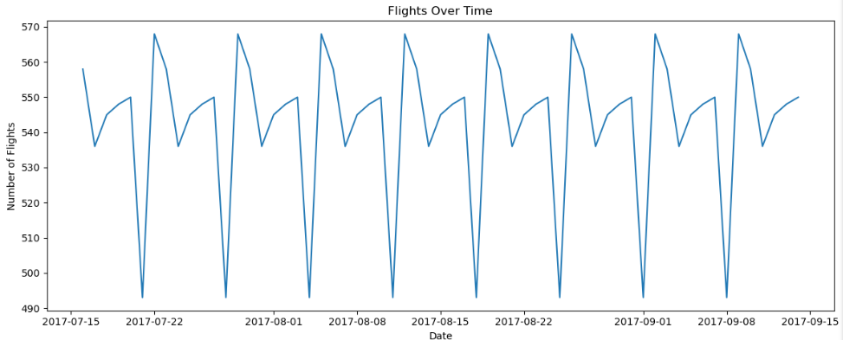

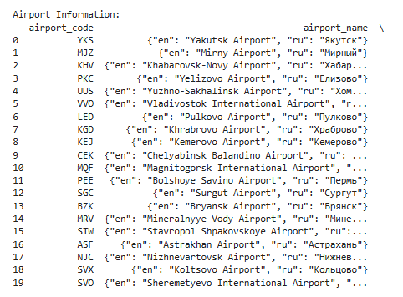

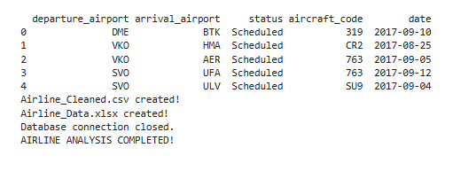

Power Bi:

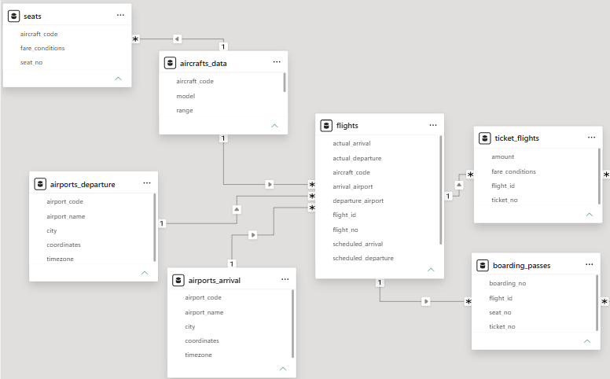
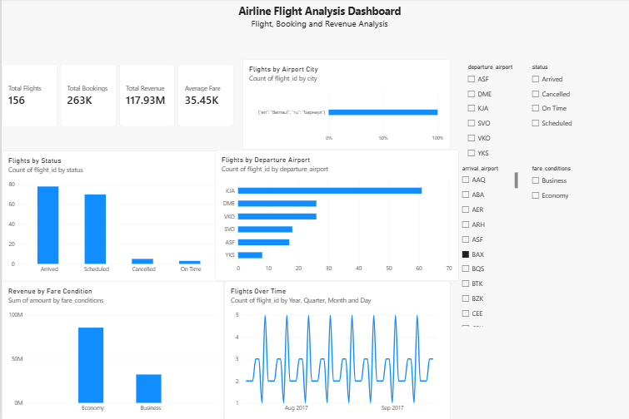

Tableau:
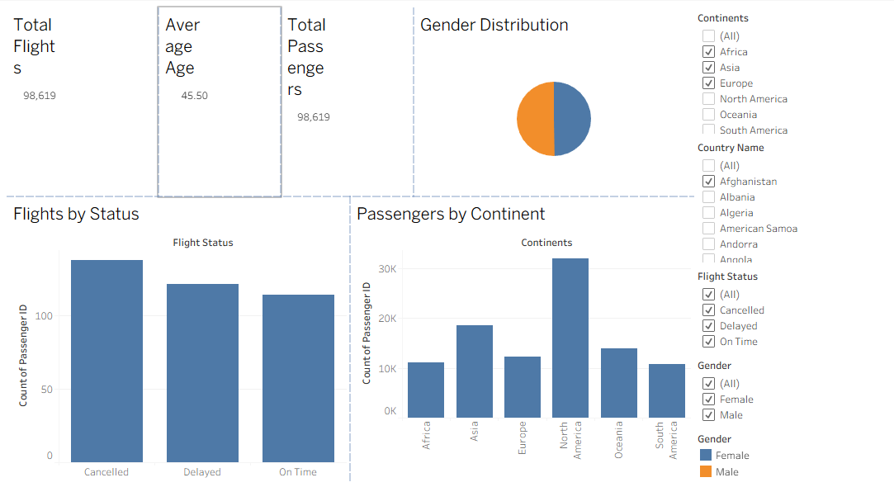

Result:
Thus the data visualization was successfully completed in jupyter,Power BI,Tabelu

