

**“AZƏRBAYCAN HAVA YOLLARI” CJSC NATIONAL AVIATION ACADEMY**

**Individual Work № 1:**

## **Topic: CPU manufacturers and brands**

**Subject: Teacher: Mehemmed Shahmaliyev**

**Group: 1459i Student: Aliyeva Ilaha**

**Date: Signature:**

**Baku 2021**

**Brands and Types of Computer CPUs (Processors)**

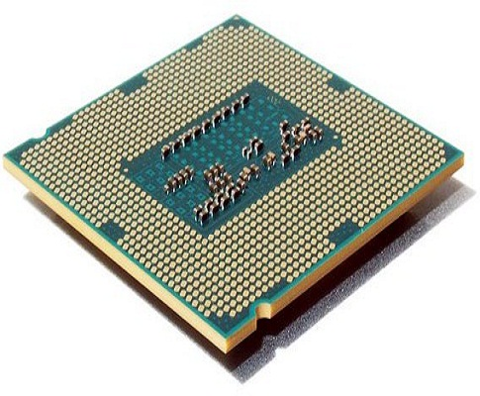  
CPU consists of Central Processing Unit which works to process, estimate, and processing the rate of information through the system on the computer. Each unit of computer CPUs will communicate with the input or output hardware devices.

Briefly, we can define the CPU as a computer hardware which is in charge of understanding and executing the commands made by the user and the data from software programs. Some people even call CPU as a processor which means the data processor of the computer.

The function of CPU becomes one of the computer hardware that is very influential as a tool that performs processing on every computer. Central Processing There are many types of CPUs and each computer hardware manufacturer release their CPU products which each of the types and brands has its excellence.

In general, each computer has a kind of processor that is installed on a specific socket where the laying has been adjusted according to a particular processor product. Parts of the CPU that are the main components of the computer are actually able to be replaced using other types of CPU components, although the suitability of socket still need to be adjusted as the system of the processor performance will affect the speed of computer performance.

## Brands of Computer CPUs on the Market

### **Intel Processors**

Intel processor is one of the most popular CPU products that is the most robust rival AMD CPUs. Intel Corporation is a multinational where was established in 1968.

The development and production center of Intel Corporation is located in the United States. Besides, Intel Corporation is known as a manufacturer that has microprocessor design. The following are the types of Intel computer CPU products which are marketed on the market:

* Intel Core 2 Quad2006
* Intel Quad Core Xeon2006
* Intel Core i7 800, i5 dan Xeon 34002009

### **AMD (Anvanced Micro Processor)**

In general, Anvanced Micro Processor is well known as AMD. Although the number of its users is still under Intel users, AMD processors production keeps continuing to create better product development. AMD is the second largest multinational company after Intel corporation in term of computer processor products development.

The development and production center of AMD is located in Sunnyvale, California. Besides, AMD is a global supplier of microprocessors that adopt the X86 architecture. The classifications of AMD products are as follow:

* To meet the market share of the server, AMD provides Opteron.
* To meet the desktop market share, AMD provides AMD FX and APU A Series.
* To meet the tablet and PC products market share, AMD provides APU Z Series.

The following are the latest of AMD processor products on the market:

* AMD Phenom II X6 1055T with spec 2.8 GHz, 6x 512,6 KB
* AMD Phenom II X6 1075T with spec 3 GHz, 6x 512,6 KB
* AMD Phenom II X6 1090T BK with spec 3.2 GHz, 6x 512,6 KB
* AMD Phenom II X6 1100T BK with spec 3.3 GHz, 6x 512,6 KB

### **ARM Processor**

ARM Processor is a company where inside of one of the products there is a processor architecture that reaches 32 bits. The ARM Processor development and production base are under the ARM Limited license. This processor is basically used for mobile phones’ processors.

The ARM processor headquarter basely is in Cambridge, England, which was established in 1990 under the name Advanced RISC Machines. ARM processor is in some specific designs that focuses on the mobile market.

The following is the list of the types of ARM Processors for mobile of the Samsung vendor:

* Qualcomm Snapdragon
* Texas Instrument OMAP
* Nvidia Tegra
* Samsung Hummingbird

### **Cyrix Processor**

Cyrix is a company that develops computer microprocessors. The beginning of the company’s establishment, as well as product production, were done in 1988. The development and production center of this processor company is in Texas. Cyrix is one of the processor suppliers with its high-performance processor products.

Here are some examples of Cyrix processors:

* Cyrix FasMath
* Cyrix 486SLC and Cyrix 486DLC
* Cyrix 5 × 86
* Cyrix 6 × 86 (M1)
* Cyrix MII
* Cyrix MediaGX
* Cyrix MII-433GP

### **Transmeta Processor**

The Transmeta is a company that conducts development in the field of semiconductor microprocessor. The development and production center is located in California.

### **Via**

Via is a company that does the development or research on a chipset that was developed in Europe. The different of this kind of processor to most processor manufacturers, one type of its processor products is the part of Formisa Plastics Group where the development center and its production is done in Taiwan.

### **Apple Processor**

At first, this company was known by the name of Apple Computer, Inc. But lately, the processor company under the apple license is referred to as Apple Inc only. The change of the name is done after the launch of the new iPhone products.

It’s a multinational company that produces a variety of processors that focus on the field of design, resources, and sales of electrical computer software products.

The development and production center is located in Silicon Valley, Supertino, California. Here is an example of Apple Inc Processor processor products:

* Apple I
* Apple II
* Apple DOS
* Apple Pascal
* Apple CP / M
* Apple SOS
* Apple ProDOS
* Macintosh

### **IBM Processor**

IBM stands for International Bussiness Machines Corporation which is a company that produces and sells a variety of hardware and software for the computer. The establishment of the IBM company was carried out on June 16, 1911, and its production operations began operating in 1888. The following are some examples of IBM processor

* 8080
* 8088 / 8086sx
* 286
* 80386 DX
* IBM 486SLC2
* Pentium Classic (P54C)
* Pentium Pro
* Pentium II Xeon
* IBM POWER4
* IBM POWER5
* IBM POWER6
* IBM POWER7

### **IDT Processor**

The name of this company is Integrated Device Technology, but better known as IDT. The processor products of IDT is cheaper other processor brands. The site of its development and production is located in San Jose, California, United States.

The establishment of this company was conducted in 1980, and then, in 1997 for the first time, IDT launched WinChip processor. Here are some types of IDT processors:

* Winchip C6 (0.35 μm)
* WinChip 2 (0.35 μm)
* WinChip 2A (0.35 μm)
* WinChip 2B (0.25 μm)
* WinChip 3 (0.25 μm)

Those are some types of computer CPUs (processors) which are available on the market in various brands and products.