

SCHOOL OF ADVANCED TECHNOLOGY

ICT - Applications & Programming

Computer Engineering Technology – Computing Science

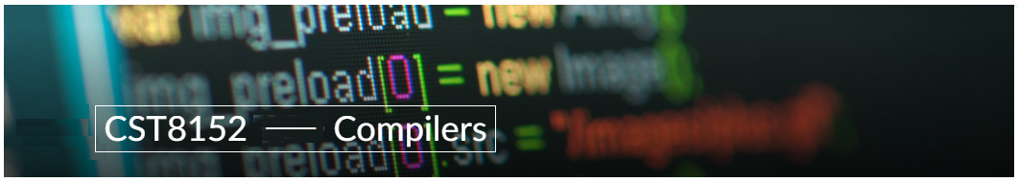

A21
Model Definitions (RE/Automaton)

Lab Professor / Lab Session:
Paulo Sousa Section 312

Team:
Sean Bradbury 041101614

Language Name Chopin

This template is suggested (not mandatory) to answer A11 Specification.

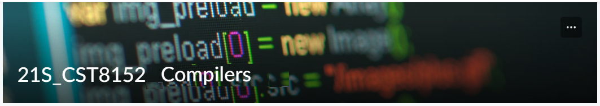

MODEL TASK FOR ASSIGNMENT 2.1 – Chopin

- Note: This task is part of the Assignment 2 from Compilers Course. Any problem, contact your lab professor.

Task 1: Language Symbols (2.0 marks)

List examples: Define main symbols to be used:
- Special symbols (ex: “{“, “(“, “<=”, etc.)
- Comments
- Variables
- Functions
- Literals (numbers, strings)
- Keywords
- Datatypes

Answer:

Special symbols:
[‘=’,’(‘,’)’,’{‘,’}’,’<’,’>’,’-‘,’+’,’/’,’*’,’#’,’;’,’_’,’,’,’.’,’&’,’|’,’:’]
Comments:
SLC: // <text>
MLC: /// <text> ///
Variables:
Ex: songName, tempo, A#, Bmaj7

Start with a letter, and then can use letters, numbers, underscores, or the # character.

Functions:
Ex: datatype functionName(parameters) { <function body> }

Datatype is a keyword for a datatype, functionName is a variable name, parameters zero or more data types with a variable name, function body contains code at least having a return statement.

Literals:
Integers: 0, 12, -190
Floats: .001, 14.331, 0.123
Strings: “This is a string”

For int: Sequence of digits
For floats: sequence of digits separated by a period, or a period followed by a sequence of digits
For strings: a series of chars surrounded by double quotes

Keywords: {return, int, dec, pitch, duration, velocity, beat, string, boolean, for, do, while, if, else, Note, Track, Project}

Datatypes: {int, dec, pitch, beat, velocity, duration, boolean, string, Note, Track, Project}
int: whole numbers
dec: floating point numbers
pitch: floating point number – represents Hz
beat: floating point number – represents time location
velocity: floating point number – represents dBs
duration: floating point number – represents number of beats
boolean: TRUE or FALSE
string: characters
Note: combines pitch, beat, velocity, and duration data types into one object. For example, a Note
could start on beat 4.25, with a pitch of 583.2, at 50dB, for 2.5 duration.
Track: an array of Notes with a name variable. For example, a Track could contain all the notes played by the piano in a song.
Project: an array of Tracks with a name variable. A Project would represent a full song, with all the
instruments as separate Tracks.

Task 2: RE – Regular Expression (3.0 mark)

Lexeme Classes: Define the classes to be used in your regular expression:

Answer:
L = {a-Z}
D = {0-9}
S = {/}
H = {#}
U = {_}
B = {.}
Q = {“}
N = {\n}
M = {-}

O (other) = { ^L, ^D, ^E, ^S, ^H, ^U, ^B, ^Q, ^N, ^P }

Define the RE to be used for: variables, literals and keywords:

Answer:
* Comments:
-SLC: SS[^N]*N
-MLC: SSS[^(SSS)]*SSS
* Variables:
L(L|D|U|H)*
* Methods:
L(L|D|U|H)*
* Literals:
- Numbers
Int: M?D+
Float: M?D*BD+

- Strings: Q(^Q)*Q

* Keywords:
{return, int, dec, pitch, duration, velocity, beat, string, boolean, for, do, while, if, else, Note, Track, Project }

Task 3: TD – Transition Diagram (3.0 marks)

Activity: Starting from the previous lexeme classes and obeying the RE, it is possible to define the automata for your language:

Answer (draw / copy image of the automata):

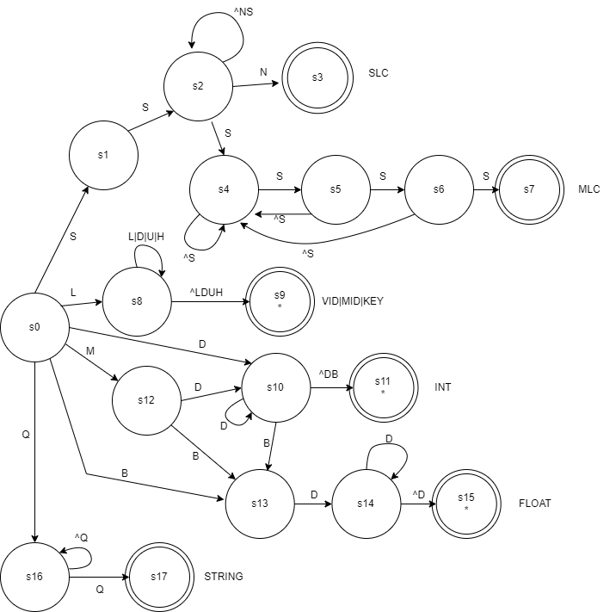

Task 4: TT – Transition Table (2.0 marks)

Activity: Now, it is possible to define the TT for these lexemes:

Answer (Transition Table):

Input | Input Symbol |  |  |  |  |  |  |  |  |  | Output
State \ Classes | 0 | 1 | 2 | 3 | 4 | 5 | 6 | 7 | 8 | 9 | Type
 | L(a-Z) | D(0-9) | S(/) | H(#) | U(_) | B(.) | Q(“) | N(\n) | M(-) | O | -
S0 | 8 | 10 | 1 | ES | ES | 13 | 16 | ES | 12 | ES | NOFS [0]
S1 | ES | ES | 2 | ES | ES | ES | ES | ES | ES | ES | NOFS [1]
S2 | 2 | 2 | 4 | 2 | 2 | 2 | 2 | 3 | 2 | 2 | NOFS [2]
S3 | FS | FS | FS | FS | FS | FS | FS | FS | FS | FS | FSNR (SLC) [3]
S4 | 4 | 4 | 5 | 4 | 4 | 4 | 4 | 4 | 4 | 4 | NOFS [4]
S5 | 5 | 5 | 6 | 5 | 5 | 5 | 5 | 5 | 5 | 5 | NOFS [5]
S6 | 6 | 6 | 7 | 6 | 6 | 6 | 6 | 6 | 6 | 6 | NOFS [6]
S7 | FS | FS | FS | FS | FS | FS | FS | FS | FS | FS | FSNR (MLC) [7]
S8 | 8 | 8 | 9 | 8 | 8 | 9 | 9 | 9 | 9 | 9 | NOFS [8]
S9 | FS | FS | FS | FS | FS | FS | FS | FS | FS | FS | FSWR (VID|MID|KEY) [9]
S10 | 11 | 10 | 11 | 11 | 11 | 13 | 11 | 11 | 11 | 11 | NOFS [10]
S11 | FS | FS | FS | FS | FS | FS | FS | FS | FS | FS | FSWR (INT) [11]
S12 | ES | 10 | ES | ES | ES | 13 | ES | ES | ES | ES | NOFS [12]
S13 | ES | 14 | ES | ES | ES | ES | ES | ES | ES | ES | NOFS [13]
S14 | 15 | 14 | 15 | 15 | 15 | 15 | 15 | 15 | 15 | 15 | NOFS [14]
S15 | FS | FS | FS | FS | FS | FS | FS | FS | FS | FS | FSWR (FLOAT) [15]
S16 | 16 | 16 | 16 | 16 | 16 | 16 | 17 | 16 | 16 | 16 | NOFS [16]
S17 | FS | FS | FS | FS | FS | FS | FS | FS | FS | FS | FSNR (STRING) [17]

Update: Jun 1st 2024.

Adapted from resources developed by Prof. Svillen Ranev (Algonquin College, 2019)

