**PROJECT ARRANGEMENTS.**

**Project proposal.**

**Project purpose and relevance.**

Shopping trips are a daily routine of every person.

But not everyone has a good memory. However, even a person with a memory like an elephant forgets some things that he told himself to buy at the beginning of the day. In addition, keeping in mind what you need to buy while working can negatively affect your performance.

And that's why our team decided to somehow contribute to solving this problem.

Key points:

* Human memory can hold 1 million GB of information
* Approximately 65 percent of the population are visual, that is, they must perceive information with their eyes in order to learn it.
* Almost every store has a shopping cart. for the convenience of the store

Nowadays, everyone has a mobile phone. and everyone can write everything down in notes. But this also requires memory, so as not to forget to go to the notes and see what to buy. Hovewer what we offer is the best. our shop list has been upgraded for a computer and a phone. That is, suddenly if you forgot your phone or it sat down, then you can go through your laptop and see what you need to take home :D

**Similar projects and competitors analysis.**

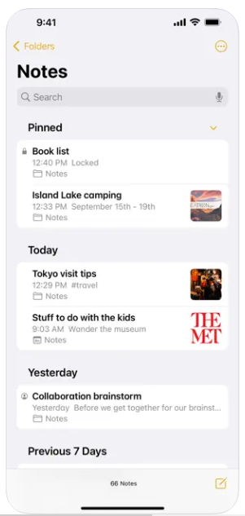

*Picture 1. The screenshot of Notes app of Iphone*

In the Notes app, you can easily sketch ideas or keep more detailed notes with checklists, images, web links, scanned documents, handwritten notes and drawings.

Effective work with notes

create checklists. Make shopping lists, wishes or tasks, and then mark the completed items with a touch. 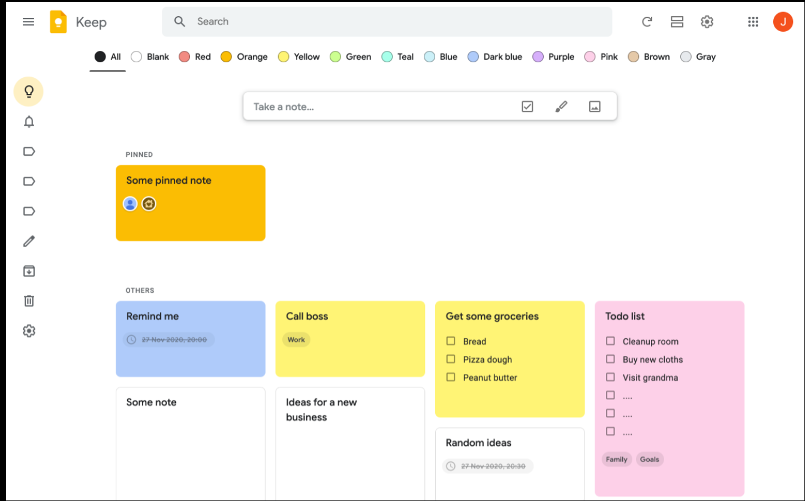

*Picture 2. Google Keep*

There is another analog for our project :D “Google Keep”

Google Keep is a simple and convenient tool for creating notes that you can share with other users. The main difference from our project is that it can be compiled together with someone else

**Project auditory.**

***Age of 18-99.***

Everyone goes to the store for shopping. and everyone had moments when they forgot to buy something. Judging by the article, every year a person's memory deteriorates. several factors contribute to this, such as depression, burnout from work

**Project features.**

A shop list website does not require particularly unique functionality. All you need is to add the thing you need to buy. and after the purchase, remove it from the list. so as not to confuse in the future. Authorization and registration have also been added. so that everyone has their shopping lists separately. for the same purpose, so as not to confuse users