Rahn Monitor

Login: Enter Username and Password to Login

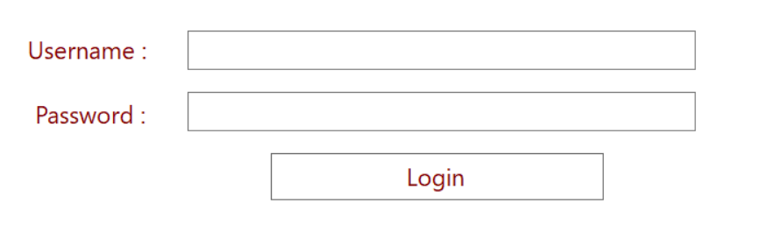Username : Roche , Password : 12

Main Search Page

The main Search page is where you can search specific items.

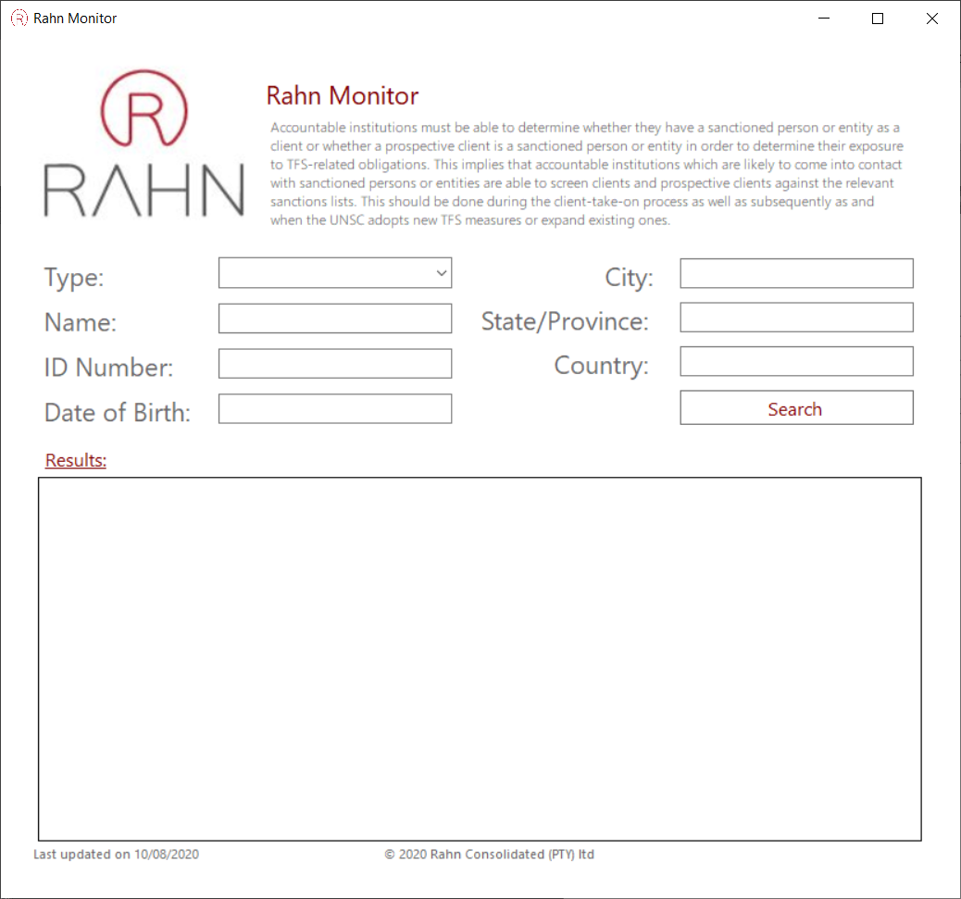

Select Entity or individual

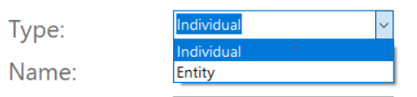

Enter any of the following information and click search.

The Results Table will display a preview of any matched items.

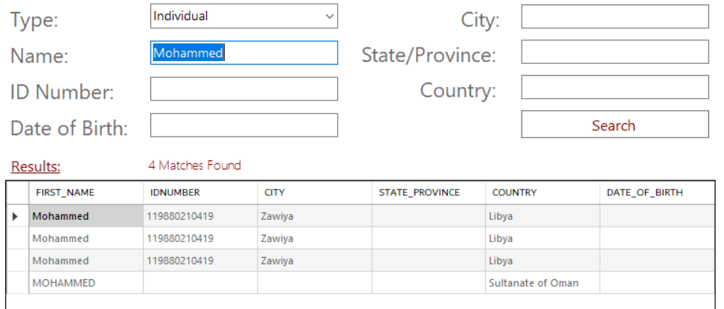

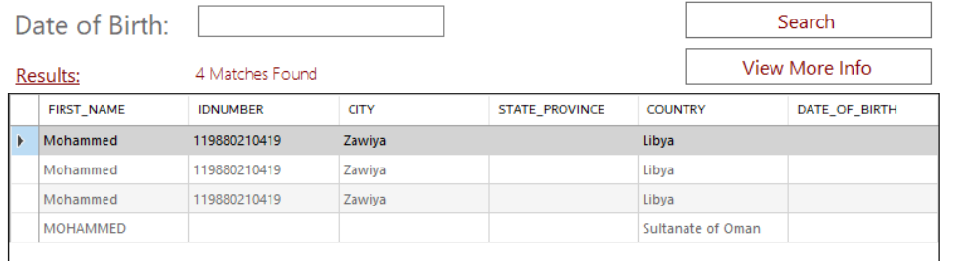When you click on the Row Header the View More Info Button will appear

Click the View More Info Button to view More Information about the Item selected.

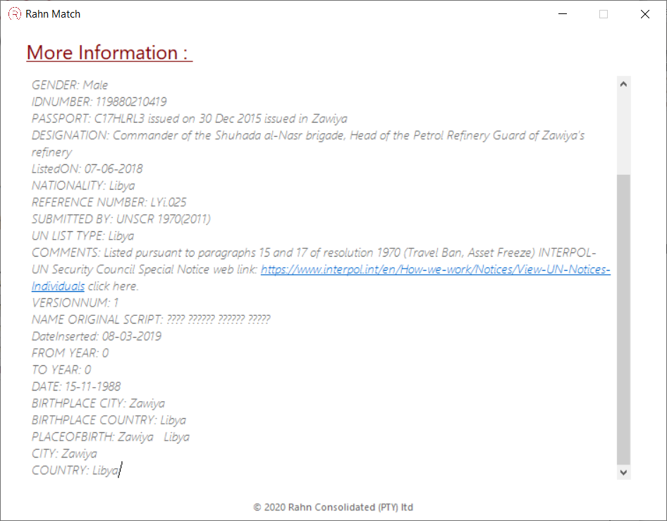

Data

The Latest data file is downloaded from the fic website.

The data is transformed from a CSV file and populated into the Rahn DB via SQL2016

The data is divided into Entity and Individual Tables.

The Database is net connected in the Code via SQL Connector

The application has an onboard database stored in the application called RahnMonitorDb.mdf

Consolidated United Nations Security Council Sanctions List

Excel.csv

Rahn Montior

RahnDB

SQL Server